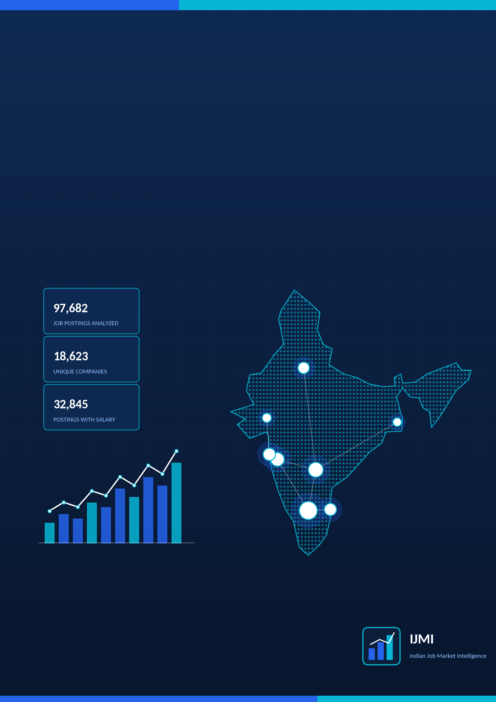
IBM SKILLSBUILD
DATA ANALYTICS WITH AI
VIRTUAL INTERNSHIP 2026
INDIAN JOB MARKET
INTELLIGENCE
Career Analytics Platform

INTERNSHIP PROJECT REPORT
Jasobanta Parida
B.Tech – Computer Science & Engineering
Program context: IBM SkillsBuild · BharatCares – SMEC Trust · AICTE

Internship Project Statement
This report documents Indian Job Market Intelligence – Career Analytics Platform, an IBM SkillsBuild Data Analytics with AI Virtual Internship Project carried out in 2026. The project turns a public job-posting dataset into an interactive analytics application that answers practical job-market and career questions using data cleaning, feature engineering, exploratory analysis, SQL analytics, statistical analysis and machine learning.
Project | Indian Job Market Intelligence
Subtitle | Career Analytics Platform
Project type | IBM SkillsBuild Data Analytics with AI Virtual Internship Project (2026)
Program context | IBM SkillsBuild · BharatCares – SMEC Trust · AICTE
Author | Jasobanta Parida
Education | B.Tech – Computer Science & Engineering, GITA Autonomous College (2026)
Deliverables | Streamlit analytics application (15screens: home page plus 14 analysis pages) and this project report
Dataset | Indian Job Market Dataset 2025 – 97,929 job postings (97,682 after de-duplication)
Technologies | Python, Pandas, NumPy, Plotly, Streamlit, SQLite, SciPy, scikit-learn

Basis of this report
Every number, feature and page described here was checked against the project workspace and recomputed by running the project's own data pipeline. Findings describe patterns within the analyzed dataset and are not claims about the entire Indian job market.
Where a capability is not present in the current implementation, this report says so explicitly. Planned ideas appear only under Future Enhancements.

Declaration
I, Jasobanta Parida, declare that this report describes the internship project Indian Job Market Intelligence – Career Analytics Platform, undertaken as part of the IBM SkillsBuild Data Analytics with AI Virtual Internship (2026).
The results, figures and observations in this report were computed from the analyzed dataset using the project's implementation. The dataset was obtained from a public source listed in the References. The Streamlit application was developed with the assistance of IBM Bob, an AI software-engineering assistant, working from requirements written by the author. All external sources and tools used are acknowledged in the References.
Signature: ______________________________
Jasobanta Parida
Place: ______________________ Date: ______________________
Acknowledgement
I am grateful to IBM SkillsBuild, BharatCares – SMEC Trust and AICTE for the opportunity to take part in the Data Analytics with AI Virtual Internship 2026. The program's structured learning path gave this project its analytical direction.
I would like to express my special thanks to Mr. Himansu Souda, my internship instructor, for his guidance, support, and valuable suggestions throughout the development of this project. His guidance helped me understand the practical aspects of data analytics and improve the overall quality of my work.I also acknowledge the publisher of the Indian Job Market Dataset 2025–2026 on Kaggle, whose openly shared data made this analysis possible, and the open-source communities behind Python, Pandas, NumPy, Plotly, Streamlit, SciPy and scikit-learn.
Executive Summary
What the project is. Indian Job Market Intelligence is an interactive analytics platform that explores job demand, skills, salaries, experience requirements and fresher opportunities, and lets a user compare their own skills with the skills that appear in postings for a chosen role. It is delivered as a Streamlit application with a home page and 13 analysis pages.
Why it was developed. Job seekers face four recurring questions: where the jobs are, which skills are mentioned most, what salaries are advertised, and how their own profile compares. The platform answers these from data instead of opinion, and demonstrates an end-to-end analytics workflow for an internship portfolio.
Dataset analyzed. The Indian Job Market Dataset 2025 contains 97,929 raw postings with 17 columns. After removing 247 exact duplicates, 97,682 postings remain, from 18,623 companies across 1,498 primary locations. Salary is disclosed for 32,845 postings (33.6%).
Methods used. Data cleaning and feature engineering in Pandas; keyword-based skill extraction; exploratory analysis with Plotly; twelve pre-built SQL analyses on an in-memory SQLite database; descriptive statistics, correlation and one-way ANOVA with SciPy; and three salary-estimation models with scikit-learn.
Selected findings within the analyzed dataset.
- Bengaluru has the most postings (18,320, 18.8%), followed by Hyderabad (10,899) and Pune (8,405).
- Advertised salary is right-skewed: mean ₹7.05 LPA versus median ₹4.20 LPA, and the median rises from ₹2.75 LPA (fresher) to ₹16.5 LPA (8+ years).
- 11,831 postings (12.1%) ask for zero years of minimum experience.
- The best salary-estimation models reach R² = 0.477 with a mean absolute error of about ₹2.95 LPA, so estimates are directional only.
Practical value. The application gives students and early-career professionals a filterable view of roles, skills, locations and pay; gives recruiters a compact demonstration of analytics, SQL, statistics, machine learning and product-style dashboard design; and documents its own limitations openly.
Project at a Glance
97,682  POSTINGS ANALYZED | 18,623  COMPANIES | 1,498  PRIMARY LOCATIONS | 13  ANALYSIS PAGES

INTERNSHIP  IBM SkillsBuild Data Analytics with AI Virtual Internship 2026 (BharatCares – SMEC Trust, AICTE) | PROJECT  Indian Job Market Intelligence – Career Analytics Platform | DATASET  Indian Job Market Dataset 2025 (Naukri.com postings): 97,929 raw rows, 17 columns, 97,682 clean rows
ANALYTICS  Demand, skills, salary, experience, fresher, company and location analysis; Job Explorer; Career Skill Gap analyzer | SQL  12 pre-built queries plus a custom editor on an in-memory SQLite table (jobs); GROUP BY, HAVING, CTEs, LIKE | STATISTICS  Descriptive statistics, percentiles, IQR outliers, Pearson correlation, one-way ANOVA
MACHINE LEARNING  Salary estimation: Linear Regression, Random Forest, Gradient Boosting (best R² 0.477) | APPLICATION  Streamlit multi-page app with grouped sidebar navigation, filters, KPI cards, Plotly charts and CSV export | TECHNOLOGIES  Python · Pandas · NumPy · Plotly · Streamlit · SQLite · SciPy · scikit-learn

Reading guide
Sections 1–8 describe the project, dataset, data preparation and architecture. Sections 9–20 document each analytical module. Sections 21–23 describe the application and its design. Sections 24–29 cover insights, value, limitations, future work and references.

Table of Contents
1. Internship Project Overview 8
2. Business Problem and Questions 8
3. Project Objectives and Scope 8
4. Dataset Overview 9
5. Data Quality and Cleaning 10
6. Feature Engineering 10
7. Technical Architecture 11
8. Technology Stack 12
9. Exploratory Data Analysis 14
10. Job Demand Intelligence 16
11. Skill Intelligence 16
12. Salary Intelligence 18
13. Experience Analysis 19
14. Fresher Opportunity Intelligence 20
15. Company and Location Intelligence 21
16. Job Explorer 22
17. Career Skill Gap Analyzer 22
18. SQL Analytics 24
19. Statistical Insights 25
20. Machine Learning: Salary Prediction 26
21. Streamlit Application 27
22. UI/UX Design 28
23. Dashboard Showcase 29
24. Key Insights 34
25. Technical and Recruiter Value 35
26. Limitations 36
27. Future Enhancements 37
28. Conclusion 38
29. References 38
Appendix 39

1. Internship Project Overview
The IBM SkillsBuild Data Analytics with AI Virtual Internship 2026 is delivered under IBM SkillsBuild with BharatCares – SMEC Trust and AICTE. This project is the practical deliverable of that internship: an end-to-end job-market analytics platform built on real job-posting data.
The platform starts from a raw CSV and ends at an interactive application. In between it cleans the data, engineers analytical features, extracts skills from free-text tags, runs SQL, statistical and machine-learning analyses, and presents the results as question-led dashboard pages.

Development approach
The application was built iteratively with IBM Bob, an AI software-engineering assistant, from written requirement prompts: an initial seven-page dashboard, then SQL, statistics, salary prediction, Job Explorer and Career Skill Gap modules, followed by debugging passes and a UI redesign. The requirements, dataset choice and analytical scope were specified by the author.

2. Business Problem and Questions
Job-market information is fragmented. A student choosing a career direction, or a professional planning a move, has to piece together which roles are hiring, which skills to build, and what pay to expect. Advertised salaries are often missing, and blog advice on skills is not always backed by evidence.
The platform addresses these questions, each of which is implemented in the current application:
- Which job roles appear most frequently in the dataset?
- Which skills are frequently mentioned, and which skills occur together?
- How do advertised salaries vary by role, location, experience and skill?
- How does experience relate to advertised salary?
- Which locations and companies have the most postings?
- What opportunities appear for freshers?
- For a selected target role, which frequently mentioned skills are not yet in the user's skill set?
- Can advertised salary be estimated from patterns in the dataset (role, location, experience)?

3. Project Objectives and Scope

Objectives
- Understand job-demand patterns across roles, cities and experience levels.
- Identify frequently mentioned skills and skill combinations.
- Analyze salary distributions and their relationship with experience.
- Build and evaluate a salary-estimation model from posting features.
- Help a user identify frequently requested skills for a target role.
- Provide a searchable, filterable view of the postings with CSV export.
- Demonstrate SQL analytics and statistical analysis on the same dataset.

Scope
In scope (implemented) | Out of scope (not implemented)
Static CSV snapshot of Naukri.com postings | Real-time job ingestion or automatic data refresh
Keyword-based skill extraction from the tags column | NLP on the job-description text (the column is present but not used)
SQLite, SciPy and scikit-learn analyses inside the app | Cloud deployment or automated pipelines
Interactive Streamlit dashboard with CSV export | User accounts, saved searches or recommendations

4. Dataset Overview
The analysis uses the Indian Job Market Dataset 2025, distributed on Kaggle and documented in the project README as job postings from Naukri.com. The file data/indian_job_market.csv contains 97,929 rows and 17 columns.
Table 1. Raw dataset columns and missing values (from the raw CSV)
Column | Type | Description | Missing (raw)
title | text | Job title | 0
jobId | integer | Posting identifier (not used in analysis) | 0
companyName | text | Employer name | 4
companyId | integer | Employer identifier (not used in analysis) | 0
location | text | Raw, possibly multi-city location string | 0
tagsAndSkills | text | Comma-separated skill tags | 571
experience | text | Experience range as text (e.g. “2-4 Yrs”) | 2,105
minimumExperience / maximumExperience | numeric | Experience bounds in years | 571
salary | text | Salary as text (e.g. “3-5 Lacs PA” or “Not disclosed”) | 0
minimumSalary / maximumSalary | numeric | Salary bounds; 0 where undisclosed | 571
currency | text | INR or USD | 0
jobUploaded | text | Relative posting time (e.g. “4 Days Ago”) | 0
AggregateRating / ReviewsCount | numeric | Company rating and review count | 35,252
jobDescription | text | Description text (not used in analysis) | 0

Within the analyzed dataset, 33.6% of postings carry a usable advertised salary, 98.9% carry an experience range, and 64.0% carry a company rating. These coverage levels shape how far each analysis can be trusted.

5. Data Quality and Cleaning
All cleaning is implemented as reusable functions in src/data_cleaning.py and applied in a fixed order by clean_data(). The steps below describe what the code does.
Table 2. Data cleaning steps as implemented in src/data_cleaning.py
Step | Implemented behaviour | Effect on this dataset
Duplicates | Exact duplicate rows are dropped | 247 rows removed (97,929 → 97,682)
Zero salary | minimumSalary / maximumSalary of 0 are treated as “not disclosed” and set to missing | 64,129 raw rows have a zero minimum salary
Currency | USD salaries are multiplied by a fixed rate of 83 to obtain INR | 129 USD rows
Salary bounds | Rows where minimum exceeds maximum are swapped; average_salary = (min + max) / 2 | Derived column added
Salary outliers | average_salary above its 99th percentile is set to missing (excluded from salary analysis) | 32,845 postings retain an average salary
Experience | Values are coerced to numeric; rows where both bounds are 0 are set to missing; average_experience is derived | 533 raw rows have 0–0 experience
Location | The first city before a comma is taken and parenthetical sub-areas are removed to form primary_location | 10,066 distinct raw strings → 1,498 primary locations
Titles | Whitespace is trimmed and collapsed (letter case is not changed) | Applied to all rows
Company names | Whitespace is trimmed; “nan”, “None” and blank become “Unknown” | Applied to all rows
Upload time | “Just now / today / few hours ago” → 0; “N days ago” → N; other text → missing | 571 rows could not be parsed
Ratings | AggregateRating and ReviewsCount are coerced to numeric; missing values are left missing | 62,517 postings carry a rating

The application also includes a Dataset & Quality page that recomputes these figures from the loaded data and displays the missing-value analysis, column types, numeric summaries, salary and experience quality metrics, and a dataset disclaimer.
Dataset disclaimer
Insights in this application describe patterns within the provided job-posting dataset and should not be interpreted as a complete representation of the entire Indian job market.

6. Feature Engineering
Derived columns are created by src/data_cleaning.py, src/feature_engineering.py and src/skill_extraction.py. The cleaned analytical table has 27 columns (17 raw plus 10 derived).
Table 3. Engineered features
Feature | Purpose | Transformation | Analytical use
average_salary | One comparable salary per posting | (minimumSalary + maximumSalary) / 2 in INR; missing above the 99th percentile | All salary analyses
average_salary_lpa | Readable salary unit | average_salary ÷ 100,000 (Lakhs per annum), rounded to 2 decimals | KPIs, charts, statistics, ML target
minimumSalary_lpa / maximumSalary_lpa | Salary range in LPA | Same conversion for each bound | Range filtering, SQL
average_experience | Single experience value | (minimumExperience + maximumExperience) / 2, missing bounds counted as 0 | Correlation, descriptive statistics
experience_group | Comparable seniority buckets | pd.cut on minimumExperience: Fresher (0 Yrs), 0–2, 2–5, 5–8, 8+ Yrs; missing → “Unknown” | Demand, salary and skill comparisons
is_fresher | Entry-level flag | True when minimumExperience equals 0 | Fresher page, SQL
primary_location | One city per posting | First city in the location string, sub-areas removed | Location analyses, ML
days_ago | Posting recency | Parsed from the relative “jobUploaded” text | Posting-activity chart
skills_list | Structured skills | Canonical skills matched from tagsAndSkills (89 canonical names defined) | Skill, career-gap analyses

7. Technical Architecture
The code is layered so that data logic is independent of the user interface. Modules in src/ contain no Streamlit calls except ui_helpers.py, which renders shared UI components; caching decorators are applied in app.py and the page files.
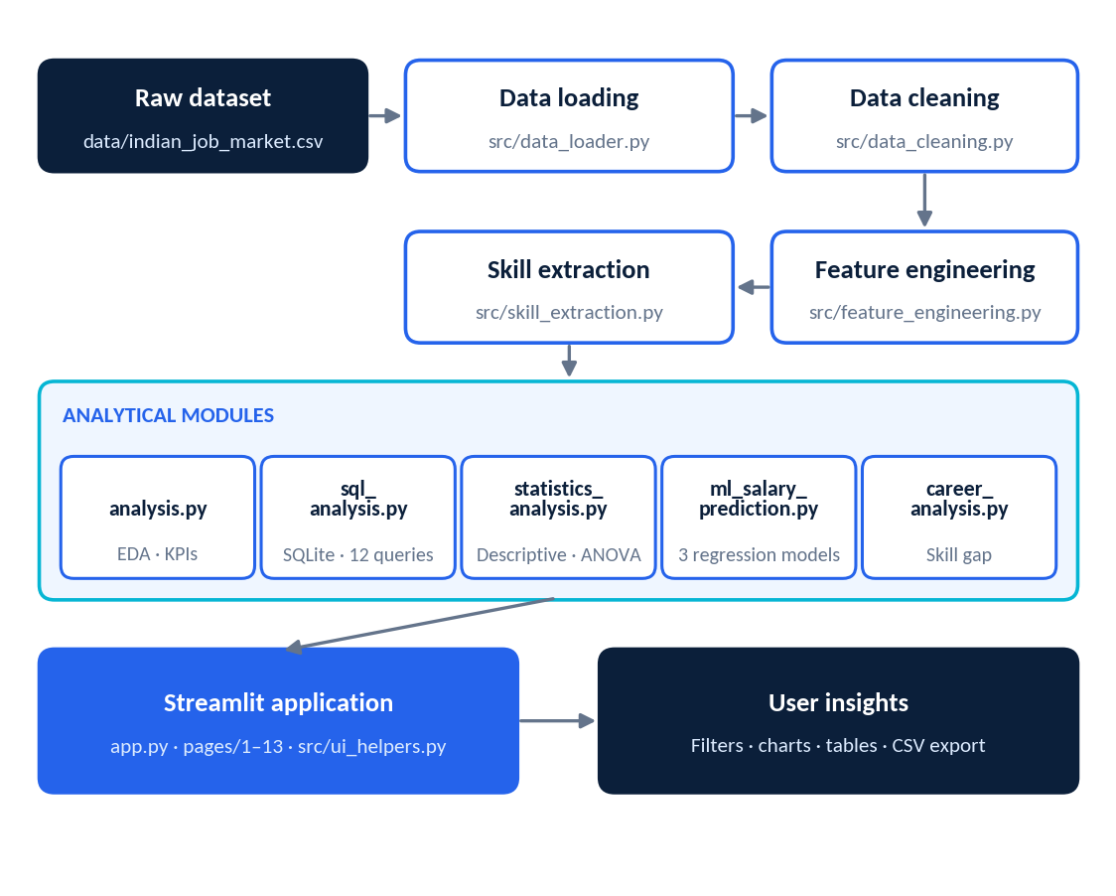
Figure 1. Data and application architecture (module names from the project)

Project structure
indian_job_market/
├── app.py home page, data loading, KPIs
├── pages/
│ ├── 1_Job_Market_Overview.py ├── 8_Dataset_Quality.py
│ ├── 2_Job_Demand.py ├── 9_SQL_Analytics.py
│ ├── 3_Skill_Intelligence.py ├── 10_Statistical_Insights.py
│ ├── 4_Salary_Intelligence.py ├── 11_Salary_Prediction.py
│ ├── 5_Experience_Analysis.py ├── 12_Career_Skill_Gap.py
│ ├── 6_Fresher_Jobs.py └── 13_Job_Explorer.py
│ └── 7_Company_Location.py
├── src/
│ ├── data_loader.py data_cleaning.py feature_engineering.py
│ ├── analysis.py skill_extraction.py career_analysis.py
│ ├── sql_analysis.py statistics_analysis.py ml_salary_prediction.py
│ └── ui_helpers.py __init__.py
├── data/indian_job_market.csv
├── .streamlit/config.toml
├── requirements.txt
└── README.md

8. Technology Stack
Only technologies that are imported or configured in the workspace are listed.
Table 4. Technology stack (requirements.txt lists streamlit, pandas, plotly, numpy, scikit-learn, scipy)
Technology | Role in the project | Where used
Python | Implementation language | All modules
Pandas | Loading, cleaning, aggregation, SQL result frames | src/, pages/
NumPy | Numeric operations | src/data_cleaning.py, pages/
Plotly (Express and Graph Objects) | Interactive charts | pages/, src/ui_helpers.py
Streamlit | Multi-page web application, widgets, layout | app.py, pages/, src/ui_helpers.py
SQLite (Python sqlite3) | In-memory database for SQL analytics, with a custom MEDIAN aggregate | src/sql_analysis.py
SciPy | One-way ANOVA (f_oneway) | src/statistics_analysis.py
scikit-learn | Pipelines, encoders, Linear Regression, Random Forest, Gradient Boosting, metrics | src/ml_salary_prediction.py

9. Exploratory Data Analysis
BUSINESS QUESTION | What does the analyzed market look like at a glance?
DATA | Cleaned postings; columns title, primary_location, companyName, average_salary_lpa, days_ago
METHOD | KPI aggregation (overview_kpis), frequency counts (top_n_by_count), recency counts (jobs_over_time)
VISUALIZATION | KPI cards, horizontal bar charts, posting-recency chart (Overview page and home page)
OBSERVATION | 97,682 postings from 18,623 companies in 1,498 primary locations; mean advertised salary ₹7.05 LPA and median ₹4.20 LPA (postings with salary only)
PRACTICAL RELEVANCE | Frames the size and coverage of the data before any filter is applied

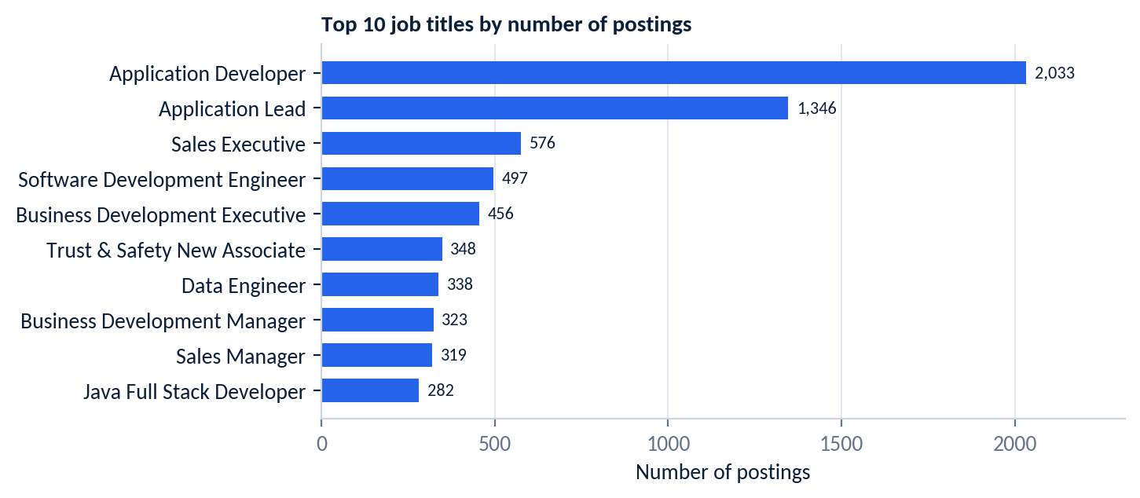
Figure 2. Top 10 job titles by number of postings
Within the analyzed dataset, Application Developer is the most frequent title (2,033 postings, 2.1% of all postings), followed by Application Lead (1,346). Titles are counted as written (normalized only for whitespace), so closely related titles are counted separately.
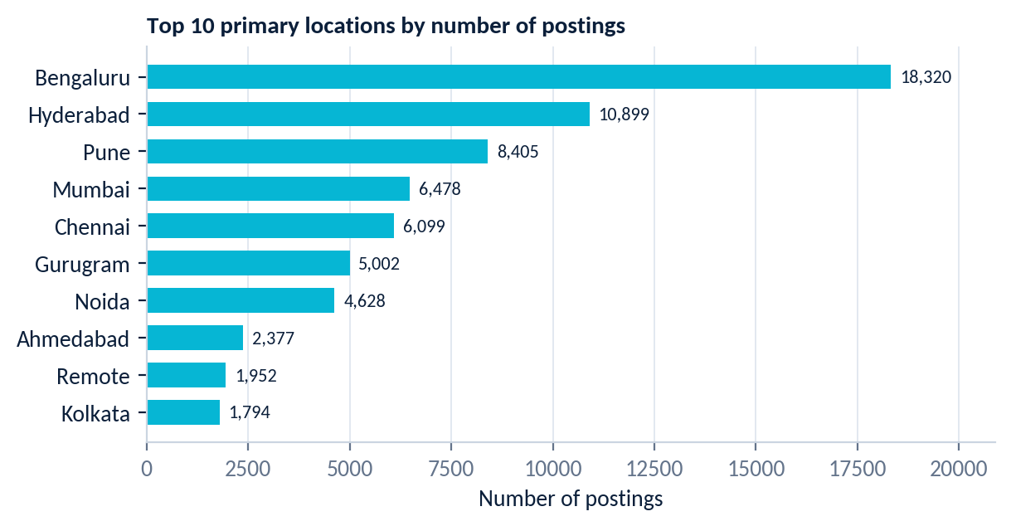
Figure 3. Top 10 primary locations by number of postings
Bengaluru leads with 18,320 postings (18.8%). The three largest cities (Bengaluru, Hyderabad, Pune) account for 37,624 postings (38.5%), and the ten largest location values for 65,954 (67.5%). “Remote” appears as a location value (1,952 postings) and is treated as a location by the current implementation.
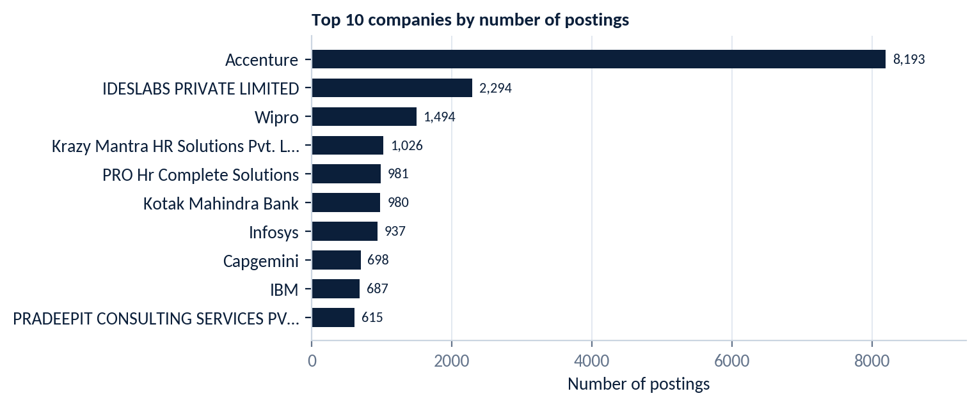
Figure 4. Top 10 companies by number of postings
Accenture has the most postings (8,193, 8.4%), followed by IDESLABS PRIVATE LIMITED (2,294) and Wipro (1,494). Staffing and consulting organizations feature prominently among the most active posters. IBM appears with 687 postings.
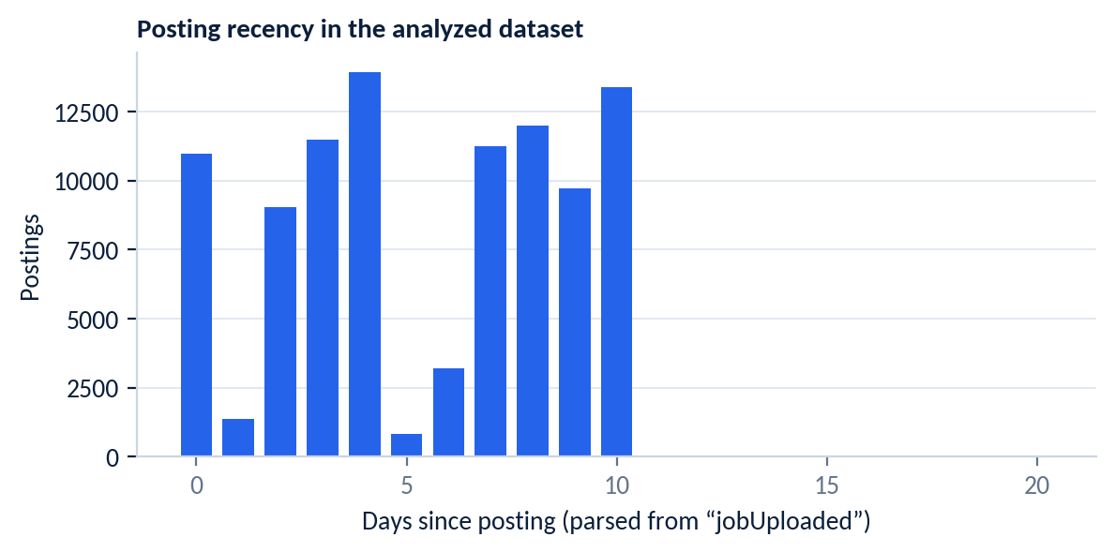
Figure 5. Posting recency (days since posting, parsed from “jobUploaded”)
Recency values run from 0 to 10 days for almost all rows (two rows fall at 15 and 20 days) and 571 rows could not be parsed. The dataset is therefore a short snapshot, not a long time series.

10. Job Demand Intelligence
BUSINESS QUESTION | Which roles, cities and experience brackets have the most postings, and how do roles and cities combine?
DATA | title, primary_location, experience_group
METHOD | Filtered frequency counts (demand_by_role, demand_by_location, demand_by_experience) with a role × location cross-tabulation
VISUALIZATION | Bar charts for roles, cities and experience brackets; role × location heatmap; filtered table with CSV export
OBSERVATION | Overall leaders are Application Developer (2,033) and Bengaluru (18,320); see Section 9. Filters let the user narrow to any role keyword, set of cities or experience levels.
PRACTICAL RELEVANCE | Shows where a chosen role is concentrated before a job search or relocation decision

Controls on the page: role keyword search, location multi-select, experience-level multi-select, a Top-N slider (5–30) and a reset button. Results can be downloaded as CSV.

11. Skill Intelligence
Skills are extracted from the tagsAndSkills column by src/skill_extraction.py. The tags of each posting are split on commas and each tag is matched against a dictionary of 89 canonical skills. In the analyzed dataset, 97,111 postings carry tags, and 48,266 of them (49.7%) contain at least one matched canonical skill.
BUSINESS QUESTION | Which skills are frequently mentioned, by role and by seniority, and which occur together?
DATA | skills_list (derived), title, experience_group
METHOD | Skill-frequency counts, skill × role and skill × experience pivots, and pairwise co-occurrence over the most frequent skills
VISUALIZATION | Top-N skill bar chart, skill-by-role and skill-by-experience views, co-occurrence matrix, CSV export
OBSERVATION | See the frequency chart and co-occurrence table below, and the interpretation note on matching
PRACTICAL RELEVANCE | Indicates which skills are frequently mentioned in the analyzed dataset; it does not show that any skill is mandatory

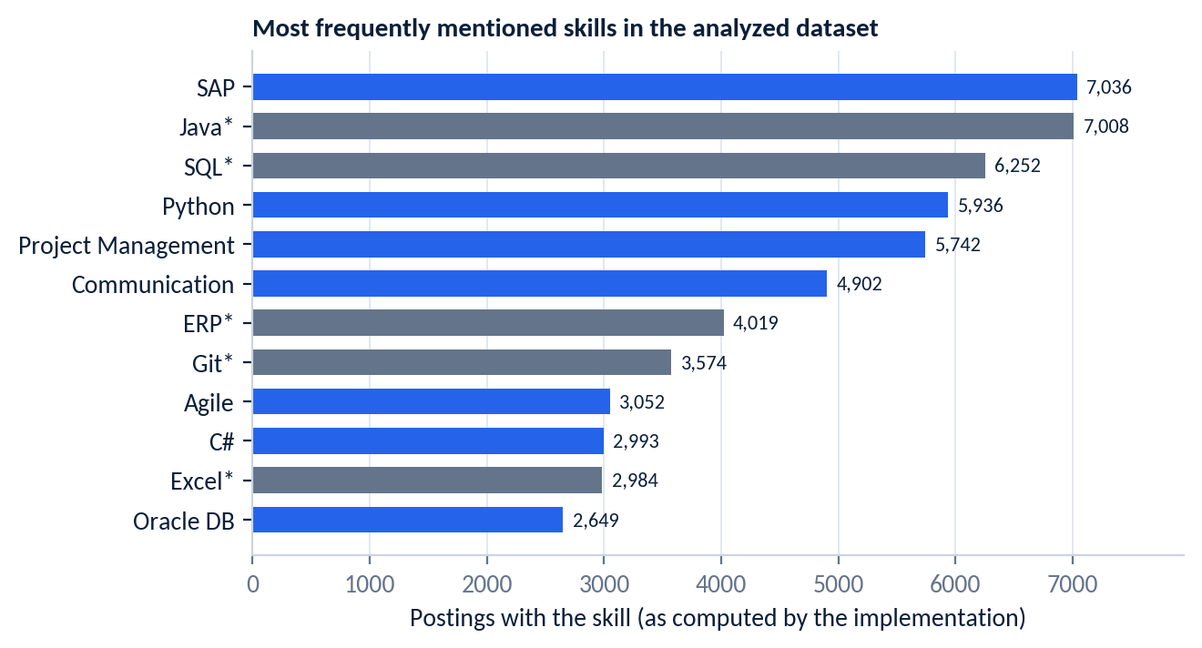
Figure 6. Most frequently mentioned skills, as computed by the current implementation (* see interpretation note)
Table 5. Ten most frequently matched skills (implementation output)
Skill | Postings | Share of all postings
SAP | 7,036 | 7.2%
Java * | 7,008 | 7.2%
SQL * | 6,252 | 6.4%
Python | 5,936 | 6.1%
Project Management | 5,742 | 5.9%
Communication | 4,902 | 5.0%
ERP * | 4,019 | 4.1%
Git * | 3,574 | 3.7%
Agile | 3,052 | 3.1%
C# | 2,993 | 3.1%

Interpretation note on skill matching
The extractor matches dictionary patterns as substrings and stops at the first match per tag. Counts marked * therefore include related or unrelated tags (for example “javascript” is matched by the pattern for Java, and “digital marketing” by the pattern for Git). Treat marked counts as upper-bound indicators; Section 26 quantifies the effect. Python, SAP, Project Management, Agile and C# counts agree closely with a whole-word check.

Skills that occur together
Table 6. Most frequent skill pairs among the 15 most frequent skills
Skill pair | Postings containing both
Python + SQL * | 1,508
Java + SQL * | 1,276
Java + Python * | 853
Project Management + SAP | 844
Oracle DB + SQL * | 752
AWS + Python | 742

The Python + SQL pair is the most frequent in the analyzed dataset (1,508 postings). The page also offers filters for role keyword, location, experience level and the number of skills shown.

12. Salary Intelligence
BUSINESS QUESTION | How do advertised salaries vary, and how are they distributed?
DATA | average_salary_lpa (postings with a disclosed salary), experience_group, primary_location, title, skills_list
METHOD | Descriptive statistics, percentile table, group means and medians, box plots
VISUALIZATION | KPI cards, histogram, box plots, bar charts by role, city, experience and skill; salary-range filter; CSV export
OBSERVATION | n = 32,845 postings with salary; mean ₹7.05 LPA, median ₹4.20 LPA, standard deviation 7.16, skewness 2.27
PRACTICAL RELEVANCE | Gives an advertised-pay benchmark, while showing that many postings do not disclose pay

Salary interpretation
Values are advertised ranges in postings (about a third of postings disclose them), not paid salaries. Salaries above the 99th percentile are excluded, USD values use a fixed conversion of 83, and all values are shown in Lakhs per annum (LPA).

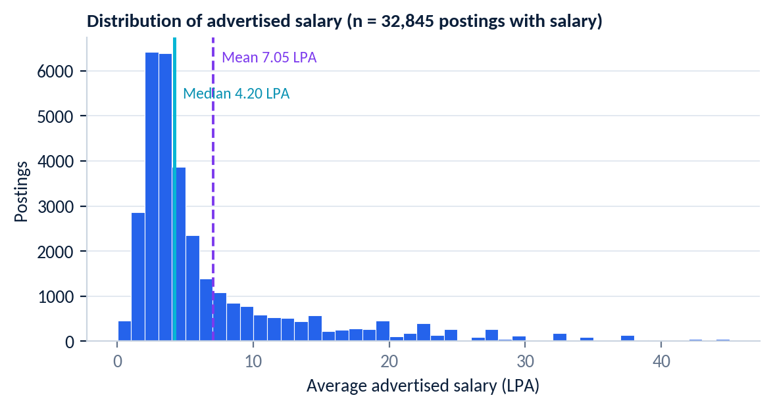
Figure 7. Distribution of advertised salary (postings with a disclosed salary)
Table 7. Salary percentiles (LPA)
Percentile | P5 | P10 | P25 | P50 | P75 | P90 | P95 | P99
Salary (LPA) | 1.68 | 2.00 | 2.88 | 4.20 | 8.00 | 17.00 | 22.50 | 35.00

The distribution is strongly right-skewed: the mean exceeds the median by ₹2.85 LPA. Using the interquartile-range rule (fences -4.8 and 15.68 LPA), 3,686 postings (11.2%) are flagged as high-salary outliers.
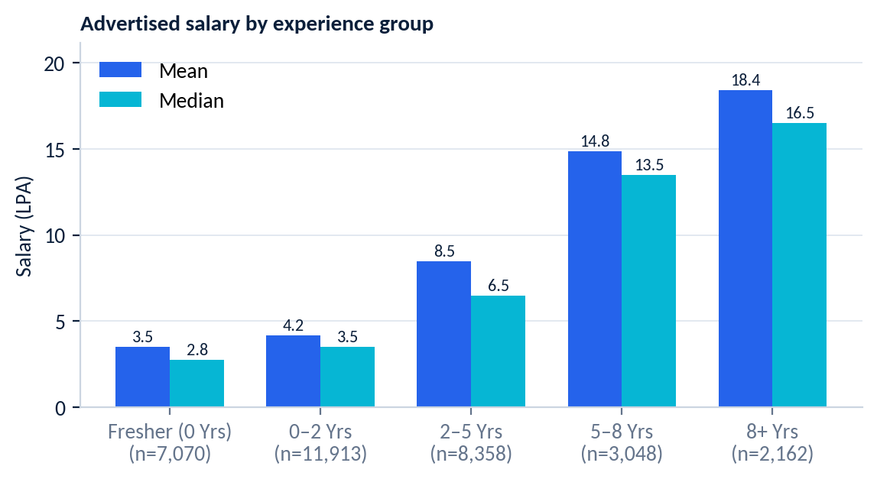
Figure 8. Advertised salary by experience group (mean and median)
Within the analyzed dataset, salary rises steadily with the experience group (see Section 13). The page also ranks roles, cities and skills by advertised salary; small groups can appear at the top of these rankings, so the sample size should be read alongside the average (for example, several top-ranked locations rest on fewer than 20 postings with salary).

13. Experience Analysis
BUSINESS QUESTION | How do postings and advertised salary differ across seniority levels?
DATA | minimumExperience, maximumExperience, experience_group, average_salary_lpa, title, skills_list
METHOD | Bucketing by minimum experience; counts, mean and median salary per bucket; role and skill pivots per bucket
VISUALIZATION | Bracket distribution, salary-by-experience chart, role and skill views per bracket, min/max experience view, CSV export
OBSERVATION | 75.0% of postings have a minimum experience of five years or less; median advertised salary rises from ₹2.75 LPA (fresher) to ₹16.5 LPA (8+ years)
PRACTICAL RELEVANCE | Shows how pay expectations and role mix change with seniority in the analyzed postings

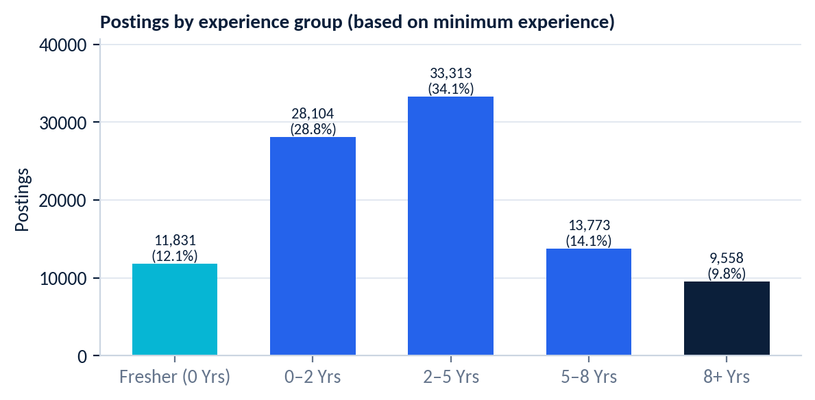
Figure 9. Postings by experience group
Table 8. Postings and advertised salary by experience group
Experience group | Postings | With salary | Mean (LPA) | Median (LPA)
Fresher (0 Yrs) | 11,831 | 7,070 | 3.54 | 2.75
0–2 Yrs | 28,104 | 11,913 | 4.19 | 3.50
2–5 Yrs | 33,313 | 8,358 | 8.49 | 6.50
5–8 Yrs | 13,773 | 3,048 | 14.85 | 13.50
8+ Yrs | 9,558 | 2,162 | 18.39 | 16.50

Groups are based on minimum experience: Fresher = 0; 0–2 = above 0 up to 2; 2–5 = above 2 up to 5; 5–8 = above 5 up to 8; 8+ = above 8.

14. Fresher Opportunity Intelligence
BUSINESS QUESTION | Which roles, skills, cities and employers offer entry-level opportunities?
DATA | Postings with is_fresher = True (minimum experience 0)
METHOD | fresher_kpis aggregation, skill frequency within the fresher subset, role × city cross-tabulation
VISUALIZATION | KPI cards, bar charts for roles, skills, cities and employers, salary view, role × city heatmap, CSV export
OBSERVATION | 11,831 fresher postings (12.1% of all postings); average advertised salary ₹3.54 LPA across the 7,070 fresher postings that disclose salary
PRACTICAL RELEVANCE | Points entry-level candidates to the roles, cities and employers that most often post zero-experience openings

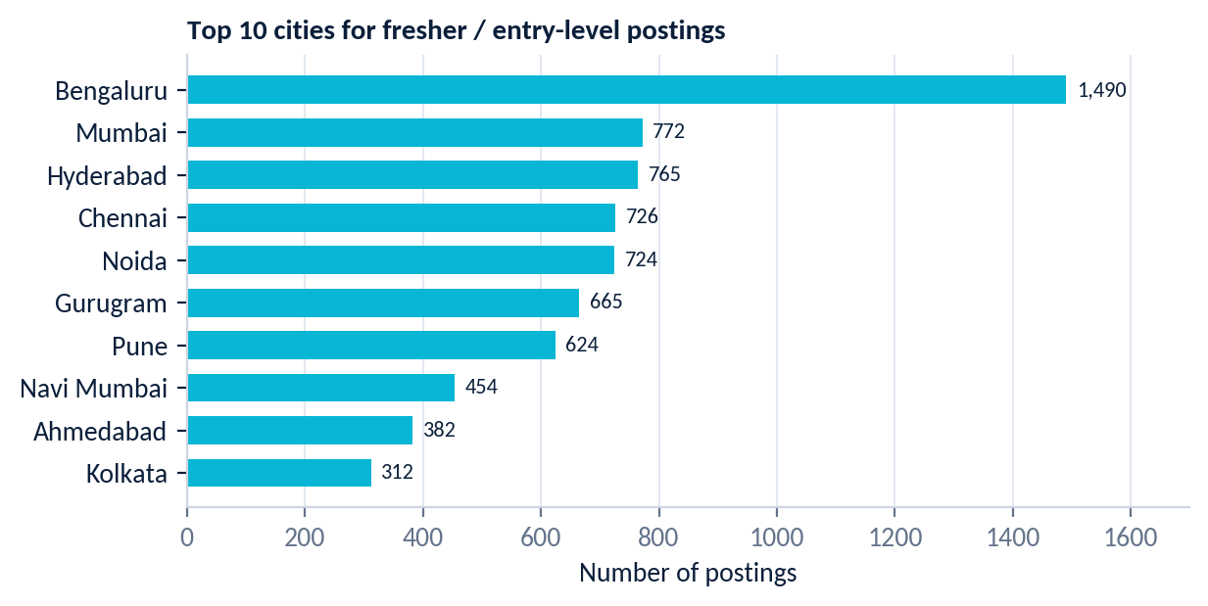
Figure 10. Top 10 cities for fresher / entry-level postings
Table 9. Most frequent fresher roles and employers (top 7 each)
Top fresher roles | Postings | Top fresher employers | Postings
Trust & Safety New Associate | 348 | Accenture | 540
Sales Executive | 198 | eClerx | 275
Business Development Executive | 146 | JobShop | 201
Customer Support Executive | 138 | Teleperformance (TP) | 116
Customer Care Executive | 104 | Tata Capital | 115
Customer Service Executive | 62 | Policybazaar | 107
Chat Support Executive | 53 | Kotak Mahindra Bank | 100

Within the analyzed dataset, the most frequent fresher roles are dominated by associate, sales, business-development and customer-support titles, with “Trust & Safety New Associate” (348) at the top. Analyst titles also appear (Analyst 51, Financial Analyst 47). Bengaluru has the most fresher postings (1,490).

15. Company and Location Intelligence
BUSINESS QUESTION | Which employers and cities dominate the postings, what do they advertise in salary, and how are companies rated?
DATA | companyName, primary_location, average_salary_lpa, AggregateRating, ReviewsCount, title
METHOD | Frequency ranking, city-level salary averages, role × city heatmap, company-rating ranking (minimum 10 reviews), role-diversity per company
VISUALIZATION | Bar charts, heatmap, rating chart, filtered tables, CSV export (filters: company search, locations, experience, Top-N)
OBSERVATION | Accenture (8,193) and Bengaluru (18,320) lead their rankings; 62,517 postings (64.0%) carry a company rating
PRACTICAL RELEVANCE | Identifies the most active employers and the cities where openings concentrate

Rankings are shown in the charts of Section 9. Company rating has a very weak correlation with advertised salary in this dataset (Pearson r = -0.039), so rating should not be read as a pay indicator.

16. Job Explorer
Job Explorer turns the dataset into a searchable product feature. Its workflow is Search → Filter → Sort → Explore → Download.
Table 10. Job Explorer controls (verified in pages/13_Job_Explorer.py)
Stage | Controls implemented
Search | Free-text search on job title, company and skill/keyword
Filter | Location (single select), experience level, salary range in LPA (slider), minimum company rating (slider)
Sort | Advertised salary high→low or low→high, company rating high→low, title A→Z, company A→Z
Explore | KPI strip for the filtered set (matching jobs, jobs with salary, average salary, unique companies, unique locations); paginated table with 25, 50, 100 or 200 rows per page
Download | CSV export of all filtered results; a reset button clears every filter

17. Career Skill Gap Analyzer
The analyzer compares a user's current skills with the skills frequently mentioned in postings for a selected role. The flow is Target role → Current skills → Dataset skill demand → Covered skills → Frequently mentioned skills not yet covered.
BUSINESS QUESTION | For a chosen role, which frequently mentioned skills are not yet in my skill set?
DATA | Postings whose title matches the role's keywords (18 supported roles, defined in ROLE_KEYWORDS), and skills_list
METHOD | filter_by_role, get_role_skill_demand, skill_gap_analysis (coverage % of the top-N skills), get_common_skill_combos
VISUALIZATION | Coverage KPI cards, demand chart, covered and not-yet-covered skill lists, common skill pairs, role salary insight
OBSERVATION | Illustrated below for the “Data Analyst” role
PRACTICAL RELEVANCE | Suggests focus areas by showing how often each skill is mentioned; it does not state that any skill is mandatory

Supported roles: Data Analyst, Business Analyst, Data Scientist, Machine Learning Engineer, Data Engineer, Software Developer / Engineer, Python Developer, Java Developer, Full Stack Developer, Backend Developer, Frontend Developer, DevOps Engineer, Business Development, Sales Executive, HR / Recruiter, Financial Analyst, Accountant, Project Manager.
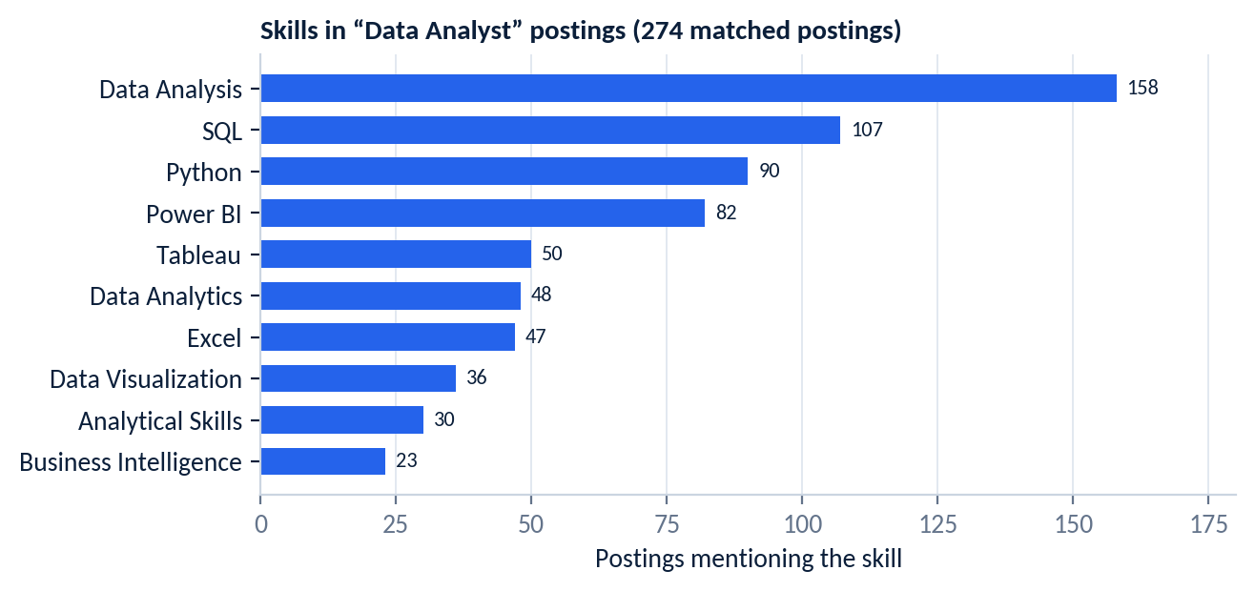
Figure 11. Skills frequently mentioned in postings matched to “Data Analyst” (top 10)
Within the analyzed dataset, 274 postings match the Data Analyst keywords. The most frequently mentioned skills are Data Analysis (57.7% of matched postings), SQL (39.1%), Python (32.8%), Power BI (29.9%) and Tableau (18.2%). Of the matched postings, 60 disclose salary, with a median advertised ₹7.63 LPA. The sample is small, so these shares are indicative only.

18. SQL Analytics
The SQL module loads the cleaned data into an in-memory SQLite database (src/sql_analysis.py), so no external database server is needed. A single table, jobs, holds 16 analytical columns, and a custom MEDIAN aggregate is registered. The page offers 12 pre-built queries with their business questions, CSV download of each result, and a custom SQL editor.
Table 11. The 12 pre-built SQL analyses
# | Pre-built query | SQL features
1–3 | Top 10 job roles, companies and locations by postings | GROUP BY, COUNT, ORDER BY, LIMIT
4 | Average salary by location (top 15) | HAVING (minimum 10 salaries), AVG, ROUND
5 | Average salary by experience group | GROUP BY, MIN, MAX, IS NOT NULL
6–8 | Jobs requiring Python; requiring SQL; requiring both | LIKE on lower-cased tags, ORDER BY
9 | Companies with the most fresher postings | HAVING (≥ 5), GROUP BY
10 | Fresher jobs by location | GROUP BY, COUNT
11 | Salary comparison across experience groups | CTE (WITH), CAST, disclosure rate
12 | Roles with the highest average salary (≥ 10 salaries) | CTE (WITH), HAVING, LIMIT

Representative query: jobs mentioning both Python and SQL
SELECT title, companyName, primary_location,
experience_group, average_salary_lpa
FROM jobs
WHERE LOWER(tagsAndSkills) LIKE '%python%'
AND LOWER(tagsAndSkills) LIKE '%sql%'
ORDER BY average_salary_lpa DESC NULLS LAST
LIMIT 50;

Representative query: salary comparison with a CTE
WITH salary_stats AS (
SELECT experience_group,
COUNT(*) AS total_jobs,
COUNT(average_salary_lpa) AS salary_disclosed,
ROUND(AVG(average_salary_lpa), 2) AS avg_lpa
FROM jobs
WHERE experience_group NOT IN ('Unknown')
GROUP BY experience_group
)
SELECT *,
ROUND(CAST(salary_disclosed AS FLOAT) / total_jobs * 100, 1) AS pct_disclosed
FROM salary_stats
ORDER BY avg_lpa DESC;
Executed on the analyzed dataset, the queries return 5,936 postings whose tags contain “python”, 6,254 containing “sql” and 1,510 containing both. Because LIKE '%sql%' is a substring test, the SQL count also includes tags such as MySQL, PostgreSQL and NoSQL.
Table 12. Result of pre-built query 5 (average salary by experience group)
Experience group | Postings with salary | Average salary (LPA)
8+ Yrs | 2,162 | 18.39
5–8 Yrs | 3,048 | 14.85
2–5 Yrs | 8,358 | 8.49
0–2 Yrs | 11,913 | 4.19
Fresher (0 Yrs) | 7,070 | 3.54

The SQL module uses one table and no joins or window functions.

19. Statistical Insights
The Statistical Insights page (src/statistics_analysis.py) documents six methods on advertised salary and experience. Each is summarized as Purpose → Method → Result → Interpretation → Limitation.
Table 13. Statistical methods implemented
Method | Purpose | Result in the analyzed dataset | Interpretation and limitation
Descriptive statistics | Summarize the salary distribution | Mean 7.05, median 4.20, std 7.16, Q1 2.88, Q3 8, max 45 LPA (n = 32,845) | Right-skewed; the median is the better centre. Only postings with disclosed salary are included.
Percentiles | Show the spread of advertised pay | P5 1.68, P50 4.2, P95 22.5, P99 35 LPA | Upper tail is thin; P99 reflects the 99th-percentile exclusion rule.
IQR outlier rule | Flag unusually high salaries | Upper fence 15.68 LPA; 3,686 postings (11.2%) above it | Outliers are flagged, not removed. The lower fence is negative, so no low outliers exist.
Group comparison | Compare salary by experience group and role | Mean, median, standard deviation and count per group (see Section 13) | Groups below a minimum sample size are not shown.
Pearson correlation | Measure linear association among numeric columns | Average salary vs minimum experience r = 0.635; vs average experience r = 0.645; vs company rating r = -0.039; vs review count r = 0.060 | Moderate positive link with experience; almost none with rating. Correlation does not imply causation.
One-way ANOVA | Test whether mean salary differs across experience groups | F = 5,354.547, p < 0.001 | With about 33,000 salary records almost any difference is significant; treat it as descriptive evidence. ANOVA assumptions (equal variances, normality) are not formally tested.

20. Machine Learning: Salary Prediction
The prediction module (src/ml_salary_prediction.py) estimates advertised salary from a small set of posting features. Outputs are labelled as estimated salary based on patterns learned from the analyzed dataset; they are not real-world salary guarantees.
Table 14. Machine-learning pipeline
Element | Implementation
Target | average_salary_lpa
Training rows | 32,845 postings with a disclosed salary
Features | minimumExperience, maximumExperience, title, primary_location
Categorical handling | title and primary_location are reduced to their 50 most frequent values (all others become “__other__”); OrdinalEncoder with unknown = −1. The top-50 titles cover 13.8% of training rows, the top-50 locations 82.0%
Numeric handling | Median imputation
Split | 80/20 train/test split, random_state = 42 (26,276 train, 6,569 test)
Models | Linear Regression (baseline); Random Forest (100 trees); Gradient Boosting (100 estimators)
Metrics | MAE, RMSE, R² on the test set

Table 15. Test-set evaluation (recomputed from the project code)
Model | MAE (LPA) | RMSE (LPA) | R²
Linear Regression (Baseline) | 3.310 | 5.635 | 0.399
Random Forest | 2.954 | 5.256 | 0.477
Gradient Boosting | 2.967 | 5.253 | 0.477

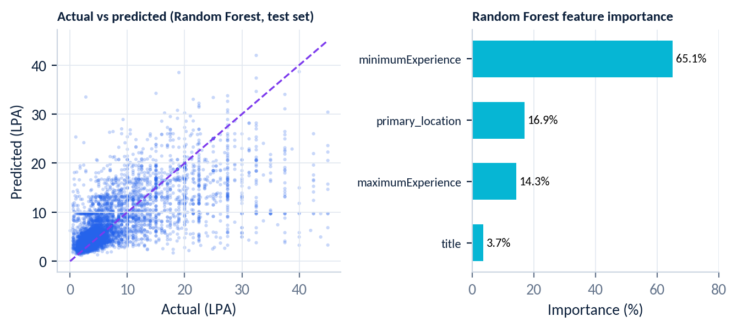
Figure 12. Actual vs predicted salary (Random Forest) and Random Forest feature importance
Random Forest and Gradient Boosting perform about equally (R² 0.477), ahead of the linear baseline (0.399). Random Forest importance is dominated by experience: minimumExperience 65.1%, primary_location 16.9%, maximumExperience 14.3% and title 3.7%. The low importance of title reflects, in part, that most titles fall into “__other__”.
The page also lets a user pick a role, a city and an experience range to obtain an estimate, and shows the metrics and the actual-vs-predicted view for the best model.
How to read the model
R² ≈ 0.48 means the chosen features explain under half of the variance in advertised salary. The training set covers only postings that disclose salary, so the model reflects that subset. Use estimates as directional guidance.

21. Streamlit Application
The application is a multi-page Streamlit app launched with streamlit run app.py. app.py provides the home page and loads, cleans and caches the data; each analysis page lives in pages/. A shared sidebar groups the pages into four navigation groups, and every analytical page starts from the same header, filter and KPI components in src/ui_helpers.py.
Table 16. Application pages and navigation groups (file numbering follows the pages/ folder)
Group | Page | What it provides
Home | Home (app.py) | Hero, KPI row, posting-activity and experience charts, quick snapshot (roles, locations, skills), four key-insight cards, page guide
MARKET | 1 Overview | KPI cards, top roles, locations, companies, recency, experience distribution, CSV export
MARKET | 2 Job Demand | Role, city and experience demand; role × location heatmap
MARKET | 3 Skill Intelligence | Top skills, skills by role and seniority, skill co-occurrence
MARKET | 4 Salary Intelligence | Salary KPIs, distribution, box plots, salary by role, city, experience and skill
MARKET | 5 Experience Analysis | Bracket counts, salary growth, roles and skills per bracket
MARKET | 6 Fresher Opportunities | Entry-level roles, skills, cities, employers, salary
MARKET | 7 Company & Location | Employers, cities, city salaries, ratings
CAREER | 13 Job Explorer | Search, filter, sort, paginate and export postings
CAREER | 12 Career Skill Gap | Role skill demand versus the user's skills
ADVANCED ANALYTICS | 9 SQL Analytics | 12 pre-built queries and a custom SQL editor
ADVANCED ANALYTICS | 10 Statistical Insights | Descriptive statistics, correlation, ANOVA
ADVANCED ANALYTICS | 11 Salary Prediction | Model training, comparison, importance, interactive estimate
DATA | 8 Dataset & Quality | Row counts, missing values, types, salary and experience quality, methodology, disclaimer

Common interaction patterns: keyword search and multi-select filters with a reset button; Top-N sliders; CSV export on the Overview, Job Demand, Skill, Salary, Experience, Fresher, Company & Location, SQL and Job Explorer pages; and the dataset path shown as a configurable text input in the sidebar of the home page.

22. UI/UX Design
The interface is designed as an analytics product rather than a default Streamlit app. Each page follows a QUESTION → FILTER → ANALYSIS → INSIGHT → ACTION flow.
Table 17. UI/UX features present in the code
Design element | Implementation in the project
Question-led hierarchy | Section titles are phrased as questions (for example “Which roles have the most postings?”), so each chart states the question it answers
Consistent shell | One CSS design system is injected on every page; shared page header, section, KPI-row, insight-card and filter components in src/ui_helpers.py
Navigation | Grouped sidebar (Market, Career, Advanced Analytics, Data) with an inline SVG logo mark; Streamlit's default page list is hidden and replaced by the grouped links
Colour and contrast | Dark navy theme configured in .streamlit/config.toml; sidebar text is styled light on dark with distinct hover and active states
KPI cards | Label, large value and supporting context on the home page and analysis pages
Charts | Plotly charts share one styling helper (apply_chart_style) and stretch to the container width
Actions | CSV downloads, reset buttons and a SQL editor let the user act on results
Trust | Salary, dataset and statistical disclaimers appear on the relevant pages

Responsive breakpoints, accessibility audits and usability testing are not available in the current implementation and are therefore not claimed.

23. Dashboard Showcase
Screenshots required
No screenshots exist in the project workspace. Each frame below marks where a real screenshot of the running Streamlit application should be inserted (run streamlit run app.py, capture each page and replace the frame). No screenshots were generated or simulated.

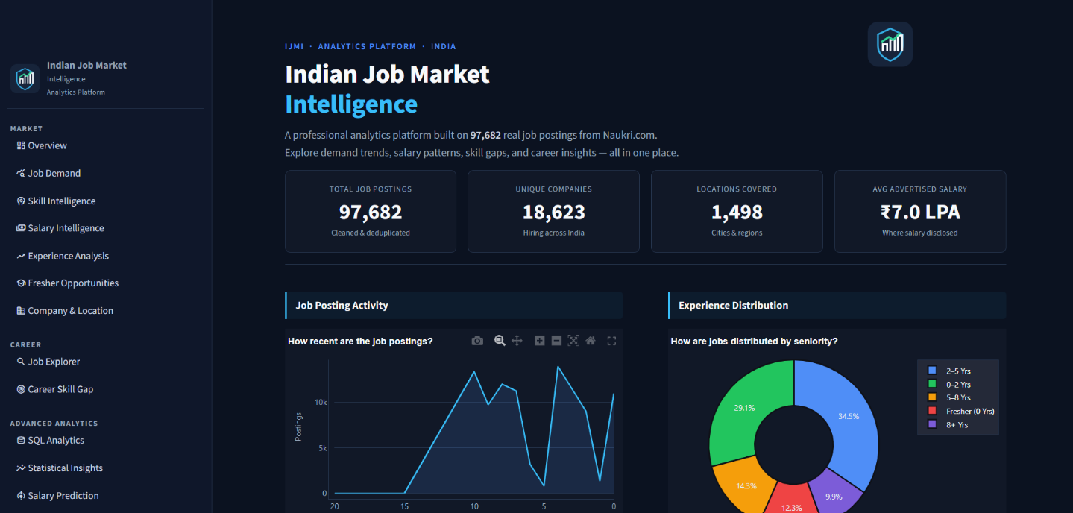
Figure 13. Home page
Purpose: Landing view with hero, KPI cards and key insights
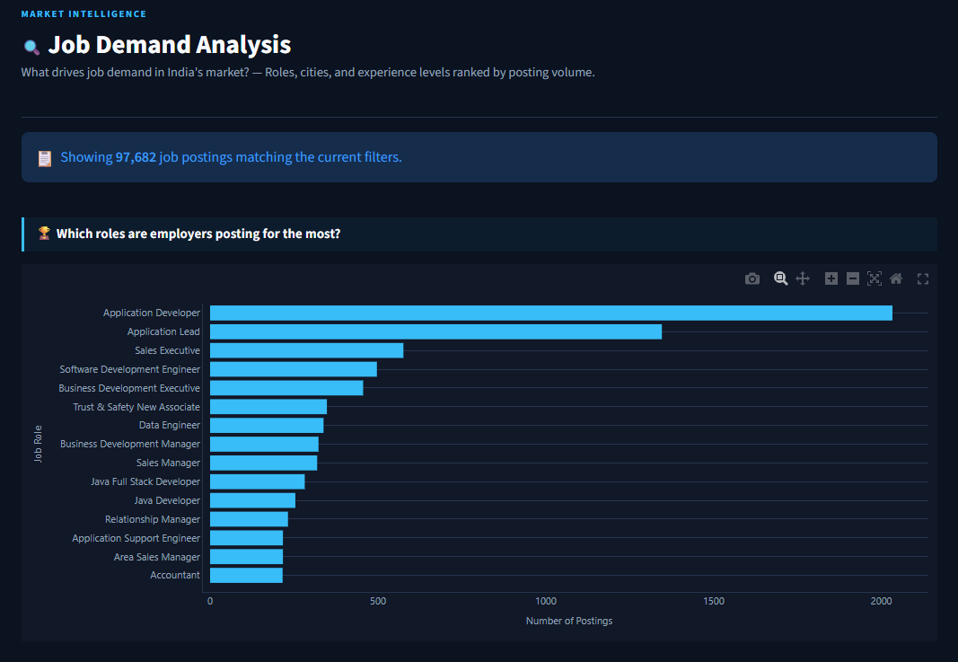

Figure 15. Job Demand (Page 2)
Purpose: Demand by role, city and experience with the role × location heatmap
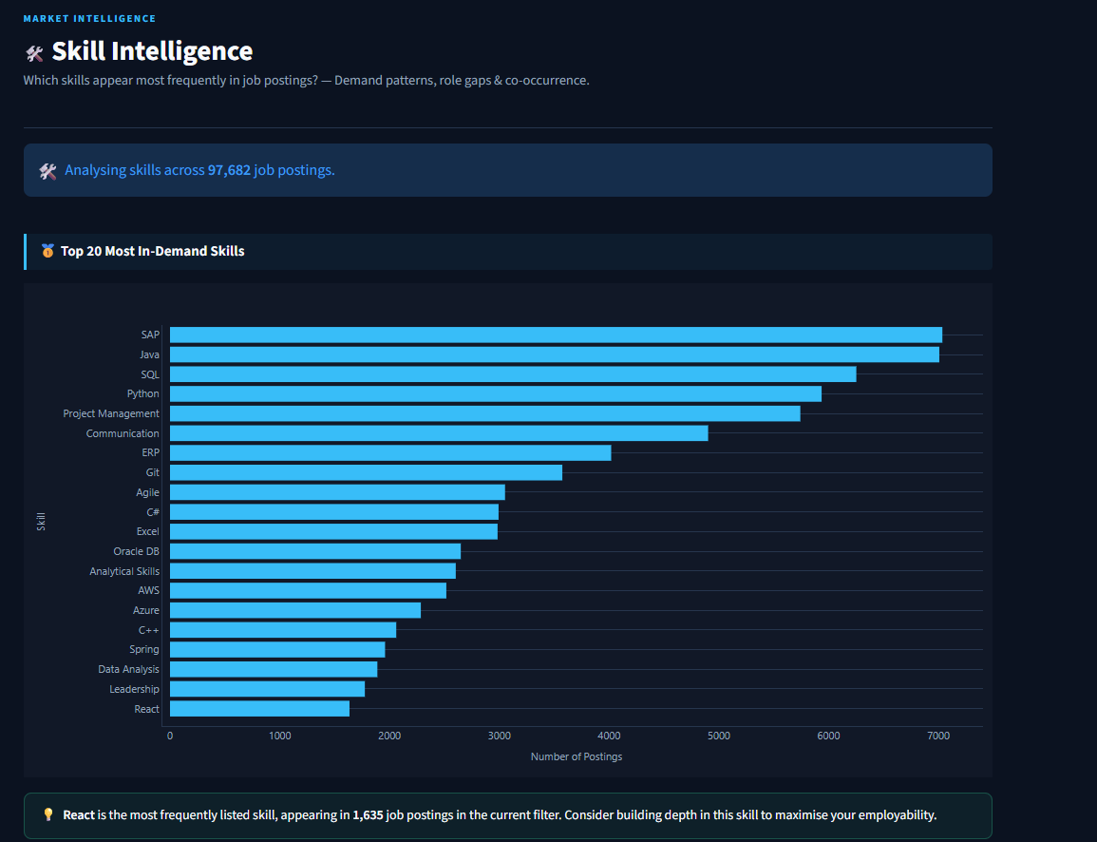Figure 16. Skill Intelligence (Page 3)
Purpose: Top skills, skill-by-role and co-occurrence views
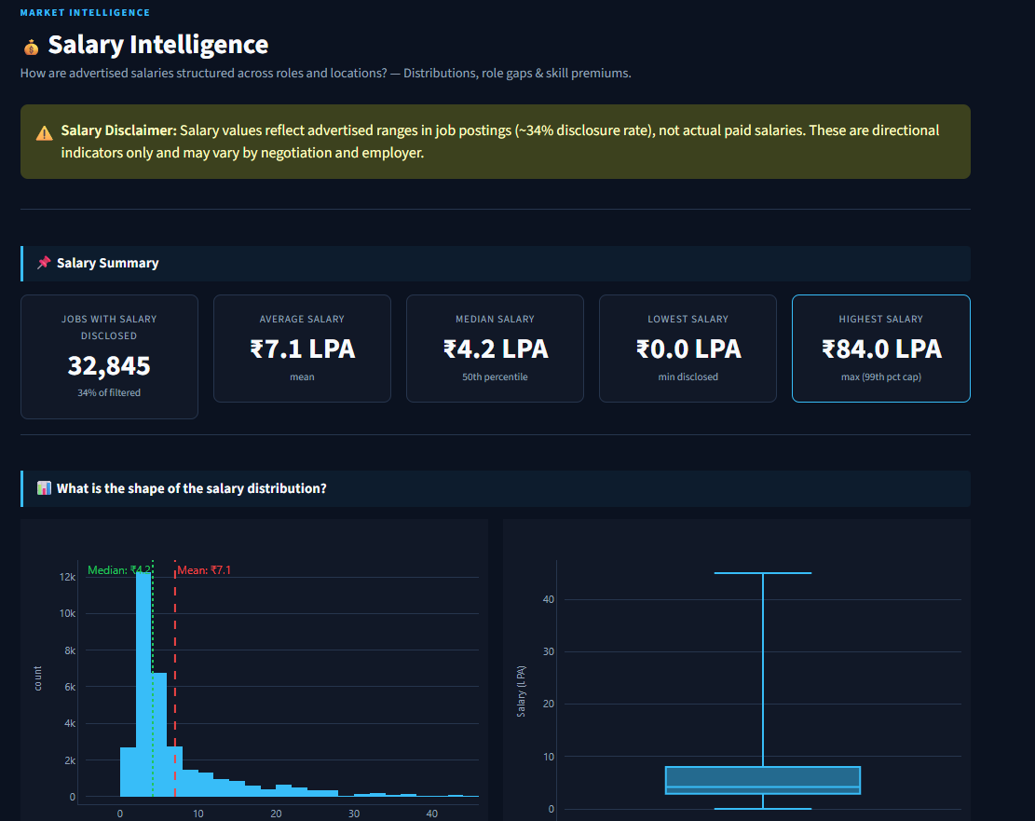Figure 17. Salary Intelligence (Page 4)
Purpose: Salary distribution and breakdowns
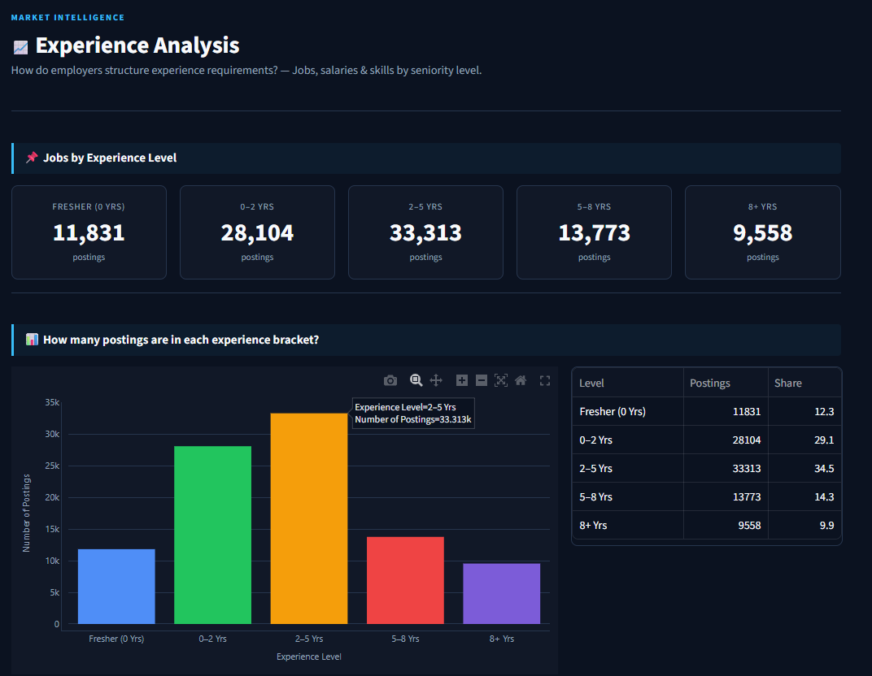 Figure 18. Experience Analysis (Page 5)
Purpose: Experience brackets and salary growth
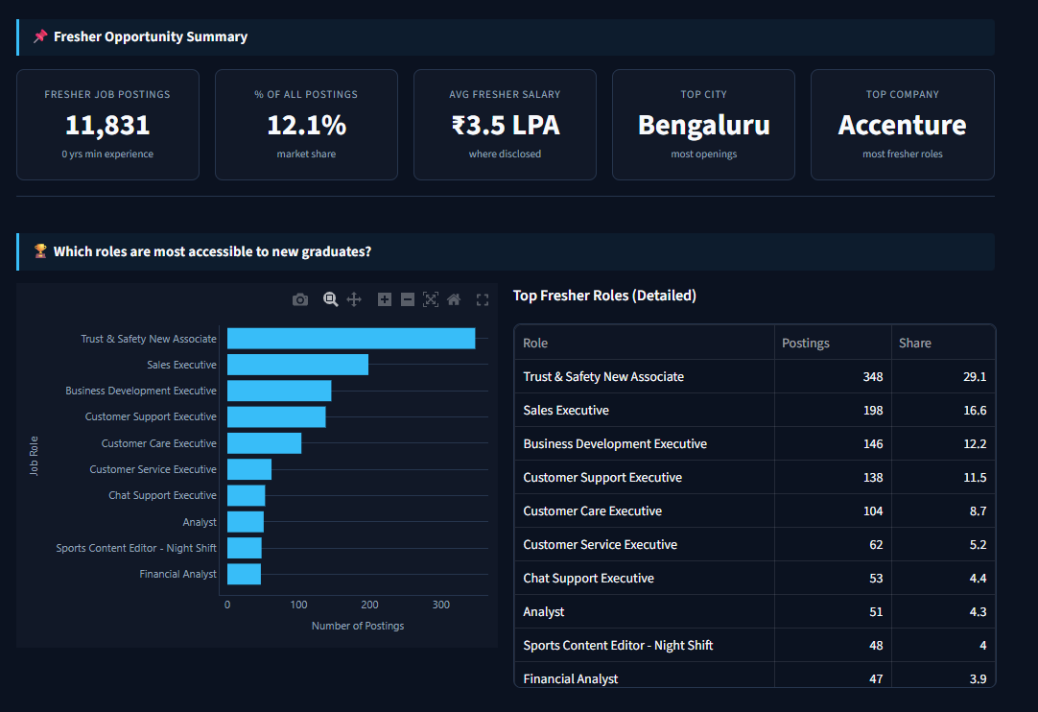Figure 19. Fresher Opportunities (Page 6)
Purpose: Entry-level roles, cities and employers
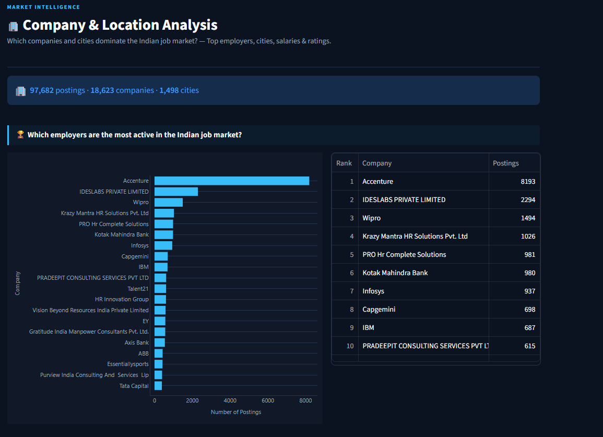Figure 20. Company & Location (Page 7)
Purpose: Employer and city rankings, ratings
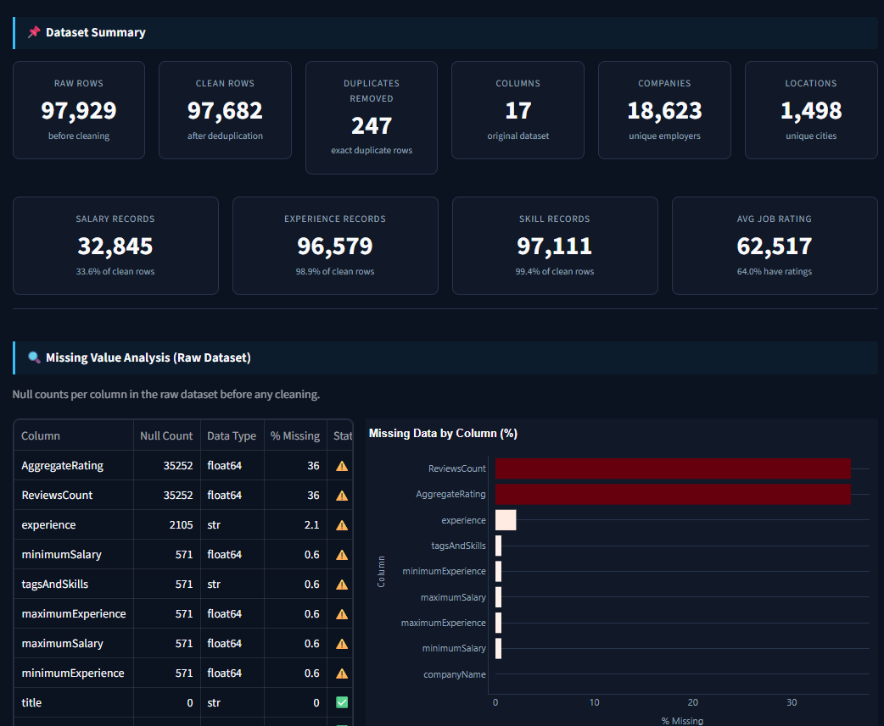Figure 21. Dataset & Quality (Page 8)
Purpose: Data-quality metrics and cleaning methodology
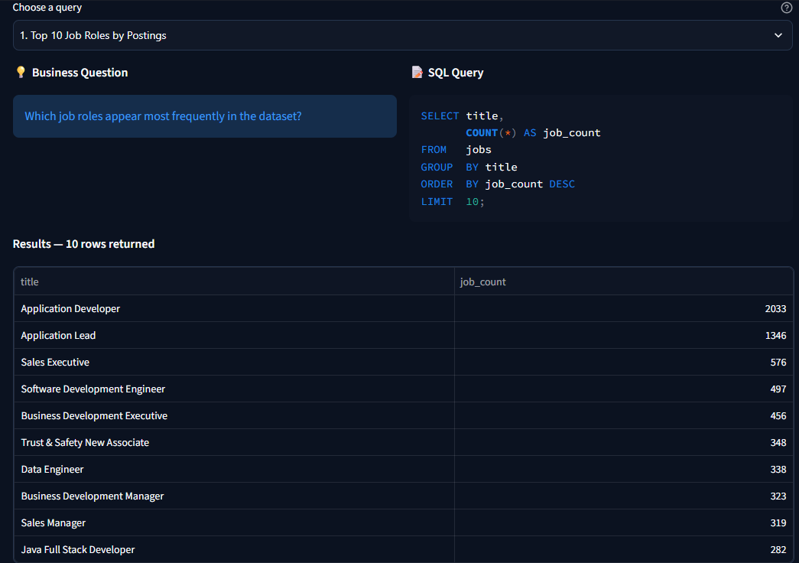Figure 22. SQL Analytics (Page 9)
Purpose: Pre-built queries and the custom SQL editor
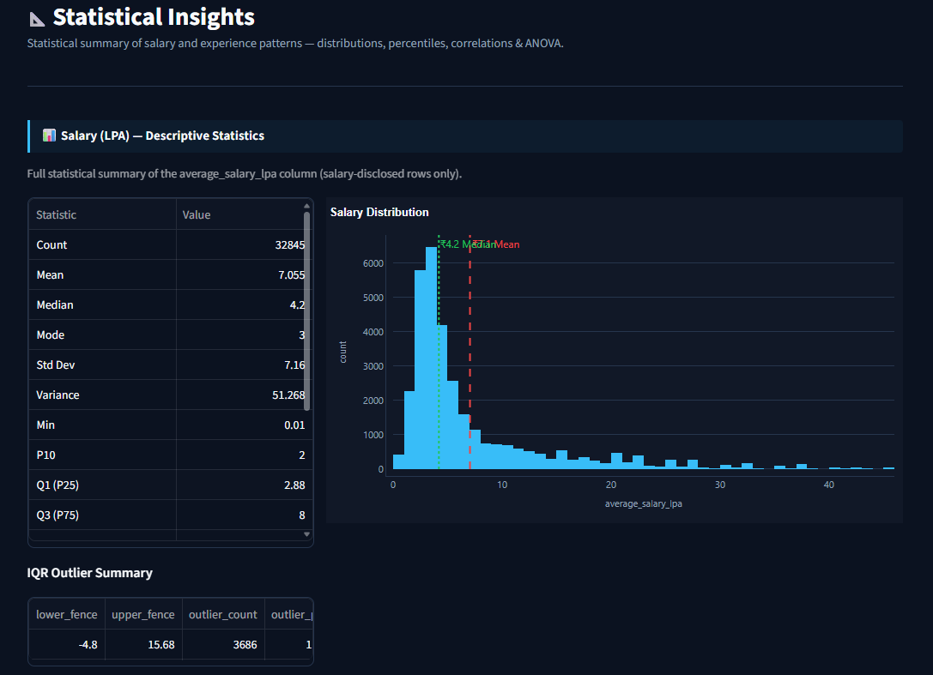Figure 23. Statistical Insights (Page 10)
Purpose: Descriptive statistics, correlation and ANOVA
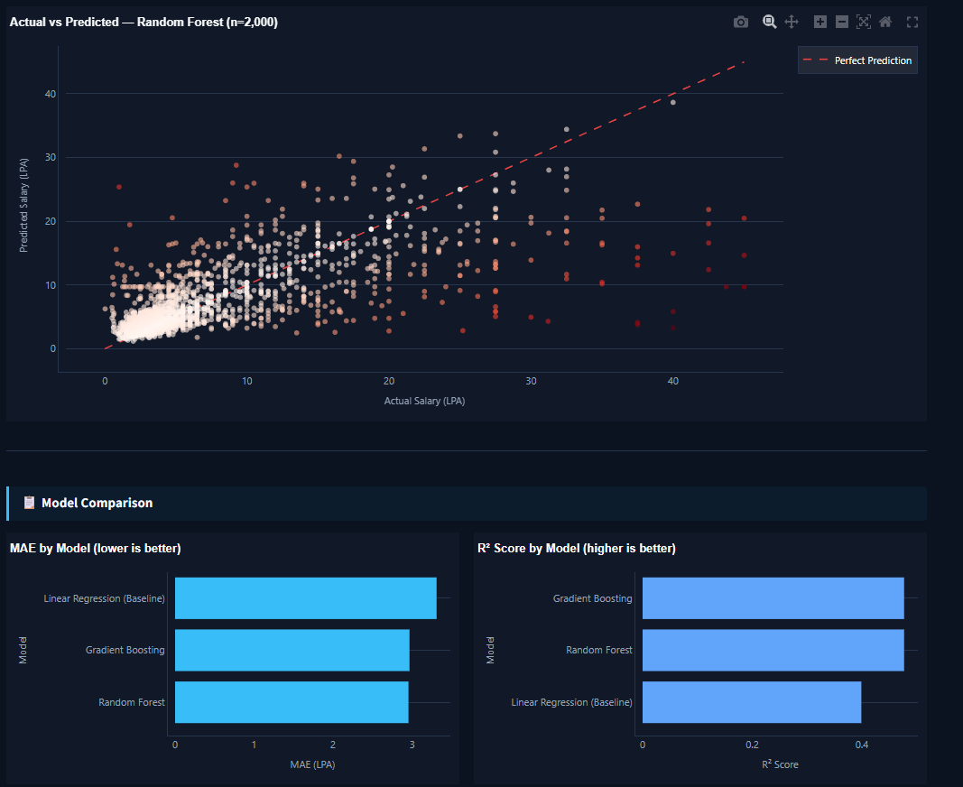Figure 24. Salary Prediction (Page 11)
Purpose: Model comparison, feature importance and interactive estimate
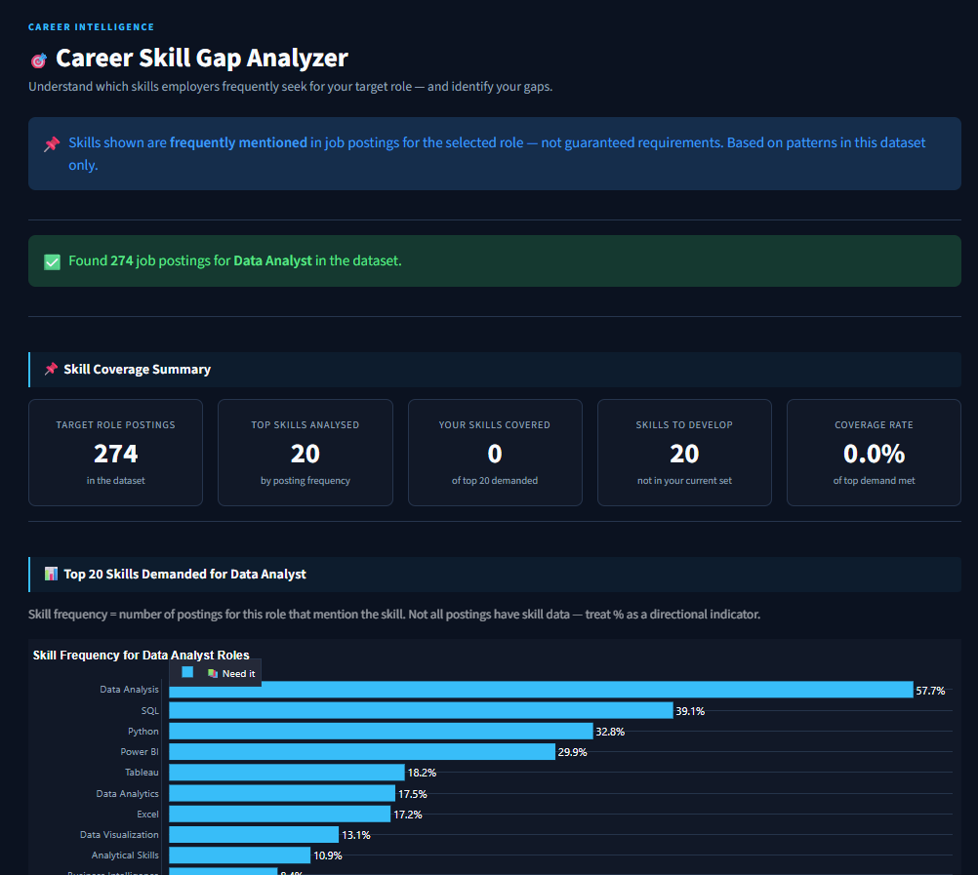Figure 25. Career Skill Gap (Page 12)
Purpose: Role skill demand, covered skills and focus areas
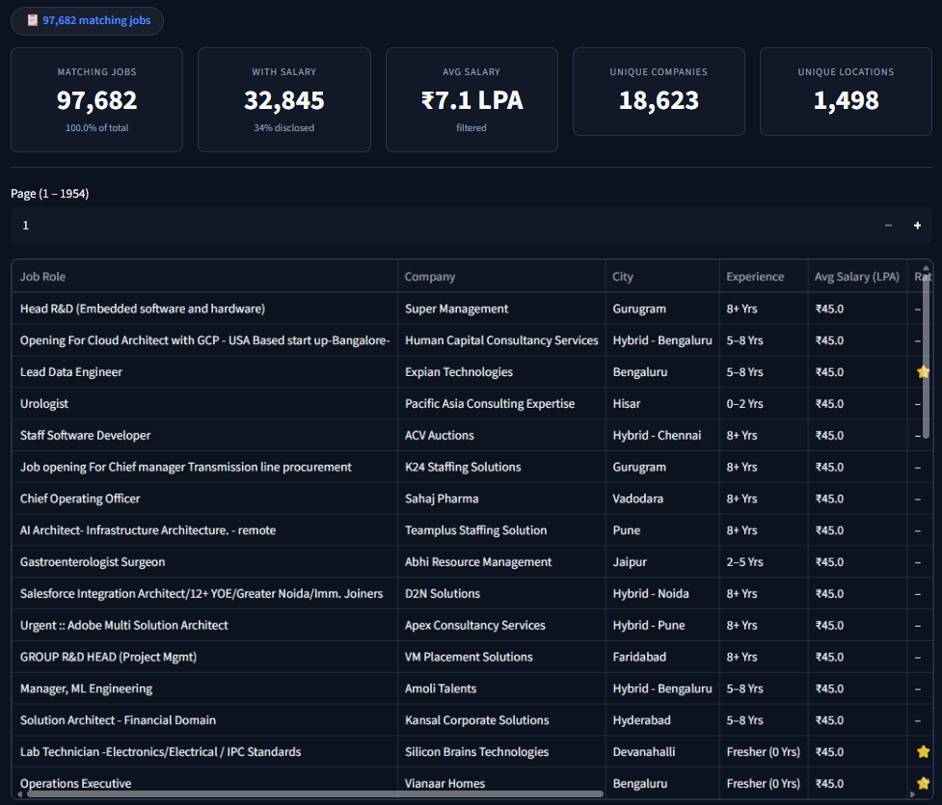Figure 26. Job Explorer (Page 13)
Purpose: Search, filters and paginated results with export

24. Key Insights
Each insight below is computed from the analyzed dataset and describes patterns within it.
INSIGHT 1 | Job postings are concentrated in a few large cities
WHAT THE DATA SHOWS | Bengaluru has 18,320 postings (18.8%); Bengaluru, Hyderabad and Pune together hold 38.5%.
EVIDENCE | Figure “Top 10 primary locations”; Section 9
INTERPRETATION | In this dataset, hiring activity is heavily weighted toward a small set of metros.
PRACTICAL RELEVANCE | Location choice strongly changes the number of visible openings for a job seeker.

INSIGHT 2 | Advertised salary rises steeply with experience
WHAT THE DATA SHOWS | Median advertised salary is ₹2.75 LPA for fresher postings and ₹16.5 LPA for 8+ years; ANOVA F = 5354.5; correlation with minimum experience r = 0.635.
EVIDENCE | Salary-by-experience chart and table; Section 19
INTERPRETATION | Experience is the strongest single pattern behind advertised pay in this data.
PRACTICAL RELEVANCE | Helps set realistic pay expectations by seniority; it is not causal proof.

INSIGHT 3 | Most advertised pay clusters at the low end, with a long tail
WHAT THE DATA SHOWS | Mean ₹7.05 LPA versus median ₹4.20 LPA; skewness 2.27; 11.2% of salaried postings are above the IQR upper fence.
EVIDENCE | Salary histogram and percentile table; Section 12
INTERPRETATION | A few high-paying postings pull the mean above the typical value.
PRACTICAL RELEVANCE | The median is the more representative benchmark.

INSIGHT 4 | Entry-level openings are a meaningful share of postings
WHAT THE DATA SHOWS | 11,831 postings (12.1%) require zero minimum experience; their average advertised salary is ₹3.54 LPA.
EVIDENCE | Fresher page metrics; Section 14
INTERPRETATION | Entry-level roles exist across sales, support and analyst titles in this dataset.
PRACTICAL RELEVANCE | Freshers can see which cities and employers post such roles most often.

INSIGHT 5 | Python and SQL frequently appear together
WHAT THE DATA SHOWS | Python + SQL is the most frequent skill pair (1,508 postings). For “Data Analyst” titles, Data Analysis, SQL, Python and Power BI are the most frequently mentioned skills.
EVIDENCE | Co-occurrence table; Career Skill Gap example; Sections 11 and 17
INTERPRETATION | Frequently mentioned in the analyzed dataset; SQL counts include related tags (see Section 26).
PRACTICAL RELEVANCE | Suggests a focus area for analyst-track learners.

INSIGHT 6 | Only a third of postings disclose salary
WHAT THE DATA SHOWS | 32,845 of 97,682 postings (33.6%) have a usable salary.
EVIDENCE | Dataset & Quality page; Section 5
INTERPRETATION | Salary findings describe the disclosing subset only.
PRACTICAL RELEVANCE | All salary figures should be read as directional.

25. Technical and Recruiter Value
The table lists what the project demonstrates. Only technologies and practices present in the workspace are included.
Table 18. Technical skills matrix based on the actual implementation
Skill area | Evidence in the project | What it demonstrates
Python | Modular code across src/, pages/ and app.py | Structured, reusable code beyond notebooks
Pandas / NumPy | Cleaning, aggregation and derived columns on ~98K rows | Practical data-wrangling
Data cleaning | Duplicates, zero salaries, currency, locations, relative dates | Handling messy real-world data with documented rules
Exploratory analysis | Pages 1–7 | Turning business questions into analyses
SQL | 12 SQLite queries with HAVING, CTEs and LIKE, plus a custom editor | Analytical SQL on a structured table
Statistics | Descriptive statistics, IQR outliers, correlation, ANOVA (SciPy) | Sound interpretation with stated caveats
Feature engineering | experience_group, is_fresher, salary LPA, primary_location, skills_list | Building analysis-ready features
Machine learning | Three scikit-learn regressors in a preprocessing pipeline with held-out evaluation | End-to-end modelling with honest limits
Data visualization | Plotly charts across all pages | Clear visual communication
Streamlit | Multi-page app with caching and shared components | Delivering analysis as a usable product
UI/UX | Design system, KPI cards, grouped navigation | Product-style presentation
Data storytelling | Question-led sections and insight cards | Connecting findings to decisions
AI-assisted development | Built iteratively with IBM Bob from written requirements | Directing AI tools with clear specifications
Git / GitHub | Not available in the current implementation (no repository metadata in the workspace) | —

26. Limitations
These limitations apply to the current implementation and should be kept in mind when reading any finding.
- Static snapshot. The data is a single CSV; there is no refresh or real-time ingestion. Posting recency covers roughly ten days.
- Source coverage. The dataset comes from one job portal (Naukri.com) and does not represent the whole market.
- Salary coverage and meaning. Only 33.6% of postings disclose salary; values are advertised ranges. Salaries above the 99th percentile are excluded, and USD values use a fixed rate of 83.
- Small groups. City and role salary rankings can be led by groups with very few salary records.
- Location normalization. Only the first listed city is kept, so multi-city postings are attributed to one city; “Remote” is treated as a location.
- Fresher definition. A fresher posting is one with minimum experience equal to 0. Postings with a 0–0 experience range (533 raw rows, 474 of them written “0 Yrs”) are set to unknown and are therefore not counted.
- Model generalization. R² ≈ 0.48; the model uses four features, most titles are grouped as “__other__”, and it is trained on salary-disclosing postings only.
- Unused fields. jobDescription, jobId and companyId are not used in any analysis.

Skill extraction
Skills are matched from tags using substring patterns rather than whole words. During report preparation, the counts were compared with a whole-word check on the same tags:
Table 19. Skill counts: implementation versus whole-word check
Skill | Implementation count | Whole-word check | Main cause of difference
SAP | 7,036 | 7,045 | —
Java | 7,008 | 4,446 | “javascript” matches the Java pattern first
SQL | 6,252 | 4,882 | MySQL, PostgreSQL and NoSQL tags match the SQL pattern first
Python | 5,936 | 5,936 | —
Project Management | 5,742 | 5,743 | —
ERP | 4,019 | 2,143 | “interpersonal” contains “erp”
Git | 3,574 | 1,061 | “digital marketing” contains “git”
Excel | 2,984 | 1,770 | “excellent…” and “operational excellence” contain “excel”
AWS | 2,517 | 2,256 | “labour laws” contains “aws”

In addition, JavaScript is counted 357 times by the implementation because most JavaScript tags are matched as Java, and R is almost never detected (6 postings). Skill counts are therefore indicative, and skills marked * in this report are upper-bound values. Word-boundary matching is listed under Future Enhancements.

27. Future Enhancements
Planned or proposed work — not implemented
The items below are future ideas. None of them is part of the current application.

Table 20. Future enhancements
Area | Enhancement
Skill extraction | Word-boundary or semantic matching so that related tags (JavaScript, MySQL) and unrelated words are handled correctly
NLP | Analyze the job-description text with NLP models
Recommendation | “Jobs similar to your profile” matching
Live data | Real-time job ingestion and automated data refresh through job APIs
Career paths | Role-transition analysis
Industry segmentation | Classify postings into industry sectors
Salary model | Richer features, confidence intervals and negotiation ranges
Geo visualization | Map-based location views
Deployment | Cloud deployment and automated pipelines

28. Conclusion
Indian Job Market Intelligence shows how a raw job-posting CSV can be turned into a decision-support application. Within the analyzed dataset of 97,682 postings, hiring concentrates in a few large cities, advertised salary rises markedly with experience, about one posting in eight is open to freshers, and Python and SQL frequently appear together in skill tags.
The project combines documented data cleaning, feature engineering, SQL, statistics and machine learning with a product-style Streamlit interface. Its limitations, especially partial salary disclosure and keyword-based skill matching, are stated openly, which keeps the findings credible. As an IBM SkillsBuild Data Analytics with AI Virtual Internship Project, it demonstrates an end-to-end analytics workflow from raw data to a usable application.

29. References
Only sources relevant to the project are listed. Internship program documentation was not available in the workspace and is therefore not cited.
- Indian Job Market Dataset 2025–2026, Kaggle — https://www.kaggle.com/datasets/shivamshrivastava21/indian-job-market-dataset-2025-2026 (source as recorded in the project README).
- IBM SkillsBuild — https://skillsbuild.org
- Python documentation — https://docs.python.org/3/
- pandas documentation — https://pandas.pydata.org/docs/
- NumPy documentation — https://numpy.org/doc/
- Streamlit documentation — https://docs.streamlit.io
- Plotly Python documentation — https://plotly.com/python/
- scikit-learn documentation — https://scikit-learn.org/stable/
- SciPy documentation — https://docs.scipy.org/doc/scipy/
- SQLite documentation — https://www.sqlite.org/docs.html

Appendix

A. Installation and run instructions
From the project README and requirements.txt:
pip install -r requirements.txt # streamlit>=1.32.0, pandas>=2.1.0, plotly>=5.20.0,
# numpy>=1.26.0, scikit-learn>=1.4.0, scipy>=1.12.0
# ensure the dataset is at data/indian_job_market.csv
streamlit run app.py # opens http://localhost:8501

B. Additional SQL query: top companies for fresher roles
SELECT companyName,
COUNT(*) AS fresher_jobs,
ROUND(AVG(average_salary_lpa), 2) AS avg_salary_lpa
FROM jobs
WHERE is_fresher = 1
GROUP BY companyName
HAVING fresher_jobs >= 5
ORDER BY fresher_jobs DESC
LIMIT 20;

C. Selected machine-learning workflow
- Select postings with a disclosed average_salary_lpa (32,845 rows).
- Reduce title and primary_location to their 50 most frequent values plus “__other__”.
- Median-impute numeric features; constant-impute and ordinal-encode categorical features.
- Split 80/20 with random_state 42 and fit each model in a scikit-learn Pipeline.
- Evaluate MAE, RMSE and R² on the test set; display feature importance for Random Forest.

D. Report figures
Charts in this report were generated by running the project's own data pipeline on the dataset and plotting the results. They are report charts, not screenshots of the application.

