**INTERNET PROGRAMMING**Laboratory work 1-1  
Variant – 7

Prepared by:

student of *Ba-121-22-4-SE*,

*Anna Kuts`*

Accepted by:

*Makliuk O.O.*

**PART 1: LISTS&LINKS  
Task**

1. Get to know how LISTs are specified in HTML language

2. Get to know how LINKs are specified in HTML language

3. Perform a task according to variant (variants are shown in the Table 2)

4. Answer the control questions

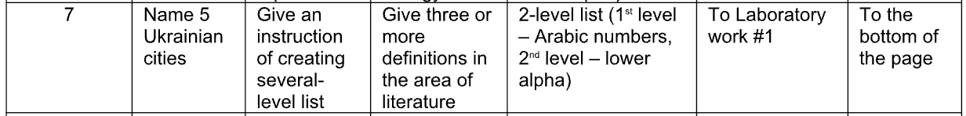

**Solution**

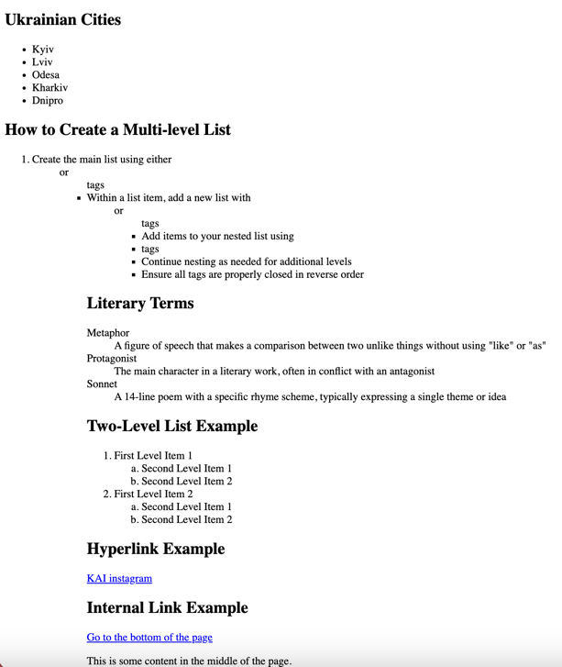  
<https://github.com/Jasokaa/IP-Olenin>

**Conclusion**

In this work, I learned how to specify LISTs and LINKs in HTML, completed the task according to my variant, and answered the control questions to reinforce my understanding of HTML structures and elements.1. Name all types of lists that you know:

* Ordered list
* Unordered list
* Definition list

2. Name all types of links that you know:

* Hyperlinks
* Internal links
* External links
* Email links (mailto:)
* File download links
* Anchor links

3. How the unordered lists are implemented in the HTML language?  
Using the <ul> tag with <li> elements.

4. How the ordered lists are implemented in the HTML language?  
Using the <ol> tag with <li> elements.

5. How are the definition lists implemented in the HTML language?  
Using the <dl> tag with <dt> for terms and <dd> for descriptions.

6. How are the hyperlinks implemented in the HTML language?  
Using the <a href="URL">text</a> tag.

7. What is the anchor?  
An <a> tag that defines a hyperlink or a target location within a page.

8. How are the internal links implemented in the HTML language?  
Using <a href="#id">text</a> and an element with id="id"

**PART 2: TABLES**

**Task**

1. Study how to use Tables in Web-pages.

2. Learn the syntax and rules of creating Tables

3. Learn all the Elements for constructing tables

- Table Attributes

- Deprecated Attributes

- Column groups: the COLGROUP and COL elements

- Table rows: The TR element

- Table cells: The TH and TD elements

- Row groups: the THEAD, TFOOT, and TBODY elements

- Cells that span several rows or columns

- Borders and rules

4. Create simple Web-page using properties according to the variant.****

**Solution**

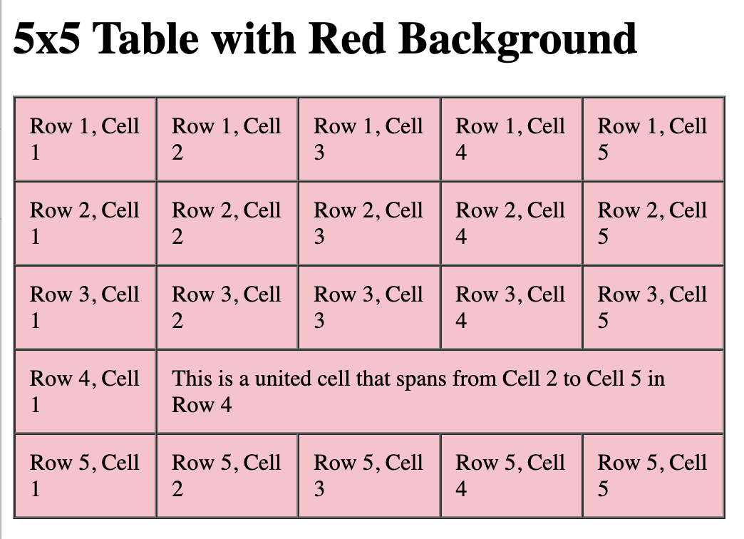

<https://github.com/Jasokaa/IP-Olenin>

**Conclusion**

In this work, I studied how to use tables in web pages, learned their syntax and elements—including attributes, row and cell tags, column groups, and spanning cells—and created a simple web page applying these table properties according to my variant.

1. What is a Table? Primary tags for use with tables:  
A table organizes data in rows and columns. Primary tags: <table>, <tr>, <th>, <td>.

2. Describe the steps for creating the table:

* Start with <table>.
* Add rows using <tr>.
* Define header cells with <th>.
* Define data cells with <td>.
* Close tags properly.

3. Name all Table Attributes and describe their properties:

* border — adds border thickness.
* cellpadding — space inside cells.
* cellspacing — space between cells.
* width — table width.
* height — table height.
* align — table alignment.
* bgcolor — background color.

4. Name all Deprecated Attributes and describe their properties:

* border (use CSS instead).
* bgcolor (use CSS).
* align (use CSS).
* cellpadding and cellspacing (use CSS).

Deprecated means replaced by CSS styling.

5. What are the COLGROUP and COL elements?  
<colgroup> groups columns; <col> defines attributes for individual columns (like width, style).

6. What is the SPAN attribute and its advantages?  
colspan and rowspan allow a cell to span multiple columns or rows, making complex table layouts easier.

7. What are THEAD, TFOOT, and TBODY elements?  
They divide a table into header (<thead>), footer (<tfoot>), and body (<tbody>) sections for better structure and styling.

8. Write an example of table using some attributes and describe the result:

<table border="1" cellpadding="5" cellspacing="2" width="50%">

<thead>

<tr>

<th>Name</th>

<th>Age</th>

</tr>

</thead>

<tbody>

<tr>

<td colspan="2" bgcolor="#f0f0f0">Group 1</td>

</tr>

<tr>

<td>Ivan</td>

<td>25</td>

</tr>

</tbody>

</table>

**PART 3: OBJECTS AND IMAGE MAPS**

**Task**

1. Get acquainted with the notions of object, applet, image map in HTML.

2. Study the declaration and instructions syntax of objects, appets and image maps.

3. Construct HTML-page, displaying the task, listed in the corresponding variant.  


**Solution**

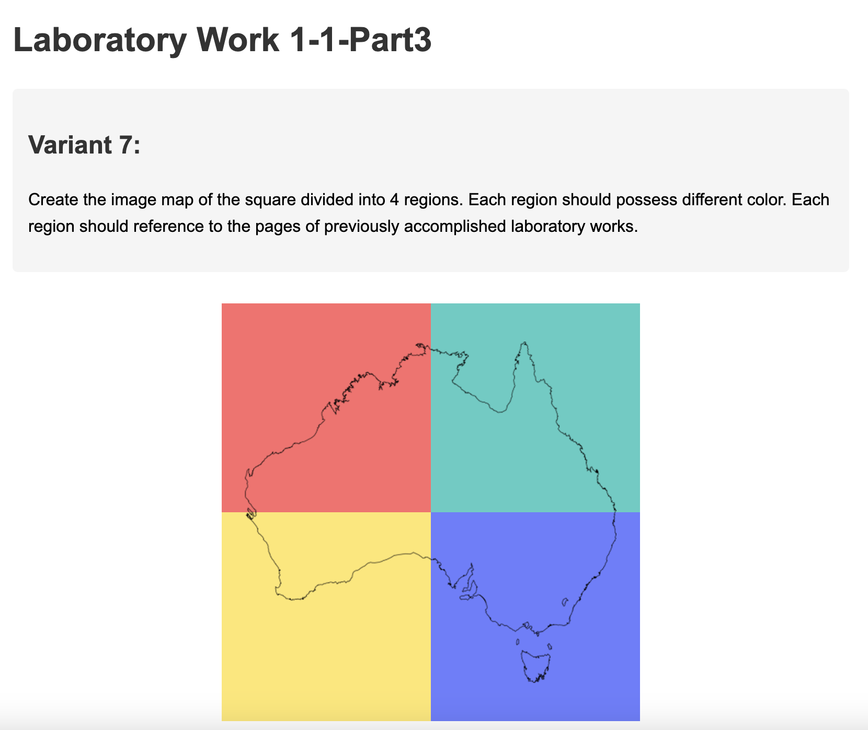

<https://github.com/Jasokaa/IP-Olenin>

**Conclusion**

In this work, I got acquainted with the concepts of object, applet, and image map in HTML, studied their declaration syntax, and created an HTML page displaying the task according to my assigned variant.

1. Definitions of object, applet, and image map in HTML:

* Object: An HTML element (<object>) to embed multimedia, applets, or other resources.
* Applet: A small Java program embedded in a web page using <applet> (deprecated).
* Image map: An image with clickable areas linked to different destinations, defined by <map> and <area> tags.

2. Ways to download (display) images in an HTML page:

* Using <img src="URL"> tag.
* Using CSS background-image property.
* Embedding in <object> or <embed> tags.

3. Object’s attributes:

* data — URL of the resource.
* type — MIME type of the resource.
* width and height — size.
* name — name of the object.
* form — associate with a form.
* usemap — reference to an image map.

4. Attributes of image maps:

* <map> has name attribute (identifier).
* <area> has shape (rect, circle, poly), coords (coordinates), href (link), alt (alternative text).

5. Types of image maps and their peculiarities:

* Client-side image maps: Defined in HTML (<map> and <area>), processed by browser.
* Server-side image maps: Click coordinates sent to server for processing.

6. Means of visual representation of images, applets, and objects; basic tags:

* Images: <img>
* Applets: <applet> (deprecated), replaced by <object> or <embed>
* Objects: <object>

**PART 4: FRAMES**

**Task**

Create an XHTML document containing frames with properties specified in Table 1.  
The page is split horizontally in 2 equal frames both having a 30 pixel margin. The first frame contains several links to images that are opened within the second frame.

**Solution**

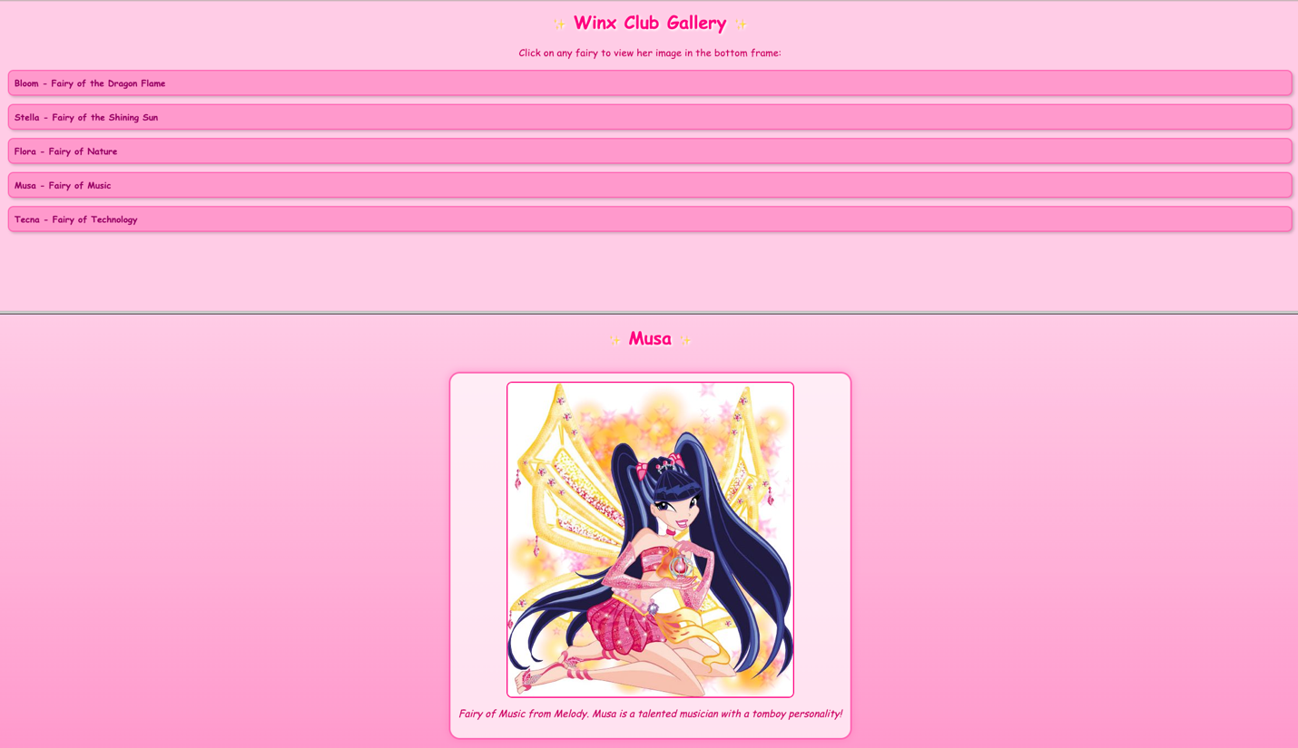

<https://github.com/Jasokaa/IP-Olenin>

**Conclusion**

In this work, I created an XHTML document with two horizontal frames, learned how to set frame margins, and implemented links that open images in the second frame according to the task requirements.

1. Purpose of using frames in HTML and XHTML:  
To divide the browser window into multiple sections, each displaying a separate HTML document simultaneously.

2. Purpose and use of the <frameset> element:  
It replaces the <body> tag to define a set of frames and their layout (rows or columns).

3. How frame sizes are specified via rows and cols attributes:

* rows defines horizontal divisions with sizes (pixels, %, or *).
* cols defines vertical divisions similarly.  
  Example: rows="100,*,200" means top frame 100px, middle fills remaining, bottom 200px.

4. Attributes of <frame> element:

* src — URL of content.
* name — frame name (for targets).
* scrolling — auto, yes, no (scrollbar behavior).
* noresize — prevent resizing.
* marginwidth and marginheight — margins inside frame.
* frameborder — show border (1 or 0).
* longdesc — URL for long description.

5. How to set initial contents and targets for links:

* Use src attribute in <frame> to set initial page.
* Use target attribute in links to specify which frame loads the linked page (target="framename").

6. Usage and purpose of <noframes> element:  
Provides alternative content for browsers that do not support frames, ensuring accessibility.