**INTERNET PROGRAMMING**Laboratory work 1-2  
Variant – 7

Prepared by:

student of *Ba-121-22-4-SE*,

*Anna Kuts`*

Accepted by:

*Makliuk O.O.*

**PART 1: XML   
Task**

1. Get to what is XML, it’s basic definitions.

2. Get to know about DTD.

3. Get to know how to use XML together with CSS.

4. Perform a task according to variant (variants are shown in the Table 1) - The data of the psychical test..

5. Answer the control questions.

**Solution**

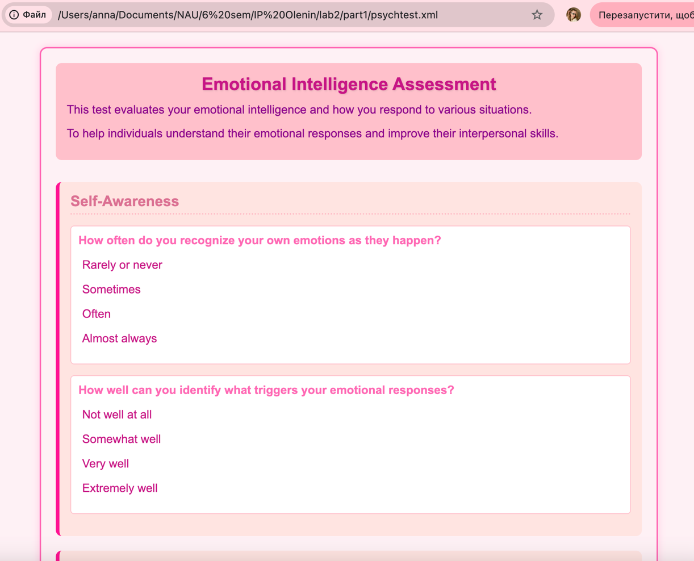  
<https://github.com/Jasokaa/IP-Olenin>

**Conclusion**

In this work, I learned the basics of XML, studied DTD, explored using XML with CSS, completed the task according to my variant, and answered control questions to deepen my understanding of XML technologies.

1. What is XML?  
XML (eXtensible Markup Language) is a markup language designed to store and transport data in a structured, both human- and machine-readable format.

2. What are the main XML definitions?

* Element: Basic building block of XML (tags).
* Attribute: Provides additional information about elements.
* Prolog: Optional XML declaration at the start.
* Well-formed: Properly structured XML.
* Valid: XML that follows a defined schema or DTD.

3. What is DTD?  
DTD (Document Type Definition) defines the structure and legal elements and attributes of an XML document.

4. Main elements and attributes of DTD:

* Elements: Declared with <!ELEMENT> specifying element name and content model.
* Attributes: Declared with <!ATTLIST> specifying attribute names, types, and defaults.
* Entities: Defined with <!ENTITY> for reusable content.

5. What is an entity?  
A named shortcut or reference to text or data defined in DTD or XML, like special characters or reusable strings.

6. How to use XML together with CSS?  
Link a CSS file or embed styles in XML using the processing instruction:

<?xml-stylesheet type="text/css" href="style.css"?>

**PART 2: XPath**

**Task**

1. Get to know how XPath is specified.

2. Perform a task according to variant (variants are shown in the Table 2)

3. Answer the control questions.

**Solution**

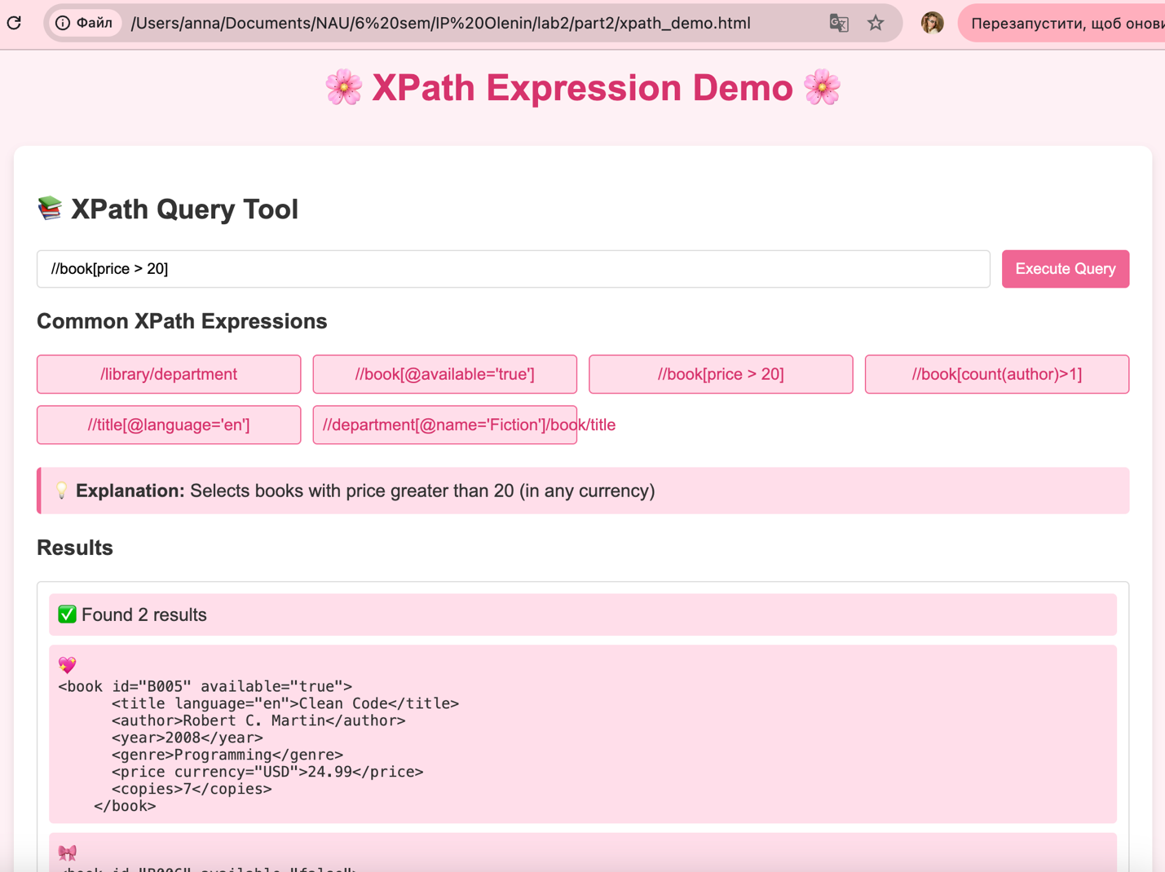

<https://github.com/Jasokaa/IP-Olenin>

**Conclusion**

In this work, I learned how XPath is specified, completed the assigned task according to my variant, and answered control questions to strengthen my understanding of navigating and querying XML data using XPath.

1. Name all types of nodes in XPath:  
Element, attribute, text, namespace, comment, processing-instruction, root.

2. What are the axes of XPath:  
Ancestor, ancestor-or-self, attribute, child, descendant, descendant-or-self, following, following-sibling, namespace, parent, preceding, preceding-sibling, self.

**PART 3: XSLT**

**Task**

1. Gain knowledge of the basic definitions of XSLT
2. Transform an XML document according to a variant (variants are given in Table 2) into HTML.

**Solution**

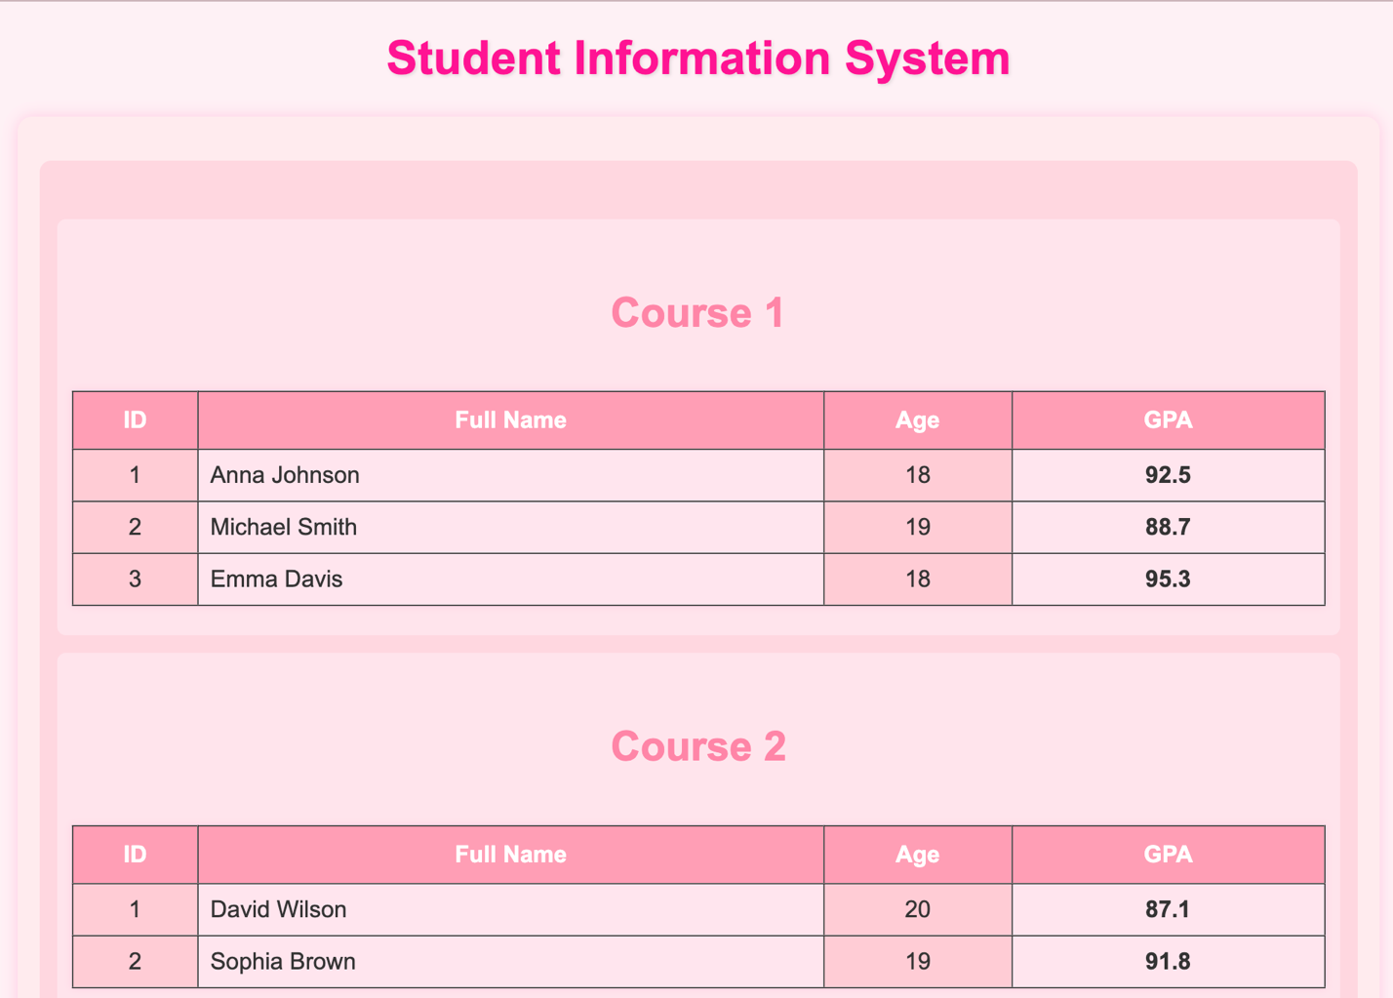

<https://github.com/Jasokaa/IP-Olenin>

**Conclusion**

In this work, I gained knowledge of the basic definitions of XSLT and transformed an XML document into HTML according to my assigned variant, applying XSLT rules for formatting and structure.

1. What is XSLT and how is it used?  
XSLT (eXtensible Stylesheet Language Transformations) is a language used to transform XML documents into other formats, such as HTML, plain text, or another XML structure. It uses templates to define rules for transforming the source XML data.

2. Name the main elements of XSLT:  
<xsl:stylesheet>, <xsl:template>, <xsl:value-of>, <xsl:for-each>, <xsl:if>, <xsl:choose>, <xsl:apply-templates>, <xsl:sort>, <xsl:variable>.