**Software Architecture and Design**

Laboratory work 5

BEHAVIORAL DESIGN PATTERNS. MEMENTO, STATE, COMMAND, INTERPRETER PATTERN

Variant - 8

*Prepared by:*

*student of SE-224B,*

*Anna Kuts’*

*Accepted by:*

*Vasilieva M.D.*

**Task**

1. Learn behavioral patterns for software design. Know the general

characteristics of behavior patterns and the purpose of each of them.

2. Study in detail the behavior patterns for software design – Memento, State,

Command, Interpreter.

For each of them:

• study the pattern, its purpose, motivation, cases when its use is appropriate,

and the results of such use;

• know the peculiarities of the implementation of the pattern, related templates,

known cases of its use in software applications;

• know the structure of the pattern, the assignment of its classes and the

relationships between them;

• be able to recognize a pattern in the UML class diagram and write the code

that implement the pattern.

3. Create the com.lab111.labwork5 software package. In the package, develop

interfaces and classes that implement tasks (according to the variant) using one or

more patterns (item 2). The methods that implement business logic should be closed

with stubs that output information about the called method and its arguments to the

console.

Example of business method implementation:

void draw(int х, int у)

{

System.out.println(“Method draw with parameters x=”+x+” y=”+y);

}

4. Complete documentation of the developed classes (also methods and fields)

using Javadoc automated tools, while the documentation should sufficiently

highlight the role of a certain class in the general structure of the pattern and the

specifics of certain implementation.

|  |  |
| --- | --- |
| **№** | **Task variant** |
| 0 | Define the specifications of classes that provide graphic elements (circle,  triangle, etc.) with different attributes (color, position, size, etc.) in the vector  editor. Implement a mechanism for saving/setting the state of the element. |

**Solution**

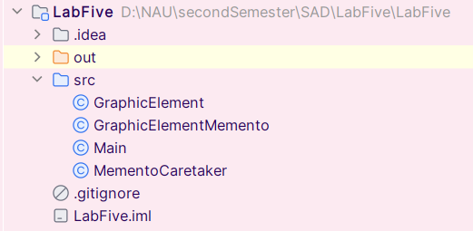

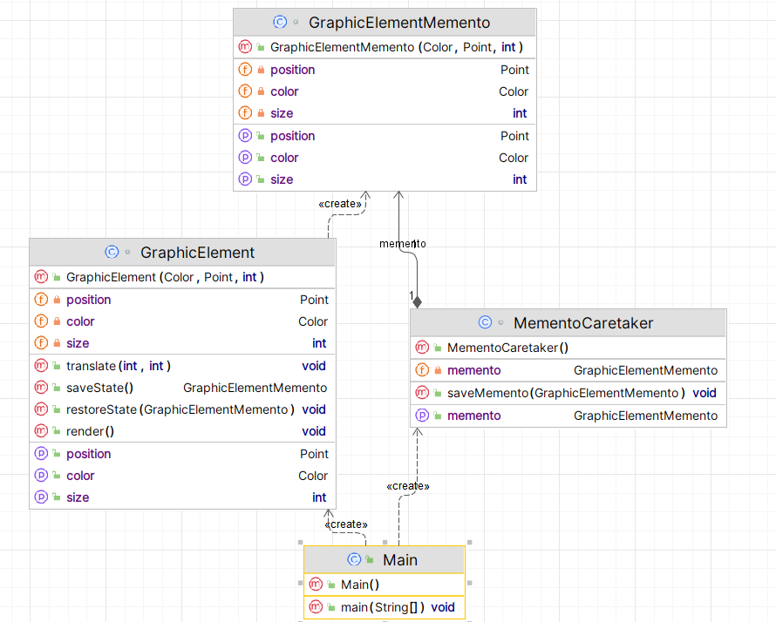

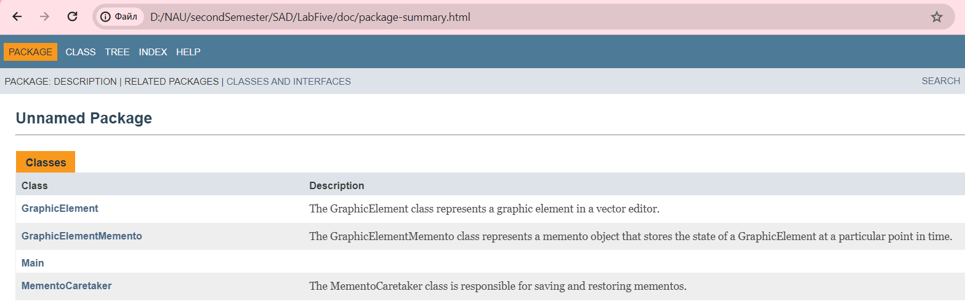

https://github.com/Jasokaa/LabFive

**Conclusion**

Having delved into software design patterns, particularly the behavioral design patterns: memento, state, command, interpreter patterns. I've acquired a profound insight into how these patterns foster improved software architecture by promoting modularity and adaptability. This understanding not only elevates my coding methodologies but also empowers me to adeptly integrate intricate designs with efficiency and ease of maintenance.