Evaluation & Recommendations Report

IDK PRO

Gong Cheng

Kasey Gillespie

Kaitlyn Gorsalitz

Halle Jackson

Evaluation & Recommendations Report

| Gong Cheng  U of S  Saskatoon, Canada  goc558@mail.usask.ca | **Kasey Gillespie**  U of S  Saskatoon, Canada  kag258@mail.usask.ca | Kaitlyn Gorsalitz  U of S  Saskatoon, Canada  krg028@mail.usask.ca | Halle Jackson  U of S  Saskatoon, Canada  hsj294@mail.usask.ca |
| --- | --- | --- | --- |

# PROBLEM AND MOTIVATION

DeviantArt is an art sharing website that allows users to upload their own pieces of art and to view other user's works. As of February 2017, the site has hosted over 325 million pieces of art and has had over 65 million unique visitors each month [1]. With this much content, browsing through art has the potential to be time consuming and difficult. Our goal is to strengthen the site by making it easier to browse through works, as a site whose purpose is to display art should make accessing that art as easy and convenient as possible. Studies show that DeviantArt users only spend about an average of 9 minutes per visit [1] on the site, and we hope that by making a more painless browsing system we are able to engage a user's attention longer.

Through our design process we have brought up several areas that could be improved to meet this goal, and ended up settling on one specific part: the ability to easily view multiple works of art in a streamlined way. On the current system, the user has to find art by browsing through a list of thumbnails. When they find a work they are interested in viewing, they can click the thumbnail to open it in a new page. If they want to view more than one work while browsing, the user is forced to either, 1) continually open new pages and click back from them when done viewing, which can be tedious, or 2) open the works in different tabs, which can be overwhelming and slow down the browser. We believe our redesigned system allows a user to more easily view multiple pieces of art at a time. We hope that by making this adjustment it will make it more convenient for a user to browse and find works relevant to their interests, and that making art more accessible will help artists receive more recognition.

# RELATED LITERATURE AND BACKGROUND

We had difficulty finding literature related to making a more efficient system for browsing through and viewing multiple images, however we were able to find literature relating to the background of DeviantArt and as to why making it easier to browse is important. In a single year there are vastly more unique visitors to DeviantArt then there are visitors to any of the most renowned art galleries in the world [2]. With DeviantArt becoming a large, relatively new marketplace for art, the ease of finding art that interests you should be intrinsic to the experience. As a viewer, the task of browsing through multiple pieces of art can be overwhelming:

It can be hard to find a specific art piece due to the amount of information’s available, the diversity and organization of the data available (endless categories and stratifications), the diversity of people (deviants types) and the need to improve the search engines available. [3]

DeviantArt gives artists the opportunity to establish relationships in the art community, which raises the probability of receiving career opportunities [3]. If their art is not easily discovered, they lose these opportunities – and with large amass of works on the site, it is difficult to stand out.

The simplicity of reaching millions does not necessarily mean that it is easy to become successful among the DA community. On the contrary, DA has a delicate power structure based on simple statistics that reflects the popularity of each member. … The more popular you are, the higher the chances of receiving new visitors to your DA page, which in return makes you more and more popular. The end result is that a few members enjoy an enormous number of pageviews, and achieve the luxury of reaching the masses easily and quickly. [2]

By making art easier to view, we will hopefully lead to users spending more time on the site, giving these artists more exposure, and giving the user a more satisfying experience.

**DESCRIPTION OF SYSTEM**

We discussed many components of DeviantArt that could be changed to make the site more accessible, and settled on improving the ability to view multiple works in succession. To accommodate this, our group brainstormed several different possibilities, and eventually developed two specific components, 1) a queue system for viewing works, and 2) that the work's detailed view is opened as a screen overlay, rather than another page. Using a queue system allows a user to view multiple works with ease, and using an overlay rather than another page allows the user to resume browsing faster, without having to reload the browsing page. For our medium-fidelity prototype, we implemented this system by creating a vertical prototype focusing specifically on the queue and work overlay interactions.

The browsing page was redesigned to accommodate this. A "plus" icon was added to the list of thumbnails present when browsing. If clicked, the work represented by this thumbnail is added to a queue of works that can be viewed consecutively. The queue is visible as a fixed sidebar on the browsing page that displays the thumbnails of all works that have been added to the queue. A work can be removed from the queue by clicking a "minus" icon that replaces the "plus" icon on the browsing thumbnail, or from a "minus" icon on the thumbnail in the queue sidebar. The queue list displays a number representing each works place in the queue next to the thumbnail in the sidebar. The sidebar is topped by three buttons. The first is a small question mark icon which represents a help cue. Clicking this will open a dialog explaining the function of the queue to the user. The second is a "View" button. Clicking this will open a queue view that showcases all queued art. The third is a "Clear" button that will clear all art from the queue, after showing the user a dialog asking them to confirm it. When left empty, the queue displays a message prompting the user to add art.

When a thumbnail in the browsing page is clicked, it will open a view overlaying the browsing page which shows the full work and its details, including the artist and their comments. Other relevant works are shown to the sides of the screen, in order to try and show the user other works they may enjoy. The user can close the overlay by clicking outside of it or clicking on an "X" icon to the top right of the overlay.

This individual work view is very similar to what is shown when the "View" button is clicked in the queue sidebar. The only difference is that instead of showing the single work in the center of the screen, the queue view also partially displays the previous and next images in the queue, with corresponding previous and next arrows. If these arrows, or the partial art, is clicked, that image becomes the main image shown in the queue view, replacing the previous one. Using this view, a user can easily page through several works. This view can also be opened by clicking the work thumbnail in the queue sidebar, except that it will be opened to that work's spot in the queue, instead of the first image in the queue.

**EVALUATION WITH USERS**

**Goals, approach and rationale**

As our system is focused on determining a more convenient way to view multiple works, our corresponding evaluation is focused on the user’s opinions on specific sections of our prototype that are related to this goal. The main evaluation's spotlight was on the queue, viewing a single piece of art, and viewing the selected work on the queue. We wanted to be able to determine how useful the queue and work overlay view was to the user by determining if they found these pages more convenient, faster, and if they would prefer use it over the default implementation.

For our evaluation we used a questionnaire approach, due to desiring a large pool of diverse opinions on our system, rather than the smaller group we would have from interviewing or observation techniques. With the larger pool of responses we were able to determine a general opinion of the usefulness of the queue and overlay view from the users.

The questionnaire was mostly comprised by scalar questions that let the user rank their opinion of the system. There were also some general questions to determine the user's demographic information and computer proficiency/usage, as well as questions to determine their interest in art and if they are familiar with the site DeviantArt. We also let them enter any other feedback that they may have about the queue and overflow designs.

**Participant pool and execution details**

Our participant pool was made up of friends and family members, with most of the participants being students. We looked to pool around 10 people for the questionnaire evaluation, but managed to end up with 12 people surveyed. We did not limit our participant pool to a certain type of user, because we designed our system with the notion that it can be used by anyone, whether they are a new user or an experienced one. Most participants did have pre-existing knowledge of the site DeviantArt, however some had no familiarity with it, or interest in art, at all. This allowed us to gauge how different levels of user experience and interest affected the user’s ability to operate the queue, and how it informed their opinion of it.

For our evaluation process, one person from our group would evaluate a single person at a time in a quiet setting. Due to constraints of the prototyping tool being used, it turned out some screen sizes distorted how the prototype was intended to be viewed, so we determined that only 3 of the group members' computers could be used for the evaluation to have a more consistent environment. We began by giving a brief, partially scripted introduction to the user explaining our overall goal and the structure of the evaluation. If the user was unfamiliar with DeviantArt we would explain the site's function to them and let them try out the site. After that we let the users explore the prototype and experiment with it, without any set goals, to see if they were able to figure out how to use it without guidance. The overviewing group member would observe the user interacting with the system, and was there to answer any questions the user had. After they finished exploring, we gave them the questionnaire to fill out. The total average evaluation time ended up being about 15-20 minutes, including filling out the survey.

**Divergence from evaluation plan**

There were not any major divergences from the evaluation plan presented in Milestone III, but there were a couple minor ones. We had planned on using the website surveymonkey for the questionnaire, but ended up having to switch to a google form because it allowed us to put more than 10 questions in without a paid account. We were also expecting an average time of about 20 to 30 minutes for each evaluation, but most evaluations ended up being done between 15 and 20 minutes.

**Results & Conclusions**

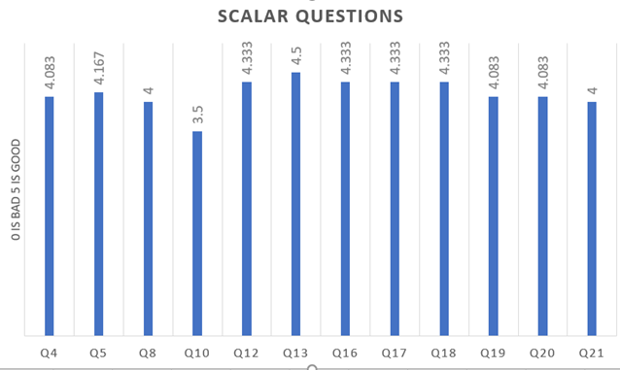

Figure 1. A chart that compares the averages of each scalar question (ranks were on a scale from 1 to 5 with 1 being unfavorable and 5 being favorable). Corresponding questions are available in the appendix.

A. Summarization of findings

Within the participant pool, the average age was about 22 and a majority (66.7%) were female. Most were confident in their computer skills (figure 1 Q4) and more so in their website navigation skill (figure 1 Q5). All were reportedly on their computer more than 3 hours a day, half even being on for more than 6. Every single participant reported to using computers for Social Media, while a majority used it for education (91.7%), gaming (75%), video streaming (75%), or shopping (66.7%). Interest in art averaged at a 4 on a scale to 5 with one 3 (neutral) and one 2 (not interested). Most of the participants were viewers of art (58.3%) although two considered themselves an artist as well. Of our participant pool we were able to gather a range of experience with DeviantArt with the average participant's familiarity ranking at 3.5 out of 5 – very close to the perfect average of 3. In regards to art sharing, aside from DeviantArt, most participants used either Facebook (83.3%) or Instagram (58.3%) to otherwise share art. Every one of the participants rated the screen overlay favorably at either 4 or 5 out of 5 (figure 1 Q12 & Q13), however 25% of the participants reported that they still prefer viewing art on a separate page. Unfortunately, none commented on why this might be. Understanding of the queue's mechanisms was consistently rated favorable (figure 1 Q16-Q18) however the queue was also rated as less convenient or quick as the individual overlay (figure 1, compare Q12 & Q13 to Q19 & Q20). A majority (66.7%) said that they would like to make use of the queue to browse art, while the rest reported neutrally on the matter. Similarly to the individual screen overlay feature, although the participants were largely positive about the queue, 41.7% reported that they would rather look at a single piece of art than multiple in the queue. Interestingly, of those that had reported preferring seeing art on a separate page, only two of the three that had reported as such retained their preference for single pages over the queue. Notably, however, those that preferred a single page over the queue did have correlating answers for how convenient or quick they found the queue, reporting closer to neutral than favorable.

B. Key strengths and weaknesses of the interface

From the results obtained, it appears that overall the interface is decently strong in all areas. People reacted favorably to not losing their position on the page, finding the feature easy to learn, and that the feature felt new but also familiar to other sites such as Facebook. However, of note is that the individual screen overlays of single pieces were more favorably received than the queue feature. There were also comments gathered that suggested improvement ideas such as minimizing the queue while not in use or expanding the flexibility of the queue's clear function.

C. Relative importance of the strengths/weaknesses

The strength of the system was overall rated favorably, but it is worth mentioning that one of the main goals with the newer interface was to help users not to get lost, so the strength of the screen overlay not losing your position was especially important. The ease of learning and familiarity were also successes as it meant that using the feature would not be a frustration.

In terms of weaknesses, however, it is notable that the queue was not as well-received as the screen overlay. While it was not rated negatively by any means, the queue made up a bit more of the implementation and design philosophy than the screen overlay – demonstrated as such by the queue using the screen overlay as a subsection of its features. Interestingly, the favorability of the screen overlay over the queue in general is a bit strange due to the aforementioned queue using the exact same basic mechanic in how it works. It would definitely be worth looking into to find out specifically why users answered the way they did about the queue, as it is one of the main features of the redesign and should be the most favorable aspect rather than ranking second.

D. How the view of the situation has changed from before the evaluation

For the most part, not much has changed, however it is interesting just how much you learn from interacting with an actual participant pool as opposed to simply what is assumed participants will think. For instance, one of the more unexpected aspects is that although users may find a feature quick or convenient, that does not necessarily mean that they will use it. Working in tandem with users throughout the design process has very clearly presented itself as far more important than imagined, due to these types of unexpected information.

E. Critique the evaluation process

Overall we believe that the questionnaire served its purpose well, however one aspect that could have been improved upon was obtaining more open-ended feedback. The tough part about committing to that task is that questionnaires are not too well-designed for open-ended questions. Only 25% of our participants commented when given the chance. Perhaps a better solution would be to have a questionnaire for the general scaling questions while the questions surrounding preferences were asked afterwards in an interview-like fashion. There also could have been a couple questions cut that perhaps didn't serve much purpose (such as what people generally went online for – the most important aspect was if they did or did not use it for art purposes).

**FINAL RECOMMENDATIONS**

**Conclusions**

We determined that the overall quality of the interface design was sufficient, as it received positive responses from our evaluations. Both non-users and users of the website DeviantArt confirmed that the new design is helpful in many ways. So overall, we concluded that our design will work well for anybody who likes to share and view art.

**Recommendations**

The overall approach was validated by the evaluations, but there are some minor adjustments that can be made in the next stage of design. These minor adjustments include refining the size of the thumbnail to make sure it serves its purpose without taking too much space, adding a queue history function so that users can always keep track of what they have viewed.

One issue we would like to look into further would be to increase the positive reception of the queue view, as was the main focus of our system but it was only mildly preferred. To determine how to increase this, we would need to brainstorm ways to make using the queue more desirable for users.

As mentioned by the comments received in the evaluation, a couple of ways to improve the queue could be to make it collapsible so that users can hide it if they do not choose to use it, or to further implement more of DeviantArt's built in functions such as favorites. As far as the latter issue is concerned, our design team had discussed placements of DeviantArt's built in functions, but ultimately decided not to include them in the prototype as we felt that they drew attention away from the actual components that we were implementing and even if added would not have been changed or implemented for the prototype in the first place.

**Reflections on process**

There are many design methods we tried in this course that have been very helpful. At the very beginning, making the design right and then making the right design concept, the 10 plus 10 sketches method and etc. really taught us how to put the judgement aside and get our ideas out first. Constantly iterating on the design with these methods lead to a better design.

The chosen approach for our prototype went very well. It was able to demonstrate the intended functionality to our users in a very realistic way without writing a single line of code. Adopting the vertical approach allowed us to demonstrate in a deeper manner which proved to be the right way to go for our group. We chose to do a questionnaire for our evaluation and it turned out to be very cost efficient and effective. We were able to get twelve evaluations done within a week. The questionnaire also gave us an insight into how the users would react to our design, and we were happy to discover that it was the positive result we were looking for.

The one thing we would change in hindsight is to, instead of recording all survey results after the user used the system, have the user use DeviantArt, survey them on that, and then have them try our system and survey them on that. It would allow us to have better statistical results, have a smaller chance of bias, and better compare the two systems.

There are many things we learned from this class and the project, and one of most important things is probably prototyping and getting user feedback before actually implementing the software. It will help us save time and reduce financial risk when our future projects get bigger. Even with just a personal project, quickly sketching the interface will organize our thoughts, and getting opinions from a couple of friends will make our future projects much better.

**REFERENCES**

[1]9 Interesting DeviantArt Stats and Facts (February 2017). (n.d.). Retrieved October 04, 2017, from <https://expandedramblings.com/index.php/business-directory/19729/deviantart-2/#.WdVPWDVrzIU>

[2] Salah, Alkim Almila Akdag. "The online potential of art creation and dissemination: DeviantArt as the next art venue." In *EVA*. 2010.

[3] Freitas, Maria. "DeviantArt: where art meets application!." *Madeira, University of Madeira* (2009).

**APPENDIX**

**A1: Evaluation Instruments**

We used a google form questionnaire that displayed to the users like this:

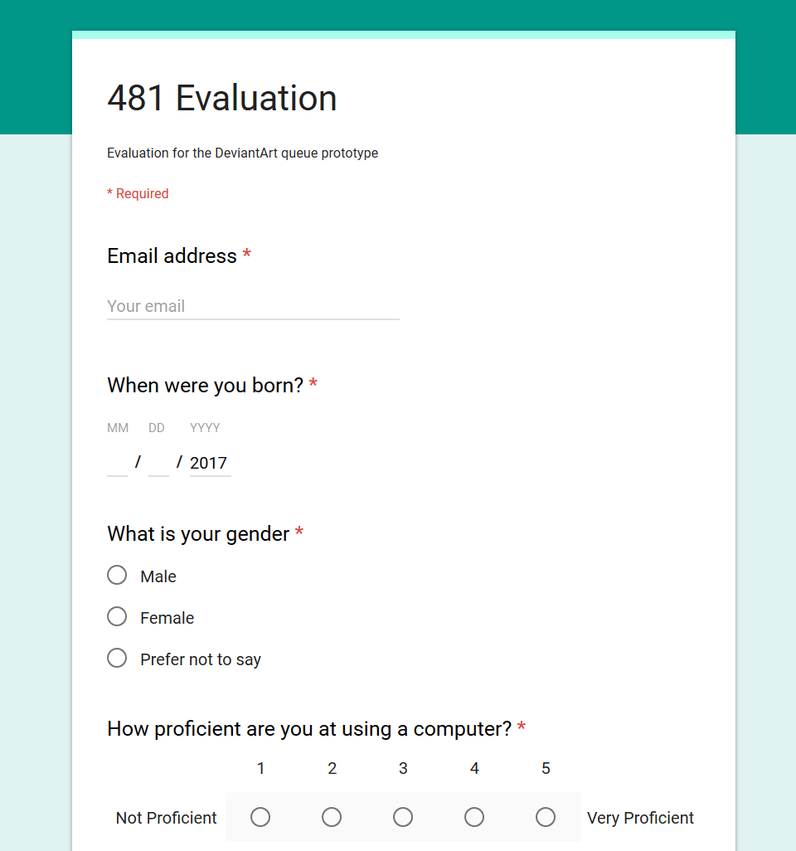

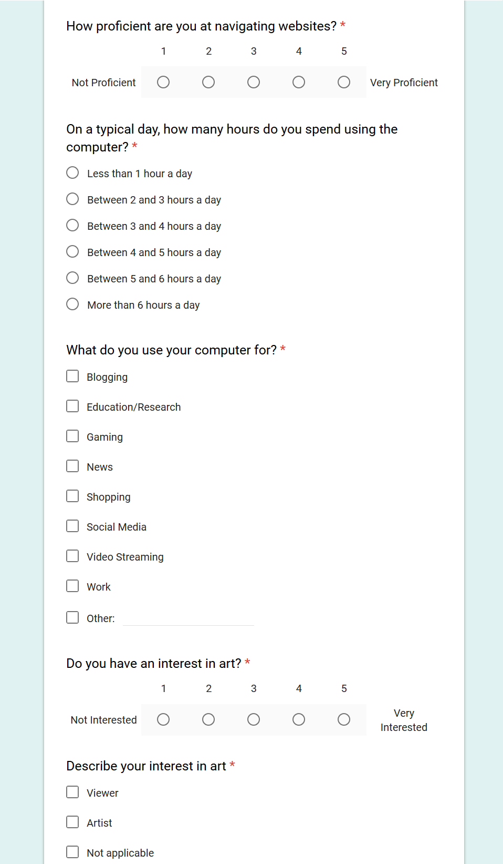

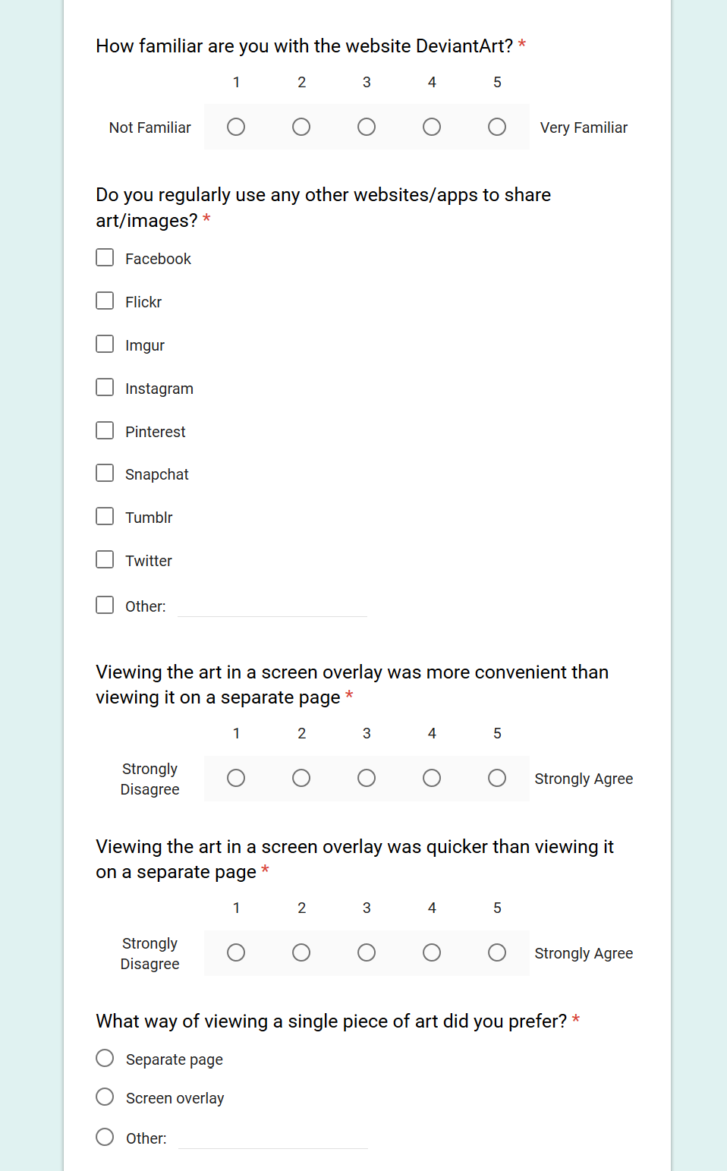

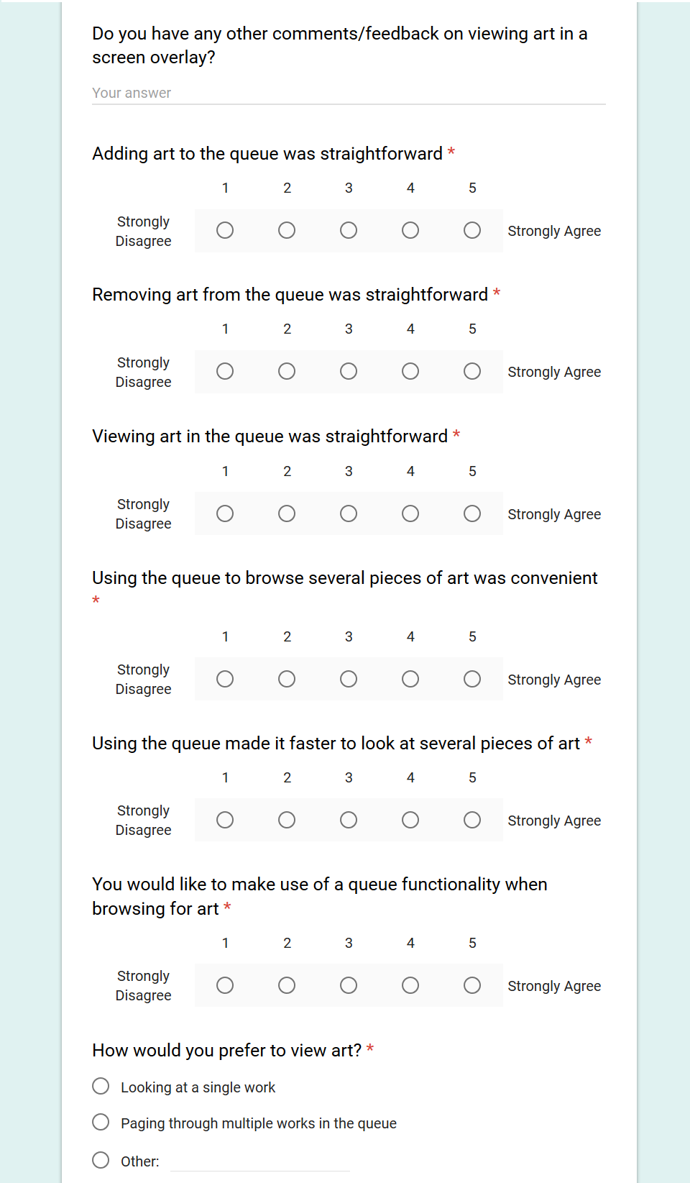

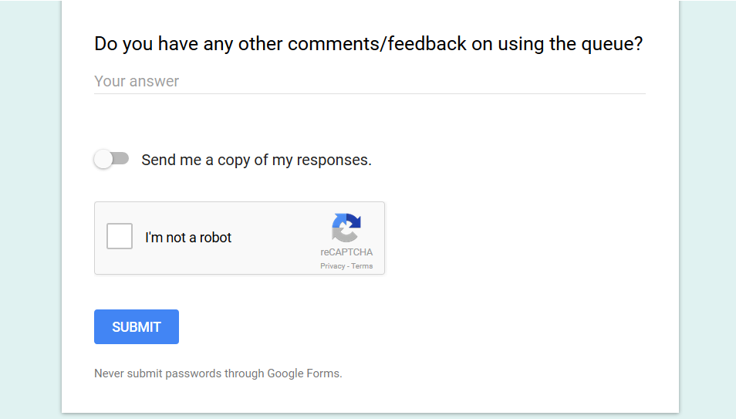

**A2: Raw Data**

|  |  |  |  |  |
| --- | --- | --- | --- | --- |
| **Username** | **When were you born?** | **What is your gender** | **How proficient are you at using a computer?** | **How proficient are you at navigating websites?** |
|  | 1994-09-27 |  | 4 | 5 |
|  | 1997-03-07 | Female | 4 | 4 |
|  | 1995-03-07 | Female | 4 | 5 |
|  | 1995-01-26 | Male | 3 | 4 |
|  | 1997-11-14 | Female | 3 | 4 |
|  | 1996-06-02 | Male | 5 | 5 |
| hanhtrang.phan@gmail.com | 1995-09-01 | Female | 3 | 2 |
| keh029@mail.usask.ca | 1990-07-08 | Male | 5 | 5 |
| adg407@mail.usask.ca | 2017-02-14 | Female | 5 | 4 |
| baljinder.bhinder@gmail.com | 1996-04-25 | Female | 5 | 5 |
| cchesheng@gmail.com | 2017-10-01 | Female | 5 | 3 |
| 1197950276cc@gmail.com | 1994-10-08 | Male | 3 | 4 |

|  |  |  |  |
| --- | --- | --- | --- |
| **On a typical day, how many hours do you spend using the computer?** | **What do you use your computer for?** | **Do you have an interest in art?** | **Describe your interest in art** |
| More than 6 hours a day | Education/Research;Gaming;Shopping;Social Media;Video Streaming | 3 |  |
| Between 5 and 6 hours a day | Education/Research;Gaming;News;Social Media;Video Streaming;Work | 5 | Viewer;Artist |
| More than 6 hours a day | Blogging;Education/Research;Gaming;News;Shopping;Social Media;Video Streaming | 4 | Viewer;Artist |
| Between 3 and 4 hours a day | Education/Research;Gaming;Shopping;Social Media | 5 | Not applicable |
| More than 6 hours a day | Education/Research;Social Media;Video Streaming | 4 | Viewer |
| More than 6 hours a day | Education/Research;Gaming;News;Social Media;Video Streaming | 3 | Viewer |
| Between 3 and 4 hours a day | Education/Research;Shopping;Social Media;Work | 3 | Viewer |
| More than 6 hours a day | Education/Research;Gaming;Shopping;Social Media;Video Streaming;Work | 2 | Viewer |
| Between 5 and 6 hours a day | Education/Research;Gaming;Shopping;Social Media;Video Streaming;Work | 5 | Artist |
| Between 4 and 5 hours a day | Education/Research;Gaming;Social Media | 5 | Artist |
| More than 6 hours a day | Shopping;Social Media;Video Streaming;Work | 4 | Viewer |
| Between 4 and 5 hours a day | Education/Research;Gaming;News;Shopping;Social Media;Video Streaming | 5 | Artist |

|  |  |  |
| --- | --- | --- |
| **How familiar are you with the website DeviantArt?** | **Do you regularly use any other websites/apps to share art/images?** | **Viewing the art in a screen overlay was more convenient than viewing it on a separate page** |
| 5 | Facebook;Instagram;Pinterest;Snapchat;Twitter | 4 |
| 4 | Facebook;Pinterest;Tumblr | 4 |
| 5 | Facebook;Instagram;Pinterest;Tumblr | 4 |
| 5 | Facebook | 4 |
| 4 | Facebook;Snapchat;Tumblr | 5 |
| 3 | Facebook;Imgur | 4 |
| 1 | Facebook;Instagram | 5 |
| 4 | Facebook;Instagram | 4 |
| 4 | Facebook;Pinterest;Tumblr | 5 |
| 4 | Instagram;Snapchat | 5 |
| 2 | Instagram | 4 |
| 1 | Facebook;Instagram;Wechat | 4 |

|  |  |  |  |
| --- | --- | --- | --- |
| **Viewing the art in a screen overlay was quicker than viewing it on a separate page** | **What way of viewing a single piece of art did you prefer?** | **Do you have any other comments/feedback on viewing art in a screen overlay?** | **Adding art to the queue was straightforward** |
| 4 | Separate page |  | 5 |
| 5 | Screen overlay |  | 5 |
| 4 | Screen overlay |  | 4 |
| 4 | Screen overlay |  | 3 |
| 5 | Screen overlay |  | 5 |
| 4 | Screen overlay | It's nice how we don't have to wait for the page to reload. | 5 |
| 5 | Screen overlay |  | 4 |
| 5 | Screen overlay |  | 5 |
| 4 | Separate page | It was a neat thing and handy that you wouldn't loose your place like you normally do in deviantart. | 4 |
| 5 | Screen overlay |  | 5 |
| 5 | Screen overlay | I like this way, it's similar to using Facebook. Also it's very new to have a queue for user to layout the picture they like. May be you can have something that add all the pictures in the queue to user favorite function. | 4 |
| 4 | Separate page |  | 3 |

|  |  |  |  |
| --- | --- | --- | --- |
| **Removing art from the queue was straightforward** | **Viewing art in the queue was straightforward** | **Using the queue to browse several pieces of art was convenient** | **Using the queue made it faster to look at several pieces of art** |
| 5 | 5 | 4 | 4 |
| 5 | 5 | 5 | 5 |
| 4 | 5 | 4 | 4 |
| 4 | 4 | 2 | 2 |
| 5 | 5 | 4 | 3 |
| 4 | 4 | 4 | 5 |
| 4 | 4 | 5 | 5 |
| 5 | 5 | 2 | 4 |
| 3 | 4 | 5 | 4 |
| 5 | 5 | 5 | 5 |
| 5 | 4 | 5 | 5 |
| 3 | 2 | 4 | 3 |

|  |  |  |
| --- | --- | --- |
| **You would like to make use of a queue functionality when browsing for art** | **How would you prefer to view art?** | **Do you have any other comments/feedback on using the queue?** |
| 3 | Looking at a single work |  |
| 4 | Paging through multiple works in the queue | me likes :) |
| 4 | Paging through multiple works in the queue |  |
| 3 | Looking at a single work |  |
| 3 | Looking at a single work |  |
| 4 | Looking at a single work |  |
| 5 | Paging through multiple works in the queue |  |
| 5 | Paging through multiple works in the queue |  |
| 5 | Paging through multiple works in the queue |  |
| 5 | Paging through multiple works in the queue | Clear takes away all of the added art in the queue. There should be an option for clearing couple of items in the queue instead of clearing all. |
| 4 | Paging through multiple works in the queue | Could be hidden when the user is not using. |
| 3 | Looking at a single work |  |

**A3: Supplementary analysis**

1. Emails
   1. 8 people put their email in, apparently we’re waiting for one of their responses? The other 6 were the first evaluations before the email part was added
2. When were you born
   1. July 8, 1990; September 27, 1994; October 8, 1994; January 26, 1995; March 7, 1995; September 1, 1995; April 25, 1996; June 2, 1996; March 7, 1997; November 14, 1997
   2. AND two people that mistakenly put 2017 as their year;;;;
   3. AVERAGE: 22.1
3. Gender
   1. 7 females (+1 for the person who didn’t answer) -> 66.7%
   2. 4 males -> 33.3%
4. How proficient at using a computer?
   1. 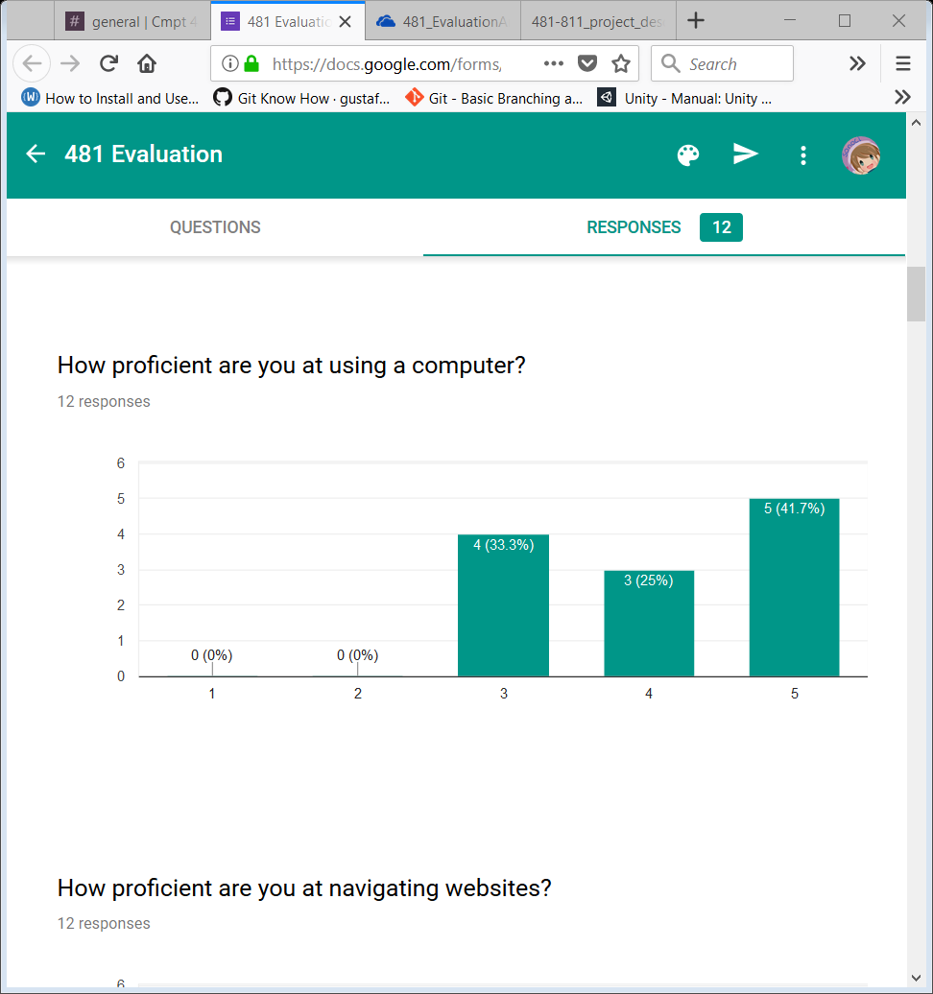
   2. AVERAGE: 4.083
5. How proficient at navigating websites?
   1. 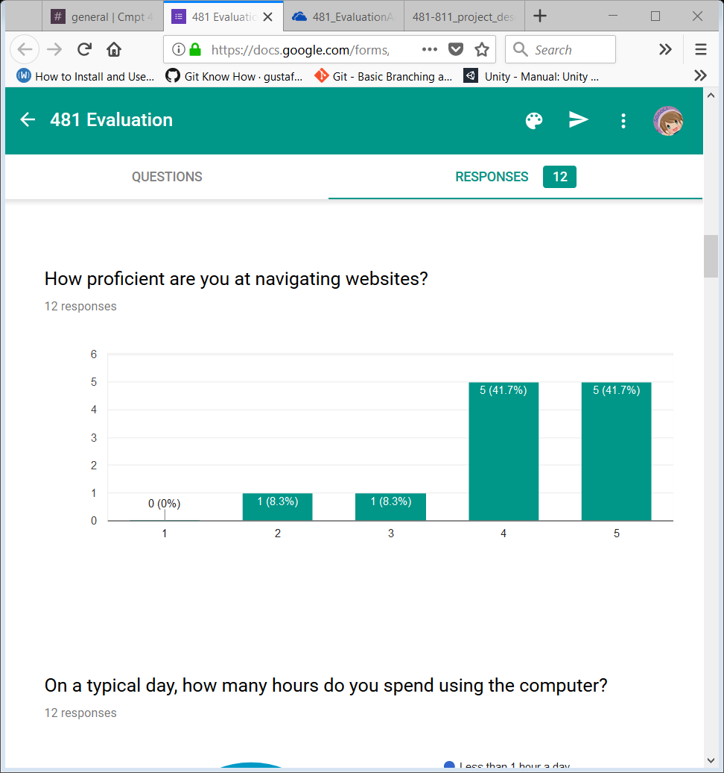
   2. AVERAGE: 4.167
6. On typical day, how many hours spent on computer?
   1. 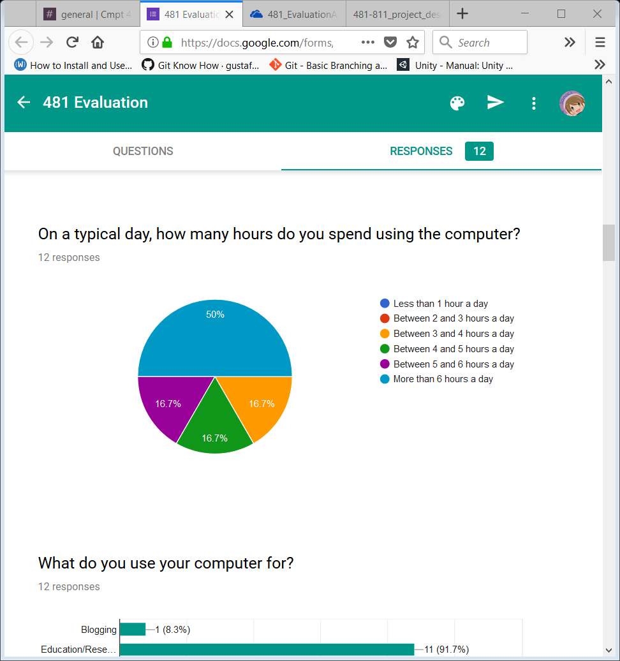
   2. AVERAGE: ~5.5 hours a day
7. What do you use your computer for?
   1. 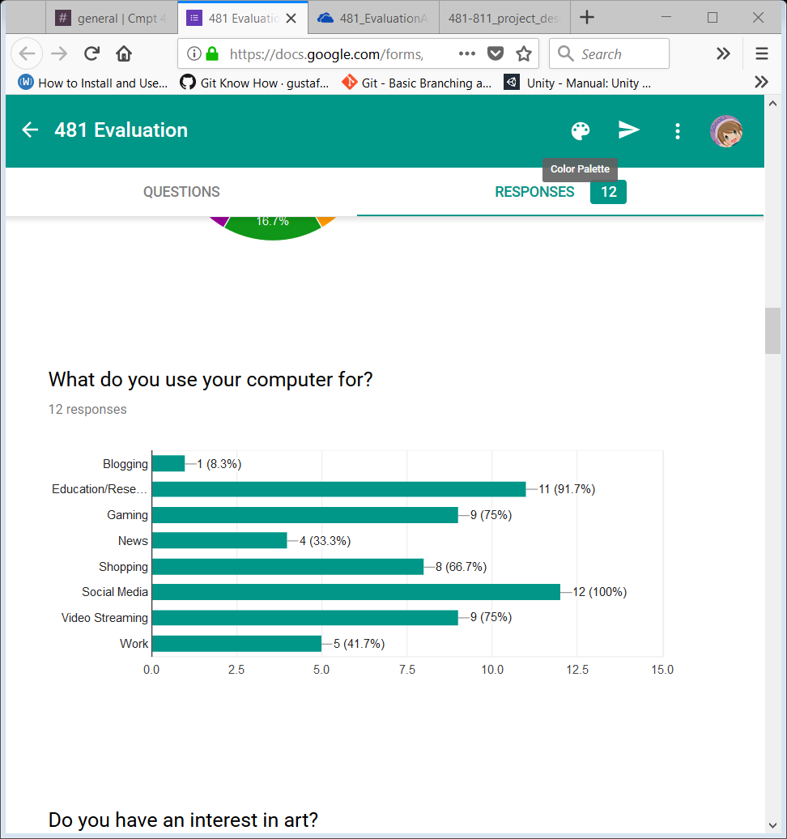
8. Do you have an interest in art?
   1. 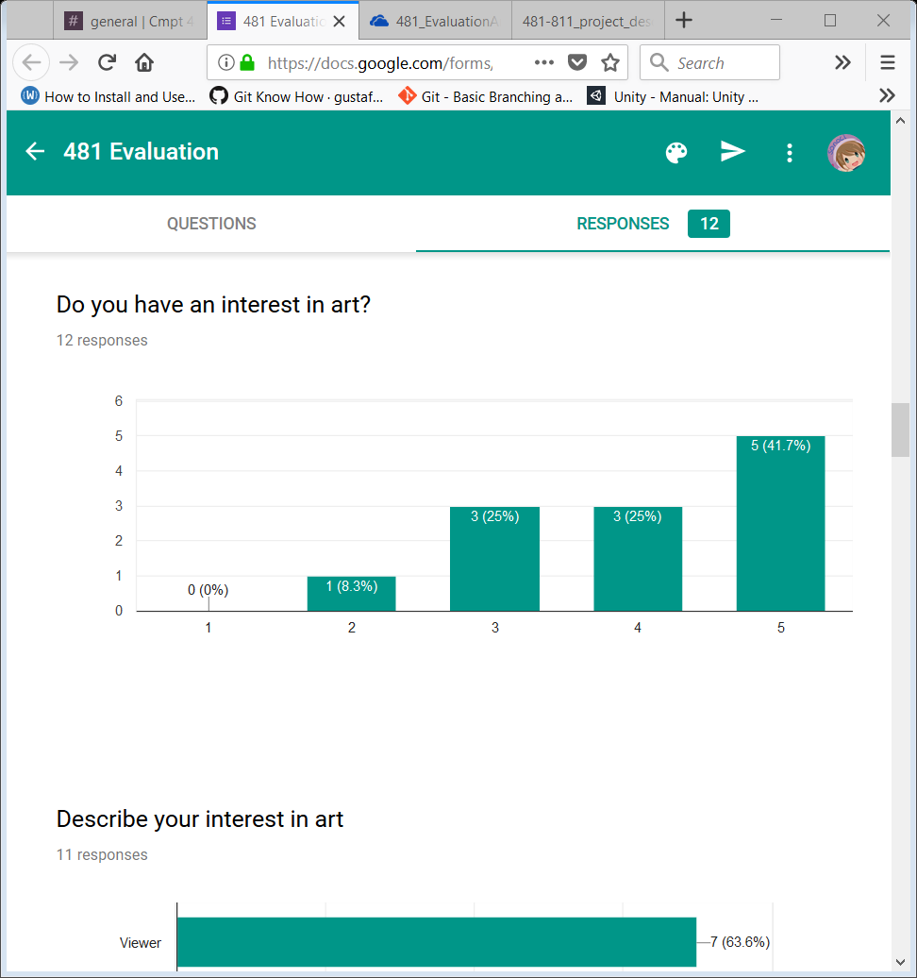
   2. AVERAGE: 4
9. Describe your interest in art (only 11 people answered this one)
   1. 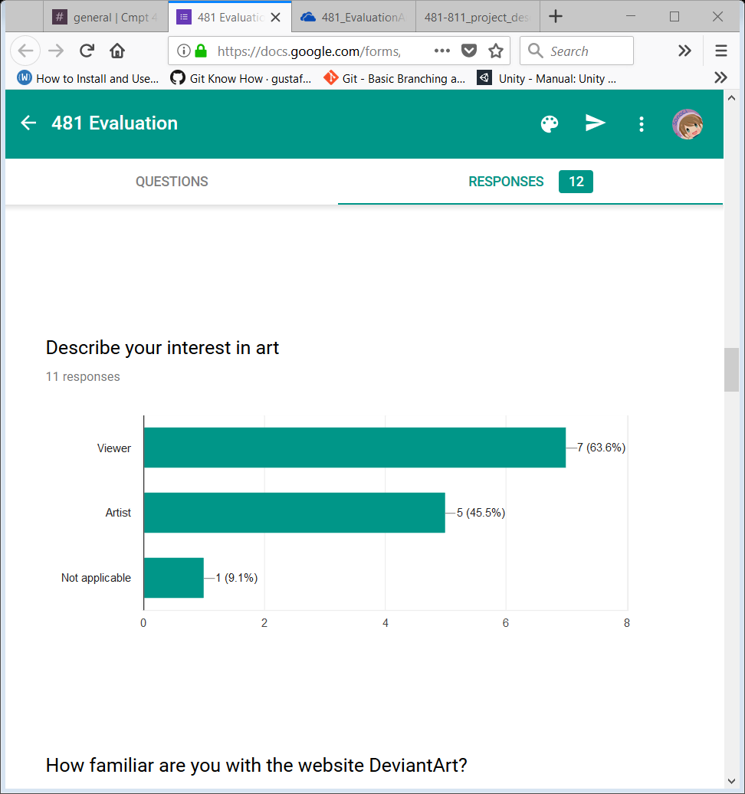
   2. WILL HAVE TO LOOK AT INDIVIDUAL FORMS TO GET MORE INFO
10. How familiar are you with DA?
    1. 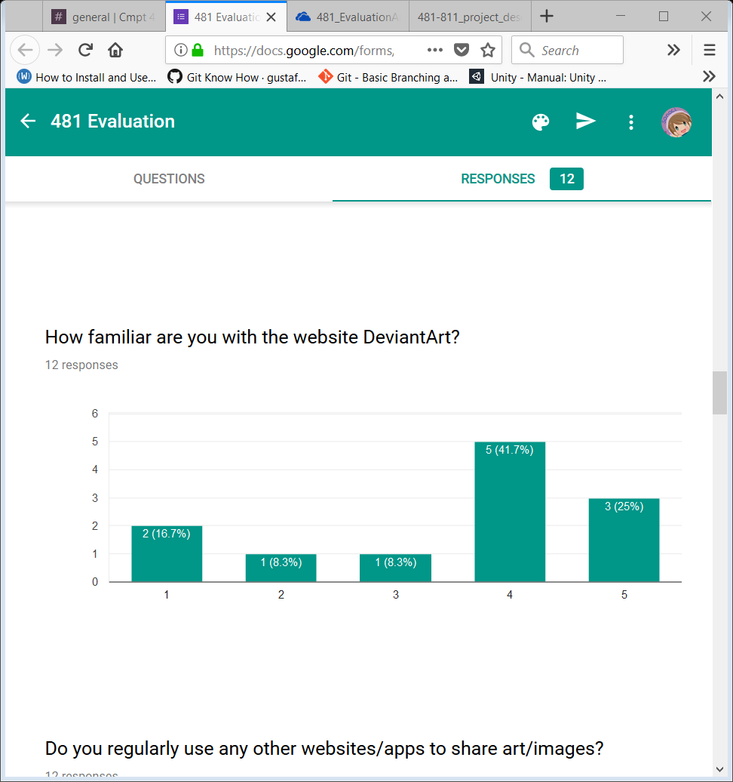
    2. AVERAGE: 3.5
11. Do you regularly use any other websites/apps to share art/images?
    1. 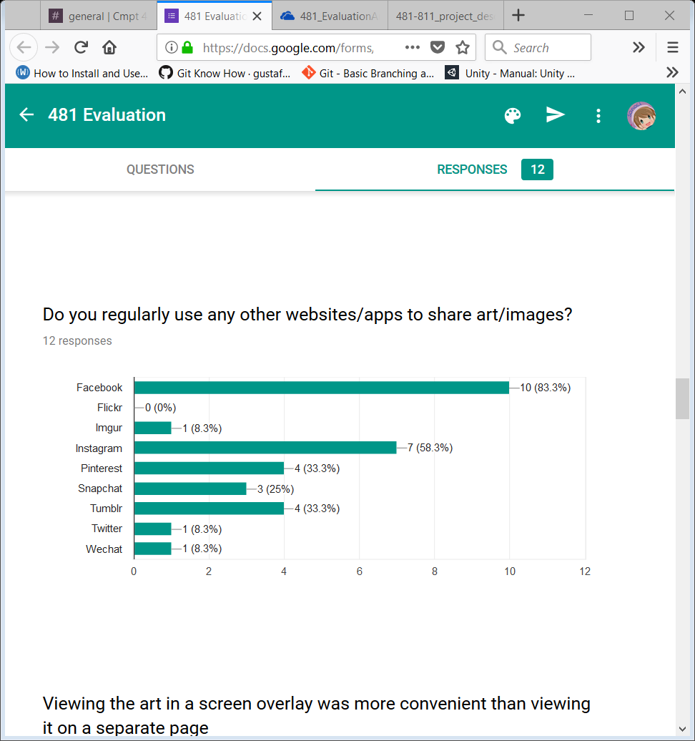
12. Viewing art in a screen overlay was more convenient than viewing it on a separate page:
    1. 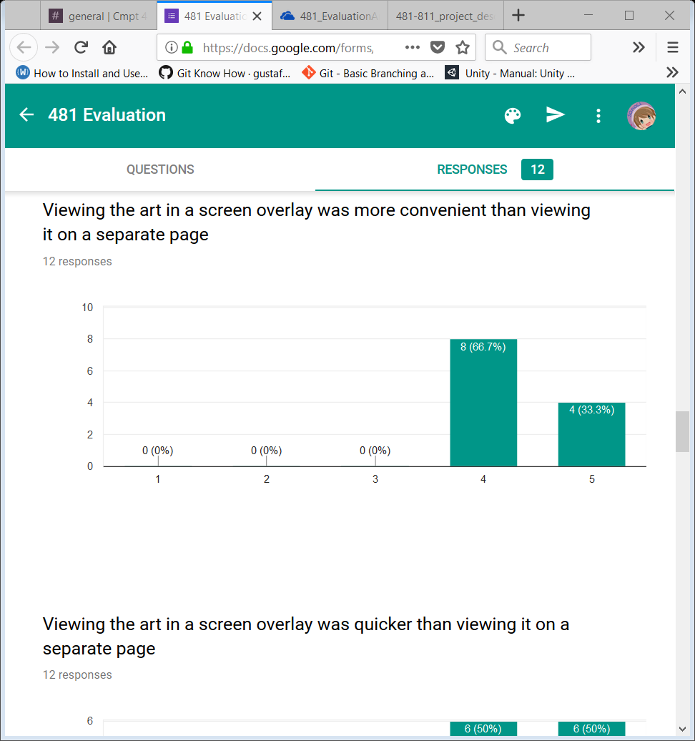
    2. AVERAGE: 4.333
13. Viewing the art in a screen overlay was quicker than viewing it on a separate page:
    1. 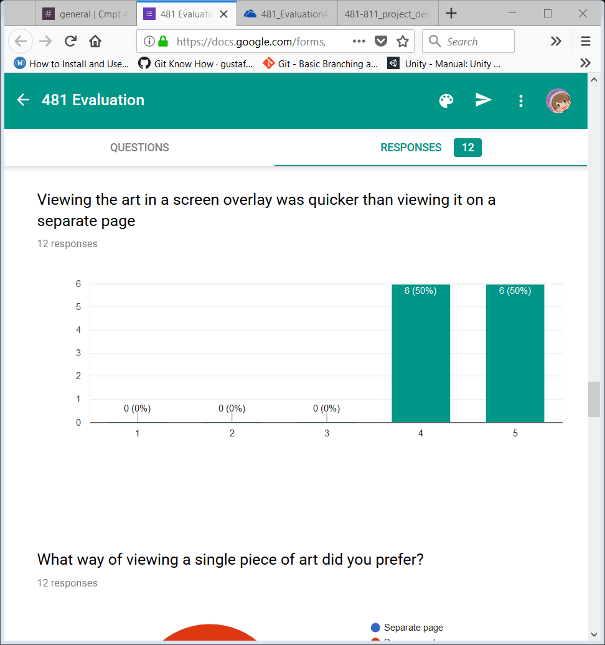
    2. AVERAGE: 4.5
14. What way of viewing a single piece of art did you prefer?
    1. 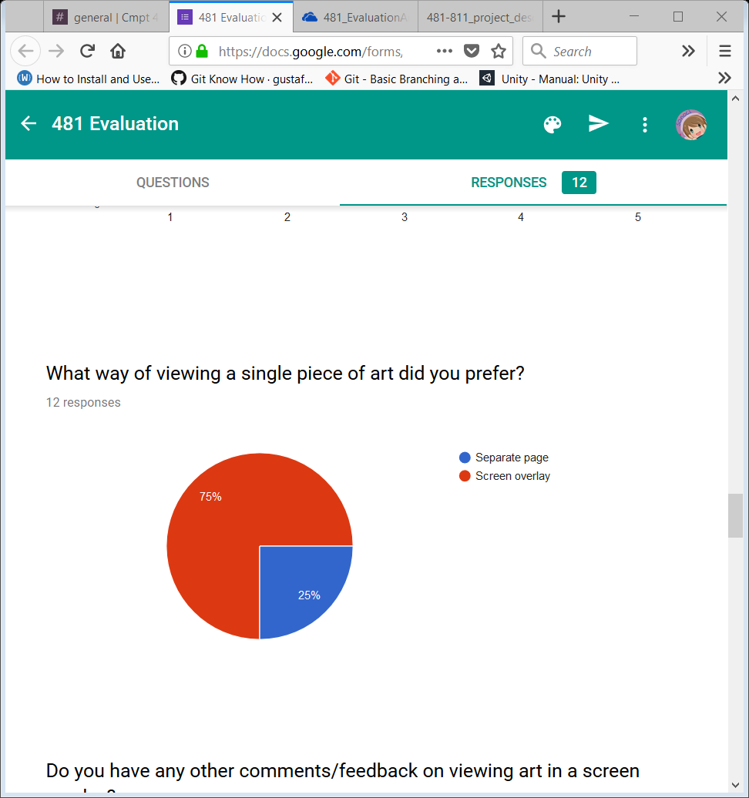
    2. POINT OF INTEREST: while EVERYONE said that the overlay was quicker/convenient, some preferred a separate page. Look into this!
15. Do you have any other comments/feedback on viewing art in a screen overlay?
    1. It's nice how we don't have to wait for the page to reload.
    2. It was a neat thing and handy that you wouldn't loose your place like you normally do in deviantart.
    3. I like this way, it's similar to using Facebook. Also it's very new to have a queue for user to layout the picture they like. May be you can have something that add all the pictures in the queue to user favorite function.
16. Adding art to the queue was straightforward:
    1. 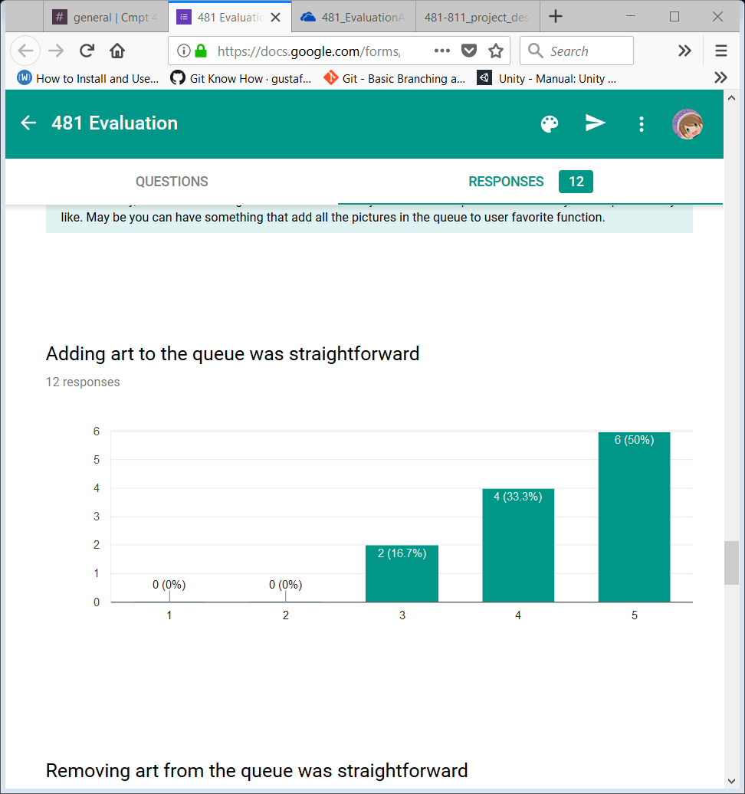
    2. AVERAGE: 4.333
17. Removing art from the queue was straightforward
    1. 
    2. AVERAGE: 4.333
18. Viewing the art in the queue was straightforward:
    1. 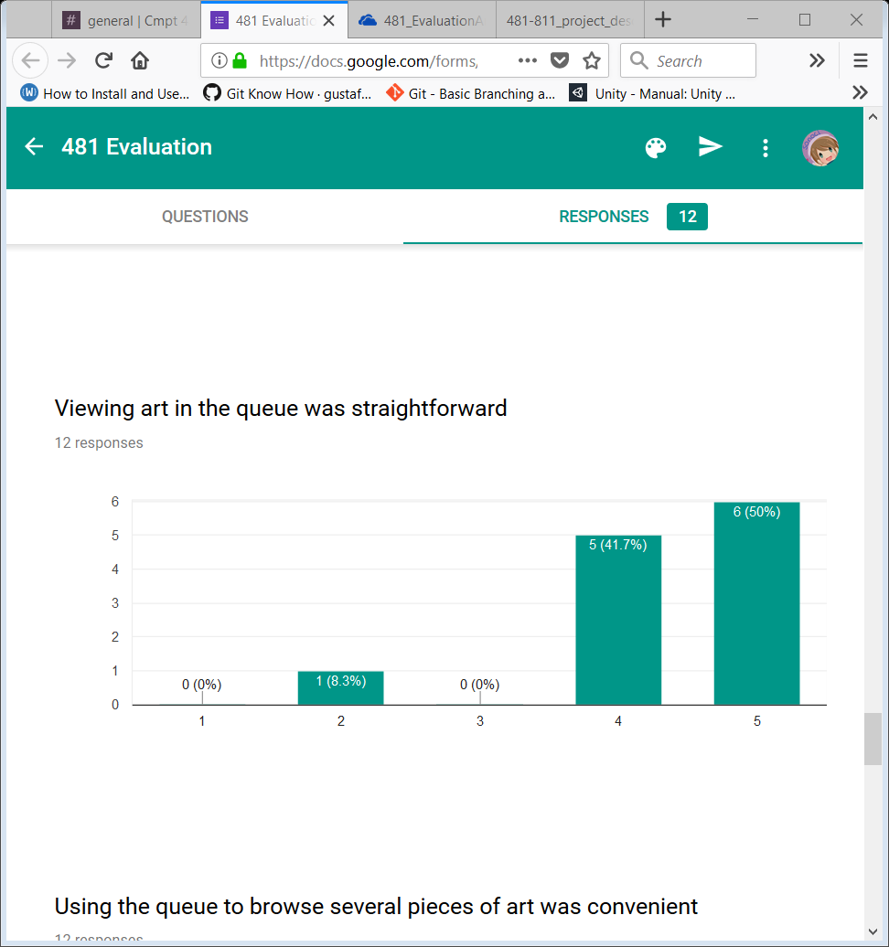
    2. AVERAGE: 4.333
19. Using the queue to browse several pieces of art was convenient:
    1. 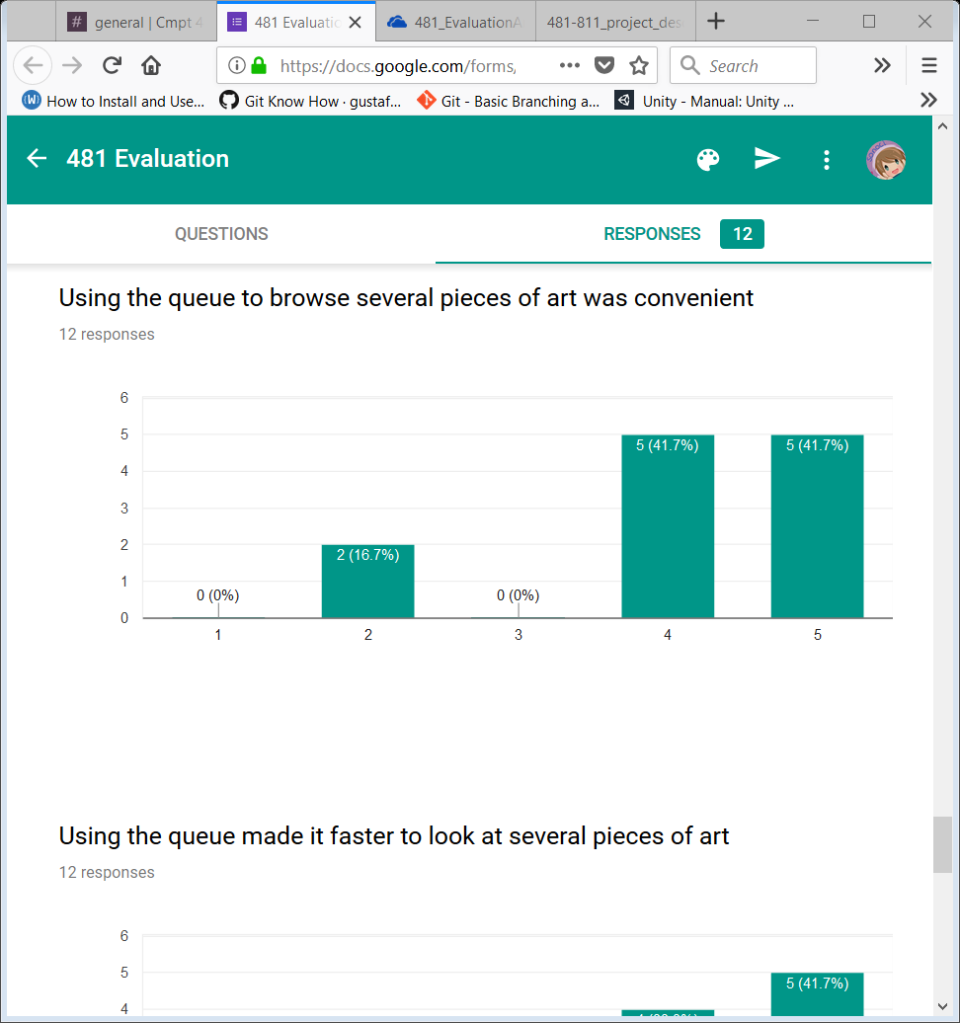
    2. AVERAGE: 4.083
20. Using the queue made it faster to look at several pieces of art:
    1. 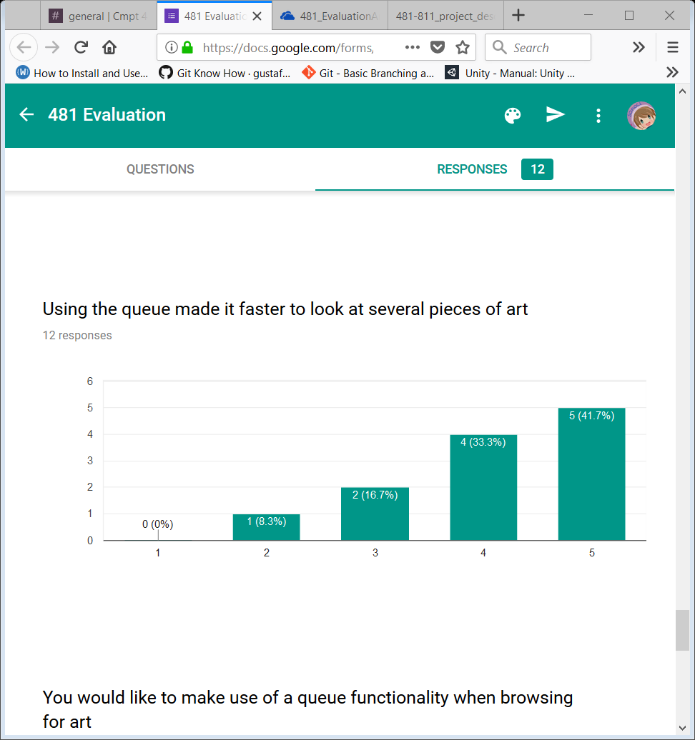
    2. AVERAGE: 4.083
21. You would like to make use of a queue functionality when browsing for art:
    1. 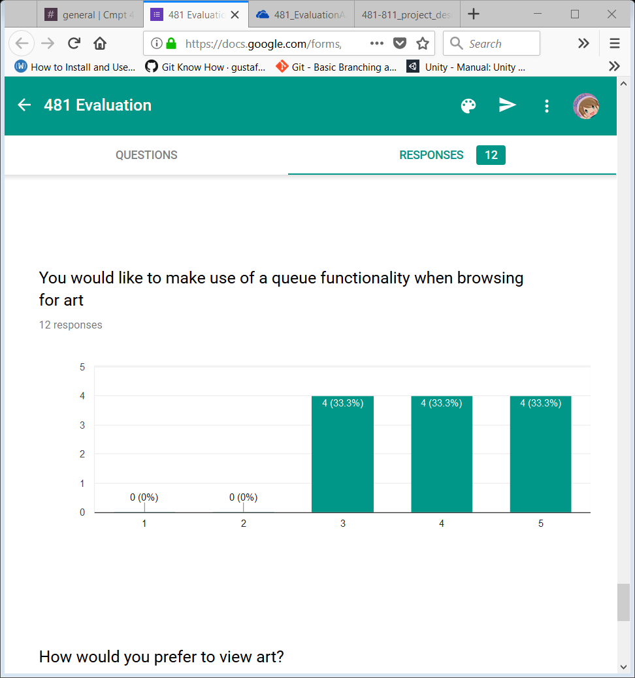
    2. AVERAGE: 4
22. How would you prefer to view art?
    1. 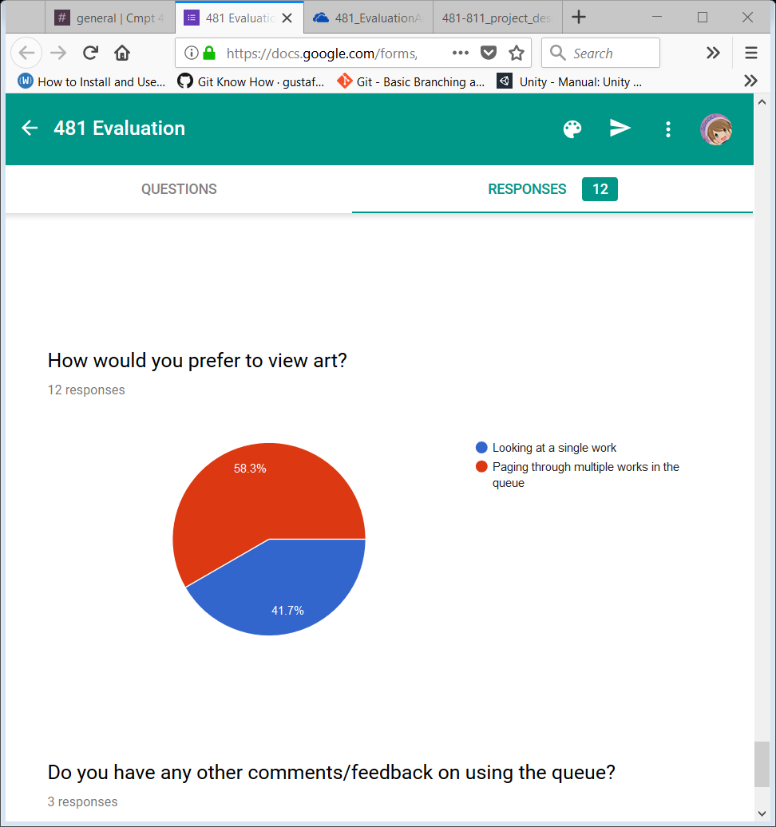
    2. More people are preferring the single page view here with the queue than above, check to see if those who preferred it above all answered the same, and who answered differently here.
23. Do you have any other comments/feedback on using the queue?
    1. me likes :)
    2. Clear takes away all of the added art in the queue. There should be an option for clearing couple of items in the queue instead of clearing all.
    3. Could be hidden when the user is not using.

