Appendix WIP

A1: Evaluation Instruments

We used a google form questionnaire that displayed to the users like this:

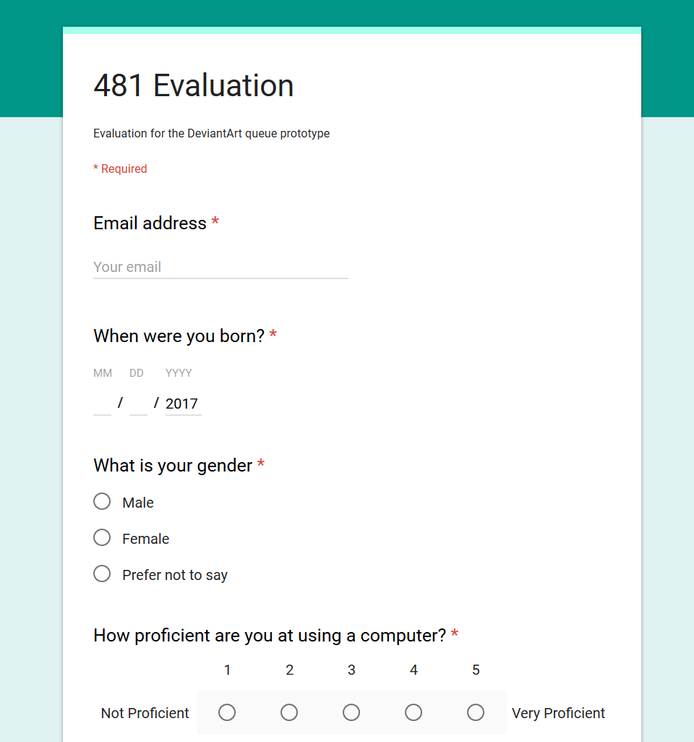

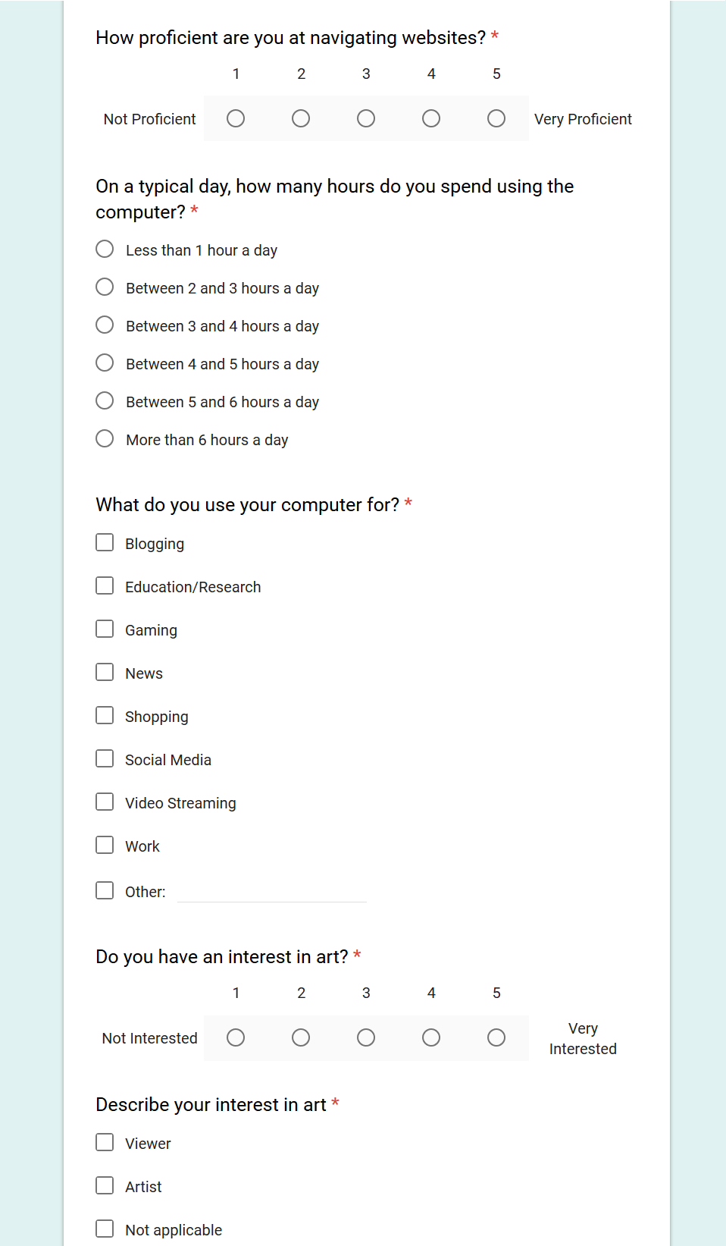

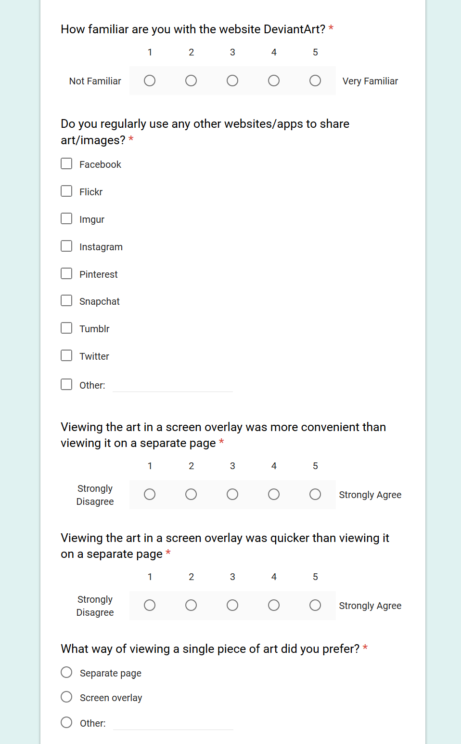

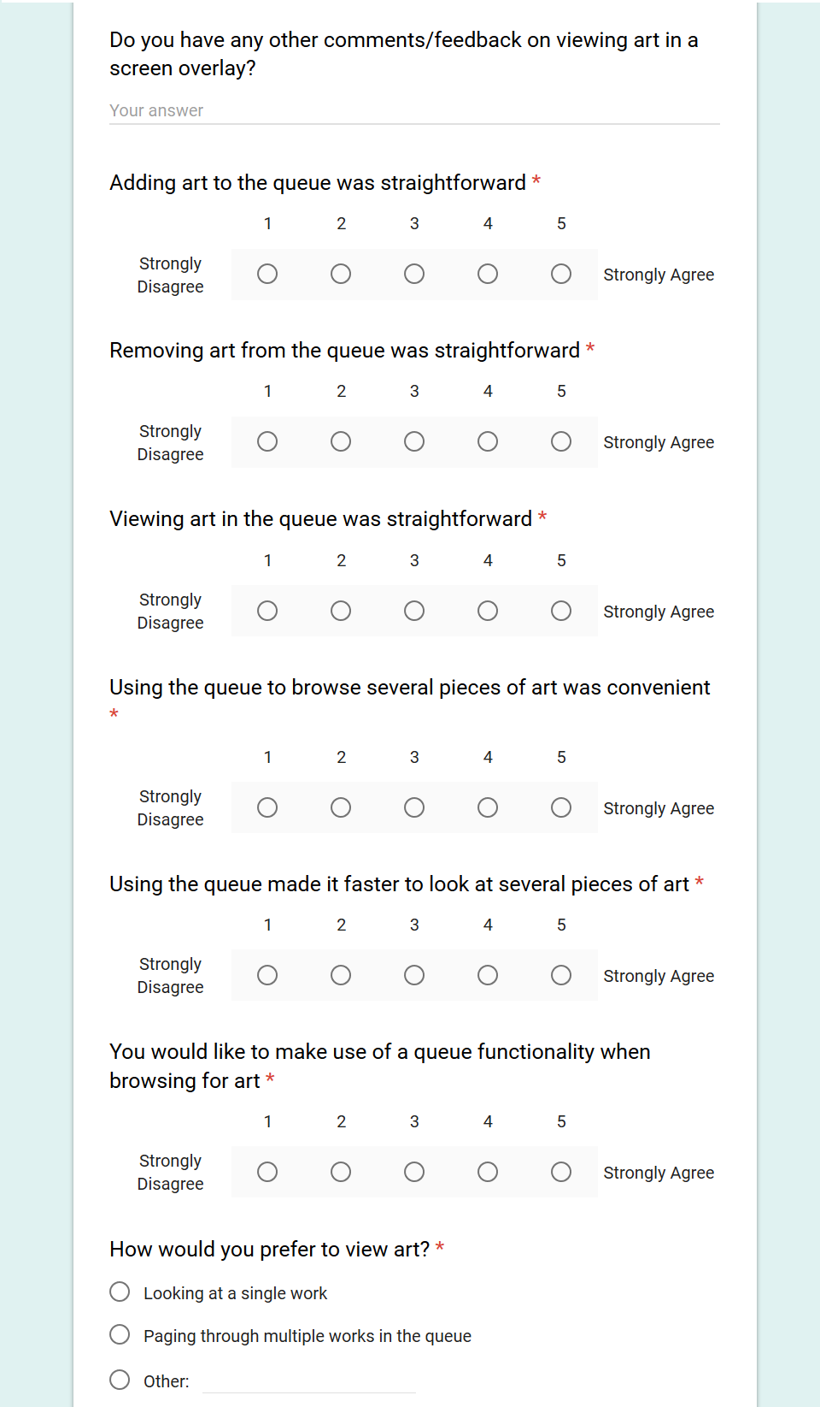

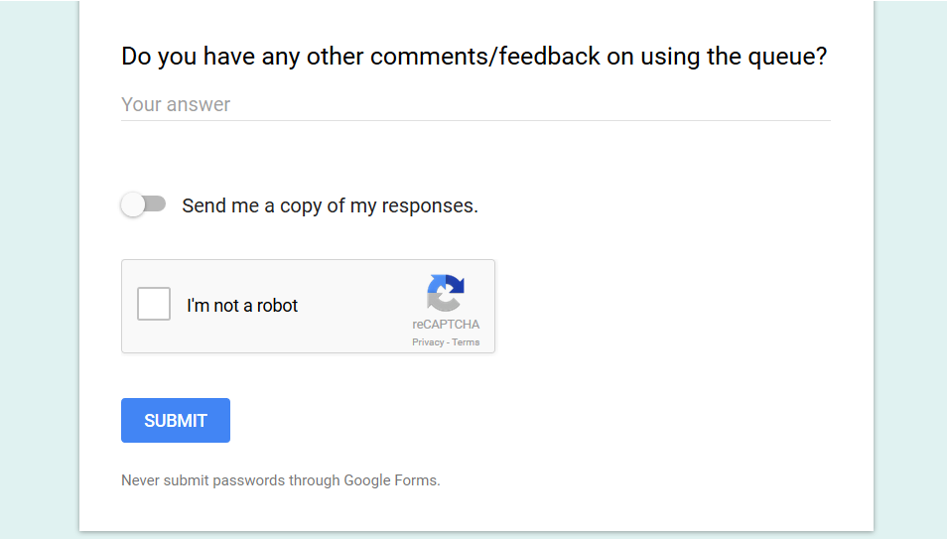

A2: Raw Data

|  |  |  |  |  |
| --- | --- | --- | --- | --- |
| **Username** | **When were you born?** | **What is your gender** | **How proficient are you at using a computer?** | **How proficient are you at navigating websites?** |
|  | 1994-09-27 |  | 4 | 5 |
|  | 1997-03-07 | Female | 4 | 4 |
|  | 1995-03-07 | Female | 4 | 5 |
|  | 1995-01-26 | Male | 3 | 4 |
|  | 1997-11-14 | Female | 3 | 4 |
|  | 1996-06-02 | Male | 5 | 5 |
| hanhtrang.phan@gmail.com | 1995-09-01 | Female | 3 | 2 |
| keh029@mail.usask.ca | 1990-07-08 | Male | 5 | 5 |
| adg407@mail.usask.ca | 2017-02-14 | Female | 5 | 4 |
| baljinder.bhinder@gmail.com | 1996-04-25 | Female | 5 | 5 |
| cchesheng@gmail.com | 2017-10-01 | Female | 5 | 3 |
| 1197950276cc@gmail.com | 1994-10-08 | Male | 3 | 4 |

|  |  |  |  |
| --- | --- | --- | --- |
| **On a typical day, how many hours do you spend using the computer?** | **What do you use your computer for?** | **Do you have an interest in art?** | **Describe your interest in art** |
| More than 6 hours a day | Education/Research;Gaming;Shopping;Social Media;Video Streaming | 3 |  |
| Between 5 and 6 hours a day | Education/Research;Gaming;News;Social Media;Video Streaming;Work | 5 | Viewer;Artist |
| More than 6 hours a day | Blogging;Education/Research;Gaming;News;Shopping;Social Media;Video Streaming | 4 | Viewer;Artist |
| Between 3 and 4 hours a day | Education/Research;Gaming;Shopping;Social Media | 5 | Not applicable |
| More than 6 hours a day | Education/Research;Social Media;Video Streaming | 4 | Viewer |
| More than 6 hours a day | Education/Research;Gaming;News;Social Media;Video Streaming | 3 | Viewer |
| Between 3 and 4 hours a day | Education/Research;Shopping;Social Media;Work | 3 | Viewer |
| More than 6 hours a day | Education/Research;Gaming;Shopping;Social Media;Video Streaming;Work | 2 | Viewer |
| Between 5 and 6 hours a day | Education/Research;Gaming;Shopping;Social Media;Video Streaming;Work | 5 | Artist |
| Between 4 and 5 hours a day | Education/Research;Gaming;Social Media | 5 | Artist |
| More than 6 hours a day | Shopping;Social Media;Video Streaming;Work | 4 | Viewer |
| Between 4 and 5 hours a day | Education/Research;Gaming;News;Shopping;Social Media;Video Streaming | 5 | Artist |

|  |  |  |
| --- | --- | --- |
| **How familiar are you with the website DeviantArt?** | **Do you regularly use any other websites/apps to share art/images?** | **Viewing the art in a screen overlay was more convenient than viewing it on a separate page** |
| 5 | Facebook;Instagram;Pinterest;Snapchat;Twitter | 4 |
| 4 | Facebook;Pinterest;Tumblr | 4 |
| 5 | Facebook;Instagram;Pinterest;Tumblr | 4 |
| 5 | Facebook | 4 |
| 4 | Facebook;Snapchat;Tumblr | 5 |
| 3 | Facebook;Imgur | 4 |
| 1 | Facebook;Instagram | 5 |
| 4 | Facebook;Instagram | 4 |
| 4 | Facebook;Pinterest;Tumblr | 5 |
| 4 | Instagram;Snapchat | 5 |
| 2 | Instagram | 4 |
| 1 | Facebook;Instagram;Wechat | 4 |

|  |  |  |  |
| --- | --- | --- | --- |
| **Viewing the art in a screen overlay was quicker than viewing it on a separate page** | **What way of viewing a single piece of art did you prefer?** | **Do you have any other comments/feedback on viewing art in a screen overlay?** | **Adding art to the queue was straightforward** |
| 4 | Separate page |  | 5 |
| 5 | Screen overlay |  | 5 |
| 4 | Screen overlay |  | 4 |
| 4 | Screen overlay |  | 3 |
| 5 | Screen overlay |  | 5 |
| 4 | Screen overlay | It's nice how we don't have to wait for the page to reload. | 5 |
| 5 | Screen overlay |  | 4 |
| 5 | Screen overlay |  | 5 |
| 4 | Separate page | It was a neat thing and handy that you wouldn't loose your place like you normally do in deviantart. | 4 |
| 5 | Screen overlay |  | 5 |
| 5 | Screen overlay | I like this way, it's similar to using Facebook. Also it's very new to have a queue for user to layout the picture they like. May be you can have something that add all the pictures in the queue to user favorite function. | 4 |
| 4 | Separate page |  | 3 |

|  |  |  |  |
| --- | --- | --- | --- |
| **Removing art from the queue was straightforward** | **Viewing art in the queue was straightforward** | **Using the queue to browse several pieces of art was convenient** | **Using the queue made it faster to look at several pieces of art** |
| 5 | 5 | 4 | 4 |
| 5 | 5 | 5 | 5 |
| 4 | 5 | 4 | 4 |
| 4 | 4 | 2 | 2 |
| 5 | 5 | 4 | 3 |
| 4 | 4 | 4 | 5 |
| 4 | 4 | 5 | 5 |
| 5 | 5 | 2 | 4 |
| 3 | 4 | 5 | 4 |
| 5 | 5 | 5 | 5 |
| 5 | 4 | 5 | 5 |
| 3 | 2 | 4 | 3 |

|  |  |  |
| --- | --- | --- |
| **You would like to make use of a queue functionality when browsing for art** | **How would you prefer to view art?** | **Do you have any other comments/feedback on using the queue?** |
| 3 | Looking at a single work |  |
| 4 | Paging through multiple works in the queue | me likes :) |
| 4 | Paging through multiple works in the queue |  |
| 3 | Looking at a single work |  |
| 3 | Looking at a single work |  |
| 4 | Looking at a single work |  |
| 5 | Paging through multiple works in the queue |  |
| 5 | Paging through multiple works in the queue |  |
| 5 | Paging through multiple works in the queue |  |
| 5 | Paging through multiple works in the queue | Clear takes away all of the added art in the queue. There should be an option for clearing couple of items in the queue instead of clearing all. |
| 4 | Paging through multiple works in the queue | Could be hidden when the user is not using. |
| 3 | Looking at a single work |  |

A3: Supplementary analysis

1. Emails
   1. 8 people put their email in, apparently we’re waiting for one of their responses? The other 6 were the first evaluations before the email part was added
2. When were you born
   1. July 8, 1990; September 27, 1994; October 8, 1994; January 26, 1995; March 7, 1995; September 1, 1995; April 25, 1996; June 2, 1996; March 7, 1997; November 14, 1997
   2. AND two people that mistakenly put 2017 as their year;;;;
   3. AVERAGE: 22.1
3. Gender
   1. 7 females (+1 for the person who didn’t answer) -> 66.7%
   2. 4 males -> 33.3%
4. How proficient at using a computer?
   1. 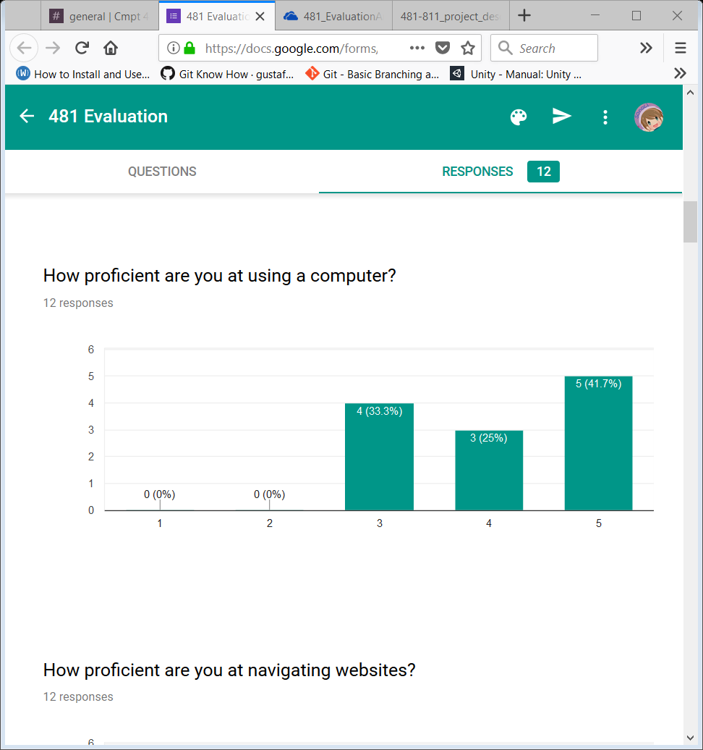
   2. AVERAGE: 4.083
5. How proficient at navigating websites?
   1. 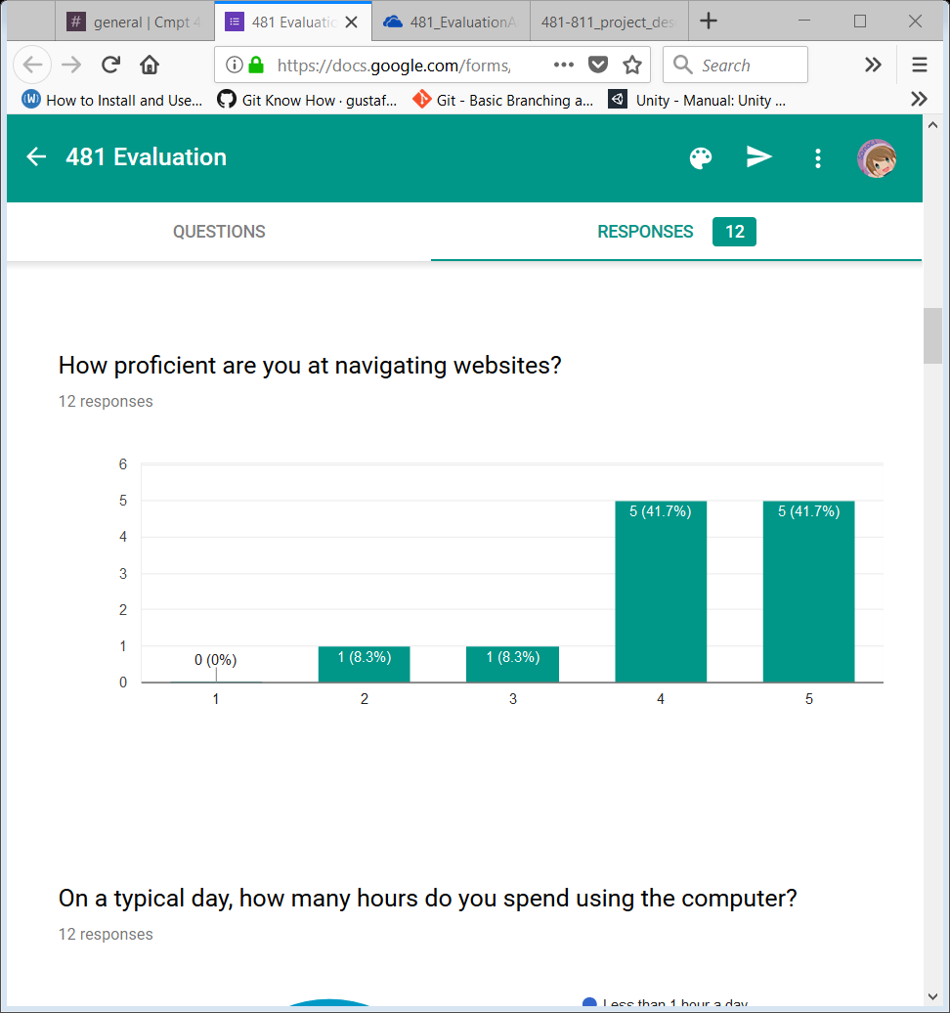
   2. AVERAGE: 4.167
6. On typical day, how many hours spent on computer?
   1. 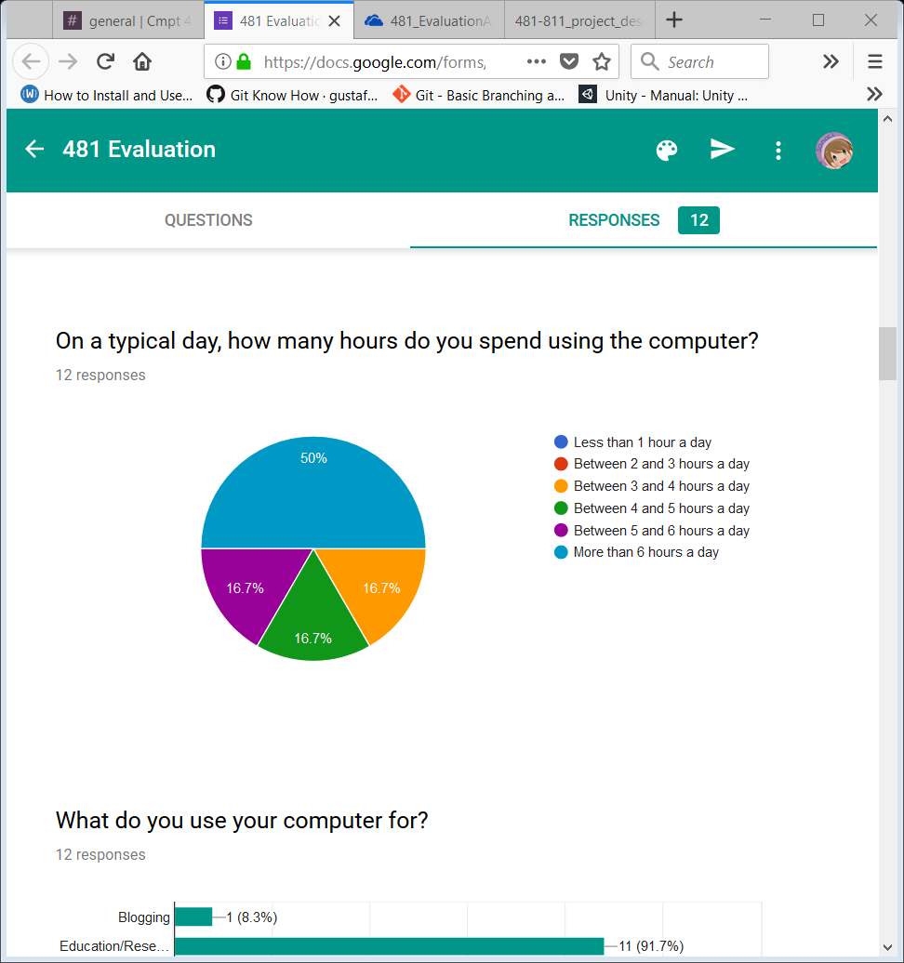
   2. AVERAGE: ~5.5 hours a day
7. What do you use your computer for?
   1. 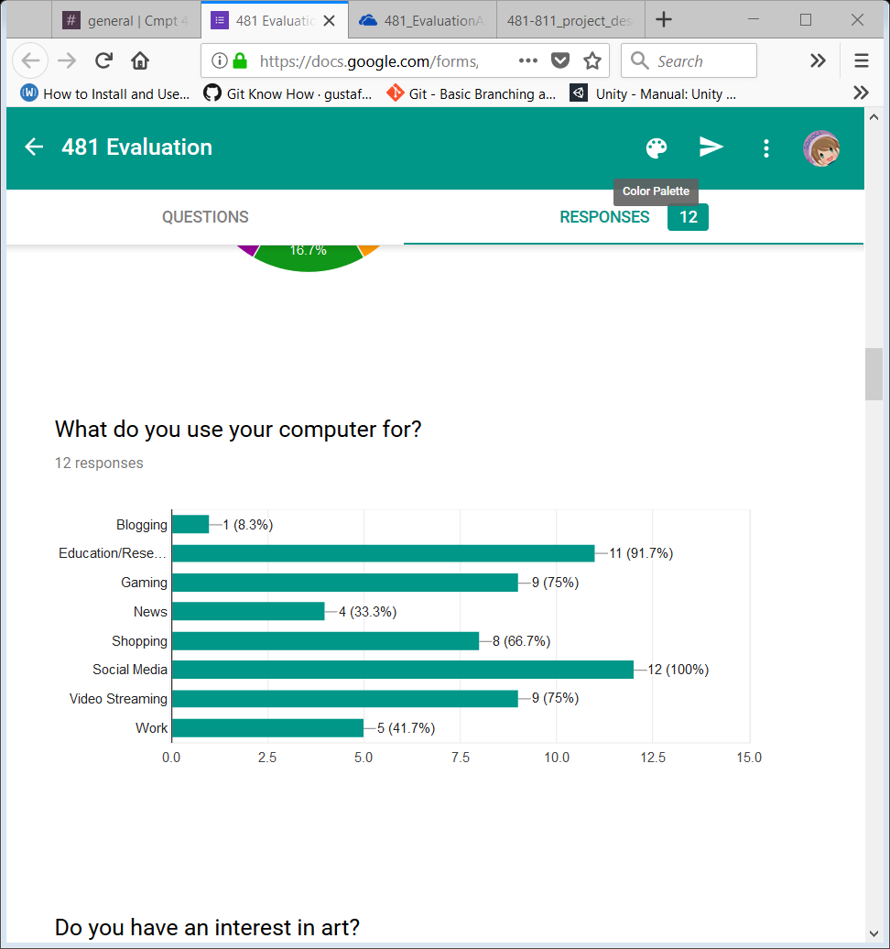
8. Do you have an interest in art?
   1. 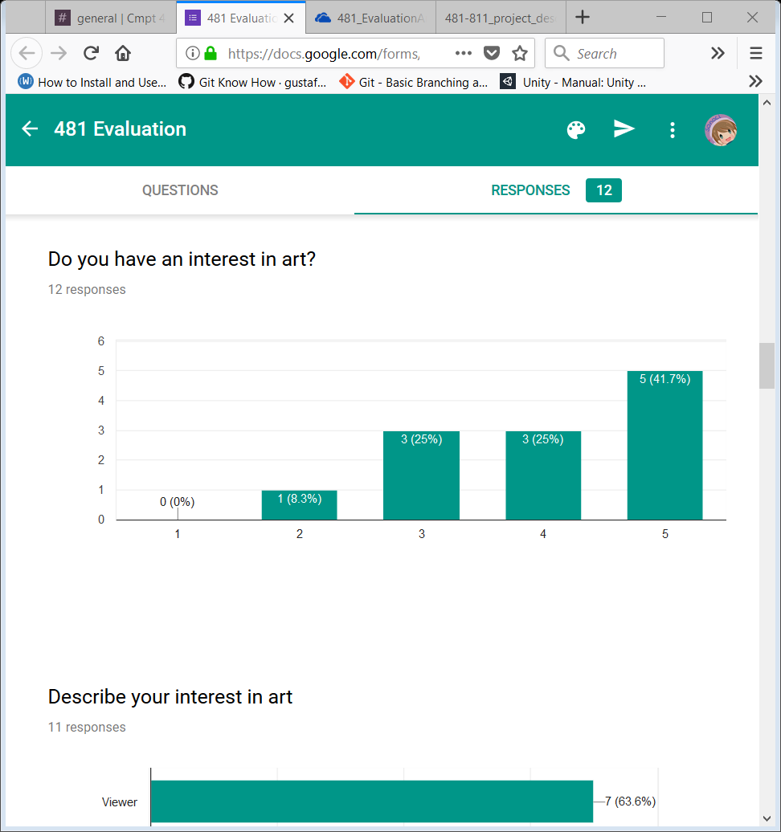
   2. AVERAGE: 4
9. Describe your interest in art (only 11 people answered this one)
   1. 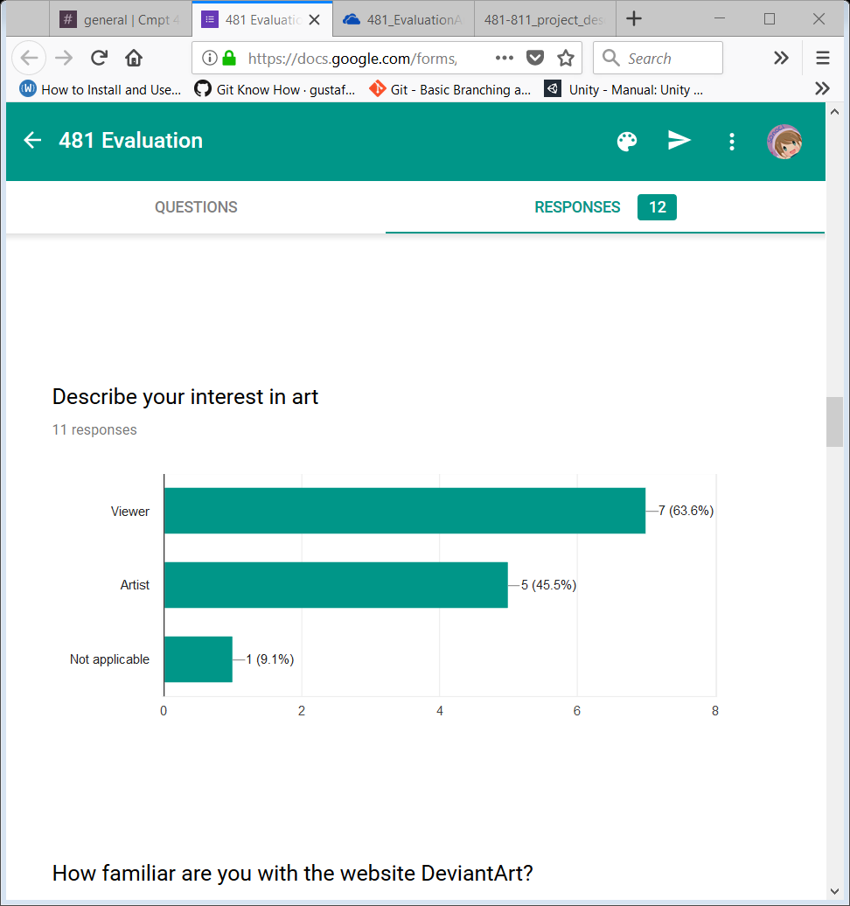
   2. WILL HAVE TO LOOK AT INDIVIDUAL FORMS TO GET MORE INFO
10. How familiar are you with DA?
    1. 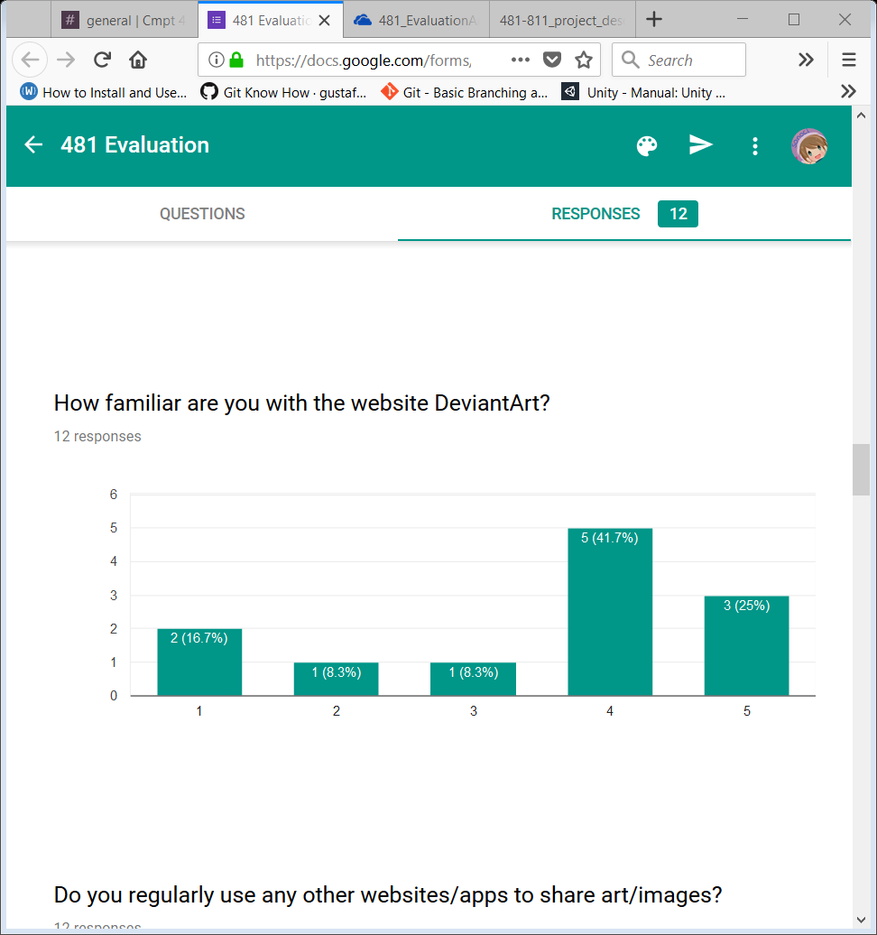
    2. AVERAGE: 3.5
11. Do you regularly use any other websites/apps to share art/images?
    1. 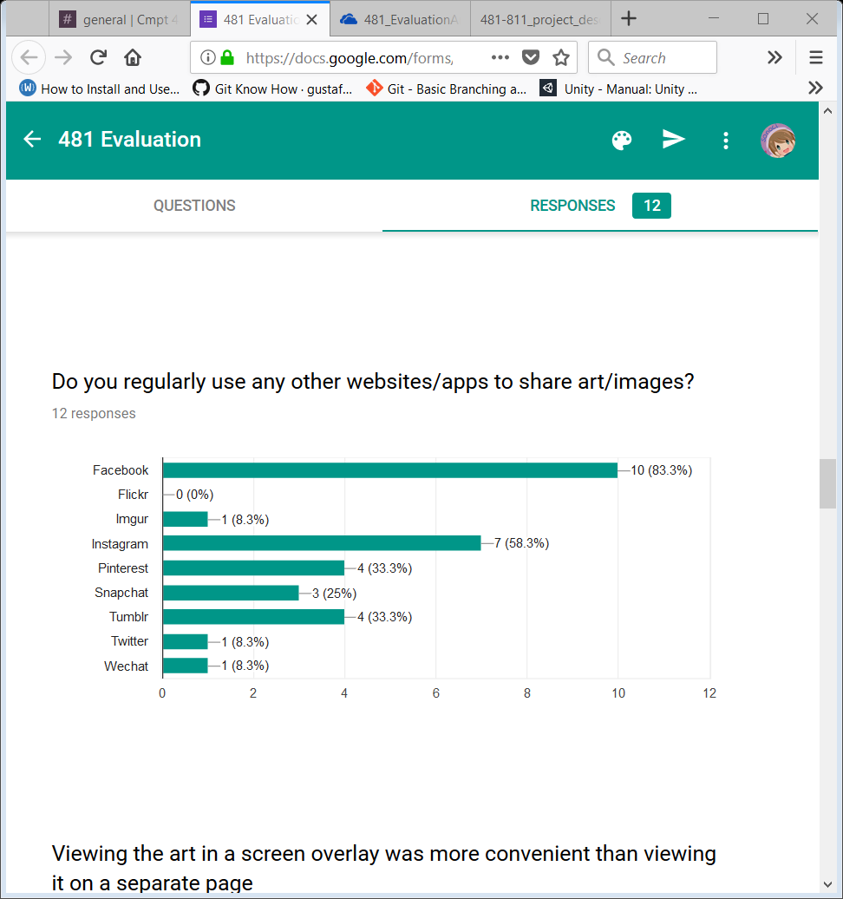
12. Viewing art in a screen overlay was more convenient than viewing it on a separate page:
    1. 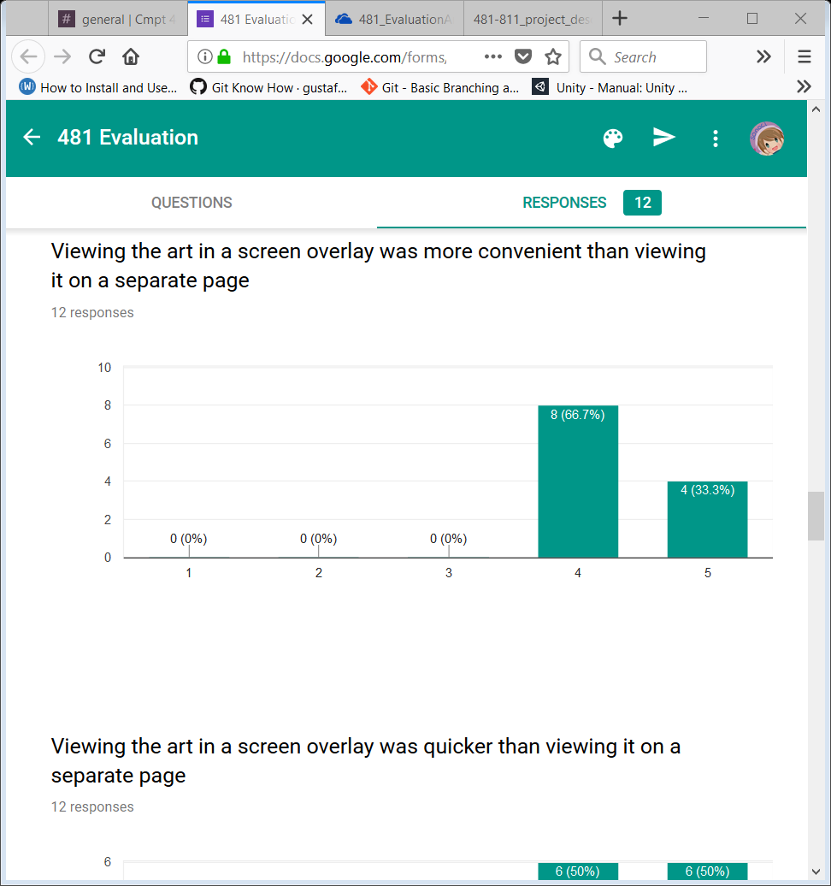
    2. AVERAGE: 4.333
13. Viewing the art in a screen overlay was quicker than viewing it on a separate page:
    1. 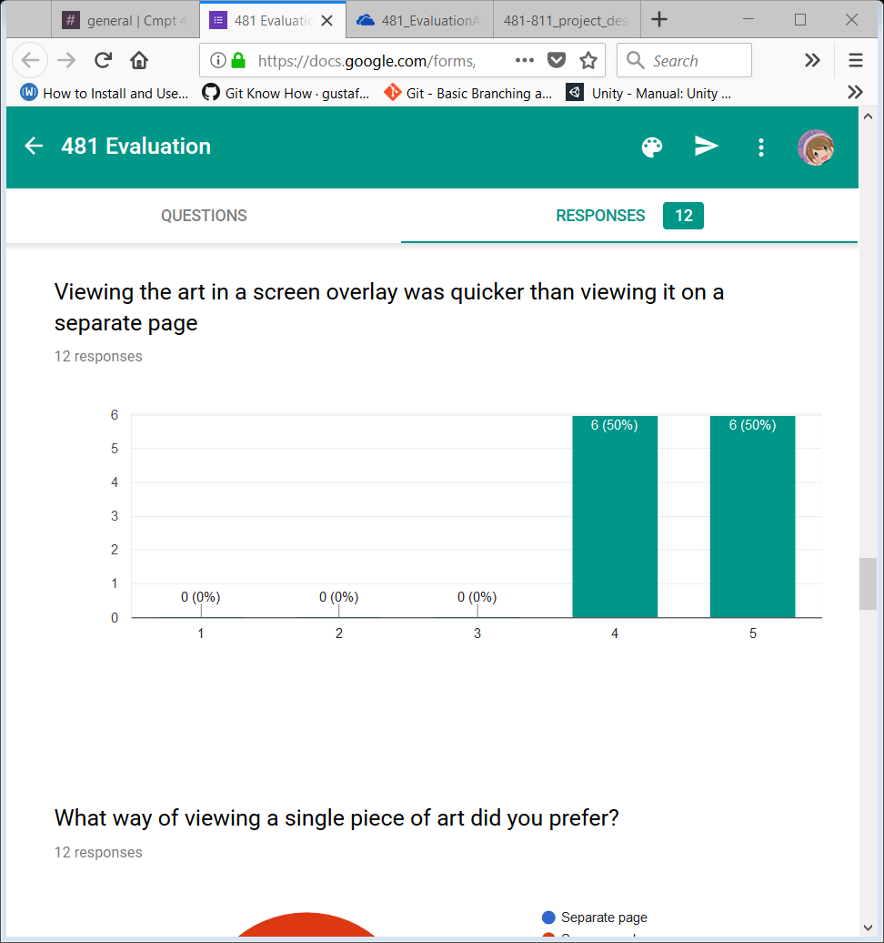
    2. AVERAGE: 4.5
14. What way of viewing a single piece of art did you prefer?
    1. 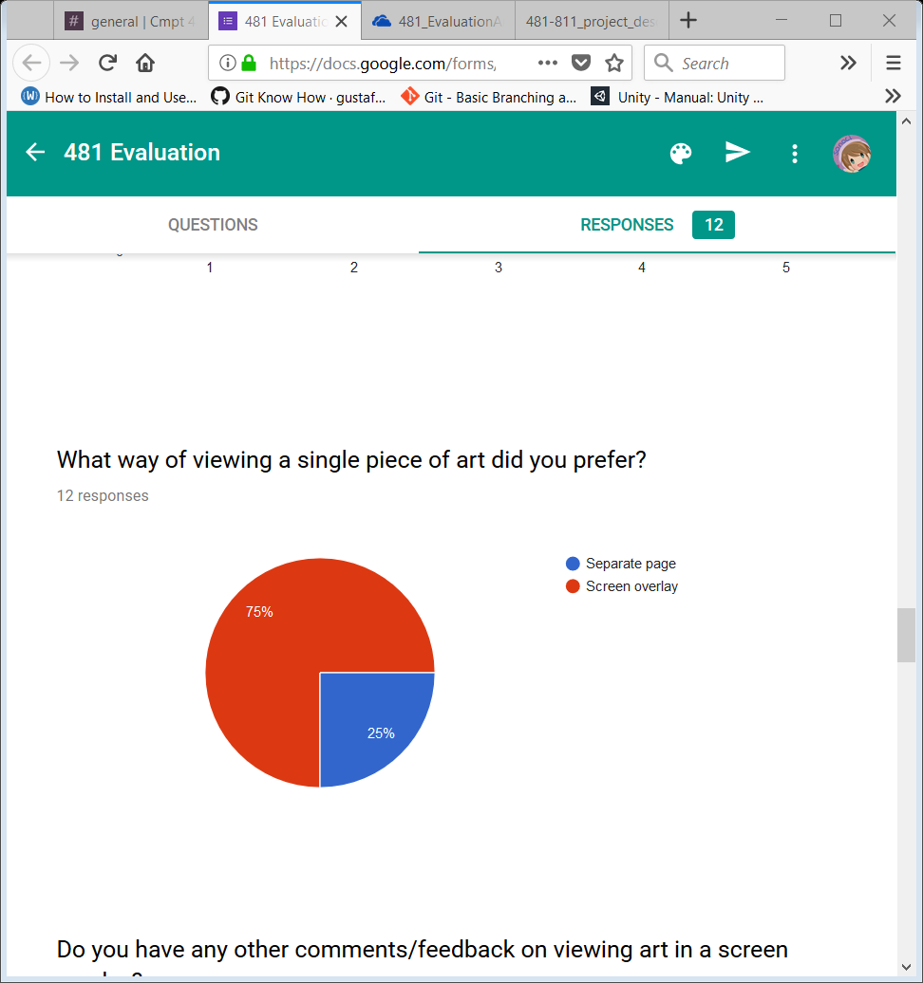
    2. POINT OF INTEREST: while EVERYONE said that the overlay was quicker/convenient, some preferred a separate page. Look into this!
15. Do you have any other comments/feedback on viewing art in a screen overlay?
    1. It's nice how we don't have to wait for the page to reload.
    2. It was a neat thing and handy that you wouldn't loose your place like you normally do in deviantart.
    3. I like this way, it's similar to using Facebook. Also it's very new to have a queue for user to layout the picture they like. May be you can have something that add all the pictures in the queue to user favorite function.
16. Adding art to the queue was straightforward:
    1. 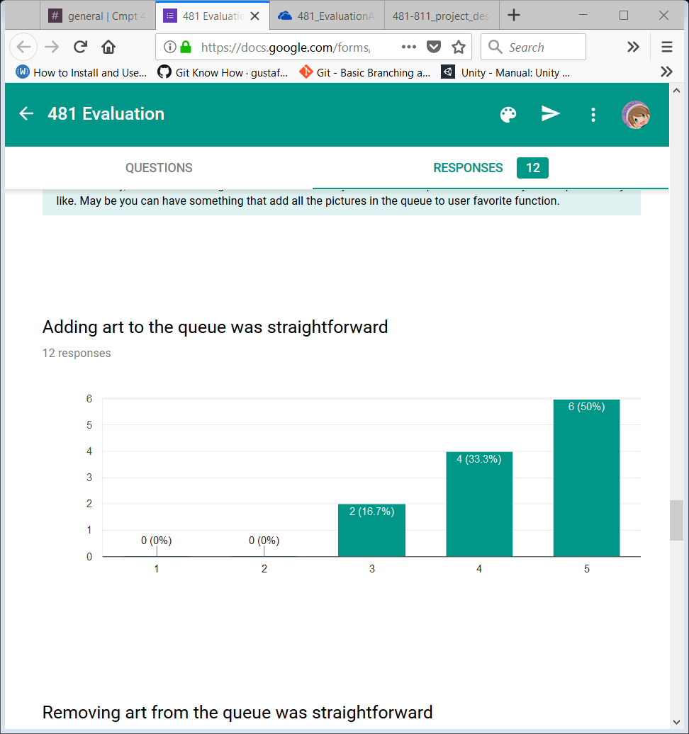
    2. AVERAGE: 4.333
17. Removing art from the queue was straightforward
    1. 
    2. AVERAGE: 4.333
18. Viewing the art in the queue was straightforward:
    1. 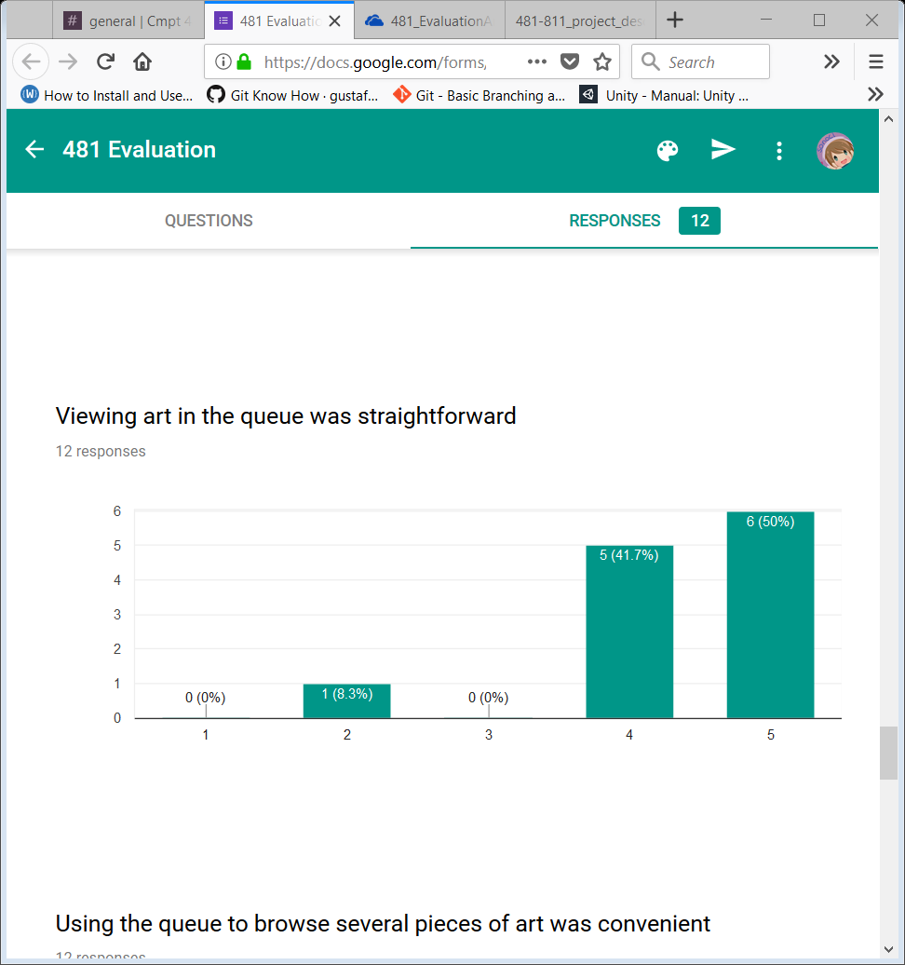
    2. AVERAGE: 4.333
19. Using the queue to browse several pieces of art was convenient:
    1. 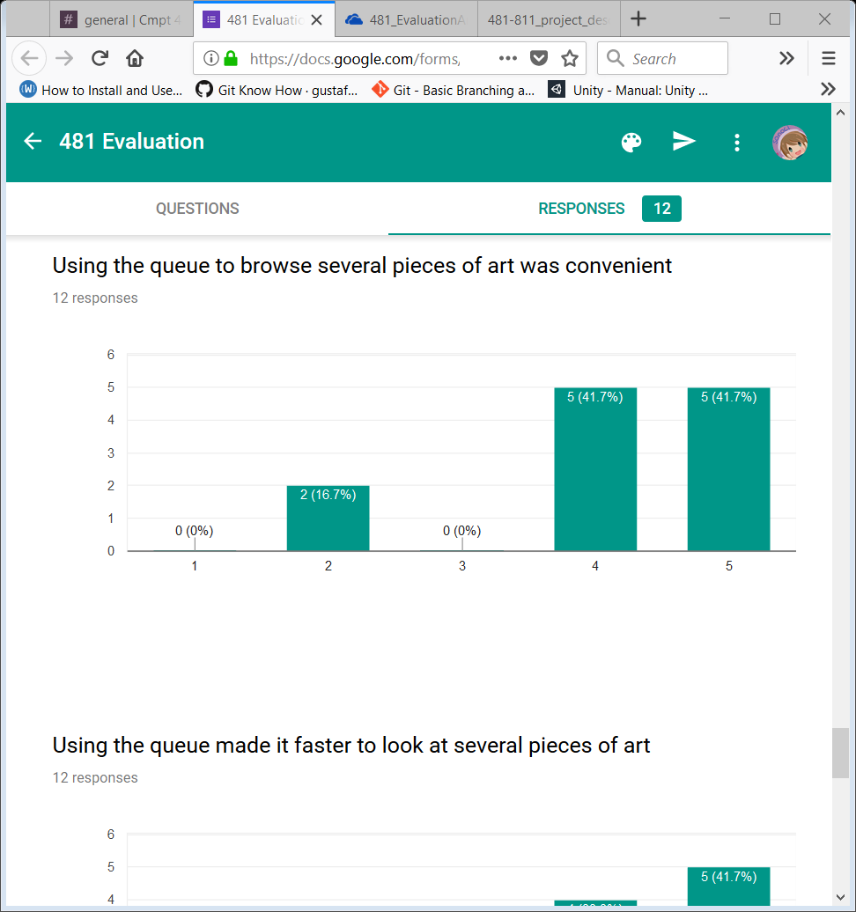
    2. AVERAGE: 4.083
20. Using the queue made it faster to look at several pieces of art:
    1. 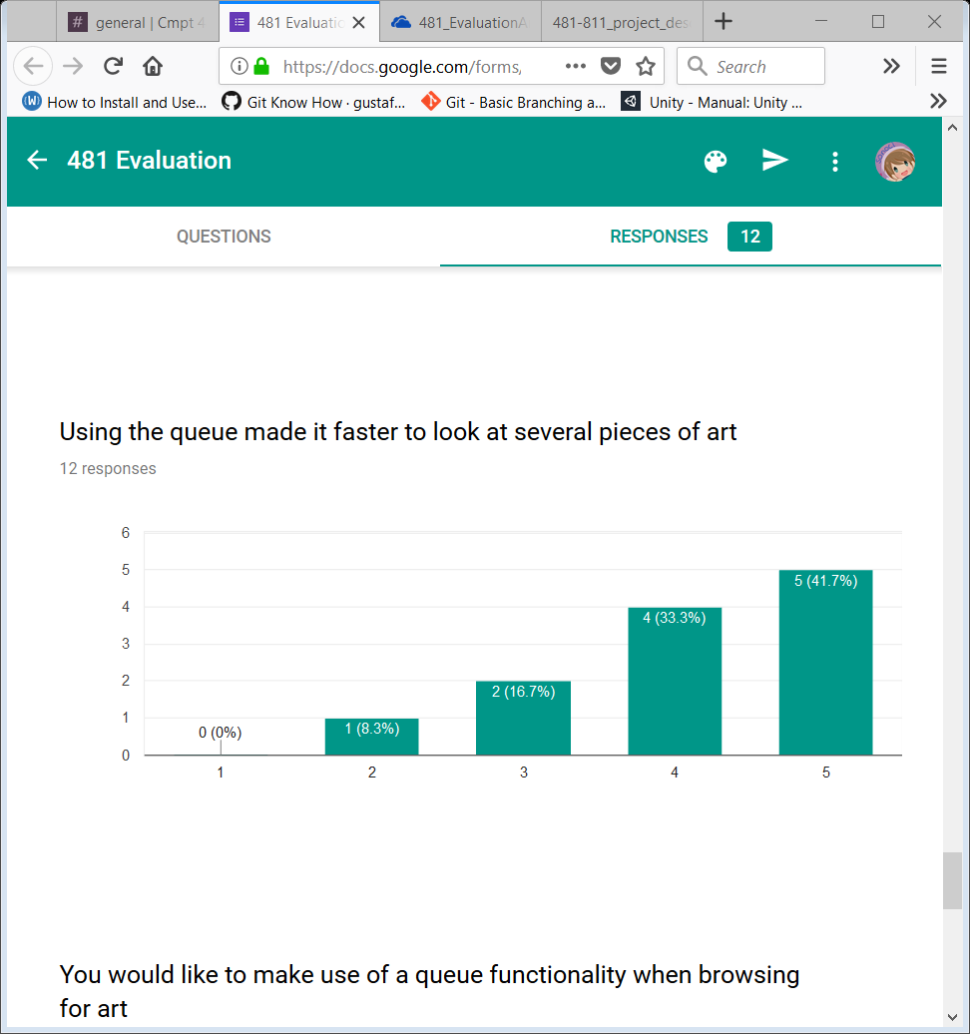
    2. AVERAGE: 4.083
21. You would like to make use of a queue functionality when browsing for art:
    1. 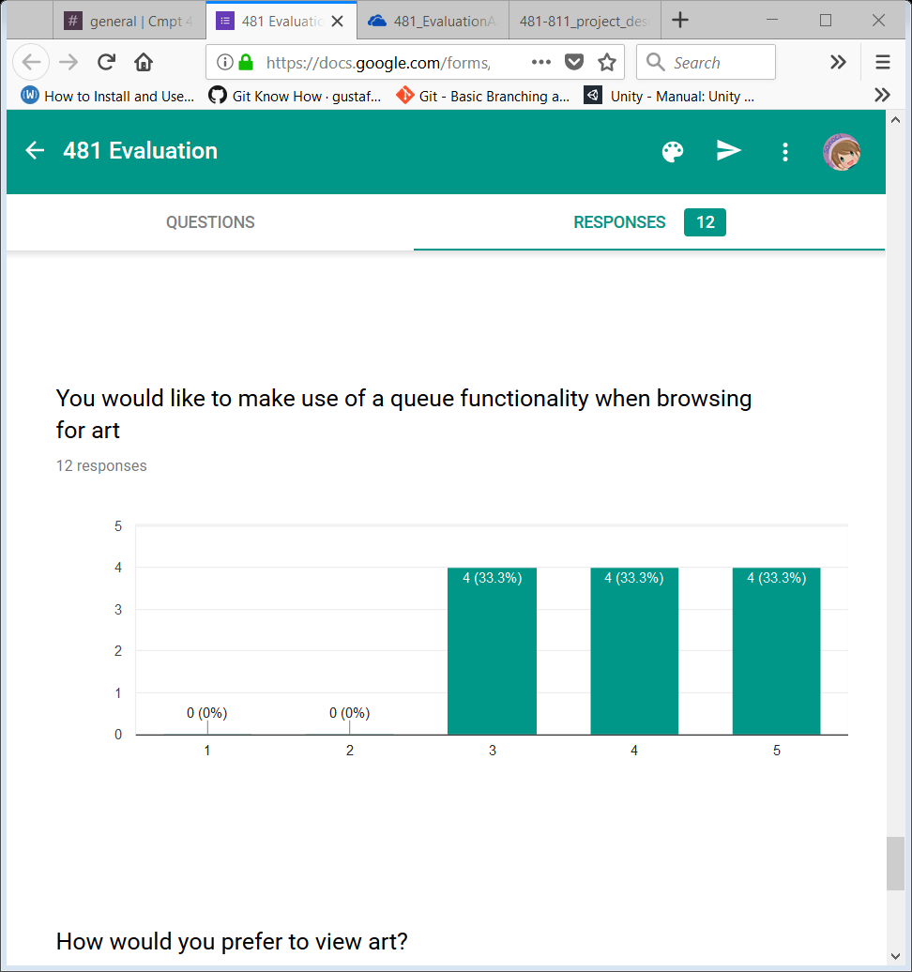
    2. AVERAGE: 4
22. How would you prefer to view art?
    1. 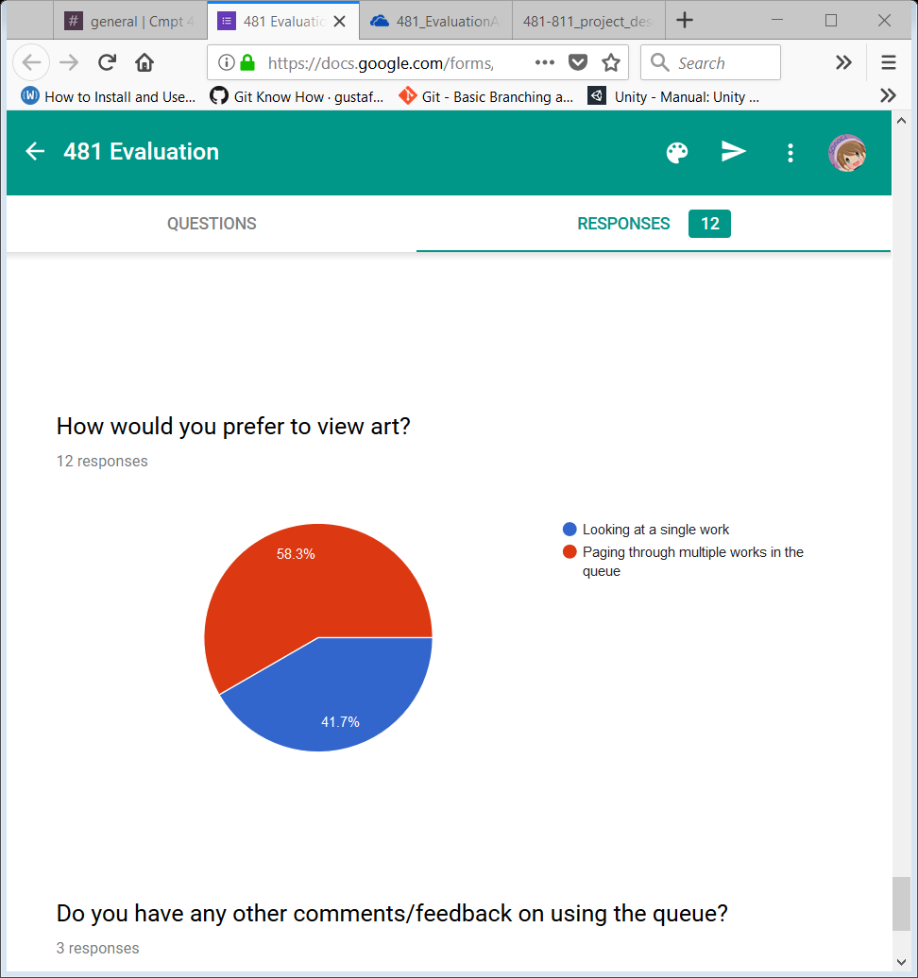
    2. More people are preferring the single page view here with the queue than above, check to see if those who preferred it above all answered the same, and who answered differently here.
23. Do you have any other comments/feedback on using the queue?
    1. me likes :)
    2. Clear takes away all of the added art in the queue. There should be an option for clearing couple of items in the queue instead of clearing all.
    3. Could be hidden when the user is not using.

