Homework 1

ID: 0851506

Name: 鄭厚雍

Step 1: Download “Linear Regression Example”.

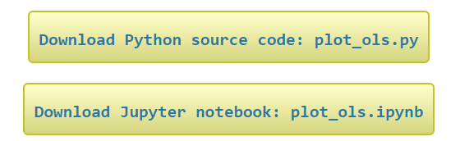

Step 2: Run “Linear Regression Example”.

Result:

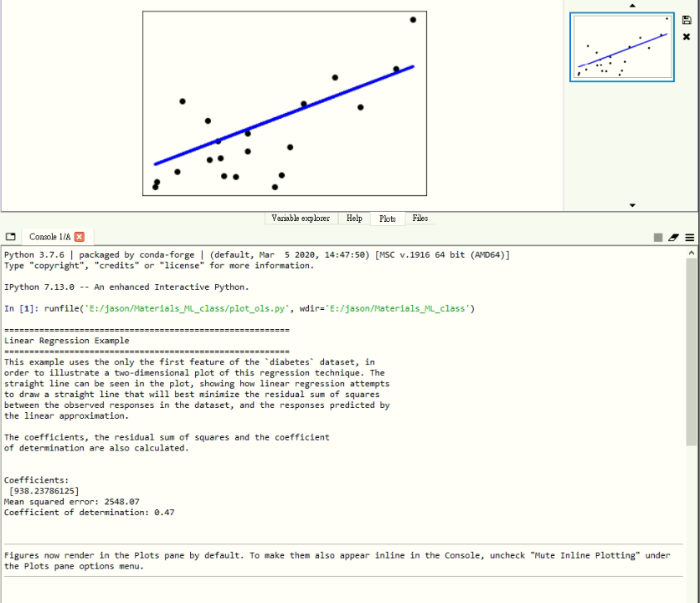

Step 3: Upload this file to GitHub.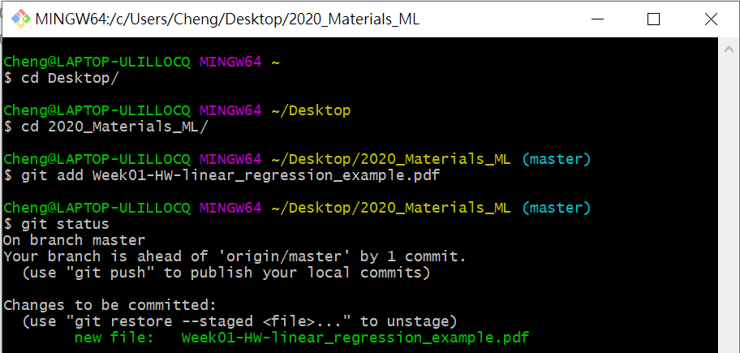

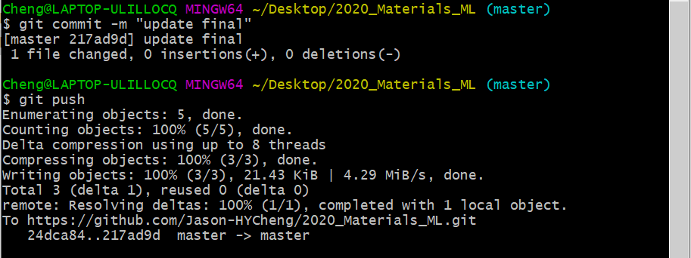

Step 4: Successfully upload the file.

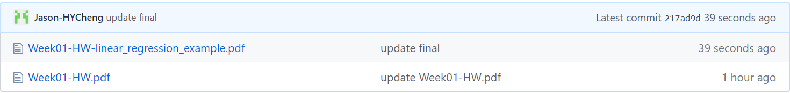

My GitHub for this class: <https://github.com/Jason-HYCheng/2020_Materials_ML>