113306085 資管一甲 何杰陞

Picture 1

Prompt: Modern university classroom with desks, whiteboard, podium, and natural light.

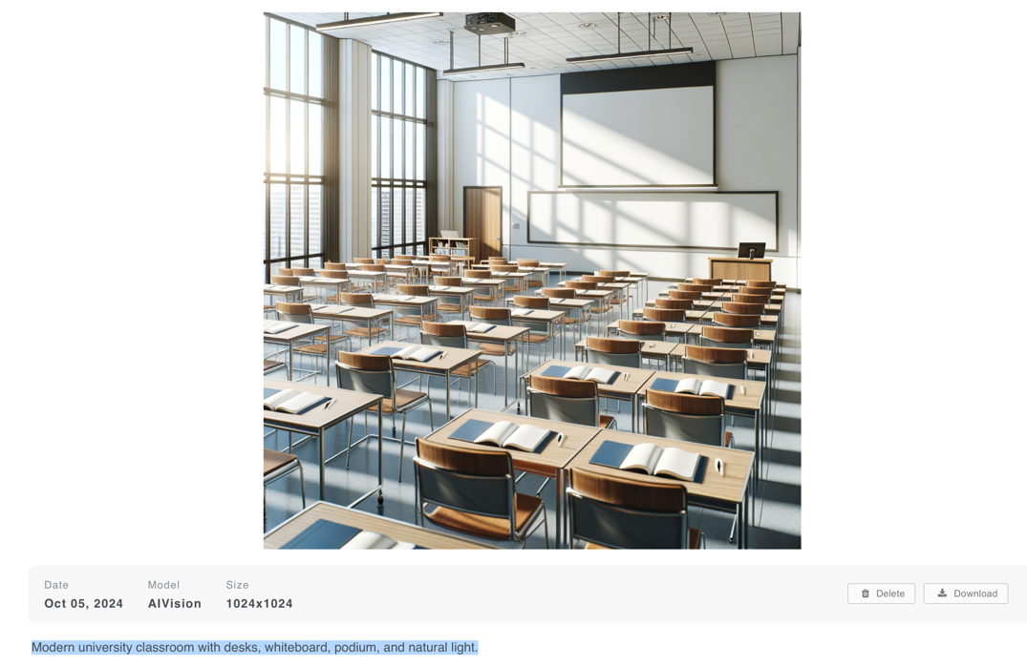

Picture 2

Use Evolve function to add: There are some students sitting in the classroom and a teacher in front of the podium.

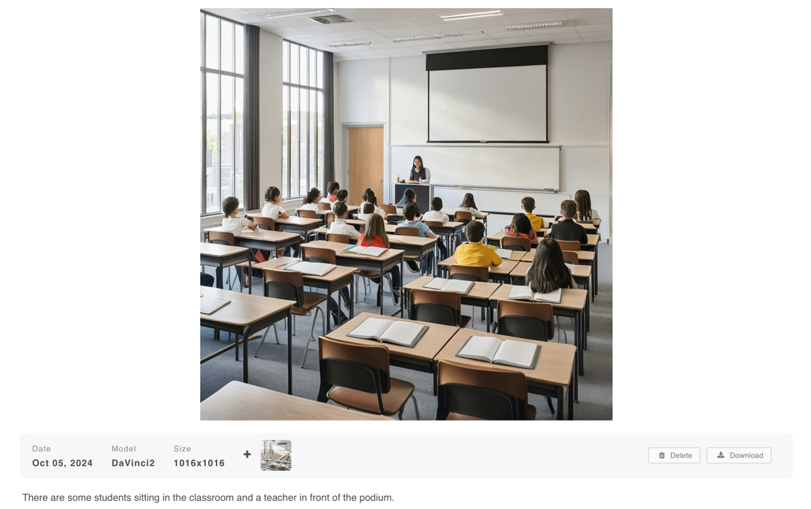

Picture 3

Prompt: A man with an eerie smile.

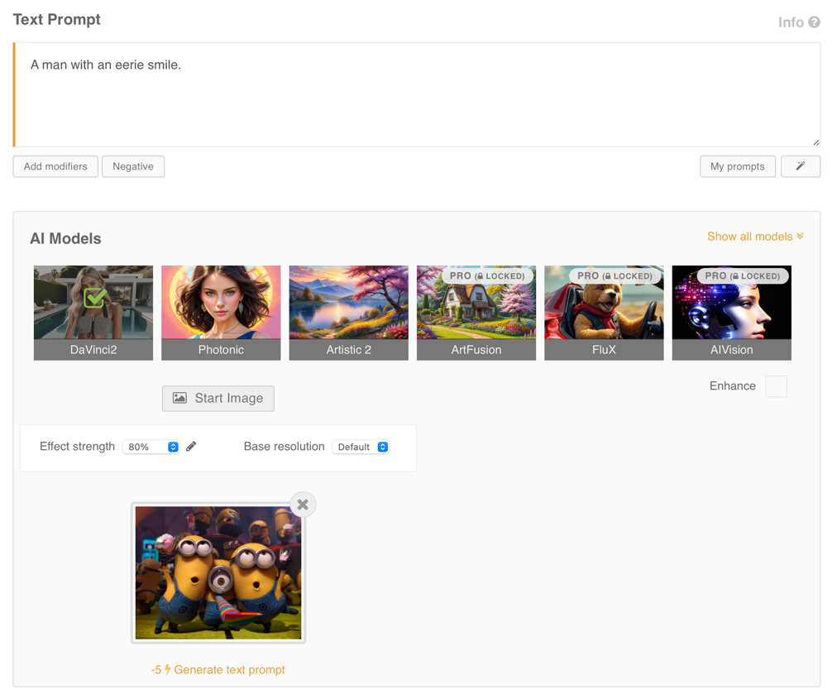

Picture 4

