CANOPY-1 CRO Oversight Plan
  - Loblolly Ridge Therapeutics | Clinical Operations | 2026-04-30 | v2.1
This plan sets out how Loblolly Ridge oversees Halvorsen Clinical Research and the other service providers on CANOPY-1. It records which obligations have been transferred, what the sponsor keeps, how each area is overseen, which indicators are tracked and how issues are escalated. Version 2.1 adds the CANOPY-OLE work order and the recruitment vendor.

1. Study and partners
CANOPY-1 is a randomized, double-blind, placebo-controlled pivotal study planned to randomize 640 adults with treatment-resistant hypertension at 112 sites in 11 countries. After a 12-week double-blind period, participants may enter the CANOPY-OLE extension.
Halvorsen Clinical Research is the full-service CRO under a master work order effective June 1, 2024, and for CANOPY-OLE under a separate work order effective April 20, 2026. Other partners are Meridian Central Laboratories (central lab), Cobalt RTSM (IRT), Pulsewell ABPM Services (ambulatory blood-pressure monitoring), Harbor Safety Services (safety database), Clearwing Clinical Supply (packaging and depots), Alder Bioanalytical (PK samples) and, since March 2026, Siteline Recruitment Services.

2. Transfer of obligations
Under 21 CFR 312.52 a transfer of sponsor obligations to a CRO must be described in writing, and anything not described stays with the sponsor. The CANOPY-1 transfer of obligations, attached to the master work order, transfers site selection and activation, monitoring, data management, the eTMF and pass-through payments to Halvorsen.
Loblolly Ridge retains the protocol, medical monitoring oversight, safety reporting decisions, approval of the statistical analysis plan, regulatory submissions and final acceptance of the trial master file. As ICH E6(R3) puts it, the sponsor keeps ultimate responsibility for transferred activities.
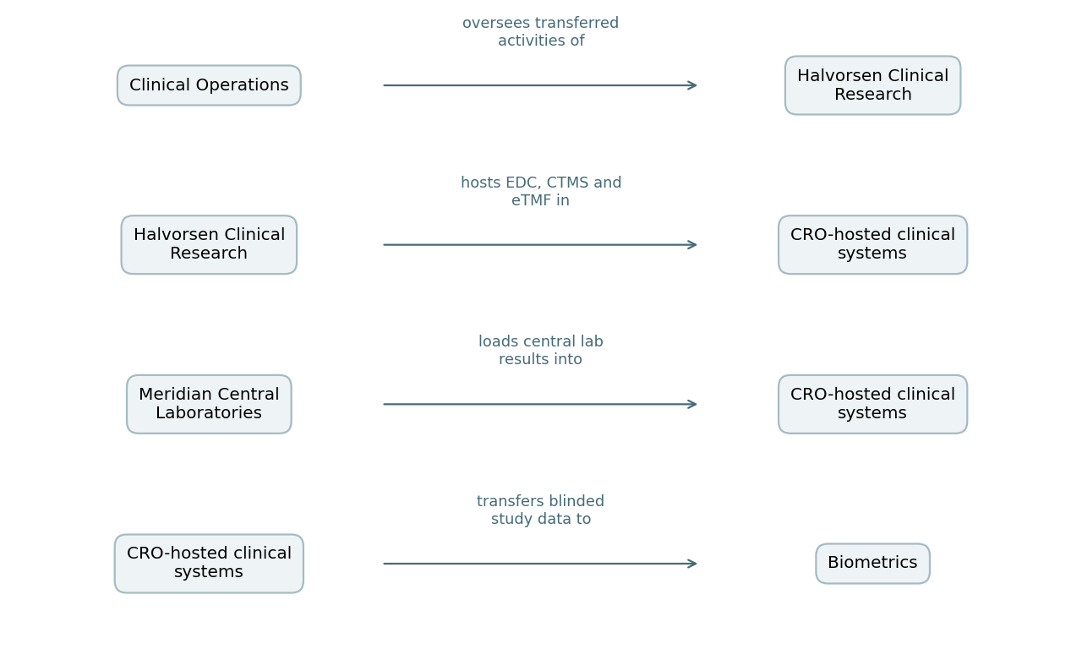

3. Sponsor study team
The Loblolly Ridge study team has 12 people in clinical operations, 3 in biometrics, 2 medical monitors and a program lead. Each oversight area below has a named sponsor owner in the study contact list.

4. Oversight by area
- Monitoring: sponsor review of monitoring visit reports and central monitoring outputs. Centralized monitoring is a systematic analytical evaluation of study conduct across sites; Halvorsen runs it and the sponsor reviews the signals monthly.
- Data: blinded EDC extracts arrive monthly, IRT extracts weekly, central lab and ambulatory blood-pressure data on schedule; Biometrics checks each transfer on receipt.
- Trial master file: quarterly completeness checks of the eTMF, the sponsor's repository of essential trial records, with final acceptance by the sponsor at close.
- Safety: medical monitors review serious adverse event reports and decide on expedited reporting; Harbor Safety Services hosts the safety database.
- Supply: IRT supply alerts and depot stock reviewed with Clinical Supply every week.
- Finance: pass-through spend and activity reports reviewed monthly for the accrual.

5. Subcontracted activities
Halvorsen subcontracts some country start-up and translation work. ICH E6(R3) expects the sponsor to oversee important transferred activities, including those a provider subcontracts, and to have access to providers' SOPs and performance metrics.
Halvorsen notifies the sponsor before adding or replacing a subcontractor, and its subcontractors are listed in the quarterly business review pack.

6. Key performance indicators
The indicators and thresholds are set out below. The calculation rules for each indicator are in Appendix B, the KPI calculation sheet.
- Site activations against the activation plan.
- Randomizations against the current forecast.
- Monitoring visit reports finalized within 10 business days of the visit.
- Queries open more than 30 days: below 5% of open queries.
- Important protocol deviations reviewed within 5 business days.
- eTMF completeness at least 90% at each quarterly check.
- Activity reports for accrual received by working day 3.

7. Governance and escalation
Sponsor and CRO hold a monthly joint operations committee and a bimonthly business review. An issue that is unresolved after two meetings escalates to the Senior Director, Clinical Operations and Halvorsen's executive sponsor. Decisions and actions are minuted by Halvorsen and approved by the sponsor within five business days.

8. Records
Oversight evidence is filed in the sponsor section of the trial master file: joint operations committee minutes, business review packs, KPI reports, transfer check logs, eTMF check results and escalation records.

