LRT-1107 Development Program Overview
  - Loblolly Ridge Therapeutics | Clinical Development | 2026-09-21 | v3.0
LRT-1107 is an investigational oral small molecule in Phase 3 development for treatment-resistant hypertension. It is not approved for any use, and this overview makes no statement about its effects. It describes the program's objective, its studies, the regulatory interactions to date, manufacturing and supply readiness, the timeline to topline results and the questions still open. Version 3.0 replaces the June 2026 edition. A shorter version is available for prospective ex-U.S. partners under a confidentiality agreement.

Program objective and status
The objective is a registration package for LRT-1107 in adults whose blood pressure remains uncontrolled despite multiple antihypertensive medicines. The program completed its end-of-phase-2 meeting with FDA in February 2024, and the Portfolio Review Committee recommended, and the board approved, the Phase 3 gate (G5) in April 2024.
Loblolly Ridge holds all rights. The company is open to partners for ex-U.S. rights to LRT-1107; an early commercial assessment by Harrowgate Insights was completed in September 2026, and its findings are not part of this overview.

Study portfolio
CANOPY-1 is the pivotal study: randomized, double-blind and placebo-controlled, planned to randomize 640 adults at 112 sites in 11 countries (the United States, Canada, Mexico, Argentina, Poland, Hungary, the Czech Republic, Spain, Germany, Bulgaria and Romania). After a 12-week double-blind period, participants may enter CANOPY-OLE, the open-label extension, which enrolled its first participant on June 11, 2026.
By August 31, 2026, CANOPY-1 had screened 1,005 and randomized 467 participants, 73% of target, with 104 of the 112 planned sites active. The chart shows randomizations by month. Earlier clinical pharmacology and Phase 2 studies are summarized in the investigator's brochure.
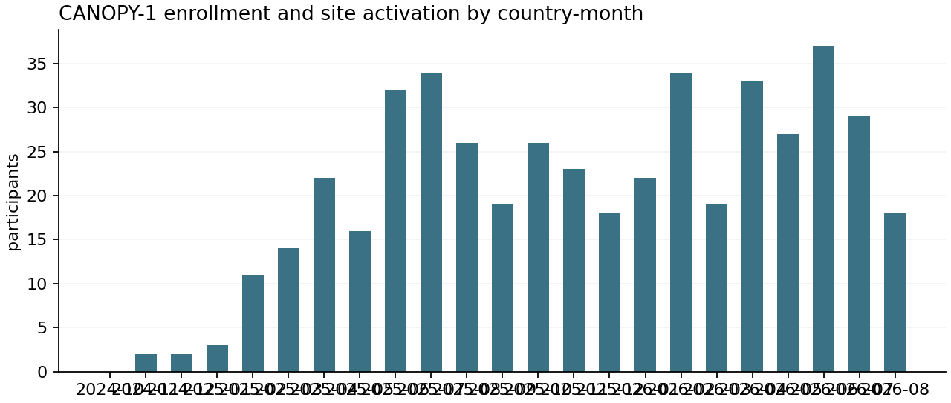
Measure | Value
Measure | participants_randomized_new
Unit | participants
Total | 467
Mean | 1.8458
Records | 253
Period | 2024-10-01 to 2026-08-31
Measure | participants_screened_new
Unit | participants
Total | 1005
Mean | 3.9723
Records | 253
Period | 2024-10-01 to 2026-08-31
Measure | sites_activated_new
Unit | sites
Total | 104
Mean | 0.4111
Records | 253
Period | 2024-10-01 to 2026-08-31
Measure | planned_randomized_new
Unit | participants
Total | 524
Mean | 2.0711
Records | 253
Period | 2024-10-01 to 2026-08-31
CANOPY-1 monthly counts by country, October 2024 to August 2026, from CRO enrollment reports: participants screened and randomized, sites activated, and the September 2024 baseline enrollment plan. Aggregate counts only; no participant-level records.

How the studies are run
Halvorsen Clinical Research is the full-service CRO for CANOPY-1 under a master work order effective June 1, 2024, and for CANOPY-OLE under a work order effective April 20, 2026.
Halvorsen performs site selection and activation, monitoring, data management, the eTMF and pass-through payments. Loblolly Ridge retains the protocol, medical monitoring oversight, safety reporting decisions, statistical analysis plan approval, regulatory submissions and final acceptance of the trial master file.
Other study partners are Meridian Central Laboratories, Cobalt RTSM, Pulsewell ABPM Services, Harbor Safety Services, Clearwing Clinical Supply, Alder Bioanalytical and, since March 2026, Siteline Recruitment Services. An independent DSMB, supported by Harborview DSMB Services, met in October 2025 and April 2026; its next review is on October 14, 2026.

Regulatory interactions
The end-of-phase-2 meeting in February 2024 is the most recent formal meeting with FDA on the program. The next planned interaction is a pre-NDA meeting request, now forecast for December 2027 after topline results. Regulatory correspondence is held by Regulatory Affairs and is not reproduced here.

Manufacturing and clinical supply
LRT-1107 drug substance (API) is made by Tessaro Fine Chemicals in Italy and drug product by Northgate Pharma Services in Ontario. Clearwing Clinical Supply packages, labels and distributes to depots in the United States and the Netherlands. Loblolly Ridge keeps at least six months of forecast drug-product demand as safety stock across the two depots, and no site has run out of study drug.
Tessaro is the only qualified API source. Hanlin Pharmatech in China is being qualified as a backup API supplier; its qualification audit took place on June 9, 2026, the audit response has not yet been accepted, and the qualification batch is forecast for February 2027.

Timeline to topline
The current forecast is last participant randomized March 16, 2027, last participant last visit July 6, 2027, database lock August 17, 2027 and topline results September 14, 2027. The FY2026 baseline had last participant randomized on December 31, 2026 and topline on July 2, 2027.
To protect the forecast, change order 4 would add one country with six planned sites and about three months of CRO services, valued at $3.72 million in services plus an estimated $2.38 million in pass-through. It needs board approval at the October 8, 2026 meeting.

Open questions
- Whether randomization recovers enough in the autumn to hold the March 2027 forecast, with or without the added country.
- Timing of backup API approval relative to the drug-product campaigns needed after 2027.
- Scope and timing of any ex-U.S. partnership, which the company would discuss before topline under a confidentiality agreement.
- Size of pharmacokinetic sampling in CANOPY-OLE, which affects 2027 bioanalytical capacity.

