LRT-3318 Technology Transfer Status Note
  - Loblolly Ridge Therapeutics | CMC & Clinical Supply | 2026-09-14 | v1.0
Status of the LRT-3318 drug-substance technology transfer from Loblolly Ridge to Castellane Pharma, as of September 14, 2026. Prepared by CMC & Clinical Supply for the Castellane technical team, the internal CMC team and the alliance manager, and shared with Castellane ahead of the October joint steering committee.

Scope of the transfer
Castellane runs all development, regulatory and commercial activities for LRT-3318, including its ongoing Phase 1b study. Loblolly Ridge supplies drug substance at a transfer price until technology transfer to Castellane's manufacturer completes, targeted for March 2027.
The transfer covers seven packages: analytical methods, reference standards, process description, batch history, stability and specifications, impurity control, and regulatory CMC module support. Tessaro Fine Chemicals, which makes LRT-3318 drug substance for Loblolly Ridge, supports the process and batch-history packages. The diagram shows how knowledge and material move between the parties.
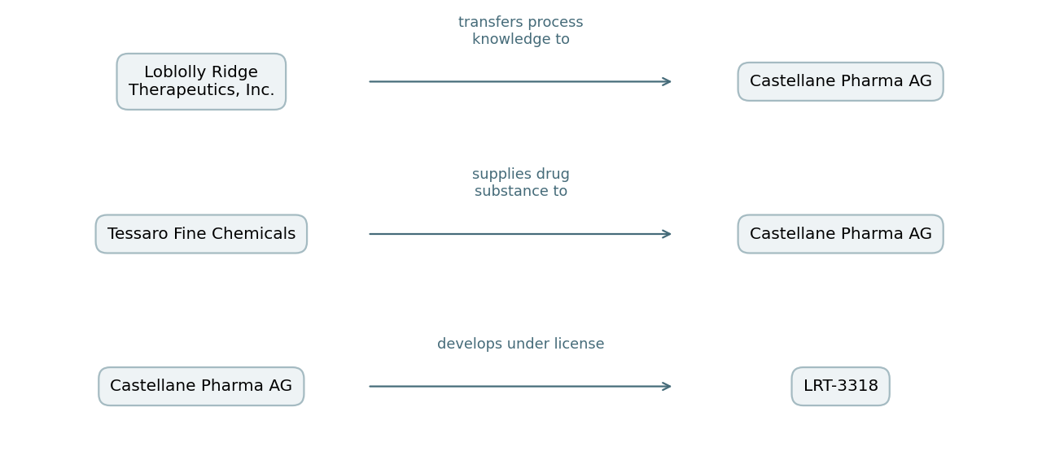

Package status
- Analytical methods – accepted April 22 (due April 30).
- Reference standards – accepted April 24 (due April 30).
- Process description – accepted July 9 (due June 30).
- Batch history – accepted August 27 (due August 31).
- Stability and specifications – accepted September 11 (due August 31).
- Impurity control – due October 30; at risk. Castellane has asked for additional purge data.
- Regulatory CMC module support – due January 29, 2027; on schedule.

Supply obligations and deliveries
Drug substance deliveries to Castellane were 6.0 kg on February 24 and 8.5 kg on June 23, 2026. The next delivery, 8.5 kg, is scheduled for November 20, 2026, with further deliveries planned for March and June 2027 while Castellane's manufacturer qualifies.
In the alliance obligations tracker at the August 31 cut, 4 of the 7 packages had been accepted and 14.5 kg had been delivered in two shipments.

Open technical items
- Impurity purge data: CMC & Clinical Supply to compile existing purge and spiking results by September 30 and agree with Castellane whether new experiments are needed. Owner: Dr. Ingrid Solberg.
- Regulatory CMC module support: Castellane to confirm the module sections it needs from Loblolly Ridge. Owner: Castellane regulatory CMC lead.
- November delivery: release testing plan confirmed with Tessaro. Owner: CMC & Clinical Supply.

Change control during transfer
Until the transfer completes, any change to the process, specifications or analytical methods is agreed by both parties before it is made. ICH Q10 notes that change-management formality generally differs before and after the initial regulatory submission, so the parties will revisit the change-control arrangement when Castellane files its own manufacturing information.

Governance and planned completion
Items are reviewed at the joint development committee and escalated to the quarterly joint steering committee; Chloe Tran is the Loblolly Ridge alliance manager. Technology transfer completion remains targeted for March 2027, and depends on closing the impurity control package.

