Research Data Flow Architecture Note
  - Loblolly Ridge Therapeutics | Research Informatics | 2026-09-02 | v1.2
This note describes how research data move at Loblolly Ridge: from laboratory instruments and the electronic lab notebook through the assay registry and compound database to the R&D Data Hub, and how data from external partners arrive. It names the components, the flows between them, when each flow runs, who owns it, what happens when it fails and the known gaps. Version 1.2 adds measured upload lag for 2026.

1. System boundary
In scope: research data generated in the Woodlands laboratory and research data received from external partners. Out of scope: CRO-hosted clinical systems (EDC, CTMS, eTMF), the safety database and finance systems, which have their own owners. Discovery research is non-GxP; the note describes good-practice controls, not validated GxP systems.

2. Components
- Instrument data server and chromatography data system: acquisition and processing for the LC-MS/MS and LC instruments.
- Electronic lab notebook: cloud ELN, in use since 2020; the record of each experiment.
- Assay and sample registry: internal lightweight LIMS built in 2021; the record of released assay results and registered samples.
- Compound registration database: legacy system from 2014; the source of compound identifiers and structures.
- R&D Data Hub: research data warehouse and dashboards; phase 1 live since March 2025 with nightly loads from the registry and compound database.
- Infrastructure: servers, backup and network are run by Bayou Managed IT under our IT team's direction.

3. Data flows
Assay results flow from instruments and the chromatography data system into ELN experiments, then to the assay registry, and nightly into the R&D Data Hub, where they are joined to compound identifiers from the compound database. The diagram shows the four internal flows.
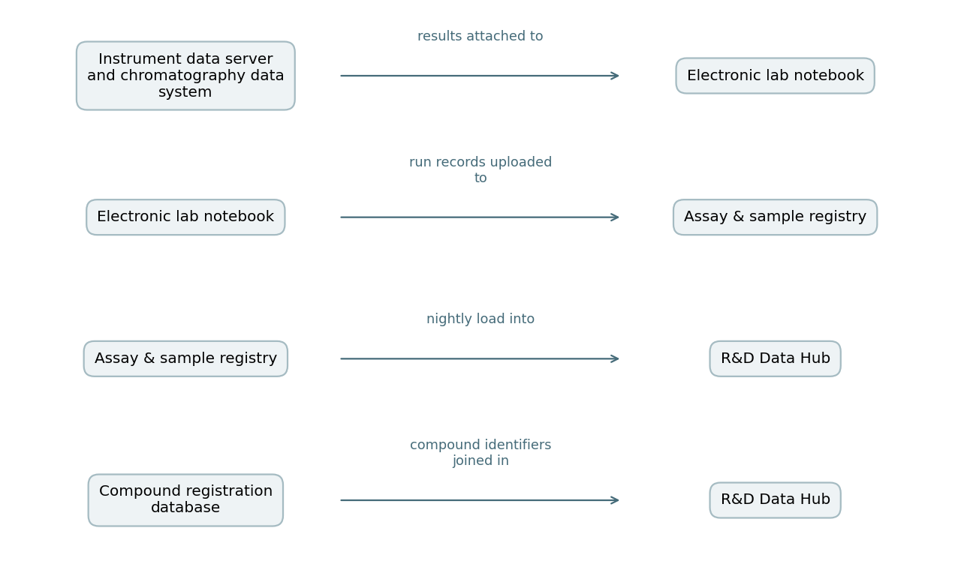

4. Interfaces and timing
- Instrument to ELN: the scientist attaches the processed export to the ELN experiment.
- ELN to registry: manual export and import by the scientist after the run passes acceptance criteria.
- Registry to Data Hub: automated nightly load of released runs.
- Compound database to Data Hub: automated nightly load of compound identifiers.
- External partners: scheduled transfers arrive as files – EDC extracts from the CRO monthly and blinded, central lab results, IRT extracts weekly, ambulatory blood-pressure data monthly and bioanalytical results per batch. These are checked by Biometrics or DMPK and are not loaded into the Data Hub.

5. Measured lag, January to August 2026
For 1,450 assay runs, the median time from run to registry upload was 4 days, with a 90th percentile of 11 days. DP-09 runs took a median of 7 days, other projects 4. 1,305 runs passed acceptance criteria, 103 failed and were repeated, and 42 were invalidated. The chart shows plates run by month.
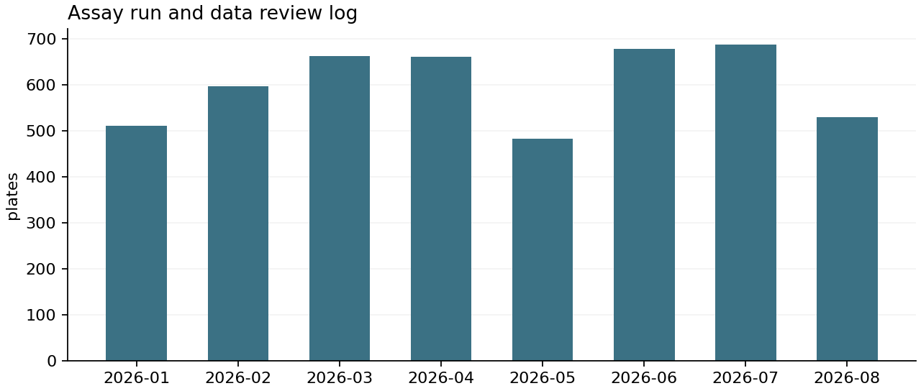
Measure | Value
Measure | plates
Unit | plates
Total | 4812
Mean | 3.3186
Records | 1450
Period | 2026-01-01 to 2026-08-31
In vitro assay runs registered January to August 2026, with ELN entry, registry upload and reviewer sign-off dates as of September 18, 2026.

6. Responsibilities
- Research Informatics: registry, Data Hub, nightly loads, correction requests.
- Discovery Biology and DMPK: ELN entries, uploads and reviews, following the assay data review and release work instruction.
- IT with Bayou Managed IT: infrastructure, access and backup.
- Data owners in each function: fitness of their data for decisions.

7. Failure and correction handling
If a nightly load fails, Research Informatics reruns it the next morning and posts a notice on the Data Hub home page. Released registry results are corrected only through a registry correction request, which keeps the original value; the ELN and registry audit trails let changes be reconstructed, in line with FDA's description of audit trails as secure, time-stamped records of changes to electronic records.

8. Known gaps
- The ELN-to-registry step is manual and accounts for most upload lag.
- External bioanalytical and CRO transfers are not loaded into the Data Hub, so project teams see them only in files.
- When a hosted system or partner contract ends, the data and linked metadata must be obtained and kept; FDA guidance makes the same point. We have no written exit checklist for research systems yet.
- The compound registration database dates from 2014; an upgrade is under discussion.
- The proposed Data Hub phase 2 would add direct ELN-to-registry transfer and intake of external bioanalytical and CRO transfers. It is a proposal and has not been approved or budgeted.

