CRO and Laboratory Data Transfer Specification
  - Loblolly Ridge Therapeutics | Biometrics with Research Informatics | 2026-05-20 | v1.4
Data transfer specification DTS-C1-001, version 1.4. It defines the scheduled data transfers from external partners to Loblolly Ridge for CANOPY-1 and CANOPY-OLE: who sends what, how often, how files are named and versioned, what is checked on receipt and how errors are handled. Owner: Biometrics, with Research Informatics. Shared with Halvorsen Clinical Research data management, Meridian Central Laboratories and Alder Bioanalytical.

1. Producers and consumers
Halvorsen Clinical Research is the full-service CRO for CANOPY-1 and, under a separate work order effective April 20, 2026, for CANOPY-OLE. It hosts the EDC and sends blinded EDC extracts. Meridian Central Laboratories loads central lab results into the CRO systems and sends them to Loblolly Ridge. Cobalt RTSM sends IRT extracts. Pulsewell ABPM Services sends ambulatory blood-pressure data. Alder Bioanalytical sends pharmacokinetic sample results.
Biometrics receives all transfers into the controlled transfer area; DMPK & Bioanalytical also reviews bioanalytical results. The diagram shows the main routes.
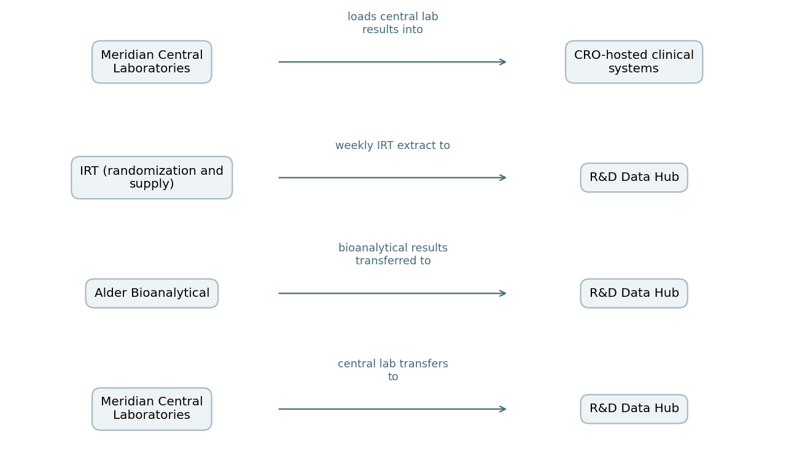

2. Record types
- EDC extract: all CRF datasets at dataset level, blinded; no treatment assignment variables.
- Central lab: results with specimen, visit, test code, units and reference ranges.
- IRT: randomization and dispensing events without treatment codes, plus depot and site inventory.
- ABPM: session-level summary records and device identifiers.
- Bioanalytical: sample-level concentration results with batch identifiers and assay run references.

3. Schedule
Scheduled transfers: EDC extracts from the CRO monthly (blinded); central lab results every two weeks; IRT extracts weekly; ambulatory blood-pressure data monthly; bioanalytical results per batch. Transfer specification version 1.4 sets the two-week central lab schedule.

4. File naming and versioning
Files are named study, source, data type, cut date and version, for example C1-MCL-LAB-20260515-v1.zip. A resent file for the same cut increments the version. Every transfer includes a transmittal listing file names, record counts per dataset and the cut date. Superseded versions are kept, not overwritten.

5. Checks on receipt
Each transfer is checked on receipt for file naming, version, record counts against the transmittal, required fields, and study and visit identifiers. Discrepancies are logged and resolved with the sender before loading. Checks and outcomes are recorded in the transfer log.

6. Error handling
- Naming or version error: sender resends with the next version.
- Record count mismatch: transfer held; sender confirms counts or resends within two business days.
- Missing required field or unknown visit: transfer held; discrepancy raised with the sender's data manager.
- Repeated failures from the same sender are raised at the joint operations committee.

7. Retention and system exit
Loblolly Ridge keeps every received file and transmittal for the life of the study archive.
FDA guidance says that when hosted systems are decommissioned or contracts end, sponsors should obtain and retain metadata linked to the data; at database lock and at contract end the CRO will provide final extracts with audit trails and metadata. FDA describes data integrity as the completeness, consistency and accuracy of data, which these checks are designed to protect.

8. Example transmittal
- Study: CANOPY-1. Source: Meridian Central Laboratories. Cut date: 2026-05-15. Version: 1.
- Files: C1-MCL-LAB-20260515-v1.zip (results), C1-MCL-REF-20260515-v1.csv (reference ranges).
- Record counts: listed per dataset. Sender contact: named data manager.

