Design Proposal: Bioanalytical LC-MS/MS Capacity
  - Loblolly Ridge Therapeutics | DMPK & Bioanalytical with Lab Operations | 2026-09-15 | v0.9 (for review)
Draft for review. This proposal sets out how DMPK & Bioanalytical and Lab Operations could meet discovery and development bioanalytical demand in 2027. It compares three options: a second LC-MS/MS triple-quadrupole system, a second shift on the existing systems, or sending more discovery bioanalysis to external laboratories. It does not recommend an option yet; research leadership expects to decide on October 2, 2026.

1. Why this is needed now
The two in-house LC-MS/MS triple-quadrupole systems ran close to their practical limit this summer, and discovery samples have been moving to external laboratories to keep projects moving. Turnaround is much longer externally, and 2027 will bring more work. An instrument ordered after October would not be in routine use before the second quarter of 2027, so the choice has to be made this autumn.

2. Evidence: instrument use
From June to August 2026 the two LC-MS/MS systems were booked for 91% and used for 84% of their capacity hours, up from 74% booked and 67% used from March to May. The other 18 bookable instruments were used for 48% of capacity. Each LC-MS/MS system has about 100 available hours a week including the unattended overnight queue, so there is no idle time left to schedule into.
Recorded downtime across the 20 bookable instruments was 265 hours from March to August, including 58 hours on INS-002 in July for an ion-source repair. With two systems, one outage halves capacity. The chart shows used hours by month for all 20 bookable instruments.
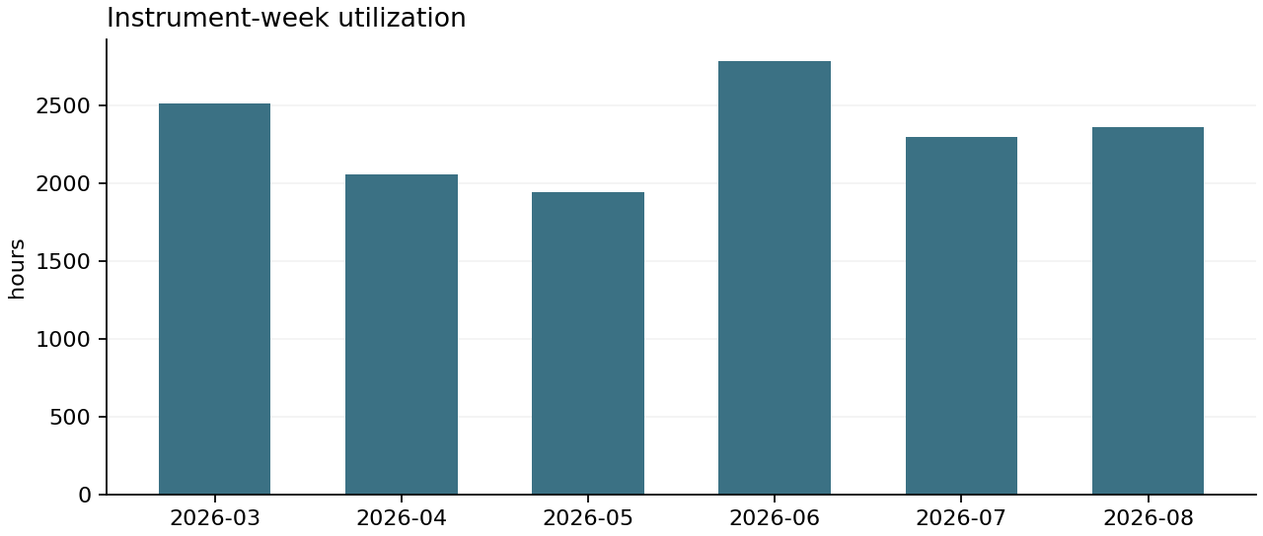
Measure | Value
Measure | used_hours
Unit | hours
Total | 13954.2
Mean | 26.835
Records | 520
Period | 2026-03-02 to 2026-08-28
Measure | available_hours
Unit | hours
Total | 27412.5
Mean | 52.7163
Records | 520
Period | 2026-03-02 to 2026-08-28
Measure | downtime_hours
Unit | hours
Total | 264.8
Mean | 0.5092
Records | 520
Period | 2026-03-02 to 2026-08-28
Measure | capacity_hours
Unit | hours
Total | 27147.7
Mean | 52.2071
Records | 520
Period | 2026-03-02 to 2026-08-28
Measure | booked_hours
Unit | hours
Total | 15230.0
Mean | 29.2885
Records | 520
Period | 2026-03-02 to 2026-08-28
Measure | runs
Unit | runs
Total | 4626
Mean | 8.8962
Records | 520
Period | 2026-03-02 to 2026-08-28
Weekly hours for the 20 bookable instruments, weeks starting March 2 to August 24, 2026: scheduled available hours, downtime, capacity (available minus downtime), booked and used hours, and runs.

3. Evidence: where samples go
From January to August 2026, 210 bioanalytical batches with 20,153 samples were shipped for analysis. The in-house share of samples fell from 31% in January to May to 15% in June to August. Median time from shipment to data transfer was 7 days in-house and 22 days at external laboratories.
Alder Bioanalytical performs clinical and GLP bioanalysis and, since June, discovery overflow under a new work order. Fenwick Bioanalysis is being qualified as a second external laboratory. The chart shows samples shipped by month across all laboratories.
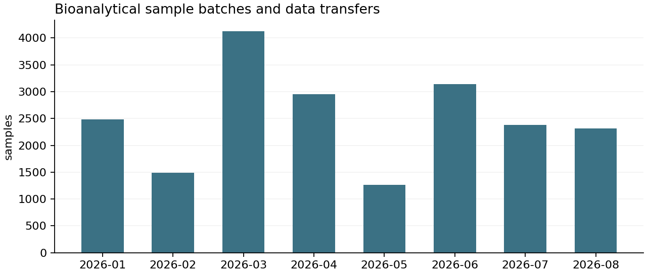
Measure | Value
Measure | sample_count
Unit | samples
Total | 20153
Mean | 95.9667
Records | 210
Period | 2026-01-01 to 2026-08-31
Measure | transfer_version
Unit | version
Total | 249
Mean | 1.2146
Records | 205
Period | 2026-01-01 to 2026-08-31
Bioanalytical sample batches shipped January to August 2026 for clinical, nonclinical and discovery studies, with receipt, analysis and data-transfer dates as of September 18, 2026. Sample counts only; no subject identifiers.

4. Demand in 2027
Bioanalytical demand will rise with DP-07 candidate profiling, LRT-4051 metabolite work and pharmacokinetic sampling in CANOPY-OLE. The CANOPY-OLE sampling volume is an assumption the clinical team has not yet confirmed. Clinical samples are analyzed externally, because the Woodlands laboratory is non-GxP, but they draw on the same external capacity that takes our discovery overflow.

5. Requirements
- Discovery pharmacokinetic results within about a week of sampling, so that design cycles are not held up.
- Enough headroom that one instrument outage does not stop discovery bioanalysis.
- Results that arrive in the assay registry and data hub without extra manual handling. External results arrive as transfer files; the proposed Data Hub phase 2 would automate their intake but is not approved.
- No change to where GLP and clinical bioanalysis is done.

6. Options
- A. Second triple-quadrupole system: about $640,000 capital and six to eight months to routine use, including installation, method transfer and qualification. Adds about 100 hours a week once running.
- B. Second shift on the existing systems: one additional scientist to run attended evening work and method development. Lower cost, faster to start, but no protection against an instrument outage. Staffing cost not yet estimated.
- C. More external discovery bioanalysis: about $30,000 a month at current volume, using Alder and, once qualified, Fenwick. No capital, but turnaround stays near three weeks.

7. Trade-offs
Option A costs most up front and takes longest, but it is the only option that restores in-house turnaround at higher volume and adds resilience. Option B could start within a quarter but depends on hiring and does not help when an instrument is down. Option C is flexible and needs no capital, but it keeps discovery waiting about 22 days for results and competes with CANOPY-OLE and LRT-4051 work at the same laboratories. Options can be combined; B or C could bridge until A is running.

8. Open decision and information needed
- Decision owner: research leadership, on October 2, 2026.
- CANOPY-OLE sampling volume, to be confirmed by the clinical team.
- Cost of a second shift, to be estimated with People and Finance.
- Fenwick qualification timing, from QA.
- Vendor quotes for option A, held by DMPK & Bioanalytical and not attached to this draft.

