FY2026 Year-End Operating Summary
  - Tallowbrook Health | Office of the COO | 2026-09-10 | v1.0 (board package, September 2026)
This summary reports Tallowbrook's operating results for the fiscal year ended June 30, 2026, with July and August 2026 trends, for the Finance & Operations Committee meeting on September 17. Financial results are unaudited; the audit is expected in October. Volume figures come from the facility activity series maintained by Decision Support.

Headlines
- Inpatient admissions rose 1.0% to 16,651; growth came entirely from Hospital Fort Bend (+7.2%), while Medical Center West was 2.2% lower.
- Emergency visits rose 3.2% to 105,599, and outpatient imaging and visits grew fastest at Stafford (about +8%).
- Operating income was $8.6 million on $618.4 million of net operating revenue, a 1.4% margin against a 2.1% budget.
- Agency nursing hours fell at both hospitals after the Central Staffing Office started, and the RN vacancy rate fell to 11.8%.
- July and August 2026 volumes are running above the same months last year at both hospitals.

Volumes by facility
Medical Center West admitted 10,758 inpatients, down 2.2% from FY2025, with 62,487 emergency visits (+1.5%), 8,370 surgical cases and 2,399 births.
Hospital Fort Bend admitted 5,893 inpatients (+7.2%) and saw 43,112 emergency visits (+5.6%) and 4,589 surgical cases.
The Surgery Center Grand Parkway performed 6,252 cases (+0.8%). The Pavilion performed 30,740 imaging exams (+2.5%) and 73,863 other outpatient visits (+3.6%).
Imaging & Therapy Stafford performed 44,825 imaging exams (+8.3%) and 19,218 therapy and other visits (+8.2%). Mission Bend recorded 41,653 clinic and urgent care visits (+3.7%).

Monthly admissions trend
The chart shows total inpatient admissions for both hospitals by month from July 2024 through August 2026. The table beneath summarizes the full 26-month extract for all six facilities, not the fiscal year alone.
The winter of 2024-25 was the busiest period in the series. The 2025-26 winter was milder.
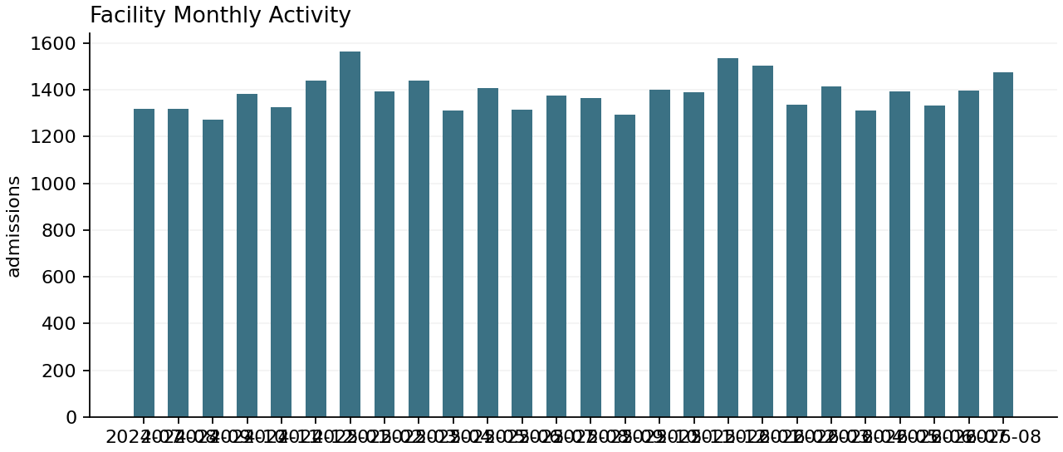
Measure | Value
Measure | inpatient_admissions
Unit | admissions
Total | 36013
Mean | 230.8526
Records | 156
Period | 2024-07-01 to 2026-08-31
Measure | patient_days
Unit | days
Total | 160996
Mean | 1032.0256
Records | 156
Period | 2024-07-01 to 2026-08-31
Measure | ed_visits
Unit | visits
Total | 226605
Mean | 1452.5962
Records | 156
Period | 2024-07-01 to 2026-08-31
Measure | surgical_cases
Unit | cases
Total | 41432
Mean | 265.5897
Records | 156
Period | 2024-07-01 to 2026-08-31
Measure | births
Unit | births
Total | 5223
Mean | 33.4808
Records | 156
Period | 2024-07-01 to 2026-08-31
Measure | imaging_exams
Unit | exams
Total | 564092
Mean | 3615.9744
Records | 156
Period | 2024-07-01 to 2026-08-31
Measure | outpatient_visits
Unit | visits
Total | 391033
Mean | 2506.6218
Records | 156
Period | 2024-07-01 to 2026-08-31
All six facilities, monthly, July 2024 to August 2026. Counts from EHR and ASC system extracts; inpatient admissions exclude observation stays; outpatient visits exclude ED visits and imaging exams.

Capacity
Average occupancy of staffed beds was 70.6% at Medical Center West (72.5% in FY2025) and 70.3% at Hospital Fort Bend, up from 66.0%. Average length of stay was 4.6 days at West and 4.18 days at Fort Bend.
West occupancy reached 82.7% in February 2025 but only 73.2% in February 2026. August 2026 reached 76.7%, higher than usual for summer.
Fort Bend's growth is the main reason the fourth-floor options study is on the committee's agenda this year.

Workforce and premium labor
We ended the year with about 3,080 employees (2,650 FTEs), including about 1,015 RN FTEs. The hospital RN vacancy rate was 11.8% at June 30, down from 14.9% a year earlier.
Agency hours fell from 4.8% to 2.7% of worked RN hours at Medical Center West after the Central Staffing Office opened in October 2025, and from 8.3% to 5.1% at Hospital Fort Bend after it joined in February 2026.
Float pool hours rose over the same periods, as intended.

Financial results
Net operating revenue was $618.4 million, up 5.2% from $587.9 million in FY2025. Operating expenses were $609.8 million, leaving operating income of $8.6 million (1.4%) against a budgeted 2.1%. FY2025 operating income was $12.3 million (2.1%).
Salaries, wages and benefits were about 48% of expense, supplies 16%, purchased services and other 30%, and depreciation and interest 6%.
Net patient revenue by payer: managed care 49%, Medicare 32%, Medicaid 14%, self-pay and other 5%.
Capital spending was $41.2 million, including the CT replacement at Medical Center West and the Stafford MRI upgrade. Community benefit was $38.6 million, unaudited.

Early FY2027 trends
In July and August 2026, Medical Center West admitted 1,865 patients against 1,792 a year earlier, with 10,988 emergency visits against 10,641.
Hospital Fort Bend admitted 1,006 against 948 and saw 7,677 emergency visits against 7,254. Two months is too short to change the FY2027 volume budget.

For the committee
- Fort Bend fourth floor: options range from deferral to 18 beds ($14.5 million) or 36 beds ($26.0 million); a board decision is planned for February 2027 with the FY2028 capital plan.
- Improvement portfolio: the West patient flow pilot, Central Staffing Phase 2 and the CMMS consolidation are active; management will report status in October.
- Margin: management will present FY2027 expense actions with the audited results.

