Administrative Systems Landscape
  - Tallowbrook Health | Information Services | 2026-04-30 | v2.0
Architecture note, version 2.0, April 30, 2026. Prepared by Arjun Mehta, Vice President and Chief Information Officer, for Information Services, Decision Support and department system owners. Describes the administrative and operational systems in use, what each holds, how data moves between them and who owns them.

1. Scope
This note covers systems used to run operations: patient flow and scheduling, finance and purchasing, workforce, equipment and facilities maintenance, and operational reporting.
Clinical ancillary systems such as laboratory, pharmacy and imaging are mentioned only where they exchange data with these systems.

2. Enterprise EHR
The vendor-hosted EHR, implemented in 2019, supports admission, discharge and transfer (ADT), bed management, enterprise scheduling and clinical documentation.
It is used at both hospitals, Outpatient Pavilion West, Imaging & Therapy Stafford and Urgent & Family Care Mission Bend.
System owner: Information Services, with Nursing, Patient Access and Capacity Management as business owners for their modules.

3. ERP and supply systems
The ERP, live since FY2021, supports general ledger, purchasing, inventory, accounts payable and HR/payroll. Point-of-use supply cabinets in procedural and nursing areas record usage, which drives replenishment orders in the ERP.
Business owners: Finance for the general ledger and payables, Supply Chain for purchasing and inventory, Human Resources for payroll.

4. Workforce scheduling and timekeeping
The workforce scheduling and timekeeping system (WFS) holds staff schedules, time punches and premium pay codes. It sends worked hours to ERP payroll every pay period and scheduled and worked hours to the EDW nightly.
Business owners: Nursing Services and the Central Staffing Office.

5. Maintenance systems
Clinical engineering records are split. The legacy CE CMMS, an on-premise system in use since 2012, holds Medical Center West and Pavilion devices.
The cloud enterprise CMMS holds facilities work orders for all sites and, since 2020, clinical engineering records for the other sites.
The legacy server reaches end of vendor support in 2027. Clinical Engineering and IS are assessing options, and any change will go to the architecture review board.

6. Surgery Center Grand Parkway
The surgery center is a joint venture with physician investors and schedules and bills cases in its own practice-management system, separate from the EHR.
It buys supply chain and clinical engineering services from Tallowbrook under a services agreement, so its purchases run through the ERP and its devices are in the enterprise CMMS.

7. Reporting and integration
The enterprise data warehouse (EDW) loads nightly between 1:00 and 5:30 a.m. and feeds the Pulse dashboard portal, which Decision Support maintains. Most dashboards refresh nightly; staffing dashboards refresh after each pay period closes.
An integration engine manages HL7 feeds between the EHR and ancillary systems and the flat-file transfers into the EDW.

8. Main data flows
Principal feeds into the EDW and payroll are shown below. Two feeds are not automated: the surgery center sends a monthly case summary file, and the legacy CE CMMS is exported by hand each month.
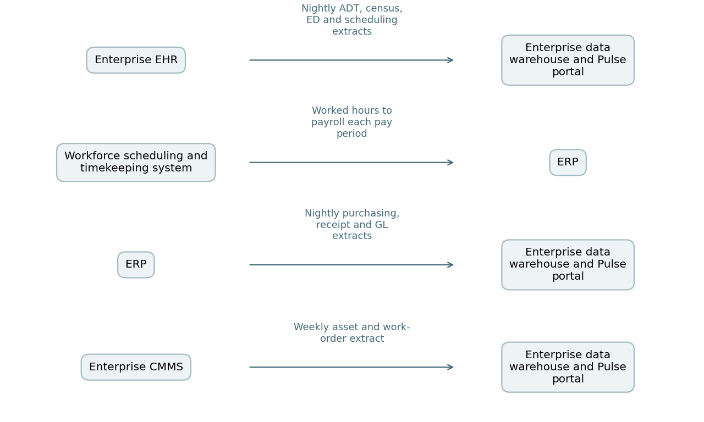

9. Governance
The architecture review board, chaired by the CIO, meets monthly to review integration changes and new applications. Departments proposing a new system or interface submit a request to IS before selecting a vendor.

