Operational Systems Landscape and Data Flows
  - Sedgewater Energy Holdings | IT and OT Enterprise Architecture | 2026-05-15 | v1.3
This document describes the operational business systems used by Sedgewater's electric and gas delivery businesses, the main data flows between them and the extracts used for reporting. It is maintained by the Enterprise Architect and reflects the landscape at May 15, 2026.

1. Scope
The landscape covers systems that hold work, outage, meter, asset, customer, market and financial records. Distribution control and substation automation systems are managed separately by IT and OT and are outside the scope of this document.

2. Core systems
- Work management system (WMS), version 8, installed 2017: work orders, scheduling and crew time.
- Outage management system (OMS), 2019: outage prediction, crew dispatch and interruption records.
- Meter data management (MDM), 2012, upgraded 2021: interval data, meter events and remote service-order execution.
- Geographic information system (GIS), 2015: network model and asset records.
- Enterprise resource planning (ERP), 2020: finance, projects, procurement and inventory.
- Gas customer information and billing system, 2016.
- Market transaction gateway: TX SET transactions with ERCOT and REPs.
- Cloud contact center platform, 2023: telephony, IVR, text and web channels.

3. Main data flows
The GIS network model feeds OMS; meter outage events flow from MDM to OMS; completed work orders send labor and material costs from WMS to ERP; service-order results flow from MDM to the market gateway. Nightly extracts from WMS, OMS and ERP load the reporting database used for management reports and regulatory filings.
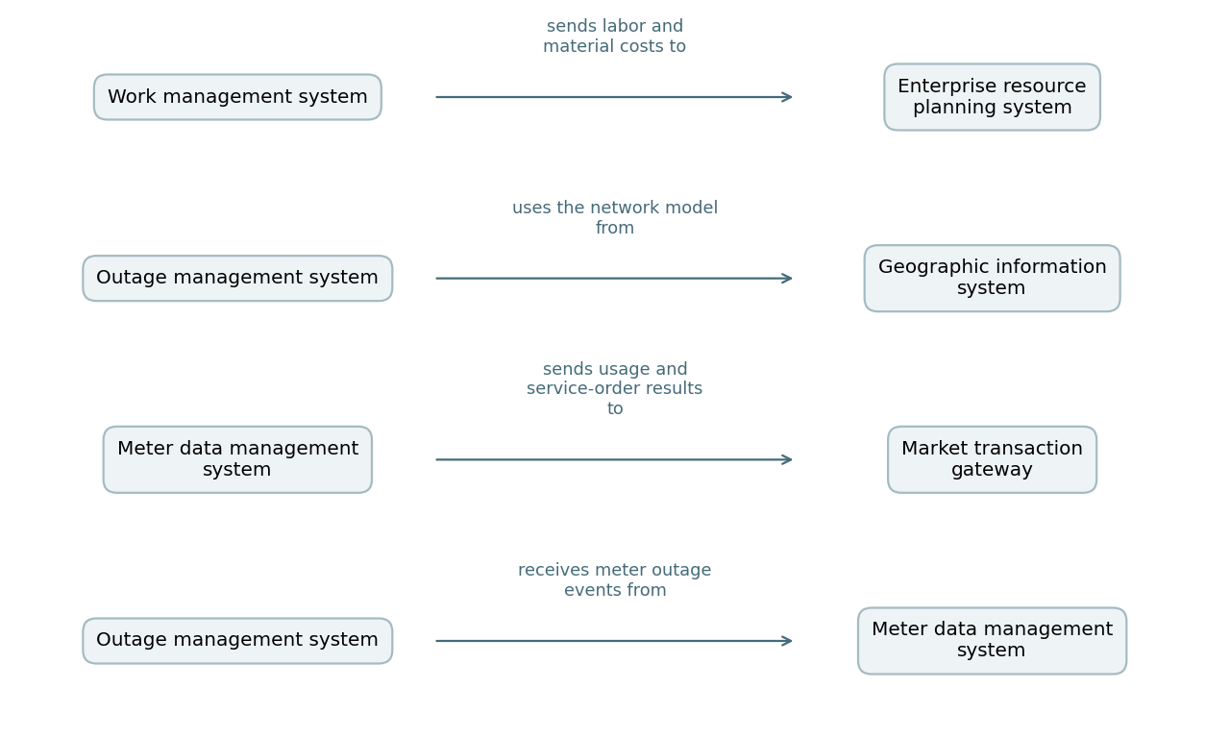

4. Interruption records
OMS is the system of record for sustained interruptions. Rules require records showing type, cause, date and time, duration, customers affected and substation and feeder identifiers, kept for five years. Reliability indices are calculated from OMS extracts under the Reliability Metric Definitions and Calculation Standard.

5. Market transactions
REPs submit service orders through the market transaction gateway, and most are completed remotely through the meter network. TX SET 814 transactions cover enrollments, switches, move-ins, move-outs and ESI ID maintenance; 867 transactions carry usage. Final usage (867_03) goes from Sedgewater to ERCOT within three business days of the meter read.

6. Meters and customer channels
The current advanced meter fleet was installed from 2011 to 2013, and vendor support for this meter generation ends in 2030. One contact center at the Houston operations center handles electric and gas contacts, with an overflow partner for storms and billing peaks; customers can also report outages by text, web and automated phone.

7. Known data gaps
Streetlight repairs are logged in WMS without a feeder code because the lighting network is recorded separately in GIS, so streetlight work cannot be joined to feeder-level reports.

