Customer Operations Overview
  - Sedgewater Energy Holdings | Customer and Market Operations | 2026-09-09 | v1.0
Overview of Sedgewater's customer operations - contact centers, REP service orders and metering - for the leadership team and the outside review. Prepared by the Senior Vice President, Customer and Market Operations, September 9, 2026.

How customer operations are organized
One contact center at the Houston operations center handles electric and gas contacts, with an overflow partner, Harborview Contact Solutions, for storms and billing peaks. Customers can also report outages by text, web and automated phone.
Electric customers buy electricity from one of 58 REPs, who bill them; Sedgewater handles outages, hazards and service orders. Each REP chooses how customer outage calls reach us: by transaction, by forwarding calls, or by giving customers our outage number. Gas customers are billed by Sedgewater directly.

Service targets
Average speed of answer of 60 seconds or less in normal operations and under three minutes during storm activation; abandonment below 5%.

Contact volumes
In 2025 we received 586,919 electric and 841,105 gas contacts; average speed of answer was 62 seconds for electric and 54 seconds for gas, and 3.7% of queued calls were abandoned. From January to August 2026 we received 562,022 electric and 555,713 gas contacts, and 53% were completed in self-service channels. The chart shows contacts offered by month for both businesses.
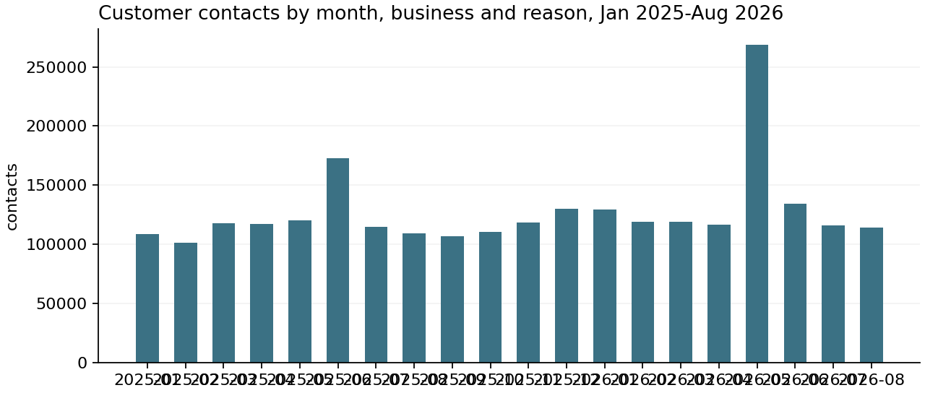
Measure | Value
Measure | contacts_offered
Unit | contacts
Total | 2545759
Mean | 10607.3292
Records | 240
Period | 2025-01-01 to 2026-08-31
Measure | handled_by_agent
Unit | contacts
Total | 1266460
Mean | 5276.9167
Records | 240
Period | 2025-01-01 to 2026-08-31
Measure | self_service
Unit | contacts
Total | 1225767
Mean | 5376.1711
Records | 228
Period | 2025-01-01 to 2026-08-31
Measure | abandoned
Unit | contacts
Total | 53532
Mean | 223.05
Records | 240
Period | 2025-01-01 to 2026-08-31
Measure | handle_minutes
Unit | minutes
Total | 7844178.1
Mean | 32684.0754
Records | 240
Period | 2025-01-01 to 2026-08-31
Measure | wait_minutes
Unit | minutes
Total | 1314790.0
Mean | 5478.2917
Records | 240
Period | 2025-01-01 to 2026-08-31
Monthly contacts offered, handled by agents, completed in self-service and abandoned, with handle and wait minutes, by business and reason, January 2025 to August 2026. Electric self-service was not counted for January and February 2025.

May 2026
Electric contacts reached 205,440 in May, against 49,645 in April. The overflow partner was activated on the evening of May 19 with 120 agents. Electric average speed of answer was 175 seconds for the month and reached 11 minutes 40 seconds on May 20; 12.1% of queued electric calls were abandoned. Contact capacity for the first 48 hours of a major event is the main customer lesson from the event.

REP service orders
REPs submit move-ins, move-outs, switches, disconnects and reconnects for non-payment, re-reads and investigations through the market transaction gateway; most are completed remotely through the meter network. In 2025 REPs submitted 1,179,882 orders, 98.7% of completed orders were on time and 91% were completed remotely. From January to August 2026 there were 804,281 orders and on-time completion was 98.3%, falling to 95.4% in May.
Measure | Value
Measure | orders_received
Unit | orders
Total | 1984163
Mean | 11023.1278
Records | 180
Period | 2025-01-01 to 2026-08-31
Measure | completed_on_time
Unit | orders
Total | 1936288
Mean | 10757.1556
Records | 180
Period | 2025-01-01 to 2026-08-31
Measure | completed_late
Unit | orders
Total | 28630
Mean | 159.0556
Records | 180
Period | 2025-01-01 to 2026-08-31
Measure | completed_unexecutable
Unit | orders
Total | 9406
Mean | 52.2556
Records | 180
Period | 2025-01-01 to 2026-08-31
Measure | rejected
Unit | orders
Total | 5922
Mean | 32.9
Records | 180
Period | 2025-01-01 to 2026-08-31
Measure | completed_remote
Unit | orders
Total | 1773967
Mean | 9855.3722
Records | 180
Period | 2025-01-01 to 2026-08-31
REP service orders by month and order type, January 2025 to August 2026: received, completed on time, completed late, completed unexecutable, rejected and completed remotely. Orders carried into the next month are not shown.

Metering
The current meter fleet was installed from 2011 to 2013, and vendor support for this generation ends in 2030. A 12,000-meter pilot of the next generation is under way in Crossroads District ahead of a fleet decision in 2027.

Data notes
In January 2026 the 'REP or service-order inquiry' contact reason was redefined to include REP calls about meter reads, so 2026 counts for that reason are not directly comparable with 2025.

