**Introduction - This research program focuses on understanding the relationship between civic engagement of youth and Information Communication Technologies (ICTs).**



The “Youth, ICTs, and Political Engagement in Asia” project spanned over two years from 2009 to 2012 and officially closed on November 15, 2012. The five-country (Singapore, Malaysia, Philippines, India, Bangladesh) comparative study was funded by [International Development Research Center, Canada](https://idrc.ca/en/homepage) through ideacorp, the Philippines, after a competitive review process. A grant of SGD 170,000 was utilized to conduct 143 in-depth interviews and 41 focus group discussions with young activists. About 35 researchers were recruited, trained, and organized to contribute to this project. The research findings from this project have been published as [a special issue in *International Communication Gazette*](http://gaz.sagepub.com/content/75/3.toc) in April 2013. Before that, the project has been presented as a panel at the *19th Asian Media Information and Communication (AMIC 2011)* and *the annual conference of International Association of Media and Communication Research (IAMCR 2012)*. The project was re-invented and continued through an NUS-University of Sydney Partnership Fund during 2019-2021.

**Collaborators**



[**Dr. Murray Print**](https://www.sydney.edu.au/arts/about/our-people/academic-staff/murray-print.html)

**Co-PI; Professor, Faculty of Arts and Social Sciences, University of Sydney**



[*Dr. Joanne Lim Bee Yin*](https://www.nottingham.edu.my/Social-Sciences/People/joanne.lim)

Co-PI; Associate Professor, University of Nottingham, Malaysia



[*Dr. Sahid Ullah*](https://www.linkedin.com/in/mohammad-sahid-ullah-6a948912/?originalSubdomain=bd)

### *Co-PI; Professor,* University of Chittagong, Bangladesh



[*Dr. Clarissa David*](https://www.linkedin.com/in/clarissa-david-5b8a851/?originalSubdomain=ph)

Co-PI; Professor, University of the Philippines



[*Dr. P. Vigneswara Ilavarasan*](https://web.iitd.ac.in/~vignes/)

Co-PI; Professor, Indian Institute of Technology Delhi

**Events**

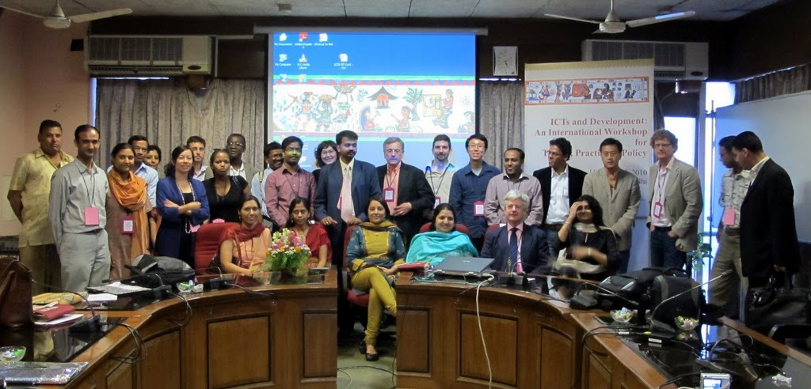

ICTs and Development: An International Workshop for Theory, Practice and Policy

March 2010, IIT Delhi



Session on “Youth, ICTs and Political Engagement in Asia” [slides]

19th AMIC Annual Conference “Technology and Culture: Communication Connectors and Dividers”

21-23 June 2010 Suntec, Singapore



Session on “Youth, ICTs, And Civil Engagement in Asia: A Comparative Approach”

International Association of Media and Communication Research Conference

15-20 July 2012, South Africa

**Publications**

1. Zhang, W. (November, 2020). *I Am Not Interested in Politics!: A Temporal Comparison of Youth between 2011 and 2020*. Paper presented at the online workshop on “Youth, News, and Democratic Engagement”, International Journal of Press/Politics.
2. Zhang, W. & Lallana, E. (2013). Editorial of “Youth, ICTs, and Civic Engagement in Asia”. *International Communication Gazette, 75*(3), 249-252.
3. Zhang, W. (2013). [Redefining youth activism through digital technology in Singapore](https://www.weiyuzhang.net/uploads/2/2/2/7/222747/weiyu.pdf). *International Communication Gazette, 75*(3), 253-270. [slides]
   1. Reprinted in *Youth Culture and Activism in Southeast Asia*. ISEAS, 2015.
4. Zhang, W. & David, C. (2012). Youth engagement and ICTs in Southeast Asia: Reflections on emerging trends. In M. M. Skoric, M. Sachs, & P. Parycek (Eds.), *Proceedings of CeDEM Asia 2012*, Singapore.

**Reports**



1. **YOUTH, ICTs AND POLITICAL ENGAGEMENT IN ASIA FINAL REPORT**



1. **COUNTRY BACKGROUND REPORT**

**Presentations**

1. Zhang, W. (2011). *Change, Youth, Failure, Excellence (****keynote lecture****)*, the 22nd International Youth Forum, Ministry of Gender Equality and Family and National Council of Youth Organizations in Korea, August 18th, 2011. [slides] [transcript]
2. Zhang, W. (2010). *Urban Youth, ICTs, and Civic Engagement in Asia*, East Asia Institute, National University of Singapore, September 13th, 2010. [slides]
3. Zhang, W. (). *Youth Engagement and ICTs in Asia: A Comparative Approach*, The Joint Summer School by Chinese University of Communication, Chinese University of Hong Kong, University of Westminster and University of Pennsylvania, Chinese University of Communication, July 8th, 2010. [slides]

**Partner Institutions**

This research was funded by NUS-University of Sydney Partnership Fund (R-124-000-102-133), International Development Research Center, Canada through ideacorp, the Philippines (R-124-000-037-597) and NUS’ FASS start-up grant (R-124-000-034-133). Any opinions, findings and conclusions or recommendations expressed on this website are those of the authors and do not necessarily reflect the views of the funder.





University of Nottingham, Malaysia

University of Chittagong, Bangladesh

University of the Philippines

Indian Institute of Technology Delhi