|  |
| --- |
| Incline studios |
| Ocean of Leviathans – Side-Scroller |
|  |
| Version 1.0  All Work Copyright © 2012 by Incline Studios  All rights reserved. |
| **Jason Pearson** |
|  |

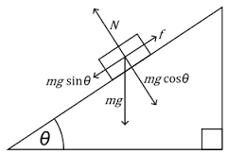

|  |
| --- |
| Nov 13th 2015 |

**Table of Contents**

[Your Table of Contents should go here. Make sure that your document’s sections are hyperlinked to their corresponding pages.]

Table of Contents

**I.** **Game Overview** 3

**II.** **Version Control** 3

**III. Game Play Mechanics** 3

***IV.*** **Camera** 3

**V.** **Controls** 3

1. **Game Overview**

*(ensure you mention the goal of the game and how to win if applicable)*

The goal of the game is to avoid as many Leviathans while plundering at least 20 barrels of loose goods from previously failed excursions. You have 5 lives, prompt an game over when you lose all of them, but if you have at least 1 life, if not all, intact when reaching 20 barrels, you win the game.

1. **Version Control**

For version control, I used Github to track my progress throughout the making of this project.

[Link]

<https://github.com/Jason-Pearson/COMP397_SideScroller-Jason_Pearson>

1. **Game Play Mechanics**

*(how does your game work?)*

You have vertical movement of your ship within the canvas, and if incorporated, the player can shoot cannonballs from the front of the ship. The player can pick up the barrels simply by having the ship (the sails are an extension of the ship body, so that counts as well) make contact with them. When the ship encounters the enemy it warrants losing a life.

1. **Camera**

*(Point of View)*

2-Dimensional, flat. Camera does not move, the ocean image scrolls left and resets to project a constant, moving ocean.

1. **Controls**

*(Which keys does your game use? Does it use the mouse or a joystick?)*

The vertical movement of the ship is attached to the movement of the mouse, having movement as sensitive as your reflexes with the mouse. If incorporated, the shooting mechanic would be mapped to the left mouse click.

1. **Interface Sketch**

*(What does the game interface look like? Provide a screen shot or sketch)*

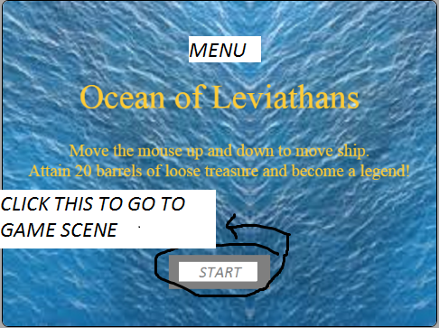

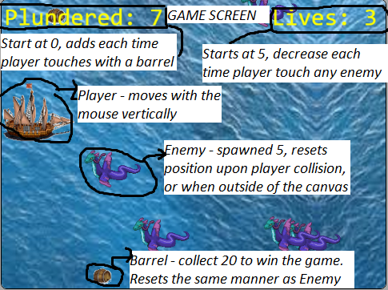

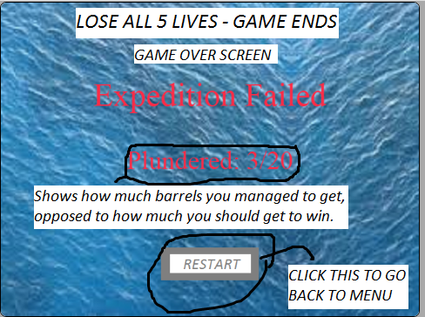

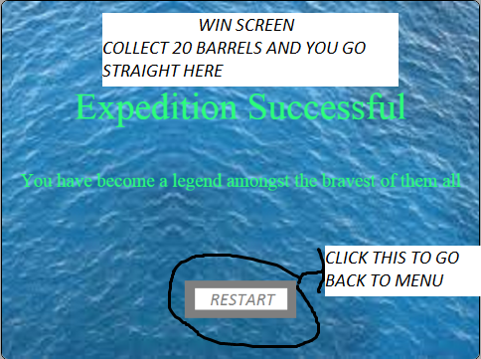

1. **Sound Index**

*(Include an index of all your sound clips)*

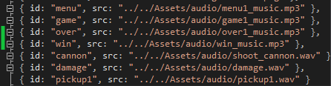

1. **Story Index**

*(Outline your game story here)*

The Wayfarers of Yore embark on their expedition through the Ocean of Leviathans, to plunder treasures from the fallen ships unfortunate to cross here during the peak of their habitation. The recent decline in their population has afforded the Wayfarers an opportunity they are willing to risk their lives on, where death or fame and fortune awaits them.

1. **Art / Multimedia Index**

*(Include an index of all your graphic and video assets here)*

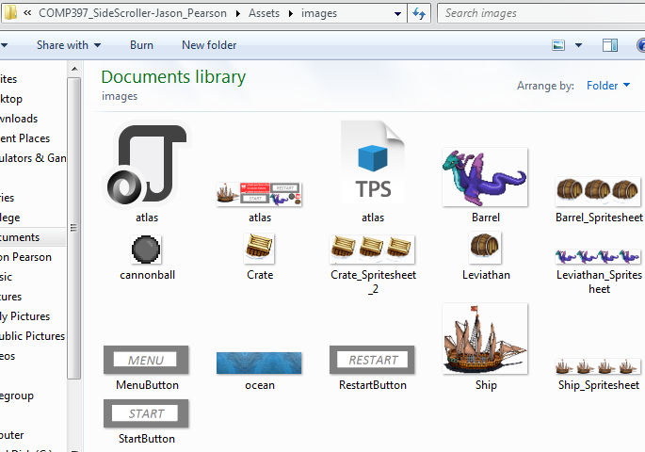

1. **Future Features**

*(Include any future features that are planned to be implemented)*

*-Shoot Cannonballs (press left mouse button, hit Enemy 2 times to defeat them, once it hits an enemy or leaves the canvas, removeChild to remove it from canvas)*

*-Add Animations for Ship, Enemy, Barrel*

*-Add another State called Music Screen (click button on menu screen to go there, you have this game’s soundtrack and full credits to original producers for each song used, click a button next to the title of a song to play it once, click another button to stop all music, click another button to go back to menu)*

*-Ask User what difficulty they prefer (select how many lives and barrels to collected to win)*

*- Story State/Screen (click button on menu to go here, a bunch of states detailing the story behind this game, clicking previous or next until you get to the last transcript, click another button available to exit and go to menu, or another button to go straight to playing the game.*