Project Title

Jason

202316801110

Isaac Aygemang
November 2025

Dissertation Outline

BSc (Hons) Data Science
Stirling College - Chengdu University

Introduction
In vehicle perception systems, understanding the distance between the vehicle and surrounding objects is important for safe driving. A vehicle needs to identify potential obstacles and estimate their locations before making decisions. Although sensors such as Light Detection and Ranging(LiDAR) can provide accurate depth information, their high cost and hardware requirements limit their use in some applications. Cameras provide a more affordable and flexible solution, but a normal RGB image does not contain direct distance information. Monocular depth estimation aims to predict depth information from a single image, making it possible to obtain distance-related information using only one camera. However, improving computational efficiency while maintaining useful depth estimation performance remains a challenge for real-time vehicle applications. This project investigates lightweight monocular depth estimation methods for ground vehicle obstacle awareness.

Background and Context
Describe the problem that you are tackling in more detail. This is likely to be a non-technical section and should be easily understood by a general reader. Motivate why the problem is interesting, and a solution would be useful.
For editorial consistency, it is helpful to use Word styles properly. You should see the most commonly used (quick styles) in the Home ribbon. Chapters are entered using the Heading 1 paragraph style; they start on a new page. The paragraph after a heading automatically uses the Body First paragraph style.
Most text uses the Body Text paragraph style like this paragraph. Ordinary text appears as 11 point Calibri, single-spaced.
In general, use the default spacing that headings and paragraphs give you. Avoid using newlines or spaces to format text. If you need to use quotes, preferably use single curly quotes ‘…’.
Sections are entered using the Heading 2 paragraph style.

Problem Analysis
Drill into the problem to the extent that such analysis is needed to define the scope and objectives of your project. This might include a requirements capture exercise, possibly involving the consultation of potential users and identifying use cases or scenarios.
This section is technical. Use appropriate technical terminology. Demonstrate that you are going to deliver the project as a computing professional (i.e. application of systematic techniques, awareness of relevant professional issues).

Scope and Objectives
Define the scope and objectives of your project. Define the expected results and how others will gain from the work.
Pay attention to your objectives. Make them SMARt (Specific, Measurable, Achievable, Relevant) so that you can develop a credible plan for evaluating them.

State of The Art
Discuss the work of others in the same area as your project. Show critical awareness of what others have done, and how you hope to extend or complement existing capabilities. Give references to other work by using cross-references like [2].
This section may also include a discussion of relevant technologies and a critical analysis of which technologies you plan to use for the project.
It is important to write a critical literature review that identifies gaps in current solutions and that clearly shows how the project was driven to address these gaps. Avoid a banal description of related work that does not carefully analyse its strengths and weaknesses. Compare strengths and weaknesses of related work explicitly to your planned project.
Avoid copying from sources. Use verbatim quotations sparingly and correctly: Use quotation marks and cite the source.

First Section
Your state of the art chapter will probably be long enough to benefit from being divided into sections.

First Subsection
If necessary, also use subsections. Subsections are entered using the Heading 3 paragraph style.

Second Subsection
Notice how Word numbers sections and subsections automatically. Very convenient if you move things around.

First Subsubsection
If you really need subsubsections, enter these using the Heading 4 paragraph style. (Not recommended – and the numbering is not quite right, for some reason.)
You may include figures with diagrams and statistics. (If you copy these, make sure you have permission to do so and attribute the source.) As an example of a figure, consider Figure 1. Captions are entered using the Figure paragraph style. Use automatic figure numbering and cross-references. Let large figures float to the top of the next page rather than having a big gap in the text. If you need something centred as for a figure, use the Body Centre paragraph style.
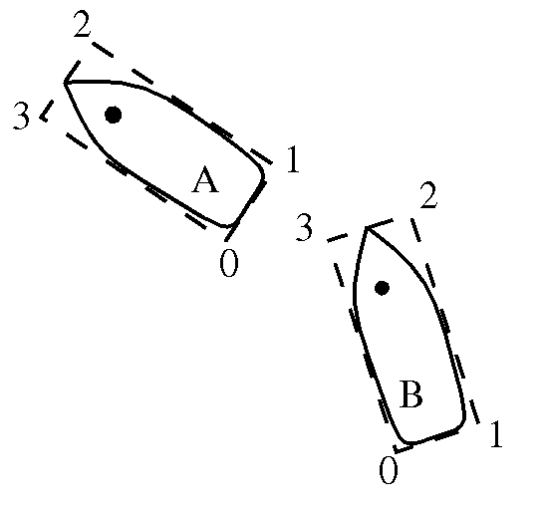
- Highly Technical Diagram

A new paragraph follows. Subsequent figures will be automatically numbered.
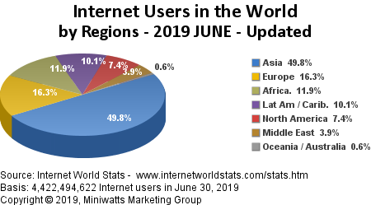
- Internet Statistics

Evaluation Plan
Describe how you will evaluate to what degree your project has achieved the previously defined objectives. Define what counts as success and how you will measure it. (That’s why objectives need to be measurable.)
Your evaluation may involve usability testing: outline how you will recruit testers, how you will conduct tests, and what level of usability counts as success. Or you may do performance evaluation: outline how you will measure performance, what input data you will be using, and what level of performance counts as success.

Project Plan
A table may be helpful to present the plan for your remaining work. You can adapt the template below but be sure to tailor the plan to your specific project – a plan as generic as the template will get low marks. Choose suitable tasks for your project and estimate the likely time you will take to complete those tasks.
Week | Project Task | Deliverables
Autumn: 7 - 8 | Familiarise with XYZ framework and ABC API.
Autumn: 9 - 10 | Implement initial prototype. Testing. | Prototype 1
Autumn: 11 - 12 | Add second feature set. User testing. | Prototype 2
Autumn: 13 - 15 | No project work - exams.

Week | Project Task | Deliverables
Pre-Spring | Continue developing prototype and testing.
Spring: 1-2 | Interim demo.  Add third feature set. | Prototype 3
Spring: 3-4 | Add fourth feature set. | Prototype 4
Spring: 5-6 | Rigorous testing of prototype. Prepare for final user tests and evaluation.  Prepare poster and attend poster session. | Test script  Poster
Spring: 7-8 | User testing and evaluation. Final tweaking of prototype.  Draft dissertation structure. Use feedback from dissertation outline to revise initial chapters. | Dissertation chapters 1-3
Spring: 9-10 | Draft technical chapters.  Submit parts of your draft to supervisor for comments (at least 2 weeks before deadline). | Dissertation chapters 4, 5, …
Spring: 11-12 | Draft evaluation and conclusions chapters. Address supervisor’s comments. Polish dissertation.  Submit dissertation and code. | Complete dissertation draft  Final Dissertation
Spring: 12-13 | Final Demo

References
Use the Reference paragraph style to enter and cross-reference document references. Books [1], standards [2], reports [3], journal articles [4], conference papers [5], and web pages [6] are conventionally presented in slightly different ways. Observe that all references should have a clickable hyperlink to the work, as shown in the bibliography below.

- Greene, D. and Williams, P. C. Linear Accelerators for Radiation Therapy, Second Edition. IOP Publishing Ltd., Bristol and Philadelphia, 1997. Link: https://doi.org/10.1201/9780429246562
- ISO. Language Of Temporal Ordering Specification, ISO 8807, International Organization for Standardization, Geneva, 1989. Link: https://www.iso.org/standard/16258.html
- Jacobson, J. and Andersen, O., editors. Software Controlled Medical Devices. SP Report 1997:11, Swedish National Testing and Research Institute, Sweden, 1997. Link: https://www.diva-portal.org/smash/get/diva2:962037/FULLTEXT01.pdf
- Turner, KJ and Jennings, MA. The Rules of Sailing Races for Hand-Held Devices, Journal of Navigation. 2002;55(2):263-275. Link: https://doi.org/10.1017/S0373463302001765
- Ji, H. and Turner, K. J. Specification and Verification of Synchronous Hardware using LOTOS. In Wu, J. Chanson, S. T. Gao, Q. editors, Proc. Formal Methods for Protocol Engineering and Distributed Systems (FORTE XII/PSTV XIX), pages 295-312, Kluwer Academic Publishers, London, UK, October 1999. Link: https://doi.org/10.1007/978-0-387-35578-8_17
- University of Stirling. Computing Science and Mathematics Research Home Page, https://www.cs.stir.ac.uk/research (accessed Sep 09, 2023).

