In the pictures below, it shows a variable “x = 5”, then it displays what the variable is equal to. If using loops, it will instantly tell you what the end product of that loop will be. This feature alone will eliminate reptitive runs and debugs.

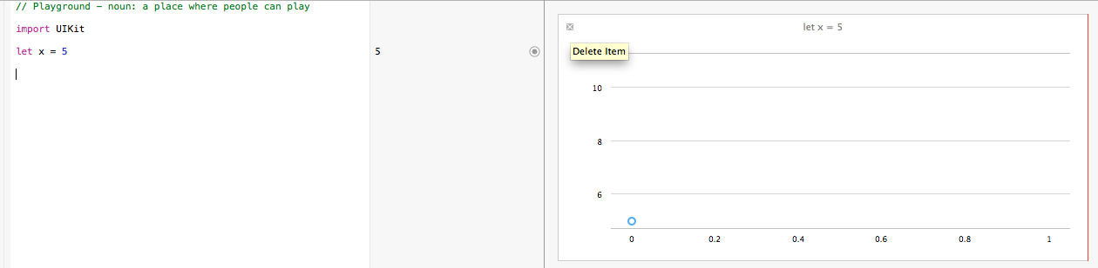

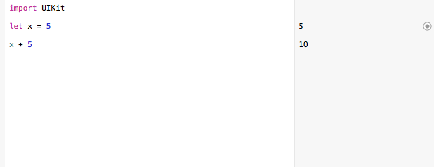

When using loops, swift will display the amount of times the loop will occur and then display the contents of the iterations in seconds

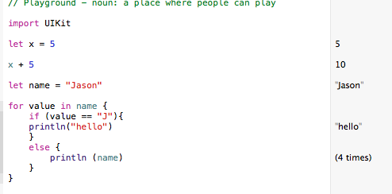

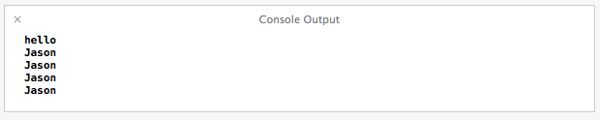

This is just one of the many great features provided in Swift

Link to code

<https://github.com/Jason-Robinson/CMP_SC-4830/blob/master/Exploration1.playground/section-1.swift>