LAB 02
Student_Name: Nguyễn Phúc Minh Châu
Student_ID: 22302421
————
PART 1 – Data Understanding & Descriptive Analytics
Step 1: Load Data
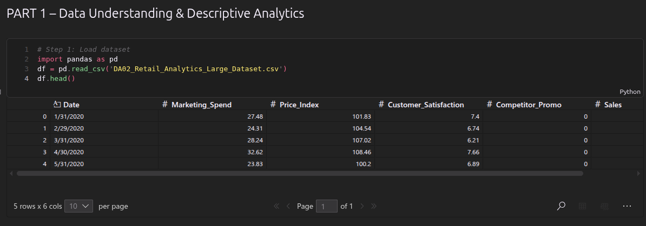
Step 2: Summary Statistics
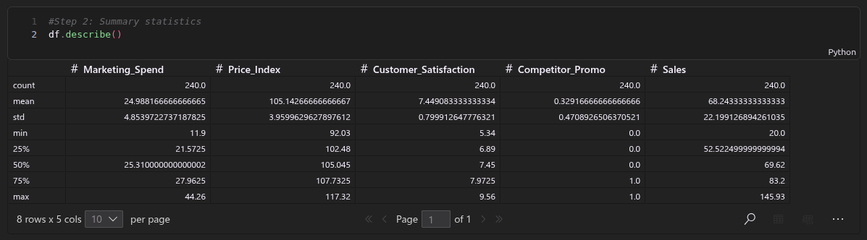
Step 3: Sales Trend Visualization
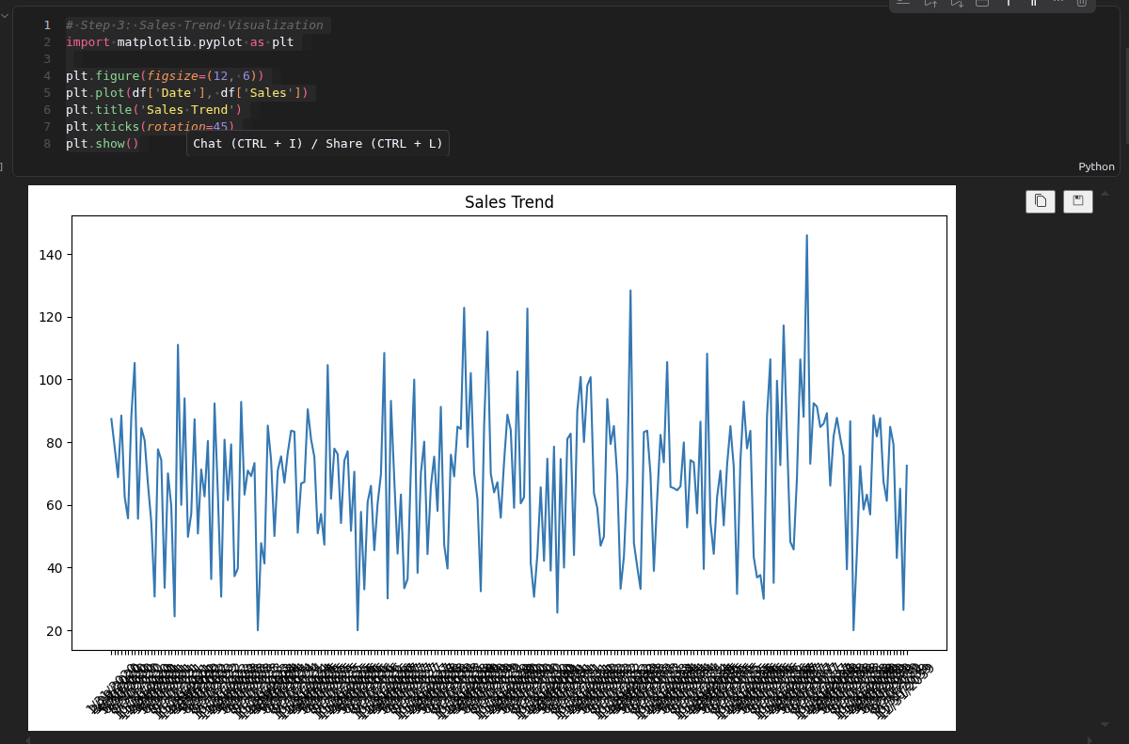
Exercise 1
What is average monthly sales? | 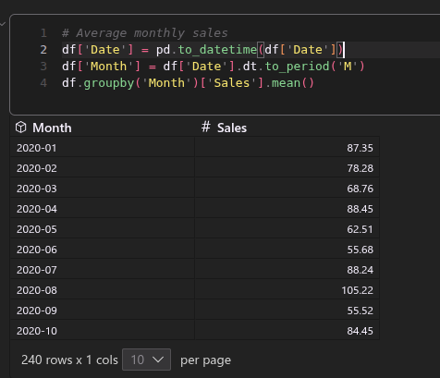
What is the highest sales month? | 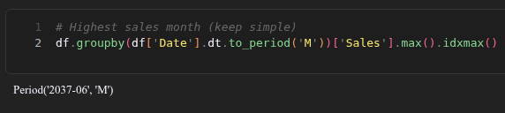
Is there an upward or downward trend? | 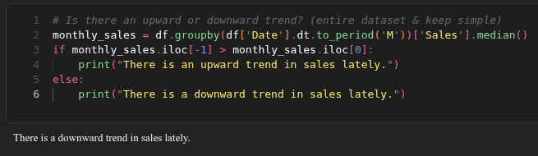
PART 2 – Diagnostic Analytics
Step 4: Correlation Matrix
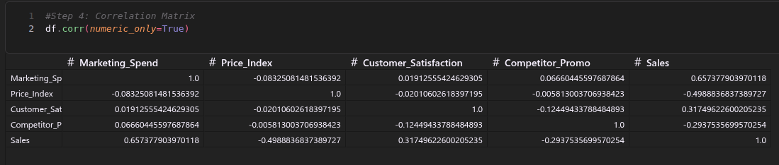
Step 5: Relationship Visualization
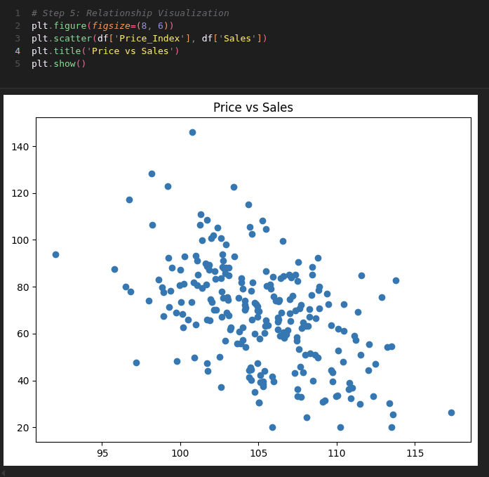
Step 6: Competitor Impact
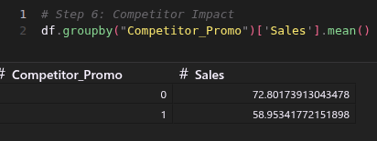
Exercise 2
Which variable has strongest impact on sales? | 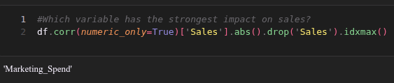
Does competitor promotion reduce sales? | 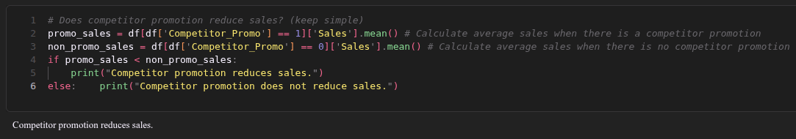
Is higher satisfaction associated with higher sales? | 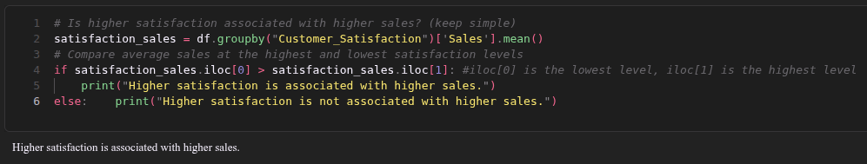
PART 3 – Predictive Analytics
Step 7: Regression Model
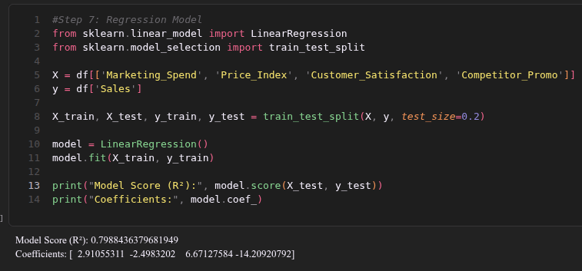
Exercise 3
Interpret coefficient of Price_Index. | 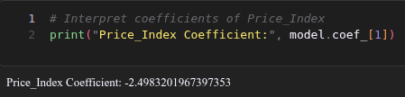
Which variable has largest impact? | 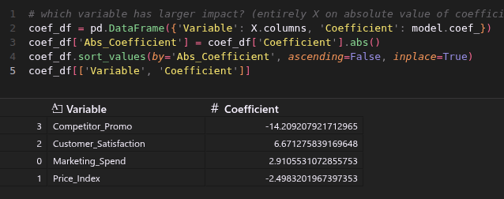
What does R² indicate? | R² measures how well a regression model explains the variability of the target variable. In other words, it tells you what proportion of the variance in the dependent variable (Sales) is predictable from the independent variables (Marketing_Spend, Competitor_Promo, etc.).  Interpretation  - R² = 1.0 → Perfect fit. The model explains 100% of the variance.  - R² = 0.0 → The model explains nothing equivalent to just predicting the mean yˉ​ every time.  - R² < 0 → The model performs worse than a horizontal mean line (very poor fit).  Applied to the dataset we can see that R2=0.7988≈80%  The model explains 79.88% of the variance in Sales using the four features — Marketing_Spend, Price_Index, Customer_Satisfaction, and Competitor_Promo. The remaining 20.12% is attributed to factors not captured in the model.
PART 4 – Prescriptive Analytics
Step 8: Scenario Testing
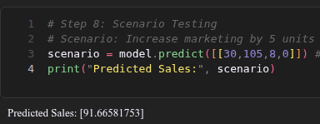
Step 9: Optimization Simulation
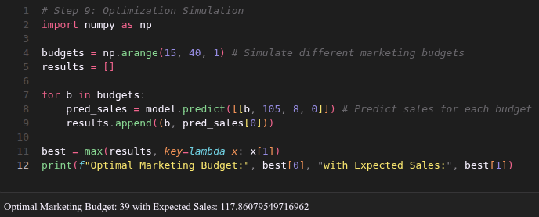
Exercise 4
What marketing budget maximizes predicted sales? | From the output: Optimal Marketing Budget: 39 with Expected Sales: 117.86  Budget = 39 units yields the highest predicted sales of ~117.86 across the simulated range of np.arange(15, 40, 1) — meaning the model was tested for every budget from 15 to 39, and 39 came out on top.  This makes sense given Marketing_Spend has a positive coefficient (+2.91) — more spend → more sales, so the optimizer naturally hits the ceiling of the tested range (39).  Worth noting: the simulation only goes up to 39. If you extend the range further, the optimal might shift higher — worth testing.
Should the company raise or lower prices? | Looking back at the coefficients: Price_Index → coefficient = -2.50  Lower prices. Price_Index has a negative relationship with Sales — every unit increase in price is associated with a ~2.50 unit drop in predicted sales.  However, this is a trade-off decision: ActionSales impactRevenue impactLower price↑ Sales volumeDepends on marginRaise price↓ Sales volumeHigher per-unit revenue  The model only predicts volume, not profit — so the final answer depends on the company's margin structure. If margins are thin, lowering price to drive volume may not be worth it.

