DA05 – Lab
Student ID: 22302421
Student name: Nguyễn Phúc Minh Châu

Business Scenario
You are a Data Analyst at a retail company.
Your manager wants insights about:
- Sales performance over time
- Best-selling products
- Revenue trends
- Opportunities for growth
Dataset Description
File: DA05_retail_sales_dataset.csv
Column | Description
date | Transaction date
product | Product name (A, B, C, D)
units_sold | Quantity sold
price | Price per unit
revenue | units_sold × price

Exercise 1: Load & Inspect Data
(read data, head, info, describe)
Answer:
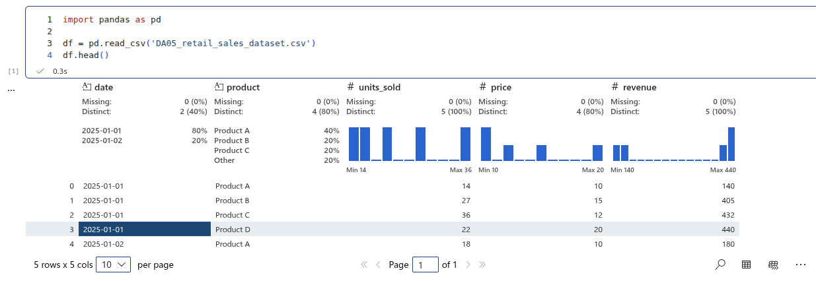
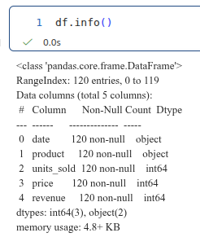 | 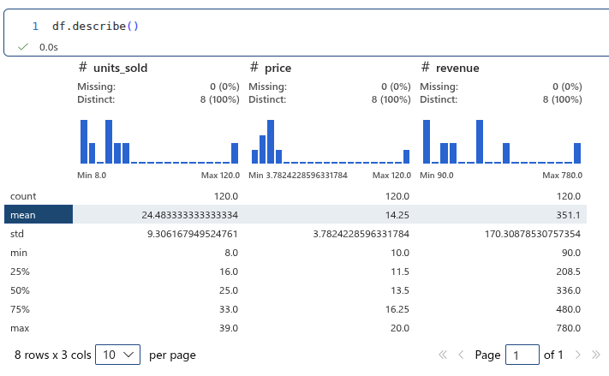

Exercise 2: Total Revenue by Product
Which product generates the most revenue?
Answer:
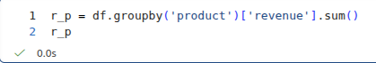
Result:
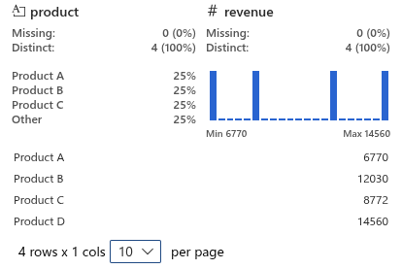
Exercise 3: Daily Revenue Trend
Answer:
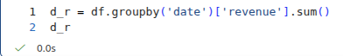
Result:
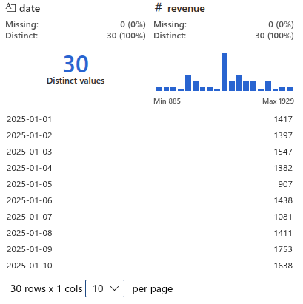
Exercise 4: Visualization – Revenue Over Time
Answer:
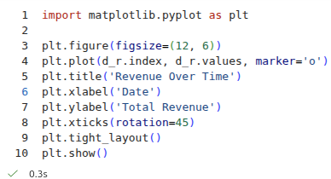
Result:
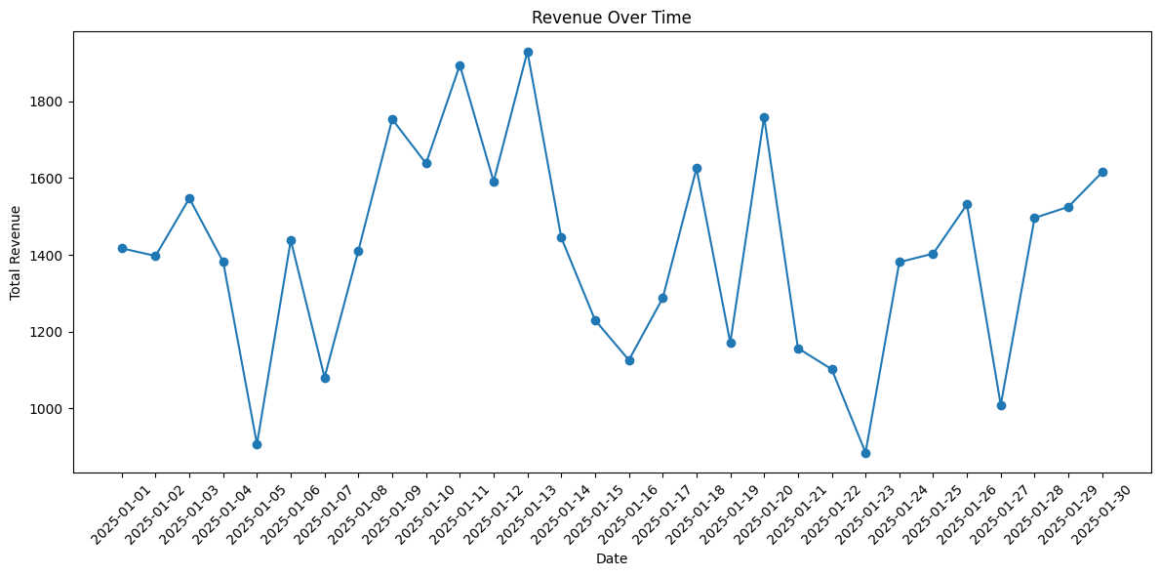
Exercise 5: Compare Product Performance (Bar Chart)
Answer:
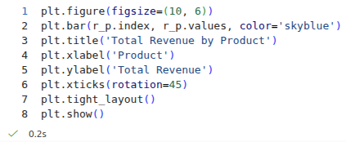
Result:
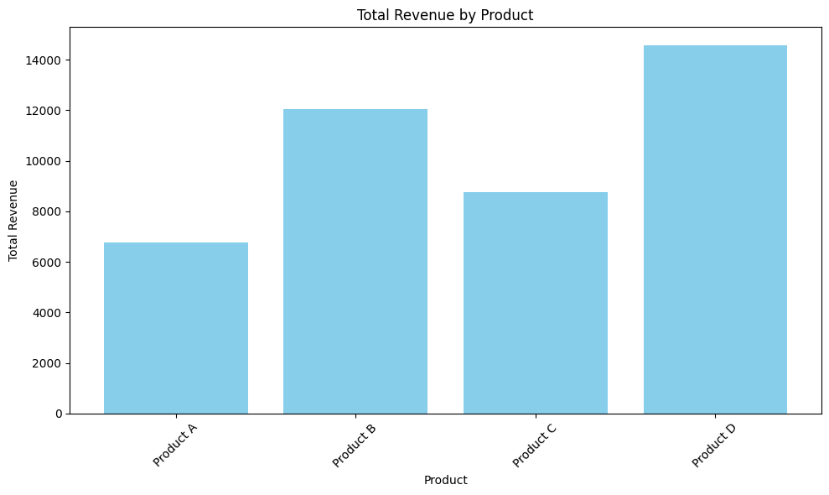
Exercise 6: Average Units Sold per Product
Answer:
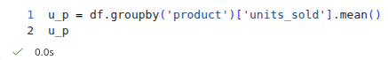
Result:
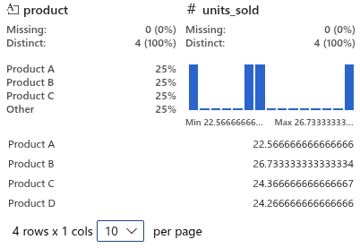
Exercise 7: Find Best Day (Highest Revenue)
Answer:
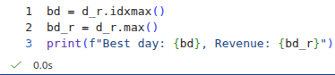
Result:

Exercise 8: Detect High Sales Days (Anomaly)
Days with revenue above average
Answer:
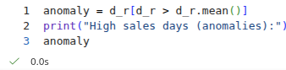
Result:
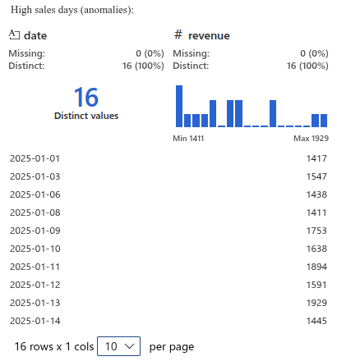
Exercise 9: Pivot Table (Business Dashboard Style)
Answer:
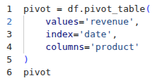
Result:
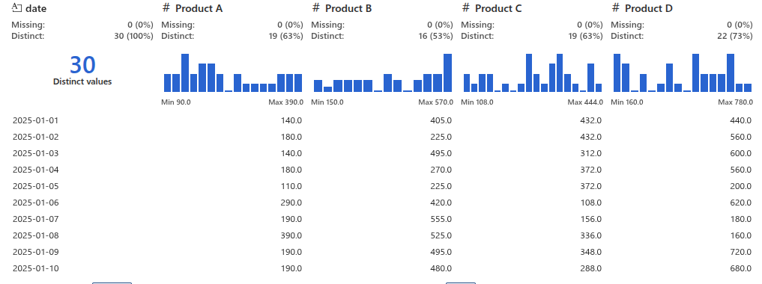
Exercise 10: Visualization – Multi-line Product Trend
Answer:
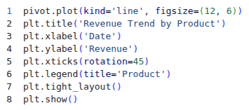
Result:
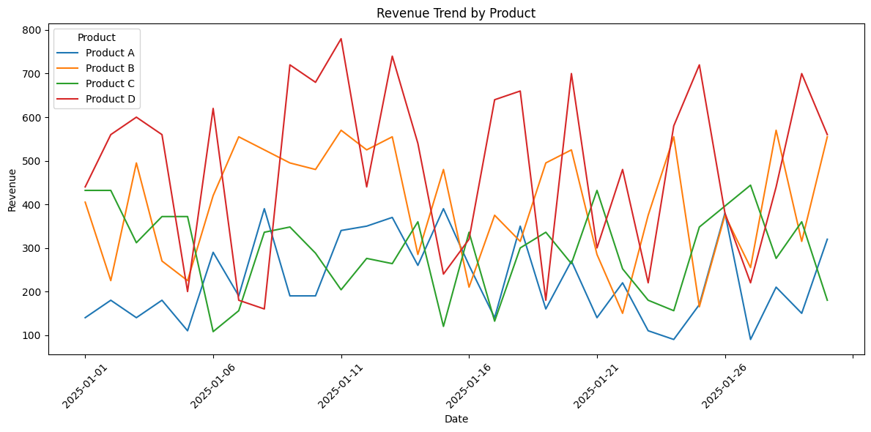
END

