DA07 – Lab
Student ID: 22302421
Student name: Nguyễn Phúc Minh Châu

Give a dataset
import pandas as pd
import numpy as np

orders = pd.DataFrame({
'order_id': [1,2,3,4,5,6],
'customer_id': ['C1','C2','C1','C3','C2','C4'],
'product': ['Laptop','Phone','Tablet','Laptop','Tablet','Phone'],
'price': [1000,500,300,1200,350,450],
'quantity': [1,2,1,1,3,2],
'date': pd.to_datetime(['2024-01-01','2024-01-02','2024-01-05','2024-02-01','2024-02-10','2024-03-01'])
})

customers = pd.DataFrame({
'customer_id': ['C1','C2','C3','C4'],
'city': ['HCM','HN','HCM','DN'],
'segment': ['VIP','Normal','VIP','Normal']
})

Exercise 1: Calculate the total revenue per customer (merge + groupby).
Answer:
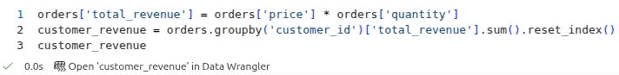
Result:
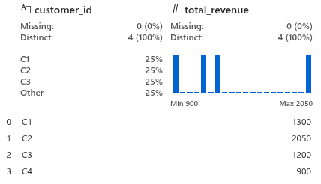
Exercise 2: Select the top 2 customers with the highest revenue.
Answer:
Result:
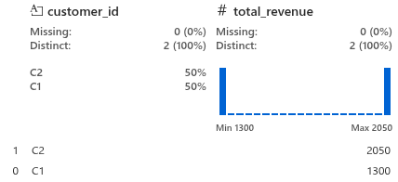
Exercise 3: Calculate total revenue by city (multi-group).
Answer:
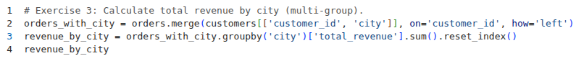
Result:
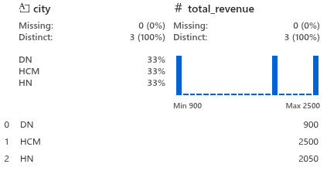
Exercise 4: Pivot table for monthly revenue
Create table: row = month, column = product, value = revenue.
Answer:
Result:
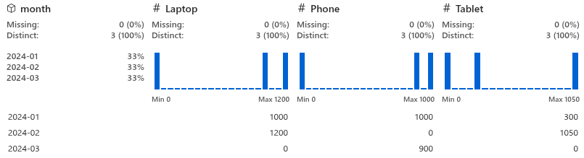
Exercise 5: Find customers who have placed more than one order.
Answer:
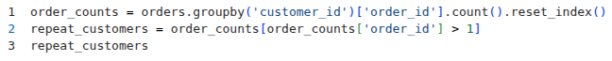
Result:
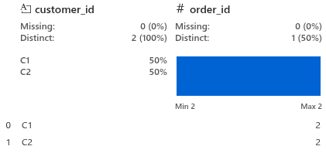
Exercise 6: Divide customers into 3 groups (binning): Low, Medium, High.
Answer:
Result:
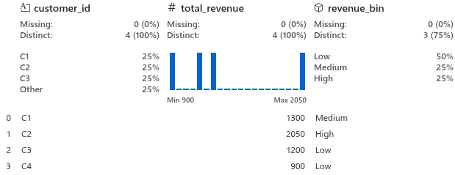
Exercise 7: If there is a missing value in the price, replace it with the average.
orders.loc[2, 'price'] = np.nan
Answer:
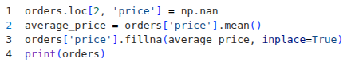
Result:
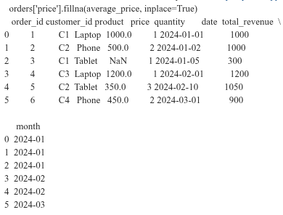
Exercise 8: Look for orders with unusually high prices (Detecting outliers (simple z-score)).
Answer:
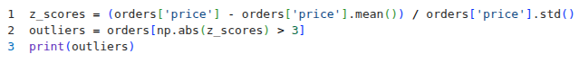
Result:
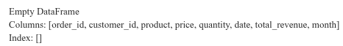
Exercise 9: Three orders are randomly selected.
Answer:
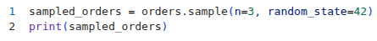
Result:
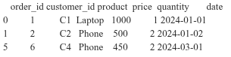
Exercise 10: Calculate total revenue by month and sort by time (Analyze time series (monthly trends)).
Answer:
Result:
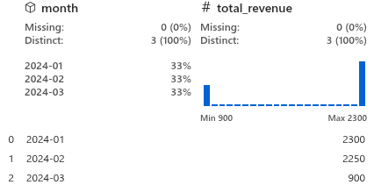

END

