DA08 – Lab
Student ID: 223025421
Student name: Nguyễn Phúc Minh Châu

File: DA08_sales_data.csv

Exercise 1: Upload data file and display the first 5 lines.
Answer:
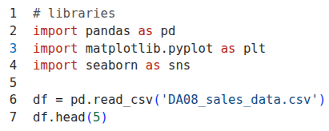
Result:
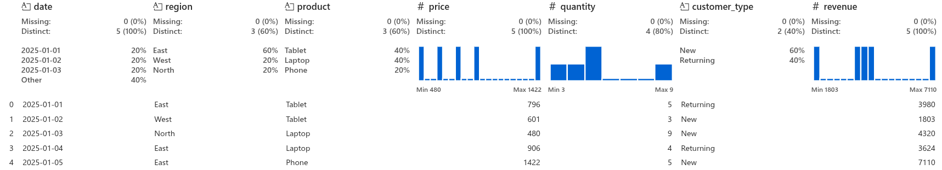
Exercise 2: Draw a line chart: total revenue over time.
Answer:
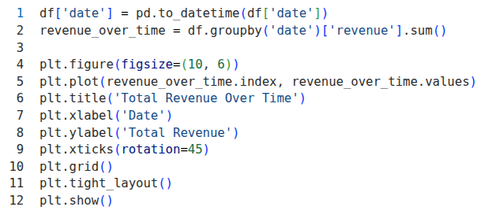
Result:
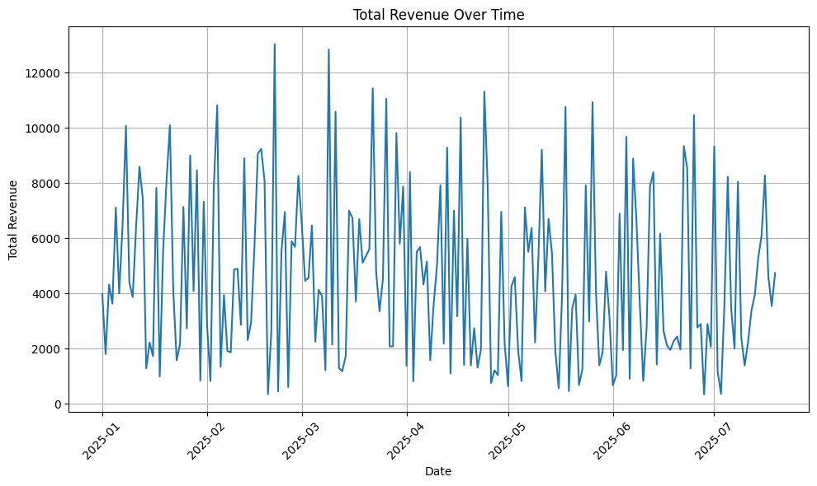
Exercise 3: Draw a bar chart: total revenue by region.
Answer:
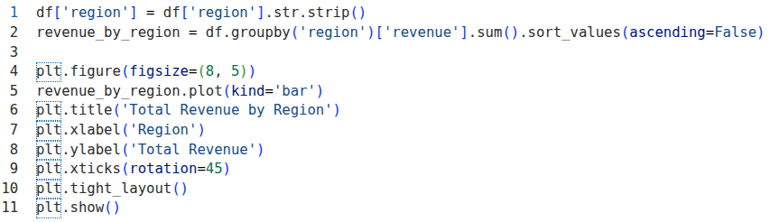
Result:
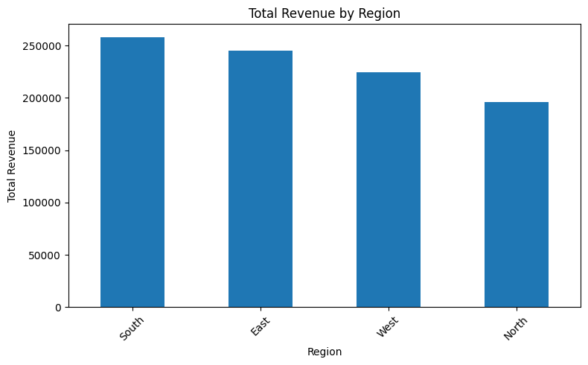
Exercise 4: Plot a histogram: revenue distribution
Answer:
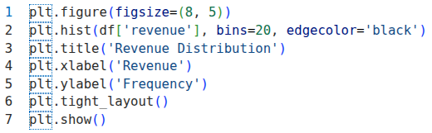
Result:
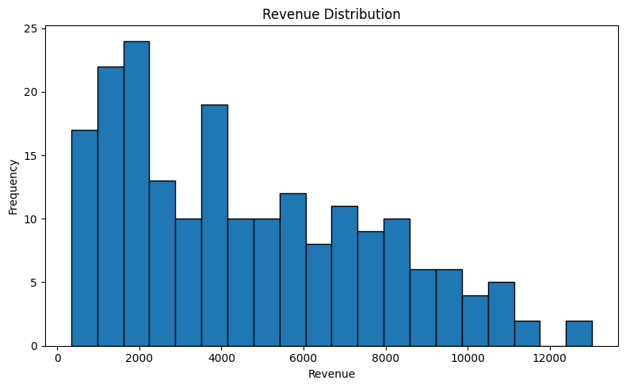
Exercise 5: Compare revenue between products over time (multi-line chart).
Answer:
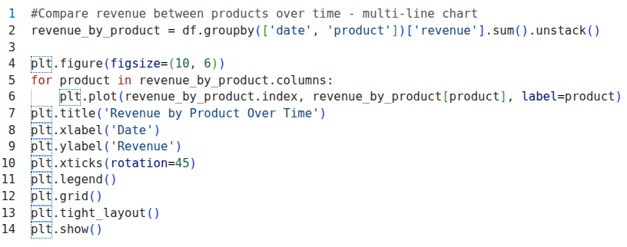
Result:
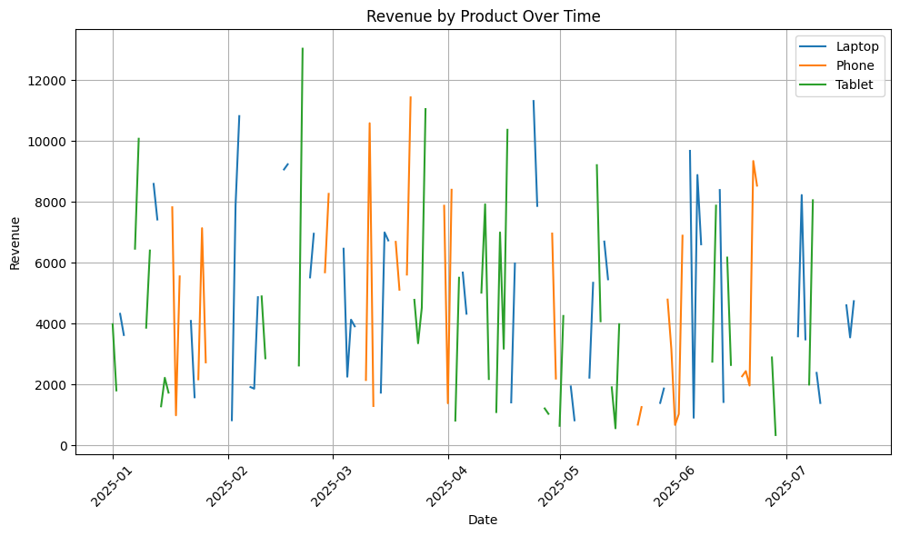
Exercise 6: Revenue according to customer_type (Draw boxplot, seaborn).
Answer:
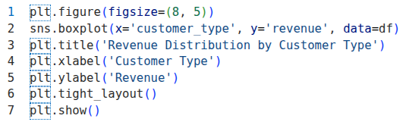
Result:
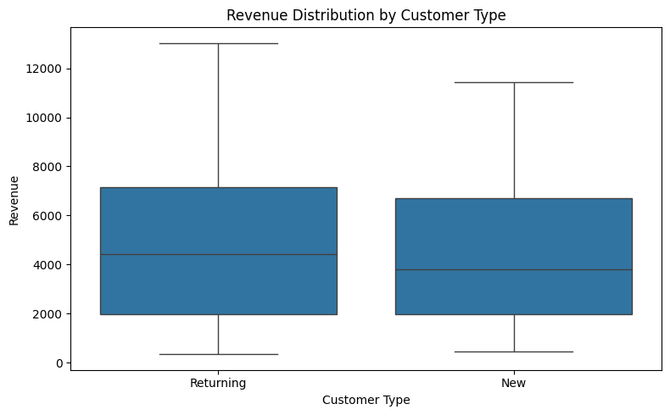
Exercise 7: Draw scatter plot: price vs quantity.
Answer:
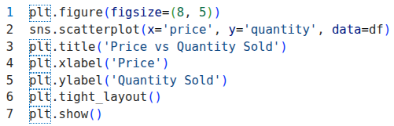
Result:
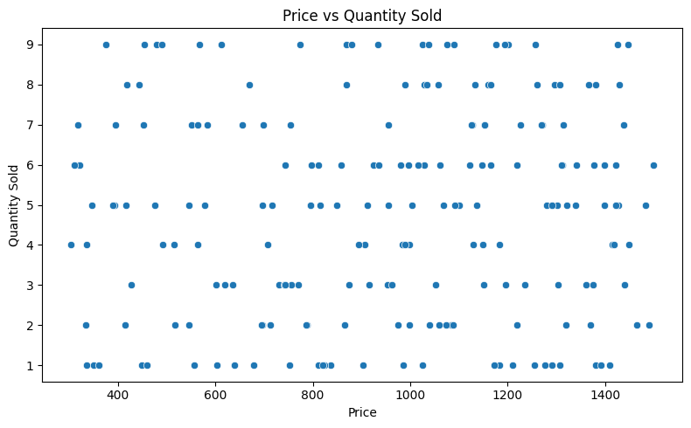
Exercise 8: Draw a Heatmap correlation.
Answer:
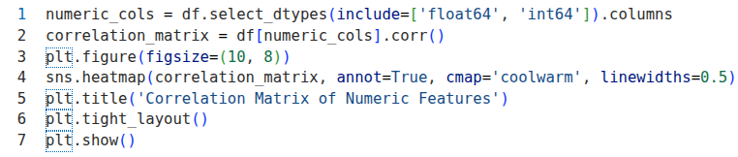
Result:
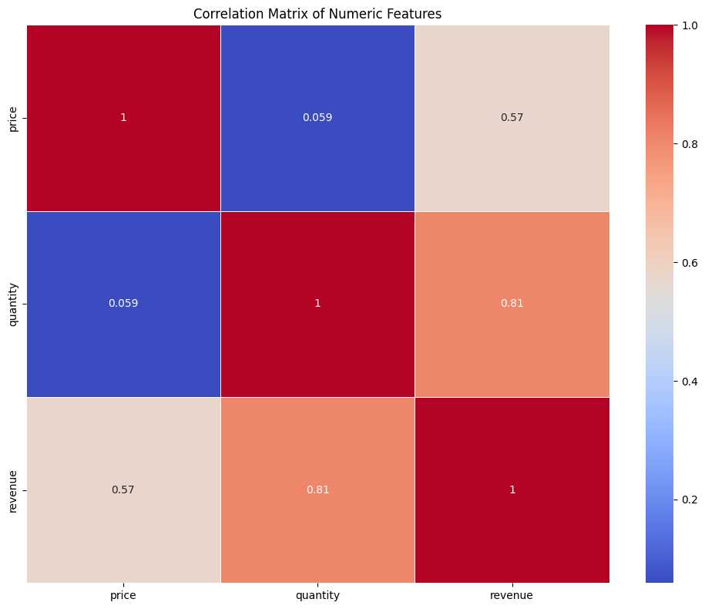
Exercise 9: Drawing Subplots:
- Revenue by region
- Revenue according to product.
Answer:
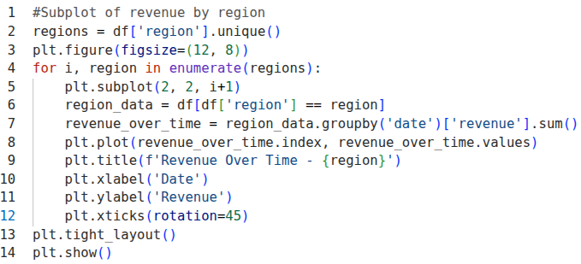
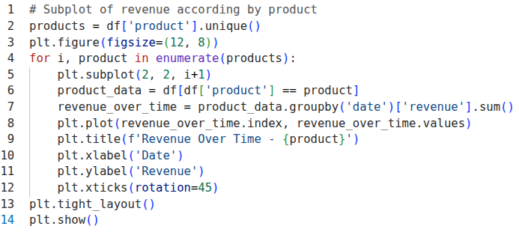
Result:
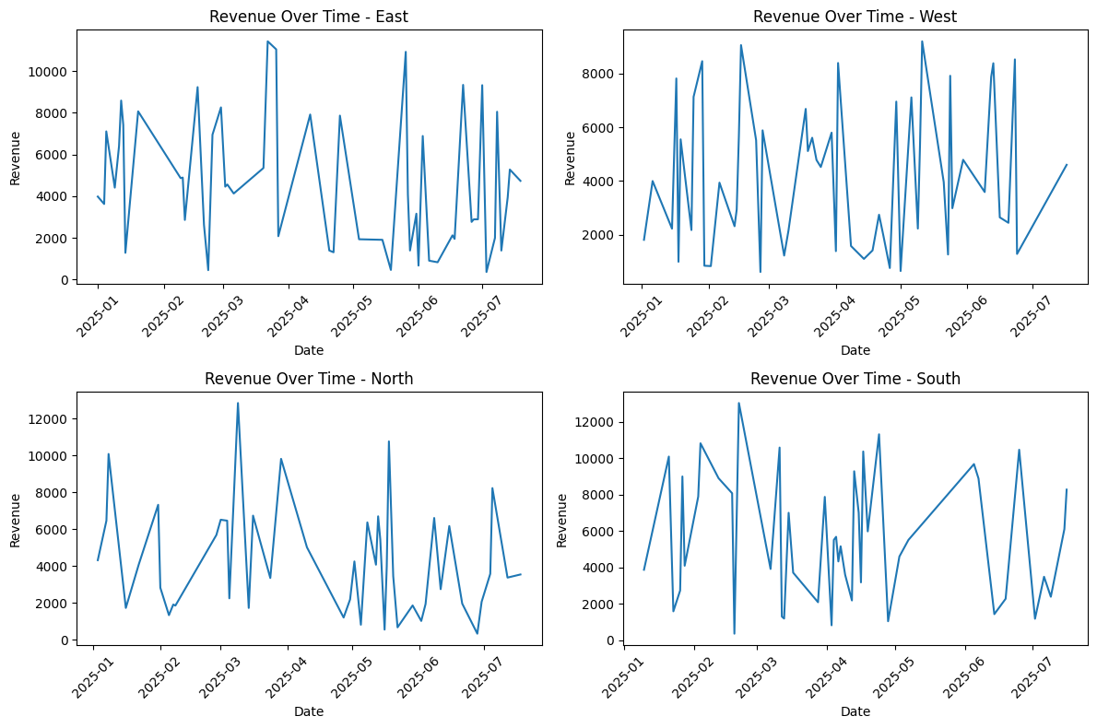
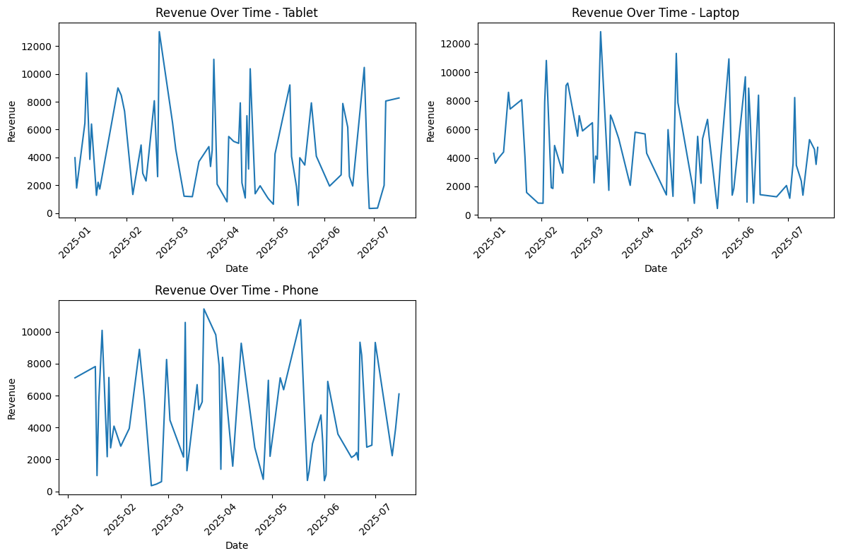
Exercise 10: Analysis:
- Which region sells best?
- Which product has the highest profit?
- How is it distributed?
- Are there any outliers?.
Answer:
Which region sells best?
Which product has the highest profit?
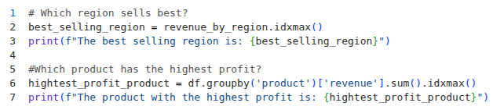
How is it distributed?
It's distributed in a way that most of the revenue is generated by a few products, while the majority of products contribute less to the total revenue.
Are there any outliers?.
Yes, there are outliers in the revenue data. The boxplot of revenue by customer type may show some points that are significantly higher than the rest of the data, indicating that there are some transactions with unusually high revenue. These outliers could be due to large orders, special promotions, or errors in the data entry. It's important to investigate these outliers further to understand their cause and impact on the overall analysis.
Result:
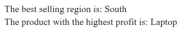
END

