TACTICAL FX RESEARCH

Short USD/THB
  - Buy the Q3 external-balance inflection
A tactical long-THB trade into end-September
Independent deep-dive anchored on Nomura's 31 Jul 2026 view and verified against BoT, U.S. Treasury, Fed/BLS, Krungsri/MUFG and current market data.
06 August 2026
Market data cut: ~11:00 ET / latest available official releases
For research and discussion only. Not personalized investment advice; execution eligibility, liquidity and local FX rules must be checked with the relevant dealer/compliance function.

Executive summary
BOTTOM LINE The trade is attractive on a rebound, not as a chase. Prefer selling USD/THB at 33.15–33.30, target 32.00 by end-September, stop/invalidation 33.90. The thesis is a flow inflection—current account, tourism and equity inflows—plus two-sided USD risk; it is not a Thai growth-boom call.

Trade sheet
Item | Recommendation | Desk rationale
Direction | Short USD/THB / long THB | Tactical; conviction 3/5
Entry | 33.15–33.30 preferred | Current ~33.06 has already moved; avoid chasing
Target / horizon | 32.00 / end-Sep 2026 | Nomura target; within broader published forecast envelope
Stop | 33.90 | Nomura invalidation anchor; reassess earlier if oil/Fed regime breaks
Carry | ~43bp headwind to 30 Sep* | 6m SOFR–THOR gap ~285bp; actual forward/basis differs
Source: Nomura, 31 Jul 2026 (user-provided); Krungsri/MUFG; Trading Economics spot
- Why it works: Q2 current account was -$17.7bn, but June improved to -$3.47bn and Nomura sees Q3 +$1.1bn; BoT independently says the external balance should improve as energy effects fade.
- Why now: tourism has troughed seasonally, July equity buying was +THB48.8bn, DXY is near a six-week low, and Brent has fallen from >$100 in late July toward ~$80.
- What can break it: a renewed oil shock, hot U.S. CPI/NFP that re-prices Fed hikes higher, persistent Thai current-account deficits, portfolio outflows, or a BoT preference for a weaker baht.
*Simple accrual estimate using the July 6m rate gap and 55 calendar days. This is a carry approximation, not an executable forward quote.

1. Thesis architecture: what survives independent verification
Nomura's five-pillar case is directionally coherent, but the evidence is uneven. The current-account and tourism channels are the highest-quality pillars; portfolio flows are supportive but more tactical; reserve/intervention evidence is suggestive rather than definitive; and the broad-USD leg has become a repricing story rather than a clean dovish-Fed story.
Pillar | Evidence now | Assessment
Q2→Q3 current account | Q2A -$17.7bn; June -$3.47bn; Nomura Q3F +$1.1bn | CORE — strongest flow catalyst
Tourism seasonality | June 1.84m; week ended 25 Jul 584k | CORE — run-rate improving
Portfolio flows | July equities +THB48.8bn; bonds -THB11.0bn | SUPPORT — equity-led, not broad
Broad USD | DXY ~99.75; Fed held 3.50–3.75%, 9–3 | SUPPORT — two-sided; NFP/CPI critical
BoT / reserves | FX reserves -$3.7bn raw 17→24 Jul | TACTICAL — intervention not proven
Source: Nomura, 31 Jul 2026; BoT; Krungsri/MUFG; Federal Reserve
INDEPENDENT ADJUSTMENT TO NOMURA Do not label the July FOMC simply 'dovish'. The Fed held, but three members dissented for a hike and the market still prices material September tightening risk. The bullish-THB angle is that the USD bar is high and data misses can unwind pricing faster than modest beats can extend it.

2. External balance: the trade is a Q2→Q3 flow inflection
The Q2 deficit was unusually large and mechanically ugly: April–June current account balances were -$7.79bn, -$6.43bn and -$3.47bn. But the monthly direction is improving, and the composition supports a tactical reversal. BoT says the Middle East shock lifted energy imports and inventory accumulation; May also carried seasonal profit repatriation and tourism low-season effects.
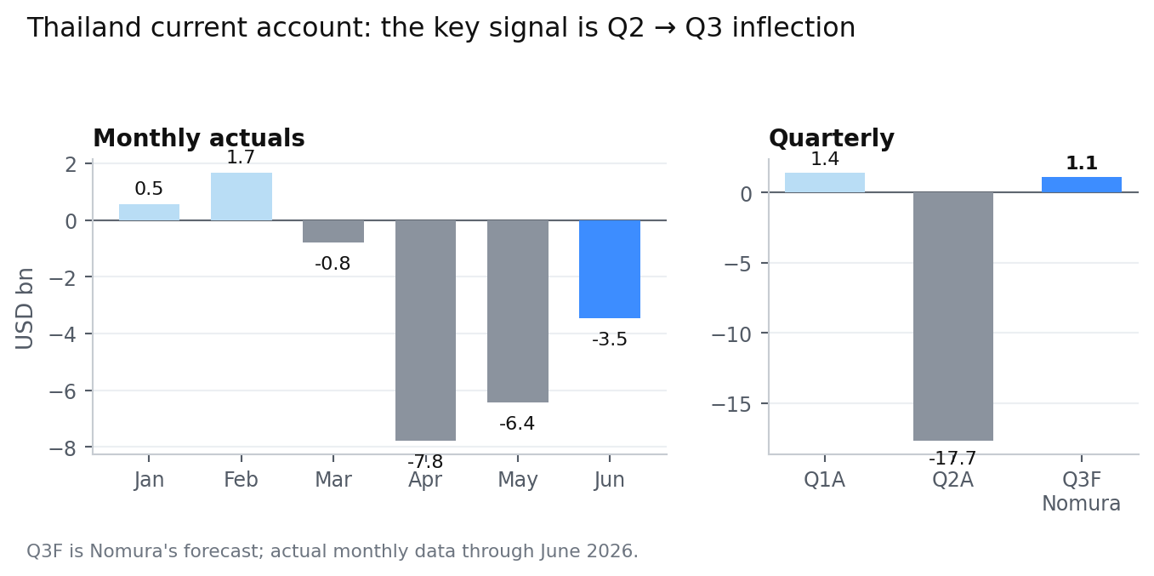
Figure 1. Current-account damage peaked in Q2; Nomura expects a swing back to surplus in Q3.
Source: BoT monthly BOP; Nomura Q3 forecast
- Q2 actual: -$17.70bn, matching Nomura's cited -$17.7bn base. June improved by ~$3.0bn versus May.
- BoT's Q2 MPR says the current account should improve as oil falls and tourism normalizes, but its longer-term language is more cautious than Nomura's near-term Q3 forecast.
- The full-year story is not a return to old-style surpluses: Thailand's Fiscal Policy Office forecast for 2026 is about -$0.5bn, so the trade depends on timing, not structural exuberance.

3. Tourism: a June trough, not yet a full recovery
Tourism is the cleanest high-frequency confirmation of the seasonal thesis. Official monthly arrivals fell from 3.28m in January to 1.84m in June. Nomura cites 584k arrivals in the week ended 25 July; annualizing that week to a monthly run-rate gives ~2.54m, roughly 38% above June's realized monthly pace.
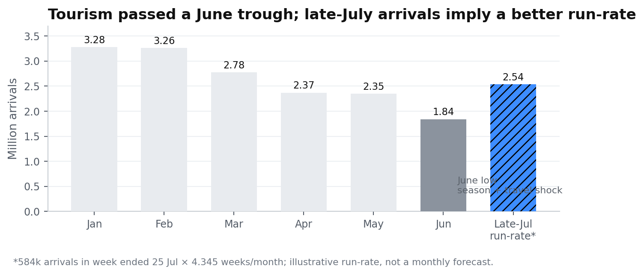
Figure 2. Late-July weekly arrivals point to a better run-rate than June.
Source: BoT tourism indicators; Nomura / Ministry of Tourism weekly data
- BoT independently expects Q3 arrivals to improve QoQ, even while contracting slightly YoY because travel costs remain high.
- Quality can matter more than headcount: BoT projects 2026 spending per trip at THB45.8k versus THB41.7k in 2025, lifting tourism receipts to ~THB1.5trn despite flat 33m arrivals.
- Risk: new visa rules, Middle East travel disruption and short-haul weakness can delay the improvement; a few strong weeks should not be mistaken for a structural tourism boom.
Source: BoT Monetary Policy Report Q2 2026

4. Portfolio flows: the equity channel flipped decisively
The July move is not a broad fixed-income carry story. It is primarily an equity-flow reversal. Krungsri/MUFG reports +THB48.8bn net foreign buying of SET shares in July against -THB11.0bn net selling of Thai government bonds. Through seven months, equities and bonds were both positive, but the July impulse came from equities.
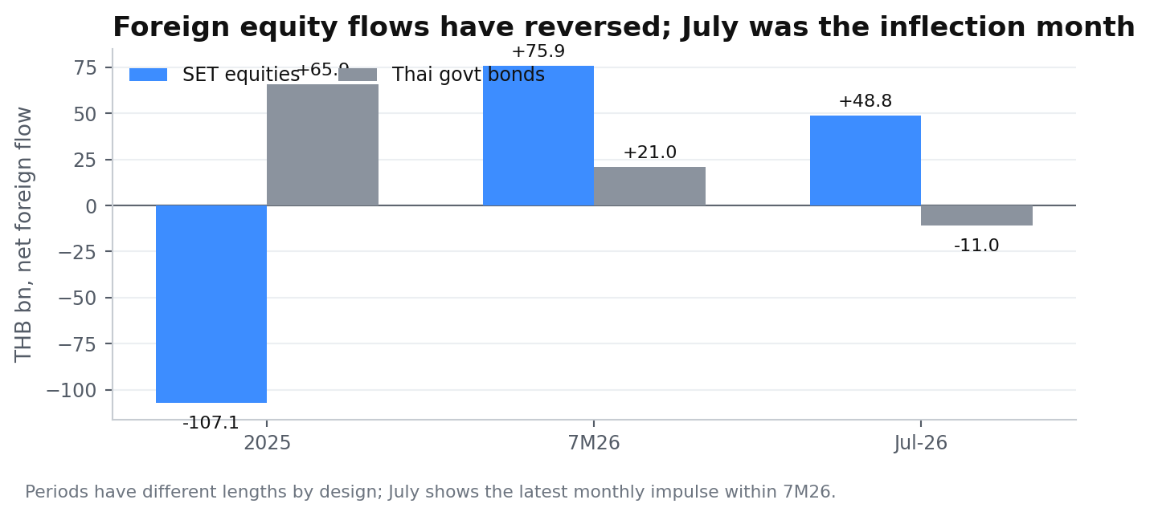
Figure 3. Equity inflows reversed a weak 2025; July drove the latest impulse.
Source: Krungsri/MUFG THB Thermometer
- This corroborates Nomura's end-July estimate (+$1.3bn equities, -$0.5bn bonds) while using the subsequently published full-month Krungsri figures.
- The composition is useful for THB spot, but fragile: an equity risk-off move or renewed energy shock could reverse it quickly.
- Medium-term FDI is constructive but slow-moving. Krungsri cites $43bn of H1 investment applications (+37% YoY); applications are not immediate FX inflows, so they are a background support, not a trade trigger.

5. BoT and reserves: a tactical floor, not a structural tailwind
Nomura estimates BoT sold about $3.3bn of FX reserves (spot + forwards) in the week ended 24 July while USD/THB was almost flat. Official weekly data show foreign-currency reserves fell by $3.69bn from 17 to 24 July. That coincidence is consistent with smoothing, but raw reserve changes include valuation and other balance-sheet effects and therefore cannot prove intervention by themselves.
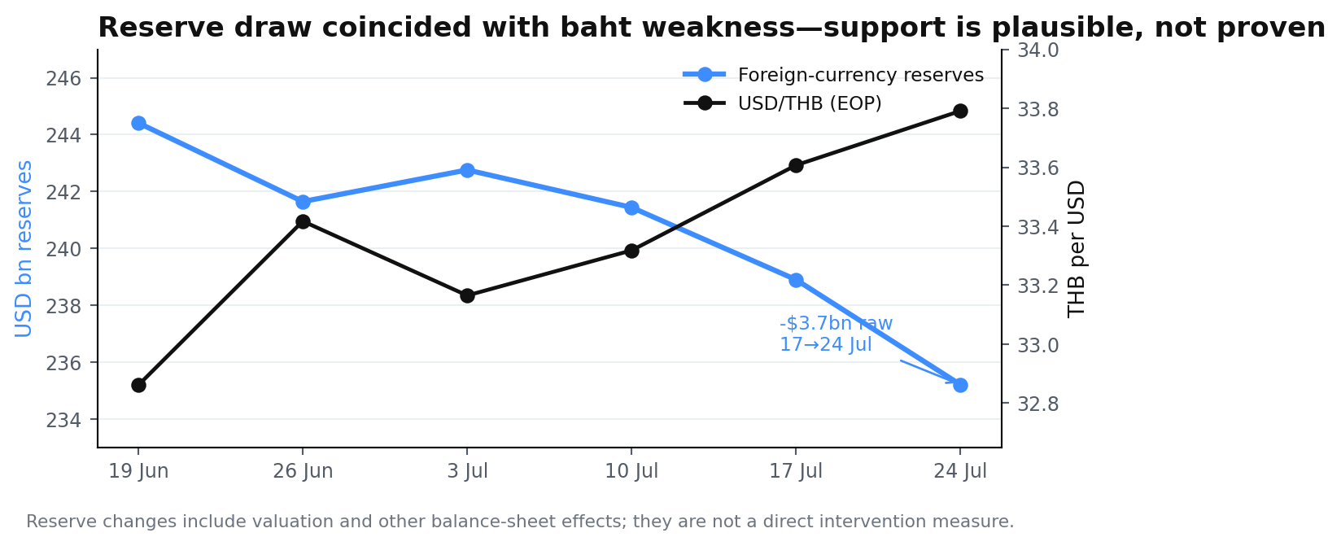
Figure 4. Reserve draw accelerated as USD/THB weakened the baht into 24 July.
Source: BoT weekly reserves; Nomura intervention estimate
IMPORTANT COUNTER-EVIDENCE U.S. Treasury reports that BoT bought about $10bn of FX in 2025 to smooth baht appreciation. That history means BoT is not structurally 'long THB'. Recent support, if present, should be treated as volatility management, not a one-way policy put.

The same Treasury report notes BoT restrictions on onshore THB NDFs with nonresidents. Execution route therefore depends on eligibility and underlying exposure; this research uses spot levels for risk/reward and does not assume a particular onshore NDF channel.
Source: U.S. Treasury July 2026 FX Report

6. USD/Fed: the asymmetry is in repricing, not in a dovish Fed
The Fed held the funds target at 3.50–3.75% on 29 July by a 9–3 vote; the three dissents preferred a 25bp hike. That is not dovish in the conventional sense. But the market's hurdle for extending USD strength is high: on 6 August DXY was about 99.75, off a six-week low, while September hike odds were around the mid-50s and below the prior week's levels.
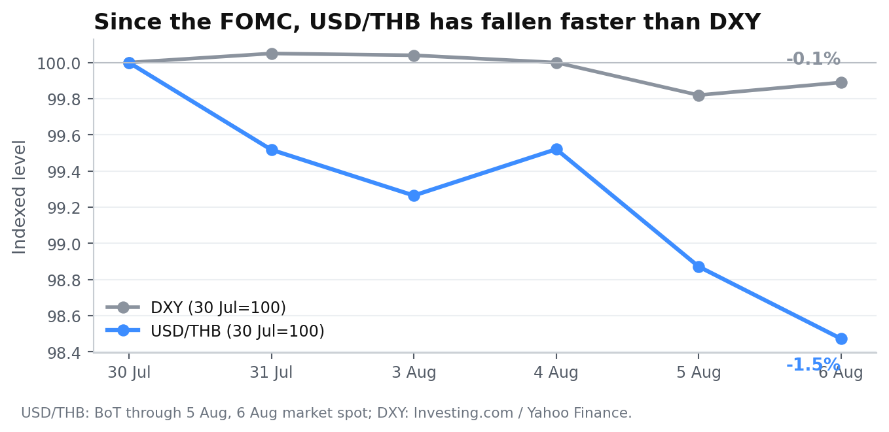
Figure 5. USD/THB amplified the post-FOMC dollar move, consistent with the pair's high broad-USD beta.
Source: BoT FX; DXY history; 6 Aug spot
- Near-term asymmetry: July NFP is due 7 Aug; Reuters consensus is ~80k with unemployment 4.2%. A large miss can cut hike pricing quickly; a modest beat may be less powerful if tightening is already priced.
- July CPI is due 12 Aug. Nomura's 31 Jul report expected core CPI near +0.22% MoM; an upside inflation surprise is the cleanest macro invalidation for the broad-USD leg.
- Jackson Hole (27–29 Aug) and the 15–16 Sep FOMC keep rate-volatility high all the way to the target horizon.
Source: Federal Reserve statement; CME FedWatch; Reuters FX, 6 Aug

7. Oil and gold: terms-of-trade help, but gold is a secondary channel
Thailand's 2026 external shock was energy-heavy. BoT explicitly attributes part of the current-account deficit to higher energy import values and expects improvement as crude prices decline. Reuters had Brent near $80.20 on 6 August, well below the >$100 levels that triggered market stress in late July. This is a direct positive for Thailand's import bill and a cleaner THB catalyst than local growth.
Channel | Current evidence | Implication for THB
Oil | Brent ~$80 vs >$100 late Jul | Positive: lowers import bill / inflation risk
Gold | Spot gold ~$4,262, near 7-week high | Mild positive: BoT has linked THB to gold flows
Gold controls | BoT tightened baht digital-gold measures in Jan 2026 | Dampens the historical gold→THB transmission
Geopolitics | Iran/Oman/Strait headlines remain fluid | Binary tail: reversal in oil can hit THB fast
Source: BoT MPR Q2 2026; Reuters gold/oil, 6 Aug; U.S. Treasury FX Report
READ-THROUGH The best version of the trade is 'oil normalizes + tourism recovers + USD data misses'. The worst version is the mirror image: oil re-spikes, U.S. inflation stays hot, and Thailand's external deficit persists.

8. Carry and implementation: the cost is real
The short USD/THB view fights a large yield differential. Krungsri's end-July data put 6m SOFR at 3.878% and 6m THOR at 1.032%, a -2.846 percentage-point gap from the THB holder's perspective. The differential widened by ~69bp since January.
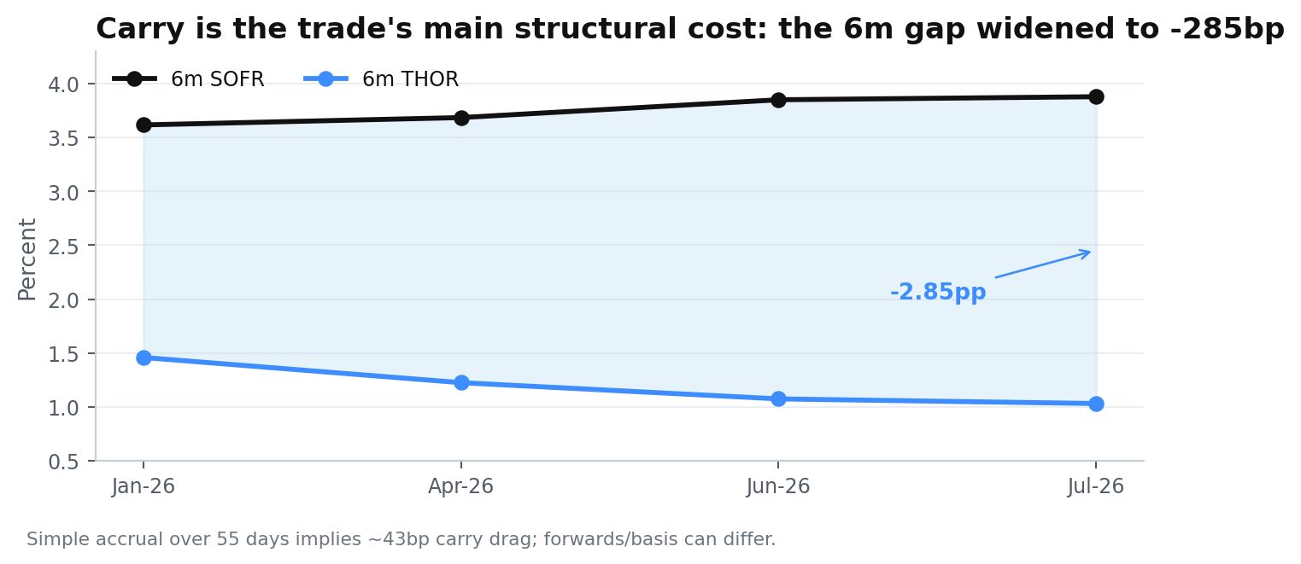
Figure 6. Negative carry widened through July even as the tactical THB case improved.
Source: Krungsri/MUFG
- From 6 Aug to 30 Sep (~55 days), simple accrual at a 2.846pp gap is roughly 43bp of carry drag. Actual deliverable forward points and basis can differ.
- At preferred 33.225 midpoint entry, spot return to 32.00 is ~3.69%; simple carry-adjusted target return is ~3.26% if held to end-Sep. At current ~33.06, spot upside falls to ~3.2%.
- Expression: use a deliverable forward where eligible, or the desk's compliant offshore instrument. Do not assume onshore THB NDF availability for nonresidents; confirm local rules, settlement, fixing and liquidity.

9. Valuation and target: 32.0 is aggressive, not heroic
The target looks less extreme when separated from spot momentum. U.S. Treasury's July 2026 FX report says the baht's 2025 REER remained around its 10-year average and cites the IMF's 2025 assessment that the baht was about 2.8% undervalued on a real effective basis. That does not imply a mechanical 2.8% spot move, but it argues against the view that further appreciation is obviously valuation-constrained.
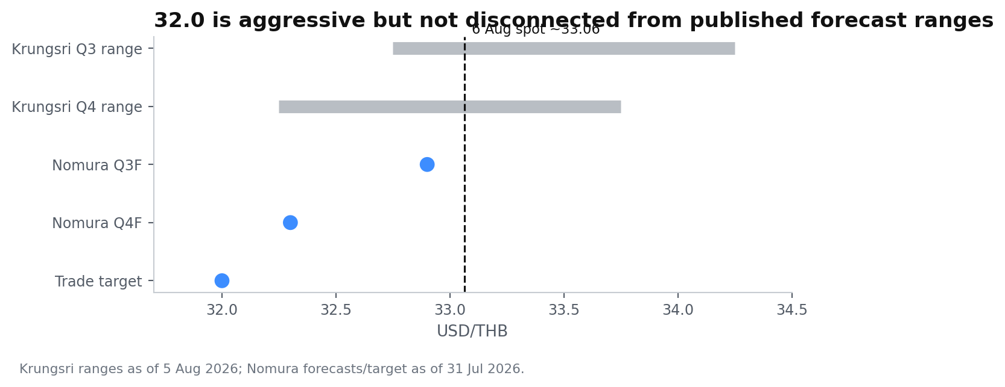
Figure 7. Nomura's 32 target sits below near-term ranges but close to Q4/Q1 published levels.
Source: Nomura forecasts / target; Krungsri/MUFG ranges
- Nomura: Q3 32.9, Q4 32.3; explicit trade target 32.0 by end-Sep.
- Krungsri: Q3 32.75–34.25; Q4 32.25–33.75; Q1 2027 32.00–33.50. A 32 print is therefore an aggressive early arrival at levels other forecasters see as plausible by Q1.
- Because spot already strengthened from 33.4 at end-July to ~33.06, expected payoff is more sensitive to entry quality than it was when Nomura initiated the trade.
Source: U.S. Treasury July 2026 FX Report

10. Scenario map and catalyst calendar
Scenarios are condition-based, not probability forecasts. The trade should be re-underwritten when the state variables move, not only when a price stop is hit.
State | USD/THB zone | What gets us there | Action
Bull THB | 31.6–32.0 | Oil <~$75; soft U.S. labor/CPI; Thai CA flips positive; equity inflows persist | Take profit into 32.0 / trail residual
Base | 32.0–32.5 | Q3 external balance improves; Fed pricing cools; tourism normalizes | Hold tactical short USD; respect horizon
Bear / invalidation | 33.9–34.3 | Oil >~$95; hot CPI/NFP; Sep Fed hike reprices higher; CA/outflows deteriorate | Exit at 33.90; rebuild only after catalyst reset
Catalyst calendar
Date | Catalyst | Trade lens
7 Aug | U.S. July NFP | Big miss = strongest near-term USD downside catalyst
12 Aug | U.S. July CPI | Upside core inflation is the cleanest USD/THB bear risk
26 Aug | BoT MPC | Rate hold expected; focus on FX / energy language
27–29 Aug | Jackson Hole | Warsh reaction function / credibility / forward guidance
4 Sep | U.S. Aug NFP | Second labor print before FOMC
11 Sep | U.S. Aug CPI | Final major inflation print before FOMC
15–16 Sep | FOMC + SEP | Core binary event for the target horizon
Weekly / month-end | Thai tourism + BoP | Confirm Q3 current-account/tourism thesis
Source: BLS jobs calendar; BLS CPI calendar; BoT MPC calendar; Kansas City Fed; Fed calendar

11. Risk register and invalidation discipline
Risk | Why it matters | Observable trigger | Response
Oil re-spike | Thailand is a net energy importer; Q2 CA shock was energy-led | Brent >~$95 and rising | Cut risk before 33.90 if CA/oil correlation reappears
Fed hawkish repricing | Negative carry widens and DXY can re-accelerate | Sep hike odds >~75% after CPI/NFP | Reduce; reassess broad-USD leg
Tourism stalls | Weakens services receipts and Q3 seasonality | Weekly arrivals slip back toward June pace | Lower conviction; wait for BoP confirmation
Portfolio reversal | July equity inflow is fragile | SET foreign selling resumes for multiple weeks | Tighten stop / size
BoT leans against THB | 2025 intervention resisted appreciation | Official rhetoric/intervention slows gains | Do not fight policy around 32 handle
Entry chase | Spot already moved ~1% from end-Jul | USD/THB <33.05 before entry | Wait for rebound; no forced entry
HARD INVALIDATION 33.90 remains the clean price stop. The macro thesis should be cut earlier if two of the three core state variables break simultaneously: (1) oil re-spikes, (2) U.S. hike pricing accelerates, (3) Thai current-account/tourism data fail to improve.

The biggest analytical mistake would be to convert a tactical seasonality trade into a structural 'Thailand is strong' view. Growth remains modest, carry remains negative, and BoT has historically resisted rapid baht appreciation.

Appendix A. Data used in the charts

A1. Monthly current account (USD mn)
Month | Exports | Imports | Trade bal. | Services/income | Current acct.
Jan-26 | 31,049.86 | 31,791.02 | -741.17 | 1,289.96 | 548.79
Feb-26 | 29,328.20 | 28,743.93 | 584.27 | 1,081.39 | 1,665.65
Mar-26 | 34,717.73 | 34,863.91 | -146.18 | -651.35 | -797.53
Apr-26 | 30,888.91 | 37,658.19 | -6,769.28 | -1,020.66 | -7,789.95
May-26 | 33,751.41 | 36,383.71 | -2,632.30 | -3,799.26 | -6,431.56
Jun-26 | 34,438.94 | 37,112.74 | -2,673.80 | -800.05 | -3,473.85
Source: BoT EC_XT_047_S3

A2. Weekly reserves / USDTHB
Week | FX reserves $bn | Gross reserves $bn | Net fwd $bn | USD/THB EOP
19 Jun | 244.411 | 282.644 | 22.800 | 32.861
26 Jun | 241.644 | 279.304 | 22.670 | 33.417
3 Jul | 242.757 | 281.088 | 23.500 | 33.165
10 Jul | 241.438 | 279.354 | 24.100 | 33.318
17 Jul | 238.896 | 276.033 | 24.580 | 33.607
24 Jul | 235.202 | 272.585 | 24.630 | 33.791
Source: BoT EC_XT_031

Appendix B. Source register and methodology
Source | Used for | Link
Nomura, Key focus and themes, 31 Jul 2026 | Anchor trade thesis, target, stop, Q3 CA forecast, weekly tourism / intervention estimate | User-provided PDF
Bank of Thailand — monthly BOP | Current account monthly actuals | Open source
Bank of Thailand — tourism indicators | Monthly foreign arrivals | Open source
Bank of Thailand — weekly reserves | Weekly reserve stock and USD/THB EOP | Open source
Bank of Thailand — MPR Q2 2026 | External-balance decomposition, tourism and macro outlook | Open source
Krungsri/MUFG THB Thermometer, Aug 2026 | Portfolio flows, rate differentials, FX ranges, FPO forecast | Open source
U.S. Treasury FX Report, Jul 2026 | REER valuation, 2025 intervention, capital-control context | Open source
Federal Reserve, 29 Jul 2026 FOMC | 3.50–3.75% target, 9–3 vote | Open source
BLS / Fed / Kansas City Fed calendars | NFP, CPI, FOMC and Jackson Hole dates | Open source
Reuters, 6 Aug 2026 | Oil, broad USD and labor-consensus context | Open source
Reuters Asian FX poll, 6 Aug 2026 | Positioning / cheaper-oil regional FX context | Open source
Market spot / DXY | 6 Aug USD/THB and DXY levels | Open source

Methodology notes
- Spot risk/reward is calculated in THB terms for a short USD/THB position: (entry − exit) / entry. Carry is a simple annualized rate-gap accrual and is shown separately from executable forward points.
- Late-July tourism run-rate multiplies one weekly arrival observation by 4.345 weeks/month; it is intentionally labelled as an illustrative run-rate, not a forecast.
- Reserve-stock changes are not equated one-for-one with intervention. Nomura's intervention estimate is kept distinct from the official raw reserve series.
- Scenario ranges are analytical judgment bands, not statistical forecasts and carry no assigned probabilities.
Disclaimer
This document is an independent research synthesis for discussion and educational use. It is not an offer, solicitation, individualized recommendation, or representation that any instrument is available or suitable in a particular jurisdiction. FX trading can involve leverage and loss beyond initial margin; verify executable pricing, liquidity, settlement and regulatory eligibility with the relevant dealer and compliance function.

