Final Project

By: Oluwatoni Jason Oderinlo

Student number: 040975977

Table of Content

Introduction ----------------------------------------------------- Page 3

Records of any suspicious activities ----------------------- Page 3

Mitigation Plan ------------------------------------------------- Page 9 -10

Conclusion ------------------------------------------------------- Page 10

Reference -------------------------------------------------------- Page 11

Introduction:
This report is to summarize the suspicious network activities that could lead to an attack from an attacker in six Wireshark files.

Records of any suspicious activities:

File 1: No Suspicious Activities
No suspicious activities were detected in File 1.

File 2: Incident Overview
Summary:
This report outlines a detected incident of suspicious activity indicating a potential Distributed Denial of Service (DDoS) attack. The attack targeted the IP address 192.168.2.108 and involved multiple attempts to gain unauthorized access through various port numbers.
Incident Details:
1. Nature of Activity:
- Multiple SYN packets were identified, suggesting a potential DDoS attack.
2. Targeted Ports:
- The attacker made attempts to exploit ports 21, 22, 53, 80,135, and 143.
3. Access Attempt via SSH:
- An attempt to access the network was made through the Secure Shell (SSH) protocol.
4. Outcome:
- Fortunately, the attacker was unsuccessful in gaining access to any files.
Ip.addr == 192.168.2.111 and tcp.flags.ack == 1
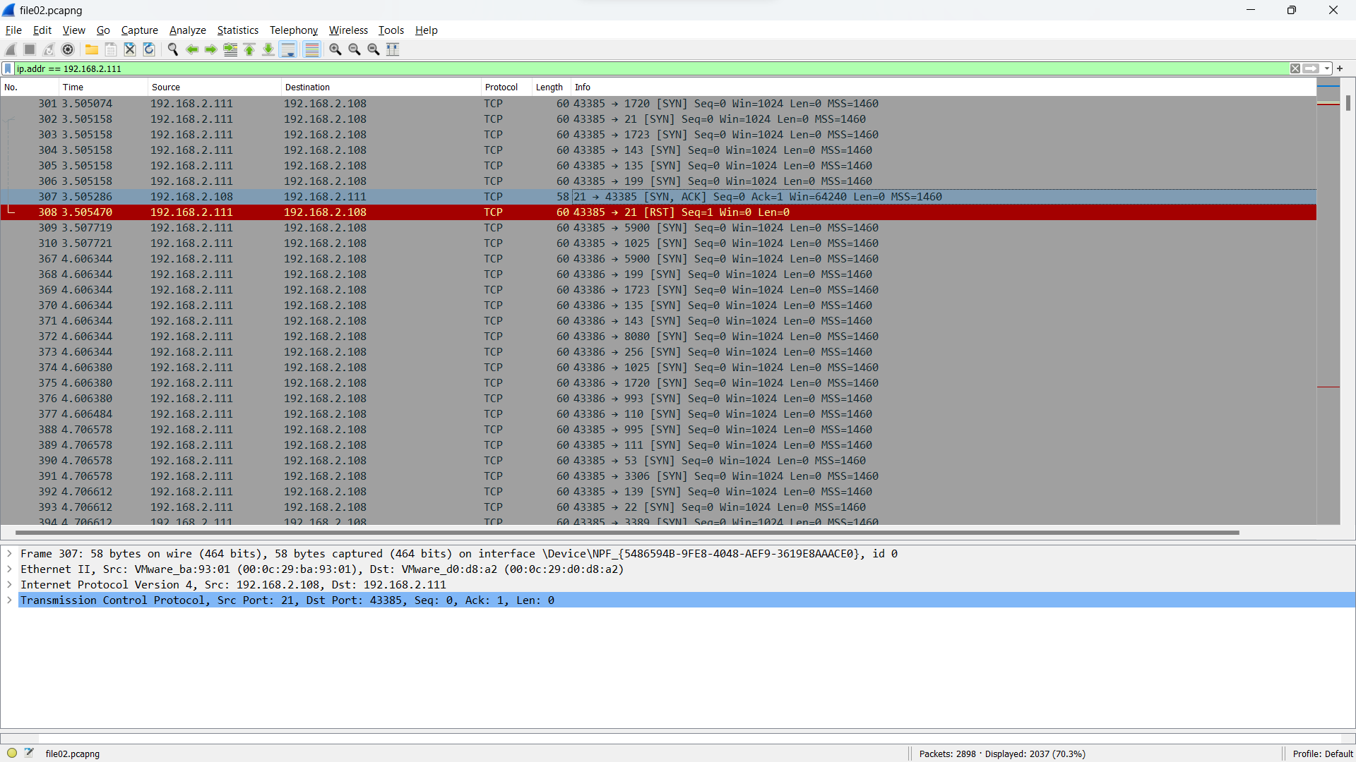

File 4: Incident Overview
Summary:
This report details a detected incident of suspicious activity, indicative of a potential Distributed Denial of Service (DDoS) attack. The attack was directed at the IP address 192.168.2.107 and primarily involved multiple SYN packets, signaling a concerted effort to disrupt network services. Notably, all access attempts were concentrated on port number 80.

Incident Details:
1. Nature of Activity:
- Multiple SYN packets were identified, suggesting a potential DDoS attack.
2. Targeted Port:
- All attempts to gain access were focused on port number 80, commonly associated with HTTP traffic.
3. Access Attempt via HTTP:
- An attempt to access the network was made through the Hypertext Transfer Protocol (HTTP).
4. Outcome:
- The attacker was unsuccessful in gaining access to any files.
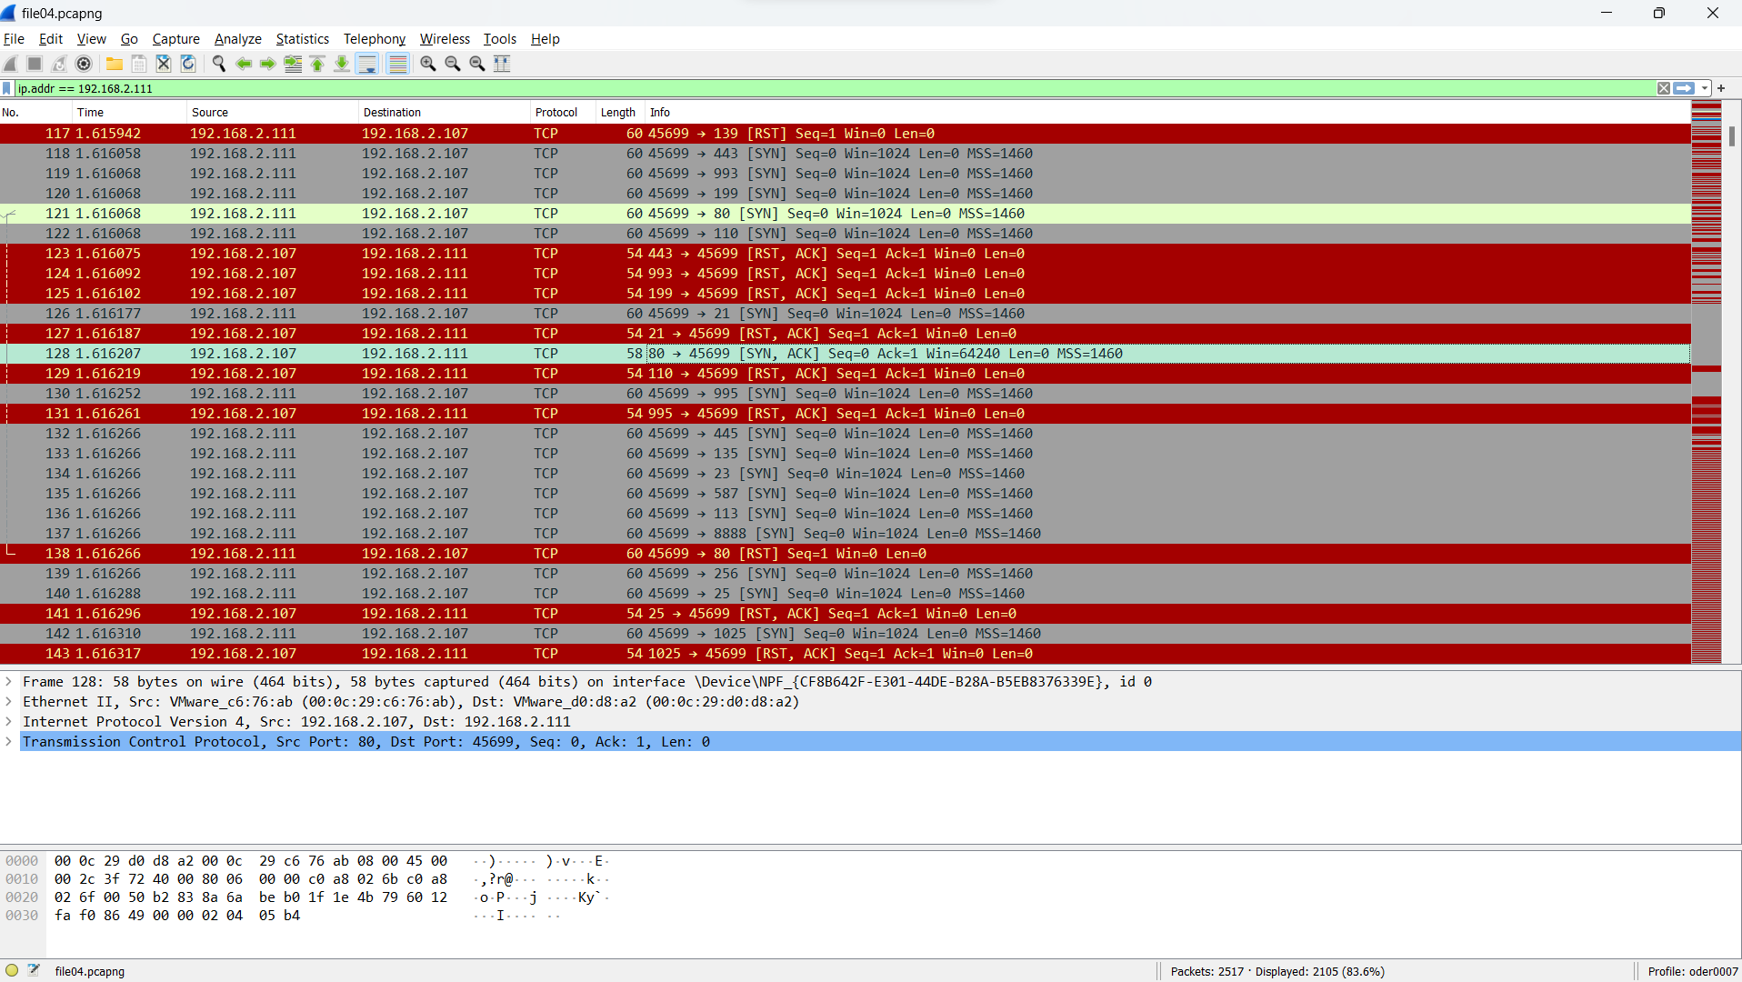

File 5: Incident Overview
Summary:
This report outlines a detected incident of suspicious activity, indicative of a potential Distributed Denial of Service (DDoS) attack. The targeted IP address for this incident is 192.168.2.107, and the attack primarily manifested through the transmission of multiple SYN packets. Notably, all access attempts were focused on port 21, and these attempts were consistently met with RESET responses.
Incident Details:
1. Nature of Activity:
- Multiple SYN packets were identified, signaling a potential DDoS attack.
2. Targeted Port:
- All attempts to gain access were concentrated on port 21.
3. Outcome:
- All access attempts were met with RESET responses, preventing unauthorized access.
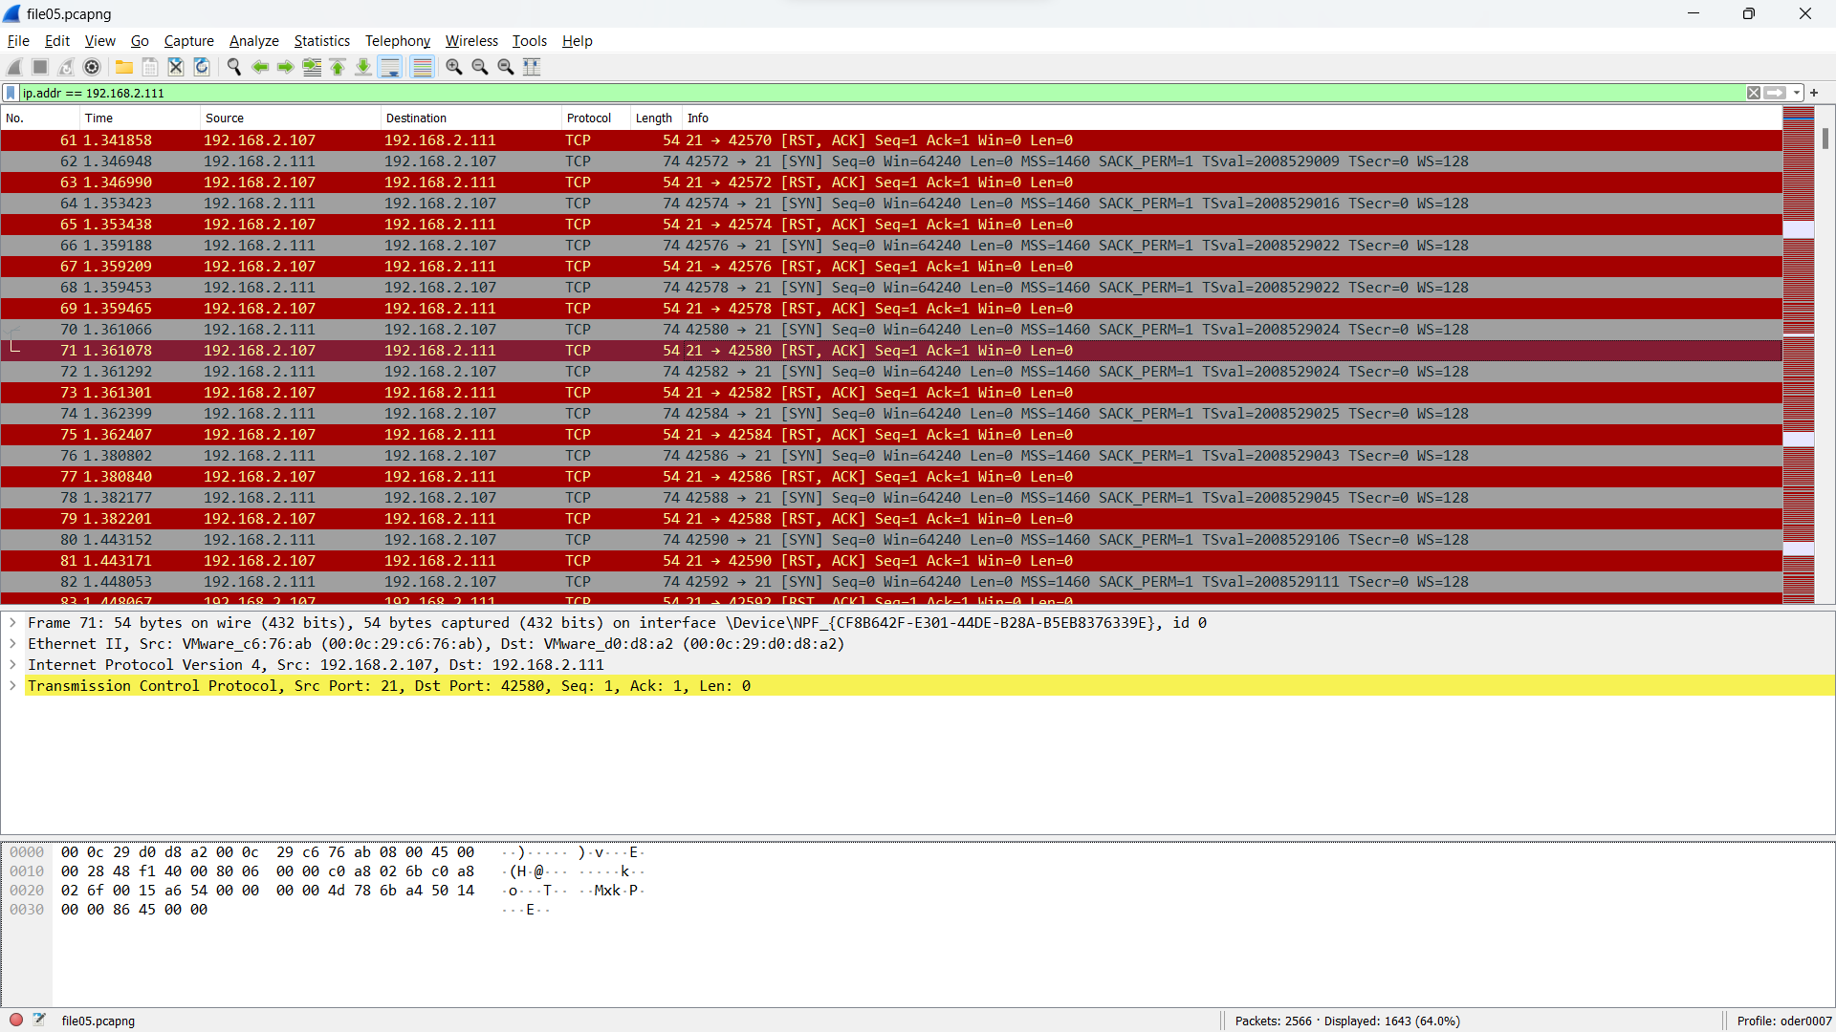

File 6: Incident Overview
Summary:
This report documents an identified instance of suspicious activity, suggestive of a potential Distributed Denial of Service (DDoS) attack. The incident focused on the IP address 192.168.2.108, with multiple SYN packets indicating an attempt to disrupt network services. Notably, all access attempts were directed at port number 21. Additionally, there was an unauthorized attempt to access the network through the Transmission Control Protocol (TCP), specifically targeting user credentials associated with the IP address 192.168.2.108.
Incident Details:
1. Nature of Activity:
- Detection of multiple SYN packets, suggesting a potential DDoS attack.
2. Targeted Port:
- All access attempts concentrated on port number 21.
3. Access Attempt via TCP:
- Unauthorized attempt to access the network through the Transmission Control Protocol (TCP).
4. Credential Targeting:
- The attacker specifically aimed to acquire user credentials associated with IP address 192.168.2.108.
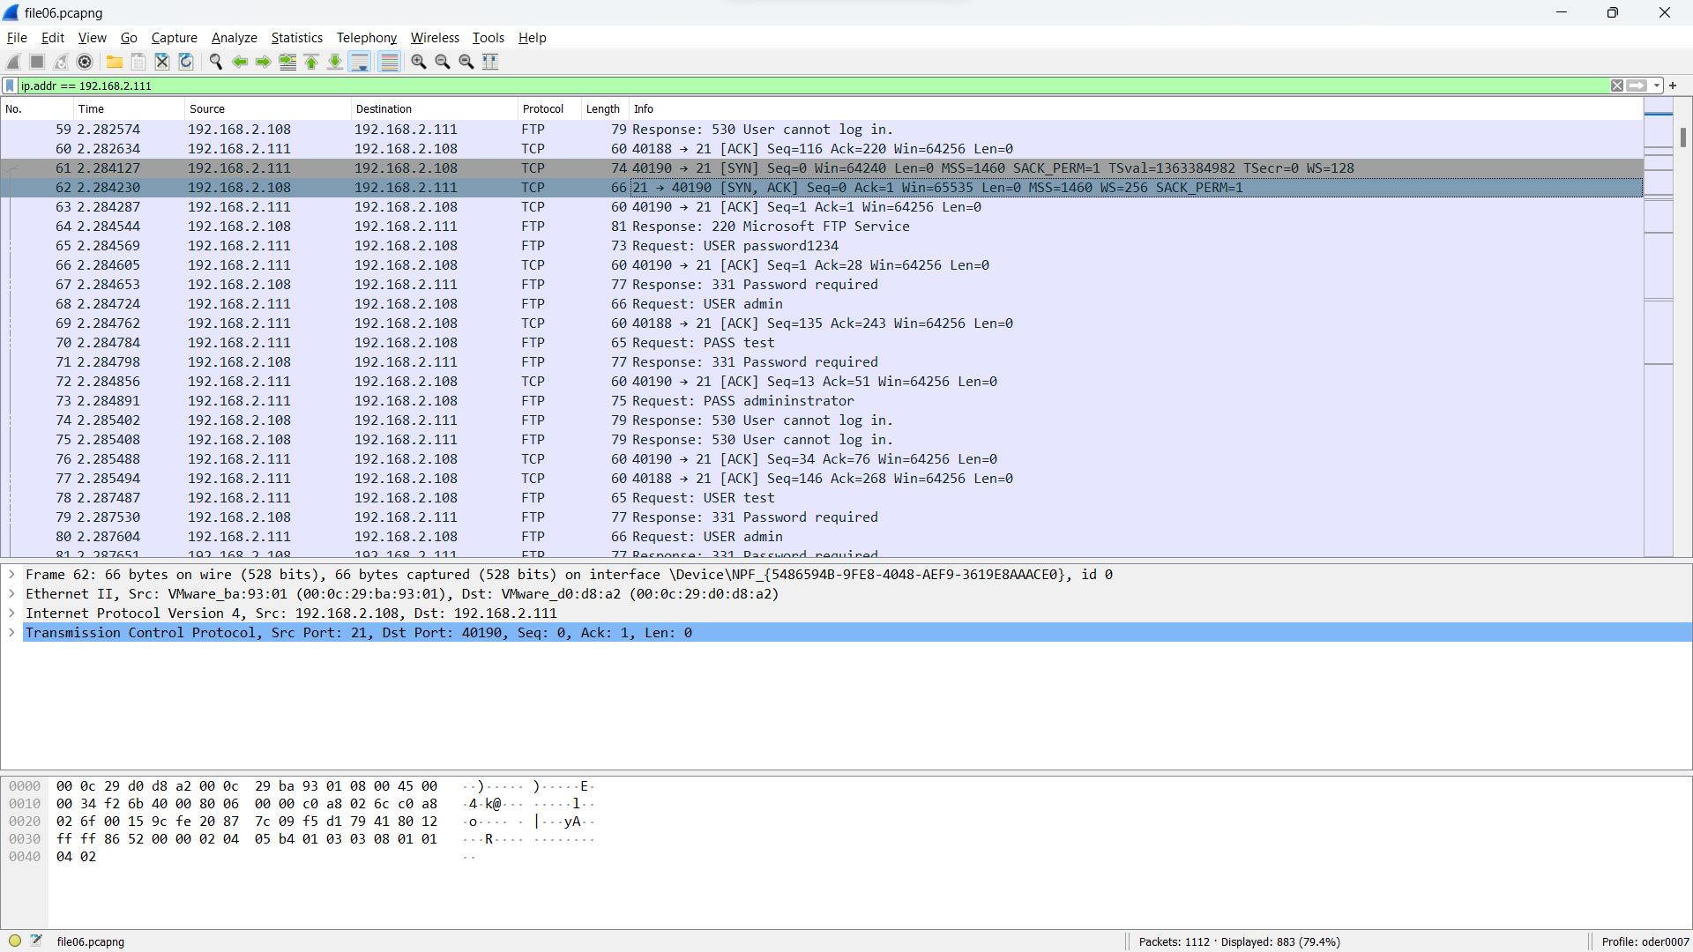
Outcome: The attacker’s attempt to gain access to the user’s credentials were detected and stopped, preventing any successful acquisition.

File 7: Incident Overview
Summary:
This report outlines a detected incident of suspicious activity indicating a potential Distributed Denial of Service (DDoS) attack. The targeted IP address for this incident is 192.168.2.108, and the attack primarily manifested through the transmission of multiple SYN packets, signifying an attempt to disrupt network services. Notably, all access attempts were concentrated on port number 20. Additionally, an unauthorized attempt to access the network through the Transmission Control Protocol (TCP) was successful, resulting in the retrieval of specific files: "file.doc," "payment.txt.txt," and "Test.txt.txt."
Incident Details:
1. Nature of Activity:
- Detection of multiple SYN packets, indicative of a potential DDoS attack.
2. Targeted Port:
- All access attempts were focused on port number 20.
3. Access Attempt via TCP:
- Unauthorized attempt to access the network through the Transmission Control Protocol (TCP).
4. File Access:
- The attacker successfully gained access to the following files:
- "file.doc"
- "payment.txt.txt"
- "Test.txt.txt”
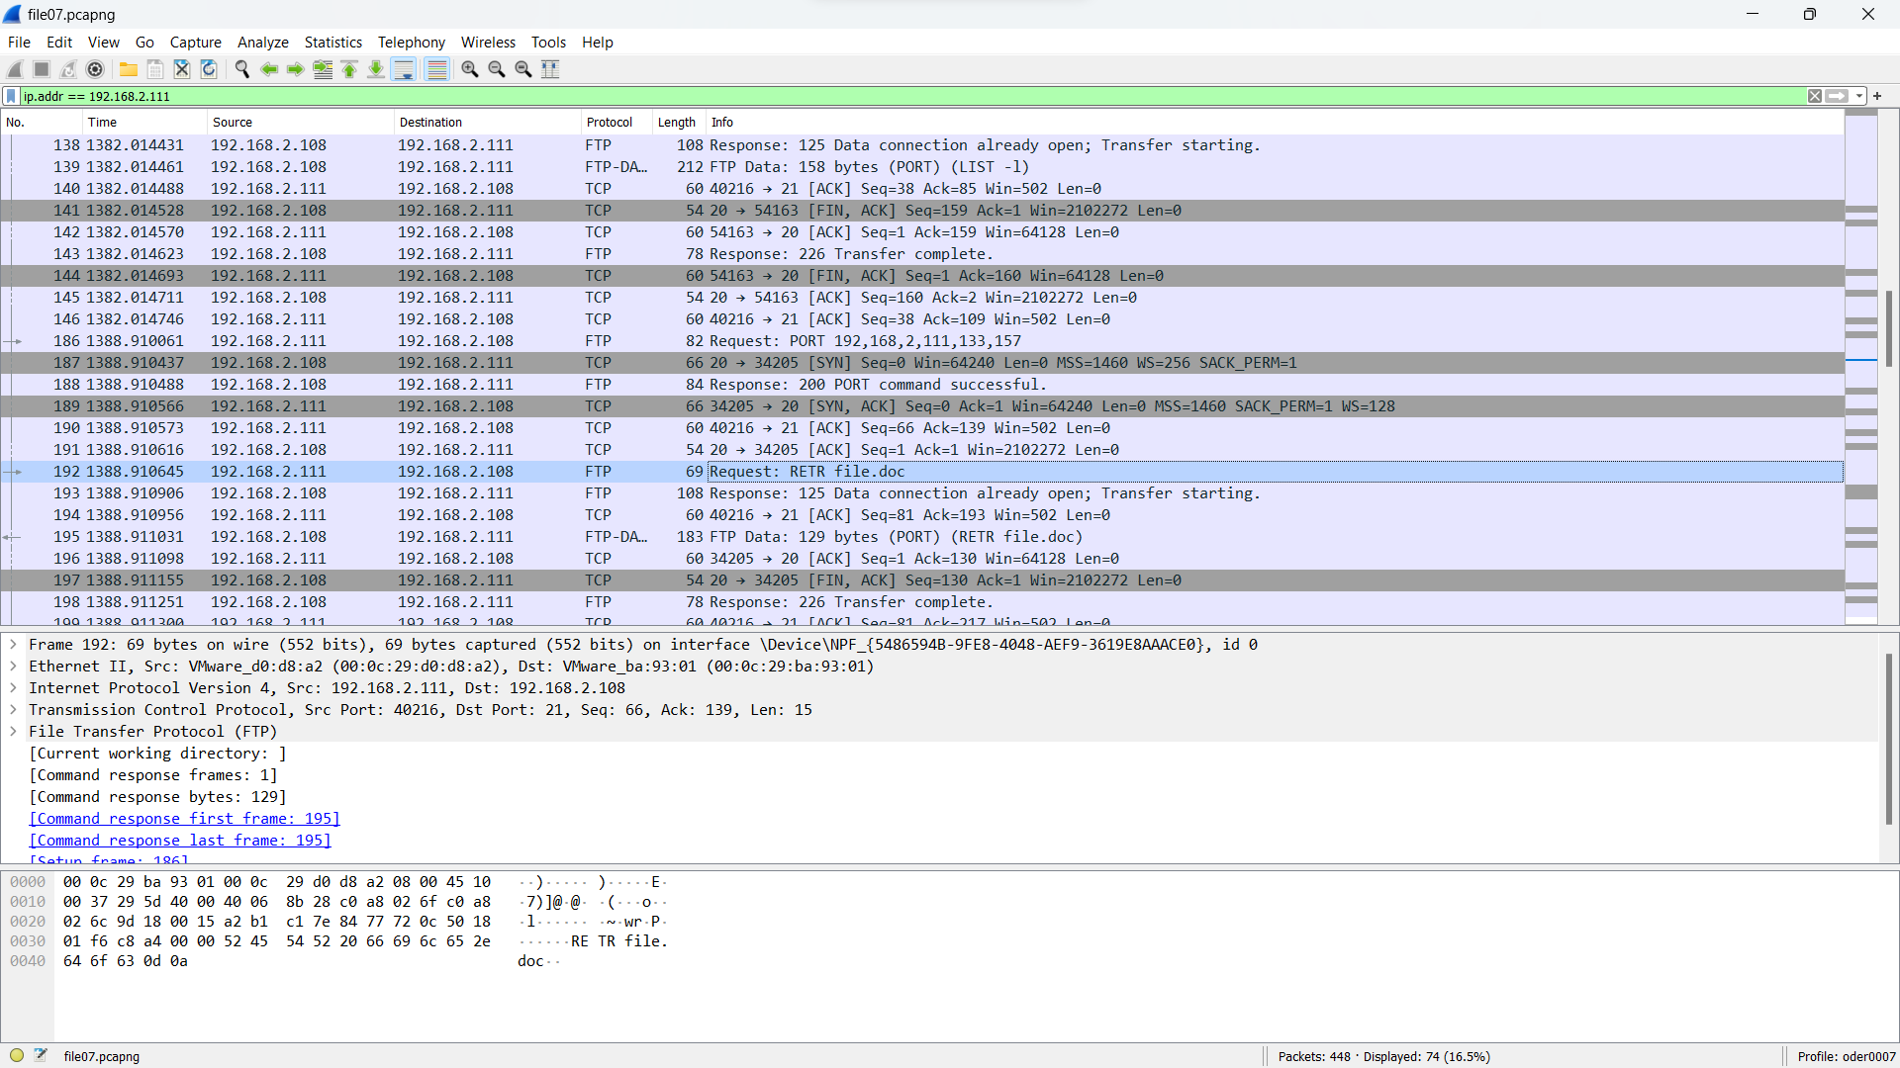
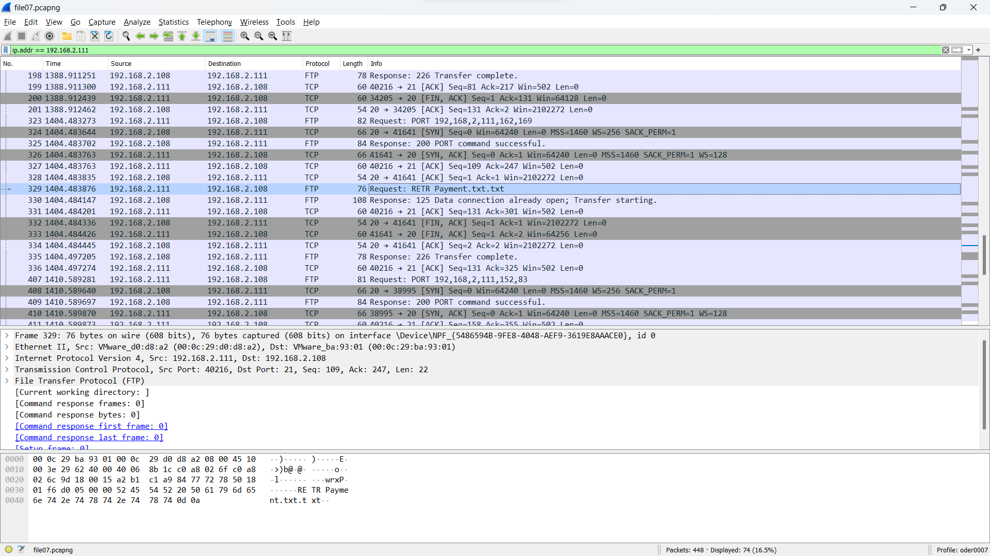
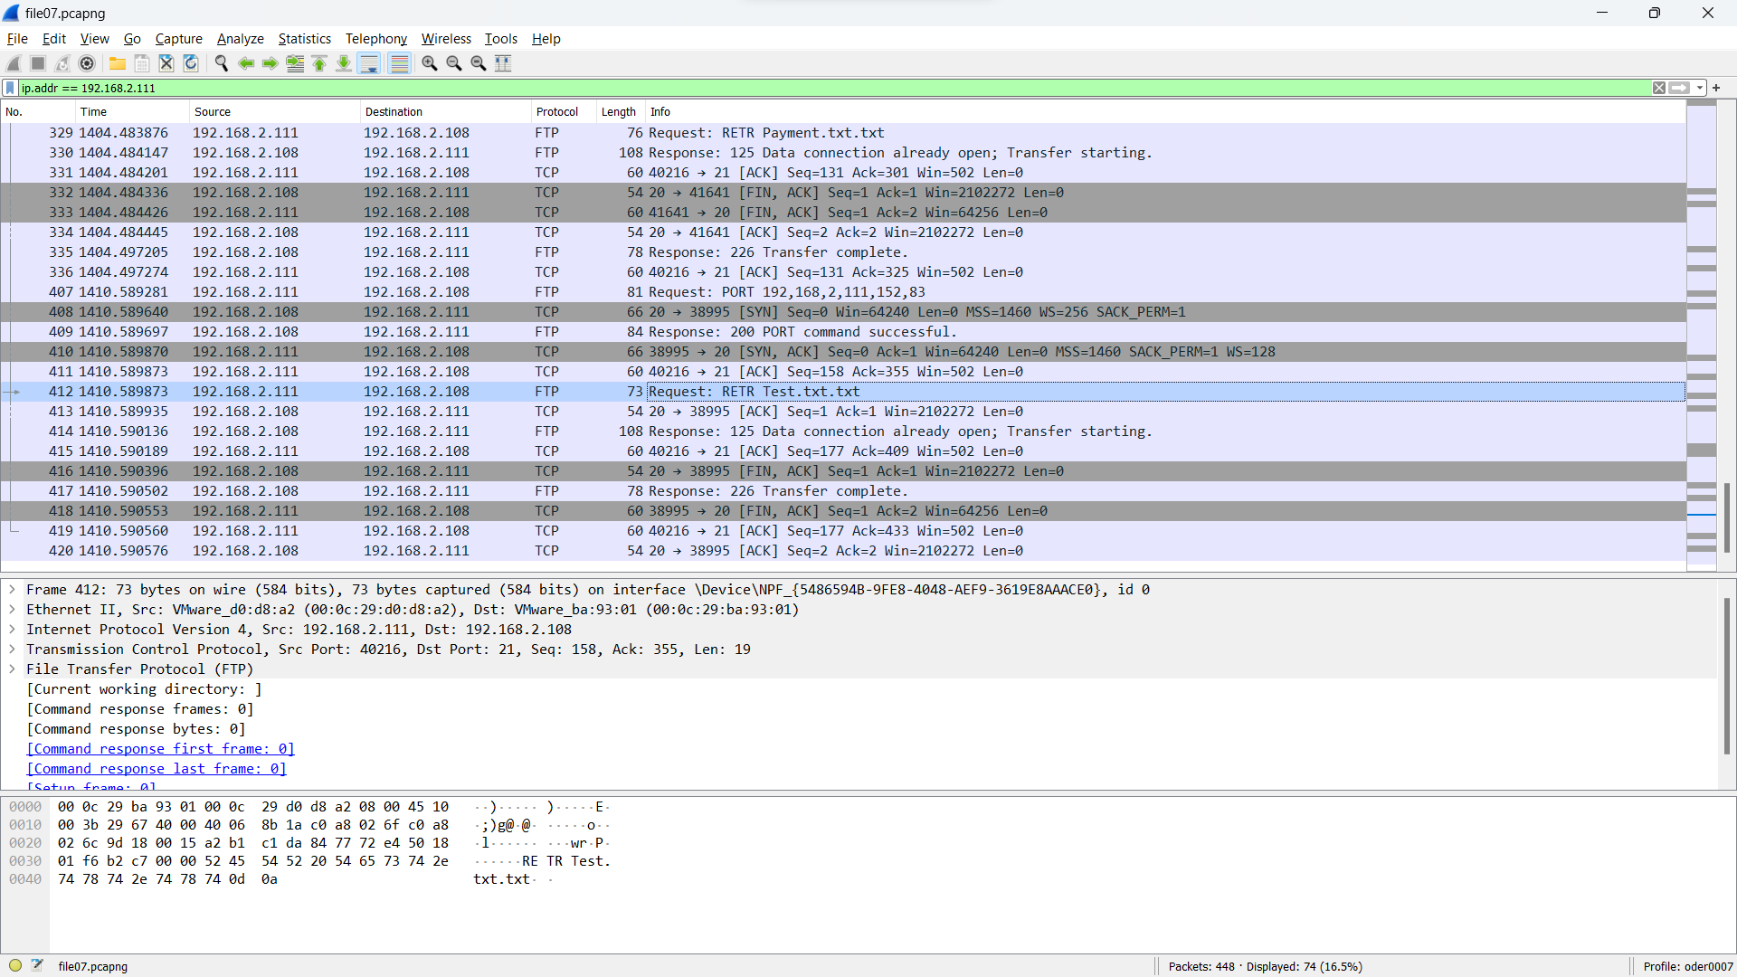

Mitigation plan for DDOS Attack:
1) Perform a Risk Assessment
Initiate the process by evaluating the vulnerabilities present in your network. Identify critical assets and assess the potential impact of a DDoS attack on your business operations.
2) Formulate an Incident Response Team
Establish a team of experts dedicated to managing DDoS incidents. Ensure that team members are adequately trained and aware of their designated roles during an attack.
3) Create a Comprehensive Incident Response Plan
Develop a detailed plan outlining the sequential steps to be taken in response to a DDoS attack. This plan should encompass communication protocols, emergency contact information, and recovery procedures.
4) Select Appropriate Tools
Invest in DDoS mitigation tools that align with your specific requirements. This may include the adoption of a Web Application Firewall (WAF), Content Delivery Network (CDN) solutions, and server-level DDoS protection.
5) Adjust Security Settings
Fine-tune the configurations of your security tools. For instance, implement rate limiting and IP filtering to mitigate the impact of a potential attack.

6) Test the Preparedness Plan
Conduct simulated DDoS attacks to evaluate the effectiveness of your incident response plan. Make necessary adjustments based on the insights gained from these simulations.
7) Provide Training for Employees
Educate your staff about DDoS attacks and equip them with the knowledge to recognize early signs of an attack. Early detection can be crucial in minimizing the impact.
8) Monitor Network Traffic
Continuously monitor network traffic for irregular patterns. Utilize analytics tools to set up alerts for any suspicious activities that may indicate a potential DDoS attack.
9) Regularly Update and Review
Consistently update your incident response plan and security tools. Given the evolving nature of cyber threats, maintaining up-to-date defenses is essential.
10) Conduct Post-Incident Analysis
Following an attack, analyze the successes and shortcomings of your response. Use this information to refine your incident response plan and enhance your preparedness for future DDoS attacks.

Conclusion:
Overall, the main attack method that the attacker used was a DDOS attack to gain files or records a user’s system.

References
Toback, M. (2023, October 19). How to Defend Against a DDoS Attack: 2023 Guide to Outsmart Cybercriminals. Retrieved from Security Bloggers Network: https://securityboulevard.com/2023/10/how-to-defend-against-a-ddos-attack-2023-guide-to-outsmart-cybercriminals/#:~:text=Seven%20Proven%20Tactics%20to%20Mitigate%20DDoS%20Attacks%201,8%20Step%208%3A%20Monitor%20Traffic%20...%20More%20items

