# Publcations Page

publication.php

1. Read file to get contents

$publication = file_get_contents('pubsList.txt');

$pubLines = explode(PHP_EOL,$publication);

Above two lines of code works for pubsList.txt which includes publication per line. Reads every contents in the text file and stores in $publication. Then next line stores the publications in pubLines for each line

$members = file_get_contents('memberList.txt');

$membList = explode(PHP_EOL,$members);

Above lines for members like pubLines.

1. find last name of all members

for( $i = 0; $i < sizeof($membList); $i++ )

{

if (strpos($membList[$i],'#') !== false)

{

$memberFirstNames[$i] = substr($membList[$i],0, strpos($membList[$i], '#'));

}

else // doesnt have '#' in name

{

$memberFirstNames[$i] =

substr( $membList[$i], strpos($membList[$i],' '));

}

}

→ Above code made for storing members’ last names on the array $memberFirstNames.

At the first if statement of for loop, check if a line of member list contains ‘#’. If true, juust store the name (because it will not have full name like ‘Simon’). Otherwise, from ‘ ‘ (space) to end of line will be stored to the array.

After that, there will be two drop-down menus, collections of years and names (last names).

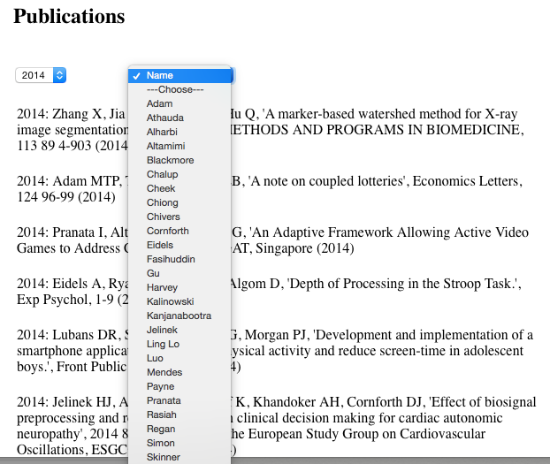

In the drop down menu for names, the list will be automatically changed by memerList.txt

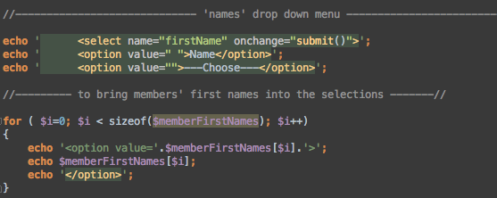

If a user chooses selection of year and name, the content (the middle, lines of publications) will change up to matching publication. For example, if the selection is 2014 & Cornforth, the result will be:

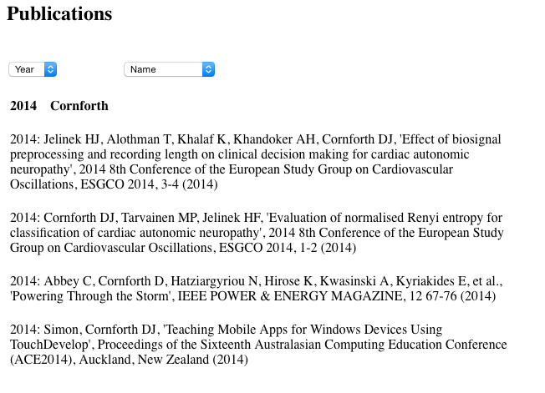

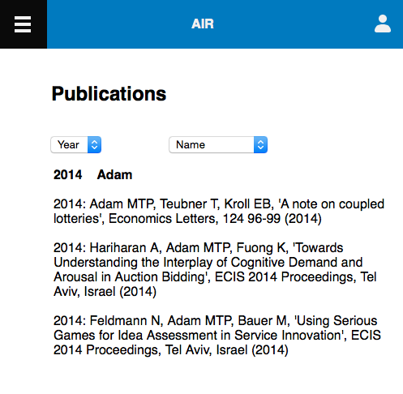

For the mobile version of publication page works exactly same. Works perfectly with the mobile context, auto re-sizing.

# Members Page

Members.php

1. Read the “memberlist” file.

$memberList = file_get_contents('memberList');

$lines = explode(PHP_EOL, $memberList);

Above two lines of code works for memberlist which includes publication per line. Reads every contents in the text file and stores in $memberLiist. Then next line stores the memberList in lines for each line

1. Make condition to compare $lines as $member.

if( strlen($member) > 4 )

{

$url = ' ';

$pos = stripos($member,'#');

if( $pos !== false )

{

$url = substr($member, $pos+2);

$member = substr($member,0,$pos);

}

else

{

$url = '../Members/'. str_replace(" ", "-", $member);

}

$member = trim($member);

$url = trim($url);

if (strlen($url) > 4)

{

if($member == 'Marc adam')

{

$lhs = '<a href="#openModal1"';

$rhs = '>details</a>';

echo '<td>'.$lhs .$url. $rhs.'</td></tr>';

}

If $member string length is longer than 4, $url have blank, and $pos(position) store the $member name who have ‘#’. stripos function mean find special symbol.

After that, make other choice to not have ‘#’.

In this time, $url have $member, using substring. It means position count plus 2, and $ $member also use substring.

If it does not match above condition, it just show directory of member name ( ex) woojin-cho)

Finally, $member and $url use trim. trim function delete the blank.

Also, we need to make another condition for $url.

If $url string length is longer than 4, it process to another condition, if we check the same name, and give the link “openModal”. OpenModal is a kind of popup. If we click the details, it show member’s name, description, and email address. It also have more details link. More details have the newcastle’s profile link.

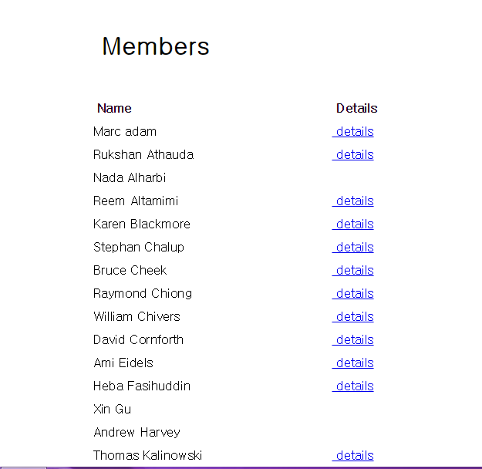

As you can see if member who have ‘#’ , it does not show ‘details’.

Next if we click the details,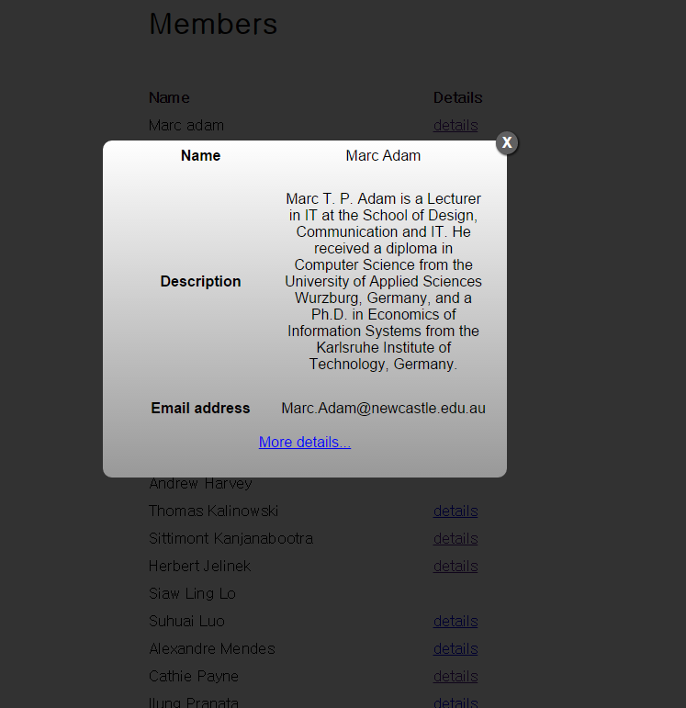

It show the member’s name,description,and Email address.

Finally, If we click the ‘more details’, it show the newcastle homepage and profile page. 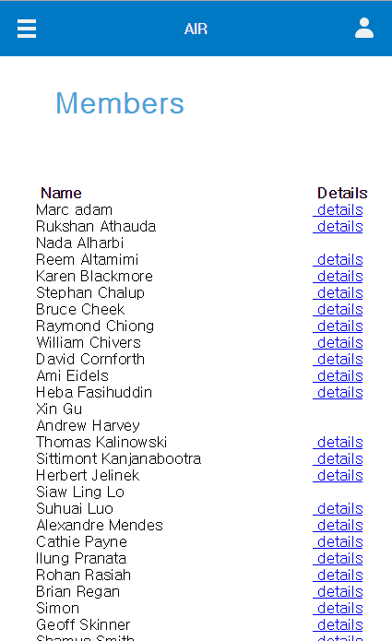

For the mobile version of Members page works exactly same.