**1. Wave Energy**

Wave Energy is a renewable energy, which can offer significant advantages compared with other kinds of energy generation including the following:

1. Sea waves offer a higher energy density than other kinds of renewable energy sources, such as solar energy. The intensity of solar energy is about 0.1-0.3kW/m2 in horizontal surface and that of wave energy is about 2-3kW/m2 in a vertical plane.

2. It can be known that wave power devices can generate electrical power up to 90% of the time, while that of wind and solar devices compared is about 20-30%.

3. With the support of prevailing winds, waves can travel large distances with little energy loss.

4. Generally, offshore devices have a lower negative impact, compared with other energy generations in use. [1]

**2. WEC Devices**

Wave Energy Converter (WEC) is type of device that can take the advantage of wave energy and transform it into electrical power. WEC can be classified according to their operating location and operating modes.

**2.1 Wave Energy Converter Devices Based on Locations**

**2.1.1 Shoreline devices**

Shoreline devices have the advantage of being close to the utility network, are easy to maintain, and as waves are attenuated as they travel through shallow water they have a reduced likelihood of being damaged in extreme conditions. This leads to one of the disadvantages of shore mounted devices, as shallow water leads to lower wave power. Tidal range can also be an issue. In addition, by nature of their location, there are generally site specific requirements including shoreline geometry and geology, and preservation of coastal scenery, so devices cannot be designed for mass manufacturing.

**2.1.2 Nearshore devices**

Nearshore devices are defined as devices that are in relatively shallow water. Devices in this location are often attached to the seabed, which gives a suitable stationary base against which an oscillating body can work. Like shoreline devices, a disadvantage is that shallow water leads to waves with reduced power, limiting the harvesting potential.

**2.1.3 Offshore devices**

Offshore devices are generally in deep water. The advantage of siting a WEC in deep water is that it can harvest greater amounts of energy because of the higher energy content in deep water waves. However, offshore devices are more difficult to construct and maintain, and because of the greater wave height and energy content in the waves, need to be designed to survive the more extreme conditions adding cost to construction [1].

**Table 2.1** Different types of wave energy conversion devices with characteristics. [2]



**2.2 Wave Energy Converter Devices Based on Operating Modes**

**2.2.1 Submerged Pressure Differential**

The submerged pressure differential device is a submerged absorber using the pressure difference on the device between wave crests and troughs. It consists of two components: a sea bed fixed air-filled cylindrical chamber and a moveable upper cylinder. While under the crest, the water pressure above the device increases and moves the upper cylinder down. While under a trough, the water pressure on the device reduces and raises upper cylinder. An advantage of this operating mode is that the submerged arrangement can avoid the slamming forces, which is usually experienced by floating devices. [3] However, drawback of this mode is the difficulty of maintenance. These devices are located nearshore.

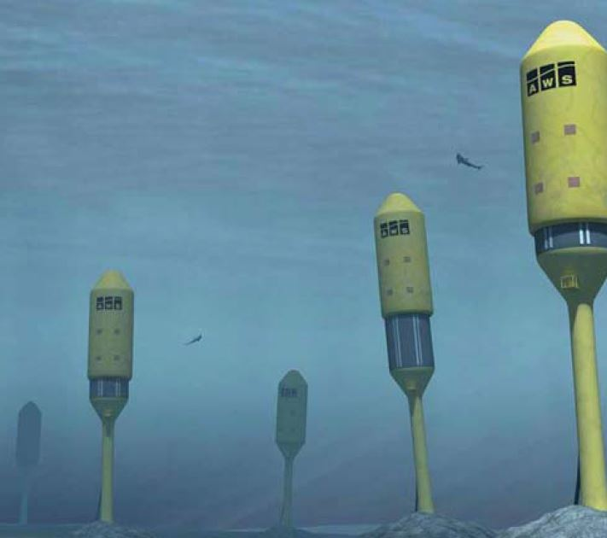

**Fig 2.2.1** Submerged pressure differential: the Archimedes Wave Swing [4]

**2.2.2 Oscillating Wave Surge Converter**

An oscillating wave surge converter consists of a hinged deflector arranged vertically, which presents the surge motion, taking the advantage of the horizontal wave particle velocity. This type of converter is typically a nearshore device and the top of the deflector is above the water surface and hinged from the sea bed.

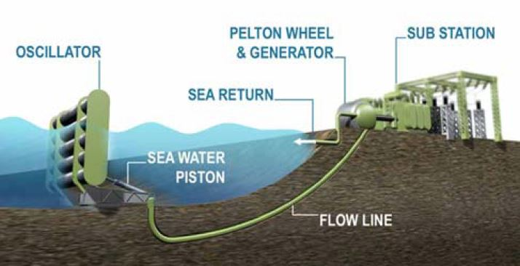

**Fig.2.2.2** Oscillating wave surge converter: Aquamarine Power Oyster [5]

**2.2.3 Oscillating water column**

The OWC concept has been proposed as a nearshore device by Oceanlinx. [6] An typical OWC consists of a chamber with an open gate to the sea below the water surface. While waves approach the device, forcing the water into the chamber and applying pressure on the air within the chamber to escape to atmosphere through the turbine. While the water retreats, air is then drawn back through the turbine. The advantage of the OWC is its simplicity and robustness. An example of a shoreline mounted device is the Wavegen Limpet installed on the island of Islay, Western Scotland, producing electricity for the national grid.

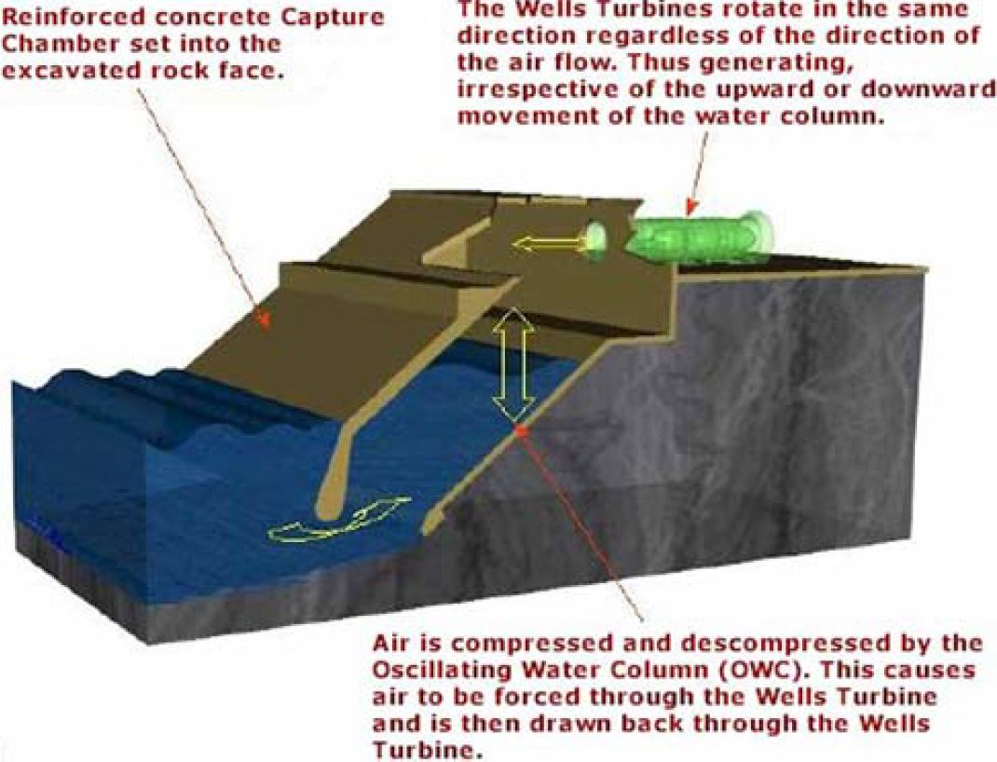

**Fig. 2.2.3** OWC: the Limpet [7]

**2.2.4 Overtopping device**

An overtopping device gathers incident waves in a reservoir above the sea level and releases the water back with turbines. This kind of device uses a pair of large curved reflectors to capture waves into the center part, with the water flowing up a ramp and over the top into a raised reservoir. The water is allowed to return to the sea through a number of low-head turbines.

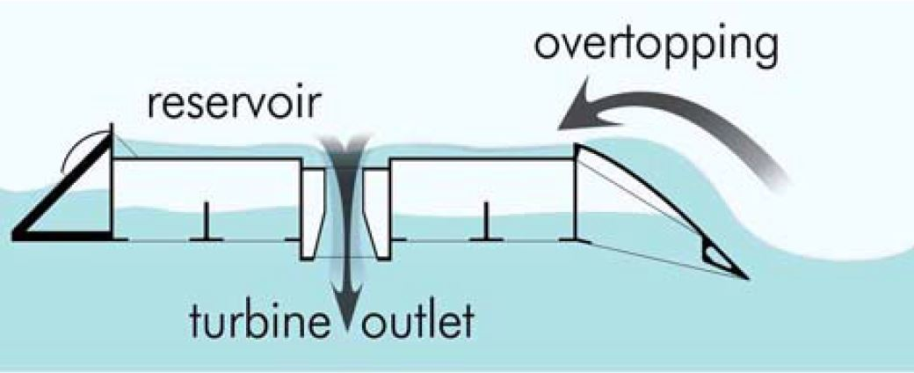

**Fig. 2.2.4** Overtopping WEC: the Wave Dragon [8]

**2.3 Evaluation of the efficiency in different WEC devices**

Besides the values of the electric power per unit in various periods and locations presented in Figure 2.3 and Table 2.1, there are two different indicators of the efficiency of wave energy transformation into electricity. The first is the load factor IL defined as the average power capture divided by the device rating.

*IL =* 100*\*PE/P*nom

The second is capture width, which represents the width of wave front from which all the energy is extracted and it is computed as the ratio of electrical power output of the WECSs (PE) to the power in the sea state (PW).

*CW = PE/PW*

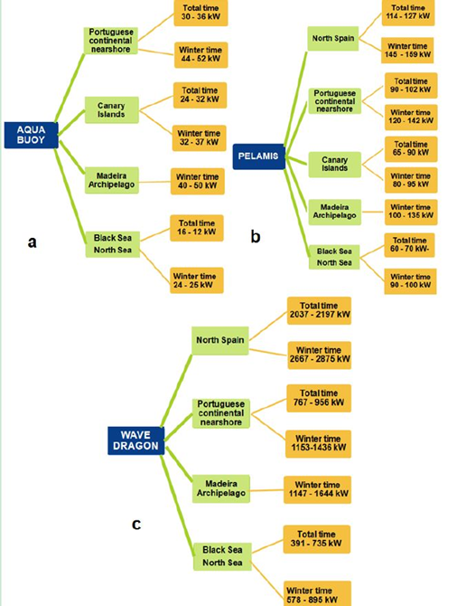According to the previous research, these two indicators of different WEC devices in various sea environments have been concluded in Table 2.2 and Table 2.3.

**Figure 2.3** Expected electric power in various coastal environments. (a) Aqua Buoy; (b) Pelamis; (c) Wave Dragon

**Table 2.1** Different types of wave energy conversion devices with characteristics. [2]

|  |  |  |  |  |
| --- | --- | --- | --- | --- |
| **Device** | **Power per Unit (kW)** | **Movement** | **Depth** | **Size** |
| Oceantec | 500 | heave | 30-50 | medium |
| Pelamis | 750 | surge & heave | 50-70 | medium |
| P P Converter | 3620 | heave | deep | large |
| Seabased | 15 | heave | 30-50 | small |
| Wave Dragon | 7000 | overtopping | 30-50 | large |
| Aqua Buoy | 250 | heave | >50 | small |
| AWS | 2320 | heave | 40-100 | medium |
| Langlee | 1665 | oscillating flaps | deep | medium |
| OE Buoy | 2800 | oscillating column | deep | medium |
| Wavebob | 1000 | heave | deep | medium |

**Table 2.2** Average values of the load factor in the Spanish nearshore and in sea environment (the Black and the North seas). The WECs considered are: Pelamis, Aqua Buoy and Wave Dragon. (TT indicates the total time and WT indicates the winter time)

|  |  |  |  |  |  |  |
| --- | --- | --- | --- | --- | --- | --- |
| **IL (%)** | **Pelamis** | | **Aqua Buoy** | | **Wave Dragon** | |
| **Location/Period** | **TT** | **WT** | **TT** | **WT** | **TT** | **WT** |
| Spanish Nearshore | 15.2-16.9 | 19.3-21.1 | - | - | 34.5-37.3 | 45.2-48.7 |
| Sea Environment | - | 11.9-13.07 | - | 8.4-9.5 | - | 8.2-12.78 |

**Table 2.3** Average values of the capture width Cw (m) in the Iberian nearshore (Spanish and Portuguese) and in Madeira archipelago. The WECs considered are Pelamis, Aqua Buoy and Wave Dragon.

|  |  |  |  |  |  |  |
| --- | --- | --- | --- | --- | --- | --- |
| **Cw (m)** | **Pelamis** | | **Aqua Buoy** | | **Wave Dragon** | |
| **Location/Period** | **TT** | **WT** | **TT** | **WT** | **TT** | **WT** |
| Spanish Nearshore | 3.98-4.13 | 2.80-2.93 | - | - | 69.42-73.05 | 51-53.77 |
| Portuguese Nearshore | 3.3-4.2 | 3.0-3.7 | 1.2-1.5 | 1.1-1.4 | 33.1-39.2 | 32.0-38.0 |
| Maderia Archipelago | - | 1.61-2.62 | - | 0.77-0.78 | - | 22.28-25.14 |

The results in Table 2.2 show that the Wave Dragon appears to be the most effective device with a maximum value of the load factor of 48.7, in comparison with Pelamis and Aqua Buoy. Table 2.3 can present a picture of the power capture efficiency in certain area for a certain device. The capture width is quite large from one environment to another. Another observation would be that the values of this index are lower for WT in comparison with TT, which means that, although in winter time the wave energy is higher, the efficiency of its transformation into electricity is lower. This phenomenon that the wave energy in winter is more scattered along the sea states may be one of the reasons.

From this perspective, it can be considered that the Wave Dragon, appears to be suitable for more sea conditions with higher energy capture efficiency and higher transform efficiency, compared with Pelamis and Aqua Buoy. Moreover, according to the previous research, the investment per installed kW will be around 2.5 kEUR and the predicted price for WD-power from the North Sea will be around 0.1 EUR/kWh. While the power levels at other locations offshore of Europe are more than 3 times the values in the Danish part of the North Sea. A WD scaled for and deployed at such locations is therefore expected to be able to produce power at a considerably lower price.

**2.4 Challenges of WEC Devices**

There are still a number of technical challenges to increase the performance and commercial competitiveness of wave energy converters.

The energy of wave varies with different amplitudes and frequencies. Converting these various power levels into smooth electrical output is challenging and prediction of average power of wave energy with more accuracy is necessary.

Though WEC devices can be designed to operate efficiently in most commonly occurring waves, they have to withstand extreme sea conditions that are very rarely. This will propose some challenging structural problems and significantly enhance the cost of device construction.

It is also challenging to undermine the highly corrosive sea environments to the WEC devices.

More detailed evaluation of the complete system is necessary if optimized, robust yet efficient systems are to be developed.

**3. Wave Dragon**

Wave Dragon (WD) that operates in intermediate water can be considered as a nearshore converter together with Oyster (that operates at about 15 m water depth) [9]. According to the current researches, wave dragon devices can present more significant indicators, namely load factor and capture width, compared with other devices in various sea environments and times [2].

**3.1 Introduction and Presentation**

The WD is a floating, slack-moored wave energy converter of the overtopping type. Compared with other types of WEC, the Wave Dragon combines the existing mature offshore and hydro turbine technologies in an original way. Another advantage of the Wave Dragon is that it is the only existing WEC technology that can be freely up-scaled.

The WD consists of three components:

• Two wave reflectors for focusing the waves.

• A ramp leading the waves to the reservoir by overtopping.

• A number of low head turbines for converting the hydraulic head and flow into electricity.

The main parts of each of the two wave reflectors are made of equal straight elements and fastened with the help of several hawsers. The upper parts of the reflectors are made of a steel shell, while the lower parts are constructed of reinforced concrete.

The main part of the WD is connected with the reservoir and the reflectors by transition elements. The reservoir’s part is only a limited fraction of the area of waterline and consists of concrete or steel. The bottom of this part is an open gate for water entering the body. When the reservoir is filled with water overtopping the ramp, the draught of the WD increases.

In the reservoir, the turbines are placed relatively high to enhance maintenance and a siphon effect is applied to allow the water flowing through turbines. But the siphon effect works only when the reservoir is always relatively full. To avoid this drawback, a vertical propeller turbine surrounded with a cylindrical gate is proposed and investigated.

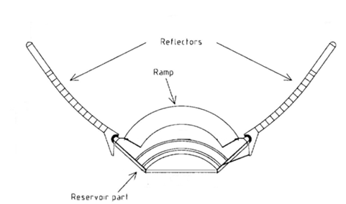The WD will usually be placed at 20 to 50 meters water depth and 25 to 100 km from the coastline. To minimize the cost of transport of the electrical power to the coast, it is necessary to arrange 50 to 200 WD units in a group.

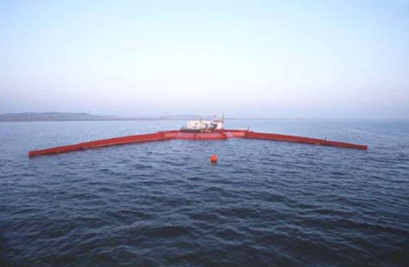

**Fig. 3.1.1** Wave Dragon [10] **Fig. 3.1.2** Top View of WD [10]

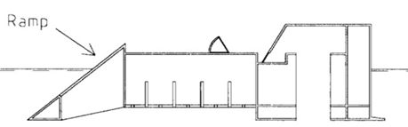

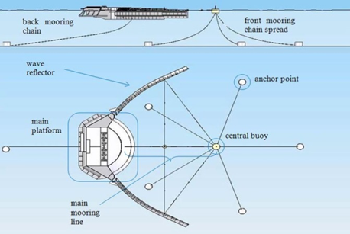

**Fig. 3.1.3** Side View of WD [10] **Fig. 3.1.4** Mooring Arrangement of WD [11]

**3.2 Yesterday, Today and Tomorrow of WD**

In 1986, Erik Friis-Madsen first initiated the development of the WD and submitted this concept for patent in 1995. After that, investigations on structural layout, financial aspects and turbine configuration were conducted. Model tests were also carried out on investigations of motions of the WD, mooring forces and ability of survival in extreme sea condition. Later on, the following projects on WD are to optimize the hydraulic performance, structural design, control and regulation of the turbines and design of electrical component and connection to grid. [10]

Model tests showed that there was an efficiency drop-off, due to the large excursions of the crest freeboard, when the significant wave heights are over 3 m. [10] This problem is to be solved through modifying the model, such as adding more ballast in the front to move the center of gravity.

Moreover, optimal geometrical design of the wave reflectors and the reservoir part are also being investigated. Experience with controlling the turbines and necessary maintenance is also necessary to achieve. Another important issue to be considered in the future is the influence on the pitch and heave motions of changing the air pressure in the different buoyancy compartments. (删除！)

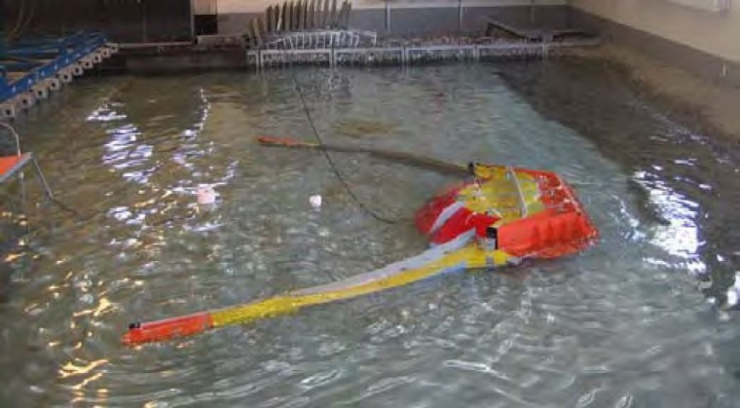

**Fig. 3.2** Model test of 1:50 scale Wave Dragon in Aalborg University wave basin [12]

Numerical calculation is also an effective method to evaluate the performance of WD in the design process. One numerical investigation has been carried out on wave transmission through the floating WD in various wave conditions. In this investigation, two numerical models, namely the partial reflecting and partial transmitting WD model and a simplified model, which is based on wave power integration below the draft of the floating structure have been proposed and calculated. In the simplified model, all wave power from the draft to the seabed is thus assumed to be fully transmitted. The possible wave radiation generated from the floating device due to heave, surge and pitch motions was neglected. The results show that the simplified approach provides results similar to the transmission obtained from the partial reflecting and partial transmitting numerical model, both for a single WD and a farm of multiple WDs, which means this simplified numerical model can provide relative accurate results with much less cost, compared with model tests.

After the design of WD, a larger scale (such as 1:3) model experiment is supposed to be conducted in inner waters. This is a necessary step before building a full-scale prototype to achieve experience with controlling the turbines, necessary maintenance, etc. In these large scale experiments, more attention should be paid to the influence of changing the air pressure in the different buoyance compartments on the motions of pitch and heave.

Parallel to the different model tests and numerical investigations, plans are being made to conduct investigations with new or partly new models in 2D and 3D numerical wave basins to establish the optimal geometrical design of the wave reflectors and the reservoir part itself to enhance the operation efficiency.

**References:**

[1] Drew, Benjamin, A. R. Plummer, and M. Necip Sahinkaya. "A review of wave energy converter technology." Proceedings of the Institution of Mechanical Engineers, Part A: Journal of Power and Energy 223.8 (2009): 887-902.

[2] Rusu, Eugen. "Evaluation of the wave energy conversion efficiency in various coastal environments." Energies 7.6 (2014): 4002-4018.

[3] Baker, N. J. and Mueller, M. A. Direct drive wave energy converters (in French). Revue des Energies Renouvelables, 2001, 4(2), 1–7.

[4] Archimedes Wave Swing. Available from <http://tinyurl>.com/archws1/ (accessed 2 July 2008).

[5] Aquamarine Power Oyster. Available from http://tinyurl.com/cn9k4k/ (access date 2 July 2008).

[6] Oceanlinx. Available from http://www.oceanlinx.com/ (access date 4 September 2008).

[7] Oscillating Water Column. Available from http://wavegen.co.uk/images/owc.jpg/ (access date 2 July 2008).

[8] Wave Dragon schematic. Available from http://tinyurl.com/wavegen2/ (access date 2 July 2008).

[9] Silva, Dina, Eugen Rusu, and Carlos Guedes Soares. "Evaluation of various technologies for wave energy conversion in the Portuguese nearshore." Energies 6.3 (2013): 1344-1364.

[10] Kofoed, J. P., Frigaard, P., Sorenson, H. C., & Friis-Madsen, E. (2000, January 1). Development of the Wave Energy Converter - Wave Dragon. International Society of Offshore and Polar Engineers.

[11] Parmeggiani, Stefano, Jens Peter Kofoed, and Erik Friis-Madsen. "Experimental Study Related To The Mooring Design For The 1.5 MW Wave Dragon WEC Demonstrator At Danwec." Energies (19961073) 6.4 (2013): 18631863-1886. Academic Search Complete. Web. 27 Apr. 2016.

[12] Testing, Analysis and Control of Wave Dragon, Available from <http://vbn.aau.dk/en/publications/testing-analysis-and-control-of-wave-dragon-wave-energy-converter(0cf50e30-8c6e-11dc-a123-000ea68e967b).html>

[13] Low-pressure Hydro Turbines and Control Equipment for Wave Energy Converters (Wave Dragon), EU-EA Research Application, Internal report, Copenhagen, April 1998.

[14] Nørgaard, J. H., & Andersen, T. L. Investigation of Wave Transmission From a Floating Wave Dragon Wave Energy Converter. International Society of Offshore and Polar Engineers. January. 2012.