Portfolio

The Micron Drones stuff i put into practice: 9/12/2025 I’ve been working on related to Micron Drones (9/12/2025). I integrated an IMU module with an ESP32 microcontroller board, which required fine-pitch soldering and careful handling due to the extremely small pin spacing.This pushed me to refine my precision soldering techniques and improve my hardware debugging workflow (continuity checks, signal validation, and stable power routing). It was a great practical exercise in embedded system integration and reinforced my comfort working at the board level.

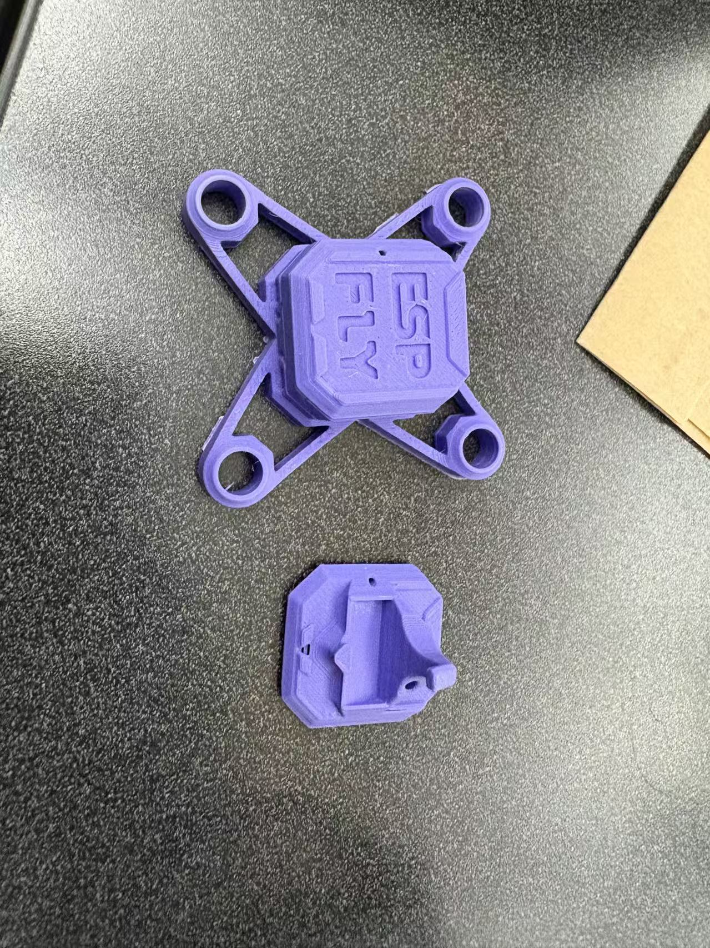

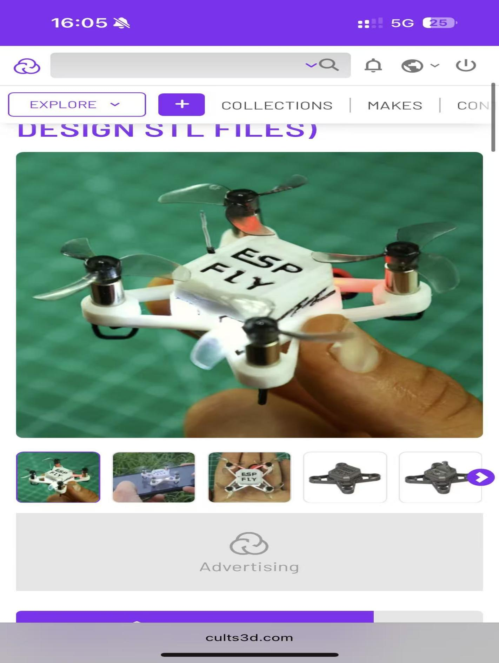

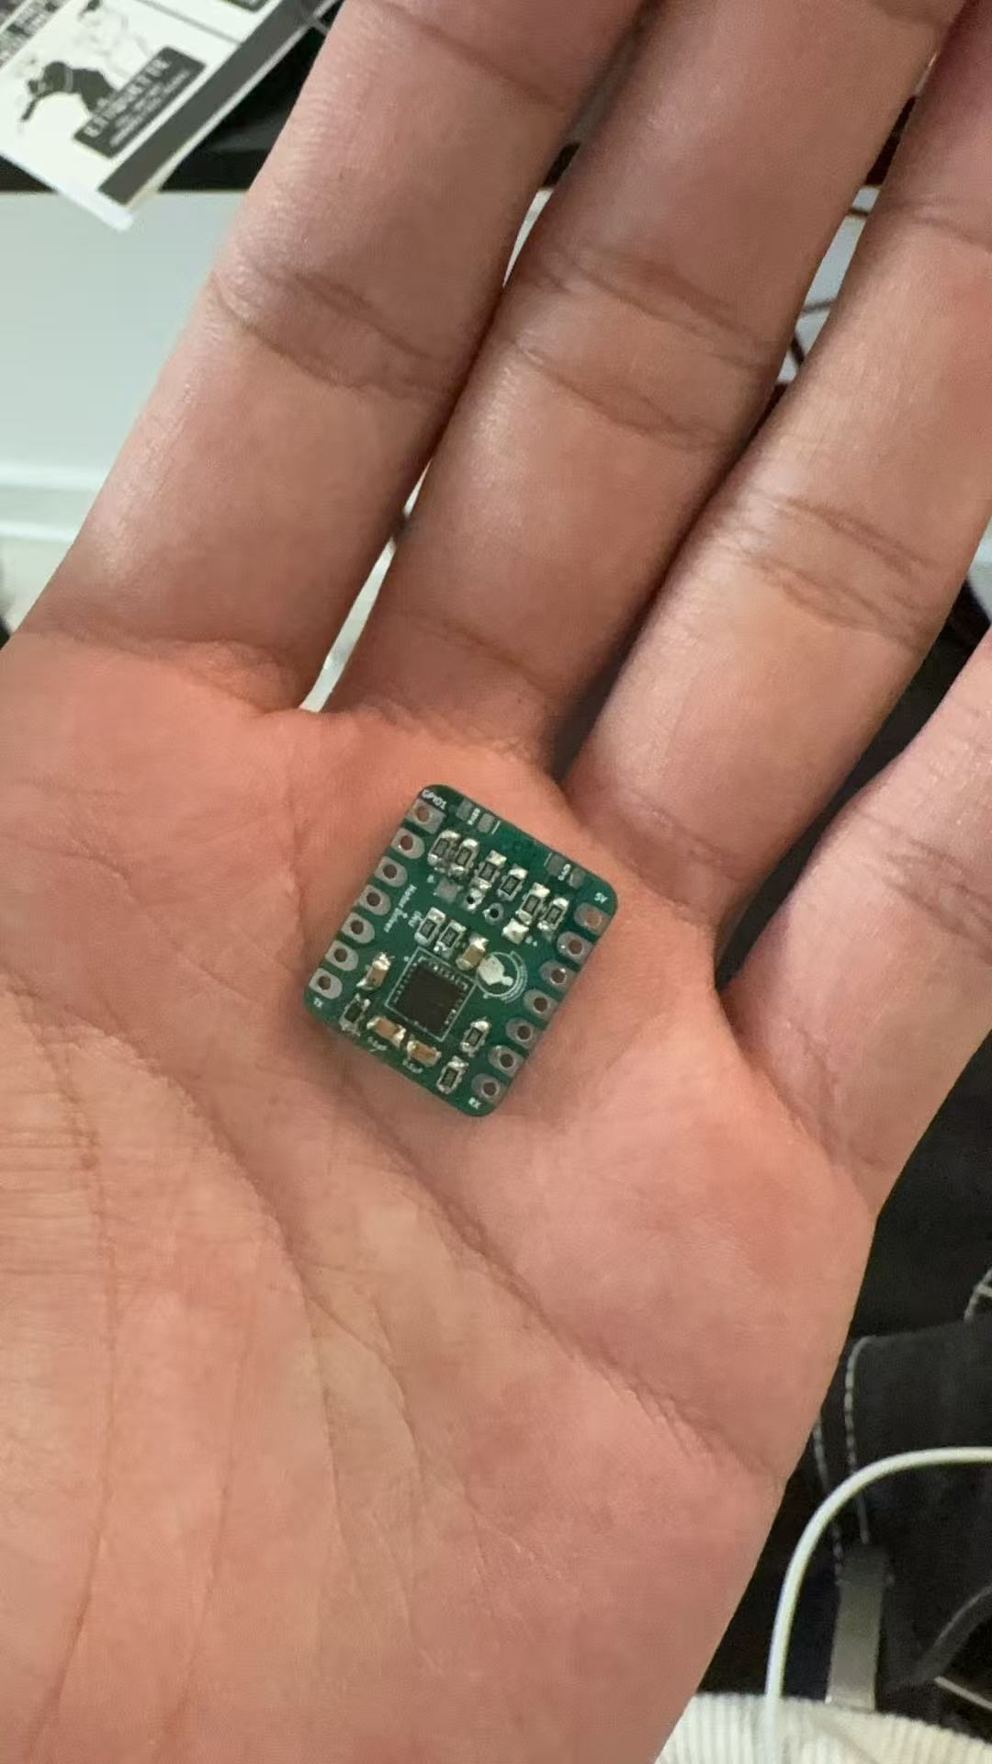

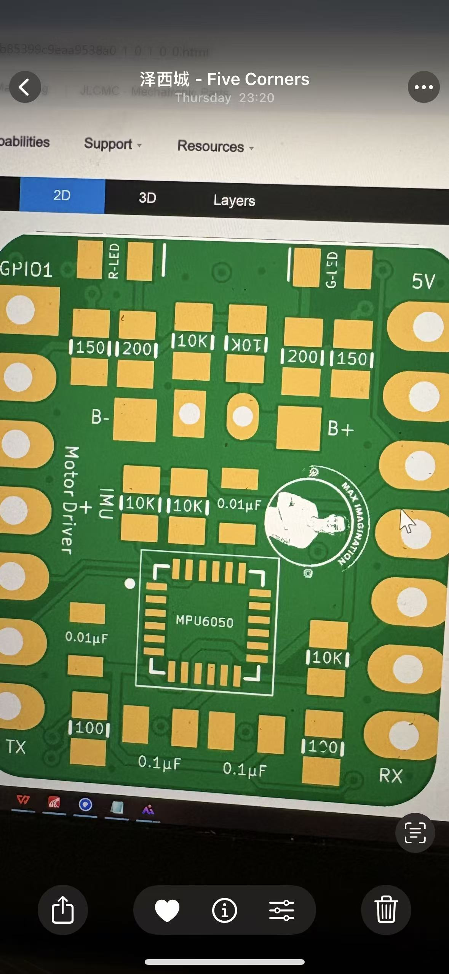

2、NYU Elisa Riedo Pico-Force Lab:
I build up a 6-layer pcb design from scratch to fabrication, i am right now testing the board and using the mcu(msp430fr2355) ccs studio(for coding ) and mux(tmux1109pwr) to switch the channel to test the leakage current between drain and source (mosfet).
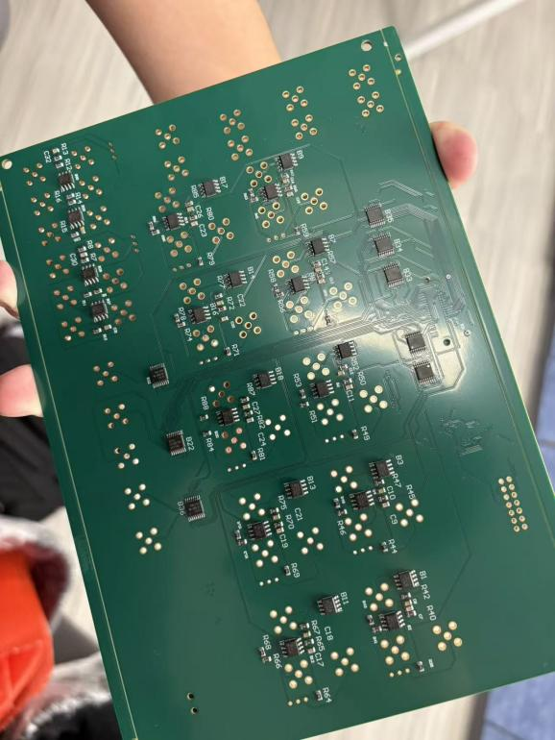

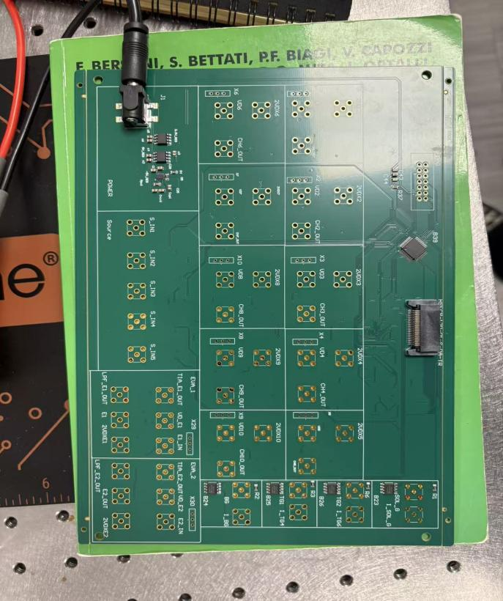

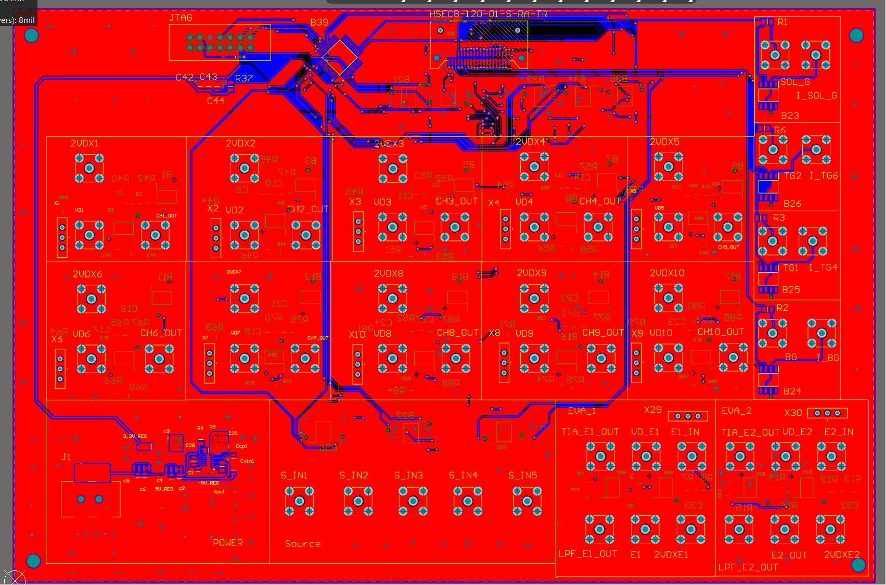

I finished the mcu testing for programming and successfully pass the electrical test and fabricated out using jlcpcb.

3、NYU Motorsports

Collaborated and design the voltage isolation part of the precharge board logic and also help the teammates draw pcb and find components on the other part for relay and voltage division.

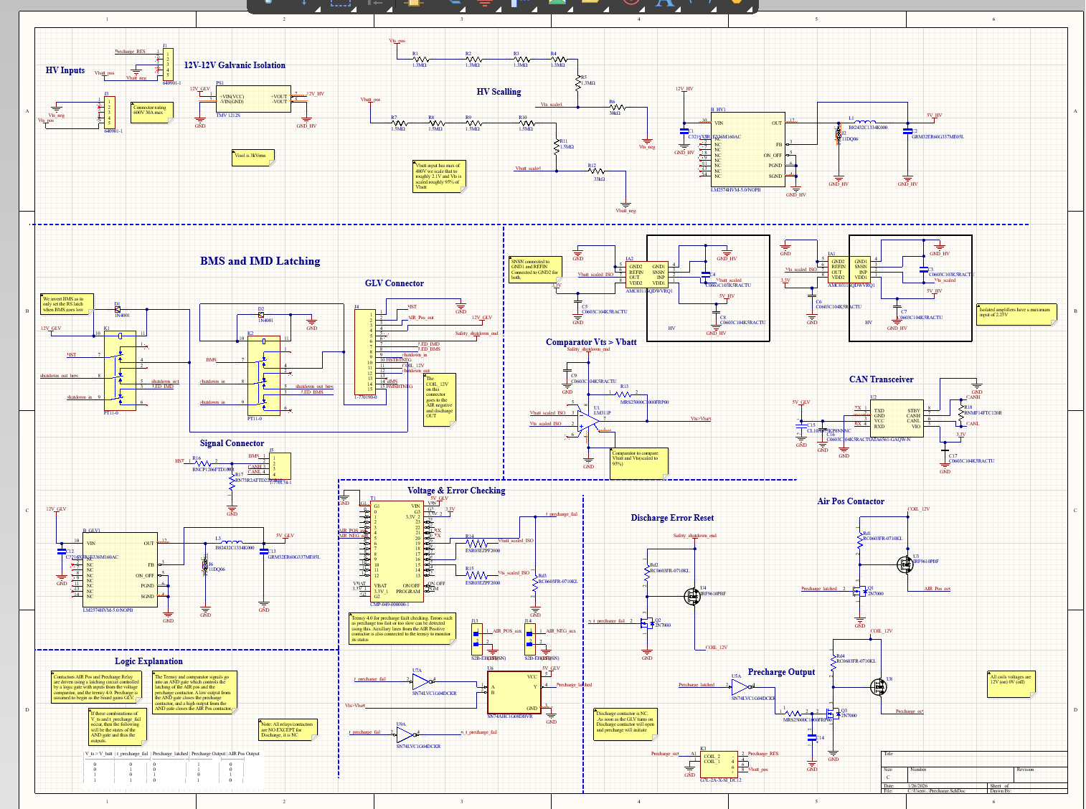

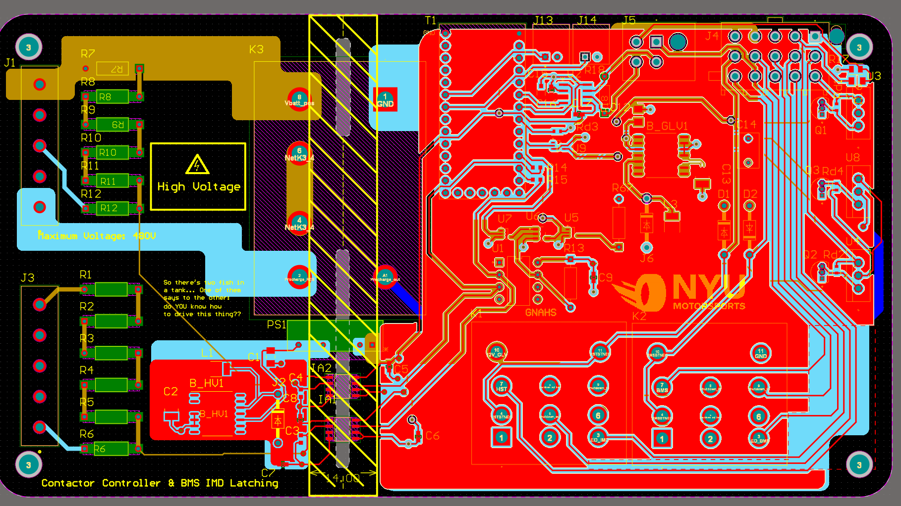

4、Implemented and debugged a RISC-V single-cycle processor using Verilog with DPI-C interfaces, with simulation, testing, and build workflows conducted on Linux Operating system
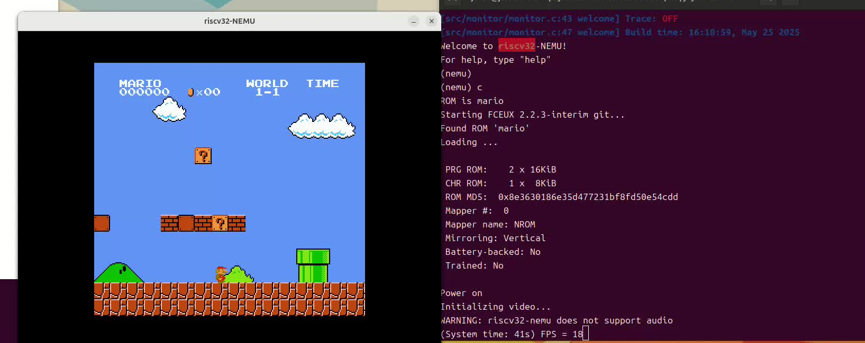

A：Used Differential Testing (DiffTest) to compare the Verilog-based CPU against a self-developed reference software model (partially assisted by ChatGPT), in order to identify unimplemented or incorrectly implemented instruction paths, particularly in control-flow and branch logic.

B、Implemented the RT-Thread OS to investigate the interaction between context switching and CPU context saving/restoration.

C、 Enhanced a software CPU simulator by modeling clock behavior and emulating peripherals such as keyboard and GPU AND FINALLY IT CAN RAN SUPER MARIO VIVIDLY

D、Integrated a clocked Verilog RTL CPU capable of running a text-based Mario application.

E、Improved performance metrics by disabling non-critical features (e.g., instruction tracing) to achieve higher CPU benchmark scores.

5、UCLA Research Group – VLSI Design of Absolute Value Comparator Summer 2023

Link:https:/doi.org/10.54097/hset.v71i.13437

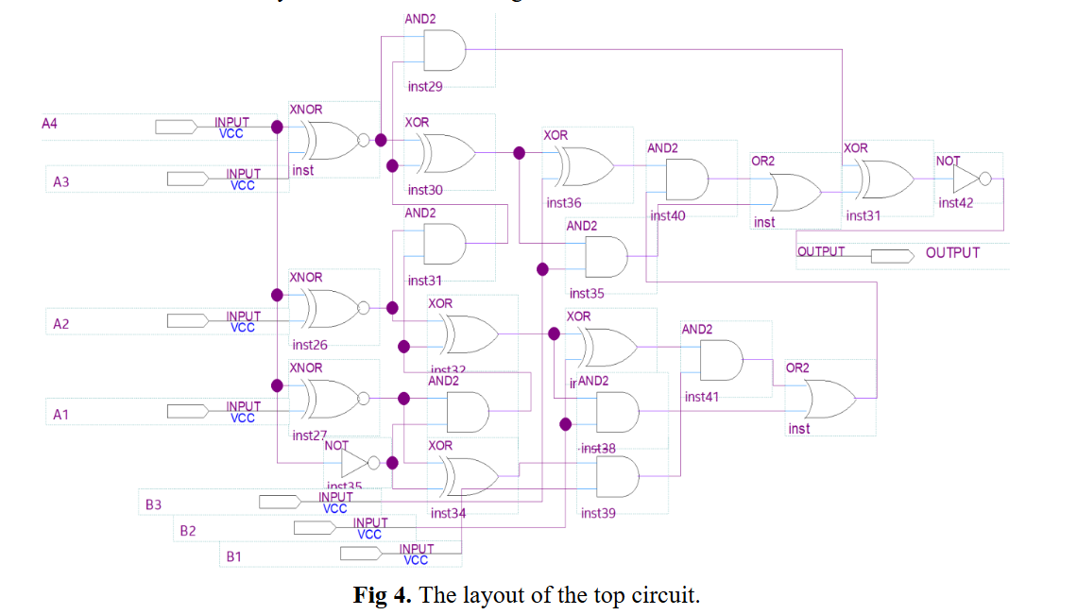

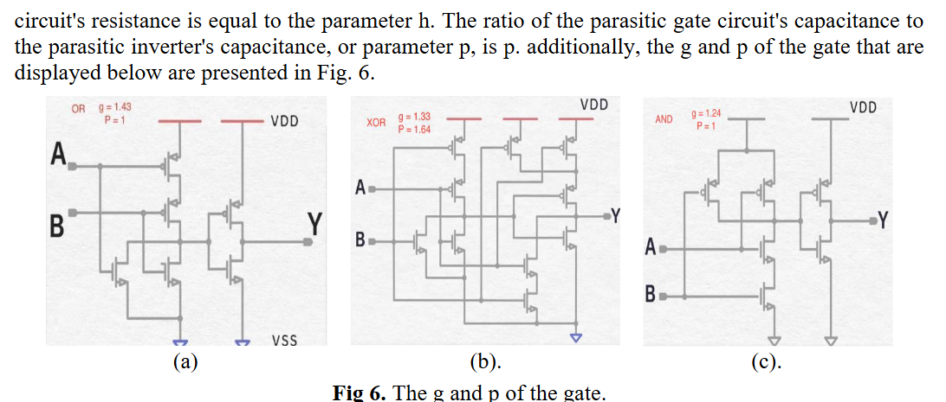

6、Embedded Systems Project — “Shake, Rattle, and Roll…and Freeze”| New York University ECE 6483 Fall 2025
- Implemented real-time detection of tremor, dyskinesia, and freezing-of-gait using on-board IMU data and a 3-second FFT-based classification pipeline.
- Built an RTOS firmware architecture with prioritized tasks and mail queues for sensor sampling, FFT processing, BLE reporting, and LED feedback with deterministic latency.
- Developed a multi-characteristic BLE interface and on-board indicators to report condition severity in real time using only dev-board resources.
https://github.com/Jason1790213836/ECEGY6483-25Fall

System Task Architecture (RTOS)
• An IMU task runs at the highest priority to acquire sensor data and push it into a mail queue.

• An FFT processing task consumes data from the mail queue and performs signal processing, operating with high priority.

• A printf/output task reads results from a secondary normal-priority queue and handles data printing/logging
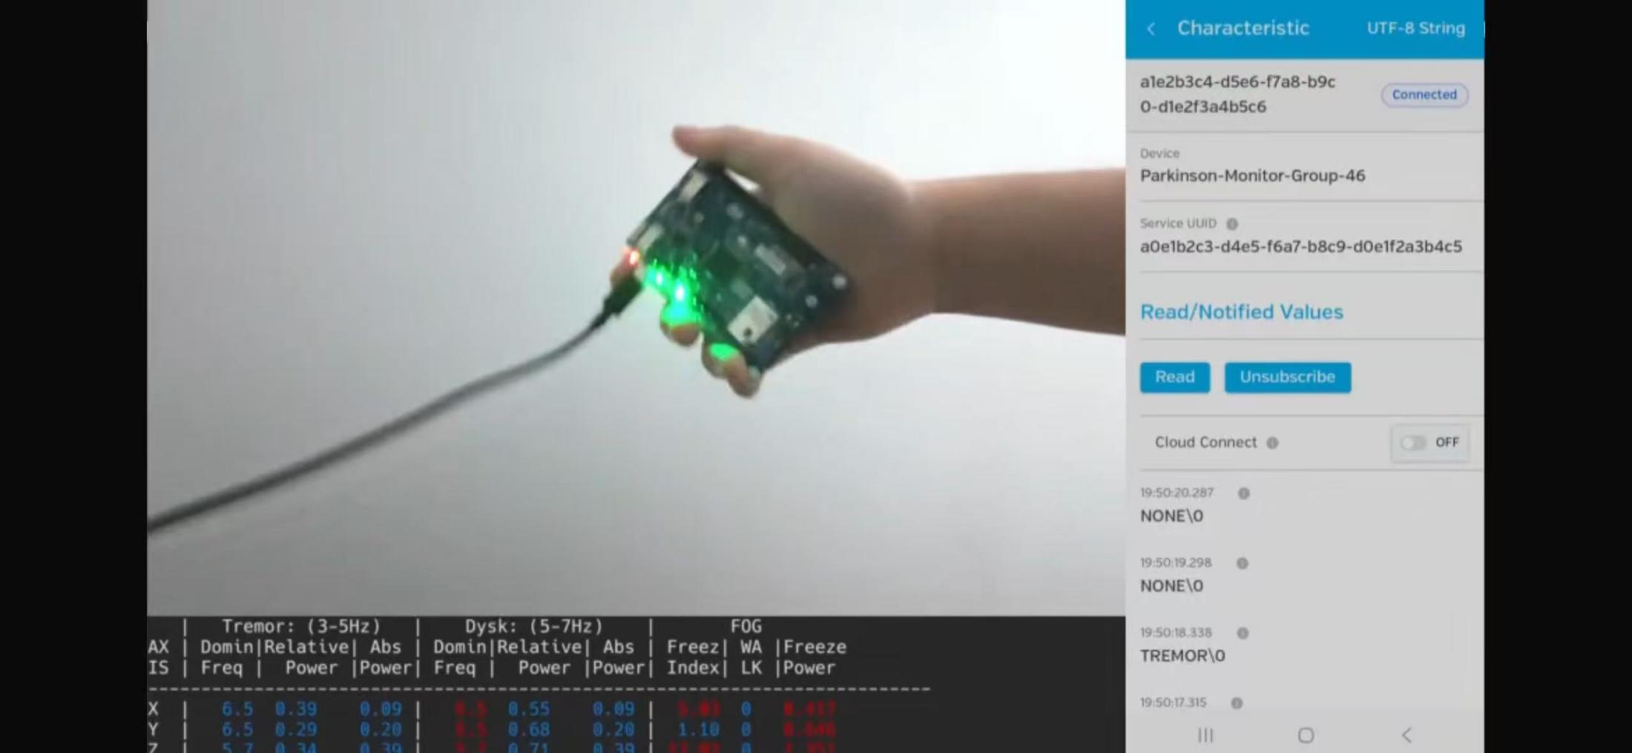
If you want to watch the whole functionality movie , you can reach out to me

7、Computer System Architecture Design | New York University C++, RISC-V Assembly, Linux Fall 2025
- Designed and implemented a 32-bit RISC-V CPU simulator in C++, featuring both Single-Cycle and 5-Stage Pipelined architectures.
- Implemented ID-stage forwarding and hazard detection for a 5-stage RISC pipeline, eliminating load-use stalls and reducing test-bench latency by 7 cycles. Validated performance gains through rigorous IPC and CPI profiling

7、Embedded Systems Intern: Shanghai Pidelo Co., Shanghai May 2025-Aug 2025
- Developed an ESP32-based PWM water pump system in C using Arduino and ESP32, leveraging GPIO to read ADC values and control the pump to simulate a human heart rhythm (~60 BPM).
Programmed a Nordic nRF52 microcontroller for a BLE health monitor, implementing complex STC31 algorithms to convert temperature and humidity readings, with timer-driven LED, button power logic, real-time Carbon dioxide transmission, and ADC-based battery monitoring. This are for teaching purpose.
