AutoChip_Report

- Overview-BCD:
In this assignment, I used AutoChip to generate synthesizable Verilog for a 5-bit Binary-to-BCD converter. The design converts a binary input (0–31) into an 8-bit packed BCD output, where:
bcd_output[7:4] = tens digit
bcd_output[3:0] = ones digit
I selected this example as the combinational design task. The provided testbench compares the DUT against a golden reference implementation using:
tens = binary_input / 10;ones = binary_input % 10;
The AutoChip workflow iteratively generated RTL, compiled it using iverilog, simulated it, and used mismatch feedback to refine the design.
2. Initial Prompt and Configuration

Model Configuration
Model: gpt-4o-mini
Iterations: 5
Num candidates: 5
Ensemble: disabled
Toolchain: iverilog -g2012
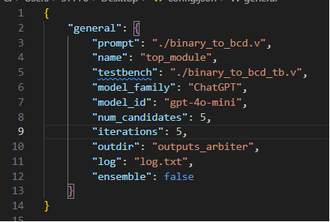

Initial Prompt
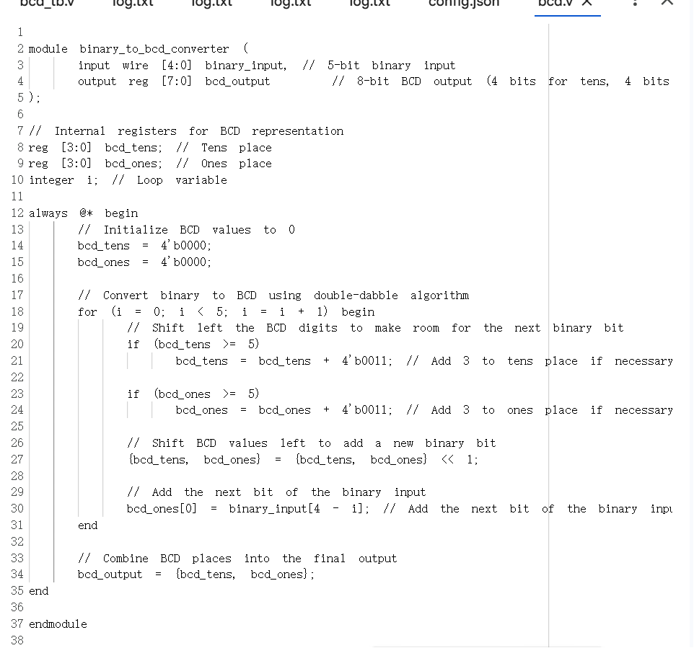

Actually my first prompt include some logic embedded into the module and logic hint for the generation.
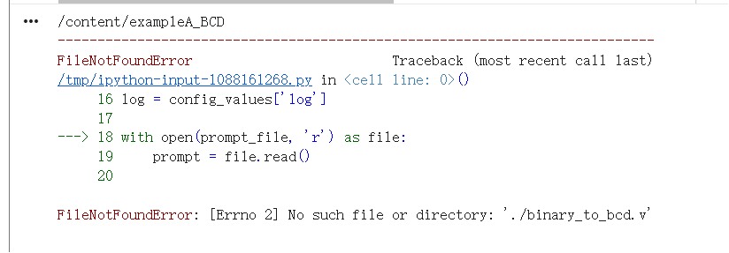
But the first time i didn’t pronounce the right file name. I mistake the binary_to_binary.v with binary_to_binary.sv so i change the file back again to .v to ensure there is no conflict and solve the problem.
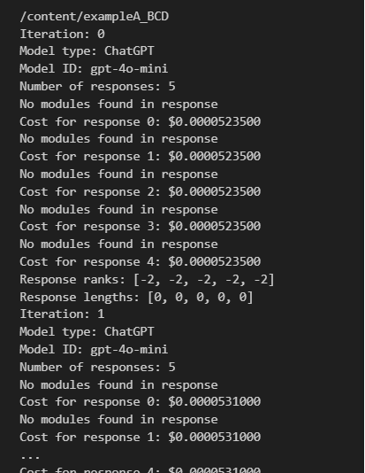
And the first output turns no response.

Second Trial:
This time i didnt change the prompt a lot but i do encounter a lot of basic compiler issue mostly is because my testbench is not corresponding with the auto chip rule

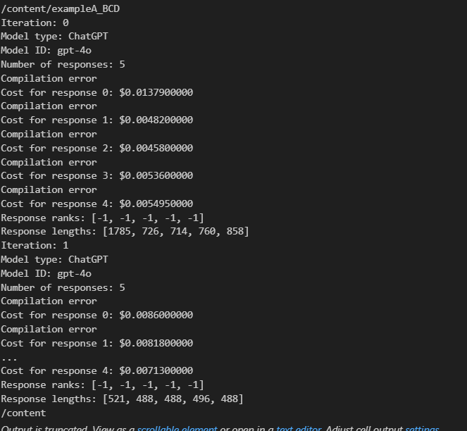

So i change the testbench name from binary_to_bcd_converter to tb and everything works it can run finally.

Third Trial:
I still didnt change the prompt a lot but it turns out to be some problems with the simulation result which is not corresponding with the ideal output from the testbench which ideally should be.
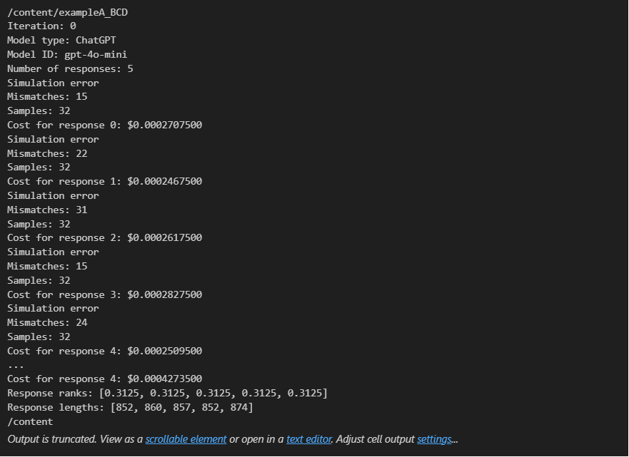

Fourth Trial：
This time i change the prompt to the right version which is : I ONLY told the llm to just using the basic assign language which avoid the complex and hard to realize result.
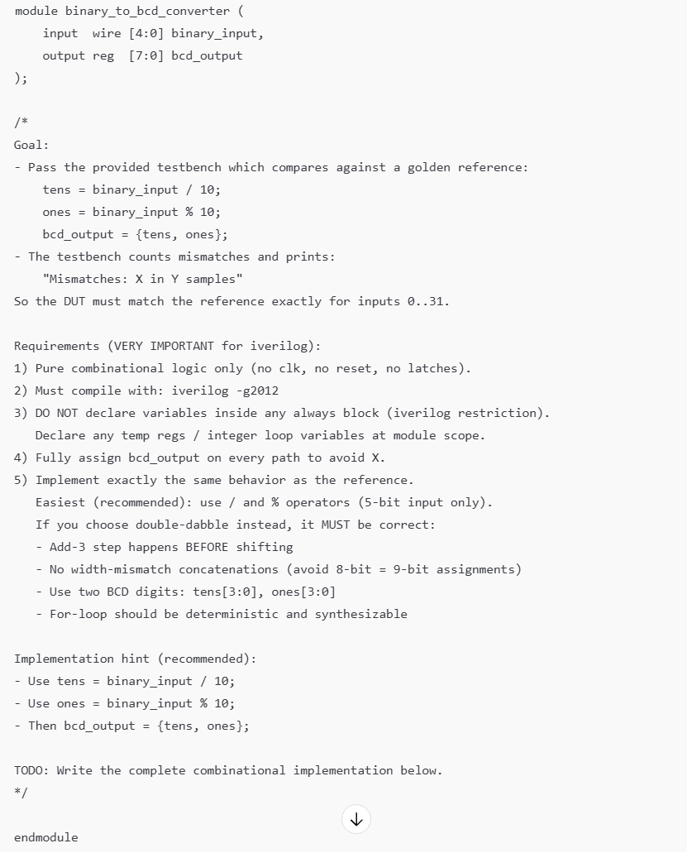

And it finally pass the test.

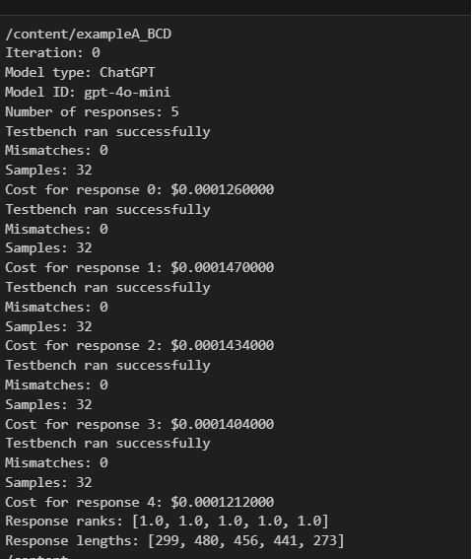

The Second Example :

I choose the registor shift. And the initial prompt is shown as follows .

'''
I am trying to create a Verilog model for a shift register. It must meet the following specifications:
- Inputs:
- Clock
- Active-low reset
- Data (1 bit)
- Shift enable
- Outputs:
- Data (8 bits)

How would I write a design that meets these specifications?

module shift_register(
input logic clk,
input logic reset_n,
input logic data_in,
input logic shift_enable,
output logic [7:0] data_out

);

But it pops up that there is a violation which is against the compilation rule, so i return back and double check whether there might be a issue with the code.

After see the log.txt. I found the mistake lies at the testbench. I am not using correct testbench name . So i changed to tb which is corresponding with the name of the Autochip Python logic.

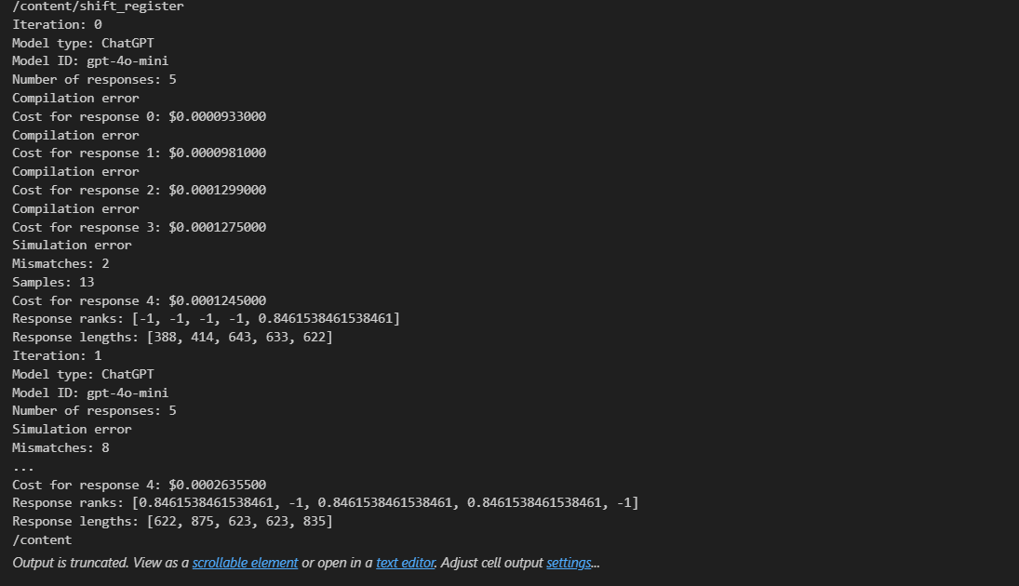

Second Trial,
The mistake is the sv code i use llm to generate didnt use the negedge reset_n. So i eliminate the negedge clk and only use the posedge clk.


The Third prompt looks like that:
I am trying to create a SystemVerilog model for an 8-bit shift register.

Ports (MUST match exactly):
- input logic clk
- input logic reset_n (active-low SYNCHRONOUS reset)
- input logic data_in (1-bit)
- input logic shift_enable
- output logic [7:0] data_out

Behavior (MUST match):
- On each posedge clk:
- If reset_n == 0, set data_out <= 8'b0 (synchronous reset: DO NOT use negedge reset in sensitivity list)
- Else if shift_enable == 1, shift left and insert data_in into LSB:
data_out <= {data_out[6:0], data_in}
- Else hold previous data_out (no change)

Constraints:
- Use SystemVerilog syntax (logic, always_ff).
- Single module only: shift_register.
- No additional helper modules.
- Provide ONLY the complete module code.

And the test finally pass all the testbench after iteration

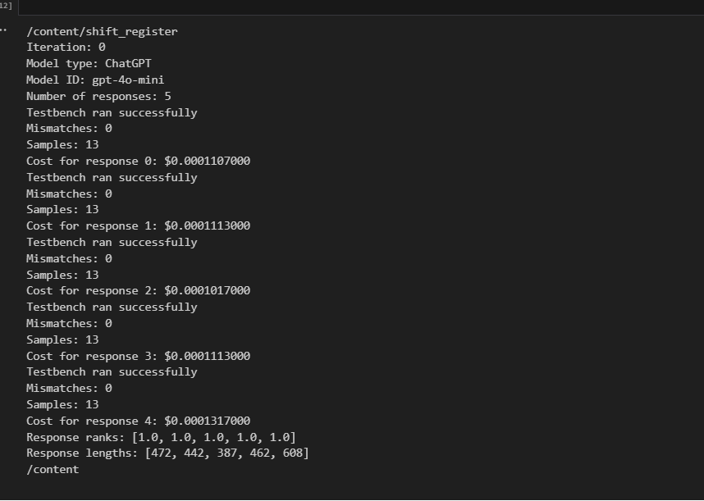
For part I(b):
I changed the config.json file
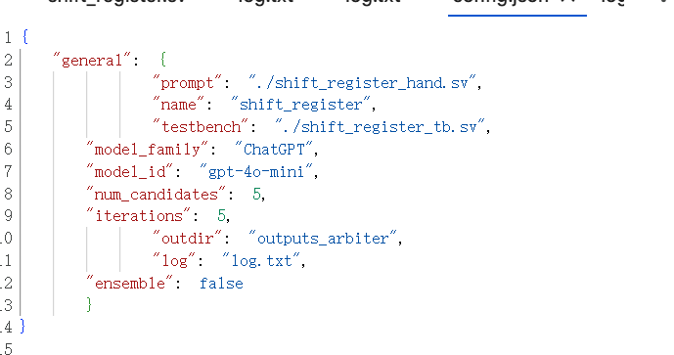
Change the promt from shift_register.sv to shift_register_hand.sv and pass the test

This is the hand written version.
