ChipChat_Report
Summary

The first example i choose is the Example 1: binary_to_bcd

The second example i choose is the Example 5: Dice_Roller
The extension example i choose is the Example 8: Traffic Light

Firstly: Binary_to_bcd:
1、The Generation Parameter:

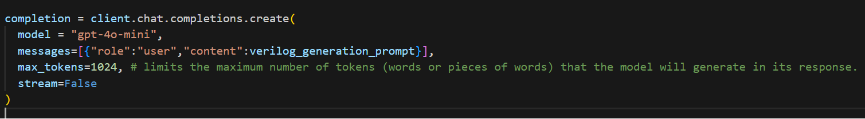
As you can see in this picture , the model is “gpt-4o-mini” The max_tokens is 1024

2、The Final Prompt i use:
verilog_generation_prompt = '''
I am trying to create a Verilog model binary_to_bcd_converter for a binary to binary-coded-decimal converter. It must meet the following specifications:
- Inputs:
- Binary input (5-bits)
- Outputs:
- BCD (8-bits: 4-bits for the 10's place and 4-bits for the 1's place)

How would I write a design that meets these specifications?
'''

- The Output Module:
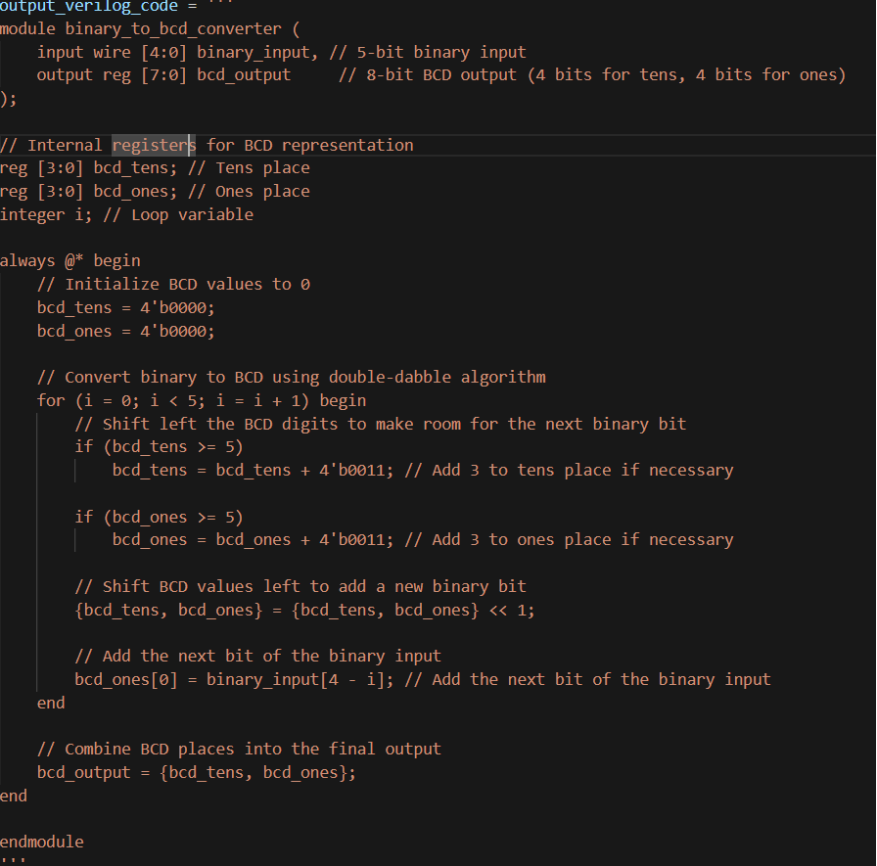

The Design explanation:
So basically the llm model gave out the final results which can perfectly fit the testbench.
The module interfaces includes the input signal which is 5bits wire binary_inputs and 8bits reg bcd_output.
And it defines two bc_tens and bcd_ones interval variables and also the interger i for the loop exclusively.
Standard binary counters carry over at 16 ($2^4$), but decimal (BCD) must carry over at 10. To fix this "gap," the algorithm follows two rules:Check: Before shifting, if any BCD digit is >=5, add 3.Shift: Shift everything left by 1 bit to process the next binary digit.

Secondly: Dice_Roller
1、The Generation Parameter:


As you can see in this picture , the model is “gpt-4o-mini” The max_tokens is 1024

- The Final Prompt i use:

verilog_generation_prompt = '''
I am trying to create a Verilog model for a simulated dice roller. It must meet the following specifications:
- Inputs:
- clk
- Active-low rst_n
- die_select (2-bits)
- roll
- Outputs:
- rolled_number (up to 8-bits)
And the internal signal should be reg
and try to keep the always sequential logic and combination logic
The design should simulate rolling either a 4-sided, 6-sided, 8-sided, or 20-sided die, based on the input die select. It should roll when the roll input goes high and output the random number based on the number of sides of the selected die.

How would I write a design that meets these specifications?
'''

- The Output Module:

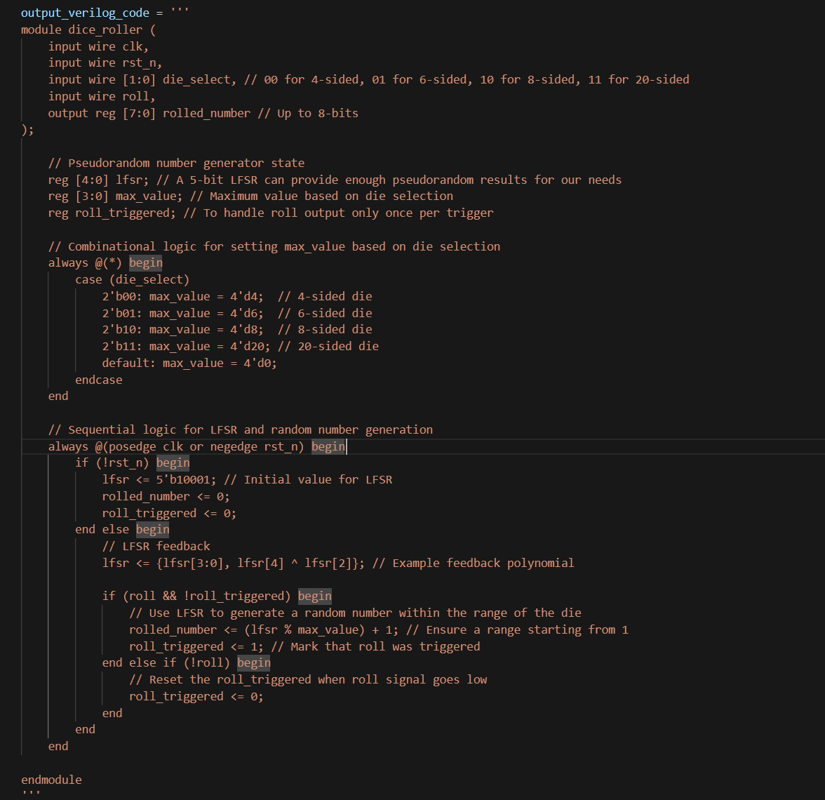

The design approach:
The module uses die_select to determine the maximum dice value (4, 6, 8, or 20). The LFSR continuously updates every clock cycle to provide pseudorandom values. When the roll signal is asserted, and no previous roll has been triggered, the current LFSR value is mapped to the valid dice range and assigned to rolled_number. The roll_triggered signal ensures that only one dice roll occurs per roll assertion, and the output remains unchanged until a new roll trigger occurs

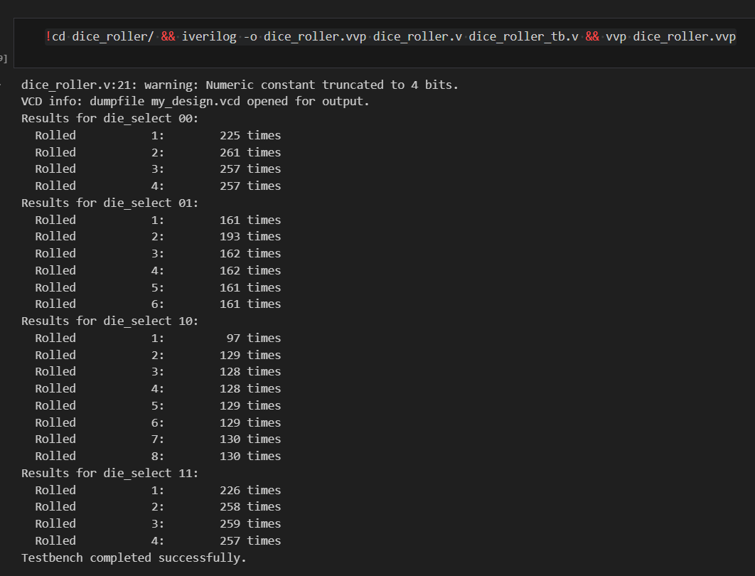

For the Part II:
The Table looks as below:

Iteration times | Issue_observed | Fix_applied | outcome | What _fail | Why i expext it can work
1 | dice_roller_tb.v:10: error: port ``die_select'' is not a port of dut.  1 error(s) during elaboration. | I changed the original port die_sel to the die_select. | dice_roller_tb.v:10: error: port ``die_select'' is not a port of dut.  1 error(s) during elaboration. | The port name die_select is not corresponding | Because the dut in the testbench is not corresponding with the .v document
2 | - The rst_n is somehow different name which is not corresponding to the .v documnet  2、The max_value which is the internal signal which should be reg type instead of the wire type | I change the reset_n in the testbench document and make it align with the testbench.  I change the max_value type from wire to reg | dice_roller_tb.v:10: error: port ``rst_n'' is not a port of dut.  dice_roller.v:17: error: max_value is not a valid l-value in tb_dice_roller.dut.  dice_roller.v:12: : max_value is declared here as wire.  dice_roller.v:18: error: max_value is not a valid l-value in tb_dice_roller.dut.  dice_roller.v:12: : max_value is declared here as wire.  dice_roller.v:19: error: max_value is not a valid l-value in tb_dice_roller.dut.  dice_roller.v:12: : max_value is declared here as wire.  dice_roller.v:20: error: max_value is not a valid l-value in tb_dice_roller.dut.  dice_roller.v:12: : max_value is declared here as wire.  dice_roller.v:21: error: max_value is not a valid l-value in tb_dice_roller.dut.  dice_roller.v:12: : max_value is declared here as wire.  6 error(s) during elaboration. | The signal name and type which has a conflict with the dut module and some violations with the verilog rules | Because the name is not corresponding which cant make the compiler to locate the signal which is a big problem.  Also, max_value is a value should be restore in the registors so basically you cant just using the assign in the always module . I mean you can use the wire signal , but you cant make it assign value in always module.
3 | The signal called nreset still regenerated wrong | I do a iteration again | module dice_roller ( input wire clk, input wire nreset, // Active-low reset input wire [1:0] die_select, // 00 - 4-sided, 01 - 6-sided, 10 - 8-sided, 11 - 20-sided input wire roll, // Signal to roll the die output reg [7:0] rolled_number // 8-bit output to represent rolled number ); | The name of the signal is not corresponding | The logic as i said above
4 | Right now its finally work | Change the .v file by generating new prompt and apply into the file | dice_roller.v:21: warning: Numeric constant truncated to 4 bits.  VCD info: dumpfile my_design.vcd opened for output.  Results for die_select 00:  Rolled 1: 225 times  Rolled 2: 261 times  Rolled 3: 257 times  Rolled 4: 257 times  Results for die_select 01:  Rolled 1: 161 times  Rolled 2: 193 times  Rolled 3: 162 times  Rolled 4: 162 times  Rolled 5: 161 times  Rolled 6: 161 times  Results for die_select 10:  Rolled 1: 97 times  Rolled 2: 129 times  Rolled 3: 128 times  Rolled 4: 128 times  Rolled 5: 129 times  Rolled 6: 129 times  Rolled 7: 130 times  Rolled 8: 130 times  Results for die_select 11:  Rolled 1: 226 times  Rolled 2: 258 times  Rolled 3: 259 times  Rolled 4: 257 times  Testbench completed successfully. | N/A | N/A

Extention: Traffic_Light
The Generation file:
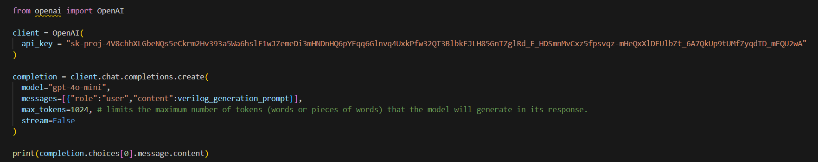
The final prompt for the extension:
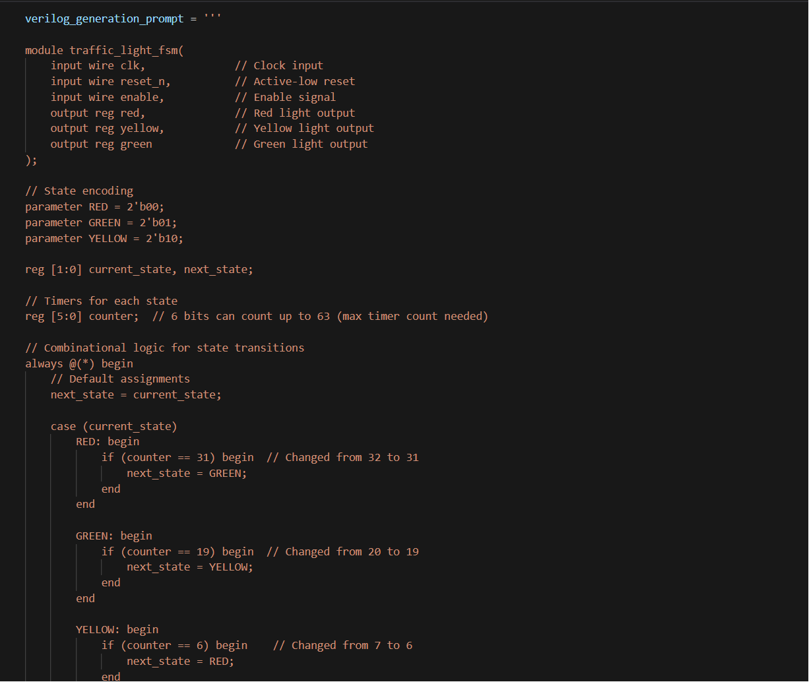

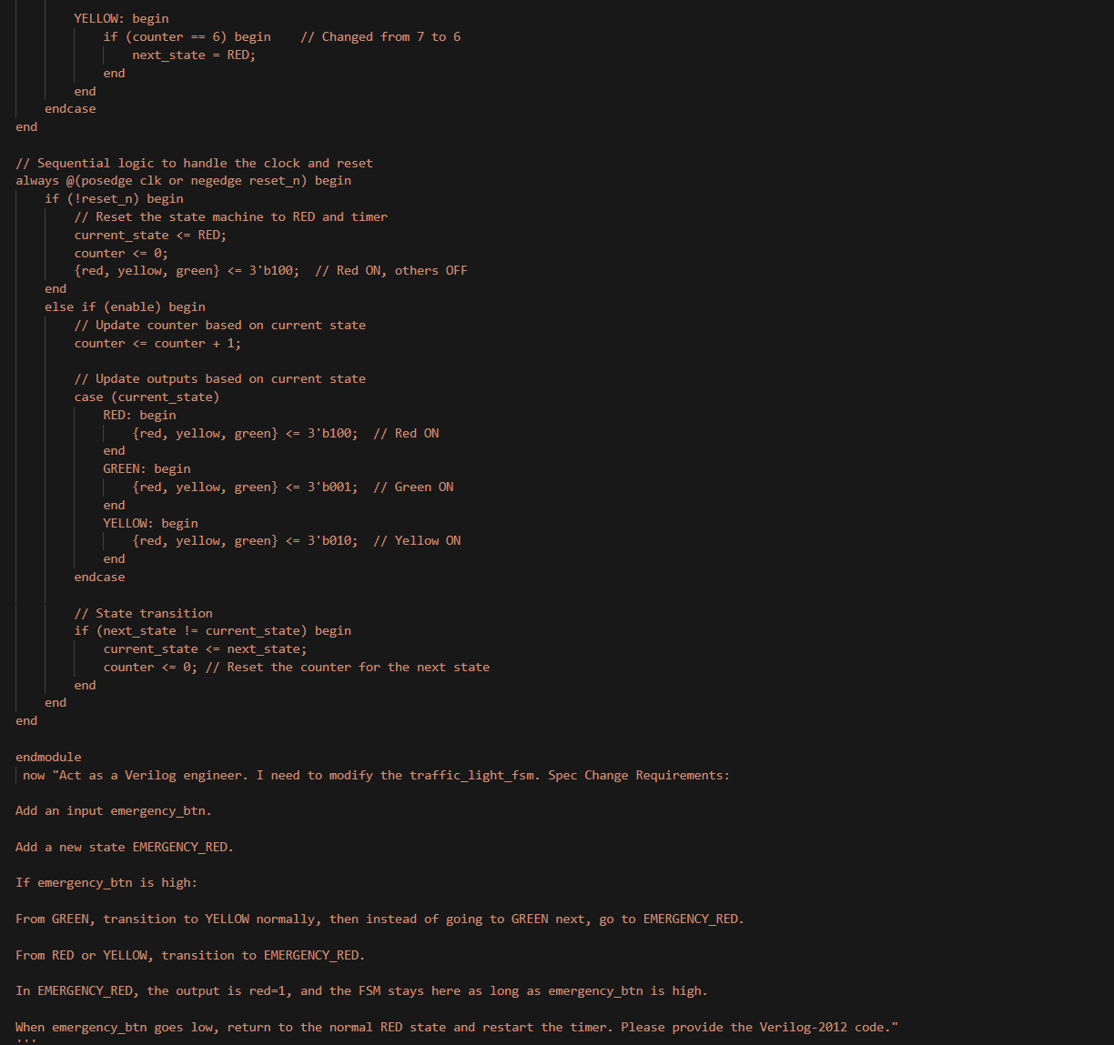
For the prompt , i added additional information about the logic for the traffic operation logic and add a specific design to the module like adding an emergency red light
Add an input emergency_btn.
Add a new state EMERGENCY_RED.
If emergency_btn is high:
From GREEN, transition to YELLOW normally, then instead of going to GREEN next, go to EMERGENCY_RED.
From RED or YELLOW, transition to EMERGENCY_RED.
In EMERGENCY_RED, the output is red=1, and the FSM stays here as long as emergency_btn is high.
When emergency_btn goes low, return to the normal RED state and restart the timer. Please provide the Verilog-2012 code."

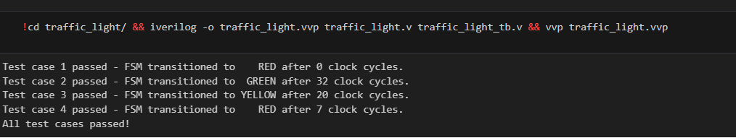
This is for the basic traffic_light

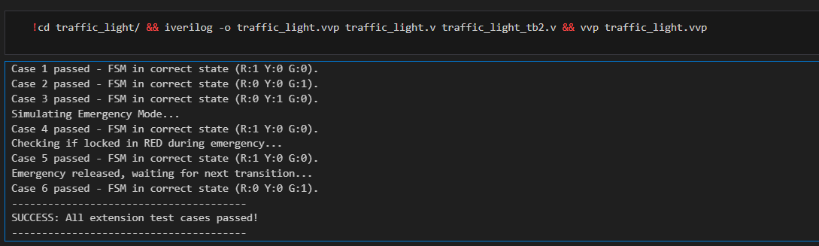
The final pass results for the emergency function testbench.v
module traffic_light_fsm(
input wire clk, // Clock input
input wire reset_n, // Active-low reset
input wire enable, // Enable signal
input wire emergency_btn, // Emergency button
output reg red, // Red light output
output reg yellow, // Yellow light output
output reg green // Green light output
);

Design Implementation and Timing Strategy:

"In the revised verilog2.v, I implemented a look-ahead state transition logic to strictly adhere to the 32-cycle specification. The core logic is partitioned into a dedicated combinational block and a sequential block to ensure precise timing:

Combinational Logic (Condition Detection): I placed the state transition and light detection logic in a combinational block. When the counter reaches 31 (during the 32nd clock cycle), the next_state is immediately evaluated and set to GREEN. This allows the FSM to 'prepare' the transition before the next clock arrival.

Sequential Logic (State Update): The actual status update occurs on the rising edge of the 32nd clock (which marks the beginning of the 33rd cycle). On this edge, the current_state is updated from RED to GREEN via non-blocking assignments.

By updating the next_state during the 32nd cycle and committing it to the register at the 32nd clock edge, the design ensures that the RED light occupies exactly 32 full clock periods. The transition to GREEN is thus visible and stable at the start of the 33rd cycle, perfectly aligning with the simulation behavior observed in the testbench."

