Microbench Automation Infrastructure
Version 2.0

REVISION HISTORY
Version | Date | Author | Summary of Changes
1.0 | Mar 11, 2016 | Chen, Davy | Overall concept of the service.
2.0 | Jan 5, 2017 | Chen, Davy | Overall concept of the service.

TABLE OF CONTENTS

1 Introduction 3
1.1 The MAI consists of three major components: 3
1.2 Design Goals 4
2 Functions of Each Component 5
2.1 Consisting of Skynet 5
2.1.1 procedure drawing 5
2.1.2 Host & Executor 5
2.1.3 WebUI 5
2.1.4 TACC 6
2.2 Preparations of Skynet 7
2.2.1 Setup Test Machines 7
2.2.2 Create TACC Test & Test Set 8
2.2.3 Create Test Plan on WebUI 9
2.2.4 Send Results to Server 10
2.2.5 After Skynet’s job Finish 11
2.3 Main Server 11
2.3.1 Major Tasks 11
2.4 MySQL Tables Relations 12
2.4.1 Major Relations 12
2.4.2 Tables Vertical Relations 12
2.4.3 Tables Relation Example 13
3 Appendix 15
3.1 SQL Table Definition 15

1 Introduction
MAI (Microbench Automation Infrastructure) consists of a group of hardware & software, it works together with Skynet, they are used to schedule Microbench tasks on a collection of hardware, software environments, and then manage produced result data, and organize the data into certain forms or charts, which can be requested and viewed by end user with internet browser.

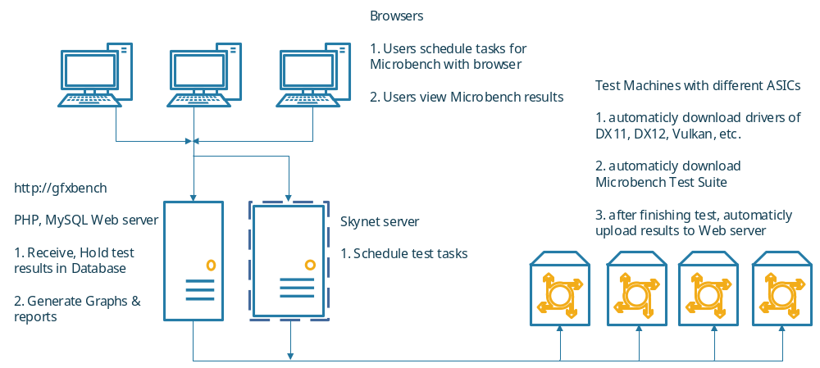
Figure 1 “Unified MAI Architecture”

1.1 The MAI consists of three major components:

- A group of test machines
The machines have different hardware, software configurations, like video cards, cpu, system. Microbench & latest drivers will be downloaded from certain paths from \\Gfxbench

- Skynet
This is a relatively mature project developed by another team in AMD. Skynet consists of a Host App, an Executor App and a WebUI. With Skynet we can manage multiple test stations, and schedule test plans from WebUI (web page).



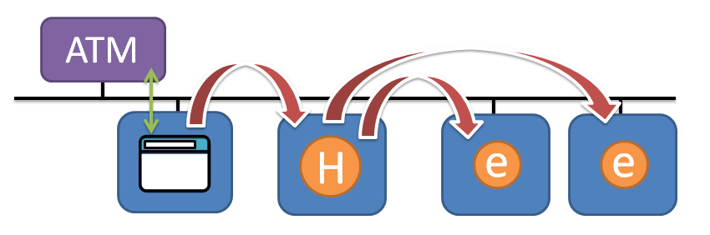

Website for Asia: http://skynet-asia/exe/

- A main server
The server has MySQL service to store Microbench results got from test machines. It also has a PHP web service to let user view Benching results comparing Graphs, and generating reports in EXCEL format.

1.2 Design Goals
- To make Microbench service can be accessed easily by remote user through internet browser.
- To schedule the tasks may be raised by user at same time. Avoid conflicts.
- To make the benching results be maintained and be processed automatically for users’ check, reduce human interference to the least.
- To well organize the results into graphs and EXCEL reports, to be helpful for users’ check through browser.

2 Functions of Each Component

2.1 Consisting of Skynet

2.1.1 procedure drawing
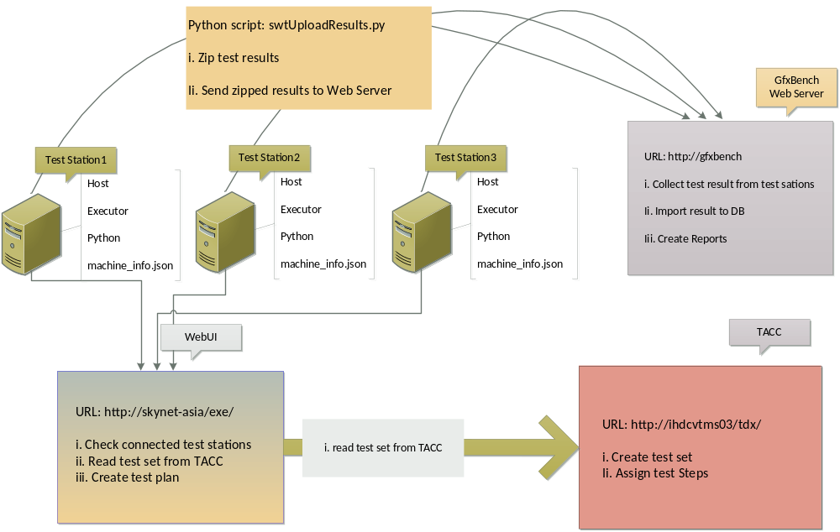
Figure 2. Whole Process

2.1.2 Host & Executor
We can download them here:
http://confluence/display/SI/User+Scenarios

to connect test stations, we need to run both of them on each test station.
There are 32bit / 64bit versions for Windows, Linux and Android.
Can add support to Metal if needed.

2.1.3 WebUI
Open this URL in browser (for Asia): http://skynet-asia/exe/
We can check connected test stations, create test plans and start test plans here.
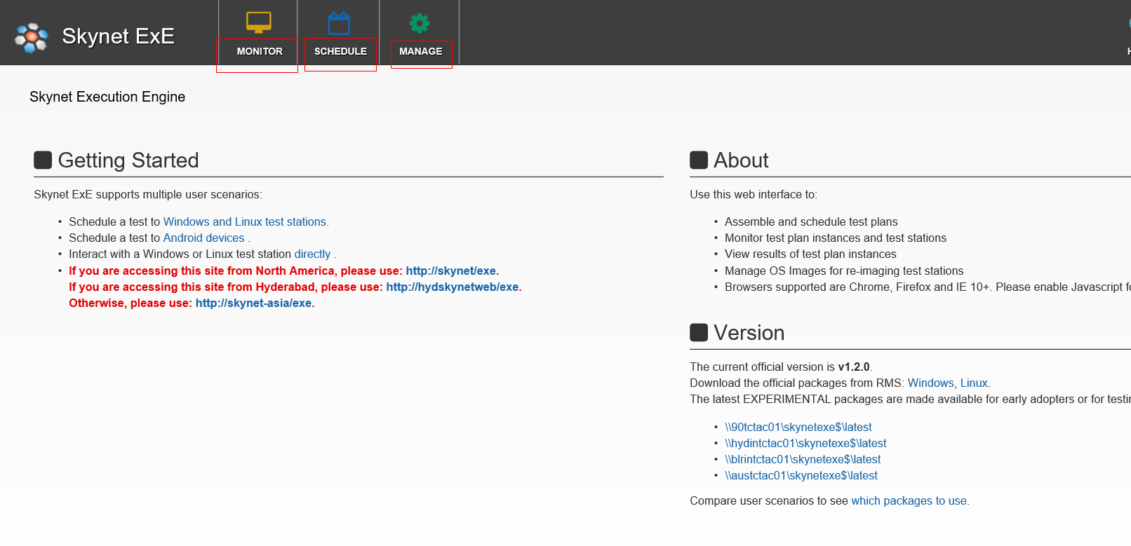

2.1.4 TACC
We need to set up a TACC test & corresponding test set, which will be read by Skynet.
In TACC test, we assign each step we want Skynet Executor to do on test station.
Web address (for Asia): http://ihdcvtms03/tdx/
Like this:
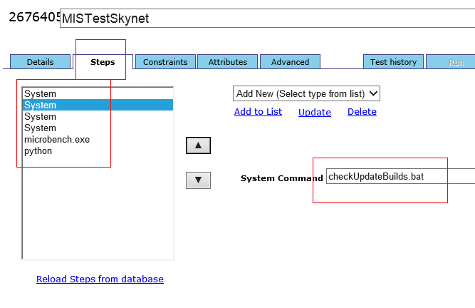

2.2 Preparations of Skynet

2.2.1 Setup Test Machines
a) Download Host & Executor for windows / Linux here (we prefer 64 bit version):
http://confluence/display/SI/User+Scenarios
copy them to each test machine.

b) Create a folder on each test machine: “c:\skynet” (for win) or “/skynet” (for linux). copy Host & Executor into the folder.

c) Start “c:\skynet\Host\startexe.exe” & “c:\skynet\Executor\startexe.exe” with administrator right.

d) Register test machine: click Executor window. Press “CTRL + R”.
i) Set “Enter Test Station Unique Identifier” as your exact machine name.
This name must be exclusive from other machines. If not the same as windows machine name, Executor will fail.
ii) Set “Enter Test Station Location” as “shanghai”.
iii) Set “Select Team Name” as “13” (Skynet Developers).
When finished, press “y” and “ENTER” to confirm.
We should see “REGISTER SUCCESSFUL”.

e) At this time, we open Skynet WebUI:
MONITOR -> Test Stations
And filter with “shanghai” as location, we should see our test station connected:

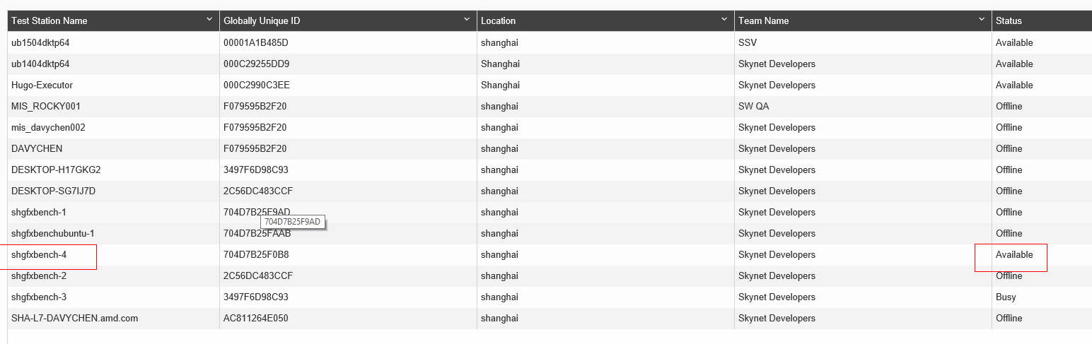

f) Copy following folder to test machine “C:\” drive or “/” for linux:
//depot/stg/PerfTools/Microbench/MIS/skynet/MIS/
Make sure “C:\MIS\json\machine_info.json” has the correct hardware info as machine hardware.
There is a “swtUploadResults.py” or “swtUploadResultsLnx.py” python script.
It will be called after microbench finished, and upload results files to http://Gfxbench

Create an empty folder: “C:\MIS\drivers”, this is to hold downloaded drivers, then the drivers will be set to system folder.

Create an empty folder: “C:\testres\default”, this is to holder Microbench configure files, if we encounter crashes, user can edit “default.ini” in the folder to skip crashed test and restart Microbench from Skynet.

g) Setup python on test machine:
Install python 2.7.13 to test machine,
And don’t forget to set python path to system environment PATH variable.
And need to install “setupTools” & “poster” packages to python.

2.2.2 Create TACC Test & Test Set
a) Open “http://ihdcvtms03/tdx/Default.aspx”.
Test & test set already created here:

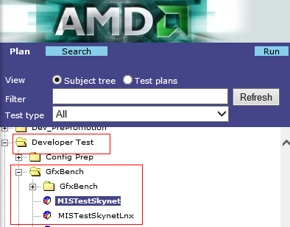

b) Click on “MISTestSkynet” -> “Steps”
Each step you want the Executor to do on test machine, can be modified here.

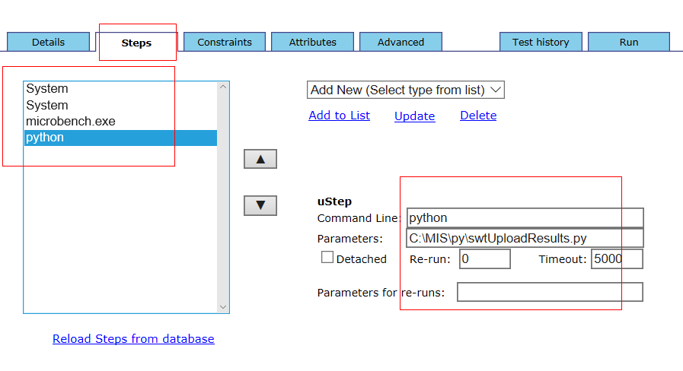
General steps:
- xcopy /s /e /h /y \\gfxbench\Skynet\builds
- xcopy /s /e /h /y ".\AMD_SPVGEN" ".\"
- microbench.exe
- python C:\MIS\py\swtUploadResults.py

2.2.3 Create Test Plan on WebUI
a) Open “http://skynet-asia/exe/#/app/plans/createPlan/”
b) Add test stations:

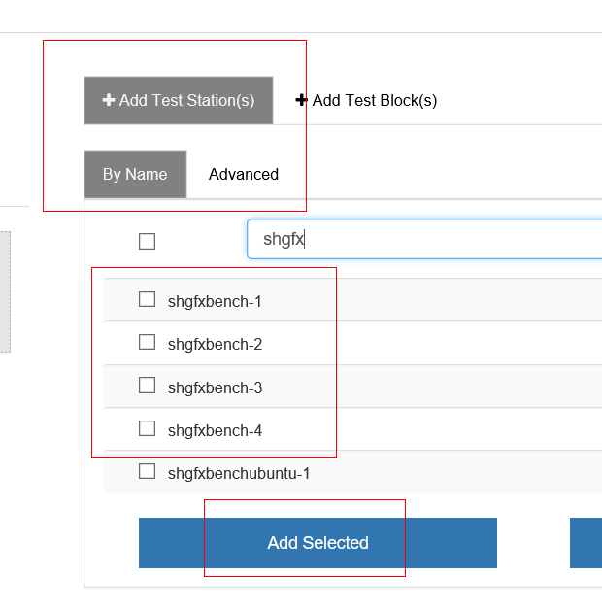

c) Add TACC test set:

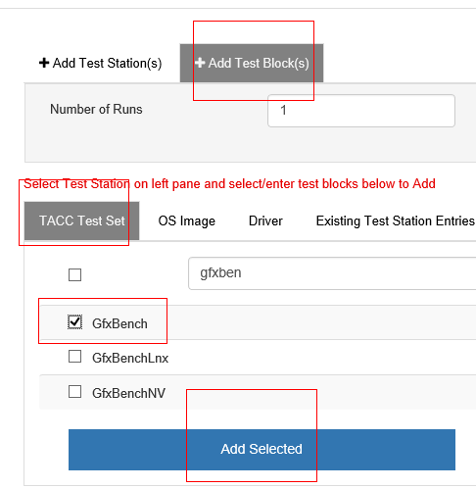

d) Click “SAVE” & “RUN” then the test is scheduled and will be run in mins.
e) Open following link:

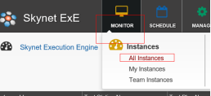

- Then you see the state of the test plan you just scheduled:
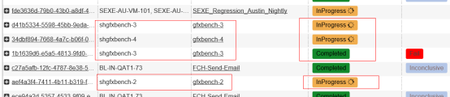

2.2.4 Send Results to Server
a) after Microbench finished and quited, “C:\MIS\py\swtUploadResults.py” will be called to zip result files and send it to Server with a PHP link from server.

2.2.5 After Skynet’s job Finish
a) Open “http://gfxbench/subPages/importLogFilesSkynet.php”
You all see the test results uploaded by test stations:

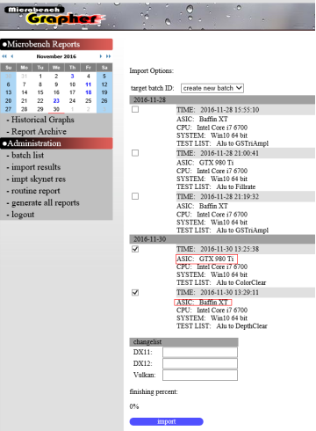

b) Then you can select the valid results to import to database.
After imported, you can generate new report or check graphs.

2.3 Main Server

2.3.1 Major Tasks
a) PHP web server

b) MySQL server

c) if test result files are uploaded Manually,
save files under folder: \\gfxbench\ logStore

d) if test results files are sent automatically from Skynet and “C:\MIS\py\swtUploadResults.py”,
save files under folder \\gfxbench\tmpResultFile temporarily.

after importing results into database,
results files will finally be moved to \\gfxbench\ logStore

e) generating JS Graphs through webpage.

f) generating EXCEL reports through user calling PHP links.

2.4 MySQL Tables Relations

2.4.1 Major Relations

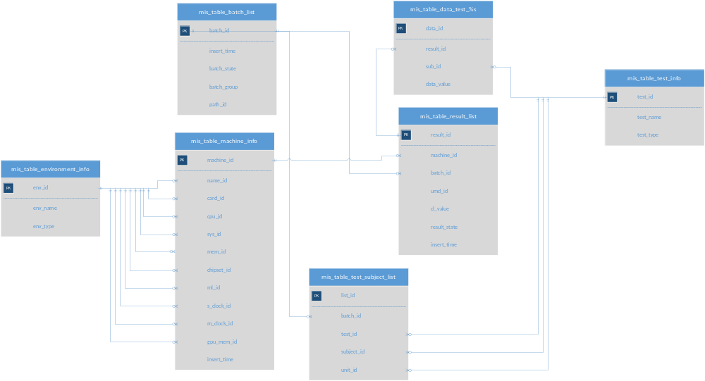


2.4.2 Tables Vertical Relations

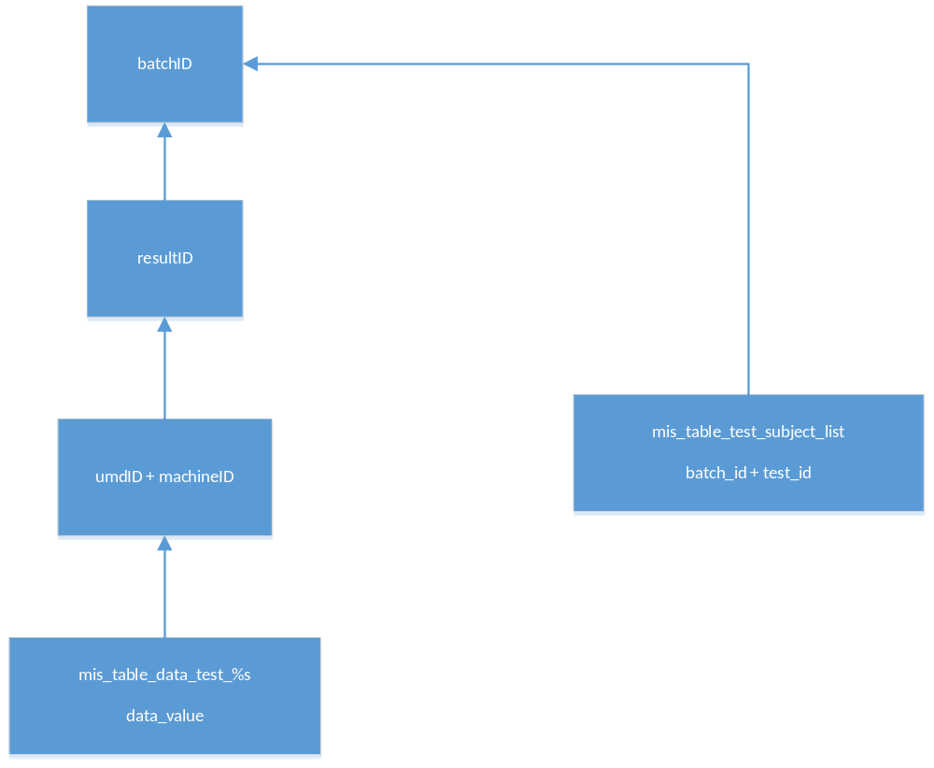

2.4.3 Tables Relation Example
a) each time we import results from a run of Microbench,
a new line will be added to table mis_table_batch_list,
we got a new batch_id, e.g. batch_id = 5.

b) if we have 5 machines to run Microbench,
they are:
- Baffin XT + Win10
- Ellesmere XT + Win10
- Fiji XT + Win10
- Fiji XT + Ubuntu
- GTX 980 Ti + Win10
We’ll get 5 lines in table mis_table_machine_info,
We got 5 machine_id for each of them. E.g. machine_id = 120, 121, 122, 123, 124.

c) if we have 3 API to run,
they are: DX11, DX12, Vulkan.
We’ll get 15 lines in table mis_table_result_list,
They are:
Machine_id = 120 + DX11
Machine_id = 120 + DX12
Machine_id = 120 + Vulkan
…
Machine_id = 124 + DX11
Machine_id = 124 + DX12
Machine_id = 124 + Vulkan

And we now have 15 result_id, e.g. result_id = 2000, 2001, 2002 … 2012, 2013, 2014

d) if we have 20 tests for current batch, batch_id = 5,
we’ll have 20 lines in table mis_table_test_subject_list,
they are:
Alu + Instructions + GInstr/s
DepthClear + ClearMethod_Format_DsSize_Samples_RenderCoverage_DepthClearValue
+ GPix/s(ClearDepth)
GSTriAmpl + Amplifier_VertOut_GsOutVecs + MVert/s
…

And we’ll have 20 tables, they are:
mis_table_data_test_Alu
mis_table_data_test_DepthClear
mis_table_data_test_GSTriAmpl
…

e) if test Alu has 100 sub-tests,
we’ll have 100 * 15 lines (100 sub-tests * 15 result_id) in table mis_table_data_test_Alu
each line has data_value FLOAT,
it’s result for the sub-test.

3 Appendix

3.1 SQL Table Definition

mis_table_environment_info:
( env_id INT UNSIGNED AUTO_INCREMENT,
env_name VARCHAR(128), // hardware name
env_type INT UNSIGNED,
PRIMARY KEY (env_id),
UNIQUE (env_name, env_type)
); // 0 for video card,
// like fiji nano, baffin, NV 950, NV 980 Ti
// 1 for cpu, like intel i7
// 2 for system name, like Win10 64
// 3 for driver main line, like 16.20
// 4 for umd name, like DXC, DXCP, DX11, DX12, Vulkan
// 5 for cumputer name
// 6 for sys mem size, like 8GB
// 7 for chipset
// 8 for desktop mode, like 1024 X 768 X 32 X 60
// 9 s_clock
// 10 m_clock
// 11 gpu_mem

mis_table_test_info:
( test_id INT UNSIGNED AUTO_INCREMENT,
test_name VARCHAR(128), // test name
test_type INT UNSIGNED,
PRIMARY KEY (test_id),
UNIQUE (test_name, test_type)
); // 0 for test name, like DepthClear
// 1 for sub test subject, like Format_DsSize_Samples
// 2 for sub-test name,
// like D16_UNORM_1024x1024_1xAA
// 3 for unit subject, like GInstr/s

mis_table_machine_info:
( machine_id INT UNSIGNED AUTO_INCREMENT PRIMARY KEY,
name_id INT UNSIGNED, // computer name index
card_id INT UNSIGNED, // video card name index
cpu_id INT UNSIGNED, // cpu name index
sys_id INT UNSIGNED, // system name index
mem_id INT UNSIGNED, // system mem size index
chipset_id INT UNSIGNED, // main board chipset index
ml_id INT UNSIGNED, // driver main line index
s_clock_id INT UNSIGNED, // gpu s_clock
m_clock_id INT UNSIGNED, // gpu m_clock
gpu_mem_id INT UNSIGNED, // gpu mem size
insert_time DATETIME
);

mis_table_result_list:
( result_id INT UNSIGNED AUTO_INCREMENT PRIMARY KEY,
machine_id INT UNSIGNED,
batch_id INT UNSIGNED,
umd_id INT UNSIGNED, // driver name index, like DXC, DXCP, DX11, DX12, Vulkan
cl_value INT UNSIGNED, // change list number
path_id INT UNSIGNED, // out of use, log file path
result_state INT UNSIGNED, // 0 for submitted, 1 for finished,
// 2 for skipped, 3 for time out, 4 for reserved
insert_time DATETIME
);

mis_table_batch_list:
( batch_id INT UNSIGNED AUTO_INCREMENT PRIMARY KEY,
insert_time DATETIME, // submit time
batch_state INT UNSIGNED, // 0 for submitted, 1 for finished, 2 for skipped, 3 for time out
batch_group INT UNSIGNED, // 0 for outside user, 1 for routine run every week
// 2 for temp report
path_id INT UNSIGNED // in use, log file path
);

mis_table_average_test_data:
( data_id INT UNSIGNED AUTO_INCREMENT PRIMARY KEY,
result_id INT UNSIGNED, // driver index
test_id INT UNSIGNED, // test index
data_value FLOAT // value
);

mis_table_test_subject_list:
( list_id INT UNSIGNED AUTO_INCREMENT,
batch_id INT UNSIGNED, //
test_id INT UNSIGNED, // test name
subject_id INT UNSIGNED, // sub test subject
unit_id INT UNSIGNED, // unit name
PRIMARY KEY (list_id),
UNIQUE (batch_id, test_id, subject_id, unit_id)
);

mis_table_result_file_info:
( result_file_id INT UNSIGNED AUTO_INCREMENT PRIMARY KEY, " .
machine_id INT UNSIGNED,
folder_id INT UNSIGNED,
test_list TEXT,
insert_time DATETIME
);

mis_table_data_test_%s:
( data_id INT UNSIGNED AUTO_INCREMENT,
result_id INT UNSIGNED, // driver index
sub_id INT UNSIGNED, // sub test index
data_value FLOAT, // value
PRIMARY KEY (data_id),
UNIQUE (result_id, sub_id)
);

