Microbench Infrastructure System
Version 1.0

REVISION HISTORY
Version | Date | Author | Summary of Changes
1.0 | Mar 11, 2015 | Chen, Davy | Overall concept of the service.

TABLE OF CONTENTS

1 Introduction 3
1.1 The MIS consists of three major components: 3
1.2 Design Goals 4
1.3 Usage Scenarios 4
2 Functions of Each Component 4
2.1 client software running on test machines 4
2.1.1 procedure drawing 4
2.1.2 source language 5
2.1.3 running schedule 6
2.1.4 query main server for new tasks 6
2.1.5 update heart beat time to main server 6
2.1.6 check if there was a hang 6
2.1.7 start bench 6
2.1.8 send log files to main server 6
2.2 main server 7
2.2.1 Procedure drawing 7
2.2.2 web service source language 7
2.2.3 web service upload drivers 7
2.2.4 web service check test machines’ health 8
2.2.5 web service store results 8
2.2.6 web service draw results into forms, charts, graphics 8
2.3 SQL table relations 8
3 Appendix 9
3.1 SQL table definition 9

1 Introduction
Microbench Infrastructure System consists of a group of hardware & software, it will be used for scheduling Microbench running tasks under a collection of hardware, software environments, managing produced result data, and organizing the data into certain forms or charts, which can be requested and viewed by end user with internet browser.

The conceptual MIS architecture is depicted in Figure 1 “Unified MIS Architecture”.

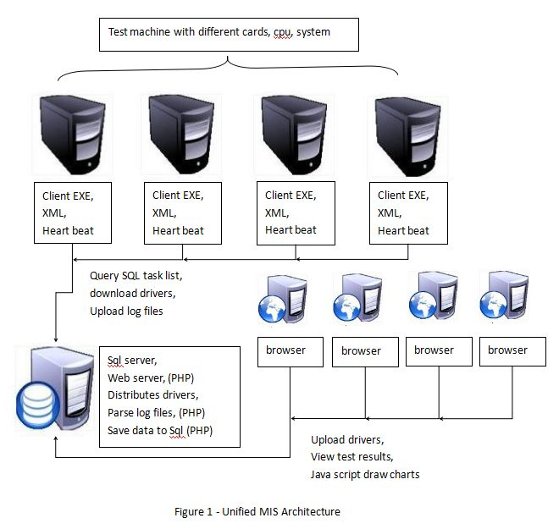

1.1 The MIS consists of three major components:

- A group of test machines
The machines have different hardware, software configurations, like video cards, cpu, system. Microbench will be set up and run on the machines, with drivers got from a main server.

- A client software running on each test machine
The software will keep querying main server to check if there are new tasks assigned by user. Then get new drivers from main server, and start benching. Then send results back to main server.

- A main server
The server will have SQL service to store Microbench results got from test machines. web service to let user upload drivers, view Benching results, also check health of each test machine to see if there are hangs that needs human interference.

1.2 Design Goals
- To make Microbench service can be accessed easily by remote user through internet browser.
- To schedule the tasks may be raised by user at same time. Avoid conflicts.
- To make the benching results be maintained and be processed automatically for users’ check, reduce human interference to the least.
- To well organize the results into graphic forms or charts, be helpful for users’ check through browser.

1.3 Usage Scenarios
Microbench users.

2 Functions of Each Component

2.1 client software running on test machines

2.1.1 procedure drawing

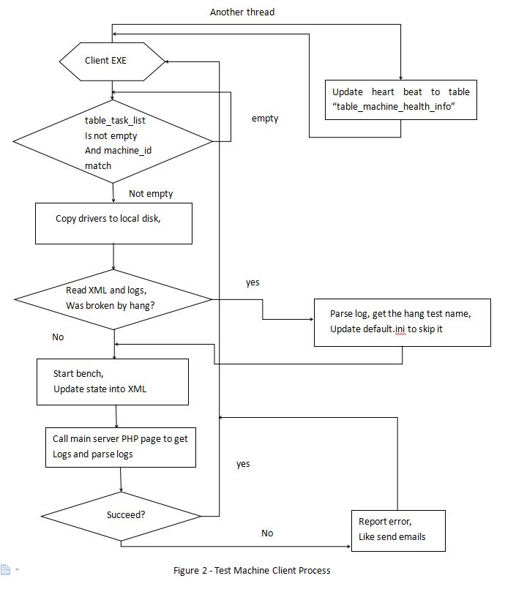

2.1.2 source language
- it’s an executable made with c++.
- Since machines might have both win & linux system, the executable should be platform independent.
- It might need “libcurl” to get drivers from main server to local disk.

2.1.3 running schedule
It will run in back ground on each test machine.

2.1.4 query main server for new tasks
- It will query main server’s SQL table ” table_task_list”, to see if there are tasks being queued.
- The query will be run in a thread in a certain time interval.
- need “libmysql” to help query database.
- Need have a XML / INI for each machines, the XML holds hardware, software configuration info of the machine. This helps query main server, to see if the queued task is for this machine.
- If there are new tasks, copy the drivers to local disk.

2.1.5 update heart beat time to main server
- Update time in SQL table “table_machine_health_info” in a certain time interval, to let main server know, this machine is in order, no hang happened, no need human interference.

2.1.6 check if there was a hang
- If there was hang, will analyze not finished log files in bench folder. Make a file list in a XML for this task, save finished test results in the file list. Then get test name that caused the hang, update “default.ini” in bench folder to skip the test.

2.1.7 start bench

2.1.8 send log files to main server
- Call PHP page on main server, upload log files to main server. And save data into SQL data base.

2.2 main server

2.2.1 Procedure drawing
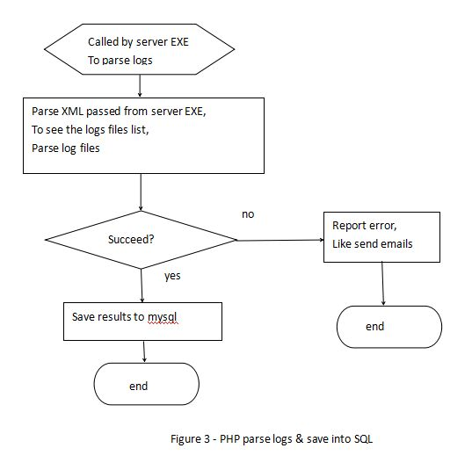

2.2.2 web service source language
- main languages will be PHP & JavaScript.

2.2.3 web service upload drivers
- will be called by user with internet browser.

2.2.4 web service check test machines’ health
- check heart beat time in SQL, to see if test machine hanged, if hanged, send emails to report error.

2.2.5 web service store results
- called by test machines, receive log files, parse the logs, save the data into SQL table “table_data_list”.

2.2.6 web service draw results into forms, charts, graphics
- called by user with browser, drawing will be done with JS.

2.3 SQL table relations

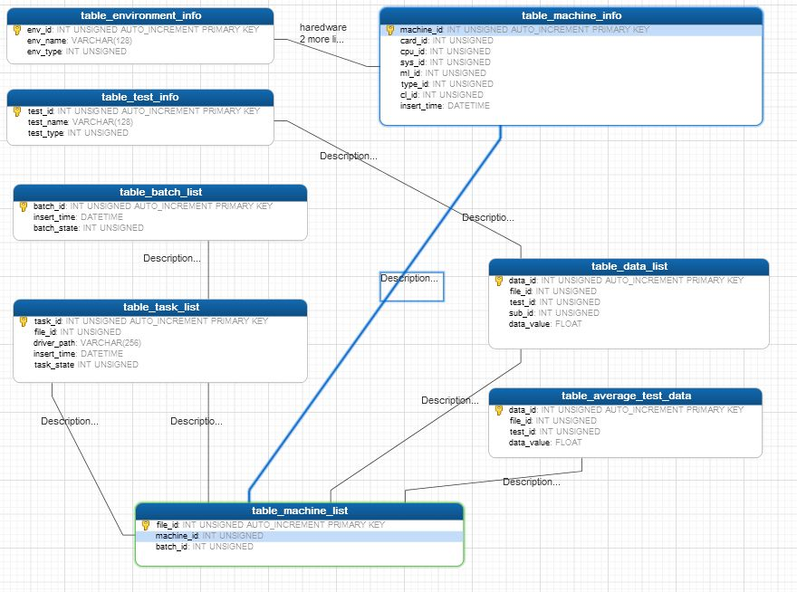

3 Appendix

3.1 SQL table definition

table_environment_info:
( env_id INT UNSIGNED AUTO_INCREMENT PRIMARY KEY,
env_name VARCHAR(128), // hardware name
env_type INT UNSIGNED // 0 for video card,
// like fiji nano, baffin, NV 950, NV 980 Ti
// 1 for cpu, like intel i7
// 2 for system name, like Win10 64
// 3 for driver main line, like 16.20
// 4 for umd name, like DXC, DXCP, DX11, DX12, Vulkan
// 5 for cumputer name
// 6 for sys mem size, like 8GB
// 7 for chipset
// 8 for desktop mode, like 1024 X 768 X 32 X 60
)

table_test_info:
( test_id INT UNSIGNED AUTO_INCREMENT PRIMARY KEY,
test_name VARCHAR(128), // test name
test_type INT UNSIGNED // 0 for test name, like DepthClear
// 1 for sub test subject, like Format_DsSize_Samples
// 2 for sub-test name,
// like D16_UNORM_1024x1024_1xAA
)

table_path_info:
( path_id INT UNSIGNED AUTO_INCREMENT PRIMARY KEY,
path_name VARCHAR(256) // folder name
)

table_machine_info:
( machine_id INT UNSIGNED AUTO_INCREMENT PRIMARY KEY,
name_id INT UNSIGNED, // computer name index
card_id INT UNSIGNED, // video card name index
cpu_id INT UNSIGNED, // cpu name index
sys_id INT UNSIGNED, // system name index
mem_id INT UNSIGNED, // system mem size index
chipset_id INT UNSIGNED, // main board chipset index
ml_id INT UNSIGNED, // driver main line index
insert_time DATETIME
)
table_result_list:
( result_id INT UNSIGNED AUTO_INCREMENT PRIMARY KEY,
machine_id INT UNSIGNED,
batch_id INT UNSIGNED,
umd_id INT UNSIGNED, // driver name index, like DXC, DXCP, DX11, DX12, Vulkan
cl_value INT UNSIGNED, // change list number
path_id INT UNSIGNED, // log file path
result_state INT UNSIGNED, // 0 for submitted, 1 for finished
insert_time DATETIME
)

table_batch_list:
( batch_id INT UNSIGNED AUTO_INCREMENT PRIMARY KEY,
insert_time DATETIME, // submit time
batch_state INT UNSIGNED // 0 for submitted, 1 for finished, 2 for skipped, 3 time out
)

table_task_list: // can be cleared from time to time
( task_id INT UNSIGNED AUTO_INCREMENT PRIMARY KEY,
result_id INT UNSIGNED,
driver_path VARCHAR(256),
insert_time DATETIME, // submit time
task_state INT UNSIGNED // 0 for submitted, 1 for finished, 2 for skipped
)

table_data_list_00001:
( data_id INT UNSIGNED AUTO_INCREMENT PRIMARY KEY,
result_id INT UNSIGNED, // driver index
sub_id INT UNSIGNED, // sub test index
data_value FLOAT // value
)

table_average_test_data:
( data_id INT UNSIGNED AUTO_INCREMENT PRIMARY KEY,
result_id INT UNSIGNED, // driver index
test_id INT UNSIGNED, // test index
data_value FLOAT // value
)

table_machine_health_info:
( info_id INT UNSIGNED AUTO_INCREMENT PRIMARY KEY,
machine_id INT UNSIGNED, // machine index
machine_state INT UNSIGNED, // 0 for not in use, 1 for in use
heartbeat_time DATETIME
)

