**Skynet’s Usage with MIS**

Version 1.0

**REVISION HISTORY**

|  |  |  |  |
| --- | --- | --- | --- |
| Version | Date | Author | Summary of Changes |
| 1.0 | Dec 08, 2016 | Chen, Davy | Detailed process of Skynet with MIS. |

TABLE OF CONTENTS

1. Introduction of Skynet 3

A. Host & Executor 3

B. WebUI 4

C. TACC 4

2. preparations 5

A. Setup Test Machines 5

B. Create TACC Test & Test Set 6

C. Create Test Plan on WebUI 7

D. After All Tests Finished 8

## 1. Introduction of Skynet

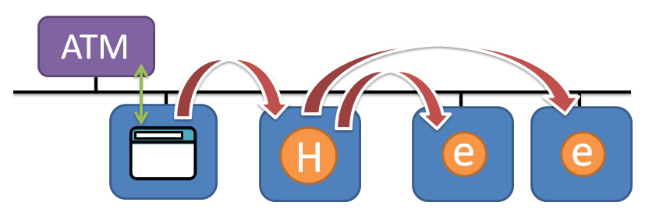

Skynet is a software system, it consists of a Host App, an Executor App and a WebUI. With Skynet we can manage multiple test stations, and schedule test plans from WebUI (web page).

Website for Asia: <http://skynet-asia/exe/>



Graph 1. Whole Process

### A. Host & Executor

We can download them here:

<http://confluence/display/SI/User+Scenarios>

to connect test stations, we need to run both of them on each test station.

There are 32bit / 64bit versions for Windows, Linux and Android.

Can add support to Metal if needed.

### B. WebUI

Open this URL in browser (for Asia): <http://skynet-asia/exe/>

We can check connected test stations, create test plans and start test plans here.

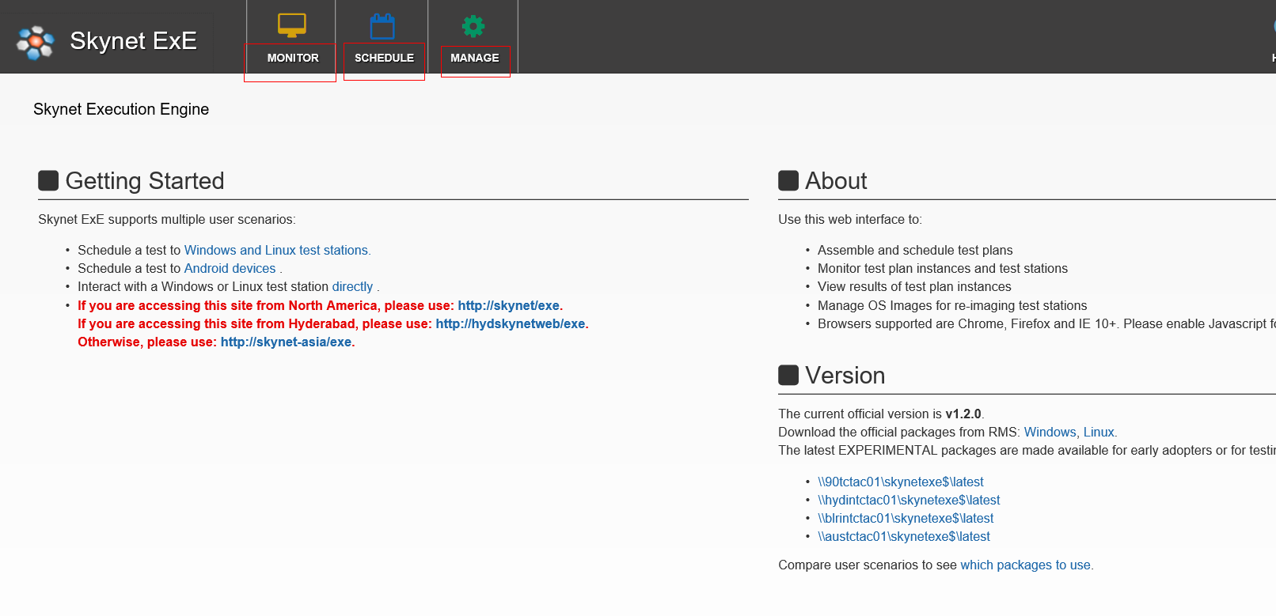

### C. TACC

We need to set up a TACC test & corresponding test set, which will be read by Skynet.

In TACC test, we assign each step we want Skynet Executor to do on test station.

Web address (for Asia): <http://ihdcvtms03/tdx/>

Like this:

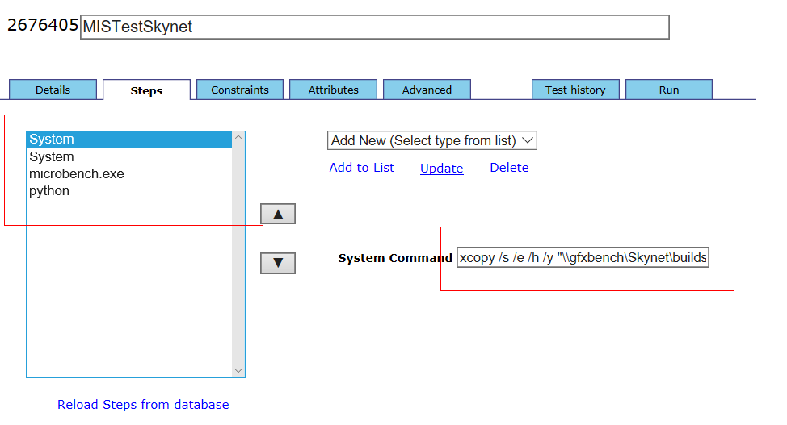

## 2. preparations

### A. Setup Test Machines

* 1. Download Host & Executor for windows / Linux here (we prefer 64 bit version):

<http://confluence/display/SI/User+Scenarios>

copy them to each test machine.

* 1. Create a folder on each test machine: “c:\skynet” (for win) or “/skynet” (for linux). copy Host & Executor into the folder.
  2. Start “c:\skynet\Host\startexe.exe” & “c:\skynet\Executor\startexe.exe” with administrator right.
  3. Register test machine: click Executor window. Press “CTRL + R”.
     1. Set “Enter Test Station Unique Identifier” as your exact machine name.

This name must be exclusive from other machines. If not the same as windows machine name, Executor will fail.

* + 1. Set “Enter Test Station Location” as “shanghai”.
    2. Set “Select Team Name” as “13” (Skynet Developers).

When finished, press “y” and “ENTER” to confirm.

We should see “REGISTER SUCCESSFUL”.

* 1. At this time, we open Skynet WebUI:

MONITOR -> Test Stations

And filter with “shanghai” as location, we should see our test station connected:

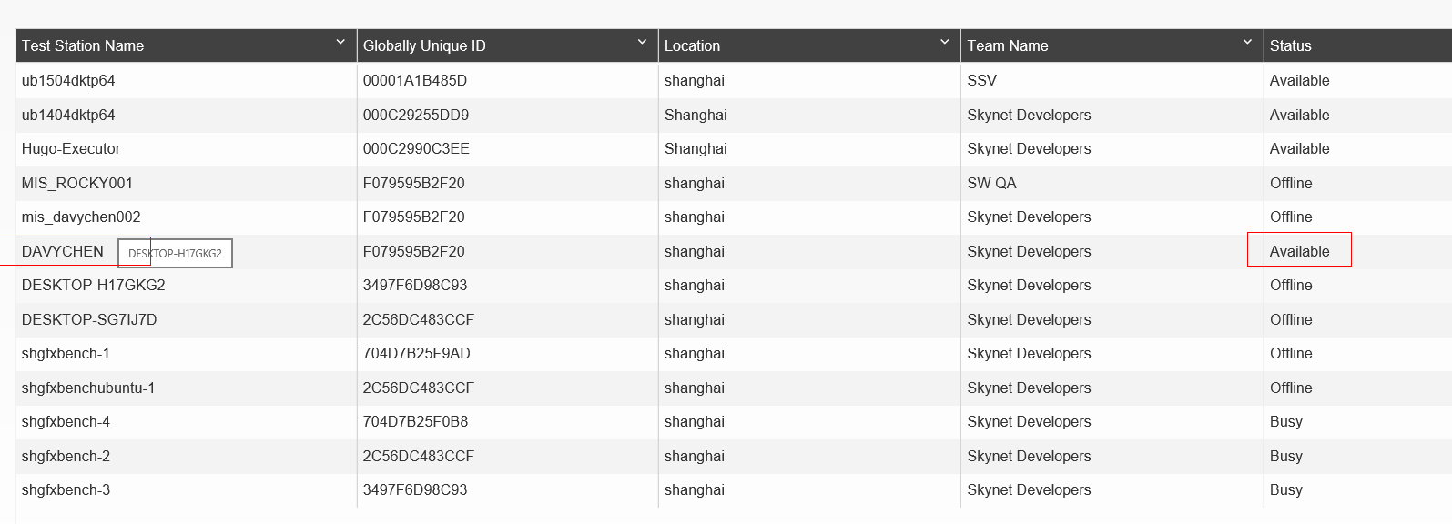

* 1. Copy following folder to test machine “C:\” drive or “/” for linux:

//depot/stg/PerfTools/Microbench/MIS/skynet/MIS/

Make sure “C:\MIS\json\machine_info.json” has the correct hardware info as machine hardware.

There is a “swtUploadResults.py” or “swtUploadResultsLnx.py” python script.

It will be called after microbench finished, and upload results files to <http://Gfxbench>

* 1. Setup python on test machine:

Install python 2.7.13 to test machine,

And don’t forget to set python path to system environment PATH variable.

And need to install “setupTools” & “poster” packages to python.

### B. Create TACC Test & Test Set

1. Open “http://ihdcvtms03/tdx/Default.aspx”.

Test & test set already created here:

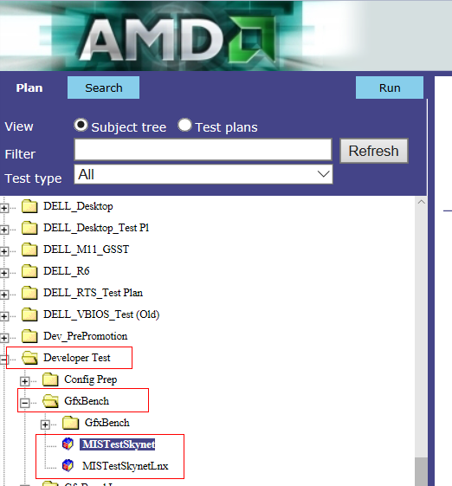

1. Click on “MISTestSkynet” -> “Steps”

Each step you want the Executor to do on test machine, can be modified here.

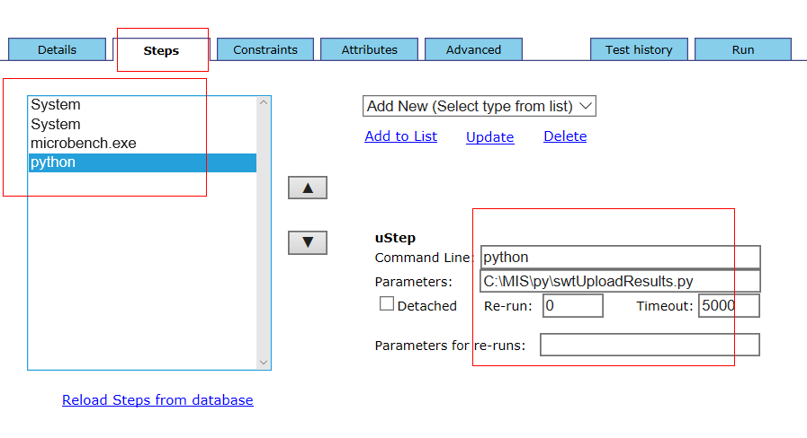

General steps:

* + 1. xcopy /s /e /h /y \\gfxbench\Skynet\builds
    2. xcopy /s /e /h /y ".\AMD_SPVGEN" ".\"
    3. microbench.exe
    4. python C:\MIS\py\swtUploadResults.py

### C. Create Test Plan on WebUI

1. Open “http://skynet-asia/exe/#/app/plans/createPlan/”
2. Add test stations:

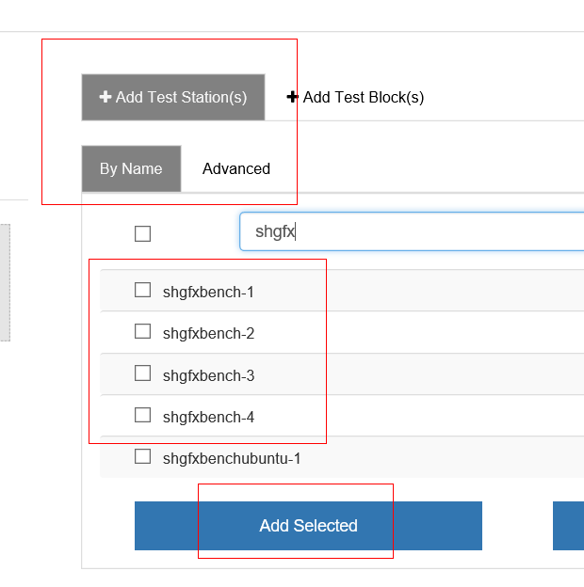

1. Add copy driver:

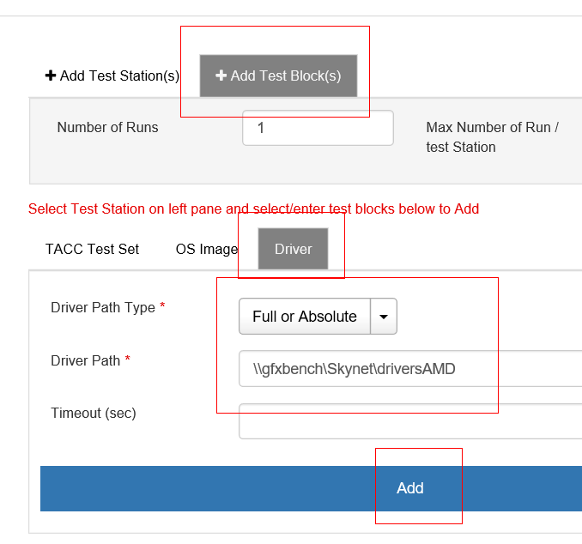

1. Add TACC test set:

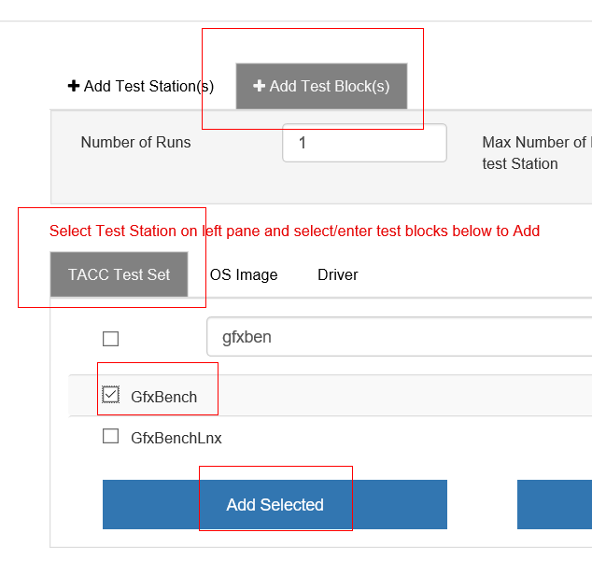

1. Click “SAVE” & “RUN” then the test is scheduled and will be run in mins.
2. Open following link:

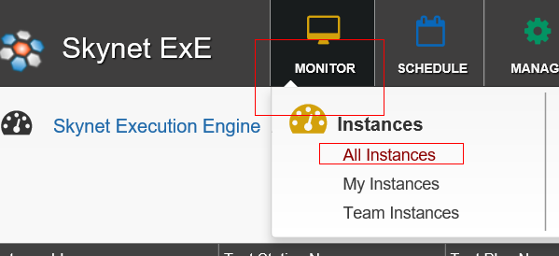

1. Then you see the state of the test plan you just scheduled:

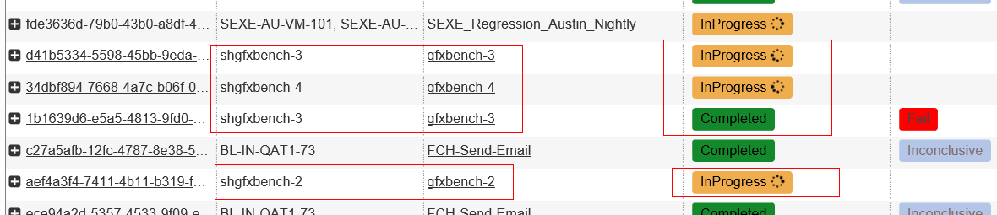

### D. After All Tests Finished

1. Open “http://gfxbench/subPages/importLogFilesSkynet.php”

You all see the test results uploaded by test stations:

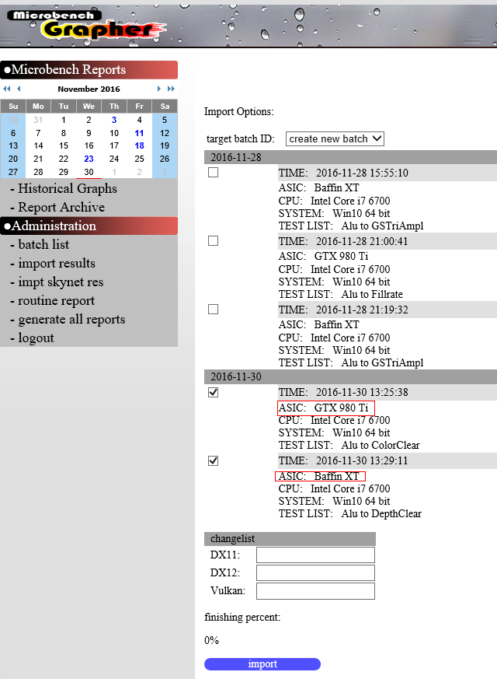

1. Then you can select the valid results to import to database.

After imported, you can generate new report or check graphs.

End of this document, thank you for reading.