**SHOW** **MANAGEMENT SYSTEM**

Step 1

Download the showmanagementsystem zip file.

Unzip the showmanagementsystem.sln and open with visual studio

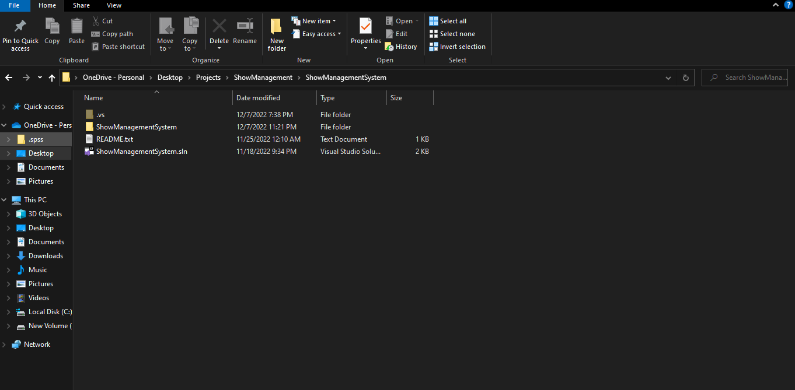

Load the database file into visual studio and open the properties

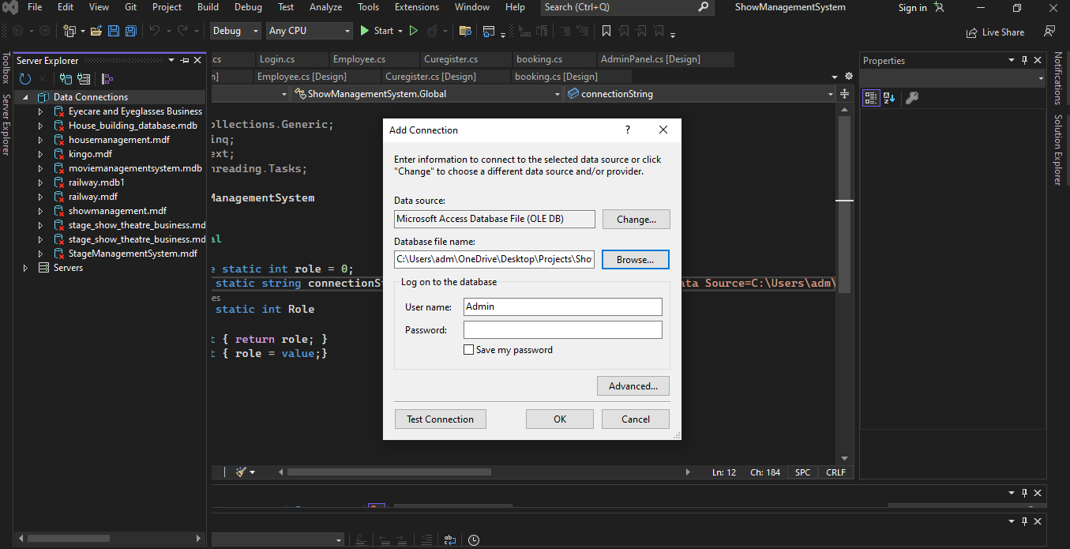

Right click to get the database properties and get connection string.

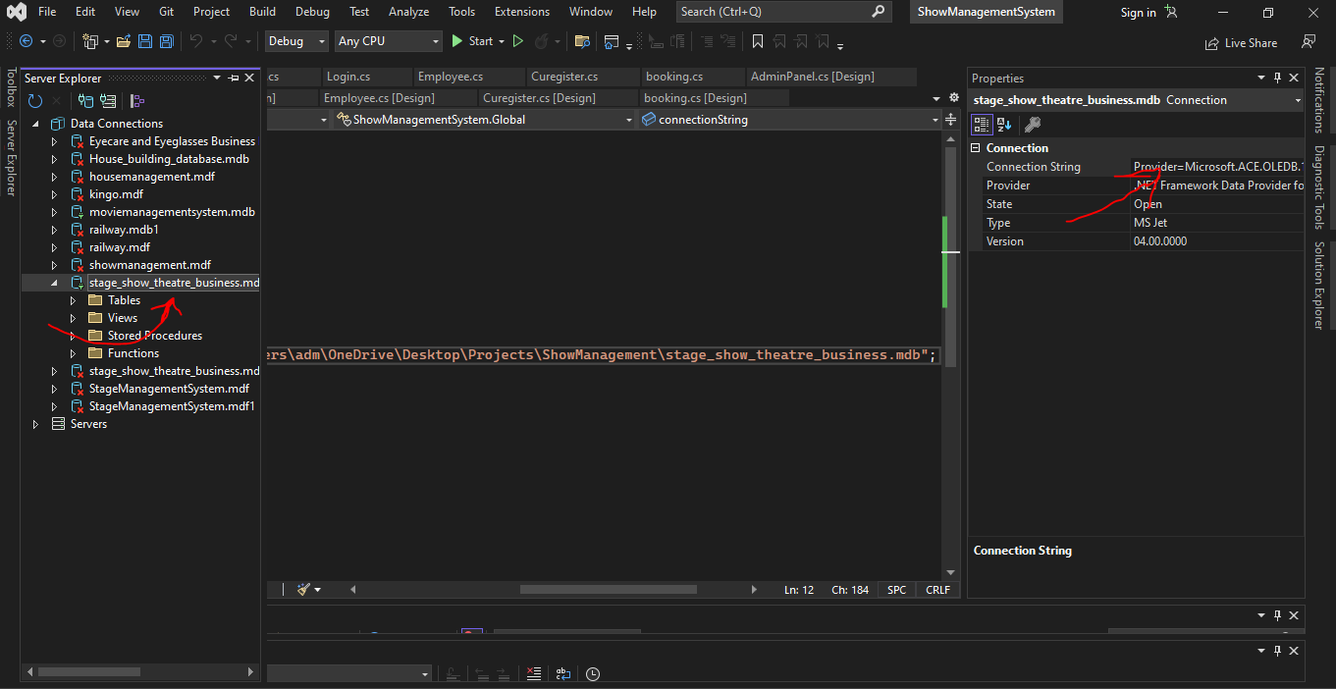

In properties, there is the connection string that the user will use. Place the connection string in global class to connect to all forms.

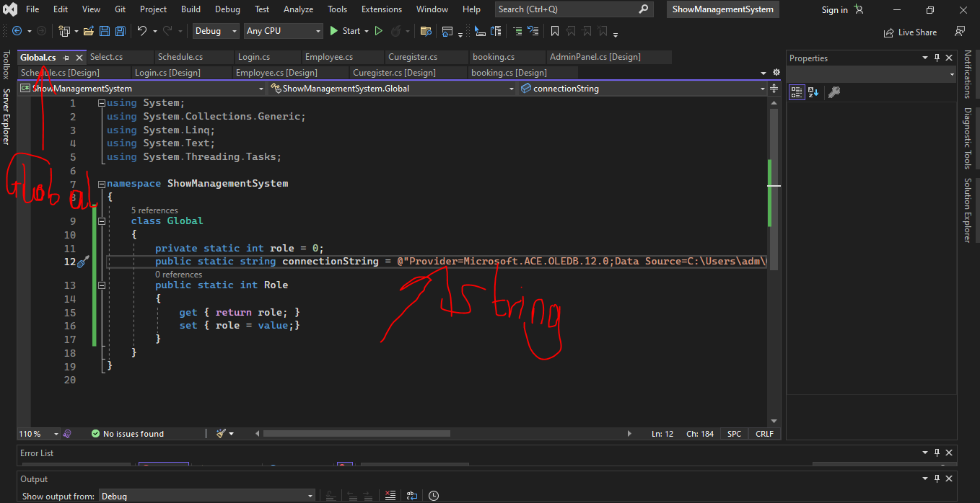

N/B Always load first the database into the system before getting the connection string.

Login into the system.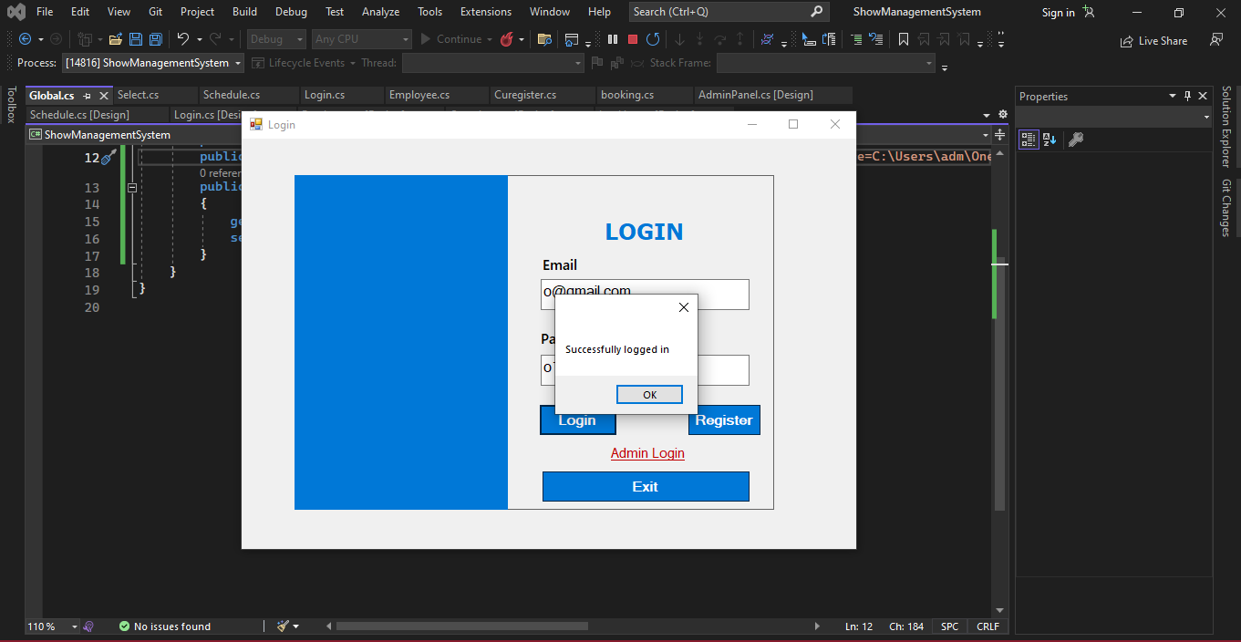

Enjoy the booking.