DATABASE SYSTEMS PROJECT
Event-Aware Subway Congestion
Decision Support Platform
Part IV: End-to-End Solution Integration and Database Programming
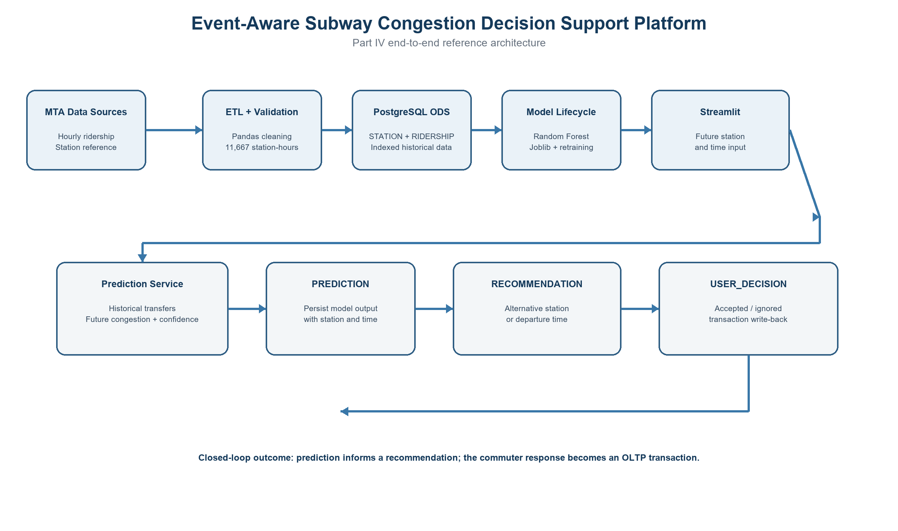
System reference architecture
Student: ______________________________
Course / Section: ______________________
Submission date: August 12, 2026

Executive Summary
This Part IV implementation integrates the physical PostgreSQL design and Random Forest model developed in Part III into a functioning end-to-end decision-support application. The completed workflow loads 11,667 station-hour observations into PostgreSQL, accepts a commuter's future station and travel time through Streamlit, derives historical transfer context, predicts congestion, generates an actionable recommendation, and records the commuter's decision as a database transaction.
The system uses SQLAlchemy as the object-relational mapping layer and preserves the existing Part III schema. Model persistence is implemented with Joblib, while a database-driven retraining module creates a candidate Random Forest model using a chronological train/test split. The final prototype demonstrates the required closed loop: machine-learning insight is not only displayed but also converted into a recommendation and an auditable OLTP write to USER_DECISION.

Key Outcomes
- 11,667 validated hourly ridership records across four NYU-area station complexes.
- Future congestion prediction with confidence scoring and historical transfer estimation.
- Rule-based recommendations for alternate stations or delayed departure times.
- Transactional persistence across PREDICTION, RECOMMENDATION, and USER_DECISION.
- Chronological retraining evaluation with 76.75% test accuracy.
- Indexed PostgreSQL lookups and workflow reconstruction verified with EXPLAIN ANALYZE.

Document Roadmap
Section | Purpose
1-3 | Business use case, workflow, and database integration
4-7 | ORM, prediction, recommendation, and transaction implementation
8-10 | Application interface, retraining, and query optimization
11-13 | Reference architecture, testing, limitations, and conclusion

1. Business Use Case and Part III Continuity
The business problem is commuter uncertainty around station congestion near the NYU campus. A warning alone is insufficient because it does not change the commuter's plan or produce a measurable system outcome. The implemented use case therefore transforms a congestion estimate into an actionable choice: use an alternate station, depart later, or retain the original plan.

1.1 Implemented User Story
A commuter selects an NYU-area station and a future travel time. The application estimates congestion from historical station-hour patterns, displays the predicted class and confidence, proposes an alternate station or departure time, and records whether the commuter accepts the recommendation.

1.2 Reused Part III Assets
Part III asset | Part IV use
PostgreSQL schema | Extended rather than replaced; existing relational entities remain authoritative.
Random Forest | Persisted as a model bundle and invoked by the prediction service.
PREDICTION / RECOMMENDATION / USER_DECISION | Implemented as the transactional chain requested by the business use case.
Indexes and physical design | Retained, audited, and extended only where the station-hour workflow required it.

2. End-to-End Application Workflow

Figure 1. End-to-end data, model, application, and transaction workflow
The top path represents the analytical pipeline from MTA data to PostgreSQL and the model lifecycle. The lower path represents the operational application. SQLAlchemy connects the services to PostgreSQL so that predictions, recommendations, and user decisions remain traceable through foreign keys.

3. Database Integration
The cleaned hourly dataset was loaded into the existing RIDERSHIP relation instead of replacing the Part III design. MTA complex identifiers were mapped to internal station surrogate keys, and the loader performed validation before a single transaction inserted the records. A unique station/timestamp index prevents duplicate station-hour records on repeated execution.
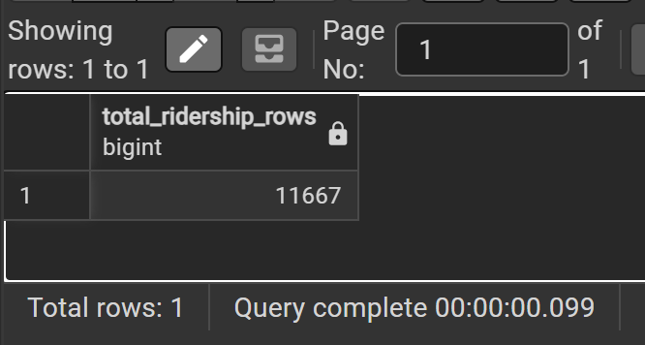
Figure 2. PostgreSQL row-count verification after loading 11,667 hourly records
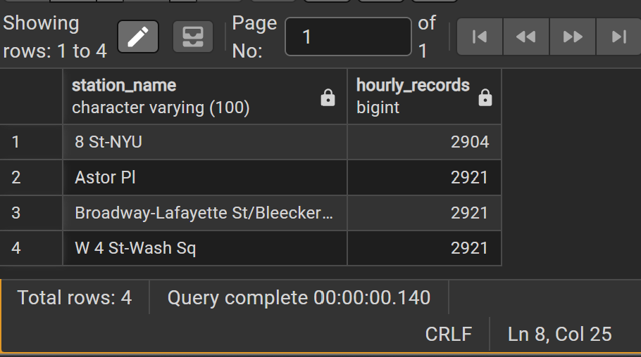
Figure 3. Hourly record distribution across the four station complexes
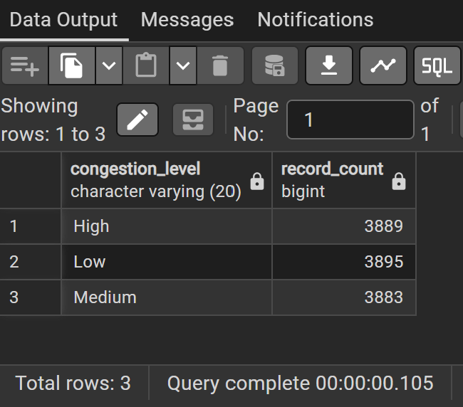
Figure 4. Balanced Low, Medium, and High congestion classes

3.1 Loaded Stations
Internal ID | MTA complex | Station | Routes
1 | 16 | 8 St-NYU | R, W
2 | 167 | W 4 St-Wash Sq | A, C, E, B, D, F, M
3 | 407 | Astor Pl | 6
4 | 619 | Broadway-Lafayette St / Bleecker St | B, D, F, M, 6

4. SQLAlchemy ORM and Service Design
SQLAlchemy provides the database connectivity and ORM layer, satisfying the optional ORM component while keeping the application logic separated from SQL connection details. The mapped entities are Station, Ridership, Prediction, Recommendation, and UserDecision.
Module | Responsibility
database.py | Builds a password-safe PostgreSQL URL from local environment settings and creates the session factory.
models.py | Maps the existing PostgreSQL tables and foreign-key relationships.
load_data.py | Validates CSV columns, maps MTA complex IDs, inserts station-hour data, and skips duplicates.
prediction_service.py | Loads the model bundle, derives features, predicts congestion, and writes PREDICTION.
recommendation_service.py | Applies congestion-specific rules and writes RECOMMENDATION.
user_decision_service.py | Validates the allowed action and writes USER_DECISION.
app.py | Coordinates the user-facing Streamlit workflow and session state.

5. Future Congestion Prediction
The production model expects hour, day of week, month, weekend indicator, MTA station complex ID, and transfers. Because transfers for a future hour are not yet observed, the service queries PostgreSQL for the historical average transfers for the same station, weekday, and hour, with a station-level fallback. This creates a reproducible feature vector without treating future ridership as known.
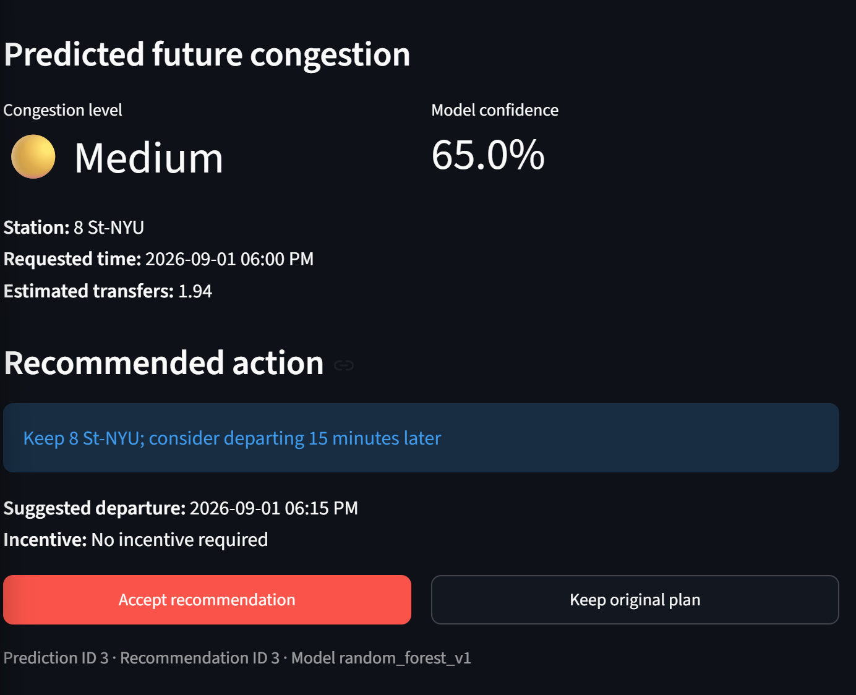
Figure 5. Future congestion prediction for September 1, 2026
In the demonstrated case, 8 St-NYU at 6:00 PM on September 1, 2026 was classified as Medium congestion with 65.0% confidence. The service persisted Prediction ID 3 before generating the recommendation.

6. Recommendation Generation
The recommendation engine is deliberately rule-based so that its actions remain explainable and auditable. The machine-learning model determines the congestion class; the recommendation service translates that class into an operational response.
Predicted level | Implemented action | Incentive
High | Suggest a mapped alternate station or depart 30 minutes later. | Off-peak travel credit recommended
Medium | Keep the selected station but depart 15 minutes later. | No incentive required
Low | Keep the original station and departure time. | No incentive required

7. User Decision Transaction
The application records the commuter's response after presenting the recommendation. The service maps user-friendly actions to the CHECK-constrained values already defined in Part III (Accepted, Rejected, Ignored, or Followed). Duplicate submissions for the same recommendation are prevented at the service layer.
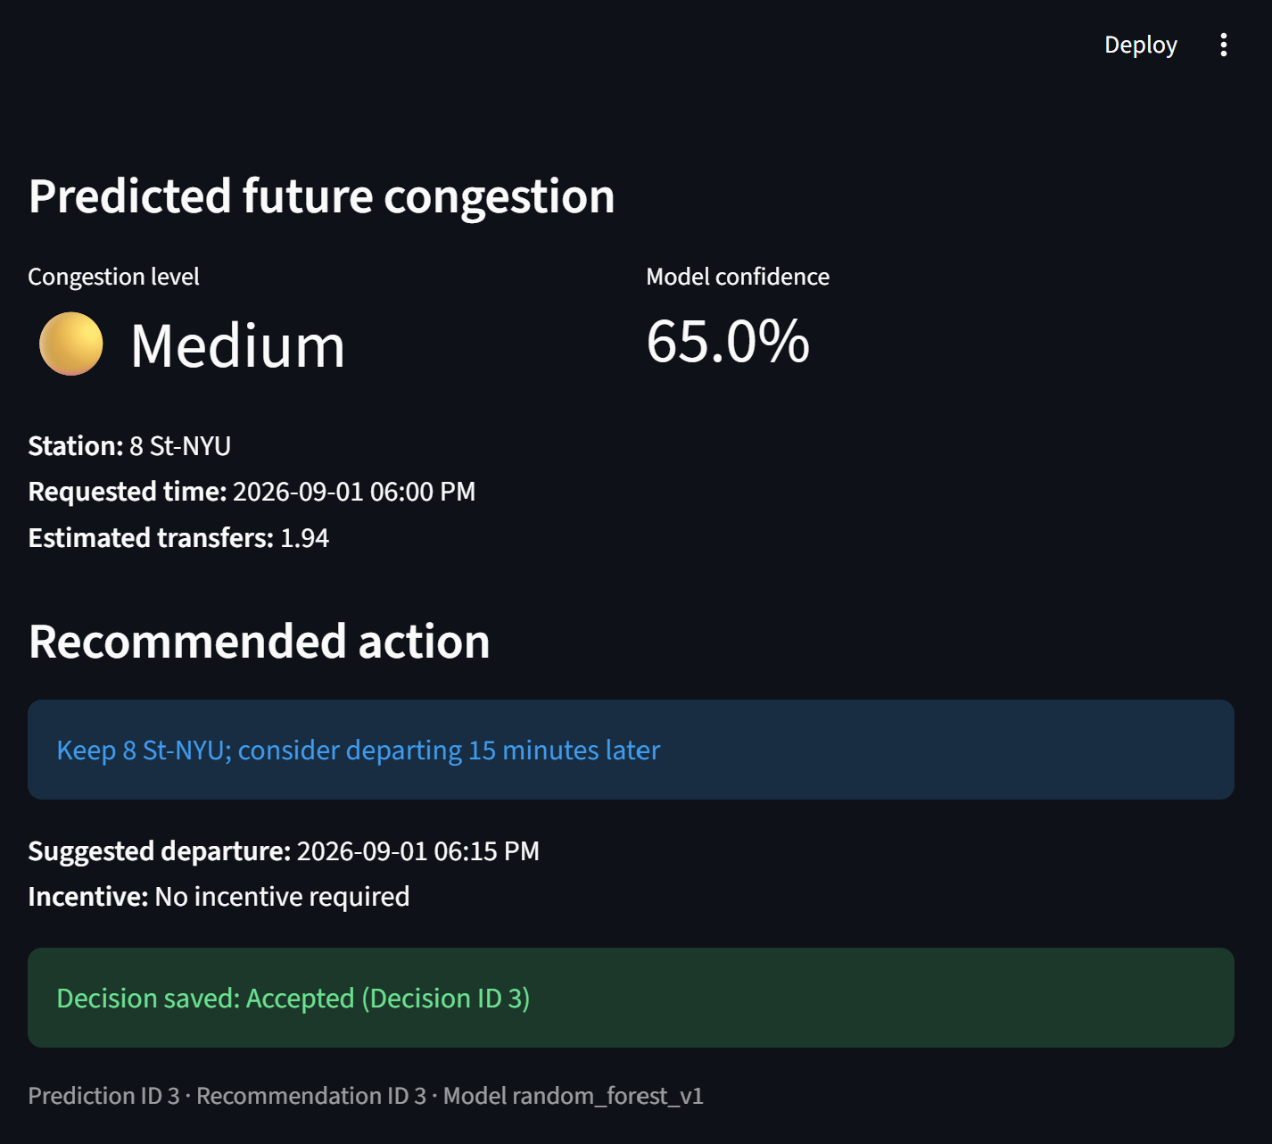
Figure 6. Accepted future recommendation persisted as Decision ID 3
The completed workflow is traceable as Prediction ID 3 -> Recommendation ID 3 -> Decision ID 3. This transaction is the critical connection between analytical insight and OLTP behavior.

8. Streamlit End-to-End Application
The Streamlit interface provides a minimal but complete application layer. It queries the station list from PostgreSQL, restricts the date picker to future dates, warns when a month is outside the model's seasonal coverage, displays the prediction and recommendation, and exposes two transactional actions: Accept Recommendation and Keep Original Plan.

8.1 Future-Date Controls
- Past dates are blocked in the date picker.
- The default prediction date is the next future date within the supported September-December seasonal window.
- Historical integration tests remain in the database as development evidence but are not used as the final future-prediction demonstration.
- Streamlit session state retains the prediction and recommendation IDs between button clicks.

9. Database-Driven Retraining
The train_model.py module reads the training features from PostgreSQL instead of relying on the original Colab notebook. It sorts station-hour records chronologically and assigns the earliest 80% of timestamps to training and the latest 20% to testing. This evaluation is more representative of future prediction than the random split used during Part III.
Metric | Result
Database rows read | 11,667
Training rows | 9,327
Test rows | 2,340
Chronological cutoff | December 7, 2024 at 3:00 PM
Candidate-model test accuracy | 76.75%
Part III random-split accuracy | 84.8%

The retraining process writes a candidate model and JSON evaluation report without automatically replacing the production artifact. This separation reduces the risk of deploying an unevaluated model.

10. Query Optimization
EXPLAIN ANALYZE was used to verify both the historical station/time lookup and the transactional workflow reconstruction. PostgreSQL used index scans rather than scanning all ridership rows. Redundant indexes created during integration were removed after comparison with the Part III physical design.
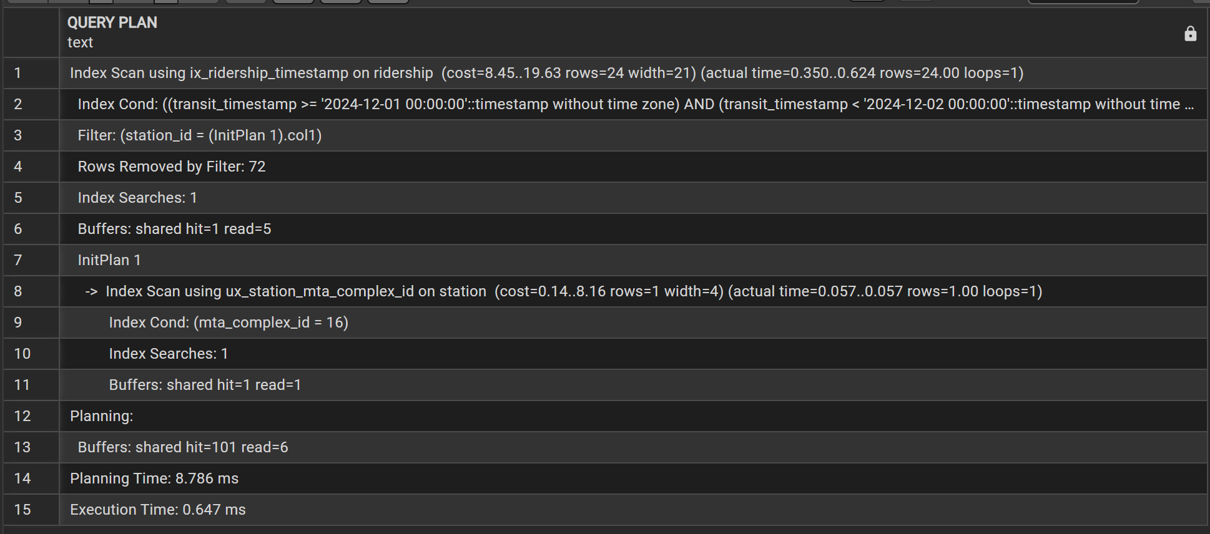
Figure 7. Indexed station/time lookup; execution time 0.647 ms
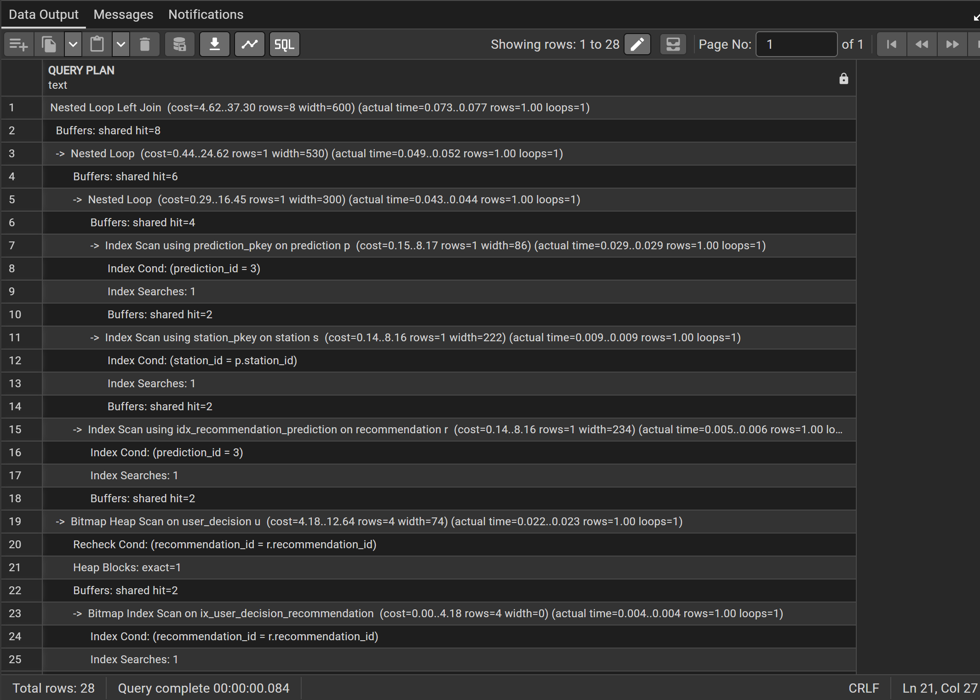
Figure 8. Indexed end-to-end workflow JOIN
Query | Index evidence | Observed execution
Station/time ridership lookup | ix_ridership_timestamp; ux_station_mta_complex_id | 0.647 ms
Prediction workflow JOIN | prediction_pkey; station_pkey; idx_recommendation_prediction; ix_user_decision_recommendation | Sub-millisecond to low-millisecond range

11. Final Reference Architecture

Figure 9. Final integrated reference architecture

11.1 Architecture Layers
Layer | Implemented components
Business | Future-trip planning, congestion reduction, commuter choice, auditable response.
Application | Streamlit UI; prediction, recommendation, and decision services.
Data / DIKW | Validated ridership -> temporal features -> congestion knowledge -> actionable recommendation.
Integration | SQLAlchemy ORM, Joblib model persistence, environment-based configuration.
Infrastructure | Local PostgreSQL 18, Python runtime, indexed relational storage.

12. Testing and Results
Test | Expected result | Observed result
Database connection | Application connects to subway_congestion_db | Passed
CSV validation | 11,667 unique station-hour records | Passed
Future prediction | Persist prediction for future station/time | Passed: Prediction ID 3
Recommendation | Generate class-specific operational response | Passed: Recommendation ID 3
Decision write-back | Persist commuter action | Passed: Decision ID 3, Accepted
Repeat-safe loading | Skip duplicate station-hour rows | Passed
Retraining | Read PostgreSQL data and save candidate artifact | Passed: 76.75% test accuracy
Query optimization | Use relevant indexes | Passed

13. Limitations and Future Work
- Seasonal coverage: the current ridership training data covers September through December 2024, so predictions are restricted to future dates in those seasonal months.
- Historical proxy: future transfers are estimated from station/weekday/hour averages rather than from a live feed.
- Recommendation scope: the recommendation engine uses transparent business rules rather than a second machine-learning model.
- Incident data: the available delay-causing incident file is monthly and line-level, not station-hour or real-time; it was therefore not represented as a live incident feature.
- Prototype deployment: PostgreSQL and Streamlit currently run locally. A production version would require managed database hosting, secrets management, authentication, monitoring, and scheduled retraining.

14. Conclusion
Part IV successfully converts the Part III database and machine-learning assets into an integrated application. The prototype demonstrates database loading, model persistence, future prediction, explainable recommendation generation, transactional user-decision capture, retraining, and indexed query execution. Most importantly, the system closes the loop between analytics and operations: the model's insight leads to an actionable recommendation, and the commuter's response becomes a durable relational transaction.

15. Software Repository
The final GitHub repository will contain the Part IV source modules, SQL scripts, environment-variable example, requirements, architecture asset, screenshots, and execution instructions. The local .env file and database password are excluded from version control.
Repository URL: ________________________________________________

Appendix A. Primary Part IV Files
File | Purpose
app.py | Streamlit future-prediction and decision interface
database.py | Database engine and session configuration
models.py | SQLAlchemy mappings
load_data.py | Validated and repeat-safe ridership loader
prediction_service.py | Feature derivation, model inference, and prediction insert
recommendation_service.py | Business-rule recommendation and insert
user_decision_service.py | Validated decision transaction
train_model.py | Database-driven chronological retraining
analyze_queries.py | Index inventory and EXPLAIN ANALYZE report
sql/query_optimization.sql | Reproducible optimization queries

