Database Systems Project Part IV
End-to-End Solution Integration and Data-Driven / Database Programming
Course: CSCI-GA.2433-001 Database Systems
Project name: Subway Congestion Decision Support Platform for the NYU Area
GitHub Repository: https://github.com/Jason980102/subway-congestion-platform
1. Introduction
2. Existing Part III Components Reused
3. End-to-End Workflow-Based Application
4. Data-Driven Programming and Machine Learning Integration
5. End-to-End Database Application
6. Database Validation and Query Optimization
7. Updated Reference Architecture
8. Conclusion
Appendix A. Implementation Screenshots

1. Introduction
This Part IV implementation integrates the physical PostgreSQL design and Random Forest model developed in Part III into a functioning end-to-end decision-support application. The completed workflow loads 11,667 station-hour observations into PostgreSQL, accepts a commuter's future station and travel time through Streamlit, derives historical transfer context, predicts congestion, generates an actionable recommendation, and records the commuter's decision as a database transaction.
The system uses SQLAlchemy as the object-relational mapping layer and preserves the existing Part III schema. Model persistence is implemented with Joblib, while a database-driven retraining module creates a candidate Random Forest model using a chronological train/test split. The final prototype demonstrates the required closed loop: machine-learning insight is not only displayed but also converted into a recommendation and an auditable OLTP write to USER_DECISION.

2. Existing Part III Components Reused
2.1 PostgreSQL Physical Schema
The Part III physical design was retained and implemented in PostgreSQL 18. The operational schema contains STATION, RIDERSHIP, PREDICTION, RECOMMENDATION, and USER_DECISION. Primary keys and foreign keys preserve referential integrity, while indexes support station-time retrieval and end-to-end workflow joins.
2.2 Historical Ridership Dataset
The cleaned dataset contains 11,667 hourly observations for four NYU-area station complexes. Part IV loaded these records into PostgreSQL, resolving the empty-database limitation documented in Part III. The three congestion classes remain balanced: 3,895 Low, 3,883 Medium, and 3,889 High records.
2.3 Existing Random Forest Model
The Random Forest classifier created in Part III was reused as the production baseline. Its 84.8% test accuracy and established feature set were preserved so that Part IV could focus on system integration, model persistence, database transactions, and the commuter workflow.

3. End-to-End Workflow-Based Application
3.1 Business Use Case
The Subway Congestion Decision Support Platform assists an NYU-area commuter in evaluating a future station and travel time. Instead of only reporting historical conditions, the application predicts a future congestion category and converts the result into an actionable recommendation, such as delaying departure or using an alternative nearby station.
The commuter selects a station, date, and time in Streamlit. The prediction service loads the persisted model, creates a PREDICTION transaction, and calls the recommendation service. The generated recommendation is written to RECOMMENDATION. The commuter then accepts the recommendation or keeps the original plan, and this final action is written to USER_DECISION for auditing and future analysis.

3.2 Application Workflow
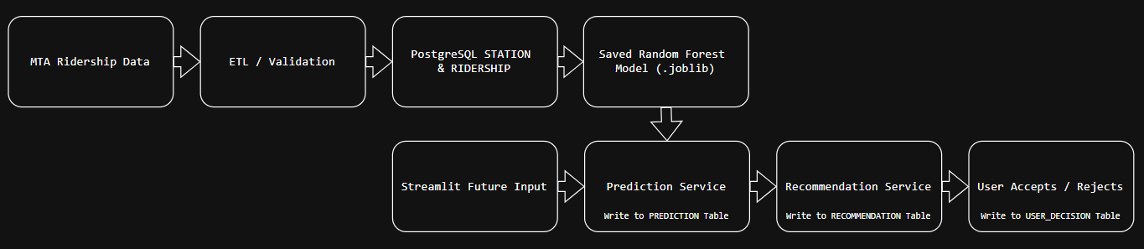
Figure 1. End-to-End Workflow of the Subway Congestion Decision Support Application
Historical MTA ridership data are validated and stored in PostgreSQL before model training. During application use, the commuter's future input and the persisted Random Forest model feed the prediction service. Prediction, recommendation, and user-decision results are then committed to their corresponding PostgreSQL tables.
3.3 Application Components
The implementation separates user-interface, prediction, recommendation, decision, database, and model-training responsibilities into Python modules. This modular design supports maintainability and demonstrates an end-to-end workflow rather than a standalone model.

4. Data-Driven Programming and Machine Learning Integration
4.1 Historical Dataset and Features
Historical subway ridership data were collected from the New York State Open Data portal (MTA Subway Hourly Ridership: 2020–2024). Since the proposed system focuses on the NYU area, only four nearby subway station complexes were selected:
- 8 St–NYU
- W 4 St–Washington Sq
- Astor Pl
- Broadway–Lafayette St / Bleecker St
Records from September 2024 to January 2025 were extracted. After removing missing values and aggregating hourly ridership records, the final dataset contained 11,667 hourly observations used for machine learning.

Figure 12. MTA Subway Hourly Ridership Dataset from New York Open Data.
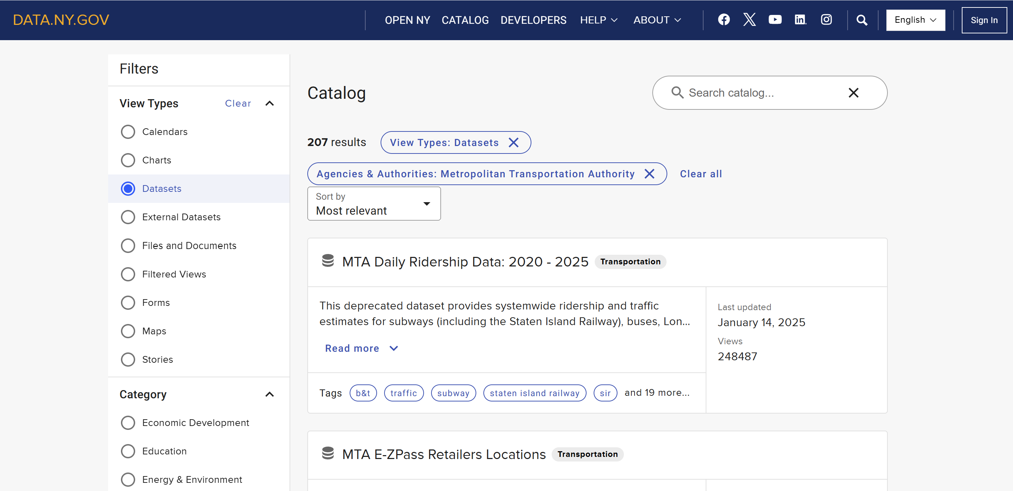
The historical subway ridership dataset was obtained from the New York Open Data portal and served as the primary data source for this project.
Figure 13. Filtering the Dataset for NYU-Area Subway Stations.
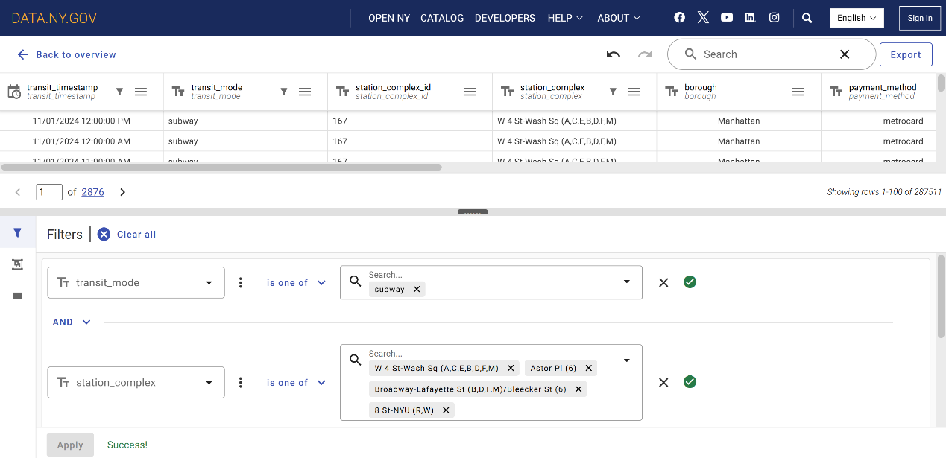
Only subway records from the four station complexes surrounding NYU and the selected time period were retained for subsequent analysis.

Figure 14. Aggregated Hourly Ridership Dataset after Data Cleaning
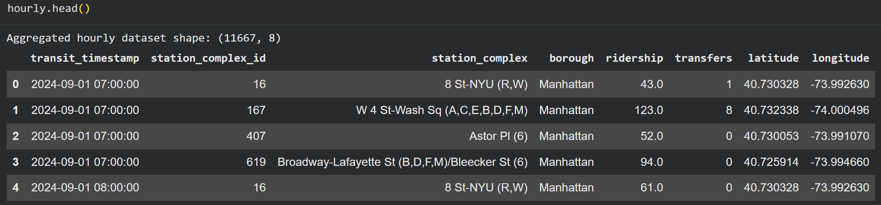
After removing missing values and aggregating duplicate records, the cleaned dataset contained 11,667 hourly observations, which served as the input for feature engineering and machine learning.

4.2 Feature Engineering
Table 1. Machine Learning Features Used for Congestion Prediction
Feature | Description
Hour | Hour of day
Day_of_week | Day of week
Month | Month
Weekend | Weekend indicator
Station_ID | Station identifier
Transfers | Number of transfers

Figure 15. Feature Engineering Results
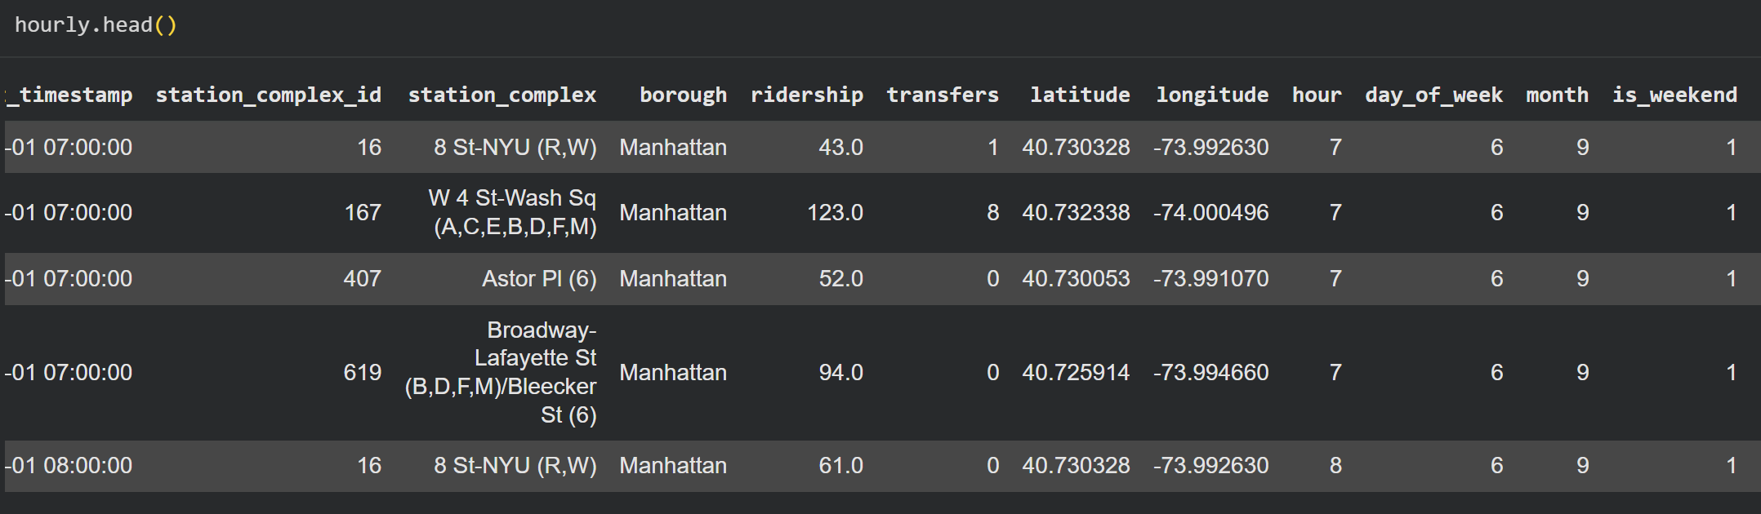
Temporal features, including hour, day of the week, month, and weekend indicator, were extracted from the timestamp to improve congestion prediction.

4.3 Production Baseline Model
Figure 16. Random Forest Model Construction
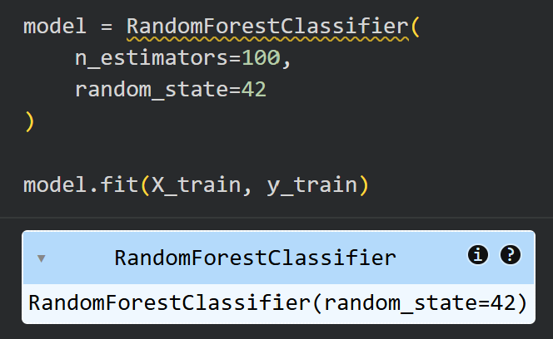
A Random Forest classifier with 100 decision trees was trained to classify congestion levels using temporal and station-related features.
4.4 Baseline Evaluation
Figure 17. Training and Testing Dataset Split.
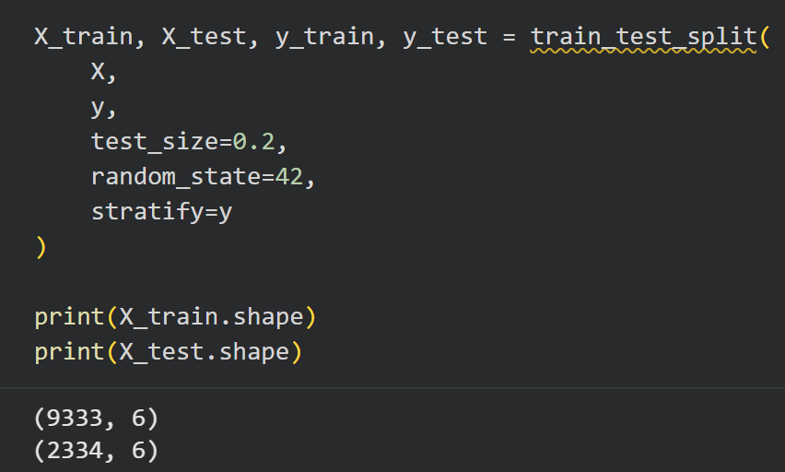
The dataset was divided into 80% training data and 20% testing data using stratified sampling to ensure balanced class distributions.

Figure 18. Overall Prediction Accuracy.
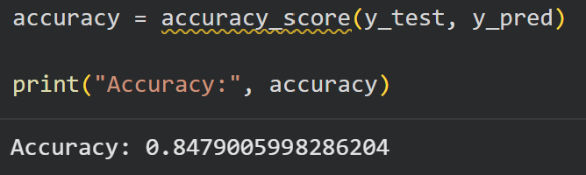
The Random Forest classifier achieved an overall prediction accuracy of 84.8% on the testing dataset.

4.5 Model Results
Figure 19. Confusion Matrix of Congestion Level Classification.
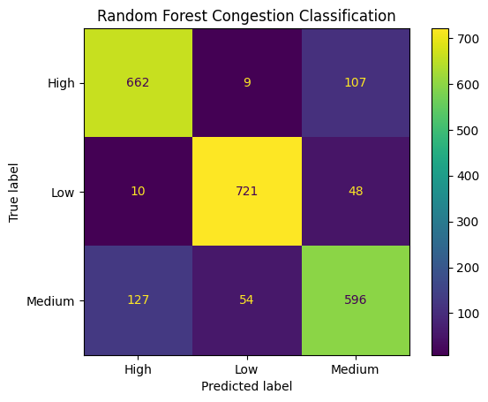
The confusion matrix illustrates the classification performance of the model across the three congestion levels (Low, Medium, and High).

Figure 20. Feature Importance of the Random Forest Model.
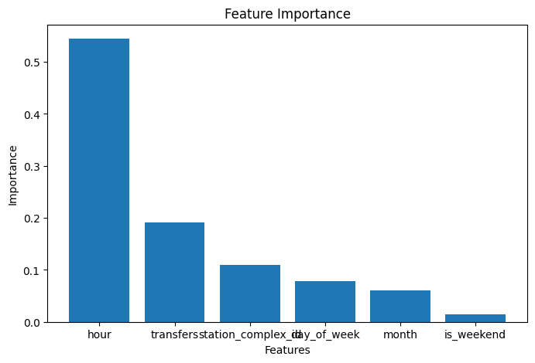
Feature importance analysis shows that hour is the most influential predictor, followed by transfers and station identifier, indicating that temporal travel patterns play a dominant role in congestion prediction.

4.6 SQLAlchemy ORM and Database Connectivity
SQLAlchemy provides the object-relational mapping layer between Python and PostgreSQL. ORM classes represent the five operational tables, and managed sessions ensure that prediction, recommendation, and decision writes are committed consistently or rolled back after an error.
4.6.1 ORM and Query Optimization
The ORM layer improves reliability and performance through reusable mapped models, parameterized queries, connection pooling, and transaction-scoped sessions. Primary-key lookups and indexed foreign-key relationships avoid unnecessary full-table scans. The application retrieves only the station and workflow records needed for a request, commits the prediction, recommendation, and decision in controlled transactions, and rolls back a session when an exception occurs. PostgreSQL indexes remain responsible for physical access optimization, while SQLAlchemy provides safe query construction and consistent connection management.
4.7 Model Persistence and Future Prediction
The trained Random Forest pipeline is persisted with Joblib and loaded by the prediction service when a user submits a future travel request. The application restricts requests to the model's represented seasonal window and clearly labels the output as predicted future congestion.
4.8 Database-Driven Retraining
A separate retraining module reads RIDERSHIP data through SQLAlchemy, applies a chronological 80/20 split, trains a candidate model, and stores both the candidate Joblib artifact and a JSON evaluation report. The candidate achieved 76.75% chronological test accuracy; therefore, the 84.8% Part III model remains the production baseline rather than being replaced automatically.
5. End-to-End Database Application
5.1 Streamlit User Interface
The Streamlit interface allows the commuter to select one of the four NYU-area stations and enter a future travel date and time. After submission, the application displays the predicted congestion level, model confidence, estimated transfer context, recommended action, suggested departure time, and incentive information.
5.2 Prediction, Recommendation, and User-Decision Transactions
Each request creates a PREDICTION record containing the station, requested future time, congestion level, confidence score, and model version. The rule-based recommendation engine then creates a linked RECOMMENDATION record. Finally, the commuter's Accepted or Kept Original Plan response is written to USER_DECISION, completing the required ML-to-OLTP closed loop.

A successful future demonstration used 8 St-NYU at 6:00 PM on September 1, 2026. The model predicted Medium congestion with 65.0% confidence, generated a recommendation to depart 15 minutes later, and saved the commuter's Accepted response as Decision ID 3.

6. Database Validation and Query Optimization
PostgreSQL validation confirmed 11,667 RIDERSHIP rows distributed across four stations and three balanced congestion classes. The complete workflow join verifies the relationship PREDICTION → RECOMMENDATION → USER_DECISION. EXPLAIN (ANALYZE, BUFFERS) shows index scans for station-time retrieval and workflow joins, including ix_ridership_timestamp, ux_station_mta_complex_id, prediction_pkey, idx_recommendation_prediction, and ix_user_decision_recommendation. Observed execution times were below two milliseconds on the local dataset.
7. Updated Reference Architecture
The final reference architecture connects the business, application, DIKW, and infrastructure domains through a governed end-to-end workflow. Its foundational principles are data quality, traceability, separation of responsibilities, least-privilege access, reproducibility, and human control over machine-generated recommendations.
7.1 Organizing Framework
The business domain defines the commuter decision-support objective and the requirement that recommendations remain optional. The application domain contains Streamlit and the prediction, recommendation, and user-decision services. The DIKW domain transforms validated ridership data into engineered features, congestion predictions, recommendations, and recorded commuter actions. The infrastructure domain provides Python, Pandas, scikit-learn, Joblib, SQLAlchemy, and PostgreSQL.
7.2 Plan, Deliver, and Operate Method
Planning begins with the business use case, database schema, feature definitions, and workflow boundaries established in Parts I-III. Delivery uses modular Python services, ORM mappings, persisted model artifacts, repeat-safe data loading, and database constraints. Operation consists of validating source data, loading incremental records, running future predictions, recording linked transactions, monitoring query plans, and evaluating candidate models before production promotion.
7.3 Data Quality and Lifecycle Governance
Data quality controls include validation of required station identifiers and timestamps, removal of missing or duplicate observations, balanced congestion-label checks, referential integrity, and a unique station/timestamp constraint. Lifecycle governance preserves source, cleaned, operational, prediction, recommendation, decision, model, and evaluation artifacts. Model versions and confidence scores provide traceability, while chronological evaluation prevents an untested candidate model from automatically replacing the production baseline.
7.4 Security, Loss Prevention, and Privacy
Database credentials are stored in a local environment file that is excluded from version control. The public repository uses an example configuration without secrets. Parameterized ORM operations reduce injection risk, transactions protect against partial writes, and database constraints prevent orphaned records. Repository, database, and model backups support recovery. The prototype records a decision outcome rather than personally identifying commuter information, minimizing privacy exposure.
7.5 Fairness, Accountability, and Transparency
The model is limited to four NYU-area stations and the seasonal patterns represented by the training data; this limitation must accompany its results. The interface reports congestion level, confidence, requested time, recommendation, and model version so that output can be audited. The system does not make an irreversible travel decision: the commuter may accept the recommendation or keep the original plan. Candidate retraining results require evaluation before promotion, limiting automated decision power and supporting fairness, accountability, and human oversight.
8. Conclusion
Part IV successfully converts the Part III database design and Random Forest model into a functioning end-to-end application. The system loads and validates operational data, predicts future congestion, persists machine-learning output, generates a linked recommendation, and records the commuter's final decision as an auditable transaction. The completed prototype therefore demonstrates the full closed loop from historical data to actionable insight and database write-back without unnecessarily redesigning Part III.

Appendix A. Implementation Screenshots
Figure A1. PostgreSQL validation of 11,667 hourly ridership records.
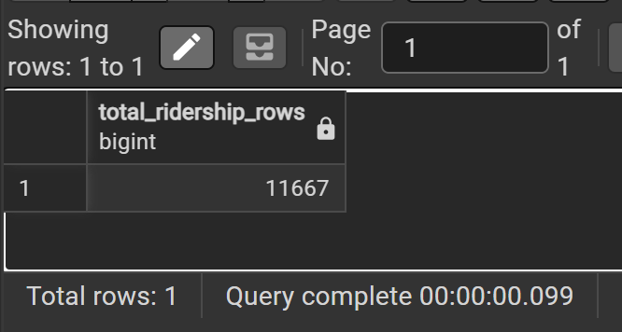
Figure A2. Hourly ridership records for the four NYU-area stations.
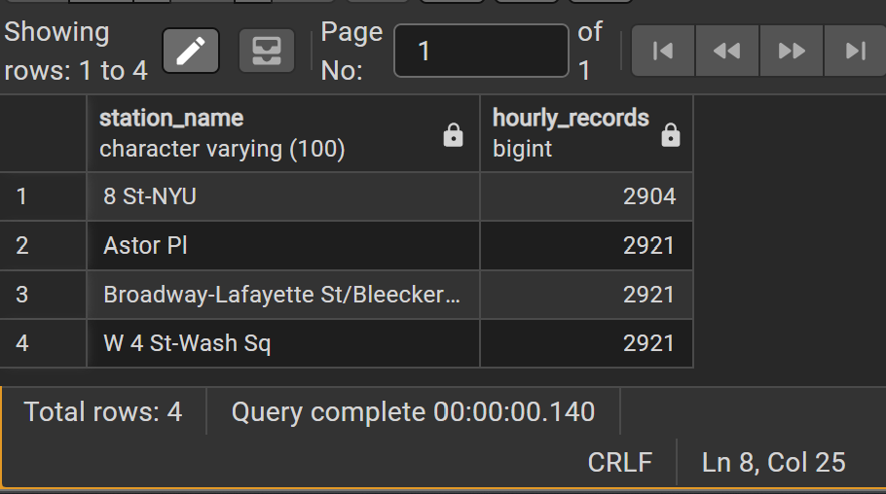
Figure A3. Distribution of Low, Medium, and High congestion classes.
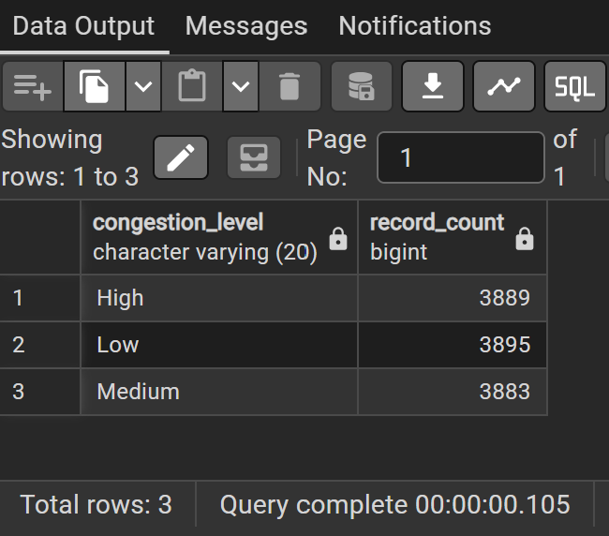
Figure A4. Streamlit future congestion prediction and recommendation.
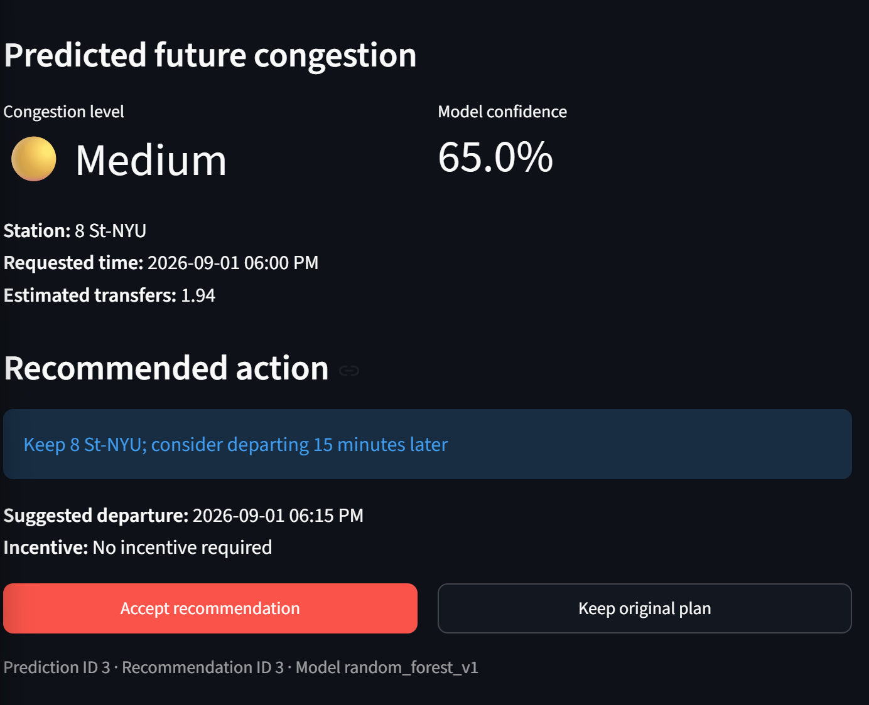
Figure A5. Streamlit confirmation that the commuter decision was saved.
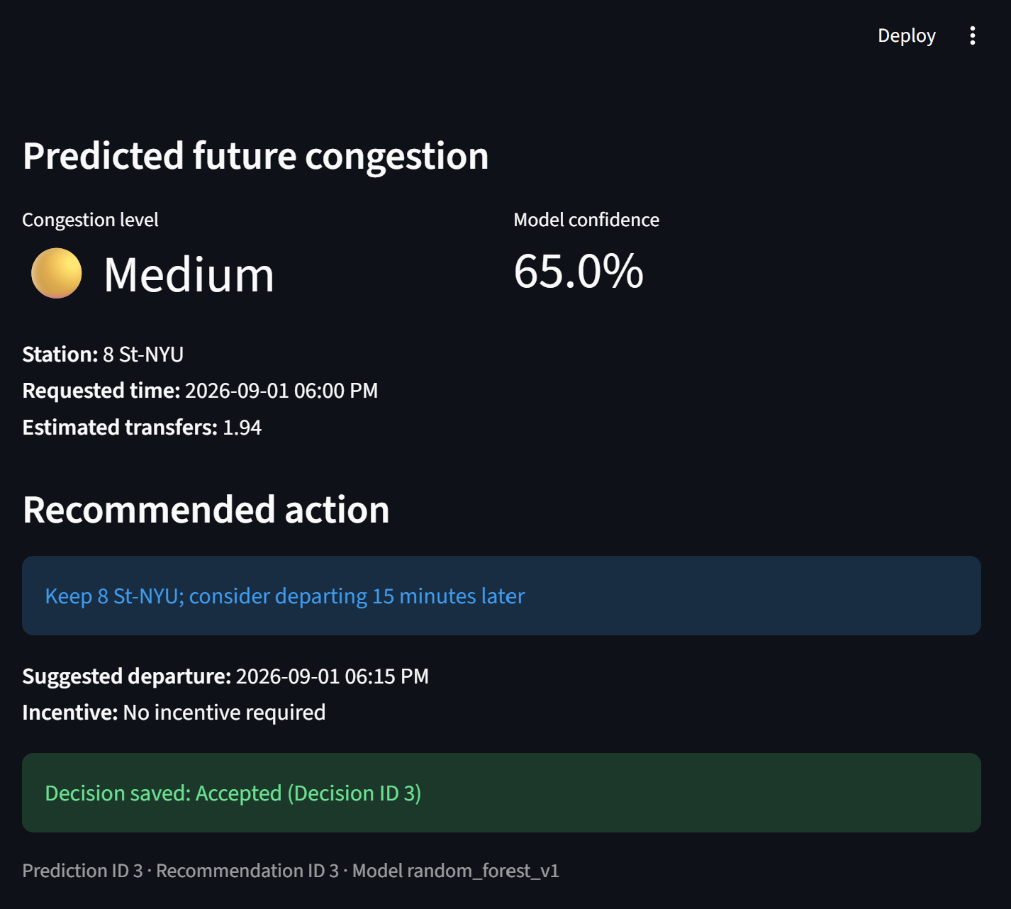
Figure A6. PostgreSQL evidence of the saved application workflow record.
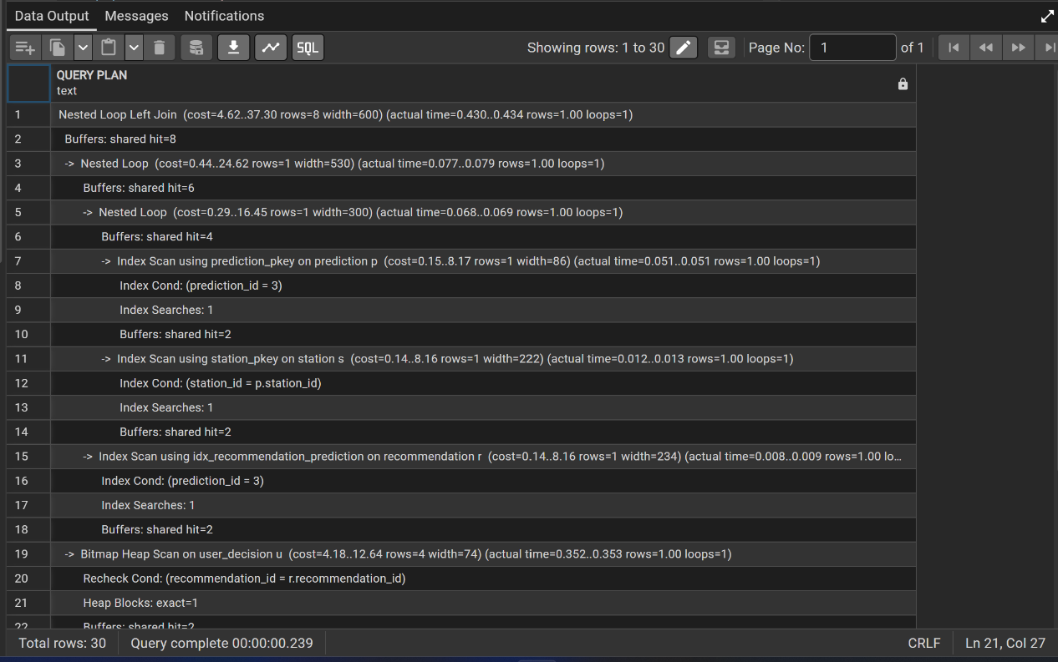
Figure A7. Query result joining prediction, recommendation, and user decision.
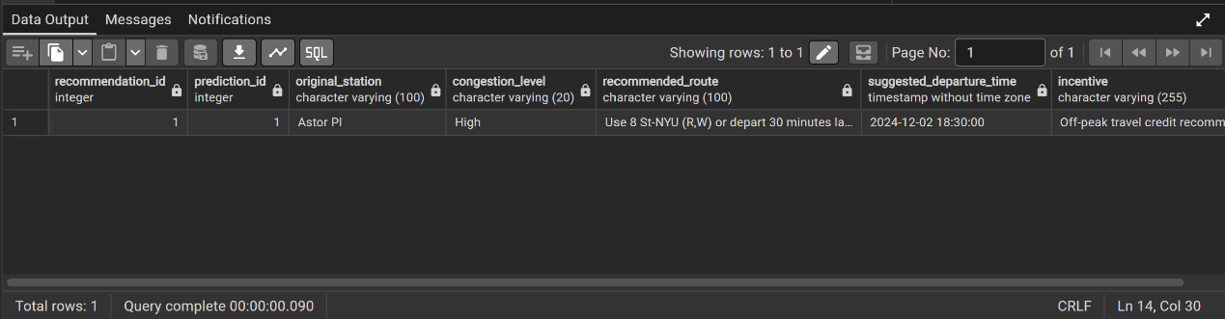

Figure A8. SQL workflow join for the future demonstration request.
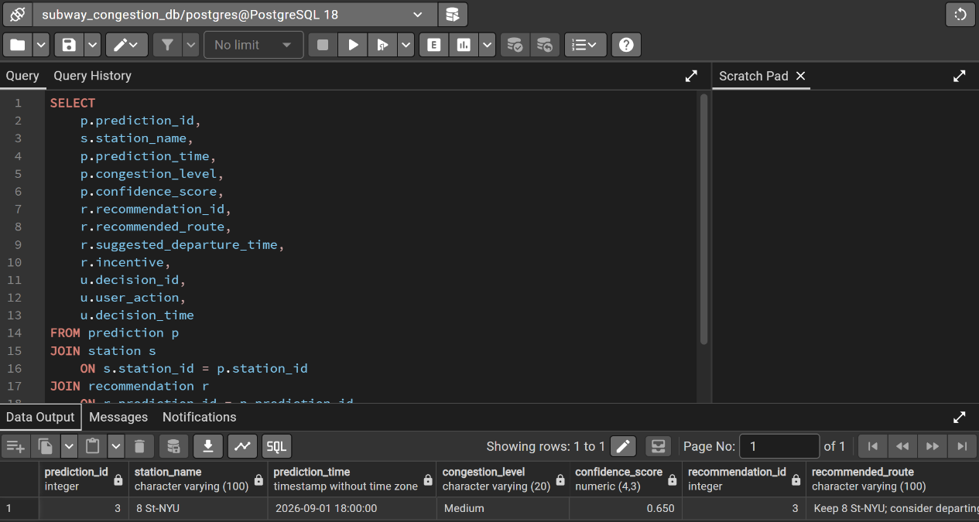
Figure A9. EXPLAIN ANALYZE plan using the ridership timestamp index.
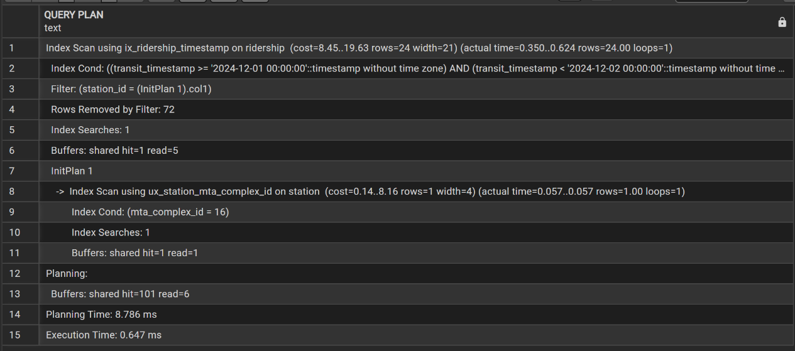
Figure A10. EXPLAIN ANALYZE plan using indexes across the complete workflow join.
