Database Systems Project Part I
Enterprise Data Architecture Modeling
Course: CSCI-GA.2433-001 Database Systems
Student: Jason Chen
Semester: Summer 2026

1. Introduction
2. Business Requirements
3. ER Diagram
4. Entity Description
5. Relationship Description
6. Business Rules
7. Model Verification
8. Conclusion

1. Introduction
The objective of this project is to design an Enterprise Data Architecture (EDA) for an Event-Aware Subway Congestion Decision Support Platform serving the New York University (NYU) area. The proposed system integrates traditional relational database concepts with enterprise data modeling principles to support subway ridership management, public event monitoring, congestion prediction, and commuter decision support.
The enterprise data model provides a foundation for subsequent logical database design, physical database implementation, and machine learning integration developed throughout the remaining project phases.

2. Business Requirements
ID | Business Requirement
BR1 | Store subway station information.
BR2 | Store hourly subway ridership records.
BR3 | Store public event information near NYU.
BR4 | Generate congestion predictions.
BR5 | Generate travel recommendations.
BR6 | Store commuter responses to generated travel recommendations.

3. ER Diagram
Figure 1. Conceptual Entity-Relationship Diagram for the Event-Aware Subway Congestion Decision Support Platform.
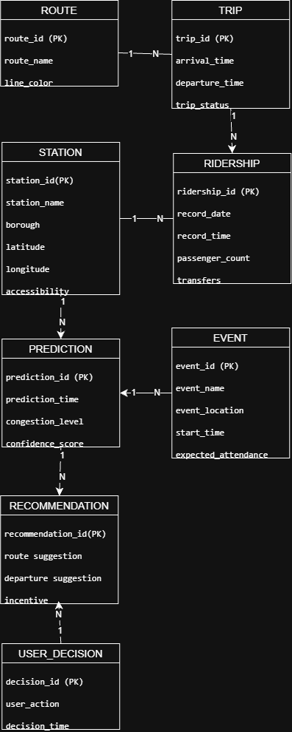
Figure 1 presents the conceptual Enterprise Data Model (ERD) designed for the proposed congestion prediction platform. The model identifies the major business entities and their relationships prior to logical and physical database implementation.
4. Entity Description
Station
Description
Stores subway station information.
Primary Key
Station_ID
Main Attributes
- Station Name
- Latitude
- Longitude
- Borough
Ridership
Stores hourly passenger counts.
Attributes
- Timestamp
- Ridership
- Transfers

Event
Stores public events affecting subway demand.
Attributes
- Event Name
- Event Date
- Location
- Expected Attendance

Prediction
Stores congestion prediction results generated by the machine learning model.
Attributes
- Prediction Time
- Congestion Level
- Confidence Score

Recommendation
Stores travel recommendations generated from prediction results.
Examples
- Delay travel
- Alternative station
- Alternative departure time

Route
Stores subway route information, including the route name and line color.

Trip
Stores scheduled subway trip information, including arrival time, departure time, and trip status.

User Decision
Stores the commuter’s response to a generated recommendation, including the selected action and decision time

5. Relationship Description
Relationship | Cardinality
Route => Trip | 1:N
Trip => Ridership | 1:N
Station => Ridership | 1:N
Station => Prediction | 1:N
Event => Prediction | 1:N
Prediction => Recommendation | 1:N
Recommendation => User_Decision | 1:N
These relationships ensure that subway operational data, public event information, prediction results, and commuter recommendations remain logically connected throughout the enterprise database.
6. Business Rules
BR1 Each subway station may contain multiple hourly ridership records.
BR2 Each ridership record belongs to one subway station.
BR3 One public event may influence multiple congestion predictions.
BR4 Each congestion prediction is generated for one station and one timestamp.
BR5 Each prediction may generate one or more recommendations.
BR6 Each recommendation may be associated with multiple user decision records.

7. Model Verification
Requirement | Supported
Subway stations | Yes
Ridership | Yes
Public events | Yes
Congestion prediction | Yes
Recommendation | Yes
User Decision | Yes
The proposed ER model satisfies the identified business requirements and provides a solid conceptual foundation for the logical and physical database implementation completed in subsequent project phases.

8. Conclusion
This project developed a conceptual Enterprise Data Model for an Event-Aware Subway Congestion Decision Support Platform focused on the NYU area. The proposed ER model captures the primary business entities, relationships, and business rules required for subway ridership management and congestion prediction. The resulting conceptual design establishes the foundation for the logical database schema, physical PostgreSQL implementation, machine learning integration, and end-to-end application developed in the subsequent project phases.

