Database Management Systems Project Specification - Part II - Logical Schema Optimization and Unstructured Data Collection
Course: CSCI-GA.2433-001 Database Systems
Project name: Event-Aware Subway Congestion Decision Support Platform for the NYU Area
Content
1. Project Overview 3
1.1 Project Objective 3
1.2 Main Business Entities 3
2. Hybrid Data Collection 4
2.1 Structured Data 4
2.2 Unstructured Data 4
2.3 Data Lake Design 4
3. Logical Database Schema 5
3.1 Relational Schema 5
3.2 Primary Keys & Foreign Keys 7
4. Schema Optimization 7
4.1 Normalization 7
4.2 Index Design 7
4.3 Structured & Unstructured Data Integration 8
5. Reference Architecture 8
6. Cloud Platform Design 9
7. Conclusion 10

1. Project Overview

1.1 Project Objective
The objective of this project is to develop an Event-Aware Subway Congestion Decision Support Platform for the NYU area. The platform integrates structured and unstructured data sources, including subway operational data, public event information, service alerts, and optional weather data to predict subway congestion, recommend alternative routes, and support data-driven travel decisions for commuters.

1.2 Main Business Entities
Entity | Description
Station | Stores subway station information such as station name and location.
Route | Stores subway route information (A, C, E, N, R, etc.).
Trip | Represents scheduled subway trips and operational information.
Event | Stores public events that may affect passenger flow.
Ridership | Stores historical passenger volume data for each station.
Prediction | Stores predicted congestion levels generated by the system.
Recommendation | Stores recommended alternative routes, travel times, or incentives.
User Decision | Stores whether a user accepts, ignores, or follows a recommendation.
These entities form the core business objects of the proposed subway congestion decision support platform and serve as the basis for the logical database schema presented in the following sections.

2. Hybrid Data Collection
This project utilizes both structured and unstructured data to support subway congestion prediction and decision-making. Structured data provides reliable operational information, while unstructured data offers additional contextual information that may affect passenger flow. Together, these data sources form a hybrid data collection framework for the proposed platform.

2.1 Structured Data
Data Source | Description | Purpose
MTA GTFS Schedule | Subway routes, stations, trips, and stop times. | Provides scheduled subway operations.
Historical Ridership Data | Historical passenger counts at subway stations. | Supports congestion prediction.
Station Information | Station names, locations, and accessibility information. | Supports route planning and visualization.
Weather Data (Optional) | Temperature, precipitation, and severe weather conditions. | Provides additional context for congestion prediction.

2.2 Unstructured Data
Data Source | Description | Purpose
Public Event Information | NYU events, concerts, sports games, and public gatherings. | Identifies potential passenger surges.
MTA Service Alerts | Delay, maintenance, and disruption announcements. | Detects unexpected operational changes.
Social Media Posts (Optional) | Passenger posts related to subway conditions. | Provides real-time user feedback.
News Articles (Optional) | Local transportation-related news. | Supplies additional contextual information.

2.3 Data Lake Design
Figure 1. Hybrid Data Collection Framework
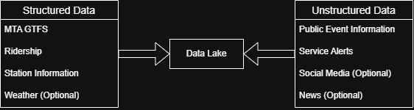
Figure 1 illustrates the hybrid data collection framework, where structured and unstructured data sources are integrated into a centralized data lake for downstream congestion prediction and decision support.

3. Logical Database Schema

3.1 Relational Schema
The logical database schema translates the conceptual business entities into relational tables. Each table is designed to reduce data redundancy, maintain data integrity, and support congestion prediction and decision-making. Primary keys uniquely identify each record, while foreign keys establish relationships between related entities.
Figure 2. Logical Relational Schema
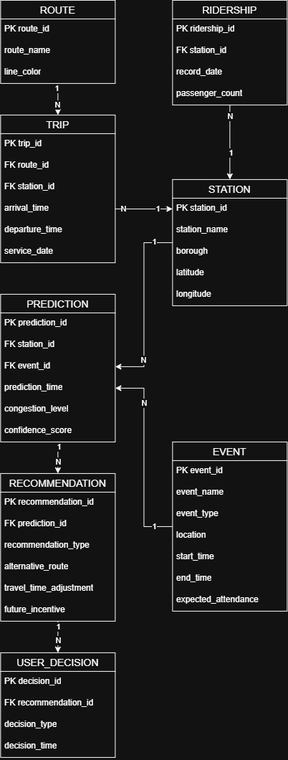
Figure 2 presents the logical relational schema of the proposed platform. It connects subway routes, trips, stations, ridership records, public events, congestion predictions, recommendations, and user decisions through primary-key and foreign-key relationships.

3.2 Primary Keys & Foreign Keys
Table | Primary Key | Foreign Key
ROUTE | route_id | -
STATION | station_id | -
TRIP | trip_id | route_id, station_id
RIDERSHIP | ridership_id | station_id
EVENT | event_id | -
PREDICTION | prediction_id | station_id, event_id
RECOMMENDATION | recommendation_id | prediction_id
USER_DECISION | decision_id | recommendation_id
The foreign key relationships maintain consistency between subway operational data, congestion predictions, recommendations, and user decisions. This design minimizes data redundancy while supporting efficient query processing and decision-making.

4. Schema Optimization

4.1 Normalization
The proposed relational schema follows the Third Normal Form (3NF) to minimize data redundancy and maintain data consistency. Each entity represents a single business concept, and non-key attributes depend only on the primary key. This design improves database maintainability and reduces update anomalies.

4.2 Index Design

Table | Indexed Attribute | Purpose
STATION | station_name | Fast station lookup
EVENT | start_time | Event search by date and time
PREDICTION | prediction_time | Retrieve recent predictions
RIDERSHIP | record_date | Historical ridership analysis
Appropriate indexes are created on frequently queried attributes to improve query performance and reduce response time.

4.3 Structured & Unstructured Data Integration
The proposed platform integrates structured data, including GTFS schedules, station information, and historical ridership, with unstructured data such as public event information and service alerts. The integrated data supports congestion prediction, route recommendation, and future decision support services. The data lake serves as the central repository for combining these heterogeneous data sources before they are processed by the relational database.

5. Reference Architecture
Figure 3. Reference Architecture
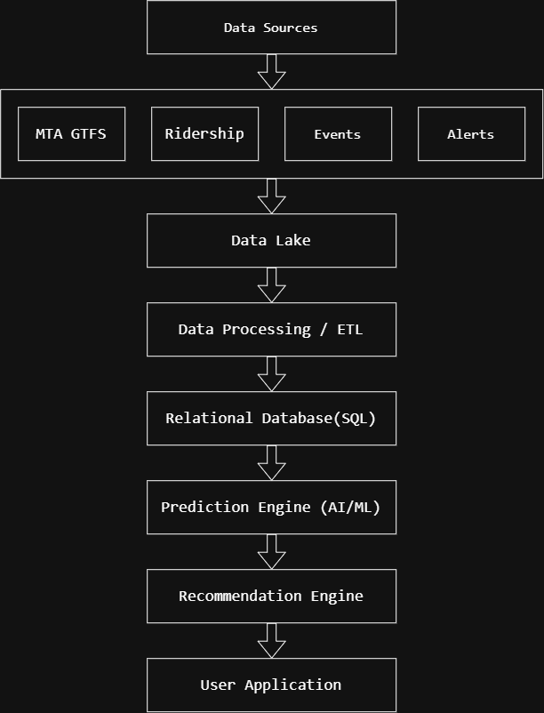
Figure 3 illustrates the proposed reference architecture of the Event-Aware Subway Congestion Decision Support Platform. Structured and unstructured data are collected from multiple sources and integrated into a centralized data lake. After ETL processing, the transformed data are stored in the logical relational database, which supports the decision support platform.

6. Cloud Platform Design
The proposed platform can be deployed on a cloud environment to improve scalability, availability, and maintainability. Structured and unstructured data are collected into a centralized data lake, while the relational database stores processed operational data. Cloud services support data collection, ETL processing, relational database management, and web-based access for commuters.

7. Conclusion
This project presents a logical database design for an Event-Aware Subway Congestion Decision Support Platform for the NYU area. By integrating structured and unstructured data, the proposed schema supports congestion prediction, recommendation generation, and future decision support functions. The logical schema and system architecture provide a solid foundation for the implementation and optimization phases in the subsequent parts of the project.

