Database Systems Project Part III
Logical Schema Optimization and Machine Learning Model Creation
Course: CSCI-GA.2433-001 Database Systems
Project name: Event-Aware Subway Congestion Decision Support Platform for the NYU Area
1. Introduction
2. Physical Database Design
2.1 Database Platform
2.2 Physical Schema
2.3 Physical Database Implementation
2.4 Physical Database Optimization
3. Workflow-Based Application
3.1 Use Case
3.2 Activity Diagram
4. Machine Learning Model
4.1 Dataset
4.2 Features
4.3 Algorithm
4.4 Training and Testing
4.5 Results
5. Big Data Platform
6. Updated Reference Architecture
7. Conclusion

1. Introduction
This phase of the project focuses on transforming the logical schema developed in Part II into an optimized physical PostgreSQL database design and creating a machine learning model for subway congestion classification. The implementation includes physical schema deployment, indexing, partitioning, materialized views, workflow modeling, and Random Forest model training using official MTA hourly ridership data.
2. Physical Database Design
2.1 Database Platform
The proposed platform uses PostgreSQL as the relational database management system because it is open-source, reliable, and fully supports advanced physical database optimization techniques required by this project, including indexing, table partitioning, materialized views, and ACID-compliant transaction management. PostgreSQL also integrates well with Python-based machine learning workflows and can be deployed either locally or on cloud platforms such as Microsoft Azure Database for PostgreSQL.
2.2 Physical Schema
2.2.1 Physical Schema Overview
The logical schema developed in Part II has been transformed into a physical database schema for PostgreSQL. The physical schema specifies the data types, primary keys, foreign keys, and integrity constraints for each table to support efficient data storage, query processing, and machine learning integration.
Table | Primary Key | Foreign Keys | Purpose
ROUTE | route_id | - | Stores subway route information
STATION | station_id | - | Stores station information
TRIP | trip_id | route_id, station_id | Stores scheduled subway trips
RIDERSHIP | ridership_id | station_id | Stores historical ridership
EVENT | event_id | - | Stores public event information
PREDICTION | prediction_id | station_id, event_id | Stores ML congestion predictions
RECOMMENDATION | recommendation_id | prediction_id | Stores alternative routes and incentives
USER_DECISION | decision_id | recommendation_id | Stores commuter responses

Figure 4. Physical Database Schema of the Event-Aware Subway Congestion Decision Support Platform
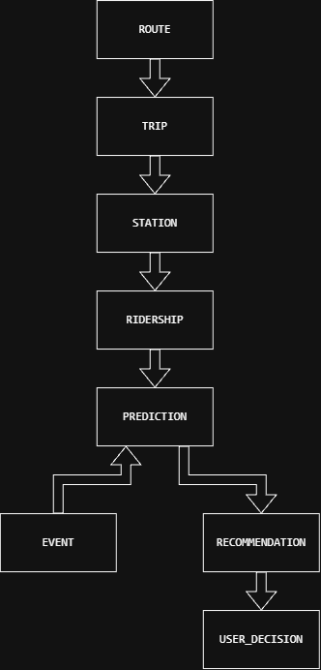
STATION
Attribute | Data Type | Constraint
station_id | SERIAL | PK
station_name | VARCHAR(100) | NOT NULL
latitude | DECIMAL(9,6)
longitude | DECIMAL(9,6)
borough | VARCHAR(50)
accessibility | BOOLEAN | DEFAULT FALSE
The STATION table stores subway station information used throughout the platform. Each station is uniquely identified by station_id and serves as a reference for trip, ridership, and congestion prediction records

TRIP
Attribute | Data Type | Constraint
trip_id | SERIAL | PK
route_id | INTEGER | FK=>ROUTE(route_id), NOT NULL
station_id | INTEGER | FK => STATION(station_id), NOT NULL
arrival_time | TIMESTAMP | NOT NULL
departure_time | TIMESTAMP | NOT NULL
trip_status | VARCHAR(30) | DEFAULT 'Scheduled'
The TRIP table stores scheduled subway operations. Foreign keys link each trip to its corresponding route and station, ensuring referential integrity across operational data.

PREDICTION
Attribute | Data Type | Constraint
prediction_id | SERIAL | PK
station_id | INTEGER | FK=> STATION(station_id), NOT NULL
event_id | INTEGER | FK => EVENT(event_id)
prediction_time | TIMESTAMP | NOT NULL
congestion_level | VARCHAR(20) | CHECK ('Low','Medium','High')
confidence_score | DECIMAL(5,4) | CHECK (confidence_score BETWEEN 0 AND 1)
The PREDICTION table stores machine learning results for subway congestion. Each prediction is associated with a station and, when applicable, a public event. The predicted congestion level and confidence score support downstream recommendation generation.

RECOMMENDATION
Attribute | Data Type | Constraint
recommendation_id | SERIAL | PK
prediction_id | INTEGER | FK=> PREDICTION(prediction_id), NOT NULL
recommended_route | VARCHAR(100)
suggested_departure_time | TIMESTAMP
incentive | VARCHAR(255)
The RECOMMENDATION table stores alternative travel recommendations generated from congestion predictions. These recommendations may include alternative routes, suggested departure times, and travel incentives to reduce congestion during peak demand.
2.2.2 Integrity Constraints
The physical database schema uses integrity constraints to ensure the accuracy, consistency, and reliability of the stored data. Primary key constraints uniquely identify each record, while foreign key constraints maintain referential integrity between related tables. NOT NULL constraints are applied to required attributes, and CHECK constraints are used to restrict values to valid business domains. DEFAULT values are also used to simplify data entry and ensure consistent initial values.
Constraint Type | Applied Attributes | Purpose
Primary Key | All table identifier fields | Uniquely identifies each record
Foreign Key | route_id, station_id, event_id, prediction_id, recommendation_id | Maintains relationships between tables
NOT NULL | Required identifiers, names, timestamps | Prevents incomplete records
CHECK | Congestion level, confidence score, passenger count, user action | Restricts values to valid ranges
DEFAULT | Accessibility, trip status, timestamps | Provides consistent initial values
UNIQUE | Route name or other stable identifiers | Prevents duplicate reference records

2.3 Physical Database Implementation
The physical database schema was successfully implemented in PostgreSQL. All eight relational tables were created successfully, providing the foundation for subsequent optimization, query processing, and machine learning integration.
Figure 5. Successful Implementation of the Physical Database Schema in PostgreSQL
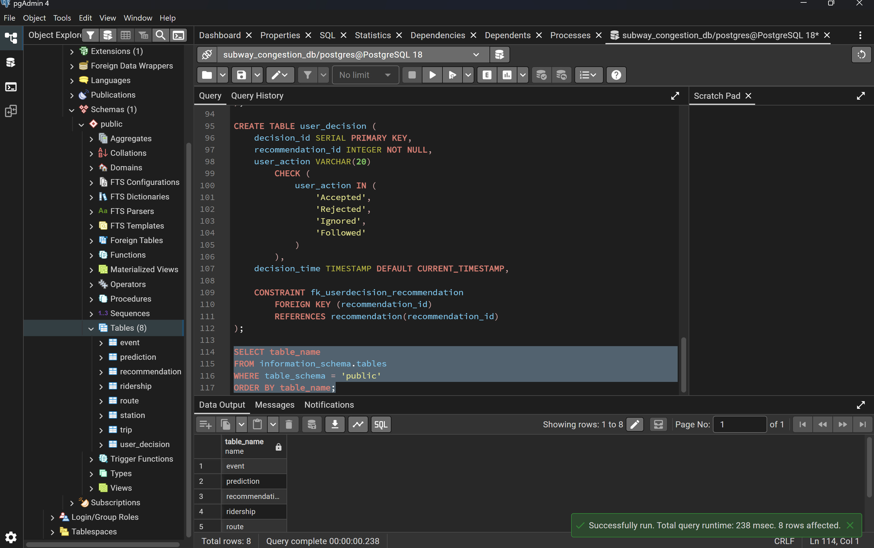
Figure 5 illustrates the successful implementation of the physical database schema in PostgreSQL. Eight relational tables, including ROUTE, STATION, EVENT, TRIP, RIDERSHIP, PREDICTION, RECOMMENDATION, and USER_DECISION, were successfully created and deployed within the public schema.

2.4 Physical Database Optimization
2.4.1 Index Design
To improve query performance, indexes were created on frequently queried attributes and foreign keys. Composite indexes were also created for historical ridership analysis and congestion prediction to reduce query execution time.
Figure 6. Indexes Created for Query Optimization in PostgreSQL
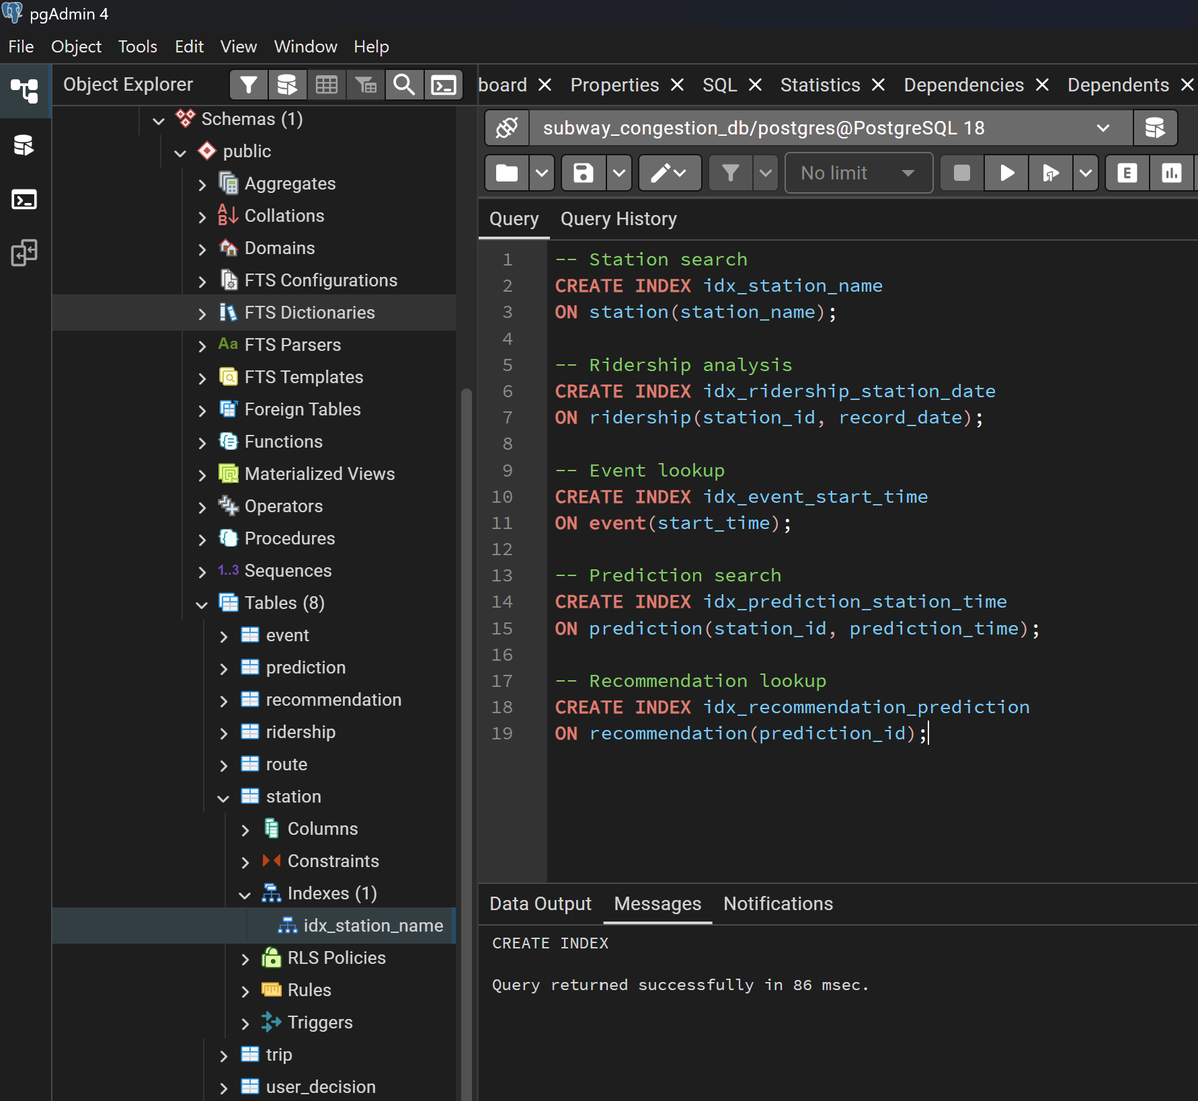
Figure 6 illustrates the indexes implemented in PostgreSQL to optimize query performance for station search, ridership analysis, congestion prediction, and recommendation retrieval.

2.4.2 Partitioning
To improve query performance for historical ridership analysis, the RIDERSHIP table was partitioned by record_date using PostgreSQL range partitioning. This design enables the database to scan only the relevant partitions for time-based queries, improving scalability and reducing query execution time.
Figure 7. Partitioned RIDERSHIP Table Created in PostgreSQL
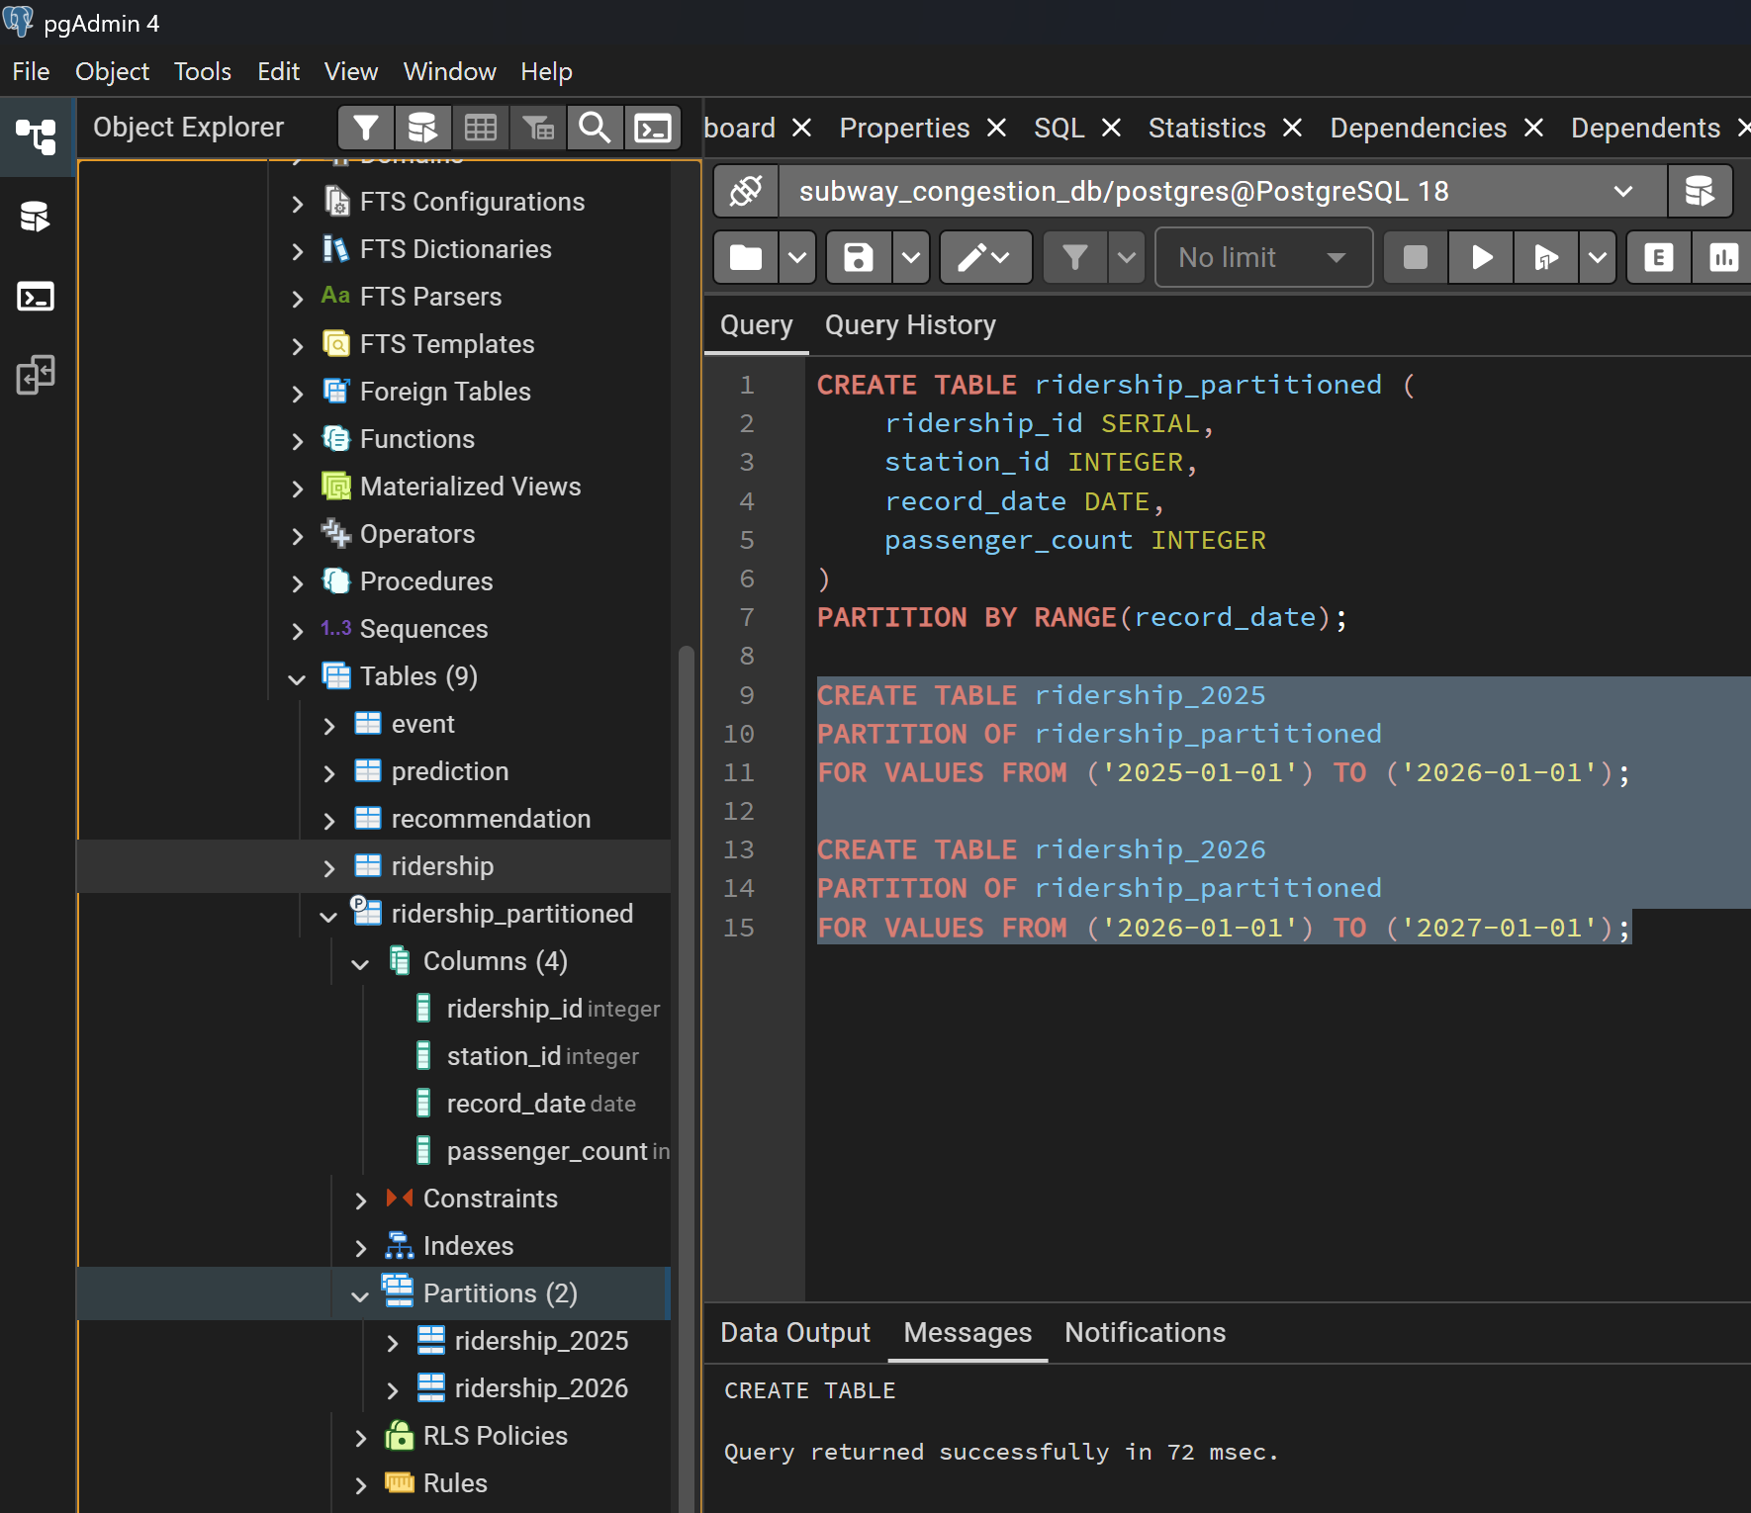
As shown in Figure 7, the RIDERSHIP table was successfully configured as a partitioned table using PostgreSQL range partitioning.

2.4.3 Materialized Views
To improve the efficiency of analytical queries, a materialized view named mv_station_daily_summary was created in PostgreSQL. The view precomputes daily ridership statistics for each station, including total and average passenger counts. By storing aggregated results, the materialized view reduces computation overhead and improves the performance of dashboard reporting and congestion analysis.
Figure 8. Materialized View for Daily Station Ridership Summary
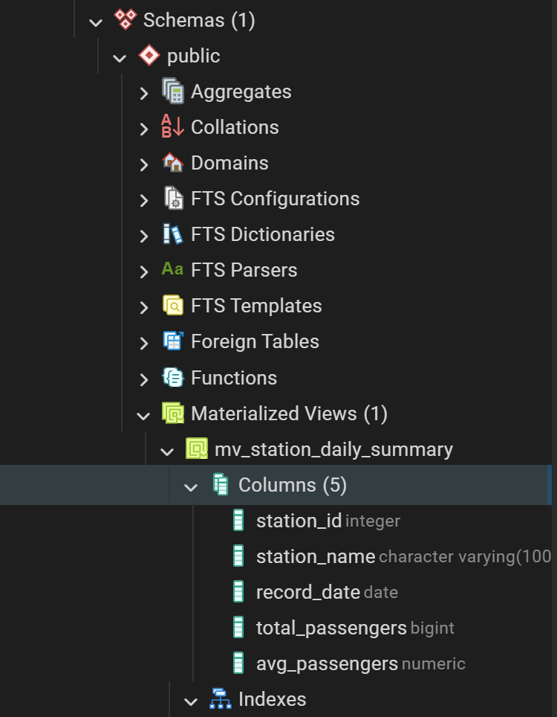
Figure 8 illustrates the successful creation of the materialized view mv_station_daily_summary in PostgreSQL. The materialized view stores precomputed daily passenger statistics for each station, supporting faster analytical queries and improving database performance.

Figure 9. Query Result of the Materialized View
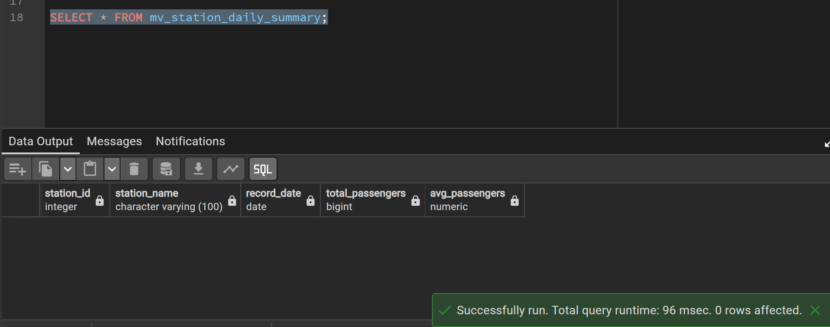
Figure 9 presents the query result of the materialized view mv_station_daily_summary. At this stage, the view returns no records because sample data has not yet been inserted into the database. This confirms that the materialized view has been created successfully and is ready for analytical queries once data becomes available.

3. Workflow-Based Application
3.1 Use Case
The Event-Aware Subway Congestion Decision Support Platform assists commuters in selecting optimal travel routes by integrating historical ridership data, public event information, and machine learning-based congestion prediction. Instead of only reporting congestion conditions, the platform provides proactive travel recommendations, including alternative subway routes, suggested departure times, and possible travel incentives.
The primary actor is the commuter. The commuter requests travel information through the application, and the system retrieves historical ridership records, identifies nearby public events, predicts congestion levels, generates personalized recommendations, and records the commuter's final decision for future analysis and model improvement.
Figure 10. Use Case Diagram of the Event-Aware Subway Congestion Decision Support Platform
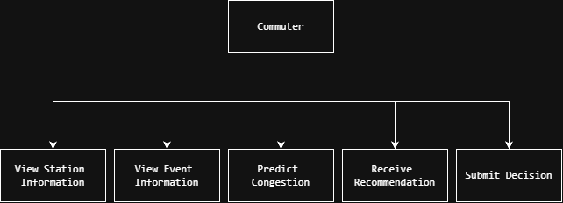
Figure 10 illustrates the primary interactions between commuters and the proposed decision support platform. The system integrates database operations and machine learning predictions to generate personalized travel recommendations.

3.2 Activity Diagram
The system begins when a commuter requests travel information. The platform first retrieves historical ridership records and public event information from the PostgreSQL database. These data are then processed by the machine learning model to estimate congestion levels. Based on the prediction results, the recommendation module generates alternative routes, departure times, and travel incentives. Finally, the commuter selects a preferred travel option, and the decision is stored in the database for future analysis.
Figure 11. Activity Diagram of the Congestion Prediction Workflow
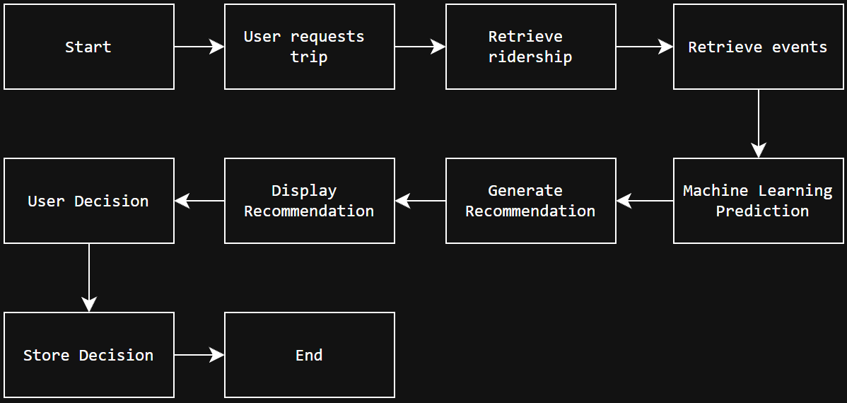
Figure 11 presents the operational workflow of the proposed decision support platform from user request to congestion prediction, recommendation generation, and user decision recording.
4. Machine Learning Model
4.1 Dataset
Historical subway ridership data were collected from the New York State Open Data portal (MTA Subway Hourly Ridership: 2020–2024). Since the proposed system focuses on the NYU area, only four nearby subway station complexes were selected:
- 8 St–NYU
- W 4 St–Washington Sq
- Astor Pl
- Broadway–Lafayette St / Bleecker St
Records from September 2024 to January 2025 were extracted. After removing missing values and aggregating hourly ridership records, the final dataset contained 11,667 hourly observations used for machine learning.

Figure 12. MTA Subway Hourly Ridership Dataset from New York Open Data.
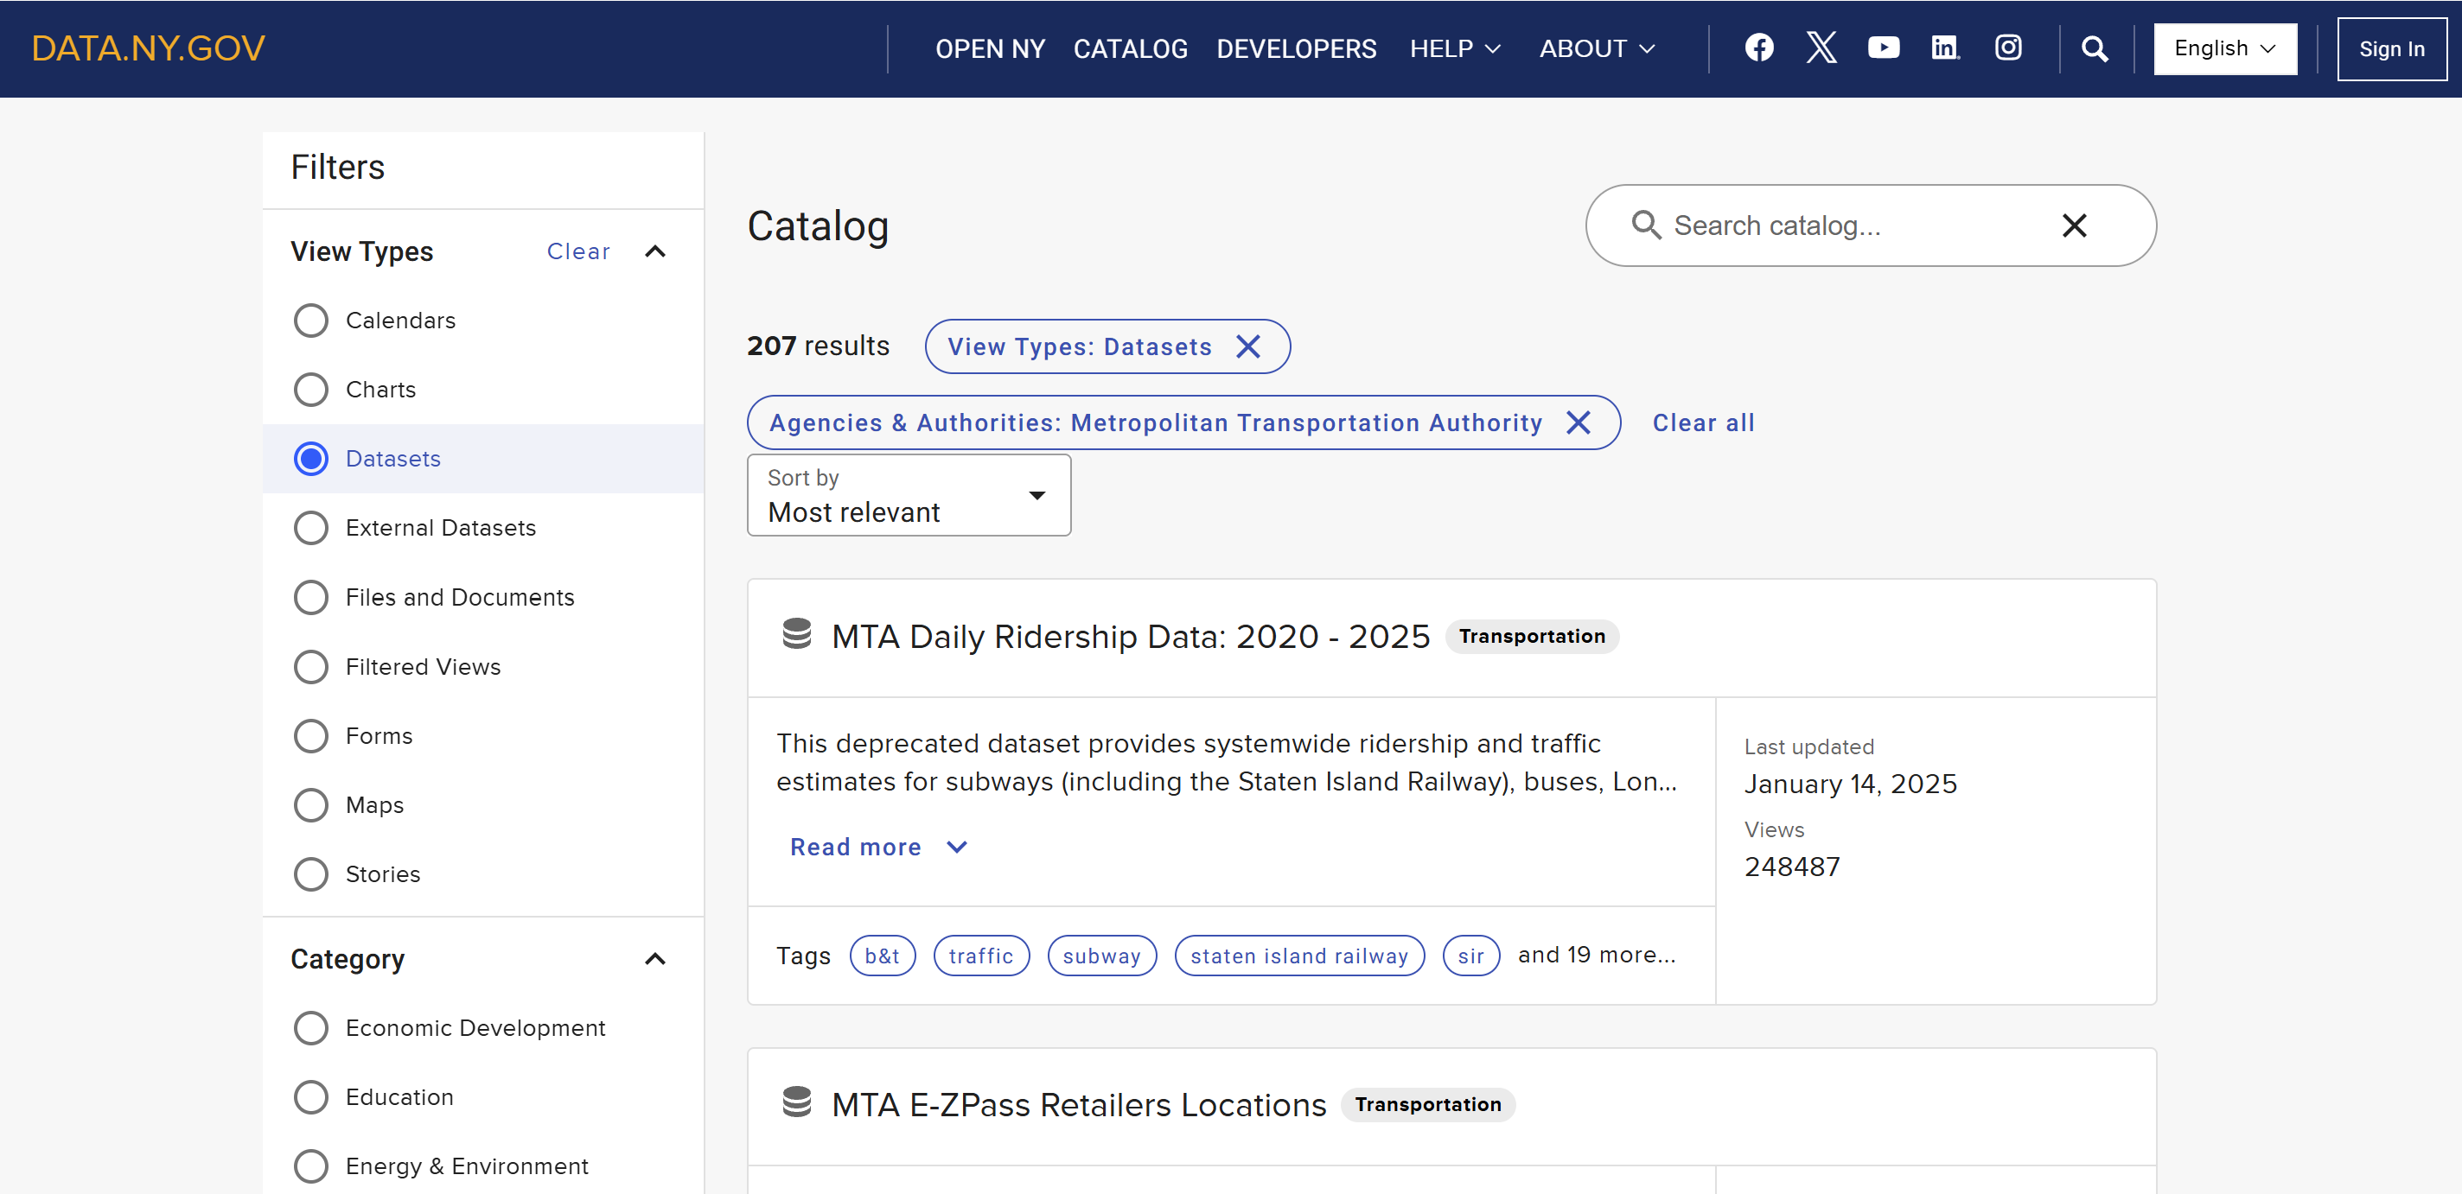
The historical subway ridership dataset was obtained from the New York Open Data portal and served as the primary data source for this project.
Figure 13. Filtering the Dataset for NYU-Area Subway Stations.
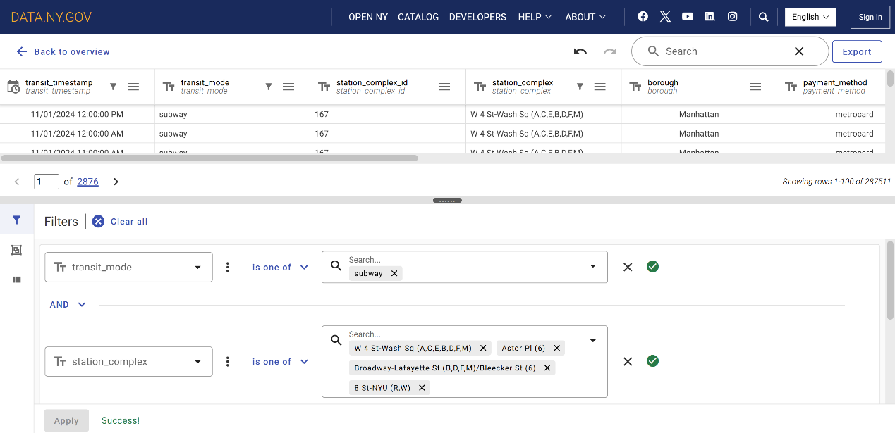
Only subway records from the four station complexes surrounding NYU and the selected time period were retained for subsequent analysis.

Figure 14. Aggregated Hourly Ridership Dataset after Data Cleaning
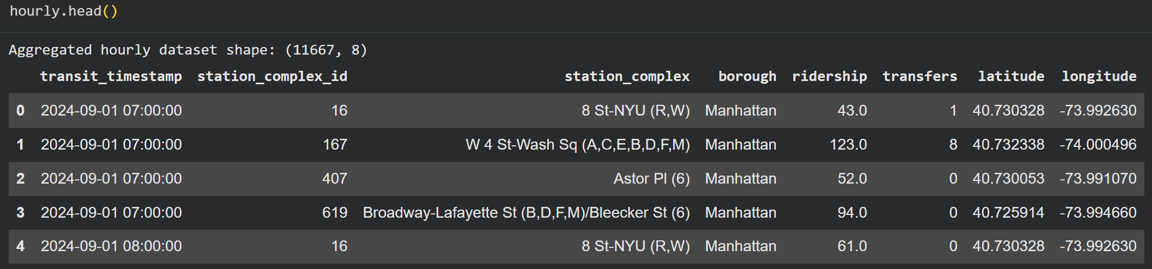
After removing missing values and aggregating duplicate records, the cleaned dataset contained 11,667 hourly observations, which served as the input for feature engineering and machine learning.

4.2 Features
Table 1. Machine Learning Features Used for Congestion Prediction
Feature | Description
Hour | Hour of day
Day_of_week | Day of week
Month | Month
Weekend | Weekend indicator
Station_ID | Station identifier
Transfers | Number of transfers

Figure 15. Feature Engineering Results
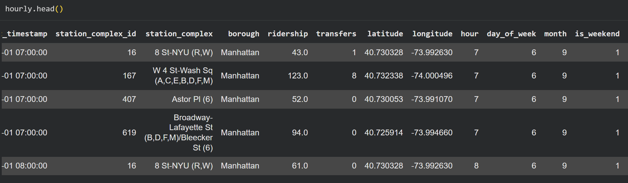
Temporal features, including hour, day of the week, month, and weekend indicator, were extracted from the timestamp to improve congestion prediction.

4.3 Algorithm
Figure 16. Random Forest Model Construction
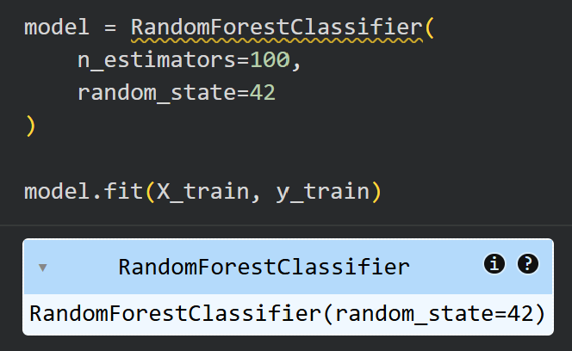
A Random Forest classifier with 100 decision trees was trained to classify congestion levels using temporal and station-related features.
4.4 Training and Testing
Figure 17. Training and Testing Dataset Split.
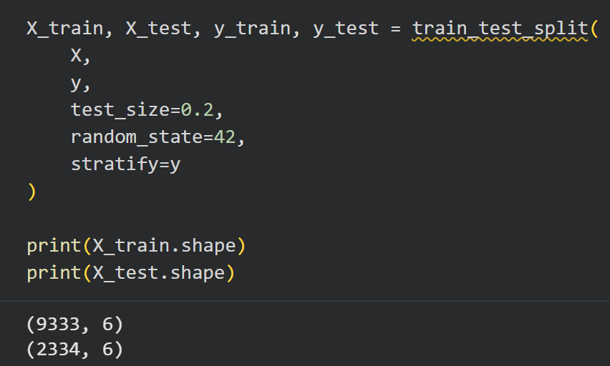
The dataset was divided into 80% training data and 20% testing data using stratified sampling to ensure balanced class distributions.

Figure 18. Overall Prediction Accuracy.
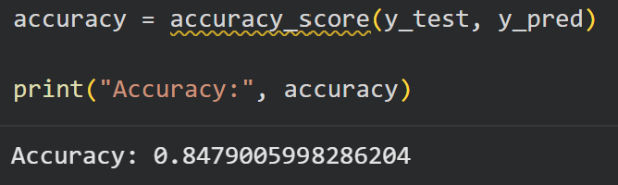
The Random Forest classifier achieved an overall prediction accuracy of 84.8% on the testing dataset.

4.5 Results
Figure 19. Confusion Matrix of Congestion Level Classification.
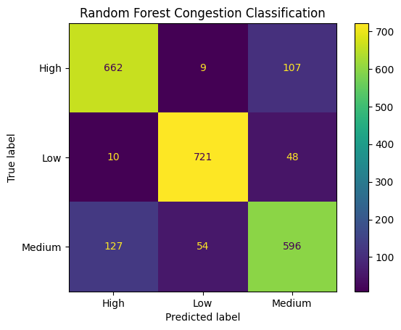
The confusion matrix illustrates the classification performance of the model across the three congestion levels (Low, Medium, and High).

Figure 20. Feature Importance of the Random Forest Model.
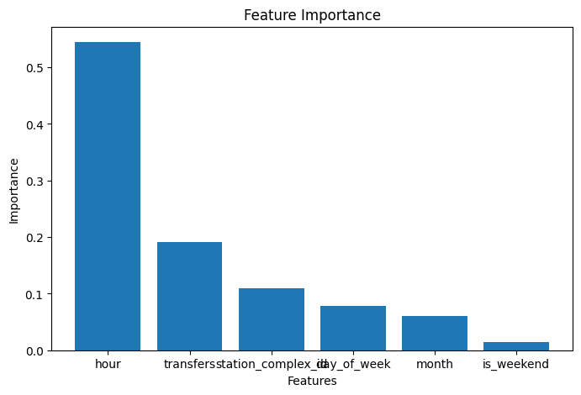
Feature importance analysis shows that hour is the most influential predictor, followed by transfers and station identifier, indicating that temporal travel patterns play a dominant role in congestion prediction.

5. Big Data Platform
The proposed Big Data platform integrates official MTA subway ridership data, relational database technologies, and machine learning analytics into a unified decision support workflow. Historical ridership data are collected from the New York Open Data portal and preprocessed using Python and Pandas. The PostgreSQL schema provides the planned storage layer for operational and analytical records, while the current machine learning prototype is trained in Google Colab using a Random Forest classifier. The resulting predictions support travel recommendations for commuters around the NYU area.
The proposed platform is intentionally designed to be extensible. In the next phase of the project (Part IV), the architecture will be expanded into a fully integrated end-to-end workflow capable of automatically updating datasets, retraining the machine learning model, and synchronizing prediction results with the operational PostgreSQL database.
Figure 21. Conceptual Big Data Platform Architecture
Figure 21 illustrates the conceptual Big Data platform used in this project. Historical subway ridership data are collected from the MTA Open Data portal, preprocessed using Python and Pandas, stored in PostgreSQL, and analyzed using a Random Forest model to predict congestion levels. The prediction results are subsequently used to generate travel recommendations for commuters around the NYU area.

6. Updated Reference Architecture
The updated reference architecture consists of four connected domains. The business domain supports congestion-aware commuter decision-making. The application domain includes data preprocessing, machine learning prediction, and recommendation generation. The DIKW domain transforms raw ridership records into engineered features, congestion predictions, and actionable recommendations. The infrastructure domain currently uses Google Colab for analytics and PostgreSQL for physical database deployment. The architecture is designed for future integration into an automated end-to-end application in Part IV.
7. Conclusion
This project successfully developed an optimized PostgreSQL-based physical database and a machine learning model for the proposed Event-Aware Subway Congestion Decision Support Platform. Historical subway ridership data from the MTA Open Data portal were collected, preprocessed, and analyzed using a Random Forest classifier to predict congestion levels around the NYU area. The resulting system integrates database optimization techniques and machine learning analytics to support intelligent travel recommendations. In the next phase of the project (Part IV), the proposed architecture will be extended into a fully integrated end-to-end workflow with automated data updates and database programming.

