## Motivation

Present problem in our school’s curriculum query and modify mode are these:

**Student’s view:**

1. The query process is complex. Student have to take multiple page jumps to find the curriculum document download links
2. Students can’t know which courses they have studied obviously(because the curriculum only a PDF document). It must be relied upon comparing manually with information on course select system(教务系统)
3. Curriculum out of time. The latest version is in April, 2018

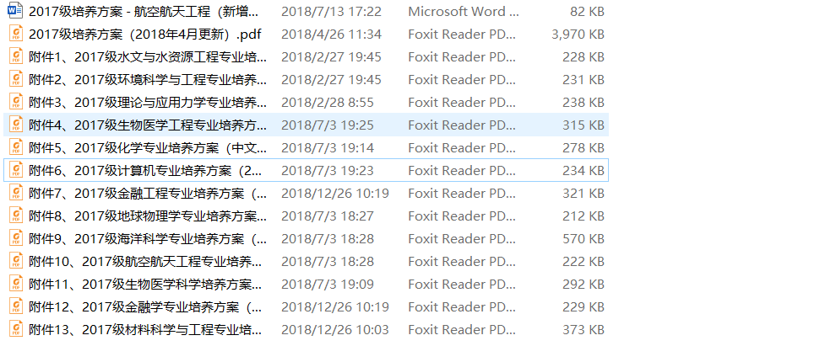

1. Courses information query is not friendly to user.

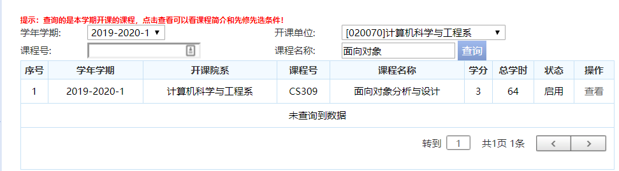

**Administrator’s view:**

1. Updating curriculum is a hard task. Relation between courses are complex and one update need to upload a complete curriculum table.
2. Prerequisite course relation in table or pdf document are not clear.

## Our strategy

A customizable system which generate tree diagram to show the courses in curriculum.

## Silver bullets: Customizability

Students can put the major curriculum which they focus on in the user home page and curriculum administrator can modify tree diagram to update curriculum conveniently.

## Feature Description

Now, we start from student point of view. Assume a student want to query some curriculums.

**Case 1:**

1. Login courschema website by student ID and password and go to user home page.

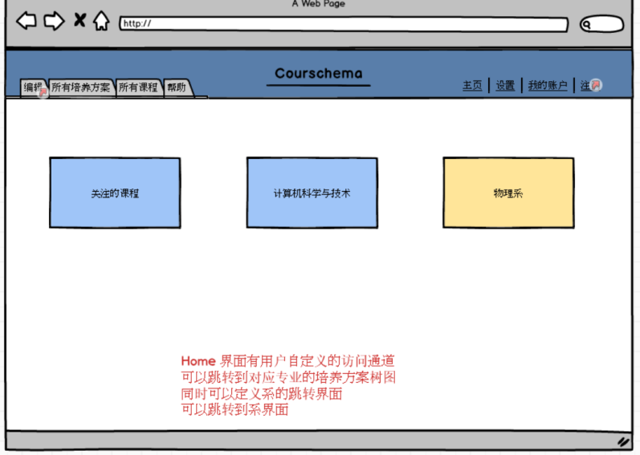

1. If the student **have customized** the home page, he/she can visit specific curriculum page by one clip

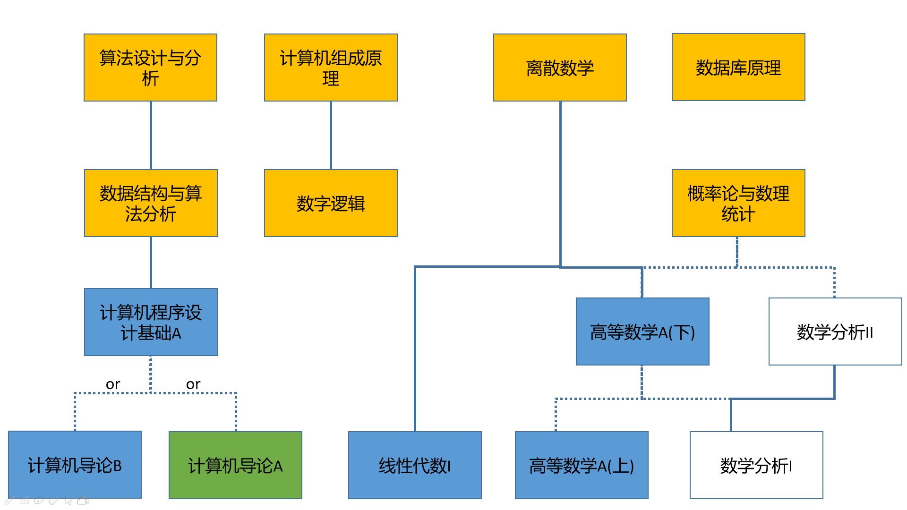(abridged general view)

1. The curriculum is showed in tree-diagram like diagram. Dash line means OR relationship and full line means AND relationship. Different color indicate different type of course. In this example, blue means General required course(通识必修课), yellow means preprofessional courses(专业先修课), green means optional course(专业选修课), white means not required in this major. If the student has studied a course, the course would be set a flag.



1. Clipping the course icon can visit the information page of corresponding course, showing the abstract of course etc.

**Case 2:**

1. If a student doesn’t customized the homepage, he/she can go to edit page to customize his major curriculums which he/she interested in.

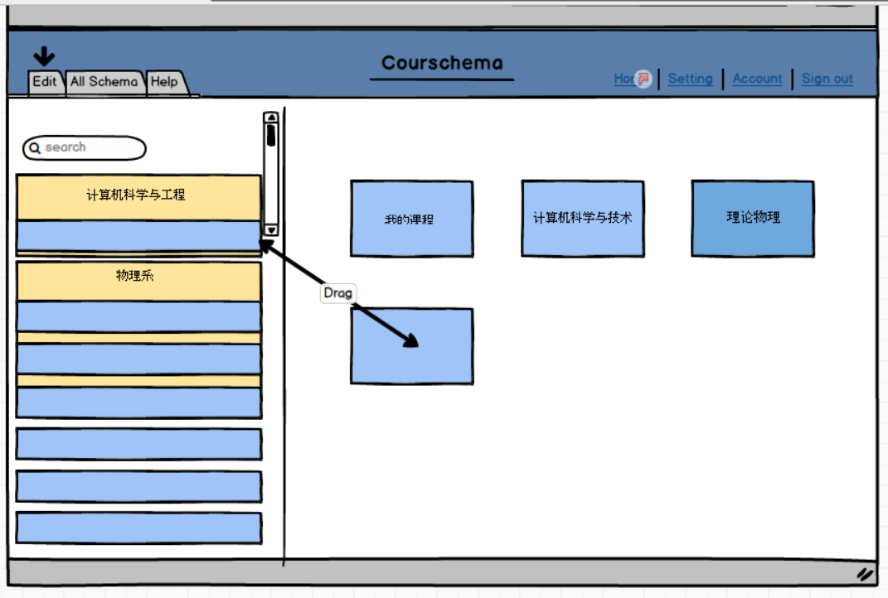

In edit page, user can edit personal home page, like create some shortcuts of these curriculum

1. If the student is interested in some courses, he/she can visit all courses page to find all courses introduction.