# Space Invaders Design document

Description of game:

In Space Invaders the player is tasked with destroying waves of alien ships as they descend from the top of the screen, by controlling a laser cannon that is positioned at the bottom of the screen and is only able to move left and right as well as shoot a laser. There are 2 ways for the player to lose, one is by running out of lives, the other is by the aliens reaching the bottom of the screen which will cause the player to instantly lose. The player is given 3 lives when starting the game and will lose one each time they are hit from an alien’s laser that is shot from the ships.

The main challenge of this game is when the alien ships increase in speed as the player get further through the level, making them much harder to hit. The player’s progress is measured by how many enemies they have killed which is displayed as a high score at the top of the screen. After the player has killed all of the aliens’ ships in the current wave, another wave will spawn lower than the original wave creating a repeatable gameplay loop until the player is defeated.

Also featured in the game are a number of “barricades” the player can use. The “barricades” are positioned above the player and can act as cover for the player to hide behind to avoid being shot by an alien ship. If the barricade is shot, either by the player or by an alien ship a chunk of it is destroyed and will not be respawned until the next game. This puts pressure on the player as the longer they are alive, the less cover they have to hide behind.

Class diagram (UML app.diagrams.net):

Enemy Behaviour:

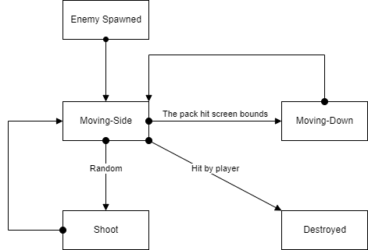

Description of programming patterns:

Description of data structures implemented:

Description of algorithms implemented:

Description of applicable testing strategies:

Mock-ups of user interface and menus: