**24 – TASK 1**

***The pie chart below shows the main reasons why agricultural land becomes less productive. The table shows how these causes affected three regions of the world during the 1990s.***Summarise the information by selecting and reporting the main features, and make comparisons where relevant.

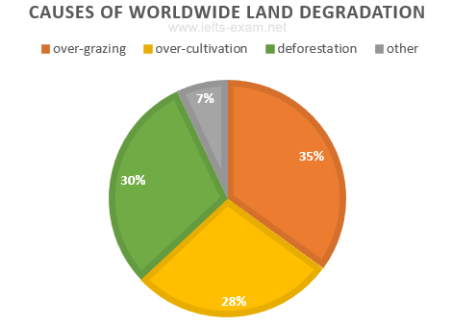

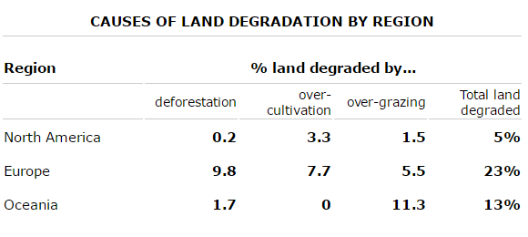

**Model answer**

The pie chart shows that there are four main causes of farmland becoming degraded in the world today.

Globally, 65% of degradation is caused by too much animal grazing and tree clearance, constituting 35% and 30% respectively. A further 28% of global degradation is due to over-cultivation of crops. Other causes account for only 7% collectively.

These causes affected different regions differently in the 1990s, with Europe having as much as 9.8% of degradation due to deforestation, while the impact of this on Oceania and North America was minimal, with only 1.7% and 0.2% of land affected respectively. Europe, with the highest overall percentage of land degraded (23%), also suffered from over-cultivation (7.7%) and over-grazing (5.5%). In contrast, Oceania had 13% of degraded farmland and this was mainly due to over-grazing (11.3%). North America had a lower proportion of degraded land at only 5%, and the main causes of this were over-cultivation (3.3%) and, to a lesser extent, over-grazing (1.5%).

Overall, it is clear that Europe suffered more from farmland degradation than the other regions and the main causes there were deforestation and over-cultivation. (184 words) 1

***The graph below shows the pollution levels in London between 1600 and 2000.*  
Summarise the information by selecting and reporting the main features, and make comparisons where relevant.**

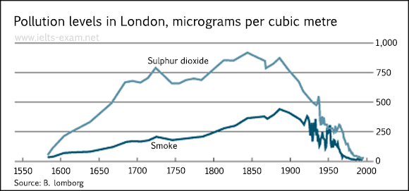

### Model answer

*(1st paragraph introduces the topic of the graph, explains what the graph shows and outlines overall trends or patterns.)*

The graph shows pollution levels in London between 1600 and 2000. It measures smoke and sulphur dioxide in micrograms per cubic metre. According to the information, the levels of both pollutants formed a similar pattern during this period, but there were always higher levels of sulphur dioxide than smoke in the atmosphere.

*(2nd paragraph describes the trends in more detail and illustrates these using data from the graph.)*

In 1600, pollution levels were low, but over the next hundred years, the levels of sulphur dioxide rose to 700 micrograms per cubic metre, while the levels of smoke rose gradually to about 200 micrograms per cubic metre. Over the next two hundred years the levels of sulphur dioxide continued to increase, although there was some fluctuation in this trend. They reached a peak in 1850. Smoke levels increased a little more sharply during this time and peaked in 1900 at about 500 micrograms. During the 20th century, the levels of both pollutants fell dramatically, though there was a great deal of fluctuation within this fall.

*(Final paragraph draws a simple conclusion from the data.)*

Clearly air pollution was a bigger problem in London in the early 20th century than it is now.

(176 words) 2

**The tables below give information about sales of Fairtrade*-labelled tea and pineapples in 2010 and 2015 in five European countries.**Summarise the information by selecting and reporting the main features, and make comparisons where relevant.

Write at least 150 words.

**Sales of Fairtrade-labelled tea and pineapples (2010 & 2015)**

|  |  |  |  |  |  |  |  |  |  |  |  |  |  |  |  |  |  |  |  |  |  |  |  |  |  |  |  |  |  |  |  |  |  |  |  |  |  |
| --- | --- | --- | --- | --- | --- | --- | --- | --- | --- | --- | --- | --- | --- | --- | --- | --- | --- | --- | --- | --- | --- | --- | --- | --- | --- | --- | --- | --- | --- | --- | --- | --- | --- | --- | --- | --- | --- |
| |  |  |  | | --- | --- | --- | | Tea | **2010 (millions of euros)** | **2015 (millions of euros)** | | France | 2.5 | 21 | | Austria | 4 | 8 | | Germany | 2.8 | 3 | | Netherlands | 2 | 2.7 | | Norway | 1.8 | 2 | | |  |  |  | | --- | --- | --- | | **Pieapples** | **2010 (millions of euros)** | **2015 (millions of euros)** | | Austria | 16 | 48 | | France | 2 | 6.5 | | Netherlands | 1.6 | 5 | | Norway | 2.8 | 2 | | Germany | 3 | 1.9 | |

The two tables contain sales data for Fairtrade tea and pineapples in 2010 and 2015, in five nations of Europe.

The first table shows low-level tea sales increasing in all five countries, albeit to widely varying degrees. In two places sales increased by the same small amount: 2.8-3 million euros in Germany, and 1.8-2 million in Norway. The increment was slightly larger in Netherlands, from 2-2.7 million euros. Meanwhile, in Austria sales doubled from 4-8 million euros. Finally, in France there was an enormous increase, from 2.5-21 million euros.

In the second table, it is Austria which stands out as buying far more Fairtrade pineapples than the other four countries. The sales figures for Austria jumped from 16-48 million euros across these five years, while in France and Netherlands sales only grew from 2-6.5 and from 1.6-5 million euros respectively. Norway and Germany showed a different pattern, with falls in pineapple sales from 2.8-2 and 3-1.9 million euros.

Comparing the two tables, it is clear that in 2010 Fairtrade tea sales ranged from 1.8-4 million euros in these five countries, while pineapple sales also mostly clustered between 1.6 and 3 million euros, with Austria the outlier at a huge 16 million euros. By 2015, sales figures for both products had risen across the board, except for Norway and Germany which recorded drops in pineapple sales. (225 words) 3

***The charts below show the results of a survey about what people of different age groups say makes them most happy.*  
Summarise the information by selecting and reporting the main features, and make comparisons where relevant.**

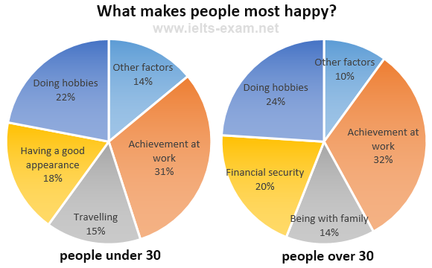

### Model answer

There are several similarities between what younger and older people say makes them most happy. However, there are several striking differences.

Firstly, let us look at the similarities. It is noticeable that for both younger and older people, the highest percentage says that achievement at work brings them most happiness: 31% for the younger age group and 32% for the older group. Doing hobbies is also very important for both groups: the second largest percentage of both age groups mentioned doing hobbies as making them most happy.

Turning now to the differences, many younger people regard having a good appearance as extremely important: 18% of them state this brings them most happiness. This is followed by 15% who state that travel brings them happiness. Neither of these two factors is mentioned by older people. Instead, 20% of older people report that having financial security is most important to their happiness and 14% say they feel most happy when they are with their family. (163 words) 4

***The chart below gives information about Someland's main exports in 2005, 2015, and future projections for 2025.*  
Summarise the information by selecting and reporting the main features, and make comparisons where relevant.**

**Someland’s main exports**

**USD billion**

### Model answer

This bar chart illustrates the performance of Someland's primary exports in 2005 and 2015. It also indicates future projections for 2025. According to the data, it seems likely that international tourism will become the dominant industry, although dairy exports will remain strong. In 2005, we can see that tourism was the greatest exports earner of the three industries, with revenue standing at just over $6 billion.

This figure has increased slightly, so that now, in 2015, it has reached almost $7 billion. It is estimated that international tourism will continue to grow, so that by 2025, it will be earning around $8 billion for the country. In 2000, dairy exports were worth around $5 billion, but since then there has been a dramatic increase, and sales for this year are approximately $8 billion. Experts are predicting that exports in this area may fall slightly, so a figure of $7.5 billion is expected for 2025. Meat products are the third key industry in Someland, but sales have dropped since 2000 and now stand at $3.5 billion. It is expected that sales will continue to decrease in the future. (187 words) 5

***The chart below gives information about the most common sports played in New Zealand in 2002.*  
Summarise the information by selecting and reporting the main features, and make comparisons where relevant.**

**Sports played in New Zealand in2002**

### Model answer

The bar graph provides information about the most Common sports played in New Zealand in 2002. It gives figures for both boys and girls and clearly shows that their participation in sports is fairly equal (both boys and girls are participants of all kinds of sports mentioned in the chart). However, their sporting preferences tend to be different.

According to the graph, the most popular sport among girls is netball, with participation rates reaching 25 per cent. A similar percentage of boys prefer soccer, which is clearly their favourite sport. Ten per cent of boys also enjoy playing cricket but hardly any girls take part in this game. While swimming is popular among both boys and girls, fewer boys participate in this sport - about 13 per cent compared to approximately 22 per cent of girls.

Other sports such as tennis, basketball and martial arts have lower levels of popularity, and a significant percentage of boys and girls say they enjoy sports not referred to on the chart. (153 words) 6

***The graph below shows relative price changes for fresh fruits and vegetables, sugars and sweets, and carbonated drinks between 1978 and 2009.***Summarise the information by selecting and reporting the main features, and make comparisons where relevant.

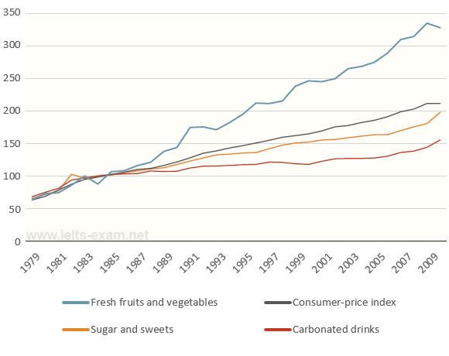

Data are from the Bureau of Labor Statistics and represent the U.S. city averages for all urban consumers in January of each year.

**Model answer**

The graph shows changes in the price of fresh fruits and vegetables, sugar and sweets, and carbonated drinks over a thirty-year period in the US between 1979 and 2009. The graph also shows the general trend in the consumer price index during this time.

While the consumer price index showed a slow and steady increase from 1979 to 2009, the same cannot be said for the price of carbonated, or soft drinks. After rising briefly between 1979 and 1981, they remained fairly constant until 1999, when the price did begin to increase slowly.

In contrast, there was a marked difference in the price of fresh fruits and vegetables, which, despite periodic fluctuations, rose steadily (dramatically) throughout this period. In fact, fresh food prices only levelled out temporarily between 1990 and 1992 and again from 2000 to 2001. However, by 2008 the price had increased by more than 300%. (147 words) 7

***The chart below gives information about science qualifications held by people in two countries.*  
Summarise the information by selecting and reporting the main features, and make comparisons where relevant.**

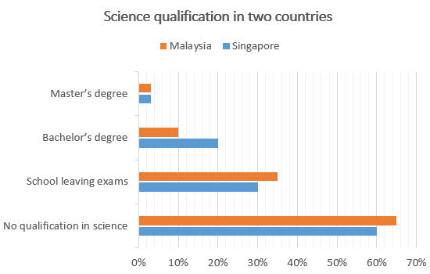

### Model answer

The bar chart illustrates the percentage of people who hold a science qualification in Singapore and Malaysia. A prominent feature is that a significantly low percentage of people hold science qualifications, that is Master’s and Bachelor’s degrees in science from university level studies in both countries. Less than 5% of people hold a qualification in science at Master’s degree level in both Singapore and Malaysia.

There is a significant difference in the percentage of people holding science qualifications at Bachelor level between the two countries; while this number is 20% in Singapore, in Malaysia it is a mere 10%. The percentage of people with school leaving exams in science is slightly higher in Malaysia than in Singapore. 35% of people in Malaysia have a science qualification at this level, whereas the number in Singapore is 5% lower. Finally, more than half the people in both countries hold no science qualification at all. (152 words) 8

***The table below shows the number of students living in the UK gaining English language teacher training qualifications in 2007/8 and 2008/9, and the proportion of male qualifiers.***Summarise the information by selecting and reporting the main features, and make comparisons where relevant.

|  |  |  |  |  |  |
| --- | --- | --- | --- | --- | --- |
| **Qualifications for English Language Teachers obtained 2007/8 and 2008/9, UK** | | | | | |
|  | | | | | |
|  | | Total | Female | Male | % Male |
| 2007/8 | Total | **32,930** | **23,842** | **8,165** | **24.7%** |
|  | TEFL | **25,446** | **18,460** | **6,870** | **26.9%** |
|  | Cambridge UCLES CELTA & other degrees | **7,484** | **5,382** | **1,295** | **17.3%** |
|  | | | | | |
| 2008/9 | Total | **32,945** | **24,324** | **7,511** | **22.7%** |
|  | TEFL | **24,917** | **18,446** | **6,545** | **26.2%** |
|  | Cambridge UCLES CELTA & other degrees | **8,028** | **5,878** | **966** | **12.1%** |

**Model answer**

This report summarises information on the total number of students in the United Kingdom who gained qualifications for English Language Teachers in two academic years, 2007/8 and 2008/9, with specific focus on the number of male qualifiers.

In both years, the total numbers of students remained the same, but there was a great difference between the numbers of male and female students who qualified. In 2007/8, out of a total of 32,930 students, only 24.7% were male. The percentage of males who qualified in 2008/9 was even lower. Out of a total of 32,945 students, only 22.7% of them were male. This is a drop of 2%.

There was also a large difference in the qualifications that students studied for. Most students qualified with a TEFL certificate; this was true for male students. The number of students who qualified with the TEFL was roughly three times the number who qualified with a Cambridge UCLES CELTA or other degrees, although the total number of students qualifying with the TEFL dropped slightly, from 25,446 in 2007/8 to 24,917 a year later. There was a drop of 0.7% in the number of male students who gained this qualification.

In general it can be seen that the number of males qualifying as English language teachers is vastly outnumbered by females and that the proportion of male qualifiers is gradually dropping. (226 words) 9

***The pie charts below show the average household expenditures in Japan and Malaysia in the year 2010.***Summarise the information by selecting and reporting the main features, and make comparisons where relevant.

**Average Household Expenditures by Major Category**  
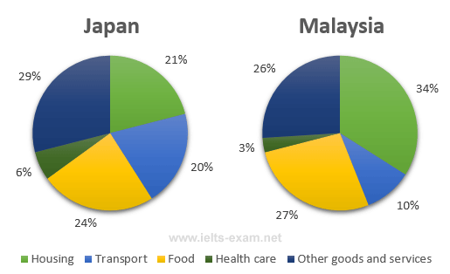

**Model answer**

The pie charts show the proportion of money spent on various household expenses in Malaysia and Japan in 2010.

We can see that in Malaysia the greatest proportion of expenditure (34%) was on housing, while in Japan housing accounted for just 21% of the total. In contrast, in Japan the greatest single expense was other goods and services at 29%, compared with 26% in Malaysia. Food came in second place in Japan, at 24%, while in Malaysia the actual proportion was higher (27%). In Japan another major expense was transport, at 20%, but this was much lower In Malaysia (10%). In both countries the smallest percentage of expenditure was on health care.

Overall, the data indicates that in both cases food, housing and other goods and services were the main expenses, but that in Japan, transport and other goods and services took up a higher proportion of total expenditure than in Malaysia. (152 words) 10

***The bar chart below shows the percentage of students who passed their high school competency exams, by subject and gender, during the period 2010-2011.*  
Summarise the information by selecting and reporting the main features, and make comparisons where relevant.**

**Students passing high school competency exams, by subject and gender, 2010-2011**  
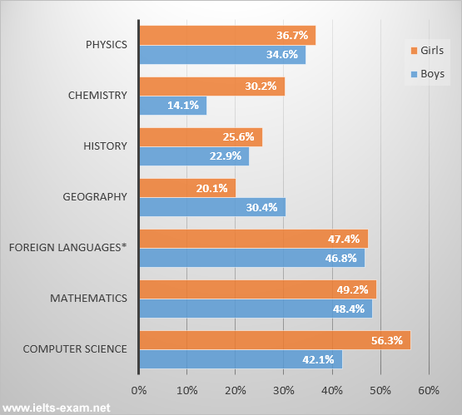

### Model answer

The graph shows the percentages of boys and girls who were successful in their high school competency exams in the period from 2010 to 2011, by subject.

Overall, students of both sexes did/performed best in Computer Science, Mathematics, and Foreign Languages, including French, German and Spanish. Results for boys and girls were roughly comparable/equivalent/equal/the same in Computer Science and Mathematics. In other subjects, however, there were some significant differences.

Girls achieved by far their best results in Computer Science, with a pass rate of 56.3%, which was considerably/much/around 14% higher than the boys. The difference was even greater/more marked in Chemistry, where over/more than 16% more girls passed. The (only/one/single) subject where boys’ results were better than girls was Geography where they achieved a pass rate of 30.4%, which was 10% higher than that/the figure/the percentage/the pass rate/the result for girls.

In general, we can (say/see)/the statistics show that during the period in question girls performed better in most subjects in the competency exams than boys. 11

***The table below shows the worldwide market share of the notebook computer market for manufacturers in the years 2006 and 2007.***Summarise the information by selecting and reporting the main features, and make comparisons where relevant.

|  |  |  |
| --- | --- | --- |
| **Company** | **2006 % Market Share** | **2007 % Market Share** |
| HP | 31.4 | 34 |
| Dell | 16.6 | 20.2 |
| Acer | 11.6 | 10.7 |
| Toshiba | 6.2 | 7.3 |
| Lenovo | 6.6 | 6.2 |
| Fujitsu-Siemens | 4.8 | 2.3 |
| Others | 22.8 | 19.3 |
| Total | 100 | 100 |

The table gives information on the market share of notebook computer manufacturers for two consecutive years, 2006 and 2007.

In both years, HP was clearly the market leader, selling 31.4% of all notebook computers in 2006, and slightly more (34%) in 2007. This is a greater market share than its two closest competitors, Dell and Acer, added together.

Dell increased its market share from 16.6% in 2006 to 20.2% in 2007. In contrast, Acer saw its share of the market decline slightly from 11.6% to 10.7%.

The other companies listed each had a much smaller share of the market. Toshiba’s share increased from 6.2% in 2006 to 7.3% in 2007, whereas Lenovo’s decreased slightly from 6.6% to 6.2%. Fujitsu-Siemens’ share more than halved from 2006 to 2007: from 4.8% of the market to only 2.3%.

Other notebook computer manufacturers accounted for 22.8% of the market in 2006 – more than all the companies mentioned except HP. However, in 2007 the other companies only made 19.3% of notebook computer sales – less than both HP and Dell. (174 words) (122) 12

You should spend about 20 minutes on this task.

**The graph below shows the number of books read by men and women at Burnaby Public Library from 2011 to 2014.  
  
Summarise the information by selecting and reporting the main features, and make comparisons where relevant.**

Write at least 150 words.

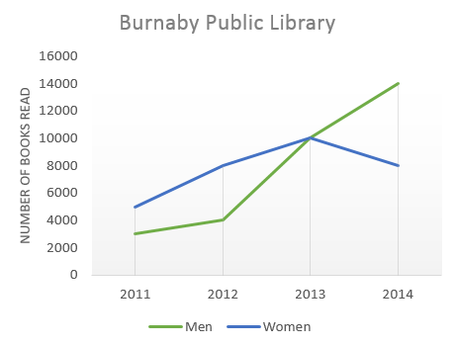

### Model answer

The graph gives information about Burnaby Public Library between 2011 and 2014. It shows how many library books people read over this four-year period.

As can be seen from the graph, there were different trends for men and women. The number of books read by men increased steadily between 2011 and 2012, from about 3000 to 4000. After that, the number rose dramatically to 14000 books in 2014. This was the highest figure in the period.

Women started off reading more books than men, but their numbers followed a different pattern. Between 2011 and 2012, there was an increase of 3000 from 5000 books to 8000 books, and then a gradual rise to 10000 books in 2013. However, in 2014, their numbers fell back to 8000 again.

Overall, there was a strong upward trend in the number of books read by men. Although women read more books than men in 2011, their reading fell to below the level of men in 2014. 13

(162 words)

You should spend about 20 minutes on this task.

**The diagrams below show the changes that have taken place at Queen Mary Hospital since its construction in 1960.  
  
Summarise the information by selecting and reporting the main features, and make comparisons where relevant.**

Write at least 150 words.

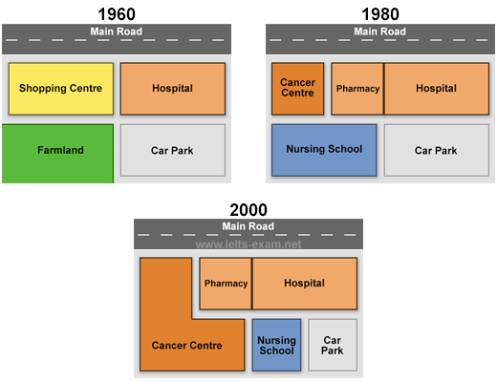

### Model answer

The diagrams show Queen Mary Hospital at three different stages in its development: 1960, 1980 and 2000.

In 1960, the hospital was built close to a main road and next to a shopping centre. A large area behind the hospital was turned into a car park, while the area behind the shopping centre was farmland.

By 1980, the shopping centre had been demolished in order to make way for two additional hospital building which became a pharmacy and a cancer centre. Furthermore, the hospital gained the farmland and converted it into a nursing school.

In 2000, the main hospital building remained unchanged but the cancer centre was extended to cover the entire nursing school. As a result of this, the original car park was divided into two so that it provided a smaller car park and a small nursing school.

During this period, the hospital has increased in size and, in addition to a new nursing school, a cancer centre has been created and extended. Hence the capacity of the car park has been reduced by a half.

(178 words) 14

You should spend about 20 minutes on this task.

**The line graph below shows the percentage of tourists to England who visited four different attractions in Brighton.**  
 **Summarise the information by selecting and reporting the main features, and make comparisons where relevant.**

Write at least 150 words.

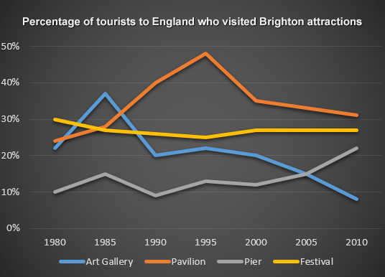

### Model answer

The line graph shows the percentage of tourists to England who visited certain Brighton attractions between 1980 and 2010. We can see that in 1980 and in 2010 the favourite attractions were the pavilion and the festival. In 1980 the least popular attraction was the pier but in 2010 this changed and the art gallery was the least popular.

During the 1980s and 1990s there was a sharp increase in visitors to the pavilion from 28% to 48% and then the percentage gradually went down to 31% in 2010. The trend for the art gallery was similar to the pavilion. Visitors increased rapidly from 22% to 37% from 1980 to 1985 then gradually decreased to less than 10% over the next twenty-five years. The number of tourists who visited the Brighton Festival fluctuated slightly but in general remained steady at about 25%. Visitors to the pier also fluctuated from 1980 to 2000 then rose significantly from 12% to 22% between 2000 and 2010. 15

(163 words)

You should spend about 20 minutes on this task.

**The diagram below shows the production of electricity using a system called Ocean Thermal Energy Conversion (OTEC).**Write a report for a university lecturer describing the information below.

Write at least 150 words.

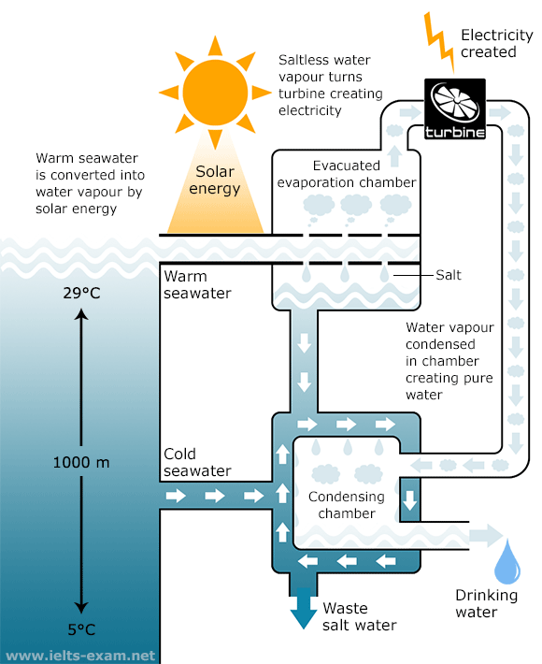  
  
**How Ocean Thermal Energy Conversion (OTEC) works**  
Source: Daily Telegraph - 8th Jan 2008

**Model answer**

Ocean thermal energy conversion (OTEC) is a system that converts heat energy into the electric power using the temperature difference between surface seawater, which can be up to 29 degrees Celsius, and deep seawater, which is only 5 degrees Celsius.

The main components of the system are an evacuated evaporation chamber, a turbine and a condensing chamber. The solar energy of the sun heats up the surface water and this warm water is introduced into the evacuated evaporation chamber, where it boils. As it boils, salt is deposited and water vapour is generated. This vapour then drives a turbine to generate electricity. After it powers the turbine, the water vapour enters the condensing chamber, which is cooled by the water from the depths of the ocean. The water vapour is condensed in this chamber, producing drinking water. Meanwhile, waste salt water is discharged into the ocean and the process can be repeated. 16

(152 words)

You should spend about 20 minutes on this task.

**The two pie charts below show some employment patterns in Great Britain in 1992.  
  
Summarise the information by selecting and reporting the main features, and make comparisons where relevant.**

Write at least 150 words.

**Employees and self-employed: by sex and occupation, 1992  
  
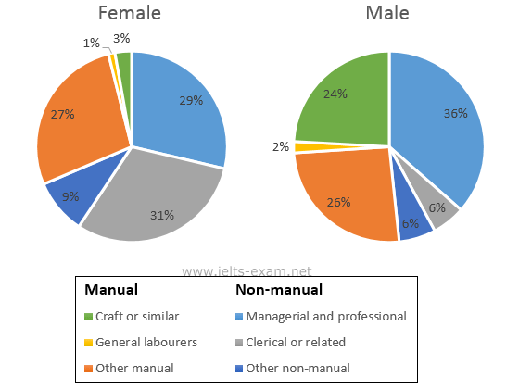**

**Model answer**

The charts provide information on the proportion of males and females in employment in 6 broad categories, divided into manual and non-manual occupations. In general, a greater percentage of women work in non-manual occupations than work in manual occupations, and the reverse is true for men.

In the non-manual occupations, while a greater percentage of working women than men are found in clerical-type positions, there is a smaller percentage of women than men employed in managerial and professional positions. The percentage of women employed in other non-manual occupations is slightly larger than the percentage of men in these occupations.

In manual employment, the biggest difference between the two sexes is in the employment of craft workers, where males make up 24% of the workforce and females just 3%. Furthermore, the percentage of women working as general working as general labourers is very small, only 1%. There is not a great deal of difference between the percentage of men doing other forms of manual work (26%) and women in other manual work (27%).

In summary, the two charts clearly show that women do not have the same access as men to certain types of employment. **17**

(194 words)

## Improve your English writing skills

Make sure you know how to use per cent and percentage.

* per cent comes after a number.
* percentage comes after words like the, a, this, that, etc. and is often preceded by an adjective, e.g. A high percentage of customers…
* Both go with the preposition of.

When writing numbers or percentages, use words up to the number ten, e.g. eight per cent, and then figures, e.g. 12 percent. However, always write a number at the beginning of a sentence in words, e.g. Twelve per cent…

You should spend about 20 minutes on this task.

**The Table below shows the results of a survey that asked 6800 Scottish adults (aged 16 years and over) whether they had taken part in different cultural activities in the past 12 months.  
  
Summarise the information by selecting and reporting the main features, and make comparisons where relevant.**

Write at least 150 words.

|  |  |  |  |  |
| --- | --- | --- | --- | --- |
| **Participation in cultural activities, by age** | | | | |
|  | | | | |
|  | *16-24* | *25-44* | *45-74* | *All aged 16 and over* |
|  | % | % | % | % |
| Any performance* | **35** | **22** | **17** | **22** |
| Undertaking any crafts | **11** | **17** | **22** | **19** |
| Cultural purchases | **11** | **17** | **18** | **16** |
| Any visual arts | **30** | **16** | **11** | **15** |
| Any writing | **17** | **6** | **5** | **7** |
| Computer based | **10** | **9** | **5** | **6** |
| * Dancing, singing, playing musical instruments and acting | | | | |

## IELTS Tip

* Begin with an [**introductory statement**](http://www.ielts-exam.net/ielts-preparation-tips/IELTS-Writing-Introduction.html), e.g. The table/graph shows…
* Don’t try to describe every detail. Look for **significant features**, e.g. the biggest change, the overall trend, etc.
* Don’t speculate about reasons for trends. **Stick to the facts**.
* End with a **comment on general trends**, e.g. From this evidence we can conclude that…

### Model answer

The table shows details of participation in a variety of cultural activities over a year, according to the age of the participants.

Overall, any performance, which includes dancing, singing, playing musical instruments and acting, had the highest level of participation, with 22% of respondents participating in the previous 12 months. By contrast, computer based activities had the lowest level of participation (6 per cent).

People aged between 45 and 74 years old were most likely to undertake any activity to do with crafts (22 per cent), while performances were more likely to be participated in by those aged 16 to 24 (35 per cent). The differences between age groups were particularly marked in the case of visual arts and writing categories, where participation rates were around three times higher for younger people than for the older ones. It is clear from the evidence that age plays a significant role in the popularity of the cultural activities listed. **18**

(157 words)

## Writing Exam Tip

You do not have to write very long sentences to do well in your Writing test. If sentences are too long, they will become less coherent and also make it harder for you to control the grammar.

You should spend about 20 minutes on this task.

**The chart below shows the number of travellers using three major airports in New York City between 1995 and 2000.  
  
Summarise the information by selecting and reporting the main features, and make comparisons where relevant.**

Write at least 150 words.

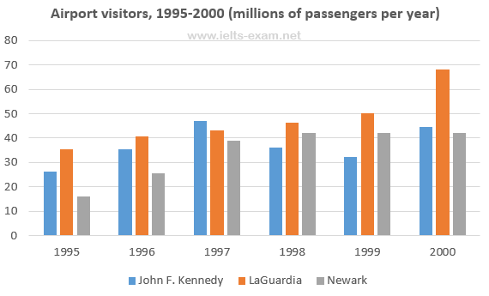

### Model answer

The bar chart gives information about how many people visited New York City through three major airports, over a six-year period between 1995 and 2000.

Overall, it can be seen that over the period, there was a fluctuant trend in the number of passengers who travelled via John F. Kennedy airport, while the other two airports saw an upward trend. Another interesting point is that LaGuardia airport was the most popular at the end.

Looking at the detail, the number of travellers at John F. Kennedy airport started at 26m in 1995, and then increased remarkably to reach the highest point of 47m in 1997. In 1999, the figure dipped to 32m. At the last year, there was a slight growth to 44m. On the other hand, LaGuardia began at 35m in 1995, after that it rose remarkably for the next three years, at 46m. In 2000, LaGuardia hit the peak point at 68m travellers.

However, if we look at Newark airport, it started at the lowest point of 16m passengers in the first year. After this point, the trend increased significantly to 42m in 1998. In the last two years it remained stable at 42m travellers. **19**

(197 words)

You should spend about 20 minutes on this task.

**The line graph below shows the changes in the share price of Outokumpu companies in euros between January 2006 and December 2010.  
  
Write a report for a university lecturer describing the information below.**

Write at least 150 words.

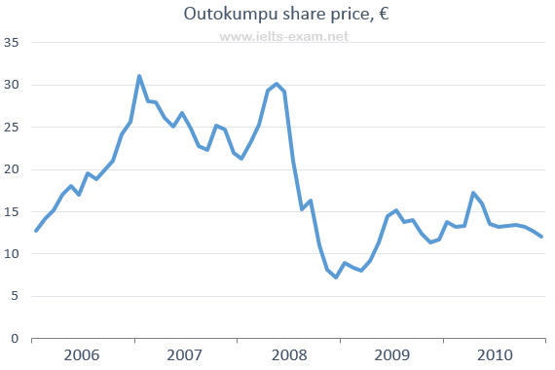  
Source: NASDAQ OMX Helsinki

## Test Tip

Work out how much space 150 of your words take on a page. This can save you having to count. Make sure your handwriting is neat and legible.

### Model answer

The graph shows the changes and a decline overall in the share price of Outokumpu in a five-year period from January 2006 through December 2010.

At the beginning of this period the share price was at EUR 13 per share. There were several fluctuations until late 2006 when there was a sudden increase from EUR 21 to EUR 31. This higher price did not last long, however, and it fell before rising strongly again in 2008. From mid-2008 there was a sharp downward trend through the end of the year when it fell to the lowest point in this period at just over EUR 7 per share. After that the share price recovered and, despite some fluctuations, continued to rise until it reached a peak of EUR 17 in early 2010. Until late 2010 the trend was downward again, ending the year at just over EUR 12.

Outokumpu made significant gains and losses during this period but overall lost around EUR 1 per share.

(164 words) **20**

## Writing Exam Tip

When describing visual information in Task 1, it is important to think about what tenses you will need. If the diagram includes time references (dates, years) you will need a range of [past](http://www.ielts-exam.net/grammar/735/) and [present](http://www.ielts-exam.net/grammar/730/) tenses. If the graph has no past time reference, you will need to use the present simple tense only.

You should spend about 20 minutes on this task.

**The graph below shows female unemployment rates in each country of the United Kingdom in 2013 and 2014.  
  
Summarise the information by selecting and reporting the main features, and make comparisons where relevant.**

Write at least 150 words.

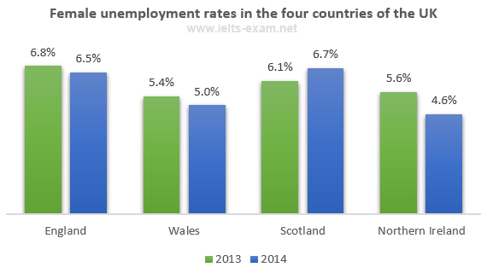

### Model answer

The bar chart shows the unemployment rates among women in the countries that make up the United Kingdom, both in 2013 and in 2014. There has generally been a small decrease in female unemployment rates from 2013 to 2014, except in Scotland.

In 2013, 5.6% of women in Northern Ireland were unemployed. The only country with a smaller percentage of women unemployed was Wales, with a rate of 5.4%. Both countries saw a decrease in the percentage of unemployed women in 2014. In Northern Ireland, the percentage fell to 4.6% and in Wales it fell to 5%.

England had the greatest percentage of unemployed women in 2013, with 6.8%. However, this decreased by 0.3% in 2014. Lastly, Scotland was the only country which had an increasing percentage of unemployed women. In 2013, it had 6.1% of women out of work. This increased to 6.7% in 2014, making it the country with the highest female unemployment rate of the four countries. **2**

(160 words)

## IELTS Tip

• Write a brief introduction in your own words using information from the question and the headings in the graph.  
• Divide the main body of your report into two or three paragraphs describing the key information in the graph. The first paragraph should list your main points. Secondary points and observations regarding surprising or interesting information should follow in subsequent paragraphs.  
• In the exam, you might be asked to describe two graphs. If this is the case, you need to compare and contrast the information and make connections between the two.

You should spend about 20 minutes on this task.

**The two pie charts below show the online shopping sales for retail sectors in Canada in 2005 and 2010.  
  
Summarise the information by selecting and reporting the main features, and make comparisons where relevant.**

Write at least 150 words.

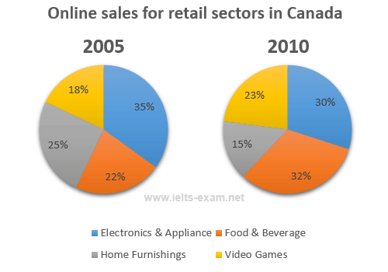

### Model answer

The two pie charts compare the percentages of online sales across different retail sectors in Canada in the years 2005 and 2010. For three of the sectors, it is evident that over this time frame there was significant change in their proportion of online transactions.

At 35% we can see that electronics and appliance sector accounted for the majority of online sales in 2005, but this percentage had dropped to 30% by 2010. During the same five-year period, as an increasing number of people chose to purchase food and beverage online, we can see that transactions went from just 22% to 32%, making it the retail sector with the largest overall proportion of the online market.  
  
In 2005, the home furnishing industry boasted an impressive 25% of the total online sales in Canada. However, by 2010, the figure had fallen considerably to 15%. Interestingly, online sales of video games eventually overtook sales of home furnishings, although video games still represented only 23% of the market. **3**

(165 words)

You should spend about 20 minutes on this task.

**The table below shows the cinema viewing figures for films by country, in millions.**

Summarise the information by selecting and reporting the main features, and make comparisons where relevant.

Write at least 150 words.

**Cinema viewing figures for films by country, in millions**

|  |  |  |  |  |  |
| --- | --- | --- | --- | --- | --- |
|  | **Action** | **Romance** | **Comedy** | **Horror** | **Totals** |
| **Indian**  **Ireland**  **New Zealand**  **Japan** | **8**  **7.6**  **7.2**  **7.1** | **7.5**  **3.8**  **4.5**  **4.5** | **6.5**  **5.5**  **3.9**  **4** | **2.5**  **6.4**  **4.7**  **2.2** | **24.5**  **23.3**  **20.3**  **17.8** |
| **Total** | **29.9** | **20.3** | **19.9** | **15.8** |  |

**Test Tip**

The word *respectively* is useful in Task 1 for placing data in the order that you write about it.

*Romance and comedy are the next popular genres, with the total number of 20.3 million viewers and 19.9 viewers* ***respectively.***

**Model answer**

The table compares four countries in terms of the number of people who watch four different genres of film at the cinema, including Action, Romance, Comedy and Horror.

The table indicates that more Indian people watch films at the cinema than the other three nationalities. In all four countries, Action is the most popular type of film. The total number of viewers for action films is nearly 30 million and in each country about 7-8 million people watch them.

Not many people like watching horror films at the cinema compared to the other genres of film. In India and Japan only 2-2.5 million people watch horror films but they are more popular in New Zealand and Ireland. On the other hand, romance films are very popular in India with 7.5 million views but it is not as popular in the other countries. New Zealand and Japan come next with 4.5 million viewers each.

(152 words) **4**

You should spend about 20 minutes on this task.

**The three pie charts below show the changes in annual spending by local authorities in Someland in 1980, 1990 and 2000.  
  
Summarise the information by selecting and reporting the main features, and make comparisons where relevant.**

Write at least 150 words.

**Expenditure by local authorities in Someland  
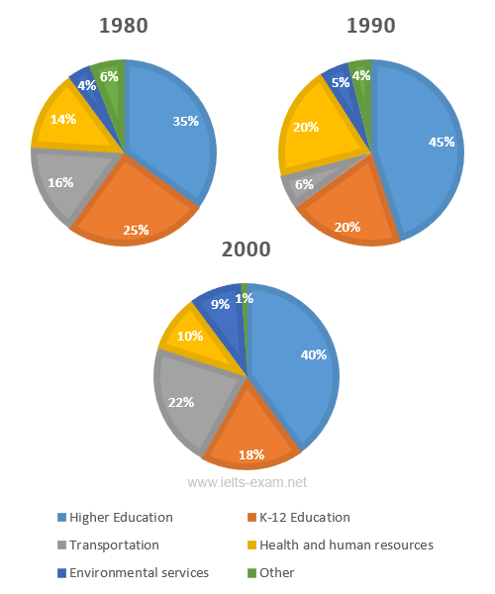**

### Model answer

The charts show how much local authorities spent on a range of services in Someland in three separate years: 1980, 1990 and 2000.

In all three years, the greatest expenditure was on education. But while K-12 education saw a fall from 25% in 1980 to only 18% of spending in 2000, higher education remained the largest proportion, reaching 45% of total spending in 1990 and ending at 40% in 2000.

Expenditure on health and human resources had increased to 20% by 1990 before decreasing to only 10% by the end of the period. In contrast, the share of transportation saw an opposite trend. This cost decreased to only 6% of total expenditure in 1990 but rose dramatically in 2000 when it represented 22% of the total budget. Similarly, the cost of environmental services experienced a period of growing from only 4% to 9% by 2000.

Overall, higher education constituted the largest cost to local authorities, and while spending increased for transportation and environmental services, there were corresponding drops in expenditure on health and human resources and K-12 education. **5**

(178 words) 110

## IELTS Tip

You will lose marks if you make grammatical errors in your writing, particularly when errors are frequent and effect meaning. Be careful of the following common mistakes when describing numbers.  
  
amount and number: amount is used with uncountable nouns; number is used with countable nouns, e.g. The ***amount of meat*** consumed in China between 1985 and 2010. **NOT** .  
  
per cent and percentage: per cent is always used with a number; percentage is used on its own without a number, e.g. The ***percentage of*** male teachers in the UK. **NOT** . According to the graph, ***four per cent*** of the total household budget went towards transportation. **NOT** .

You should spend about 20 minutes on this task.

**The graph below shows the amount of money spent on books in Germany, France, Italy and Austria between 1995 and 2005.  
Write a report for a university lecturer describing the information below.**

Write at least 150 words.

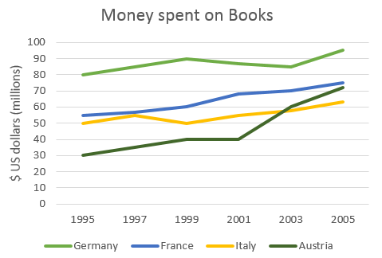

The line graph compares the amount of money spent on buying books in Germany, France, Italy and Austria over a period of ten years between 1995 and 2005.  
  
In 1995 Austria spent the least amount of money on books, while Italy and France spent about as much as each other. However, by 2001, the gap in spending between these two countries had widened and considerably more money was spent in France than In Italy.  
  
As can be seen from the graph, the amount of money spent increased in all four countries but rose the most dramatically in Austria. The period between 2000 and 2005 saw a sharp growth and in 2005 the Austrians spent three times as much money as they did in 1995.  
  
However, during this ten-year period, Germany remained the biggest spenders on book, with all three other countries spending much less on them. **6**

You should spend about 20 minutes on this task.

**The graph below shows the population change between 1940 and 2000 in three different counties in the U.S. state of Oregon.  
  
Summarise the information by selecting and reporting the main features, and make comparisons where relevant.**

Write at least 150 words.

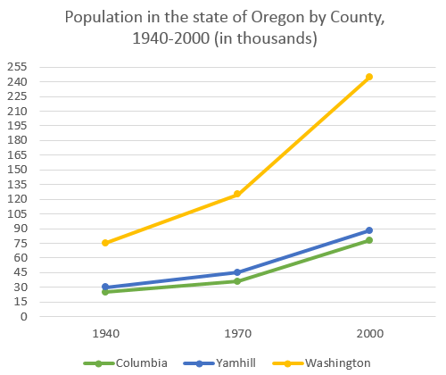

## IELTS Tip

The structure of your answer would look like this:

**Introduction** - [Explain](javascript:void(0)) briefly in your own words what the information shows. Give more detail than the question and make [comparisons](javascript:void(0)) where appropriate.

**Main Body** - Decide how to organise your paragraphs. For example, in the model answer below, [paragraph 2](javascript:void(0)) is about 1940-1970, [paragraph 3](javascript:void(0)) is about 1970-2000 for Columbia and Yamhill, and [paragraph 4](javascript:void(0)) is about 1970-2000 for Washington. Use words such as [although](javascript:void(0)) and [however](javascript:void(0)) to make contrasts, and words such as [likewise](javascript:void(0)) to introduce similarities. Always include the actual data you have been given. The [final paragraph](javascript:void(0)) is not a conclusion in this type of task.

### Model answer

The graph shows the increase in population of three counties, Columbia, Yamhill and Washington in the U.S. state of Oregon, between 1940 and 2000. In 1940, Columbia had the lowest population of the three counties, at around 25,000. This compared with about 30,000 in Yamhill and approximately 75,000 in Washington.

By 1970, Columbia’s population had risen to just under 36,000. Although this appears on the graph to be a gentle increase, it is in fact an increase of approximately 50%. Yamhill’s population also rose by nearly 50% between 1940 and 1970: from 30,000 to just under 45,000. However, the greatest real increase was in Washington, where the population in 1970 had increased by approximately 75,000, to 125,000.

The years 1970 to 2000 saw the populations of Columbia and Yamhill increase by approximately the same amounts that they had increased by the thirty years before. In 2000, Columbia’s population – at approximately 76,000 – was triple what it had been in 1940. Likewise, Yamhill’s population, at around 90,000, was almost triple what it was in 1940.

Although Washington’s increase in population between 1940 and 1970 was large, its increase in the following thirty years was even sharper, rising from about 125,000 in 1970 to more than 240,000 in 2000. (206 words) **7**

# IELTS Writing Task 1 #107

You should spend about 20 minutes on this task.

**The graph below shows the changes in food consumption by Chinese people between 1985 and 2010.  
  
Summarise the information by selecting and reporting the main features, and make comparisons where relevant.**

Write at least 150 words.

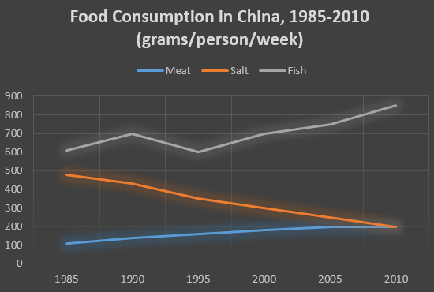

## Writing Tip

It is best to use **amount** and **quantity** for uncountable nouns, although both are used for countable nouns as well, particularly **quantity**.  
  
The **amount** of consumption decreased in the last 25 years.

**Put the sentences in the correct order to describe the graph.**

**1)** The graph shows changes in the amount of fish, salt and meat eaten per person per week in China between 1985 and 2010.  
**3)** In 1985, the consumption of fish stood at 610 grams, then increased to 700 grams in 1990.   
**6)** The amount consumed decreased steadily from almost 500 grams per person to only 200 grams by 2010.  
**8)** However, this gradually increased throughout the period.  
**10)** Overall, the consumption of fish rose, while the consumption of salt fell.  
**7)** The amount of meat consumed weekly started at about 100 grams.  
**2)** From the graph we can see that people in China consumed more fish than either meat or salt throughout the period.  
**9)** By 2010 it was at the same level as the consumption of salt.  
**5)** In contrast, there was a consistent drop in salt consumption.  
**4)** Although it dipped in 1995, it then rose steadily and reached 850 grams in 2010.  
**11)** In addition, the consumption of meat, while at a relatively low level, rose significantly during this period.



**Answer**  
The graph shows changes in the amount of fish, salt and meat eaten per person per week in China between 1985 and 2010.  
  
From the graph we can see that people in China consumed more fish than either meat or salt throughout the period. In 1985, the consumption of fish stood at 610 grams, then increased to 700 grams in 1990. Although it dipped in 1995, it then rose steadily and reached 850 grams in 2010.  
  
In contrast, there was a consistent drop in salt consumption. The amount consumed decreased steadily from almost 500 grams per person to only 200 grams by 2010. The amount of meat consumed weekly started at about 100 grams. However, this gradually increased throughout the period. By 2010 it was at the same level as the consumption of salt.  
  
Overall, the consumption of fish rose, while the consumption of salt fell. In addition, the consumption of meat, while at a relatively low level, rose significantly during this period. **8**

# IELTS Writing Task 1 #106

## Vocabulary Tip

Notice the following rules for the spelling of the words programme and program:  
programme (UK only) = a show on television  
program (US only) = a show on television  
program (UK and US) = instructions for a computer (a verb and a noun)

You should spend about 20 minutes on this task.

**The charts give information about two genres of TV programmes watched by men and women and four different age groups in Australia.  
  
Summarise the information by selecting and reporting the main features, and make comparisons where relevant.**

Write at least 150 words.

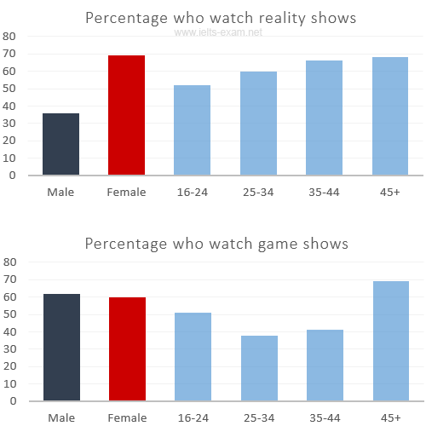

## IELTS Tip

* With [graphs](http://www.ielts-exam.net/IELTS-Writing-Samples/Line-Graph.html), make sure you understand what each axis is measuring.
* With [bar](http://www.ielts-exam.net/IELTS-Writing-Samples/Bar-Chart.html) and [pie](http://www.ielts-exam.net/IELTS-Writing-Samples/Pie-Chart.html) charts, there is often a key which tells you what each different bar or area represents.
* With tables, read the data across the rows and down the columns to identify the key features.

The charts give information about the genres of TV programmes that Australian men and women and different age groups watch. It is clear from the charts that women tend to watch **more** television than man overall, although they watch slightly **fewer** game shows. The people who watch the **most** television are in the 45+ age group.  
  
Nearly 70% of women watch reality shows, which is almost **twice** as many as the percentage of men who choose this genre of programme. Nevertheless, most age groups watch **more** reality shows than game shows revealing that game shows are generally **less** popular than reality shows.  
  
The percentage of people watching reality shows increases steadily from ages 16 to 45 with the **lowest / smallest** percentage of viewers, at just over 50% of the age group 16-24 and the **highest / biggest / largest / greatest** percentage, at 68% of the over-45s.  
  
However, the pattern is different for game shows. The number of programmes watched by 25- to 44-year-olds is **significantly / considerably** lower than the number watched by 16- to 24-year-olds and those over 45. Just over 50% of 16- to 24-year-olds watch game shows, but this share is not **as** high as the share of people aged 45 and over watching game shows, at nearly 70%. Only 41% of 35- to 44-year-olds watch game shows, and the share of 24- to 34-year-olds is **slightly / even** lower at 38%. **9**

# IELTS Writing Task 1 #105

## IELTS Tip

The majority of Task 1 questions in the IELTS exam are either a graph with trends or a graph with comparatives. However, there are two other possible types of questions:

* Describing a process (for example, how to produce chocolate)
* Describing a map (often of a city in two time periods)

You should spend about 20 minutes on this task.

**The map below is of the town of Canterbury. A new school (S) is planned for the area. The map shows two possible sites for the school.  
  
Summarise the information by selecting and reporting the main features, and make comparisons where relevant.**

Write at least 150 words.

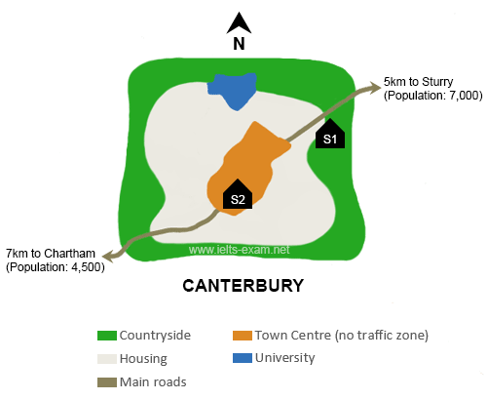

### Model answer

The map shows two proposed sites for a new school for the town of Canterbury and the surrounding area.  
  
The first site (S1) is situated in the countryside, to the north-east of the town centre. It is just outside the main housing area of the town and not far from the main road that links Sturry with Canterbury. It would therefore probably be in an ideal location for students coming from Sturry, which is only 5 kilometres away, and those who live on the east side of Canterbury. If there are students coming from Chartham, which is 7 kilometres to the south-west, they would be able to reach the school by taking the main road that runs south-west of Canterbury.

The second site (S2) is located in the town centre itself. There are advantages of this: it makes it practically equidistant for students coming from either Sturry or Chartham. Moreover, it would presumably be relatively easy for students who live in the housing area around the town centre to reach the school. However, because of the no traffic zone in the town centre, no parent would be able to drive their child all the way to school. This may make travel arrangements difficult for some parents.

(206 words) **10**

## Writing Tip

It is important to use paragraphs in your Writing Task 1 answer. Paragraphs show that your answer is well organised.

# IELTS Writing Task 1 #104

You should spend about 20 minutes on this task.

**The bar chart below shows shares of expenditures for five major categories in the United States, Canada, the United Kingdom, and Japan in the year 2009.  
  
Write a report for a university lecturer describing the information below.**

Write at least 150 words.

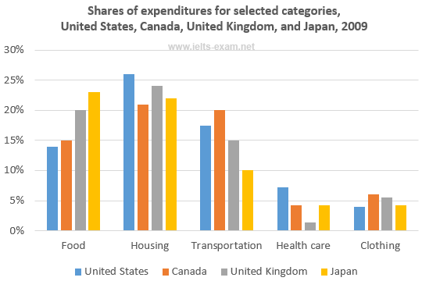  
Source: U.S. Bureau of Labor Statistics

## Test Tip

In Writing Task 1, it is a good idea to end your answer by summarizing the main information shown by the diagram. You are not required to explain this information.

The bar chart compares how consumers in the United States, Canada, the United Kingdom, and Japan allocated different shares of total spending to categories such as food, housing, and transportation in 2009.  
  
We can see that the United States had the highest **housing** expenditure share, 26% of total expenditures in 2009. The United Kingdom and Japan followed, with 24% and 22%, respectively. Canada had the lowest housing share at 21%. Housing was the largest expenditure component in all countries except Japan.  
  
By contrast, Canada had the largest **transportation** share of all four countries at 20%. The United States and the United Kingdom had the next-highest transportation shares, 17% and 15%, respectively. Japan had the lowest, at 10%.  
  
However, in Japan, consumers spent 23% of their total expenditures on **food** in 2009. The United Kingdom had the second-highest share at 20%. Canada, with 15%, and the United States, with 14% had the lowest food expenditure shares among the countries studied.  
  
Overall, the data indicates that housing and health care shares of total expenditures were higher in the United States than in Canada, the United Kingdom, and Japan in 2009, whereas Americans had the lowest clothing share. Canada had the highest clothing and transportation shares, and Japan had the highest food share, among the countries compared. **11**

(214 words)

# IELTS Writing Task 1 #103

You should spend about 20 minutes on this task.

**The chart below shows the percentage change in the share of international students among university graduates in different Canadian provinces between 2001 and 2006.  
  
Summarise the information by selecting and reporting the main features, and make comparisons where relevant.**

Write at least 150 words.

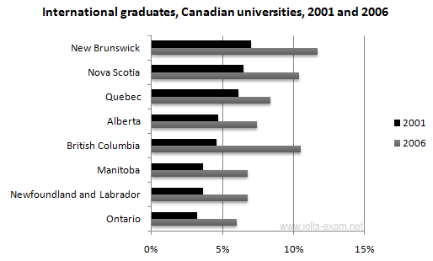  
Source: Statistics Canada, Postsecondary Student Information System

## Test Tip

In Task 1 of the IELTS Writing modules, you may be asked to describe a graph which shows changes over a period of time. To do this you need to use language expressing change and appropriate tenses. In the exam, make sure you leave time to edit your written answer. You will lose marks if you make too many mistakes in grammar and vocabulary.

### Model answer

The chart shows changes in the share of international students who graduated from universities in different Canadian provinces over a period of 5 years.  
  
In 2001, this share had a relatively narrow range, from 3% in Ontario to 7.0% in New Brunswick. Nova Scotia had the second highest proportion at 6.5%. Five years later, the figures for most provinces had risen, with the exception of Alberta. There, the figures fell by 1% to just over 4%.  
  
By 2006, some parts of Canada experienced a considerable increase in their share of international graduates. Growth in this share was especially strong in the case of New Brunswick, where the figures rose from 7% to 12%. The largest growth occurred in British Columbia, where it more than doubled to 11%.  
  
Over this five-year period, changes in the proportion of international graduates have been very uneven across the provinces of Canada. However, New Brunswick remained the province with the highest percentage overall.

(158 words)

12

# IELTS Writing Task 1 #102

You should spend about 20 minutes on this task.

**The diagrams show a structure that is used to generate electricity from wave power.  
  
Summarise the information by selecting and reporting the main features, and make comparisons where relevant.**

Write at least 150 words.

**Generating electricity from sea waves  
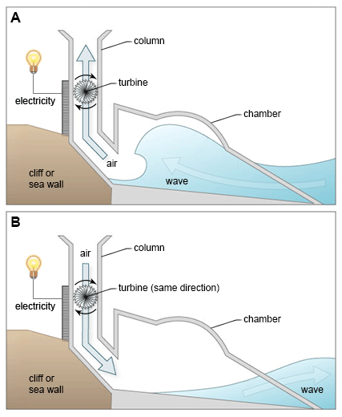**

## Test Tip

1) Describe key stages in the process in a logical order, making comparisons where appropriate.  
2) Use suitable words and phrases to structure and link the process clearly.  
3) Remember to include an overview summerising the main features of the process.  
4) Vary your vocabulary and use your own words as far as possible.

### Model answer

The two diagrams show how electricity can be generated from the rise and fall of water caused by sea waves.  
  
The process involves a structure which is mounted/installed/arranged on the side of a cliff or sea wall. This structure consists of a large chamber. One end is open to the sea, and the other leads into a vertical column, which is open to the atmosphere. A turbine is installed inside this column and this is used to generate the electricity in two phases.  
  
The first diagram indicates that when a wave approaches/withdraw/retreat the device, water is forced into the chamber, applying pressure on the air within the column. This air escapes to atmosphere through the turbine, thereby producing electricity.  
  
The second diagram illustrates the next part of the process when wave retreats. As the water level falls, the air from outside the column is sucked back in through the turbine. As a result, electricity continues to be generated. The turbine rotates only in one direction, regardless of the direction of the air flow.  
  
In conclusion, we can see that this structure is useful as electricity is generated in both phases: entering and retreating of water. (13)

(195 words)

# IELTS Writing Task 1 #101

You should spend about 20 minutes on this task.

**The chart below gives information about the UK's ageing population in 1985 and makes predictions for 2035.  
  
Summarise the information by selecting and reporting the main features, and make comparisons where relevant.**

Write at least 150 words.

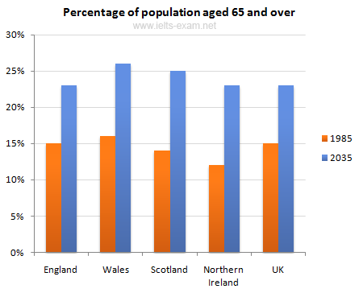  
Source: Office for National Statistics, National Records of Scotland, Northern Ireland Statistics and Research Agency

## Exam Tip

In Writing Task 1, it is essential to understand what the graph or chart is representing. Look closely at the information in the instructions as well as all details of the graph or chart.  
The graph in this task shows the percentage of over 65s in each country of the UK. The following are **incorrect** statements:

* Wales had more over 65s than England. (The graph is in percentages, not numbers)
* Northern Ireland had 12% of over 65s in 1985. (The countries do not add up to 100% so Northern Ireland did not have 12% of all over 65s. The graph shows that 12% of the population of Northern Ireland was over 65.)

### Model answer

The graph shows how the size and distribution of the UK's ageing population is likely to change over a 50-year period.  
  
Overall, the proportions are predicted to increase in all UK countries. In 1985, 15 per cent of the UK population was over 65, but by 2035, this will account for 23 per cent of the total population.  
  
A closer look at the data reveals that the ageing population is expected to rise more in some parts of the UK than in other. In 1985, Wales had the highest percentage of people aged 65 and over, at 16 per cent. The second-largest group could be found in England and the third in Scotland. Northern Ireland had lowest proportion, with 12 per cent aged 65 and over.  
  
By 2035, Wales is still going to have by far the greatest percentage of over 65s, with figures likely to reach 26 per cent. However, the biggest increases in this age group, relative to the rest of the population, are predicted to occur in Northern Ireland and Scotland. In Northern Ireland, for example, this figure will increase almost double to 23 per cent. (14)

(189 words)

# IELTS Writing Task 1 #100

You should spend about 20 minutes on this task.

**The diagrams below give information on transport and car use in Edmonton.  
  
Summarise the information by selecting and reporting the main features, and make comparisons where relevant.**

Write at least 150 words.

|  |  |  |  |  |  |  |  |  |  |  |  |
| --- | --- | --- | --- | --- | --- | --- | --- | --- | --- | --- | --- |
| ielts writing task 1 preparation | |  |  | | --- | --- | | Commute to work | 55% | | Shopping | 15% | | Leisure activities | 15% | | Taking children to school | 40% | | Business | 45% | |
| People’s reasons for using the car in city | |

## Test Tip

In IELTS Writing Task 1, when you must describe two figures, ask yourself the following:  
  
**1)** What do both figures relate to?  
**2)** What kind of relationship is evident? (a similarity, a difference, a cause and effect relationship or some other type of relationship)  
**3)** Which aspects of each figure should be highlighted?  
**4)** Should I describe the figures in separate paragraphs, or should I compare different aspects of the figures within a series of paragraph?

### Model answer

The table shows the reason why people in Edmonton use their cars in the city and the pie chart explains what type of transport people prefer to use most of the time.  
  
Looking at the pie chart first, it is clear that the car is the most popular means of transport in this city. 45% of the people say that they prefer to commute by car. The second most popular form of transport is the LRT, while busses and taxis are the main means of transport for the rest of the people.  
  
The table gives more detailed information about why people use their cars. Surprisingly, 55% of the people need to commute to work by car. Cars are also used a lot for taking children to school or business purposes. Only 15% of drivers are doing their shopping and, similarly, 15% need to travel by car for leisure.  
  
Overall, people in Edmonton make good use of alternative methods of transport but there is a heavy dependence on cars for work. (15)

(170 words)