Project Milestone 4
Project title: Early Identification of At-Risk Students Team / Author(s): Team 7 "The Null Hypothesis": Jason Badwal, Cort Auger, Saad Siddiqui, Adlene Oudahmane

1. Current Methods and Approaches

1.1 Data
Item | Details
Source(s) | "Predict Students' Dropout and Academic Success", UCI Machine Learning Repository #697 (Realinho et al., 2021). Administrative records from one Portuguese polytechnic institute, students enrolled 2008/09 to 2018/19. CC BY 4.0.
Size | 4,424 students. 169 features after cleaning and one-hot encoding (13 continuous, 9 binary, 147 one-hot). 3 classes: Dropout, Enrolled, Graduate.
Split strategy | Stratified 70/15/15 train/validation/test (3,096 / 664 / 664), seed 42, row indices saved in the repository. Split seeds 0-9 are used to measure variability.
Class balance | Graduate 49.9%, Dropout 32.1%, Enrolled 17.9%. Enrolled is the minority class and the hardest one.
Known quality issues | No NaNs or duplicate rows. Hidden missing values: 180 Course 171 students have 0 recorded first-semester units, and parent qualification/occupation have "Unknown"/blank codes. Leakage risk: the six 2nd-semester columns happen after our prediction point and give the outcome away, so we drop them.
Preprocessing and feature engineering: We strip and fix the column names, drop Nationality (it duplicates International), add a no_units_1st_sem flag for the Course 171 recording gap, group occupation codes into 10 major groups, and one-hot encode the 8 categorical columns. The continuous columns are normalized to mean 0 / std 1 using the training-set mean and standard deviation only (plus ε = 0.0001); validation and test reuse those numbers. Lab 2 undersampling, when used, is applied to the training split only. One-hot encoding runs before the split, but it only decides which columns exist and doesn't learn any statistics from the data.

1.2 Models
Stage | Model | Purpose | Key hyperparameters
Baseline | Majority class; stratified random; softmax (multinomial logistic) regression written in NumPy (M3) | Lower bound and course-level baseline | Softmax: α = 0.3, λ = 0, 5,000 full-batch gradient-descent steps, W initialised to 0
Intermediate | k-nearest neighbours (scikit-learn, Lab 3) | Non-parametric, distance-based model | k = 7, Euclidean distance (searched odd k from 1 to 55, Euclidean and cosine)
Main | Decision tree (scikit-learn, Lab 4) | Non-linear, interpretable model | Entropy criterion, max_depth = 12, min_samples_split = 32 (searched 2 criteria × 14 depths × 9 split sizes = 252 trees); 158 leaves

1.3 Training and Evaluation Setup
- Framework and tooling: Python 3.13.15 with NumPy 2.1.3, pandas 2.2.3, scikit-learn 1.6.1 (pinned in requirements.txt). Softmax regression is our own NumPy code; kNN and trees use scikit-learn. Git and GitHub for version control; every run appends to an experiment log CSV.
- Hardware: Laptop CPU, no GPU. The whole M4 comparison (308 kNN and tree fits, 10-seed refits, imbalance runs) takes about 22 seconds. Fit times: softmax 3.0 s, tree 0.02 s, kNN under 0.01 s (kNN does its work at prediction time).
- Loss function and optimiser: Softmax regression minimises average cross-entropy plus an L2 term (λ/2)‖W‖² with full-batch gradient descent at a fixed learning rate. kNN has no training loss. The tree greedily picks the split with the largest information gain.
- Regularisation: L2 (weight decay) for softmax, tuned over λ ∈ {0, 0.001, 0.01, 0.1, 1}; with λ = 0 chosen, stopping at 5,000 steps acts as early stopping. The tree is regularised with max_depth and min_samples_split; kNN with k.
- Hyperparameter search: Grid search on validation macro-F1 only. Softmax: 4 learning rates × 5 λ values (20 models, M3). kNN: 28 values of k × 2 distances (56 models). Tree: 252 models. The test set is not used.
- Evaluation metrics: Primary: macro-F1, fixed in M2 before any model was trained, because it weights all three classes equally and the classes are imbalanced. Secondary: accuracy, per-class recall (Dropout recall matters most for an early-warning tool), confusion matrices, and mean ± std over 10 split seeds.
- Reproducibility: Fixed seeds (split 42, plus 0-9 for variability; random_state 42 for every model), saved split indices, dataset SHA-256 check on every load, pinned environment, automated checks (8 tests), and one command per milestone: python -m src.run_baselines (M3) and python -m src.compare_models (M4). Repository: github.com/JasonB2004/csci3052u-ml-group-project.

2. Theoretical Justification for Chosen Methods

2.1 Choice of Model Family
Claim: kNN and a decision tree are the right next step after a linear baseline because they make very different assumptions about the decision boundary. Reasoning: softmax regression is parametric and draws linear boundaries between classes (W5 p.84-87). kNN is non-parametric and labels a student by majority vote among the k nearest training students under the Euclidean distance ‖x⁽ᵃ⁾ − x⁽ᵇ⁾‖₂ (W3 p.15), so its boundary can take any shape. A decision tree splits on one feature at a time, choosing the split with the largest information gain IG(Y|X) = H(Y) − H(Y|X), where H(Y) = −Σ p(y) log₂ p(y) (W3 p.101-108). Trees handle a mix of binary, one-hot and continuous features without any scaling, and the splits can be read off directly, which matters for an advising office. Evidence: our results test exactly this question (Section 3), and the dataset authors use tree-based models on this data (Realinho et al., 2022).

2.2 Choice of Loss Function and Optimisation
Softmax regression uses cross-entropy, L_CE = −Σₖ tₖ log yₖ, which is the negative log-likelihood of a categorical model and heavily penalises confident wrong predictions (W5 p.70, 94). The loss is convex in W, so gradient descent from W = 0 heads to the global minimum with a small enough learning rate (W5 p.79), and the update W ← W − α[(1/N)Xᵀ(Y − T) + λW] is the per-example (yₖ − tₖ)x rule plus weight decay. We picked the learning rate with the W4 p.90 grid and checked the training curve. We did not reweight the loss for imbalance in the baseline; instead we test undersampling and class weights separately (Section 3) so that the effect of each choice is visible.

2.3 Bias-Variance and Generalisation
The softmax baseline has a small train-validation gap (0.705 vs 0.661 macro-F1, a gap of 0.044), so it is closer to the high-bias end (W4 p.59), and adding L2 only made it underfit more. The tree's depth curve (Figure 1) shows the Lab 4 story: shallow trees underfit, and past depth 12 training macro-F1 keeps rising while validation flattens around 0.61. At the chosen depth the gap is 0.114 (0.748 vs 0.634), so the tree fits the training set much harder without generalising better. kNN overfits completely at k = 1 (train macro-F1 1.00, validation 0.51), and validation never gets much past 0.55 for larger k (Figure 2). With 3,096 training students and 169 mostly-sparse features, the extra flexibility of the non-linear models mainly turns into variance.

2.4 Evaluation Methodology
Accuracy is misleading here: always predicting Graduate scores 50% accuracy but only 0.222 macro-F1, because it never finds a Dropout or Enrolled student. Macro-F1 averages the three per-class F1 scores, so the small Enrolled class counts as much as Graduate. The split is stratified so every class has the same share in train, validation and test. All tuning uses the validation set, and the test set is scored once, in M5 (W3 p.51-52). Because a single split of 664 students can be lucky, every tuned model is refit on 10 other splits and compared split by split.

2.5 Alternatives Considered
Alternative | Why it was not chosen
Neural network (W5 p.108-126) | Only introduced at the end of Week 5, and with 3,096 rows and a linear model already strong it would add complexity and compute without a clear reason. Kept as optional future work.
Ensembles (bagging / random forest) | Bagging appears in Lab 4. We kept M4 to the two models our M3 plan promised and moved bagged trees to M5, where they're a natural fix for the tree's high variance.
Oversampling (e.g. SMOTE) | Mentioned by the dataset authors (Realinho et al., 2022) but not taught; Lab 2 undersampling and class weights cover the same question with course methods.

3. Preliminary Results and Findings

3.1 Quantitative Results
Model | Train macro-F1 | Validation macro-F1 (seed 42) | Validation, 10 seeds (mean ± std) | Test macro-F1 | Training time
Majority class | 0.222 | 0.222 | 0.222 ± 0.000 | held out until M5 | not timed
Stratified random | 0.329 | 0.313 | 0.343 ± 0.012 | held out until M5 | not timed
Softmax regression (baseline) | 0.705 | 0.661 | 0.667 ± 0.020 | held out until M5 | 3.0 s
kNN (k = 7) | 0.671 | 0.554 | 0.564 ± 0.023 | held out until M5 | < 0.01 s
Decision tree (depth 12) | 0.748 | 0.634 | 0.624 ± 0.018 | held out until M5 | 0.02 s
Variability and significance: the models were scored on the same 10 splits, so we compared them split by split. Softmax beats the tree on 9 of 10 splits (mean difference 0.043, std 0.027) and kNN on all 10 (mean 0.103). The tree beats kNN on all 10 (mean 0.060). These gaps are larger than the seed-to-seed spread and consistent in direction, so we treat them as real, though we haven't run a formal significance test.

3.2 Visualisations
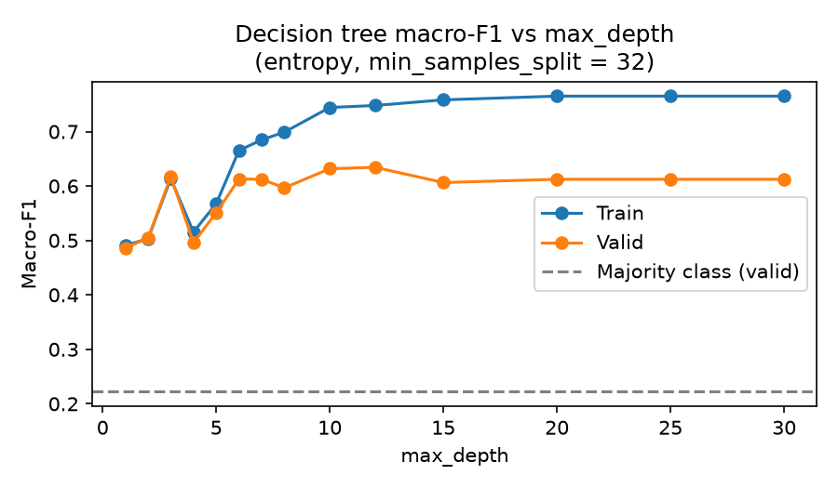
Figure 1: Decision tree train vs validation macro-F1 against max_depth.
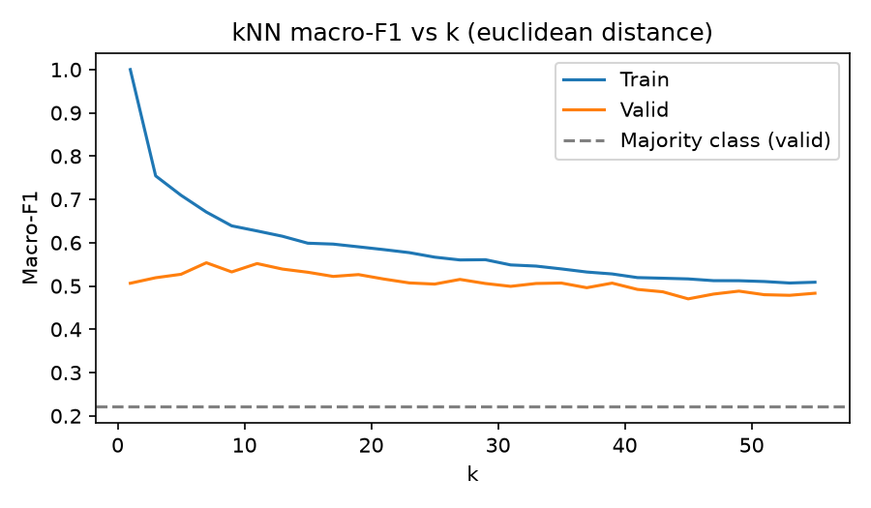
Figure 2: kNN train vs validation macro-F1 against k (Euclidean distance).
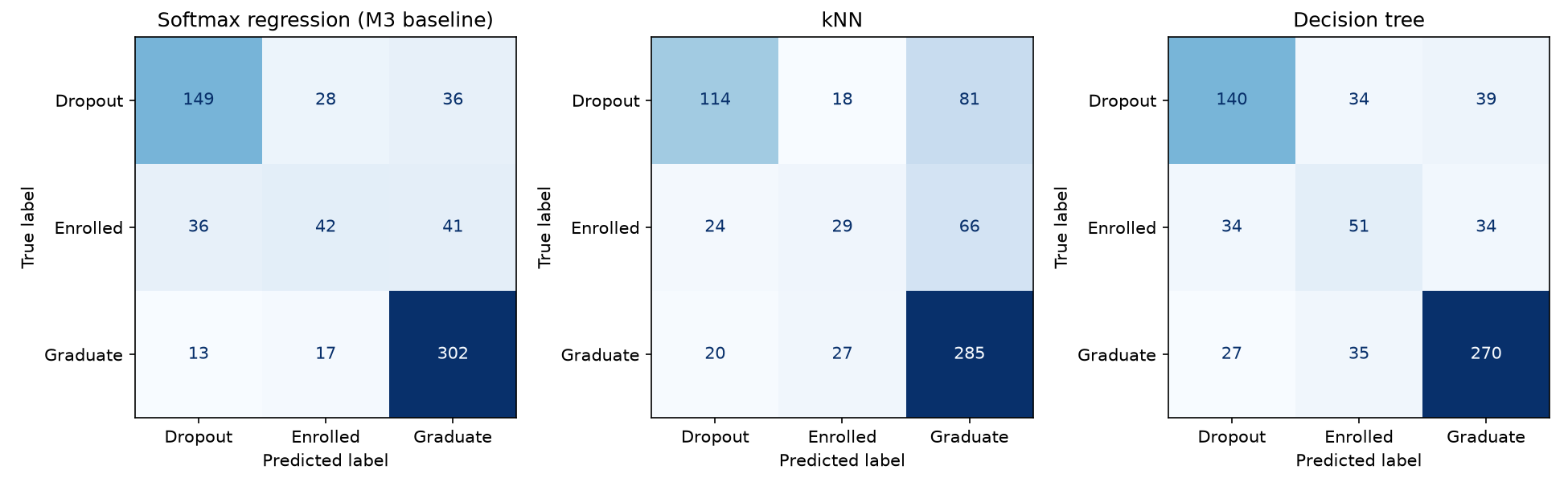
Figure 3: Validation confusion matrices for softmax regression, kNN and the decision tree.
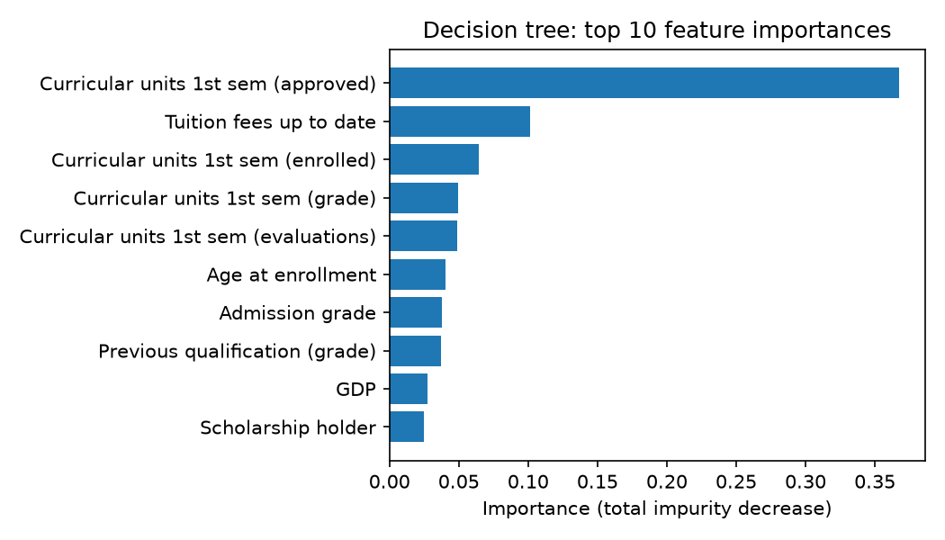
Figure 4: Top-10 decision-tree feature importances.
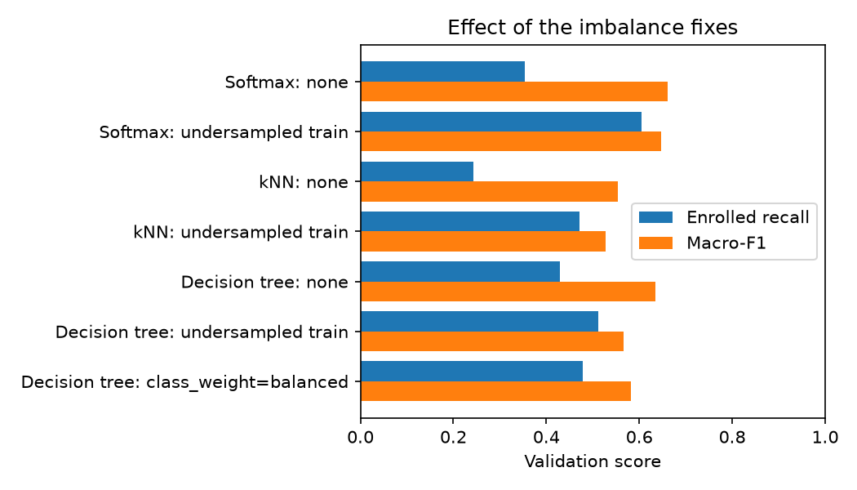
Figure 5: Enrolled recall and macro-F1 with and without the imbalance fixes.
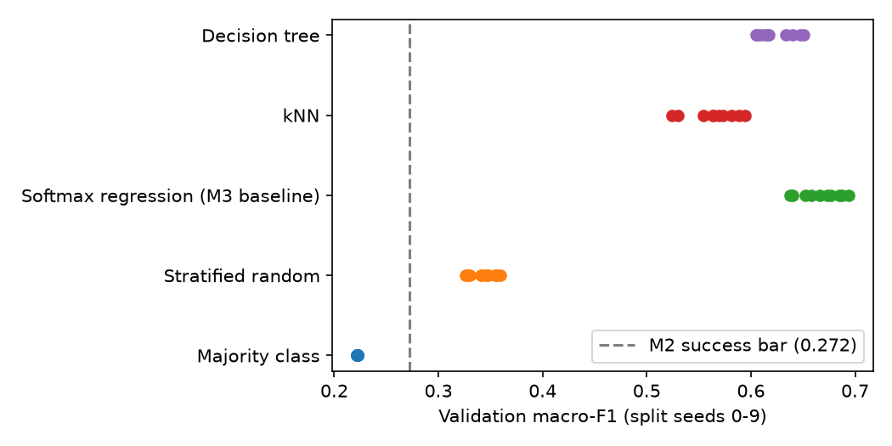
Figure 6: Validation macro-F1 of each model across split seeds 0-9.

3.3 Key Findings
- Neither non-linear model beats the linear baseline. Softmax regression stays best on macro-F1 (0.667 ± 0.020 vs 0.624 for the tree and 0.564 for kNN). This is a negative result for our second research question, and it suggests the main signal is close to linear: the tree gets 37% of its information gain from one feature, first-semester units approved.
- Undersampling the training set trades Graduate recall for Enrolled recall. For softmax, Enrolled recall rises from 0.35 to 0.61 and Enrolled F1 from 0.41 to 0.46, while Graduate recall falls from 0.91 to 0.73 and macro-F1 drops slightly (0.661 → 0.647). For kNN and the tree the macro-F1 drop is larger, and class weights on the tree (0.582) don't help either.
- A preliminary subgroup check shows the baseline leans on tuition status. For the 77 validation students behind on tuition, it predicts Dropout for 75 and Graduate for 2, so it catches all 64 real Dropouts but none of the 8 Enrolled students (Dropout recall 1.00, Enrolled recall 0.00). For scholarship holders (n = 154), Dropout recall is 0.54 against 0.72 for students without a scholarship. Macro-F1 for men and women is similar (0.65 and 0.66).

3.4 Error Analysis
Enrolled is the most common failure for every model. For softmax, 36 of the 119 Enrolled validation students are predicted Dropout and 41 Graduate. The missed Enrolled students look like the class they were assigned: several passed most of their first-semester units with decent grades (one passed 7 of 7 at 13.8/20) and were called Graduates, and one who passed 0 of 5 was called a Dropout. A delayed student's first semester simply doesn't look different from the other two outcomes, so first-semester features may not be enough to separate Enrolled. kNN also sends 81 of 213 Dropouts to Graduate, the worst mistake for an early-warning tool. Our hypothesis is the curse of dimensionality (W3): with 169 mostly-zero one-hot features, distances between students become similar, so the nearest neighbours aren't very informative.

5.5 Limitations of Current Results
The data come from one Portuguese institution, so results may not transfer. The validation set has 664 students and only 119 Enrolled, so per-class and subgroup scores move by several points between splits, and some subgroups are small (n = 72-154). The softmax baseline uses λ = 0, so its result depends on stopping after 5,000 steps. Hyperparameters were tuned on the seed-42 split only and not re-tuned for the other seeds. The subgroup check is only a first look, on the validation set. No model has been scored on the test set yet.

4. Deviations from the Original Plan
Planned | What actually happened | Reason | Impact
Proposal M4: preliminary results from kNN, a decision tree "and/or ensemble" | kNN and a decision tree only; ensemble moved to M5 | Kept to the two models promised in our M3 plan | None on the timeline; bagging is the first M5 experiment
Logistic regression baseline (proposal) | Softmax regression written in NumPy, with no L2 penalty chosen on validation | Three classes; λ = 0 scored best on validation | The baseline depends on early stopping; we will tune the number of steps or use a small λ in M5
Pinned environment for every run (M3) | One teammate re-ran M3 on Python 3.13.2 / scikit-learn 1.9.1 | Local setup | All NumPy results were identical; only the unconverged scikit-learn check moved (95.3% → 95.2% agreement). We now flag version drift in environment.json
Imbalance handling in M5 (M2 plan) | Started in M4 (undersampling and class weights) | Enrolled recall was the weakest result in M3 | Earlier evidence of the trade-off; the final choice is still made on validation in M5
There were no other deviations.

5. Current Blockers and Challenges
Challenge | Severity | Effect on project | Mitigation / support needed | Owner
Enrolled is hard to separate with first-semester data | High | Caps Enrolled F1 around 0.4-0.46 and limits macro-F1 | Imbalance fixes (done), better features from the first semester, possibly a per-class decision threshold | Jason
Model leans on tuition status (subgroup check) | Medium | 75 of the 77 students behind on tuition are predicted Dropout; fairness risk | Extend the subgroup analysis; ablation without financial/socioeconomic features | Adlene
Small validation set (664, 119 Enrolled) | Medium | Noisy per-class and subgroup scores | Keep reporting 10-seed mean ± std; consider cross-validation once it's covered in lectures | Cort
Keeping everyone on the pinned environment | Low | Small differences between machines | requirements.txt + environment.json check; run tests before every merge | Cort
Help requested from supervisor or peers: Is per-class threshold tuning on the validation set acceptable for M5 (it isn't covered in lectures yet)? Should the final comparison use cross-validation once it's taught, or keep the fixed split plus 10 seeds? We'd also like to know whether the λ = 0 baseline's dependence on the number of steps is a problem.

6. Revised Timeline and Next Steps

6.1 Revised Timeline
Phase | Tasks | Original date | Revised date | Status
Data collection and cleaning | Dataset, data card, cleaning, split | Oct 2 | Oct 2 | Complete
Baseline and initial models | Naive benchmarks, softmax baseline (M3); kNN and tree (M4) | Oct 19 / Oct 30 | Oct 19 / Oct 30 | Complete
Model improvement and tuning | Imbalance fixes, bagged trees, baseline tuning (steps or small λ) | Nov 20 | Nov 13 | In progress
Ablations and robustness testing | Subgroup analysis, socioeconomic-feature ablation, seed variability | Nov 20 | Nov 18 | In progress (preliminary subgroup check done)
Final evaluation on held-out test set | Score the chosen model once on the test set | Nov 20 | Nov 20 | Not started
Final report and presentation | 6-8 page report, repository release, presentation | Dec 4 | Dec 4 | Not started

6.2 Prioritised Next Steps
- Highest priority: choose between the plain and undersampled softmax on validation, and fix the λ = 0 early-stopping dependence (tune the step count or use λ = 0.001). Owner Jason, due Nov 13. Expected outcome: a final baseline with one reproducible optimum.
- Second priority: bagged decision trees (Lab 4) on the same split and seeds, to see whether averaging trees closes the 0.04 gap with softmax. Owner Cort, due Nov 13. Expected outcome: a third model in the final comparison.
- Third priority: full subgroup analysis (adding parental education) and an ablation without financial/socioeconomic features. Owner Adlene, due Nov 18. Expected outcome: evidence for the fairness part of our success criterion.

6.3 Risks to the Revised Plan and Contingencies
- If bagging doesn't beat softmax: report softmax as the final model and the non-linear results as negative findings; that still answers our research question.
- If no fix makes Enrolled meaningfully better: report the trade-off honestly and frame the tool as a Dropout early-warning system, with Enrolled as a known limitation.
- If someone's environment drifts again: rerun the M3 and M4 commands on the pinned environment before the final release and compare with the logged results.

7. Responses to Feedback Received So Far
Feedback (source, date) | Our response | Action taken | Status
Missing Report for Milestone 2 | Created reports for future milestones | Created reports for future milestones | Done

9. Midpoint Peer Check-In
Peer / group consulted: Group 22 Date and format: October 29th, online meeting, written review.

9.1 What We Shared
We shared our slides, progress report and repository with Group 22, along with a written mock peer review of our project.

9.2 Feedback Received from Peers
The points below come from that written review. Group 22 read it and told us they agree with it.
- Strengths noted: The problem is well-defined and has a clear end user: an advising office making decisions after first semester. The evaluation is rigorous: macro-F1 was chosen before training, tuning used only the validation set, results were checked across 10 splits, and models were compared with a paired test. You openly report that the linear model outperformed kNN and the decision tree rather than burying it, which the rubric specifically rewards. The theory connects directly to your own learning curves and confusion matrices.
- Concerns or questions raised: The "77 / 77" figure on slide 10 is incorrect. The undersampling result is based on a single split and reverses when the experiment is repeated. The claim that the test set is never touched doesn't fully hold for the 10-split scores. The repo linked in the report doesn't include any M4 code. There's little evidence of team process, with no pull requests, issues, or release tag.
- Suggestions: Benchmark against advisors' current approach, such as a simple GPA cutoff. Check when the tuition and debtor columns were recorded, since they may leak future information. Rerun the imbalance experiments over multiple seeds and re-tune hyperparameters after resampling. Report precision for the Dropout class and include a precision-recall curve. Test generalization by holding out each cohort one at a time.

9.3 Feedback We Gave to Peers
- Observations, strengths: The group has a clearly stated problem and target variable, and their data preprocessing steps were well explained. Their visualizations made the dataset easy to understand, and splitting the data into training, validation, and test sets showed a solid evaluation plan.
- Observations, gaps: There was no simple baseline model, so it was hard to judge how much their models actually improve on a naive approach. The choice of evaluation metric wasn't justified, which matters if the classes are imbalanced. Results came from a single run, so it's unclear how stable they are, and it wasn't clear whether hyperparameters were tuned on the validation set only or whether any features might leak information about the target.
- Observations, suggestions: We recommended adding a baseline such as a majority-class predictor or logistic regression, and explaining why their chosen metric fits the problem. We suggested using cross-validation or repeated runs with different seeds to report variability, and adding an error analysis to show where the model fails. We also suggested comparing at least one simpler and one more complex model, and checking feature importance to make the results easier to interpret.

9.4 Changes Resulting from the Check-In
We will report the full cost of undersampling. Section 1.3 names Dropout recall as our priority, and undersampling lowers it from 0.70 to 0.65 (138 of the 213 Dropouts caught instead of 149), while accuracy falls from 0.742 to 0.681. Slide 9 and the script will include these alongside Graduate recall and macro-F1, and our answer to RQ3 will be that we can't lift Enrolled recall without hurting the other classes.
We will stop presenting the macro-F1 drop as a result, because it comes from a single split and reverses when the experiment is repeated. The repeated check is not in our repository yet, so we will add it before quoting its numbers.
We will qualify the claim that the test set is untouched, with a sentence in Section 5.5 and new wording on slide 4, because official test rows appear in the train and validation sets of our 10-split runs.

12. Conclusion
We have a working, reproducible pipeline, three tuned models and a fixed evaluation protocol. The linear softmax baseline is still our best model (validation macro-F1 0.667 ± 0.020), ahead of a decision tree and kNN on almost every split, and undersampling can raise Enrolled recall from 0.35 to 0.61 at a small cost in macro-F1. Our top risk is the Enrolled class, which first-semester data barely separate. We're confident we can deliver the final comparison, subgroup analysis and test-set evaluation on schedule.

References
- Realinho, V., Vieira Martins, M., Machado, J., & Baptista, L. (2021). Predict Students' Dropout and Academic Success [Dataset]. UCI Machine Learning Repository. https://doi.org/10.24432/C5MC89
- Realinho, V., Machado, J., Baptista, L., & Martins, M. V. (2022). Predicting Student Dropout and Academic Success. Data, 7(11), 146. https://doi.org/10.3390/data7110146
- Pedregosa, F., et al. (2011). Scikit-learn: Machine Learning in Python. Journal of Machine Learning Research, 12, 2825-2830.
- CSCI 3052U Machine Learning I lecture slides, Weeks 2-5 (Fall 2026). Ontario Tech University.

