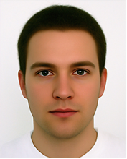

A

B

C

D

P

Q

M

N

In order to crop and scale the face of the person to a particular passport standard the following approach was investigated. Given the set of detected face landmarks A, B, C and D, we would like to estimate P and Q with an accuracy that is sufficient to ensure that the face in the output photo fall within the limits of the requirements. In other words, the estimated location of the crown (P’) and chin point (Q’) should be such that the distance P’Q’ scaled by the distance between the ideal location of the crown (P) and chin point (Q) falls within the scale range allowed. For the Australian passport requirement, the allowed scale range is ±5.88% [ = (36mm - 32mm)/(36mm + 32mm)].

To validate the proposed approach, facial landmarks [ATVS] for the SCFace [link] database were used. The SCFace database contains images for 130 different subjects and the frontal images of each individual were carefully annotated by the Biometric Recognition Group (ATVS) from Universidad Autonoma de Madrid.

The procedure to estimate P’ and Q’ from A, B, C and D is as follow: Firstly, points M and N are found as the center of segments AB and CD respectively. P’ and Q’ are expected to fall in the line that passes through M and N. Then using a normalization distance ND (to be defined) and scale constants α and β, we estimate P’Q’ = αND and M’Q’ = βND