Lab 4 Exercise – Fun with MLPs & MNIST

Justin Ugwudike (jknu1g19@soton.ac.uk)

March 14, 2023

**1 Question 1**

While experimenting with the width of the MLP for predicting the MNIST dataset I discovered that around 1,000 hidden unit was required to reach a validation prediction accuracy just above 98% (0.9807 (4.s.f)). Increasing the number of hidden units after achieving this accuracy had little to no benefits on the accuracy.

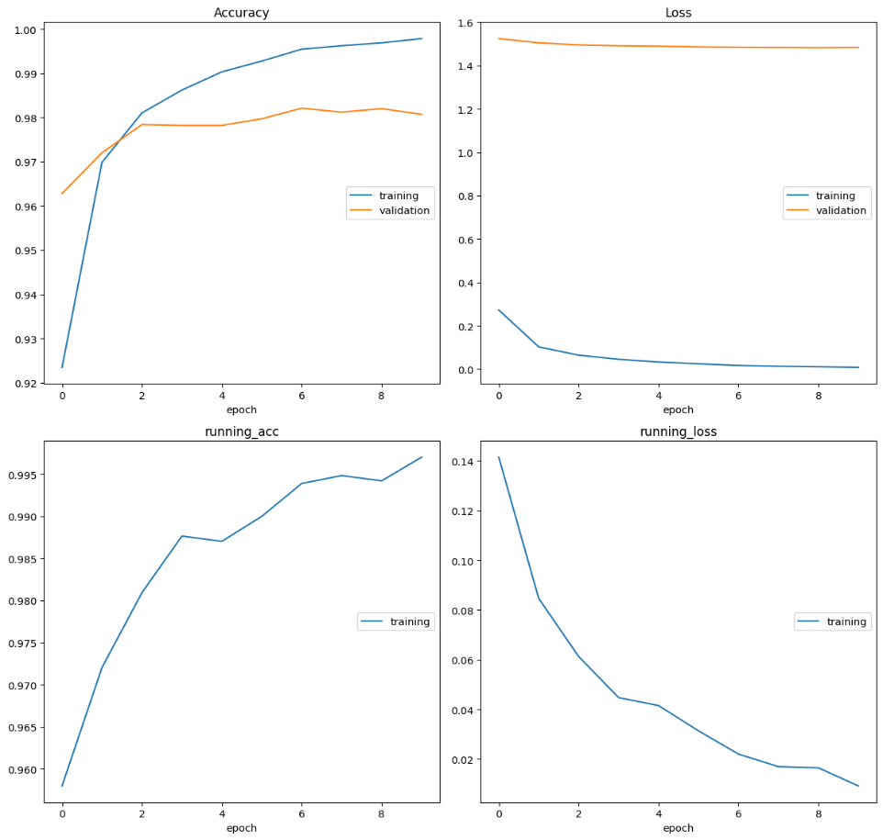

Figure 1 –Training and Validation accuracies of the MLP with 1,000 hidden units.

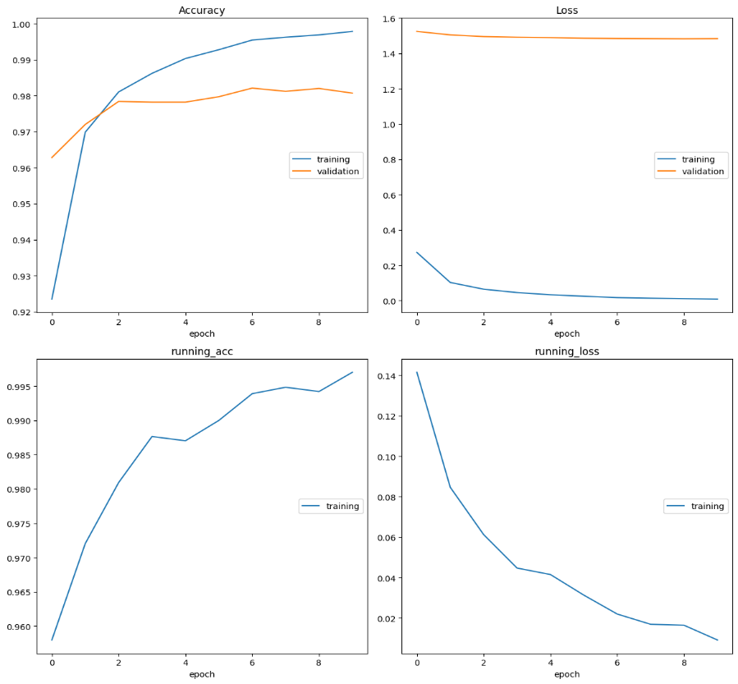

Figure 2 –Training and Validation losses of the MLP with 1,000 hidden units.

Figure 1 shows that with 1,000 hidden units the training accuracy reaches a value around 99.6% (0.9963 (4.s.f)) and the validation accuracy reaches a value around 98%. Figure 2 shows that the training loss reaches a value close to 0 (0.008170 (4.s.f)), whereas the validation loss is just below 1.5 (1.483 (4.s.f)). The difference in accuracies shown in figure 1 already indicate that the model is overfitting to the data as the training accuracy is close to 100% whereas the validation accuracy is just 98%.

Reducing the width to 10 hidden units gives accuracies in the training validation data around 92.5% for each. These accuracies are closer together but ideally, we would an accuracy closer to 100%.

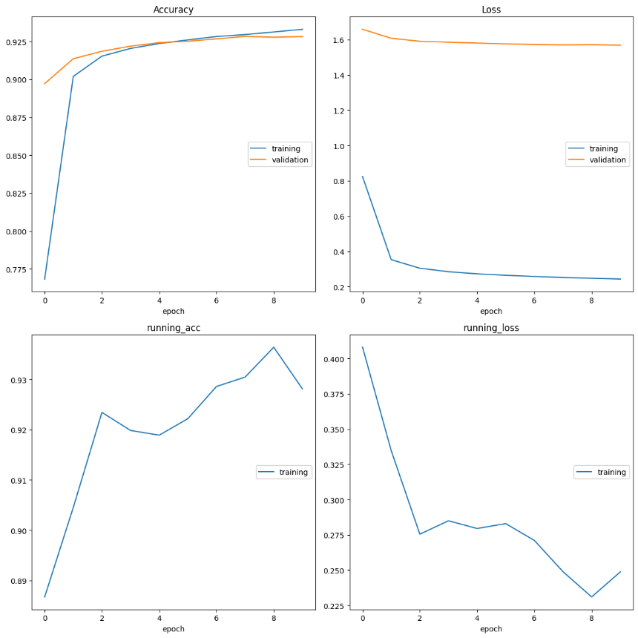

Figure 3–Training and Validation accuracies of the MLP with 10 hidden units.

Increasing the number of hidden units to 10,000 showed results similar to an MLP with 1,000 hidden units:

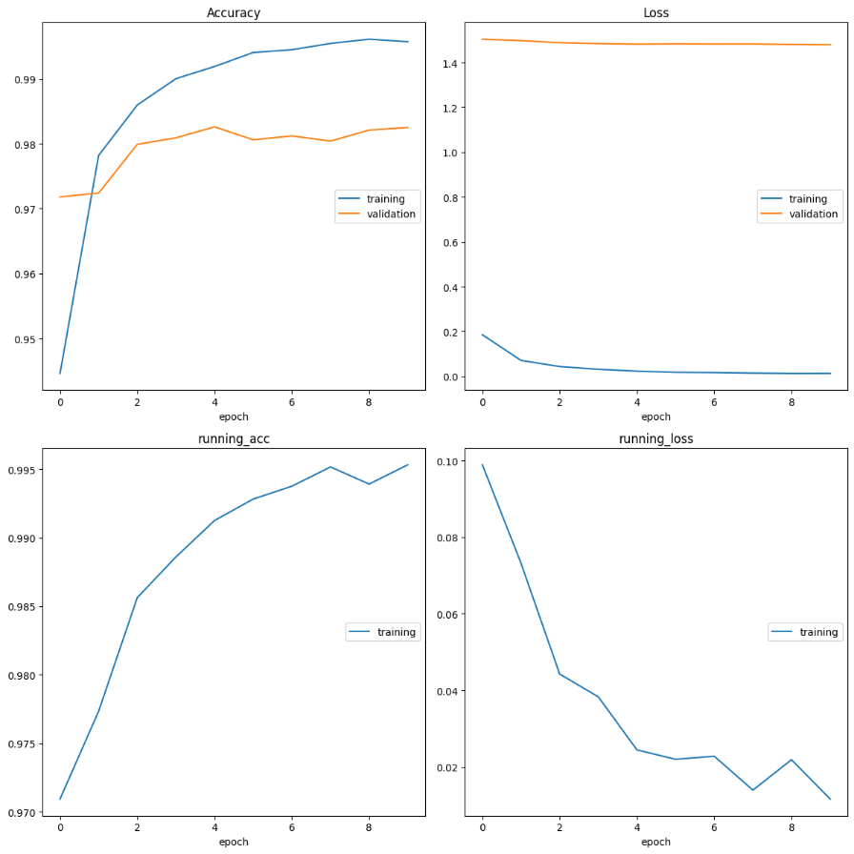

Figure 4 –Training and Validation accuracies of the MLP with 10,000 hidden units.

This was also true for MLPs with 50,000, 100,000, 150,000 and 500,000 hidden units. This led me to conclude that the model begins to overfit when the number of hidden units are greater than 10, however, to achieve high accuracies, the number of hidden units must be greater than 100, the best model should utilise at least 100 units but less than 1,000 hidden units where the amount of overfitting becomes high.