

Title of Dissertation
Author’s Name

June 8, 2007

MSc in High Performance Computing
The University of Edinburgh
Year of Presentation: 2007

Abstract
This is the bit where you summarise what is in your dissertation.
Contents
Chapter 1 Introduction 1
Chapter 2 Background Theory 2
2.1 The easy bits 2
2.2 The more difficult bits 2
2.2.1 Hard bits 3
2.2.2 Even harder bits 3
Chapter 3 Experimental design 5
Chapter 4 Results and Analysis 6
4.1 Some results 6
4.1.1 More results 6
Chapter 5 Conclusions 8
Appendix A Stuff which is too detailed 9
Appendix B Stuff which no-one will read 10
References 11
List of Tables
Table 1: This is a simple table. More complicated tables can have headings which pass over more than one column. 5
List of Figures
Figure 1: The University Crest 4
Figure 2: Simple Gnuplot example 6

Acknowledgements
This template is based on David Henty’s LaTeX template, which in turn was based on a LaTeX template created by Prof. Charles Duncan for MSc students in the Dept. of Meteorology. His acknowledgement follows:
This template has been produced with help from many former students who have shown different ways of doing things. Please make suggestions for further improvements.

Introduction
This chapter provides a general overview of the dissertation, including background, aims, methods, study value, and main structure of this research.

Dissertation Background
In the era of rapid development of the Internet and smartphones, searching restaurants or specific food has become easier. For example, with Google Maps, customers could find the type of restaurant or food they are interested in more simply and more accurately. At the same time, restaurant operators can use these techniques to better expand their business [1]. On discovering this business opportunity, an increasing number of restaurant operators are advertising the link to their menu on some information applications and websites, such as Google Maps and TripAdvisor [2]. This has resulted in a large amount of restaurant information such as menu and restaurant description, being publicly available in a digital form. In terms of ordinary diners, the content in restaurants’ websites can only provide them with a reference for catering. However, in the eyes of data workers, a lot of potential valuable information can be mined from these restaurants’ data. That means some valuable findings such as regional differences in a country or region can be found if using data mining techniques [3] on restaurants’ websites. This dissertation will introduce a method to get, process very messy restaurants’ websites data, mining regional features and classifying regional content from this data to reveal the regional differences.

Research Aim and Research Focus
The aim of this dissertation is to mine menu data from the “Fish&Chips” shops, revealing regional differences in the UK based on the geographical distribution of the content of the menu data. For example, 'Haggis' is a traditional food in Scotland and widely distributed, while rarely seen in England. According to the methodologies applied in this dissertation, we could provide evidence that 'Haggis' is loved by the Scottish people and it is a regional dish in Scotland. ‘Fish & Chips’ is one of the most famous foods in the UK and there are more than 1,000 ‘Fish & Chip’ shops in this country [4]. To achieve the project aim we will obtain the raw HTML data from the websites of some of these ‘Fish & Chip’ shops, and then employ data cleaning, mining, and visualisation techniques to find the content associated with particular regions.

Research Methods
In terms of data crawling, the dissertation will illustrate the selection of data sources and methods for crawling data from ‘Fish & Chip’ shops’ websites in the UK. The data cleaning procedure focuses on extracting and cleaning text content which is used for exploring regionality from the website HTML content, such as single independent words, noun phrases, and word pairs. The methods used for extracting and cleaning HTML content is the combination of Regular Expressions, HTMLParser and Natural Language Processing (NLP) (will be detailed in 2.2). Considering the data mining procedure of the research, data visualisation technologies will be applied to mine the regional features based on the geographical distribution of the extracted content. In terms of the classification (regional content and national content) of the extracted datasets, the project employs machine learning methods, such as decision trees and regression classifiers (will be detailed in 2.4) to generate the regionality result. Specifically, this research is an iterative process and includes four rounds of evaluation and improvement (showed by Figure. 1) since the entire study is an exploratory process. Excepting for the first iteration, each of the remaining iterations depends on the result of the last iteration. This means the project knows what to proceed next only after getting and evaluating the results of each iteration. Besides, there are no existing criteria to verify the rationality of the method selection and the correctness of the results. Thus, only after each iteration has finished, the project can know whether the choice of method is reasonable and whether the result is correct. In addition, the features that could be used for reflecting regionality of the text is unknown and the evaluation of regionality content is based on the evaluator’s experiences to some extent. For example, the evaluator knows the ‘irn bru’ is a Scottish drink, so when this phrase is judged to be regional, the evaluator can assume the decision is correct. Therefore, regional features and regional results are derived from each iteration, including exploration, evaluations, and improvements. In each iteration, the project may use or update the methods in the previous iteration. Besides, each iteration will also evaluate the results to identify problems and propose improvements for the next iteration.
Figure 1: Workflow Diagram

Value of the Research
The research is an innovative study that links seemingly unrelated menu information to regional differences of the UK through exploring regional content from the messy menu dataset. Thus, the biggest challenge for this project is that there are no existing ideas or methods to refer to and all ideas and methods require the project to explore and evaluate. Fortunately, the project succeeded in finding a solution to explore regional content and reflect regional differences, including ideas for finding regional features and methods for regional words classification. The methods and algorithms used in this project are universal, and they can also be used to find regional differences in other countries or used in similar studies. As a result, the project laid the foundation for similar subsequent researches.

Structure of the Dissertation
The structure of this dissertation is organised as follows: Chapter 2 covers background knowledge, which mainly illustrates the main techniques and algorithms used in this research. Chapter 3, Chapter 4, Chapter 5 and Chapter 6 introduce the details of each iteration in the project, including methodologies, findings, evaluations, and improvements and summary and future work. Chapter 3 describes the first iteration, presenting the procedures of exploring features of regional independent single words. Chapter 4 is related to the second iteration, which describes the application of decision tree to get regional results of the single word. This chapter uses two types of decision tree algorithms and the makes comparison between the two algorithms. Chapter 5 covers the third-round iteration, which introduces the logistic regression to obtain the probability that the single independent word is judged as a regional word. This chapter focuses on evaluating the importance of the selected features and the threshold regarding probability, in order to identify the number of probabilities exceeds the threshold, which would be judged as regional word. Chapter 6 is about the fourth iteration, which demonstrates the results of using the other two kinds of datasets (noun phrases and word pairs). Chapter 7 is a conclusion about this research. Chapter 8 provides a description of the improvement could be included in future work and also introduces the limitations, and recommendations.

Background Theory
This chapter focuses on describing the techniques and methods used in the dissertation. Section 2.1 states the selection of data source and the definition of the web crawling. Section 2.2 presents an overview of data cleaning procedure and techniques used in the project. Section 2.3 provides the description of core algorithm and techniques used for geographic data visualisation. Section 2.4 aims to illustrate the data mining process in the project and some machine learning methods used for classifying regional content.

Web crawling
Before crawling data from websites of ‘Fish & Chips’ shops, the dissertation selected data sources that included food delivery websites such as Just-Eat [5] and independent ‘Fish & Chips’ shops’ websites. The advantages of using food delivery websites as data source is that it is convenient to search ‘Fish & Chips’ shops in each city of the UK by postcode. In addition, each shop which is searched out from food delivery websites is available to crawl data directly that the shop has a valid link and the page of that link has menu content. Whereas when searching on independent websites it may be the case that the desired content (e.g. menu) is only available in a PDF and hence cannot be crawled. Further on independent websites it may be the case that the URLs provide on the site are broken and hence also cannot be crawled. Thus, the dissertation originally planned to use the food delivery website as a data source. However, sites like Just-Eat clearly state that direct crawling of their web site data is not allowed [6]. Therefore, using such a food delivery website to crawl data directly in this dissertation project may be illegal. This fatal flaw meant this method could not be used. As a consequence, Google Maps has been used to find independent websites of ‘Fish & Chips’ shops and the data from these independent websites has then been used as the data source.
Web crawling is the mechanism by which information has been collected from target websites [7]. Specifically, the Python module urllib2 has been used to simulate browser behaviour to download web pages and handle request errors [8] to get the full website HTML data of ‘Fish & Chips’ shops.

HTML data cleaning techniques
Data cleaning is used for improving the quality of data which is used for subsequent processing through detecting inconsistencies and removing errors [9]. In this project, the dataset required to be cleaned is HTML data. The goal of data cleaning in this project is to obtain independent words (such as ‘haggis’), noun phrases (such as ‘monday supper deal haggis’) and word pairs (such as ‘salad with haggis’ can be divided into ‘salad with’ and ‘with haggis’ word pairs) with shop coordinates from HTML datasets and city dataset which contains coordinates.
In the web-based dataset, there is a lot of content that is not required by this project, such as name, attributes of HTML tags, script code and special symbols. The project only focuses on information which the user can see on the page rather than the implementation details of the page. However, in terms of content which customers can see, there is a lot of redundancy, such as the singular and plural of the same noun all represent the same word. Therefore, the project should not only filter useless content in the HTML data, but also classifying words that represent the same meaning such as ‘chip’ and ‘chips’ into the same category (mainly focuses on the classification of singular and plural nouns with the same meaning). Fortunately, the regular expression, HTMLParser and NLP can help the project to achieve the data cleaning goal.

HTMLParser
HTMLParser is an open source, fast and robust HTML parsing tool for extracting and cleaning content of HTML Error: Reference source not found. It can customize HTML tag content extraction based on user requirements [11]. In this project, the HTMLParser mainly responsible for data extraction and filtering. The data source used in the project are independent websites that the HTML structure of most websites is different as Fig. 2 and Fig. 3 shows (small parts of the website structure are the same because they are developed by the same company). Fig. 2 shows part of the HTML source code of one of the websites that this website writes all the CSS styles on the page. Fig. 3 shows part of the HTML source code of another website that this page introduces some JavaScript code between the HTML element tags. In addition, these two websites are completely different in the HTML structure of the menu. Therefore, in order to extract content from HTML source code with different structures, the HTMLParser plays an important role. It does not pay attention to the structure of the website design, it only pays attention to the name of the HTML tag, such as ‘div’ and ‘script’. As a consequence, the project can easily filter absolutely useless content based on the tag name, such as the content in the ‘script’ tag and extract potentially valuable content from the remaining tags. However, because the design styles of different web pages are different, the extracted data may also contain special symbols such as field trailing space symbol that will interfere with the cleaning result. Thus, the project also uses the regular expression which is a source language which can locate specific character strings in text [12] to filter the result of the HTMLParser.
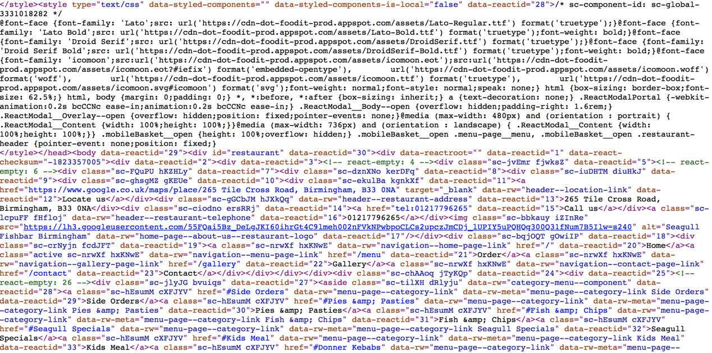
Figure 2: HTML source code with HTML style of one of ‘Fish & Chips’ shops’ websites
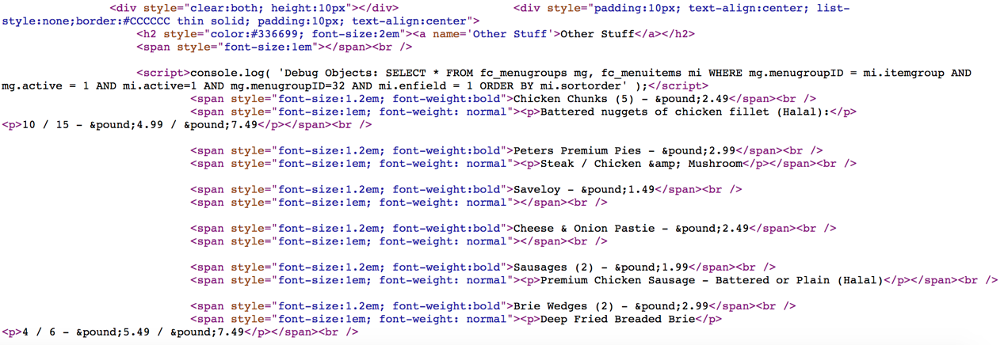
Figure 3: HTML source code of one of ‘Fish & Chips’ shops’ websites

Natural Language Processing (NLP)
In order to solve the problem of data redundancy in the extracted content, the project uses method of semantic recognition in NLP. Natural Language Processing (NLP) is using computer to understand and manipulate natural text or speech to process tasks [13]. This project mainly wants to change the singular and plural nouns of the same root into singular nouns and the Natural Language Toolkit (nltk) can provide the solution. nltk is an open source tool written by Python with collection of modules and corpora [14]. nltk determines the part of speech of a word based on its corpus and the identification method has been encapsulated which the project can use directly to identify plural nouns and convert them to singular forms. However, in English some words can be both plural nouns and verbs and the nltk will treats all words as nouns and converts them into singular. Fortunately, this project does not care whether the word being converted is a verb or a noun. It only cares whether the word is distributed regionally.

Geographic data visualisation
One of the aims of the project is to explore geographically distributed features to represent regionality, so the project uses Cartesian coordinate systems for geolocation calculations and Matplotlib for data visualisation.

Central point calculation algorithm
The core calculation in this project is the set of coordinates’ (the method of obtaining it will be described in detail in 3.1.2) central point which is the centre of all shops which contain a specific content. The importance of the central point is that most regional features found in this project are derived from it. The project uses a set of geographic coordinates containing this content to calculate the centroid. The algorithm used in this project for calculating the central point through combining geographical coordinate system with Cartesian coordinate systems which regards the Earth as a sphere (Fig. 4). This combination is also known as ECEF ("earth-centered, earth-fixed") [12]. In Cartesian coordinates, earth is a sphere centered at the origin [13]. The z axis points to the north pole. The x, y axes are on the equatorial plane that the x-axis passes through the equator and the prime meridian and the y-axis points to the equator at 90 degrees east [14]. However, the coordinates of the central point obtained by using this algorithm in the project are not accurate since the algorithm regards the earth as a sphere rather than ellipse which is the shape of the earth itself. Fortunately, the requirement of the accuracy of the coordinates of the central point in this project is not high, because this project is concerned with the distribution of content.
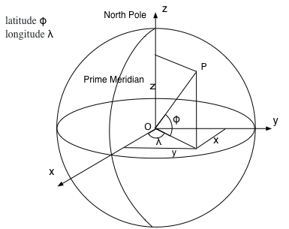
Figure. 4: geographical coordinate system with a cartesian coordinate systems
As Fig. 4 shows, point P in Fig. 1 represents a geographical coordinate with latitude and longitude . A series of coordinates can be represented as latitude , longitude (i = 1n). Thus, in cartesian coordinate systems, the coordinates of the three directions can be expressed as:
= ,
= ,
= 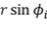,
The centroid of these points is the average of the sum of 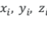:
(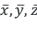) = 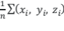,
The coordinate of the centroid can be expressed as:
= 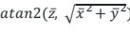,
= 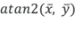

The easy bits
This is just to show how to break things into sections.
Some paragraphs in this demonstration document are here to provide some padding so that sections last for more than one page to illustrate what happens on subsequent pages. Note that the page numbering style is usually different on the first page of a new chapter than on subsequent pages.

Here is a padding paragraph. Rhubarb. More rhubarb. Yet more rhubarb. Rhubarb. More rhubarb. Yet more rhubarb. Rhubarb. More rhubarb. Yet more rhubarb. Rhubarb. More rhubarb. Yet more rhubarb. Rhubarb. More rhubarb. Yet more rhubarb. Rhubarb. More rhubarb. Yet more rhubarb. Rhubarb. More rhubarb. Yet more rhubarb. Rhubarb. More rhubarb. Yet more rhubarb. Rhubarb. More rhubarb. Yet more rhubarb. Rhubarb. More rhubarb. Yet more rhubarb. Rhubarb. More rhubarb. Yet more rhubarb. Rhubarb. More rhubarb. Yet more rhubarb. Rhubarb. More rhubarb. Yet more rhubarb. Rhubarb. More rhubarb. Yet more rhubarb. Rhubarb. More rhubarb. Yet more rhubarb. Rhubarb. More rhubarb. Yet more rhubarb. Rhubarb. More rhubarb. Yet more rhubarb. Rhubarb. More rhubarb. Yet more rhubarb. Rhubarb. More rhubarb. Yet more rhubarb. Rhubarb. More rhubarb. Yet more rhubarb.

The more difficult bits
Some bits are hard.
Here is a padding paragraph. Rhubarb. More rhubarb. Yet more rhubarb. Rhubarb. More rhubarb. Yet more rhubarb. Rhubarb. More rhubarb. Yet more rhubarb. Rhubarb. More rhubarb. Yet more rhubarb. Rhubarb. More rhubarb. Yet more rhubarb. Rhubarb. More rhubarb. Yet more rhubarb. Rhubarb. More rhubarb. Yet more rhubarb. Rhubarb. More rhubarb. Yet more rhubarb. Rhubarb. More rhubarb. Yet more rhubarb. Rhubarb. More rhubarb. Yet more rhubarb. Rhubarb. More rhubarb. Yet more rhubarb. Rhubarb. More rhubarb. Yet more rhubarb. Rhubarb. More rhubarb. Yet more rhubarb. Rhubarb. More rhubarb. Yet more rhubarb. Rhubarb. More rhubarb. Yet more rhubarb. Rhubarb. More rhubarb. Yet more rhubarb. Rhubarb. More rhubarb. Yet more rhubarb. Rhubarb. More rhubarb. Yet more rhubarb. Rhubarb. More rhubarb. Yet more rhubarb. Rhubarb. More rhubarb. Yet more rhubarb.

Hard bits
You might want to include an equation here:
- δN_{ν}=(δN_{ν})_{ex}+(δNν)_{au}
Note that when you format an equation using the Equation style (as illustrated above), the equation is automatically numbered, and can be referred to using a cross-reference.
Here is a padding paragraph. Rhubarb. More rhubarb. Yet more rhubarb. Rhubarb. More rhubarb. Yet more rhubarb. Rhubarb. More rhubarb. Yet more rhubarb. Rhubarb. More rhubarb. Yet more rhubarb. Rhubarb. More rhubarb. Yet more rhubarb. Rhubarb. More rhubarb. Yet more rhubarb. Rhubarb. More rhubarb. Yet more rhubarb. Rhubarb. More rhubarb. Yet more rhubarb. Rhubarb. More rhubarb. Yet more rhubarb. Rhubarb. More rhubarb. Yet more rhubarb. Rhubarb. More rhubarb. Yet more rhubarb. Rhubarb. More rhubarb. Yet more rhubarb. Rhubarb. More rhubarb. Yet more rhubarb. Rhubarb. More rhubarb. Yet more rhubarb. Rhubarb. More rhubarb. Yet more rhubarb. Rhubarb. More rhubarb. Yet more rhubarb. Rhubarb. More rhubarb. Yet more rhubarb. Rhubarb. More rhubarb. Yet more rhubarb. Rhubarb. More rhubarb. Yet more rhubarb. Rhubarb. More rhubarb. Yet more rhubarb.
Here is a padding paragraph. Rhubarb. More rhubarb. Yet more rhubarb. Rhubarb. More rhubarb. Yet more rhubarb. Rhubarb. More rhubarb. Yet more rhubarb. Rhubarb. More rhubarb. Yet more rhubarb. Rhubarb. More rhubarb. Yet more rhubarb. Rhubarb. More rhubarb. Yet more rhubarb. Rhubarb. More rhubarb. Yet more rhubarb. Rhubarb. More rhubarb. Yet more rhubarb. Rhubarb. More rhubarb. Yet more rhubarb. Rhubarb. More rhubarb. Yet more rhubarb. Rhubarb. More rhubarb. Yet more rhubarb. Rhubarb. More rhubarb. Yet more rhubarb. Rhubarb. More rhubarb. Yet more rhubarb. Rhubarb. More rhubarb. Yet more rhubarb. Rhubarb. More rhubarb. Yet more rhubarb. Rhubarb. More rhubarb. Yet more rhubarb. Rhubarb. More rhubarb. Yet more rhubarb. Rhubarb. More rhubarb. Yet more rhubarb. Rhubarb. More rhubarb. Yet more rhubarb. Rhubarb. More rhubarb. Yet more rhubarb.

Even harder bits
This might be one of the places where you might want to refer to equation (1). When the numbering of equations changes (for example, if you insert an additional equation between two existing equations), the cross-references will not automatically update. You can either update the relevant cross-reference by right clicking and choosing Update Field or you can update all fields in a document by doing a Select All (Ctrl+A), and then pressing F9.

Numbering
You can keep subdividing but eventually you will get to a level where the numbering stops. This text is in outline level 4 which is not numbered by default.

Experimental design
You might sometimes want to include equations without numbering them.
E = mc²
You might also want to include diagrams. To insert a figure, choose Insert > Picture > From File… A caption will be created automatically, and will include a figure number. You should centre the figure, and ensure that the Caption style is applied to the caption.

Figure 1: The University Crest
You can use a label on a figure to refer to it later. The university crest is in Figure 1. Note that you should not use phrases like “the figure above” or “the following figure” since later formatting changes can affect the relative position of the image with respect to the text.

Results and Analysis

Some results
Here are some results.

More results
When showing results you are likely to use tables and graphs. You can create tables easily in Word. To insert a caption for a table such as the one in Table 1, place your cursor in the table, and then choose Insert > Reference > Caption. From the Label menu in the dialog box that appears, choose Table.

File names | Satellite | Resolution
worldr | Meteosat | 5km
worldg | Meteosat | 5km
worldb | Meteosat | 5km
Table 1: This is a simple table. More complicated tables can have headings which pass over more than one column.
From many MS Windows programs you can simply cut and paste images into your document. You can select a caption in a similar way to the caption in the table above (but choose Figure instead of Table).
One way to produce simple graphs is to use gnuplot which can produce output in various formats. You can output in png format and use Insert > Picture > From File… as described above. Figure 2 was produced using gnuplot. For more details, see gnuplot’s internal help system (try, help display and help output).
Another approach is to draw simple ﬁgures using xﬁg which allows you to export your results in many formats including jpeg and png.
Word can also import graphics in eps format.
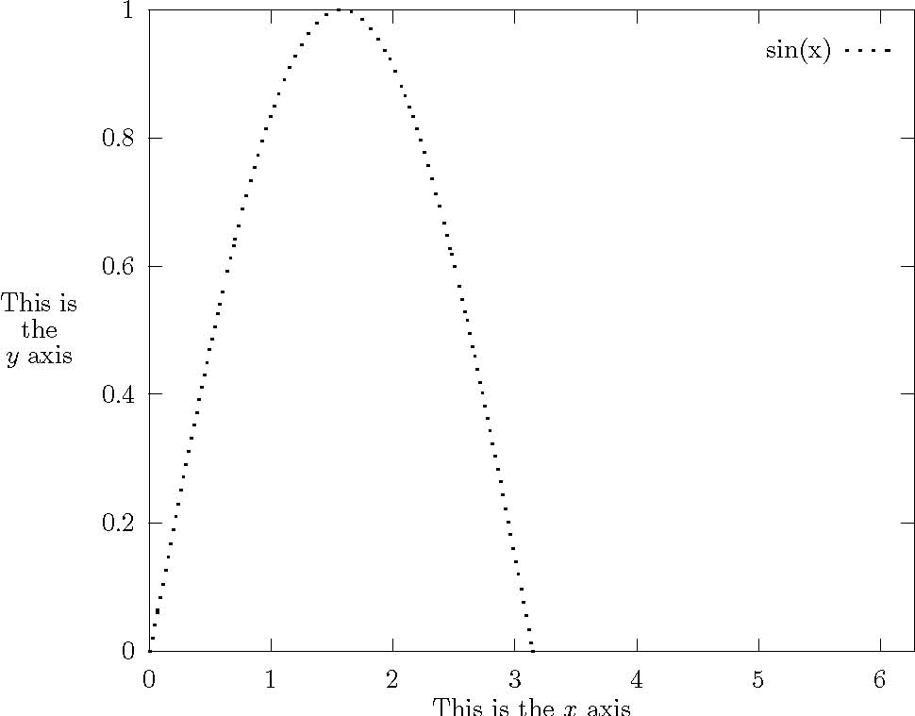
Figure 2: Simple Gnuplot example

Conclusions
This is the place to put your conclusions about your work. You can split it into different subsections if appropriate. You may want to include a subsection of future work which could be carried out to continue your research.

- Stuff which is too detailed
Appendices should contain all the material which is considered too detailed to be included in the main body but which is, nevertheless, important enough to be included in the thesis.
- Stuff which no-one will read
Some people include in their thesis a lot of detail, particularly computer code, which no-one will ever read. You should be careful that anything like this you include should contain some element of uniqueness which justifies its inclusion.
References
- Vasumita S Adarsh. (2013, December 26). TastyKhana launches Google map feature for website.(Internet). The Economic Times, p. The Economic Times, Dec 26, 2013.
- O'Connor, P. (2010). Managing a hotel's image on TripAdvisor. Journal of Hospitality Marketing & Management, 19(7), 754-772.
- Hand, D. J. (2007). Principles of data mining. Drug safety, 30(7), 621-622.
- Fish and chips. (2010). Nutrition & Food Science, 40(6), 157-165.
- Just Eat. Online at https://www.just-eat.co.uk/ (referenced 19/08/2018).
- JUST EAT WEBSITE TERMS AND CONDITIONS. Online at https://www.just-eat.co.uk/termsandconditions (referenced 19/08/2018).
- Castillo, C. (2005, June). Effective web crawling. In Acm sigir forum (Vol. 39, No. 1, pp. 55-56). Acm.
- Goerzen, J. (2004). Web Client Access. In Foundations of Python Network Programming (pp. 113-126). Apress, Berkeley, CA.
- Rahm, E., & Do, H. H. (2000). Data cleaning: Problems and current
- LI, W., & HUANG, Y. (2007). Web information extraction based on HtmlPaser [J]. Ordnance Industry Automation, 7, 024.
- Lin, S., & Hu, Y. (2010, July). An approach of extracting web information based on htmlparser. In Information Technology and Computer Science (ITCS), 2010 Second International Conference on (pp. 284-287). IEEE.
- Thompson, K. (1968). Programming techniques: Regular expression search algorithm. Communications of the ACM, 11(6), 419-422.
- Chowdhury, G. G. (2003). Natural language processing. Annual review of information science and technology, 37(1), 51-89.
- Bird, S., & Loper, E. (2004, July). NLTK: the natural language toolkit. In Proceedings of the ACL 2004 on Interactive poster and demonstration sessions (p. 31). Association for Computational Linguistics.

