Jason Cripps

Student number: 16435199

GitHub URL: https://github.com/JasonCripps/csy1018-assign1

Assignment 1: Web Development

Submission Date: 15/01/2017

# Change log

|  |  |  |
| --- | --- | --- |
| Date | Details | Approx. time to complete |
| 06/01/2017 | Created folders, structure as specified in assignment brief | 0:15 |
| 06/01/2017 | Created empty files: index.html, cv.html, contact.html and bio.html in root of ‘htdocs’ folder | 0:15 |
| 15/01/2017 | Added designs for each of the html pages | 0:45 |
| 15/01/2017 | Added basic setup of the index.html | 0:20 |
| 15/01/2017 | Basic setup of bio.html, cv.html & contact.html | 0:05 |
|  |  |  |
|  |  |  |
|  |  |  |
|  |  |  |

# Designs

## Index

The design for the ‘index.html’ page

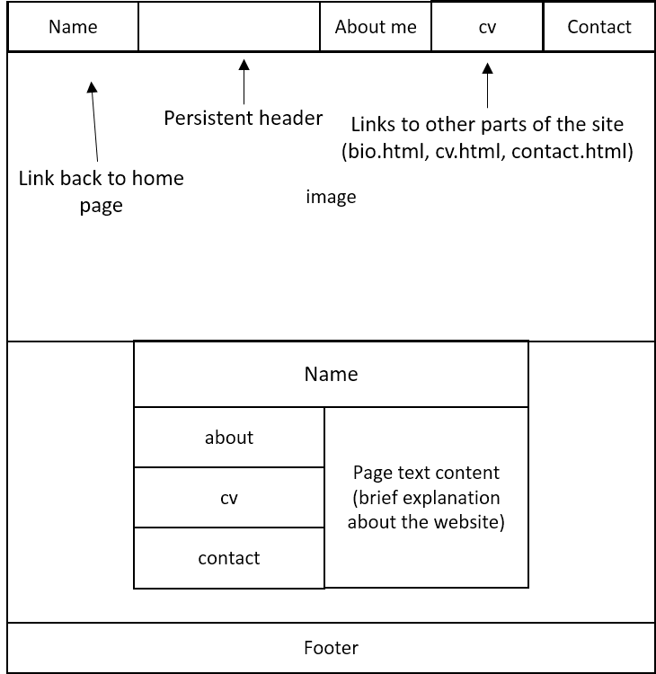

## Bio

The design for the ‘bio.html’ page

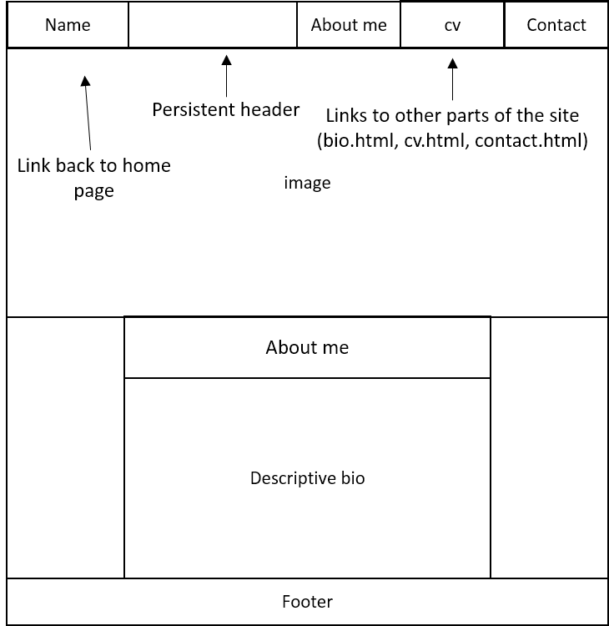

## CV

The design for the ‘cv.html’ page

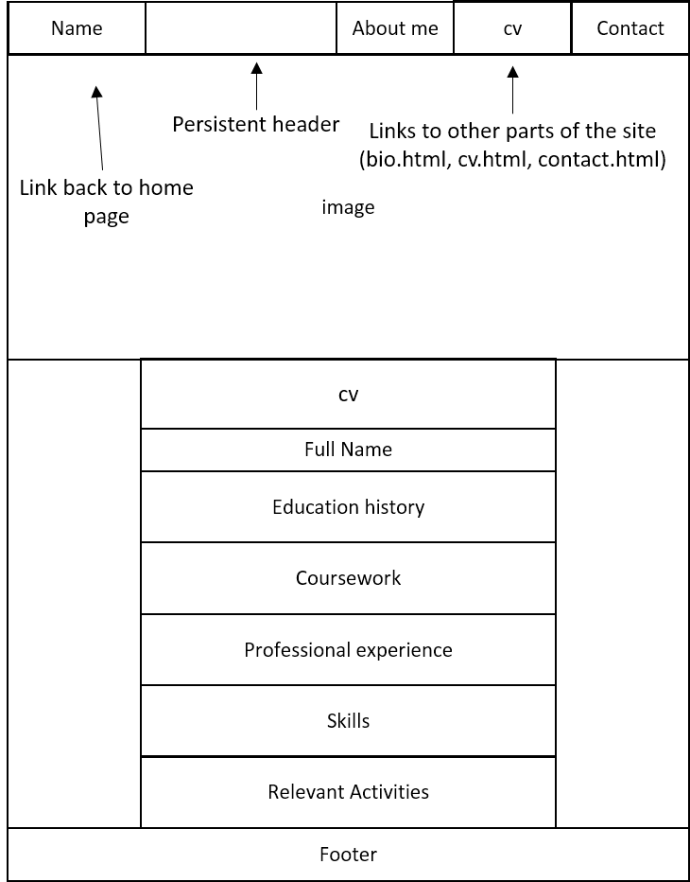

## Contact

The design for the ‘contact.html’ page

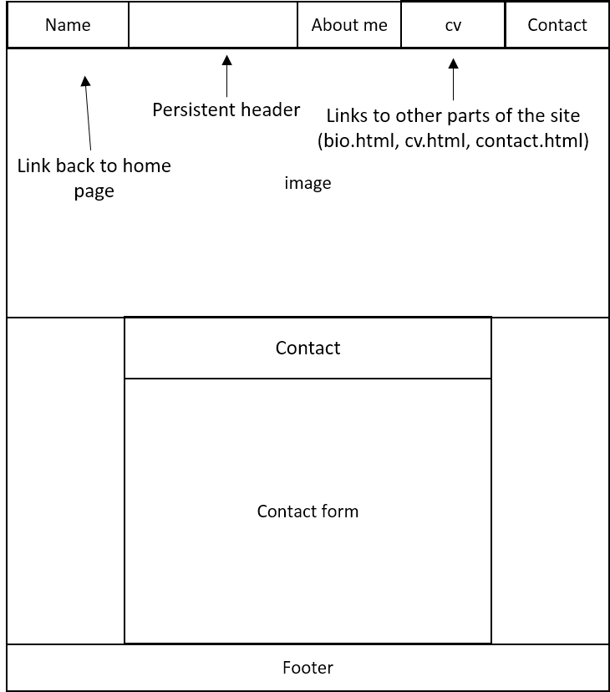

# References

W3Schools (2017) *HTML Head* [online]. Available from <http://www.w3schools.com/html/html_head.asp> [Accessed 15 January 2017]